Geogrids- its Types, Functions and Applications and Advantages in Construction

Geogrids is a geosynthetic materials used as reinforcement in construction works. Types of geogrids, its functions and applications in construction works are discussed.
Geogrids can be categorized as geosynthetic materials that are used in the construction industry in the form of a reinforcing material. It can be used in the soil reinforcement or used in the reinforcement of retaining walls and even many applications of the material are on its way to being flourished.
The high demand and application of Geogrids in construction are due to the fact that it is good in tension and has a higher ability to distribute load across a large area.
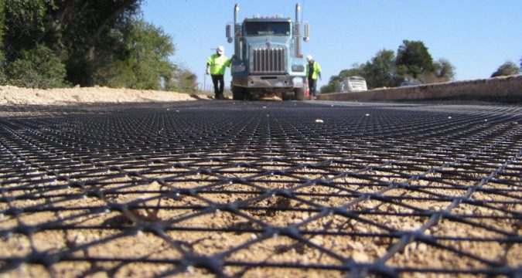

Origin of Geogrids and its Manufacture
The geosynthetic material, geogrids, are polymeric products which are formed by means of intersecting grids. The polymeric materials like polyester, high-density polyethylene and polypropylene are the main composition of geogrids.
These grids are formed by material ribs that are intersected by their manufacture in two directions: one in the machine direction (md), which is conducted in the direction of the manufacturing process. The other direction will be perpendicular to the machine direction ribs, which are called as the cross-machine direction (CMD).
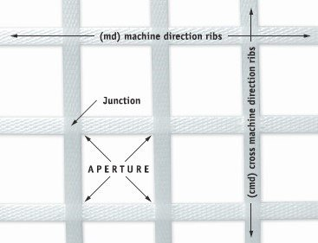
Fig. Geogrid’s rib formation in machine and cross machine directions of manufacturing process
These materials form matrix structured materials. The open space, as shown in the above figure, due to the intersection of perpendicular ribs are called as the apertures. This aperture varies from 2.5 to 15cm based on the longitudinal and transverse arrangement of the ribs.
Among different types of geotextiles, geogrids are considered stiffer. In the case of geogrids, the strength at the junction is considered more important because the loads are transmitted from adjacent ribs through these junctions.
Many manufacturing choices are available for ribs. Here we are going to discuss three most used method of manufacturing of geogrids:

Method-1: By Extruding
This manufacturing method of geogrids involves extrusion of a flat sheet of plastic into the desired configuration. The plastic material used may be high-density polypropylene or high-density polyethylene. Already set punching pattern is placed over the sheet to make holes for the formation of desired grids.
The punching of a pattern of holes would result in the formation of so-called apertures. Next step involves the development of tensile strength, by stretching the material to both longitudinal and transverse direction. A figure representing an extruded Geogrid is shown below.
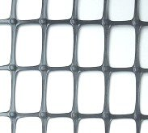
Fig. A Geogrid manufactured from the method of extrusion

Method-2: By Knitting or Weaving
In this method of Geogrid manufacture, single yarns of polyester or polypropylene material undergo either knitting or weaving to form flexible junctions forming apertures. These materials are recommended to have high tenacity, to give the Geogrid the final desired property.
The product is bought into the market by giving them an additional coating of either bituminous material or a polyvinyl chloride or a latex. This choice varies with the manufacturer of geogrids.
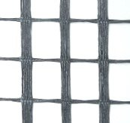
Fig. A Geogrid sample manufactured by knitting

Method-3: By Welding and Extrusion
This is recently developed a method by Secugrid manufactures. The method involves the extrusion of flat polyester or polypropylene ribs by passing them through rollers as shown in the figure below. These are done in automated machines that run at different speeds, enabling stretching of ribs and increasing their tenacity.
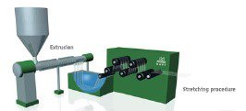
Fig. The stretching of ribs through extrusion process
As shown in the figure below, the ribs obtained are sent to the welding section through either side. One in the machine direction and other in the perpendicular direction. Forming a high-quality Geogrid.
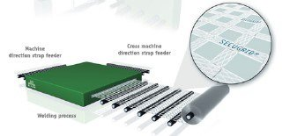
Fig. The welding of the ribs forming apertures

Functions and Working of Geogrids
The geogrids serve the function of holding or capturing the aggregates together. This method of interlocking the aggregates would help in an earthwork that is stabilized mechanically. The apertures in geogrids help in interlocking the aggregates or the soil that are placed over them. A representation of this concept is shown below.

Fig. A representation of Geogrid Confining the aggregates
The geogrids as mentioned above helps in redistribution of load over a wider area. This function has made the pavement construction more stabilized and strong. It has the following functional mechanisms when applied for pavement construction:

Tension Membrane Effect
This mechanism is based on the concept of vertical stress distribution. This vertical stress is from the deformed shape of the membrane as shown in the figure below. This mechanism was initially considered as the primary mechanism. But later studies proved the lateral restraining mechanism is the major criteria that must be taken into consideration.
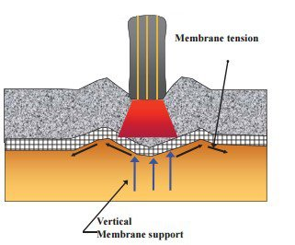

Improvement of Bearing Capacity
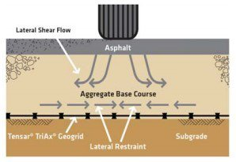
Fig. Mechanism for Improved Bearing Capacity
One of the main mechanism happening after Geogrid installation in pavement is the reduction in lateral movement of the aggregate. This would result in the elimination of stresses; that if exists would have moved to the subgrade.
The Geogrid layer possesses sufficient frictional resistance that opposes subgrade lateral movement. This mechanism hence improves the bearing capacity of the layer. Reduction of outward stresses means inward stresses are formed, which is the reason behind the increase in bearing capacity.

Lateral Restraining Capability
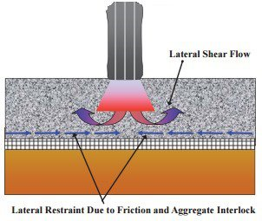
The stresses produced by means of the wheel loadings coming over the pavement results in the lateral movement of the aggregates. Which in turn affects the stability of the whole pavement arrangement. The Geogrid act a restraint against this lateral movement.

Types of Geogrids
Based on the manufacturing process involved in geogrids it can be of
- Extruded Geogrid
- Woven Geogrid
- Bonded Geogrid
Based on which direction the stretching is done during manufacture, geogrids are classified as
- Uniaxial geogrids
- Biaxial Geogrids

Uniaxial Geogrids
These geogrids are formed by the stretching of ribs in the longitudinal direction. So, in this case, the material possesses high tensile strength in the longitudinal direction than on the transverse direction.

Biaxial Geogrids
Here during the punching of polymer sheets, the stretching is done in both directions. Hence the function of tensile strength is equally given to both transverse and longitudinal direction.
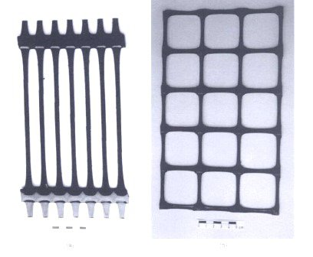
Fig. Uniaxial and Biaxial Geogrids manufactured by the method of extrusion

Advantages of Geogrids
- Ease of Construction: he Geogrid can be installed in any weather conditions. This makes it more demanding.
- Land Optimization: This method of Geogrid installation in soils makes an unsuitable area suitable for preparing it to meet desired properties for construction. Geogrid thus helps in proper land utilization.
- Geogrid promotes soil stabilization
- A higher strength soil mass is obtained
- Higher load bearing capacity
- It is a good remedy to retain soil from erosion
- No requirement of mortar. The material is implemented dry.
- No difficulty in material availability
- Geogrids are flexible in nature. They are known for their versatility.
- Geogrids have high durability reducing maintenance cost. They are highly resistant against environmental influences.
- Materials are tested based on standard codes and regulations.
Read More:
Design of Geogrid Segmental Retaining Wall with Calculations
Geosynthetics in Civil Engineering and Construction Works

