Network and Cybersecurity Essentials

Author: Zakriya Fathi
Module Name with Code:
Network and Cybersecurity (ACCA4024)

School of Applied Computing Wales Institute of Science and Art

Date and Time of submission:
08/01/2021 18:00

Introduction

I have been asked to produce a report highlighting the Cybersecurity, and the threats on a network and I will be talking about how users can secure their networks. I will then demonstrate my Che-Si design using Packet Tracer and explaining the steps and labelling with screen shots briefly as I can.

Task ONE

Through studying and evaluating Che-Si’s current policies and in infrastructure, there are many possible network risks and issues. Considering the company uses cloud storage, though it has many benefits, it is unfortunately a possible week point and a risk for the network architecture. Cloud storage is very vulnerable to being hack if the current security measures are not put in place. Files being stored and transmitted over the internet is also risk factor. A simple risk measure of ensuring all files is encrypted and transmitted and transmitted over a secure connection will prevent threats such as non-authorised members from accessing the cloud’s directory or from hackers. Besides security risks, a draw back with cloud storage facility internet speed causing the backing up data to be slower varied of speed depending on internet bandwidth. Cloud storage is also known to be expensive, the vendor lock-in if user put all of their files on Google platform you are locked into that provider and causing it difficult to move to another provider. Sometimes that users have just a limited amount of space to backup with them.

Mitigation strategies can focus on lower the chance when occurring different events happening. Different ways of [1] [2]mitigation can happen when taken action in the form of projects and then eliminate the repetitive losses of the same hazard.

Digital signatures

“Digital Signature is a process that guarantees that the contents of a message have not been altered in transit. When you, the server, digitally sign a document, you add a one-way hash (encryption) of the message content using your public and private key pair” ^{[1]}. Digital signatures are one of the main safeguarding the security and integrity of data features that is stored in a blockchain. Digital signatures are a mathematical way of verifying the authenticity of digital messages to prevent fraud and harmful sending and receiving process. Think of it as the digital equivalent to a handwritten signature. Digital signatures do not only prevent impersonation but it provides evidence of electronic messages too.

Digital signatures are based on asymmetric cryptography which is a process which protects sensitive information with two mathematically linked keys: a private key which is only known to the person it belongs, and a public key which can be shared with anyone who needs to access the digital message. For example, Zak will send a document digitally signed to Emily. John has two keys that come in the form of random numbers and characters a private and a public key.

The private key should always kept private but to be able digitally sign a document for Emily. She will then have to verify the authenticity of the document and the signature. When the document is sent, its content is processed through a hashing algorithm. The algorithm creates a unique sequence of numbers and letters which is called digest or the summary. The digest is then encrypted with John’s private key finally resulting in the digital signature of the document. A digital signature is the combination of the content of the certifying document and the author’s private key. Any variation in the content of the document or on John’s private key, it will create a different signature because the user digital signature to reverse the process and verifying its legitimacy.

For example, so that Emily can process the document through the same hashing algorithm that John previously used and get a digest in a summary if the documents was not altered and the digest should be exactly the same. Also, how John processed the summary with the algorithm of the user private key to create a digital signature, Emily then can decrypt the digital signature with the algorithm of John’s public key to also get a summary. If the signature was not altered the summary should also be exactly the same. Finally, Emily will have two summaries one based on digital signature and the another based on the content of the document if the two summaries match, then Emily can be sure that the message was not altered in any instance, and verify that John is indeed the author. This is why digital signatures is one of the key elements to secure information on the blockchain.

Encryption

Encryption is a file or text that can be transmitted electronically to its plaintext form. Business are very vulnerable, “For businesses it's worse, as the exposure of sensitive or confidential records can result in financial losses as well as heavy fines” ^{[2]} it if better to be safe or pay the price. It is basically putting the text or file through an algorithm or a maths equation that tells the user how to encrypt it and putting that out in an encrypted form. For example, the name Zak if you sent in plain text to anybody that I would recommend to update Che-Si by having a secure software such as Avast or the most popular Firewall. A firewall keeps cyber criminals and hackers from penetrating the user computer, a firewall acts as a defence system for a local computer against viruses, worms, Trojans, brute force attack and other network attacks or attempts to compromise the user computer. I would recommend using Firewall it is a popular and powerful to use.

Task TWO

In this following section, I will be creating and advising on potential guidelines that a company can make their works adhere to ensure a responsible working method are met and portable devices are kept and are used securely

Proxy server
When it comes to using personal device, there is are no ways of making the device itself fully secure not counting putting basic security such as password or pin among of privacy options. However, when it comes to the app within the device, proxy servers are very convenient in controlling the security of some apps. A proxy server is a router that basically functions as a relay between client and server. Its main purpose is to prevent malicious attackers from accessing and invading a private networking and one of the many tools used to build a firewall. The proxy is basically acting on behalf of a user.

Loss of theft
Portable devices have the vulnerability of being lost or stolen potentially causing and sensitive information to be stolen or accessed. They are at most time used in open view places which is not as security and the same as using the device on your own secure premises. This can compromise sensitive information of authentication credentials.

Risk of meddling
Leaving a device unattended will leave it vulnerable to an attack attempt. This could allow them to monitor all user activity on the device, such as authentication credentials or install malicious software.

Assessing risks and working mobile policy
Analysing risks associated with mobile working and remote working will help avoid and potential security risks. The security policy will include the process for authoring users to all off-site work, type of information and service that is able to be accessed or saved on the device and the main practical security controls.

Providing training to workers
Any worker within the company that is to use a portable device will be given basic education or training to ensure they are working safely at all times and are aware of all possible risks. All users will operate securely by following clear procedures such as:

- Management credentials and secure storage
- Report any incidents
- Environmental potential risks (being overlooked, device being stolen etc.)

Protecting company data:
Information that is stored within the device is to be minimised and limited to only what is needed to fulfil the business activity. To add extra precaution, any information taken to off-site needs to be encrypted.

Incident plan
In a case where a device is stolen, data is lost or stolen, stores are to follow security procedures. The incident plan will deal with the range of security incidents that have the possibility of occurring that can vary from loss of compromise of a device. A technical process should ideally be in place to remotely disable and lost or stolen device to deny unverified users to the company’s network and data.

Packet Tracer Sniffer Design
The first thing I was finding is the sniffer which is under end devices:

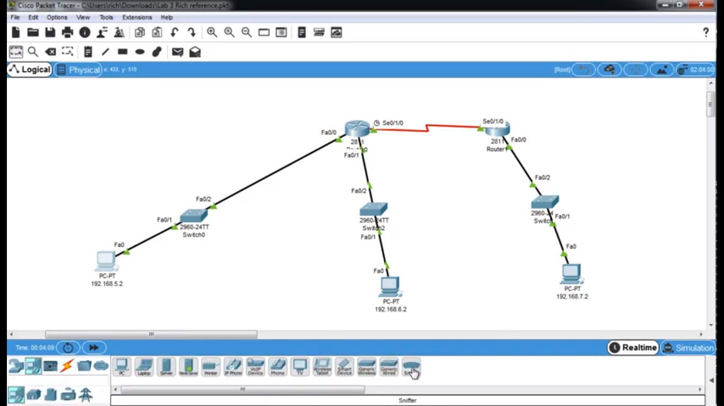

I looked at the sniffer functionality as you can see there isn’t much to it users switch it on or off in which side has the incoming packets and obviously that implies this other side has the outgoing and then some filters:

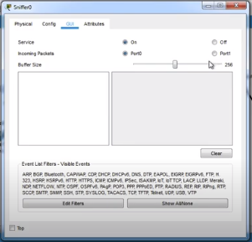

Then I will be going to connect port 0 from the inside so I will gonna get rid of this wire as shown in the screenshot below:
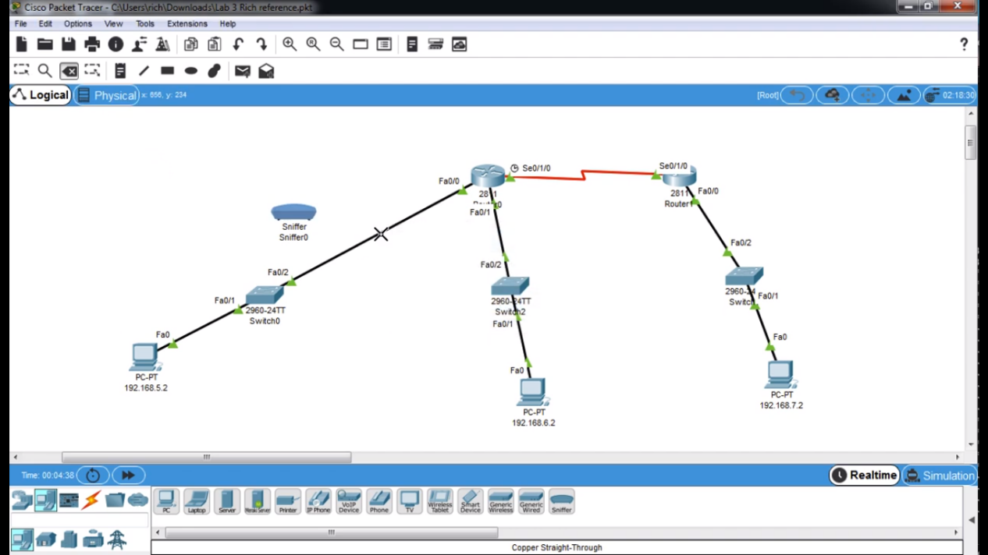

And then going to connect from the switch to port 0 so this means it will it’s going to look at the frames that are coming in port 0 from the screenshot below:

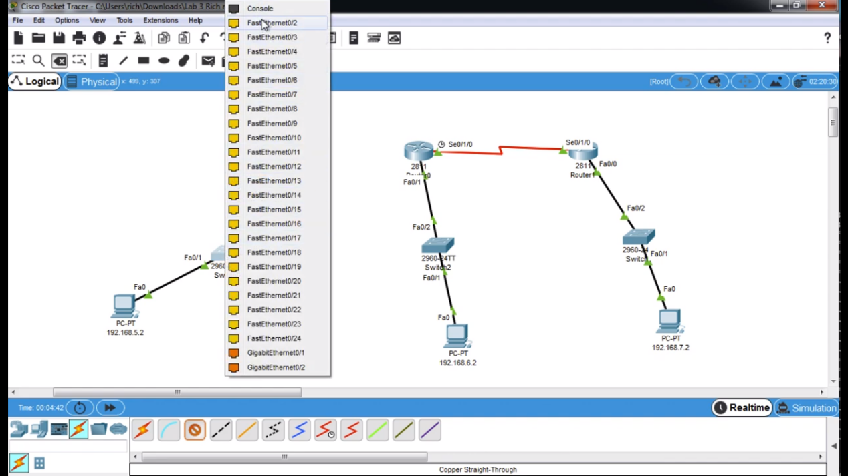

Then I will be connecting from port 1 to the router port.

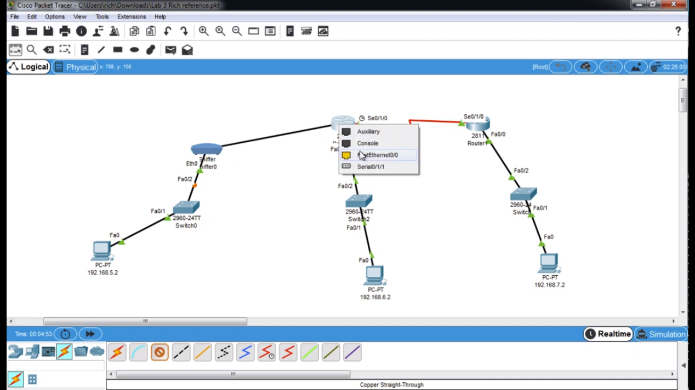

Now that's all connected successfully I will make sure that it still works by going to the PC port and ping to make sure that the traffic is still flowing.

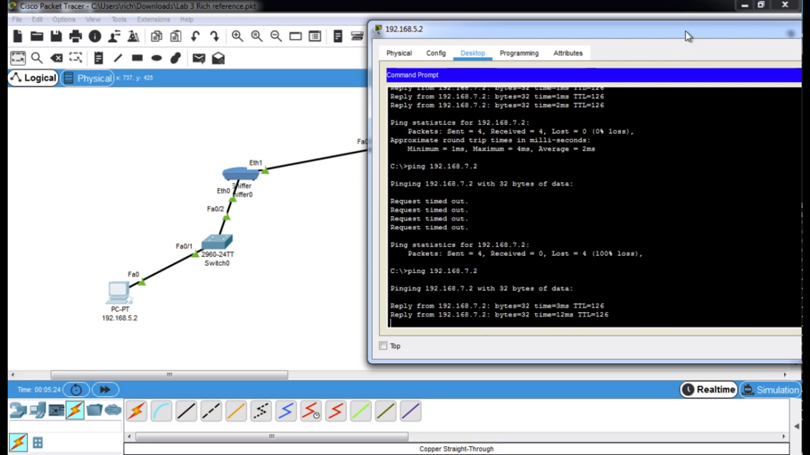

Since now we have functionality again I can if the sniffer has caught any packets by clicking on sniffer and if I go to GUI as you can see from the screenshot below it shows the different packets.
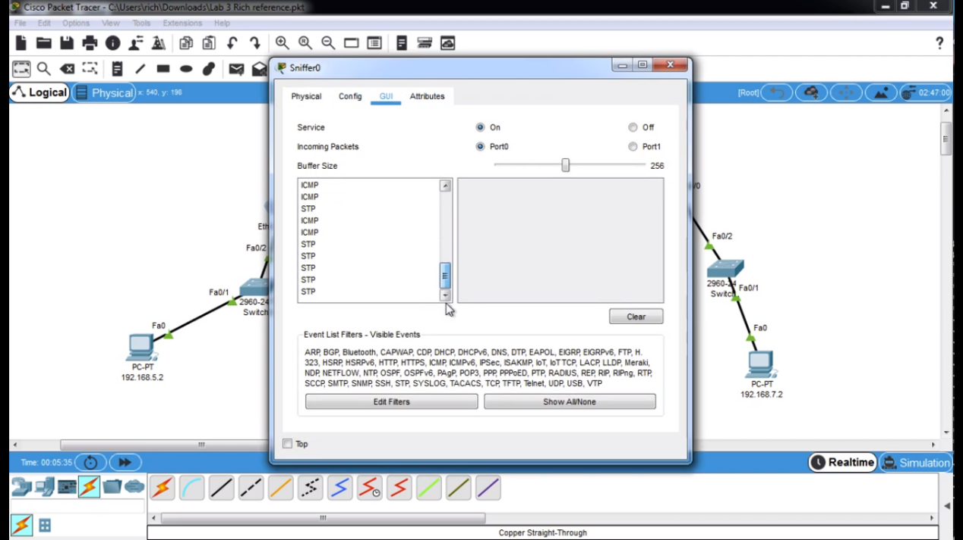

So now I will need to find ICMP and click on that packet. As you can see from the screenshot below here’s the ethernet frame it has got a destination MAC address (DEST ADDR:0090.0C8D.0501) and the source address (SRC ADDR:0090.2B66.994A).

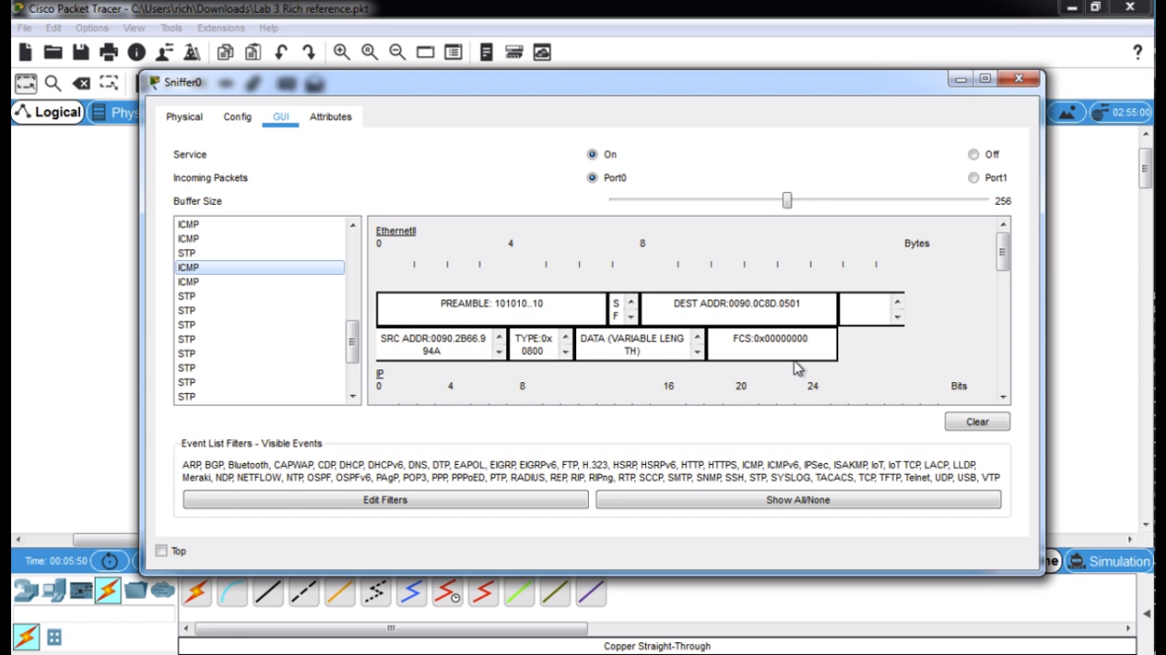

The MAC address for the sniffer should match the PC MAC address as you can see form the screenshot below it does:

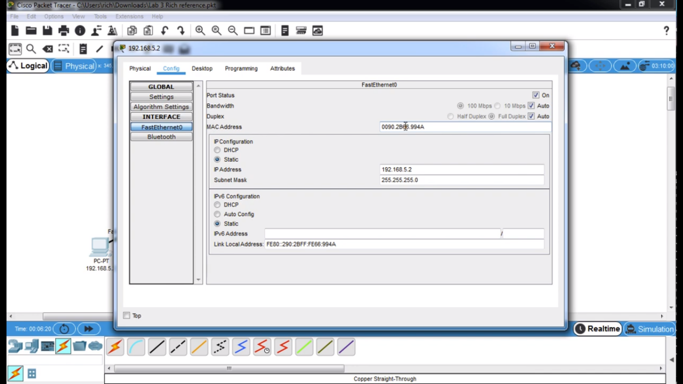

And it should match the MAC address of the router interface too, as you can see from the screenshot below it matches well:

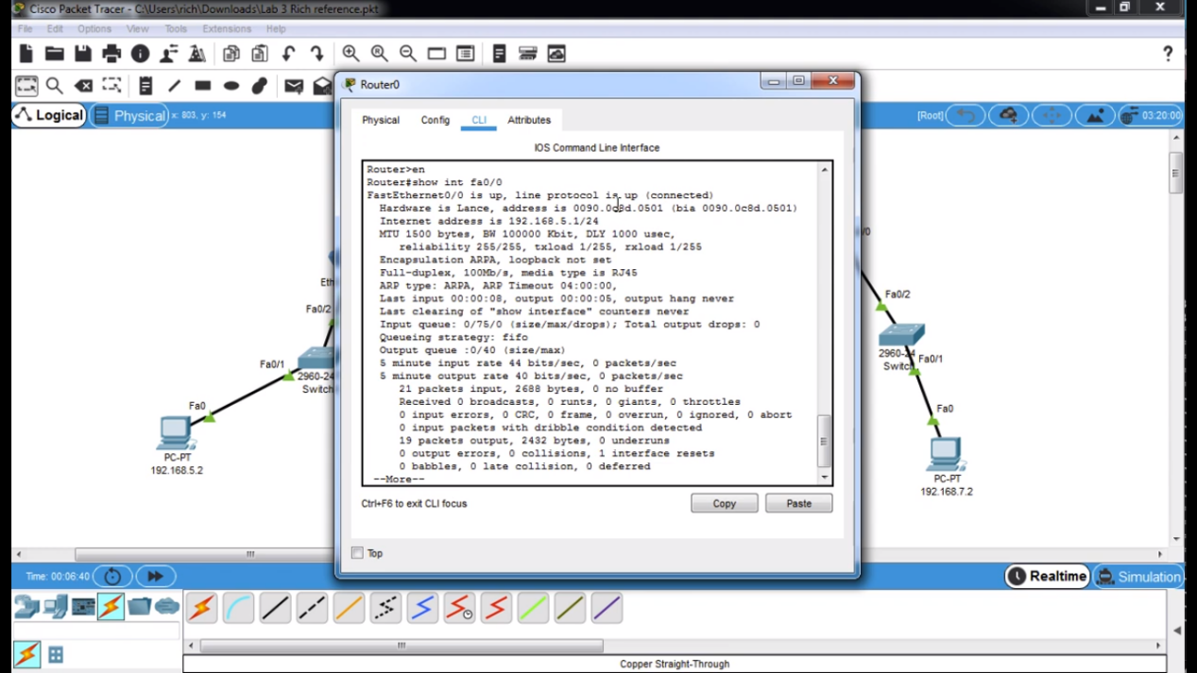

Now I will be adding another sniffer to my packet tracer design but this time I am going to connect Ethernet0 on the router side so it will be looking at the traffic coming from the router from the screenshot below:
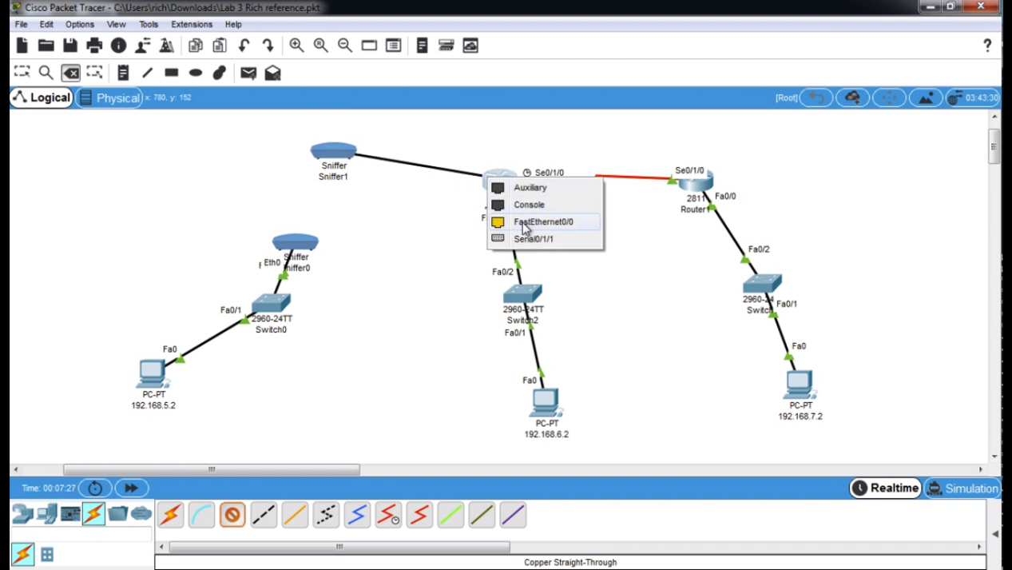

Then between these sniffers I will use a cross over cables:

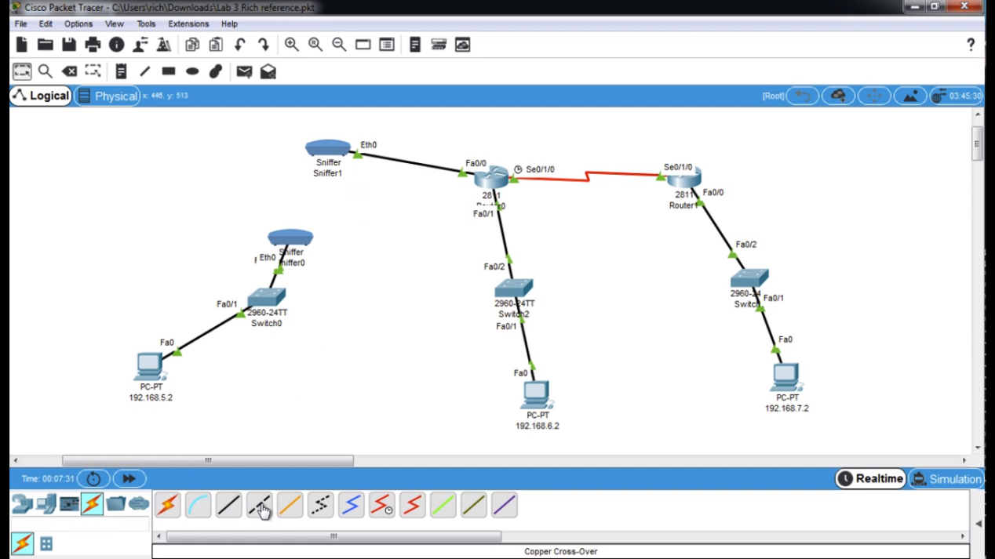

Now I will begin to ping and make sure if it is working and so I will capture some traffic as you can see from the screenshot bellow it is still working:
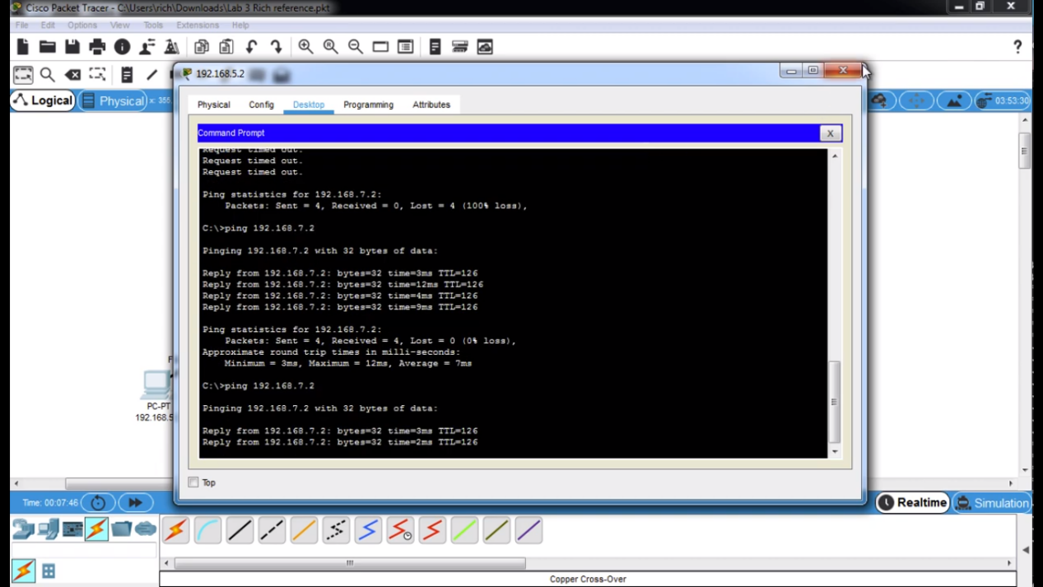

Now if I go look at the sniffer, I will see that I have ICMP traffic.

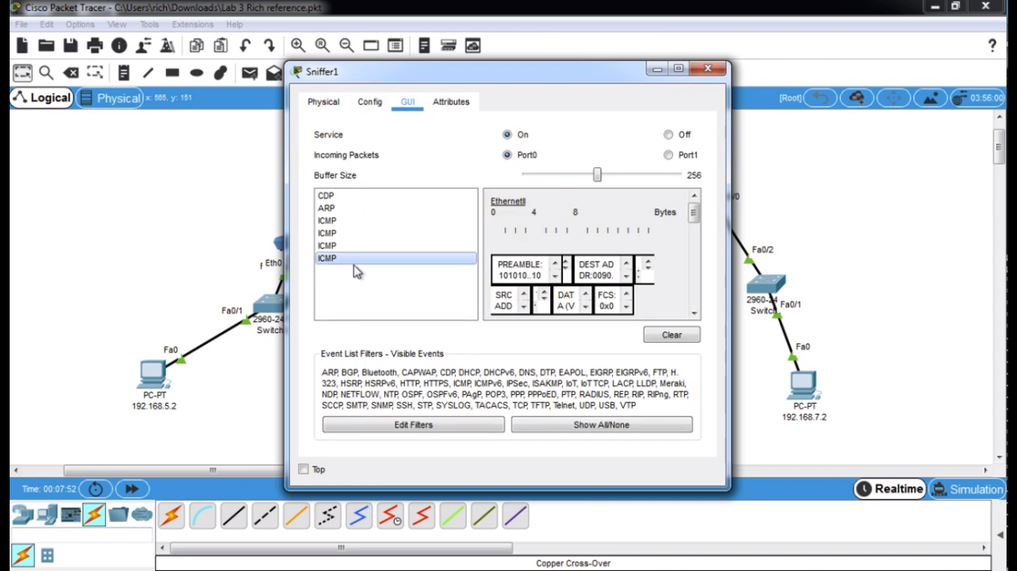

From looking at the router you can see by looking at the frames to verify indeed that anything that the user is sending from the PC of their network goes to the router.

Finally, another thing that can be useful about sniffer once the user has too many packets in the GUI the user can clear and then make disappear so then if the user sends traffic again and going back to the sniffer.

One another thing that the user can do is that they can edit the filters by choosing different GUI as you can see from the screenshot below:

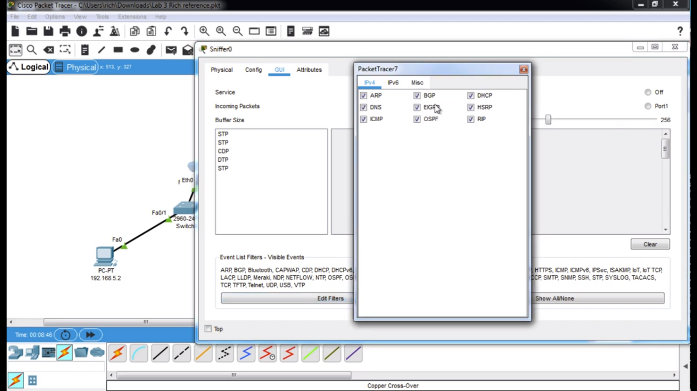

Final design

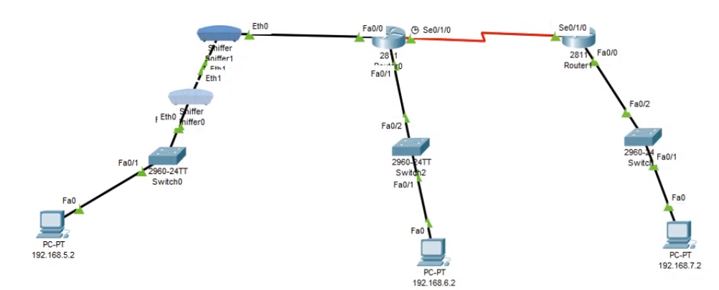
The Che-Si’s possible week points are that the video conferencing is hard to maintain because of time zones can be different for the businesses and will need to find the right time to hold online meetings. And the possible week points for the network architecture is that the cloud storage facility this is because backing up data can be slower, the internet bandwidth and the cloud storage will take in the maximum speed maybe it will be more limited than the local network. Another drawback of having cloud storage is that it is expensive, and the vendor lock-in if user put all of their files on Google platform you are locked in to that provider and it’s difficult to move to another provider. Sometimes that users have just a limited amount of space to backup with them.

Conclusion

To summarize and conclude, Che-Si will need to be more careful when dealing situations for example protect their personal data from hackers such as the black hat hackers which they can damage the user computer system or PC for criminal activities and Gray hat hackers will try gain access illegally without permission of the owner.

References

[1] | instantssl, "What Is a Digital Signature?," instantssl, [Online]. Available: https://www.instantssl.com/digital-signature#:~:text=Digital%20Signature%20is%20a%20process,public%20and%20private%20key%20pair..
[2] | M. BECENTI, "Mitigation Strategies for Cyber Attacks at Your Small Business," sitelock, 15 july 2019. [Online]. Available: https://www.sitelock.com/blog/mitigation-strategies-for-cyber-attacks/.
[3] | B. T. Nicholas Fearn, "Best encryption software of 2021: Free, paid and business tools and services," techradar, 30 November 2020. [Online]. Available: https://www.techradar.com/uk/best/best-encryption-software.

