Assignment title
Workplace culture
Module: Workplace culture and its impact on organisational efficiency
Module code: BMSW5105
Student Name: Vasilica-Madalin Iliuta
Student ID: 2007277
Lecturer’s name: Samuel Ofori
Contents
1. The impact of the environmental factors on the culture of the Evri organisation. 2
2. Ethics withing organisation. 2
3. Important factors of a successful culture in the organisation 3
4. The barriers to the effective functioning of the organisation’s culture 3
Recommendations. 7
Coclusion. 7
References. 7

Introduction
Culture is a collective phenomenon, being at least partially accepted by people who they live or have lived in the same social environment, it is the collective programming of thinking that distinguishes the members of one group from another (Treven et al., 2008). Van den Berg, and Wilderom (2004) together with other authors stated that culture is learned, not inherited, coming from a social environment of its individuals not from their genes.
The report analise the culture and organisational culture, as well as the environmental factors that affects the chosen organisation, which is Evri. It is a cheap parcel delivery and courier service in UK, that has over 18.000 couriers delivering around 700 million packages worldwide in a year (Evri, 2023).
Porter’s 5 Forces analysis of the environment is conducted, as well as good aspects successful culture in the organisation and barriers to its effective functioning. Reccommendation is given on how positively to impact organisational efficiency.

Organisational culture.
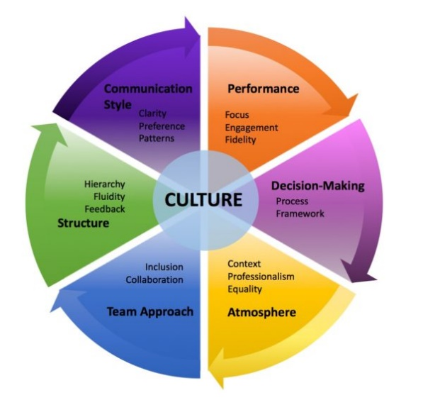
Organizational culture is defined by Denison and Spreitzer (1991) as the way work is done and the way people are treated in a company. Organizations have cultures, just like people have personalities.
It is very important for a company to have a strong culture, where the employees have and share the company’s basic values . This encourage loyalty to the company and increases dedication, prevents employees to leave the organisation (Mullins and McLean, 2019).
Figure 1https://www.surpassyourgoals.com/2018/05/6-elements-to-assess-your-companys-culture/

The impact of the environmental factors on the culture of the Evri organisation.

Porter’s 5 Forces is an important tool that points out and analyses five competitive forces from any segment of an industry and helps to identify its weaknesses and strengths. It helps an organisation to improve long term profitability (Dobbs, 2014). The model Porter’s 5 Forces will help to determine out factors that have an impact on Evri’s culture.
Competition in the Industry
Potential of New Entrants Into an Industry
Power of Suppliers is medium. Evri has sometimes issues with the deliveries, as the company have old lorries. Various suppliers
Power of Customers is High as Evri has millions of customers that are satisfied by the prices and the quality of products. The fact that Evri’s drivers are workin 24/24 are very convenient for any customer. They are devoted to the company, bringing profit and new customers.
Threat of Substitutes
However, the supplier's power is medium leading to ensuring better productivity in the organisation while maintaining a better working environment. It is because various suppliers provide quality raw materials to the organisation within time. The threat of fresh entrants is medium as an organisation requires a better image, value, technology, and money to enter and perform better in a new sector. The threat of substitute products and competitive rivalry is as high competitors can deliver similar kinds of products with innovative techniques leading to decreasing success.
Since Porter's five forces help to improve competition level so Fyffes’s organisation has a good opportunity to increase employee productivity by selecting and implementing unique tactics and ideas. The reason is innovative tactics not only will help staff to work nicely and complete goals in time but will also increase the organisation 's stability and feasibility in the market. It is because customers want a better quality of products at less price while helping in the better progress of a company. Fyffes already has a good value and place including customer support which can increase employee commitment as they may get good growth opportunities besides increasing the company's success.

Organizational culture has an impact on any behavior in a company. Are you punctual when it comes to meetings? Do you respect other people's time? Do you announce vacation days in advance? When you return from vacation do you bring something to the office for your colleagues? Do you celebrate your birthdays at work? All these types of behaviors are given by the culture of an organization.
If an organization did not emphasize in its culture the relationship between members, there would be no birthdays or small attentions for colleagues.
Beyond that, a well-crafted and carefully communicated organizational culture makes the recruitment process much easier. 77% of employees look for information about a company's culture before applying and 50% would leave their current job for a lower offer but an organization with a better culture.
What does this tell us? That people are looking, beyond the financial benefits, to get to a place where they can express themselves authentically, feel like they matter to that gear, and be surrounded by people who share the same values.
The factors that influence a culture are the external environment, the size of the organization, as well as its vision, purpose or objectives and, last but not least, the more or less dramatic events. According to Howard H. Stevenson, the factors that influence cultures are economic restructuring - because it generates insecurity in the business environment -, the collapse of former geopolitical structures, the mobility of individuals, anti-globalization movements, political alliances and the rapid development of information technologies.

Ethics withing organisation.
Another defining element of ensuring efficiency in managerial activity is ethics of business, which can be treated as a systematic study of moral aspects in the business, as a reflection on the moral consequences of decisions. Business ethics involves the establishment of ethical rules and principles in an economic context, which proposes a set of decision tools useful in establishing the organization's strategies, in solving conflicts between the groups that interact in the economic environment: employers and employees, managers, shareholders, suppliers, customers, public institutions (Chye Koh and Boo, 2004). Business ethics requires not only compliance with the legislative framework, but also finding one balance between the interests of the shareholders and those of the groups affected or involved, from partners to customers, consumers, and society (Robbins and Judge, 2016).

Important factors of a successful culture in the organisation.
Organizational culture maintains good relations between team members. The better the company's organizational culture is, the better the quality of relations between employees will be. Practically, conflicts and individualities will be diminished. Then, people will feel that they have a common goal that unites them as a team.
The organizational culture ensures good staff retention, so in most situations, employees are interested in staying in companies where the organizational culture is of quality, the leaders are of quality, there is room for personal and professional development. Otherwise, at the first more advantageous offer, many of the company's employees will leave for competing companies, and the best employees will be the first to do so.
There are several management styles that a business can adopt when creating a company culture. The leader is responsible for the team he works with. He can be an entrepreneur or work in a department of a company. Regardless of the position he occupies, the leader must know how to lead his team and how to get results.
The mission of the company is the very purpose of the enterprise. Say why your business exists, what results you hope to achieve and what values ​​you follow. A strong mission is important because it gives employees something to rally around – a reason to work for your company, beyond the pay check.
Businesses need goals to grow, and employees need to understand those goals to meet them. Ask employees to strive to achieve milestones that contribute to business goals. This can increase productivity, especially if there are incentives for meeting goals.

The barriers to the effective functioning of the organisation’s culture.

Each organisation develops and maintains a unique culture that provides guidelines and boundaries for the behavior of organization members. This involves a whole range of elements that will differentiate the organization from other companies.
Organizational culture is fundamental in any organization because it guides the direction of the company and guides how it should be run. It also directs the treatment that should be given to employees, customers and society at large.
The factors that influence a culture are the managers of the organization, the external environment, the size of the organization, as well as its vision, purpose or objectives and, last but not least, the more or less dramatic events. According to Howard H. Stevenson, the factors that influence cultures are economic restructuring - because it generates insecurity in the business environment, the collapse of former geopolitical structures, the mobility of individuals, anti-globalization movements, political alliances and the rapid development of information technologies.
Culture is based on the fact that these values ​​will be shared by everyone in an organization and impact how they decide to behave in their daily lives.
When a group of people come together every day to achieve the same goals set by a company, it becomes extremely important that those people behave as such. That means they know what it means to be part of that group, share common values, feel that their work matters, and know exactly what benefits they get from achieving goals and what the company wants from them. As employees increasingly look for their work to be valued and see the workplace as a social context as well, they will look for companies whose organizational culture matches their beliefs.

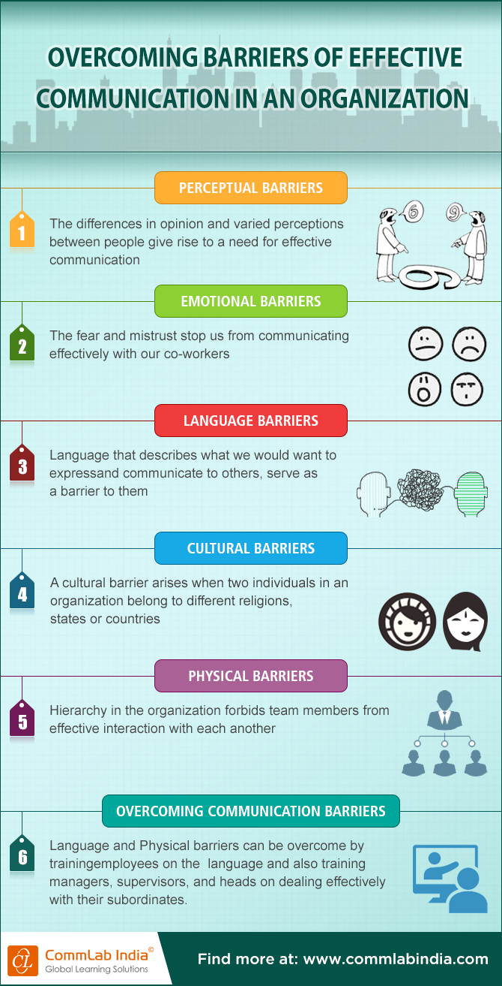
https://blog.commlabindia.com/elearning-design/barriers-for-effective-communication-infographic

Recommendations.
Creating a great company culture takes time and commitment and must be built on a solid foundation. Below are some recommendations how positively to impact organisational efficiency.
- To create a positive company culture, you need to understand what motivates the employees and what matters most to them. For example, a flexible work schedule is only great if the staff wants it. The impact any action will have on the company's profit is as well important. For example, it wouldn't make sense to offer free meals if it would lead to the bankruptcy of the business.
- Whether the company’s culture is created from scratch or there is a try to reinvent an existing one, employees' voices must be heard. If employees are not happy at work, their productivity will suffer. Survey employees to get an idea of ​​how they feel, and what changes they might want to do.
- Organizations must adopt a code of ethics, make it known to managers, employees, customers, and suppliers and respect it in entirety. The code of ethics is something specific to each individual organization, it must be in accordance with the feelings and experiences in the organisation, to be related to the functions of the management and to be respected by all employees, regardless of the position in the organisation.
- Any cultural changes, as economic, technical, or law, should be achieved through rewards or sanctions for behavior, milestones for promotion, premiums and salary facilities, appreciation, evaluations, professional, or disciplinary procedures.
- In terms of creativity, employees should be encouraged to think in a more inventive way, so the tendency to take risks to be much lower compared to employees who belong to a well-established organizational culture.

Coclusion.

References.
Denison, D.R. and Spreitzer, G.M. (1991) ‘Organizational culture and organizational development: A competing values approach’, Research in organizational change and development, 5(1), pp.1-21.
Evri (2023) About us. Available at: https://www.evri.com/ (Accessed: 16th March, 2023)
Mullins, L. and McLean, J.E. (2019) Mullins: Organisational behaviour in the workplace. Pearson Education: Harlow.
Robbins, S. and Judge, T. (2016) Organizational Behavior. Pearson Education: Harlow.
Martins, E.C. and Terblanche, F. (2003) ‘Building organisational culture that stimulates creativity and innovation’, European journal of innovation management, 6(1), pp.64-74.
Van den Berg, P.T. and Wilderom, C.P. (2004) ‘Defining, measuring, and comparing organisational cultures’, Applied psychology, 53(4), pp.570-582.
Chye Koh, H. and Boo, E.F.H. (2004) ‘Organisational ethics and employee satisfaction and commitment’, Management Decision, 42(5), pp.677-693.
Treven, S., Mulej, M. and Lynn, M. (2008) ‘The impact of culture on organizational behaviour’, Management: journal of contemporary management issues, 13(2), pp.27-39.
Mats, A. (2013) Understanding organizational culture. 2nd edn. SAGE: London.
Dobbs, M.E. (2014) ‘Guidelines for applying Porter's five forces framework: a set of industry analysis templates’, Competitiveness review.
Grundy, T. (2006) ‘Rethinking and reinventing Michael Porter's five forces model’, Strategic change,15(5), pp.213-229.
Organizational culture represents a way of life, being the outcome of internal practices, codes of behaviour, values, goals and beliefs particular to the respective organization. This culture is what make the difference and identity to an organization (Treven et al., 2008).
Organizational culture is the collection of values, expectations, and practices that guide all members of a team. An organization's culture includes its values, its philosophy, the way it treats its employees and interacts with the world outside the company, its customs, systems and language (Mats, 2013).
Culture is based on the fact that these values will be shared by everyone in an organization and impact how they decide to behave in their daily lives.
Organizational culture has an impact on any behaviour in a company. Are you punctual when it comes to meetings? Do you respect other people's time? Do you announce vacation days in advance? When you return from vacation do you bring something to the office for your colleagues? Do you celebrate your birthdays at work? All these types of behaviours are given by the culture of an organization.
On the other hand, when there is a weak culture, employees are not convinced of the organizational values and do not share them. This leads to much stricter supervision and increased control over staff, as values are imposed by superiors and not naturally manifested by employees (Mats, 2013).
In societies with weak cultures, work is standardized, management focuses much more on production, on quantity, and interest in the level of employee satisfaction is reduced. To determine the degree of employee satisfaction, we provide you with a Satisfaction Evaluation Questionnaire, which aims to identify aspects that require improvement and ways to increase employee performance.

