UNIVERSITY OF WALES TRINITY SAINT DAVID
PROBLEM SOLVING AND DECSION MAKING
Student name: Cristina Alexandra Niculescu
Module code” BMSW4004
Student ID:1916777
Lecturer: Amare Desta

Table of Contents
Introduction of Age discrimination 1
Situational analysis from literature 1
Range of Solutions to Problem 3
Selection of most appropriate solution 5
Develop a plan for implementing the solution 6
Communicate the plan to stakeholders 6
Assessment of technique for successful implementation of plan 6
Conclusion 7
References 8

Introduction of Age discrimination
The organizational culture impacts the social behavior of people (Tianya, 2015). Depression, anxiety, and various other complex psychological problems are increasing. Employees spend considerable time at the workplace and everything that happened to them affects their attitude when they come to their families. Age discrimination is also one of them that is becoming one of the biggest concerns of government. Age discrimination can be defined as treating an employee or a group of workers unfavorably due to their age (Button, 2019). Most of the victims of age discrimination are older people that are why it is also called ageism. Due to the economic crisis, organizations are also working to improve the performances of existing staff instead of more hiring to cut down their extra expenses. This study explains the findings of secondary research on different aspects involved in age discrimination.

Situational analysis from literature
Medical sciences have increased the life expectancy in developing countries. In some EU countries such as Italy, the ratio of older people is more in the EU than younger people. According to reliable resources, more than 100 million living in EU countries are above the age of 65 and this count can reach the level of 149 million in the next 3 decades. The retirement age is also extended (Mahony, 2010). This decision covers the workforce requirement but it is also making things complicated. More business practices encourage the participation of young professionals who can handle modern technology in a better way. In this way, various people have researched the development of models and theories for the control of these issues which is increasing at an alarming rate. In general, people of different age groups can be affected by age discrimination but it depends on the nature of the organizational environment but more complaints are from older people (Zacher and Steinvik, 2015).

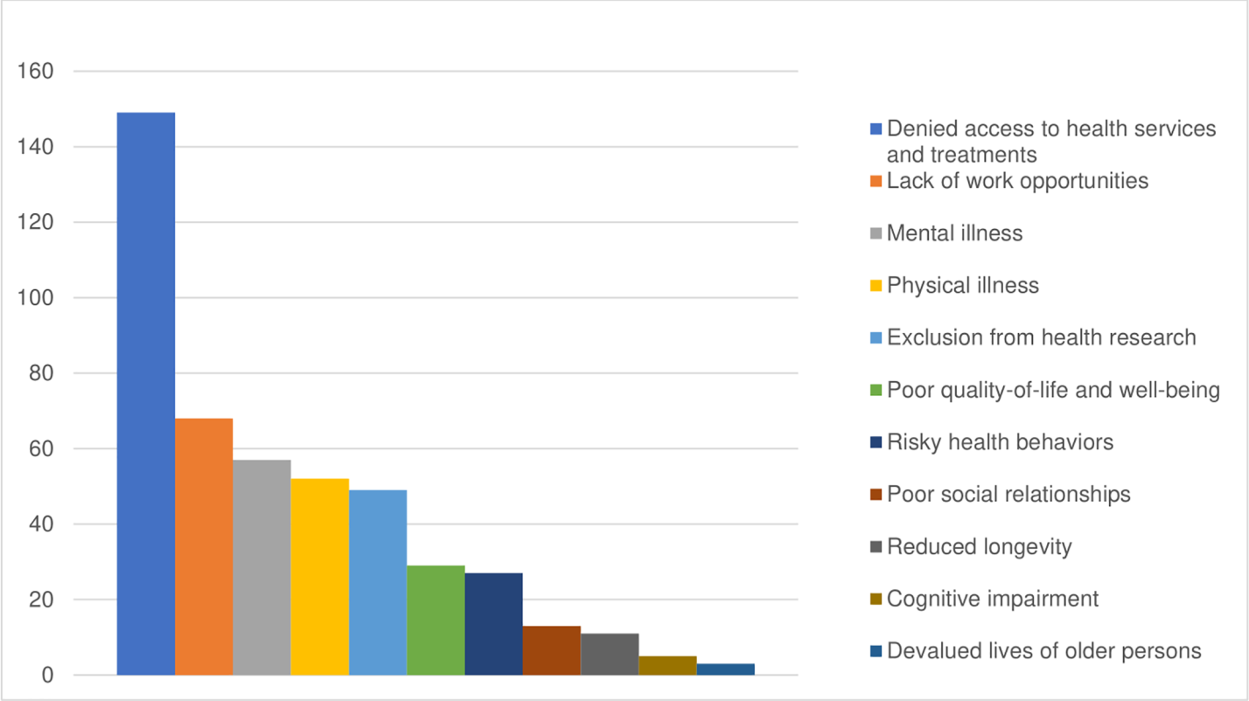
Figure shows the different impacts of ageism (Chang et al., 2020)
The issue of age discrimination was realized much earlier in the US and an act was formed in 1967 which was named the age discrimination employment act (Kenton, 2020). The cost of labor is already high and spending more money on social benefits to retired people is increasing burden on the national economy. Both government and business organizations are doing their research to find suitable solutions for the concern of both parties. The perception of some business organizations is also valid which shows that older staff is more reluctant to participate in training and want to stick with their conventional and most practiced methods. It is also elaborated that technological advancements are so fast and the companies need to equip employees with innovations and technical advancements otherwise it will be difficult to survive in a competitive environment. Nearly every business organization has its training and development schedule which is happily adopted by young staff in most cases but many older people don't like to improve themselves in the use of technology and feel discrimination at the workplace. It seems logical but there is another side to the coin. Where people use different tactics to get rid of older staff. They use those ways to disturb the employee to compel him/her to resign and in this way, they avoid the legal complications. Such practices include the transfer in the irrelevant department, performance pressure, forced overtime, promotion of subordinates as departmental heads, delay of promotions, reduction in salaries due to performance pressure. As a result, either they resign or face extreme mental pressure which affects their physical and mental health. There is another attitude observed where employers are reducing the age limit and the applications of senior people either declined or face the strict process of recruitment. Understanding these situations, the older employees afraid to leave a job and face all kinds of circumstances. The most prevailing ways of age discrimination which are researched most in literature are performance appraisal, biased decisions from managers, irrelevant job descriptions, and promotion decisions. Further reports show that biased decisions are seen in the selection of candidates for training where senior people don't get selected in the training of their interest. As a result, they are blamed for not focusing on training. This attitude is dividing the workforce into two groups and the impact on the performance of the overall company is affected.
Age stereotypes affect decision making processes, behavior, evaluations, and create negativity in the mind of organizational members. Cognitive categorization theories suggest that this discrimination is the result of negative and positive schemes that become activated in contact with older and younger employees (Zacher and Steinvik, 2015). Another stereotyping cognitive model suggests that lack of understanding and knowledge is the reason for the perception of young employees for the older employees which is inaccurate and less positive (Falkenberg, 1990).

Range of Solutions to Problem
The British Government did legislation in the form of the Equity Act 2010 to protect employees against age discrimination (Jarman, 2014). In the same way, the Equity commission in Northern Ireland also proposed reforms and recommended legislation similar to Great Britain. It shows that government-provided solution by approving law against all kind of discrimination but there comes liability of employer most to make sure the implementation of legislation to avoid any discrimination with the worker of old age. the employer is accountable for engaging in unlawful discrimination (Ghosheh, 2008). It shows that people affected by it can file a case against the employer but it is not so easy. The penalties are handsome every year which employers pay but these discriminations are not easy to prove and many workers in threat of losing job and threat of expensive case don't file these cases. These complications should be addressed but deeply rooted discriminatory practices can take a bit longer time to change. Some strategies are reviewed in previous research (UNECE, 2019). These strategies are listed below:
- Addressing negative Stereotypes by campaigns: The negative stereotype of ageism can be addressed by doing research and then its propagation to society to dispel the myths about older people. It can be done by promoting the positive aspects such as experiences, wisdom, better knowledge, understanding which comes with age and helps in conflict management. These qualities are better for older people. The awareness campaign can be raised to highlight the significant role of aged people in society building. It can be done by social media or contact through mentoring. Further practices include addressing the negative aspects of age stereotypes. This way of awareness can reduce at least unintentional discrimination.
- Boosting confidence and Self Esteem: The above discussion shows that age discrimination results in demoralized employees, a decrease in confidence, and low performance. It can be reversed by boosting confidence in employees. It is possible by engaging them according to their capacity in the workplace. In this way, employ work with self-esteem and more energy because they feel the caring attitude of the organization.
- Enhancement of skills and employability: Instead of developing a strategy to get rid of old-aged employees, working on the enhancement of skills can have a better impact and their performance will be improved. Many companies are working on this strategy. Kellogg which is a top cereal manufacturing company is developing various employee benefits campaigns that make it the best place to work. Working on this strategy can decrease the drop-out ratio and skilled workers will remain loyal to the company.
- Job Sharing Schemes: Instead of forcing the employees to work overtime, the working hours can be reduced and work can be shared. In this way, unemployment can be reduced. The older employees will work comfortably without taking much pressure. In this way, the employer should make sure of the needs of workers by paying them better.
- Promotion of employ rights: The employer should place the equity act and other Govt. regulations at prominent places to provide awareness to staff about all kinds of discrimination. In this way, staff will know about their rights and unintentional discrimination will be reduced. It is possible that many people don't know about the activities they are doing comes under discrimination. Creating awareness among employees can boost up the aged employees and discourage people from creating discrimination.
- Encouraging age management: Getting old is a natural process but its effect can be reduced by taking care of ourselves. Feel of younger and wellbeing are ways to reduce depression (Armenta, 2017). Companies should give financial incentives and allowances to employees specifically for their fitness. In a visionary approach, the allowance for age management can create awareness of fitness and productivity can be increased.

Selection of most appropriate solution
From the above-given solutions from previous research, some of them seem not possible to be adopted at workplaces because it can increase the economic burden on the employers but there are few strategies which can give a better result. Creating awareness about negative stereotypes by the campaign and focusing on the enhancement of skills is the most suitable strategy. The reason for the selection of this strategy is due to the possibility that many people don't know about the law and the impact of ageism on mental health and this awareness can improve the situation. Along with this awareness, staff should be trained enough with modern technology to make them more productive. The staff motivation with awareness and equipping them with technology seems the appropriate solution to the issue.

Develop a plan for implementing the solution
The development of the plan with complete detail of action is very important to achieve the required objectives in a given time. The plan is developed for the selected solution of age discrimination at the workplace. The successful outcome can't be guaranteed but I have assumed based on research that this plan can be a good initiative by business organizations to improve their organizational culture and in this way, staff will also remain motivated.
Plan for the implementation of the strategy
Goal | Actions | Responsibility | Relevance | Time
Overcoming the age discrimination at the workplace | Training | Employer, Managers,  Workers | All the actions are related to overcoming the work-based problem of age discrimination which is affecting performance | It is a prolonged step and needs to continue for at least 2-3 years for better results
Overcoming the age discrimination at the workplace | Motivation | Employer, Leadership,  Trainers
Overcoming the age discrimination at the workplace | Awareness | Employer, Media
Overcoming the age discrimination at the workplace | Display of rights | Employer

Communicate the plan to stakeholders
It is more common at workplace, so the stakeholders are employers and workers. Government is also stakeholder because this issue is causing social pressure on the society. Unemployed aged person will also become eligible of social benefits and overall burden on the economy increases. This plan can be communicated to stakeholders by use of videos, letters, messages by using different media and social media channels.

Assessment of technique for successful implementation of plan
Due to complexity of psychological nature, it is difficult to monitor output. The change in behavior comes slow which need continuous efforts. The assessment can be made with survey of selected organizations which are affected most. Regular evaluations determine whether is any need to change the plan or it is working in right direction.

Conclusion
This report is written on very important work-based problem of Age discrimination which is increasing with alarming rate. Important reason is increase in life expectancy, extension in the age limit and advancement in technology. The victims of age discriminatory can be of any age, either young or old. Mostly old age people become victims of discrimination. Government approved the equity act 2010 but number of complaints are increased. Different strategies reviewed in previous research are given in detail and suitable strategy is selected for the plan development. Important stakeholder of the issue are everybody at workplace and government. Family and other peoples are also affected indirectly but the direct stakeholders are employer and staff. The plan for implementation of solution is given with the assessment technique.

References
- Armenta, B. M., Stroebe, K., Scheibe, S., Postmes, T., and Yperen, N. W. V. (2019). Feeling younger and identifying with older adults: Testing two routes to maintaining well-being in the face of age discrimination. Plos One. Retrieved from: https://journals.plos.org/plosone/article?id=10.1371/journal.pone.0187805 (Accessed on December 15th, 2020).
- Button, P. (2019). Population, aging, age discrimination, and age discrimination protections at the 50th anniversary of the age discrimination in employment act. Retrieved from: http://ftp.iza.org/dp12265.pdf (Accessed on December 14th, 2020).
- Chang, E., Kannoth, S., Levy, S., Wang, S., Lee, J. E. and Levy, B. R. (2020). global reach of ageism on older persons health: A systematic review. Plos One. Retrieved from: https://journals.plos.org/plosone/article?id=10.1371/journal.pone.0220857 (Accessed on December 12th, 2020).
- Falkenberg, L. (1990). Improving the accuracy of stereotypes within the workplace. Journal of Management, 16(1), 107–118. Retrieved from: doi:10.1177/014920639001600108 (Accessed on December 10th, 2020).
- Ghosheh, N. (2008). Age discrimination and older workers: Theory and legislation in comparative context. Retrieved from: https://www.ilo.org/wcmsp5/groups/public/---ed_protect/---protrav/---travail/documents/publication/wcms_travail_pub_19.pdf (Accessed on December 13th, 2020).
- Jarman, N. (2014). A report for the Equity Commission. Retrieved from: https://www.equalityni.org/ECNI/media/ECNI/Publications/Delivering%20Equality/Age-Discrimination-ICR-Final-Report-Final.pdf (Accessed on December 12th, 2020).
- Kenton, W. (March 30th, 2020). What is the age discrimination in employment act of 1967. Investopedia. Retrieved form: https://www.investopedia.com/terms/a/age-discrimination-employment-act-1967.asp (Accessed on December 10th, 2020).
- Mahony, H. (May 28th, 2010). Brussels suggests raising retirement age for EU citizens. Eurobserver. Retrieved from: https://euobserver.com/news/30160#:~:text=The%20commission%20paper%2C%20to%20be,men%20and%2062.3%20for%20women (Accessed on December 9th, 2020).
- Tianya, L. (2015). Organizational culture and employee behavior. Retrieved from: https://core.ac.uk/download/pdf/38122623.pdf (Accessed on December 12th, 2020).
- UNECE (2019). Combating ageism in the world of work. UNECE policy brief on ageing. Retrieved from: https://unece.org/fileadmin/DAM/pau/age/Policy_briefs/ECE-WG1-30.pdf (Accessed on December 13th, 2020).
- Zacher, H., and Steinvik, H. R. (2015). Workplace age discrimination. In book: The encyclopedia of adulthood and aging. Retrieved from: https://www.researchgate.net/publication/316375424_Workplace_Age_Discrimination (Accessed on December 8th, 2020)

