Fundamentals of Construction Technology – Construction Detailing
Module code: ACBA4001

Julia James
Student No: 0251098

Contents

- Introduction ……………………………………………………………………p.3
- Site conditions and foundations
- Construction details
- Linking the foundations to the Superstructure of the building …p.4
- Damp Proof Course (DPC) ………………………………………. p.5
- Cavity wall construction …………………………………………. ..p.6
Thermal insulation ………………………………………………….p.7
- The ground floors …………………………..................................p.9
- The first floor ………………………………………………………. p.11
- Openings ……………………………………………………………p.13
- Eaves detailing ……………………………………………………. p.15
Roof covering ………………………………………………………p.16
- The main roof structures …………………………………………. p.17
Insulating an attic room ……………………………………………p.18
- Conclusion ………………………………………………………………………p.19
- References ……………………………………………………………………...p.20
- Bibliography ……………………………………………………………………. p.21
- Appendix
No. 1 - Building Regulations Document A, Table 10
No. 2 - Timber Suspended Ground Floor
No. 3 - Cavity Wall
No. 4 - Timber First Floor
No. 5 - Tongue and Groove Floor
No. 6 - Opening Window Detail
No. 7 - Eaves Detail
No. 8 - Wall Plate Detail
No. 9 – Roof Cover
No.10 – Attic Truss
No. 11 – Attic Truss
No.12 – Attic Roof Insulation
- Introduction
Planning consent has been granted on a greenfield site to build a single, two storey detached domestic building incorporating a loft room. The choice of building materials and methods have been selected and are detailed in this report, explanations and diagrams are provided.

Site conditions and foundations
The land is a greenfield site so there is no made ground to consider, the topsoil is 450mm above a firm subsoil with a low clay content, above the water table. The firm subsoil provides uniform stable ground for the foundations.

The composition of the ground and the soil conditions translate into the bearing capacity of the soil. One domestic building has relatively low loading with uniform distribution of loads, this combined with the site topography being level means Concrete Strip Foundations are recommended.

Riley and Cotgrave (2018) explains the considerations for the dimensions of the strip foundations as follows:
‘the width of the foundation is adjusted to provide a sufficient area of contact to avoid overstressing of the soil. The depth will be related to the depth of appropriate bearing strata but will generally be around 1 metre so as to avoid the danger of frost-related heave and shrinkage of the soil close to the surface.’ (Riley and Cotgrave, 2018, p.104)

The use of Strip Foundations has the benefits of being a cheaper form of foundation, expensive plant is not needed or deep excavations. It is also a commonly used foundation type so trained labour is more easily obtained to carry out the work. Labour costs are reduced due to the reduction in time it takes to lay this type of foundation. Appendix No. 1 shows Building Regulations Document A – Table of minimum width of strip footings.

The appropriate regulations to consider are:
Building Regulations Approved Document A, Structure (2004 including 2010 and 2013 amendments)
BS 1377: Methods of test for soils for civil engineering purposes (2016)
BS 5997: Guide to British Standard codes of practice for building services (1980)
BS 6515: Specification for polyethylene damp-proof courses for masonry (1984)
BS 8004: Code of practice for foundations (2015)
BS 8103: Structural design of low-rise buildings. Code of practice for stability, site investigation, foundations, precast concrete floors and ground floor slabs for housing (1996, 2011 & 2013)
BS 8110: Structural use of concrete (1997)
BS 8215: code of practice for design and installation of damp-proof courses in masonry construction (1991)
BRE Digest 64: Soils and foundations

- Construction Details

- Linking the foundations to the Superstructure of the building

The sub ground walls link the foundations to the superstructure of the building.
These sub ground walls have the purpose of transferring loads from the building to the foundations providing stability and durability but also to prevent moisture from the ground entering the building.

These ‘walls are subject to lateral loadings from the ground surrounding them’ and may be subject to ‘hydrostatic pressure driving moisture through the structure’ (Riley and Cotgrave, 2018, p.125)

The choice of materials used in this build would be Trenchblock which has a high density and low porosity.

Foundation block construction - by using larger blocks below ground cost and time efficiencies can be made, they are a cheaper material and take less time to lay, the wall is constructed in a single construction activity and can be backfilled after construction in a shorter time.
The blocks dimensions allow them to support the full thickness of the cavity walls.

- Damp Proof Course (DPC)

DPC’s are positioned to prevent moisture from entering the building either via absorption through capillary attraction (rising moisture from the ground), hydrostatic pressure (driving moisture through the structure) or rain splash, the DPC must be positioned a minimum of 150mm above external ground level.

‘DPC’s are positioned in internal and external walls. They must link with damp proof membranes (DPM’s) in floors to create a continuous barrier’ (Riley and Cotgrave, 2018, p.127)

Appendix No. 2 illustrates the position of the DPC and DPM in relation to the ground floor.

- Cavity Wall Construction

The below ground walls provide the base for the cavity walls which must be a minimum of 250mm thick and can be up to 300mm thick to improve the buildings thermal properties.

The cavity walls are loadbearing walls which must support their own weight and the weight of the loading from the rest of the building, this load is transferred through to the foundations.

For stability of the building the specific requirements of the wall height, wall thickness and the number of openings are stated in the Building Regulations.

As well as load bearing the cavity walls must also:
- provide protection from the weather: wind, snow, rain and heat
- prevent moisture from entering the building
- be durable
- provide thermal insulation
- provide acoustic insulation
- provide the aesthetic finish required
Cavity walls are commonly used in modern construction, so trained labour is easily obtained and the effect on time, cost and quality are all controllable i.e. the level of buildability is acceptable.
See Appendix No. 3 Cross section of a Cavity Wall.
This cross section shows the inner and outer leaf of the walls joined together with metal ties, these effectively connect different types of materials e.g. brick and concrete block. providing stability to the walls.

The cross section also shows the position of the insulation in the cavity wall. A Vapour Control Barrier is also used between the insulation and the inner leaf of the wall to prevent water vapour from tracking through the internal wall and into the insulation creating damp. Water vapour can be created within a home by carrying out activities like washing, showers, cooking etc.
The cross section also shows the construction of the inner and outer walls with a cavity inside which is designed to ensure water does not reach the internal wall. The flashing directs water away from the inner wall to the weep holes in the outer wall which release the moisture caused by weather conditions or humidity.
The function of a cavity wall is that it ‘creates a break in the capillary path of moisture’ (Riley and Cotgrave, 2018, p.167) The outer part of the wall can be saturated but the inner part of the wall remains dry, any connections and opening will also require additional damp proof protection especially around connections between materials.

An additional assessment can be made of the requirements for damp proofing a building, by considering its location and orientation with regards to the weather its subjected to. Maps are available that illustrate the ‘driving rain index’ in the UK. (NHBC Standards, 2010 Appendix 6.1-A Map showing categories of exposure to wind and driven rain/ Areas of severe exposure to frost attack) Driving Rain Index (NHBC, 2020).

Thermal Insulation
Changes to the Building Regulations affecting standards of thermal insulation have been driven by sustainability, the reduction of carbon emissions and the conservation of fuel and power. For the end user this means a reduction in fuel costs and a more efficient home.
The cavity walls will need to be built to ensure an acceptable level of heat loss. This is solved by correctly using insulation but not only within the cavity but also around the connecting points between materials and construction elements.
‘Cold bridging must be avoided by the installation of an insulative material at the potential bridge points, alternatively, a thermal break can be incorporated by using an insulative cavity closer’ (Riley and Cotgrave, 2018, p.170)

The appropriate regulations to consider are:
Building Regulations Approved Document A, Structure (2004 including 2010 and 2013 amendments)
Building Regulations Approved Document L, Conservation of fuel and power (2013)
BS EN 845: Specification for ancillary components for masonry. Lintels (2003)
BS 1243: Specification for metal ties for cavity wall construction (1978)
BS 3921: Specification for clay bricks (1985)
BS 5268: Structural use of timber (2006)
BS 5977: Lintels (1981)
BS 6073: Precast concrete masonry units. Specification for precast concrete masonry units (1981)
BS 8103: Code of practice for masonry walls in housing (2005)
BS 8215: Code of practice for design and installation of damp-proof courses in masonry construction (1991)
NF41: Low and Zero Carbon Homes: understanding the performance challenge (2012) NHBC Foundation
Thermal Bridging Guide (2016) Zero Carbon Hub
Part L 2013 – Where to start: An introduction for housebuilders and designers – masonry construction (2014) NHBC Foundation
Part L 2013 – Where to start: An introduction for housebuilders and designers – timber frame construction (2014) NHBC Foundation

- The ground floors

The type of ground floor selected for this building considers the functional requirements within the building, the ground conditions and features at the site and links into the foundation and external wall choice.

Timber suspended floors are used in high quality projects, they have a modern aesthetically pleasing finish and are warmer than the concrete alternative.

The timber suspended ground floor provides:
- ‘a safe and stable platform
- structural stability
- thermal insulation
- exclusion of groundwater and contaminants
- durability’ (Riley and Cotgrave, 2018, p.144)

The suspended floor must be robust and structurally stable enough to support the dead and live loads of the building, ‘the mechanism is one of load transfer to the supporting elements of the structure, normally taking the form of dwarf or sleeper walls at low level’ (Riley and Cotgrave, 2018, p.145)

The benefit of a suspended floor is that they are easily and cheaply constructed, they can be adapted to specific site conditions and they do not require any wet trades which would increase construction time. They do however create a void area beneath the floor which can be used to install services; central heating pipes and electrical cabling.

The suspended floor must also provide thermal insulation in line with Building Regulations. Due to the void beneath the floor the transfer of heat can occur through the base of the floor and at the edges where it joins the external walls. ‘Hence it is essential to provide a uniform level of insulation across the whole of the floor’, also incorporating insulation at the connecting edges to avoid cold bridges. (Riley and Cotgrave, 2018, p.146)

It is vitally important to prevent damp conditions from occurring in the void which would cause the timber floor to rot, ‘it is now standard procedure to prevent contact between external walls of the property by standing the floor joists on supportive sleeper walls’ (Riley and Cotgrave, 2018, p.154)

It is also important to provide cross ventilation in the void using airbricks and honeycombed sleeper walls.

Appendix No. 2 details the ventilation created in the void area using air bricks and honeycombed sleeper walls, the vent sleeves also slope downwards to the outer wall to allow any moisture to escape.

The cross section also shows the positioning of the Damp Proof Course linked to the Damp Proof Membrane to prevent water ingress into the building.

Part C of the Building Regulations includes the prevention of the passage of water through capillary attraction into the building, also the passage of contaminates into the building.
‘In some areas there may be a risk of ground-borne methane or radon gas. It is essential that these do not build up beneath the floor’ (Riley and Cotgrave, 2018, p.147)

The appropriate regulations to consider are:
Radon: Guidance on protective measures for new buildings (2015)
BS 6515: Specification for polyethylene damp-proof courses for masonry (1984)
BS 8215: code of practice for design and installation of damp-proof courses in masonry construction (1991)
BS 8102: Code of practice for protection of below ground structures against water from the ground (2009)
BS 8110: Structural use of concrete (1997)
Domestic floors: Part 1: Construction, insulation and damp proofing (GG28/1 revised 2015) Building Research Establishment, Garston, Watford
Insulating ground floors (2001), Building Research Establishment, Garston, Watford
Building Regulations Approved Document C
Building Regulations Approved Document Part M: Access to and Use of Buildings (2015 Edition incorporating 2016 amendments)

- The first floor

The upper floors have been selected as traditional solid timber with tongue and groove softwood flooring. The upper floors support the loads dead and applied necessary over the specific span of the floor. They are durable, easily constructed whilst providing thermal and acoustic insulation and fire resistance. The timber upper floors provide a void underneath for services like central heating pipes and electrical cabling.

The timber floor is made up of ‘joists, a boarded covering, and sometimes herringbone strutting between the joists to prevent warping’ (Riley and Cotgrave, 2018, p.245)

The floor joists can either rest on the inner skin of the external cavity wall, the blockwork or another alternative is placing the joists into pressed steel joist hangers.

Considerations for room span of the largest room will dictate the size/depth of joists to use, to obtain a level floor throughout. There may be a need for additional support with larger spans at the centre of the span by using noggins or herringbone strutting. Building Regulations Document, A provides technical specifications of joist dimensions and span etc.

Appendix No. 4 illustrates the use of steel joist hangers to support the joists of the first floor.

Traditionally softwood tongue and groove flooring are commonly used, Appendix No. 5 shows the detail of the tongue and groove joint.

The appropriate regulations to consider are:
Building Regulations Approved Document A, Structure (2004 including 2010 and 2013 amendments)
Building Regulations Approved Document K, Protection from falling, collision and impact (2013)
Building Regulations Approved Document E, Resistance to the passage of sound
BS 5395: Stairs, ladders and walkways. Code of practice for the design, construction and maintenance of straight stairs and winders (2010)

- Openings

Windows and external doors have been selected in light oak wood effect UPVC with double glazed units.

The windows, doors, glazing, frames are designed to ensure they are:
- Weather resistant
- Durable
- Resistant to the transmission of sound
- Provide thermal performance
- Provide air tightness
- Strong to withstand operational loads
- Strong to withstand wind loads
- Provide security to the building
- Provide means of escape in a fire
- Provide resistance to the spread of fire
- Able to provide natural ventilation
- Provide access for disabled people
UPVC and double glazing provides the above elements at an economical cost. They are factory produced to tight tolerances and specified quality, with low maintenance requirements for the end user.
Appendix No. 6 shows a vertical cross section of a window showing the materials used to ensure thermal insulation, air tightness and weather protection.
A metal lintel is used which provides a lightweight, cheap and quick fitting solution, the lintel however must be insulated fully to avoid cold bridging.
It is recommended that a vertical DPC layer is fitted around the window or door frame to ensure weather protection. Inside the cavity wall a cavity tray will be fitted to direct any moisture outside through weep holes inserted at least 2 per opening of not more than 450mm apart.
The sill of the window or door effectively collects and diverts rainwater away from the walls, the layer of DPC must also be fitted underneath and vertically around the back of the sill to ensure protection from water ingress into the wall.
The jambs are the vertical sides of an opening (window/door), there also needs to be a method used to prevent water ingress in these areas tracking through to the inside wall and cavity. A layer of DPC around the frame of the opening including vertically and fixed to the inside walls will effectively prevent water ingress.
Natural sandstone has been selected for the plinths, soldier course and porch pillars.
This material has a classic natural appearance which is aesthetically pleasing. The material is strong, durable and resistant to weathering. The sandstone soldier courses above the windows and patio doors will provide an attractive architectural detail and will coordinate effectively with the sandstone porch pillars.

The appropriate regulations to consider are:
Building Regulations Approved Document F (2004 including 2011 amendments)
Building Regulations, Conservation of fuel and power, Approved Document L1A – Work in new dwellings
Building Regulations Approved Document E, Resistance to the passage of sound
BS5250: Control of condensation in buildings (2002)
BS6262: Glazing for buildings (2005)
BS6375: Performance of windows (2009)
BS6375 – 1: Weather tightness
BS 8213 Windows, doors and roof lights
BS 8213-4: Workmanship
BS 7412: Design and construction factory assembled windows
Air Permeability BS EN 12207 – classification and BS EN 1026 -Test method
Water Resistance BS EN 12208 – classification and BS EN 1027 – Test method
Wind Resistance BS EN 12210 – classification and BS EN 12211 – Test method

- Eaves detailing

Closed eaves have been selected; the overhang allows for additional protection from the weather for the walls. The eaves being closed by a soffit also prevents moisture from entering the roof area causing damp.
Appendix No. 7 illustrates the detail of closed eaves.

Appendix no. 8 illustrates a simplified version of the connections between the external walls and roof structure through the connecting wall plate. The wall plate provides the distribution of the load to the wall evenly and allows the structures and materials to be effectively joined.

Roof covering

The roof covering chosen is natural slate which is aesthetically pleasing and will match the high quality of this project.
Slate also has the benefits of being hard, durable, fire resistant with a low water absorption rate. The size and thickness of the slate required can be easily obtained. Slates are commonly used so specialised roofers are not required.

Appendix No. 9 shows the detail of the roof joists, the layer of breathable membrane or roof felt and the roof battens which the slates are attached to by galvanised steel or alloy nails. The slates are attached in a slate and a half width to verge arrangement, this allows for the optimum strength, durability and weather protection for the roof.
BS 5534: 2014 and A2: 2018 can provide further information.

Appendix No. 12 shows the detailing of the insulation between the roof rafters, the vapour control barrier and breathable membrane.

Roof windows will be installed to British Standards BS EN 14351-1:2010, this standard applies to roof windows which are installed in the same orientation and in plane with the surrounding roof.

All detailing for insulation and damp proofing will be in place for these windows as in the rest of the building.

- The main roof structures

The roof structure will be formed using trussed rafters at a 40-degree pitch.

‘a trussed rafter is the title that is given to the detail which combines rafter and ceiling joist’ (Riley and Cotgrave, 2018, p.283)

A specialised Attic Truss will be used to allow movement in the roof area and allow the space to be used as a room, the Attic Truss has smaller side struts with the rafters being supported by chevron braces. The benefits of using a truss is that it can cover larger spans and it is designed specifically for the building and its use. It is important to note that a truss must not be altered, the designer must be involved in any changes.

The truss is constructed off site to high quality standards and tolerances and must be stored upright and correctly away from weather conditions once delivered to the site. The assembly of the roof using the truss is much quicker, needing less labour and less expertise passing on savings in cost and time to the project.

Appendix No. 10 and Appendix No. 11 show the details of the main roof structure and the attic truss.

Insulating an attic room roof

‘Where a roof space is used for habitable space, insulation must be provided within the roof slope, between or above the rafters – this is known as a ‘warm roof’’ (Chudley and Greeno, 2020, p.406)
Insulating the roof will provide the retention of heat and will reduce the risk of cold bridges/cold spots and condensation.
Appendix No. 12 illustrates the warm roof, showing the insulation, vapour control layer (VCL) and the breathable membrane.
Condensation ‘can be controlled with a well-sealed vapour control layer (for instance, foil (metallised polyester) backed plasterboard) incorporated in the ceiling lining and used with a vapour permeable underlay to the tiling’ (Chudley and Greeno, 2020, p.411)

The appropriate regulations to consider are:
Building Regulations Approved Document A, Structure (2004 including 2010 and 2013 amendments)
BS 680: Specifications for roofing slates (1994)
BS 747: Specification for roofing felts (1999)
BS 5269: Structural use of timber. Code of practice for trussed rafter roofs (2006)
BS 5534: Code of practice for slating and tiling (2003)
BS 6399: Part 3: Loading for buildings. Code of practice for imposed roof loads (1998)
BRE Digest 299: Dry rot: its recognition and control (1993)
BRE Digest 307: Identifying damage by wood boring insects (1992)
BRE Digest 327: Insecticidal treatments against wood boring insects (1992)
BRE Digest 345: Wet rots: recognition and control (1989)
BRE Digest 346: The assessment of wind loads (1992)

- Conclusion

The materials chosen and the construction methods used are to provide the highest quality building. Decisions are made throughout relating to costs, time, the quality of materials and ease of construction.

Within each part of the structure methods are used to ensure the building has good levels of:
- Thermal insulation
- Acoustic insulation
- Ventilation
- Damp proofing
- Structural stability
- Durability

The final quality of the building will be experienced by the end user, with the aim of providing high levels of satisfaction and comfort to the owner with the minimum of ongoing maintenance required.

- References

Chudley, R. and Greeno. R (2020) Building Construction Handbook. London: Routledge

LABC Warranty Technical Manual (2020) Version 9.
England: MD Insurance Ltd

NHBC (2020) Driving Rain Index
Available at: http://nhbccampaigns.co.uk/landingpages/techzone/previous_versions/2010/Part6/section1/appendix.htm
(Accessed: 20th April 2020)

Riley, M. and Cotgrave. A (2018) Construction Technology 1 House Construction. London: Palgrave.

UK Government (2020) Building Regulations
Available at: https://www.gov.uk/search/all?keywords=roof+truss&order=relevance
(Accessed: 2nd February 2020)

- Bibliography

Chudley, R. and Greeno. R (2020) Building Construction Handbook. London: Routledge

Glazing Vision (2020) Rooflights
Available at: https://Glazingvision.co.uk
(Accessed: 12th April 2020)

LABC Warranty Technical Manual (2020) Version 9.
England: MD Insurance Ltd

NHBC (2020) Driving Rain Index
Available at: http://nhbccampaigns.co.uk/landingpages/techzone/previous_versions/2010/Part6/section1/appendix.htm
(Accessed: 20th April 2020)

Riley, M. and Cotgrave. A (2018) Construction Technology 1 House Construction. London: Palgrave.

UK Government (2020) Building Regulations
Available at: https://www.gov.uk/search/all?keywords=roof+truss&order=relevance
(Accessed: 2nd February 2020)

- Appendix No 1
Building Regulations Document, A – Table 10

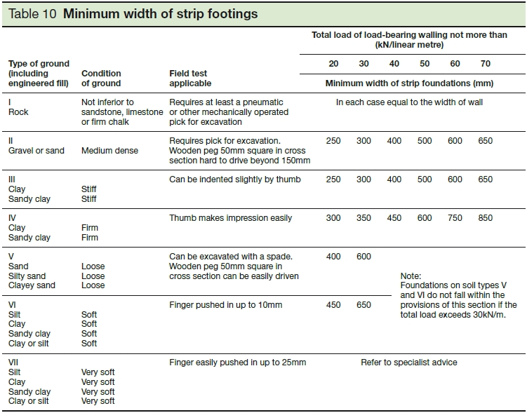

Appendix No 2 – Timber Suspended Ground Floor

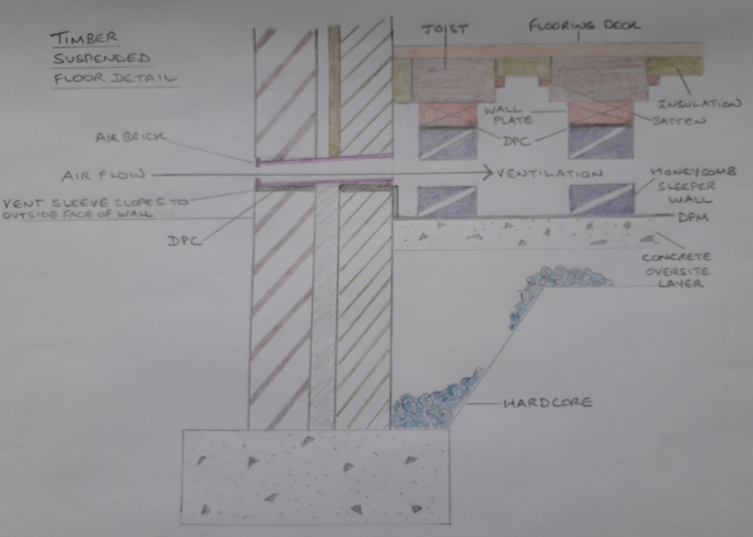

Appendix No 3 – Cavity Wall

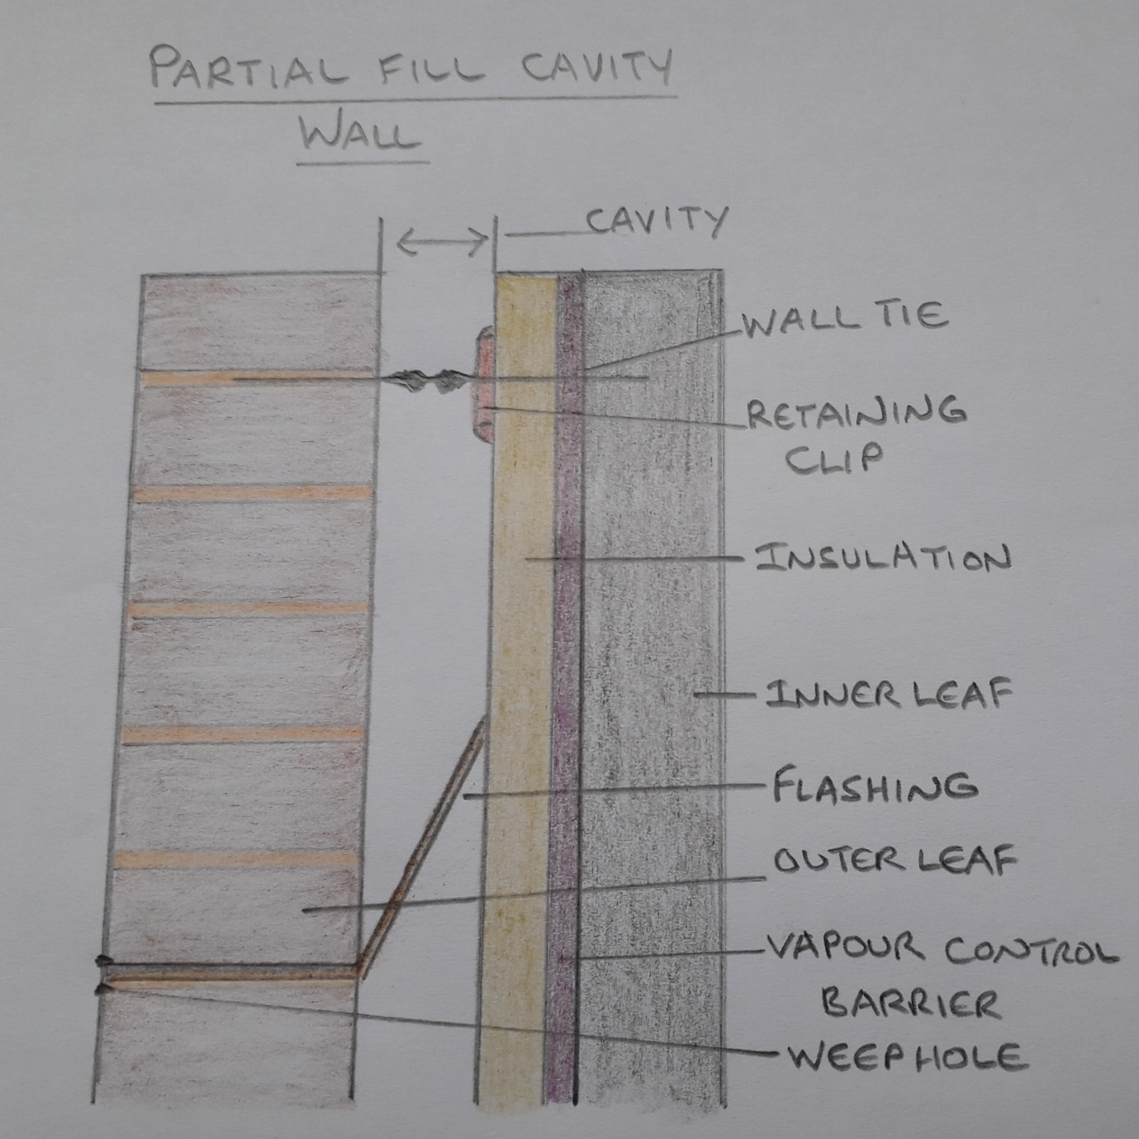

Appendix No 4 – Timber First Floor

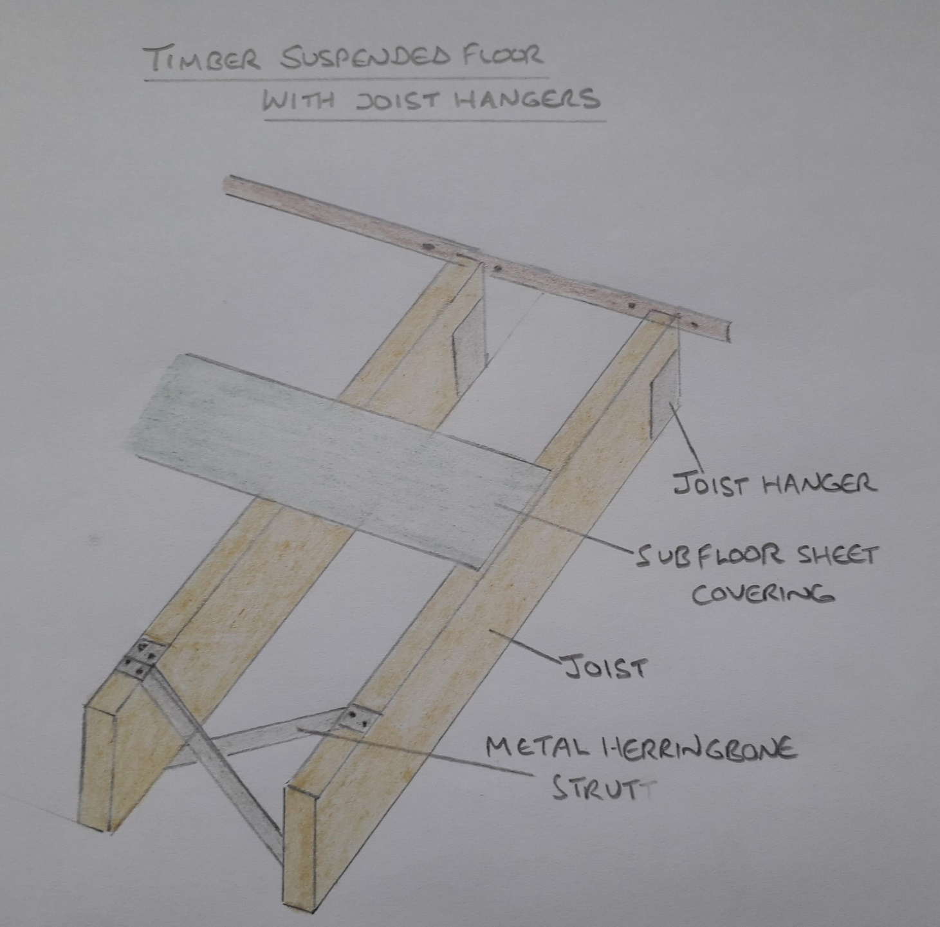

Appendix No 5 – Tongue and Groove Flooring

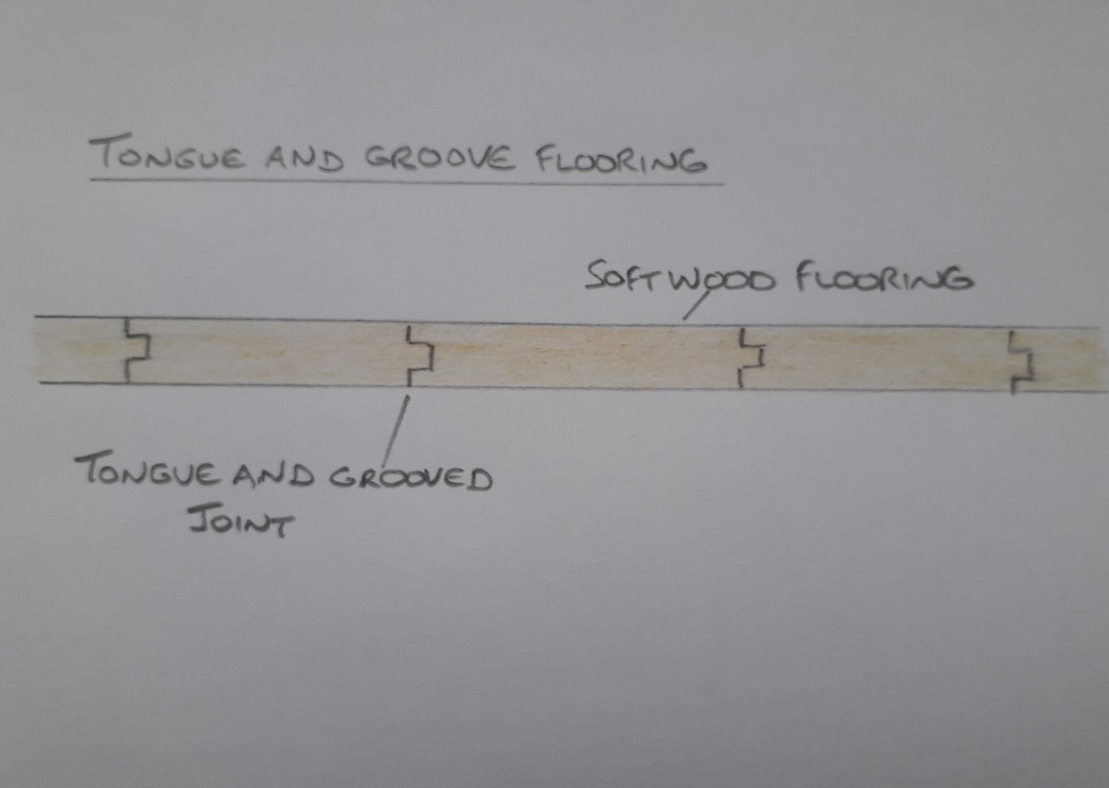

Appendix No 6 – Opening Window Detail

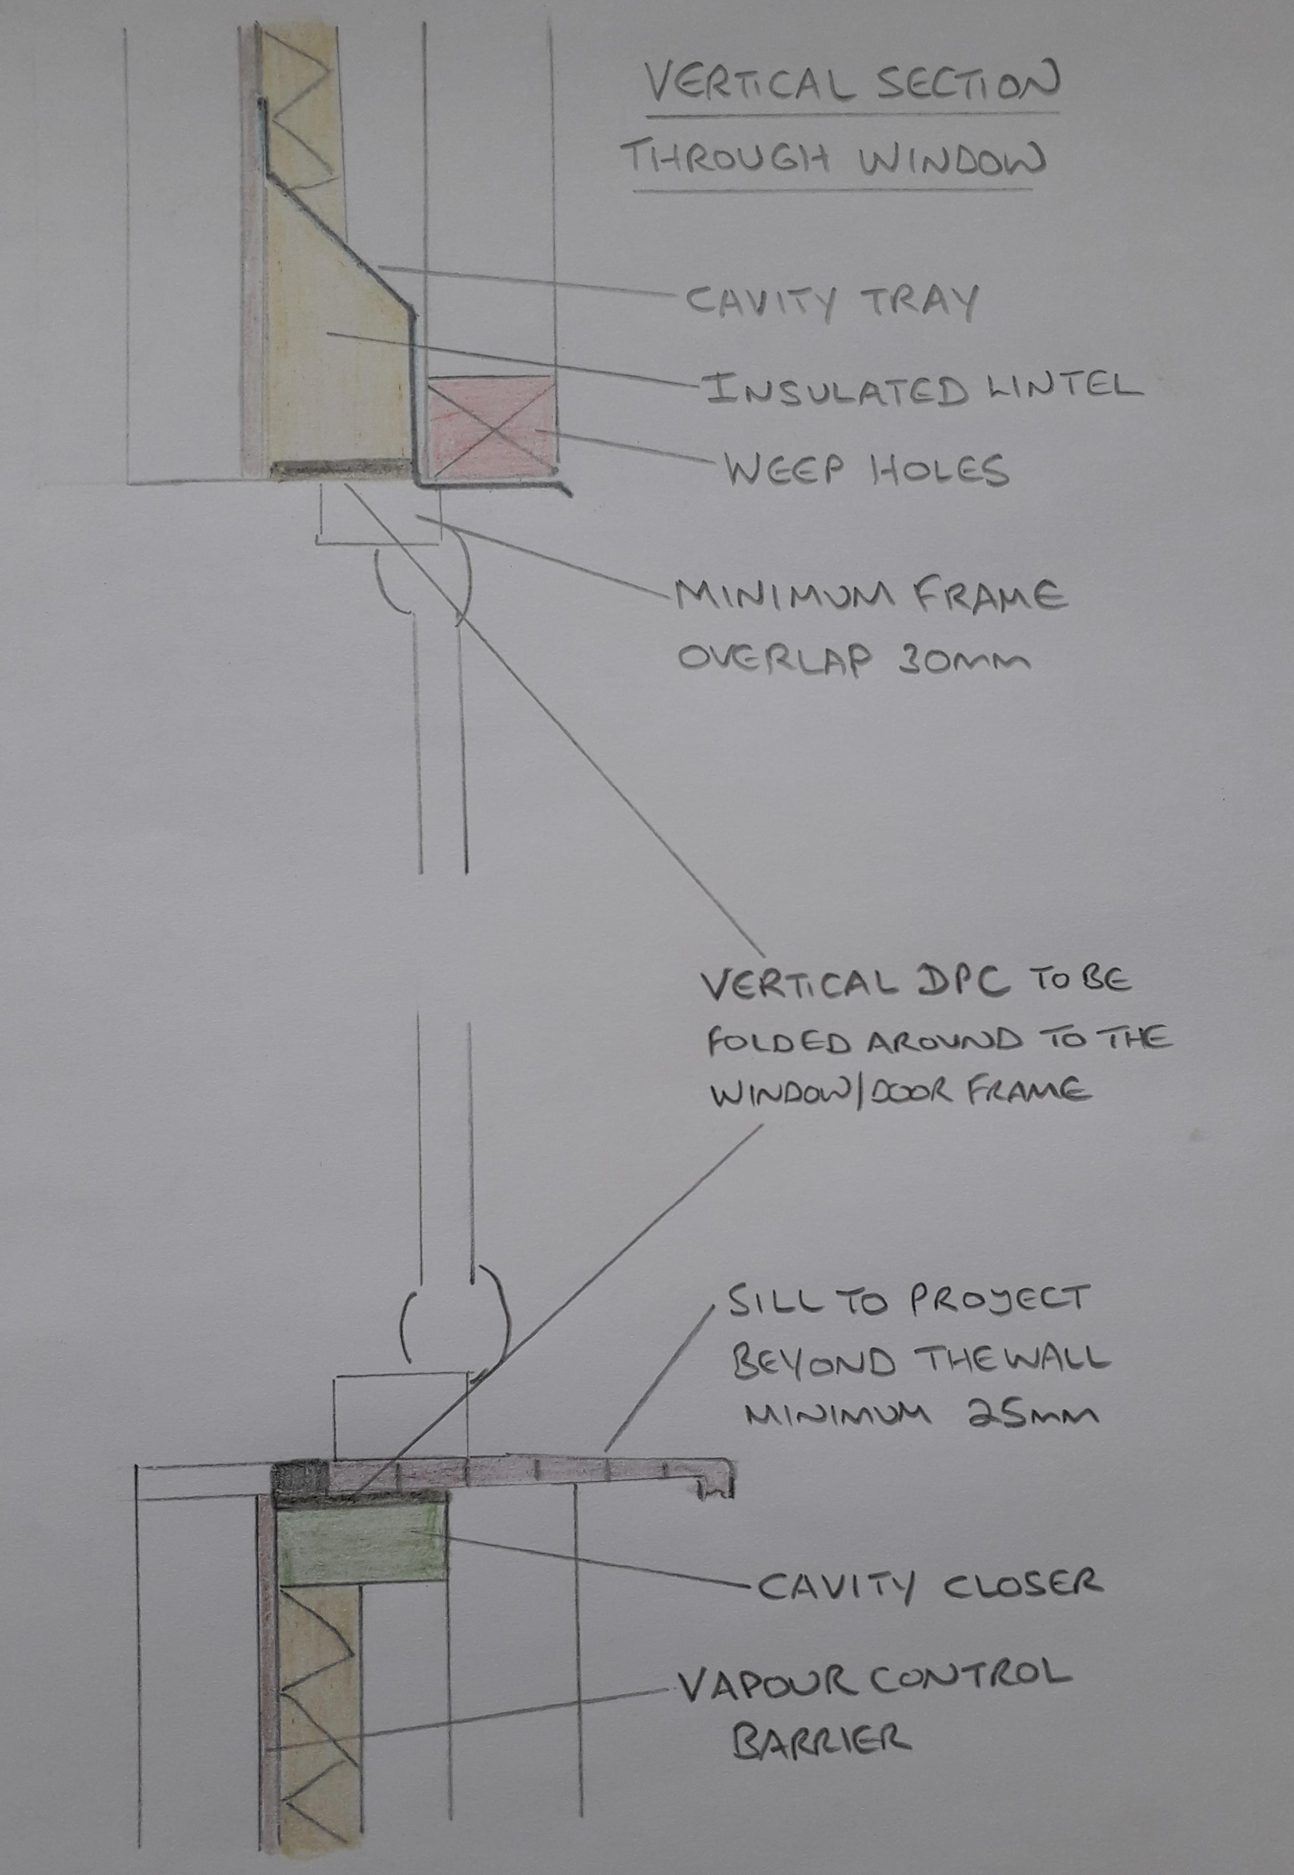

Appendix No 7 – Eaves Detail

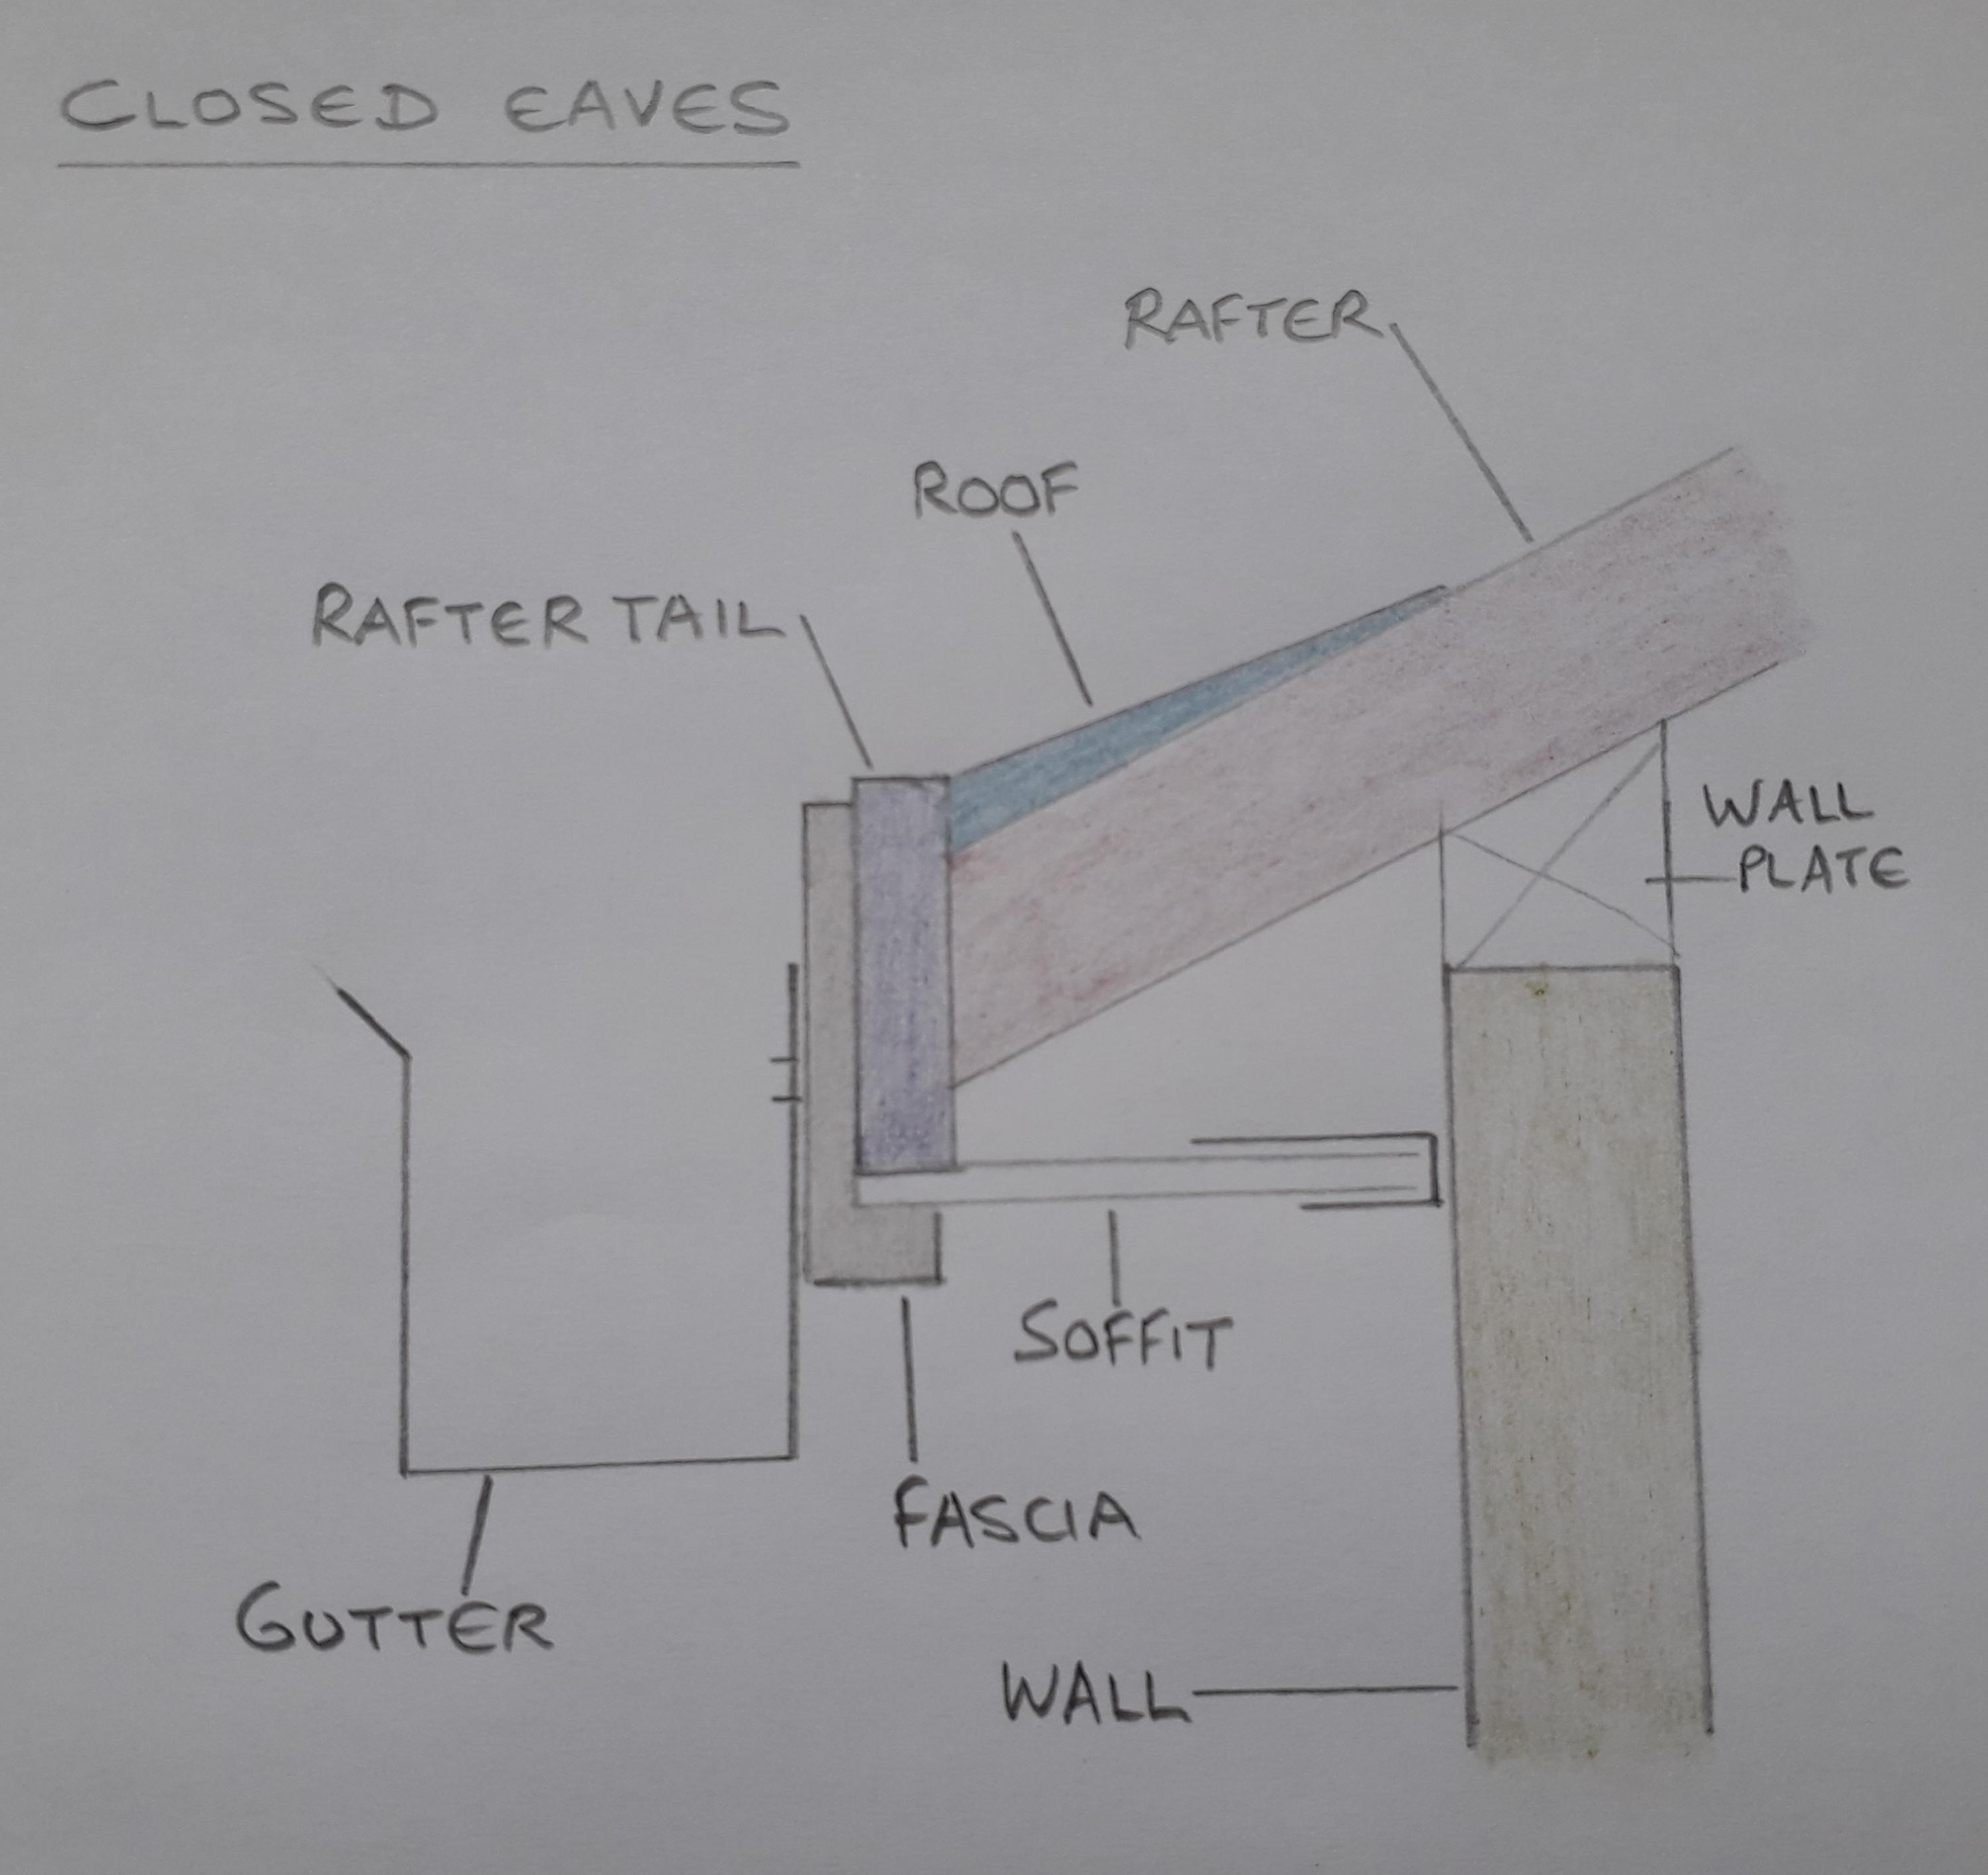

Appendix No 8 – Wall Plate Detail

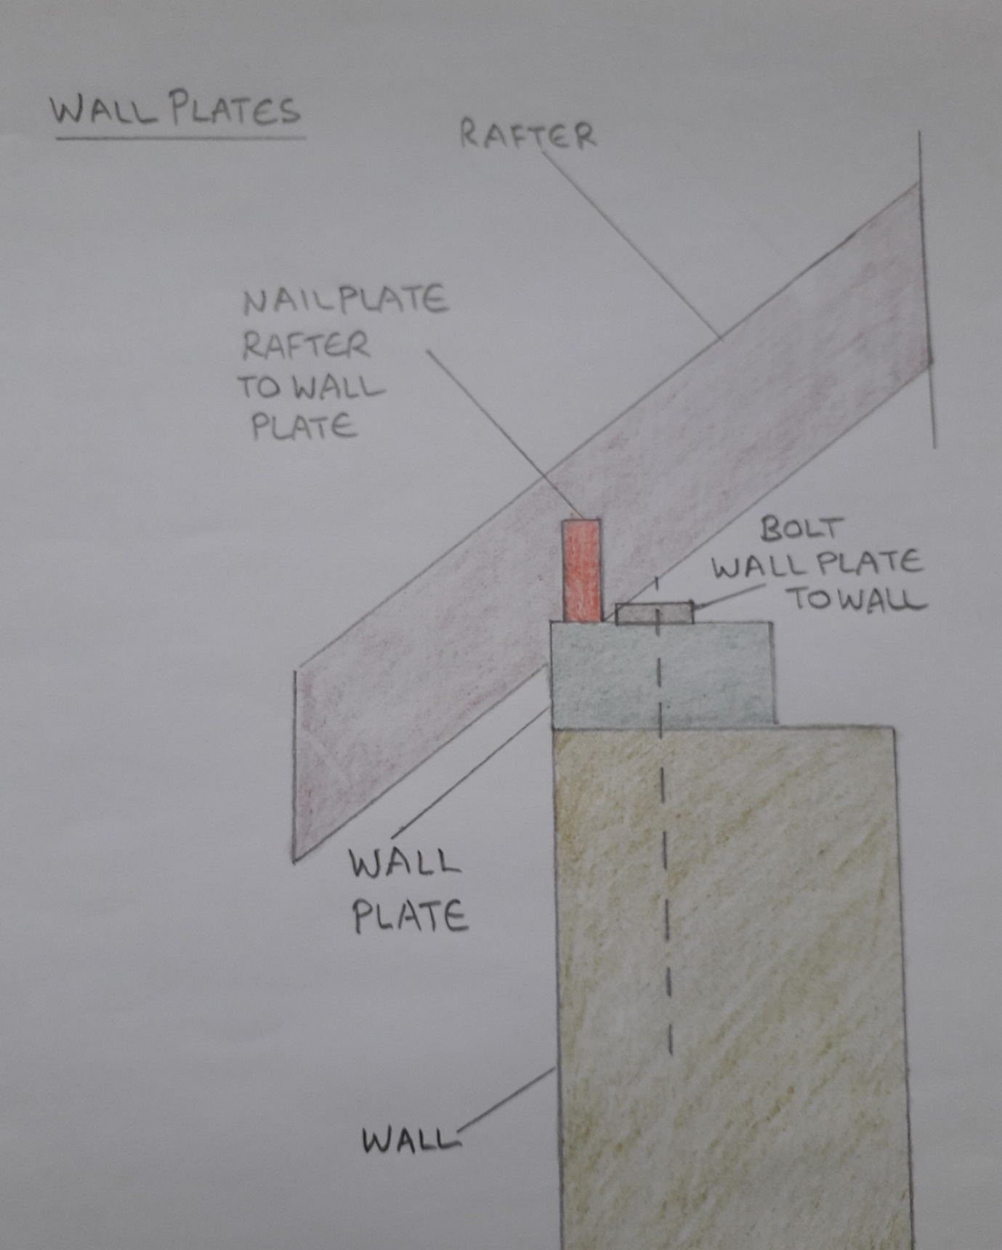

Appendix No 9 – Roof Cover

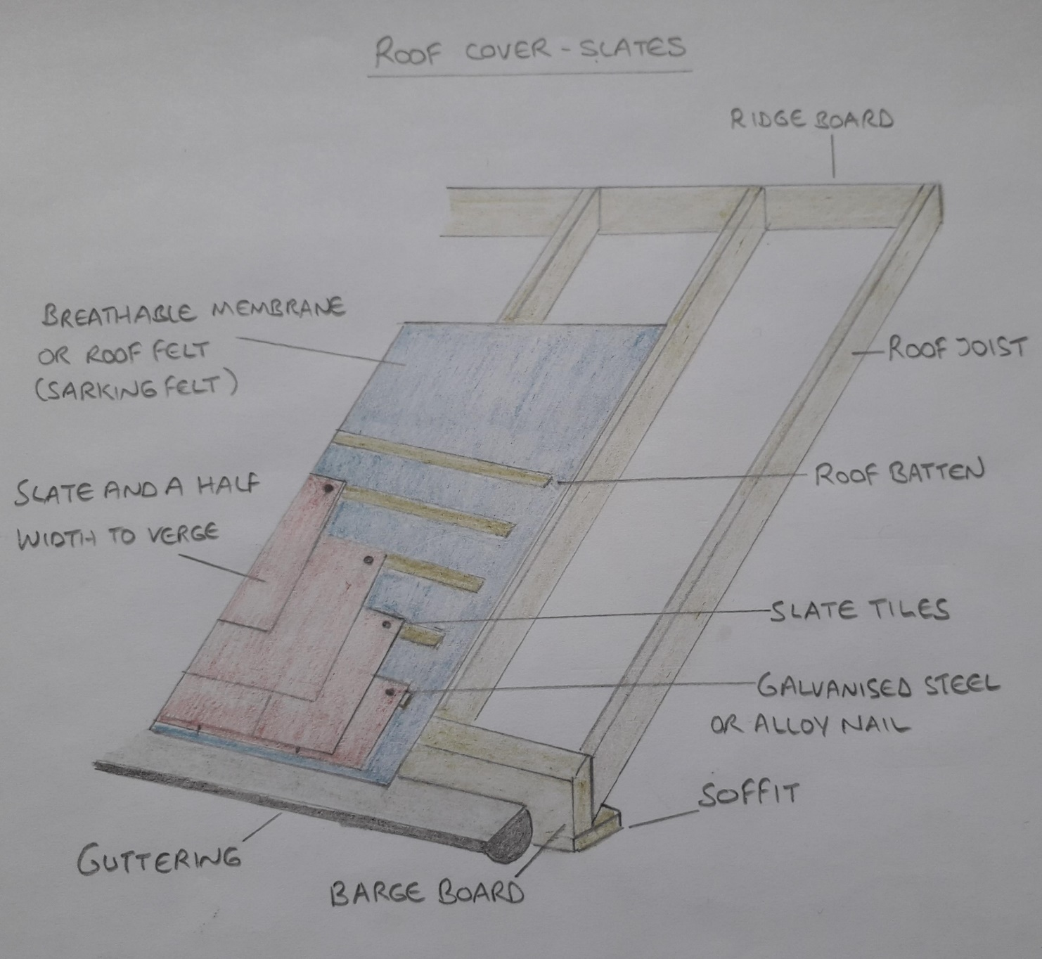

Appendix No 10 – Attic Truss

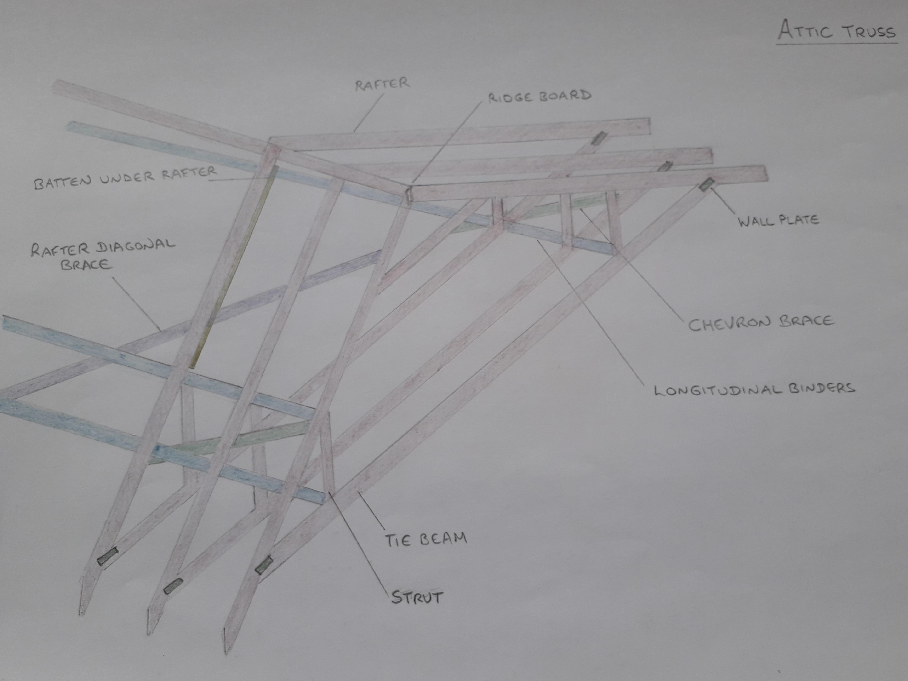

Appendix No 11 – Attic Truss

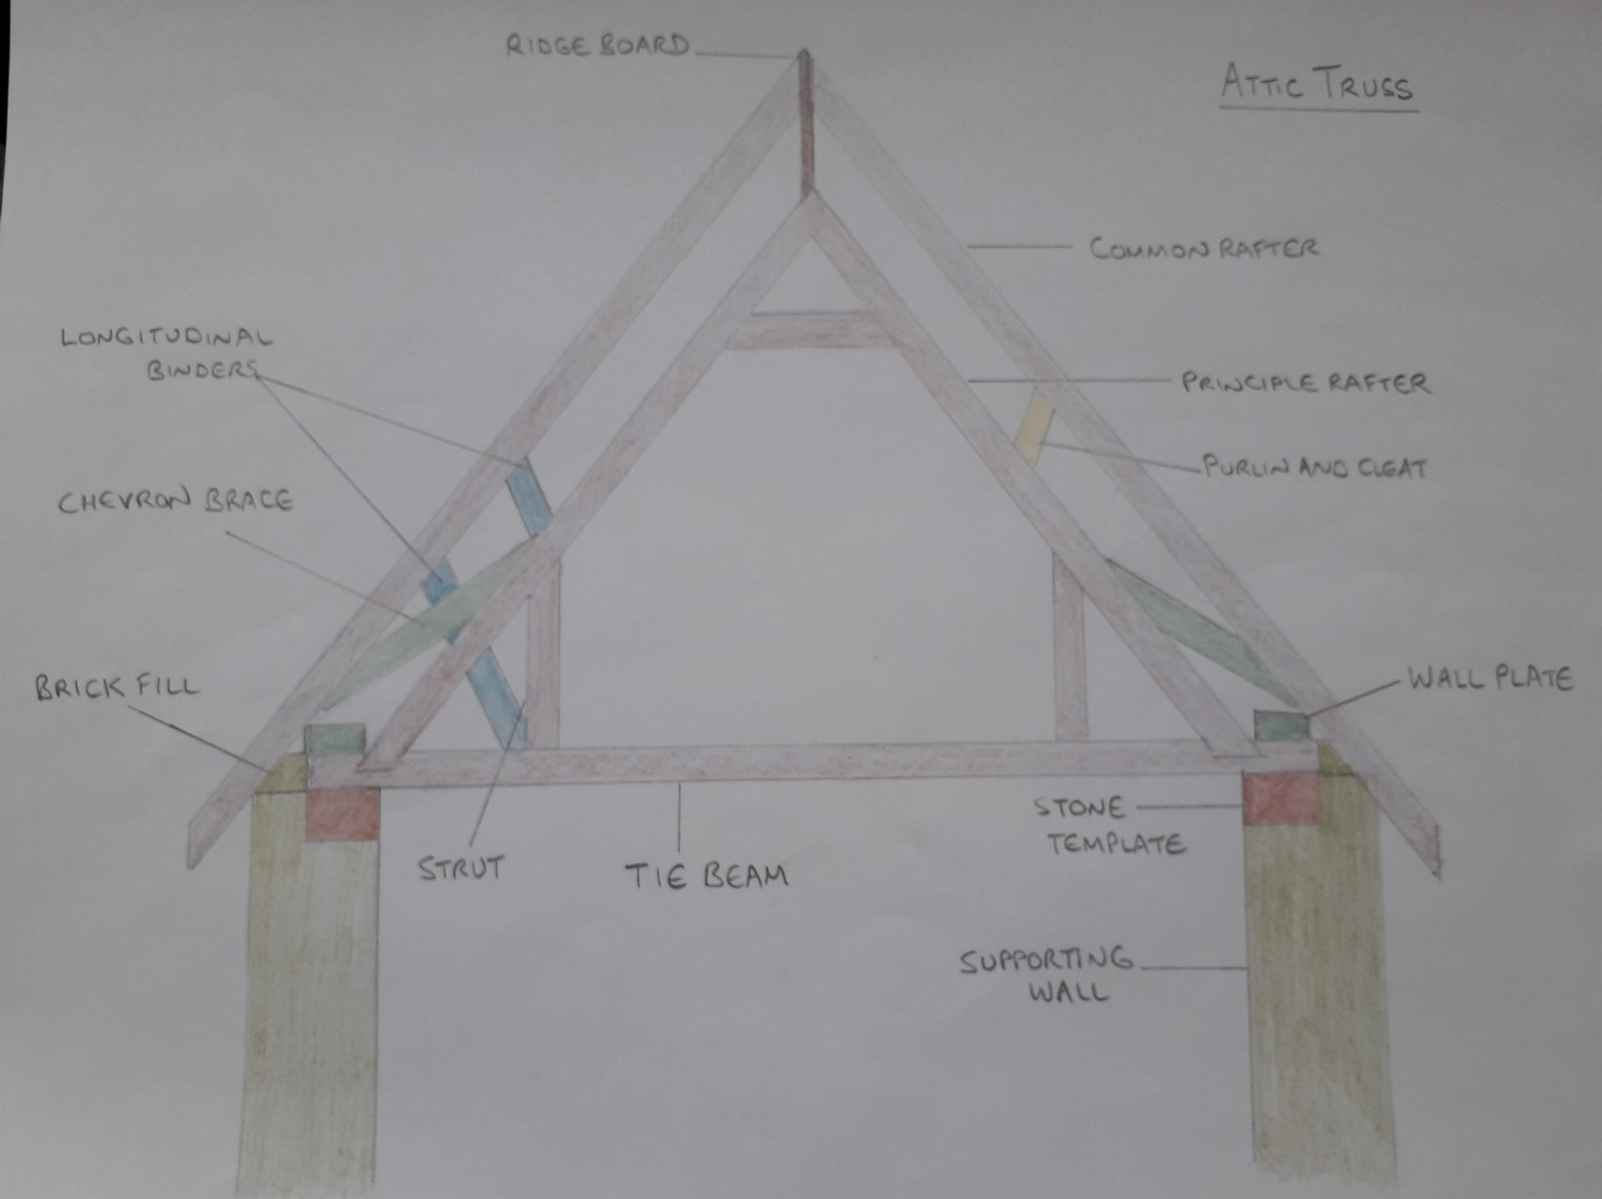

Appendix No 12 – Attic Roof Insulation



