James Price
P148136
Research Practices Dissertation proposal
My 3 key words
Games, Marketing, Generations
I want to begin by looking at marketing experts, the current game advertising market and how people at different ages link into the current industry.
Exploring the methodology used in advertising, the assumptions behind age, payment models and how they appeal to different people. How the wealth bracket of a potential buyer or target market effects the payment model used when selling a gaming product.
The gaming content itself, the use of online and how it effects game users, the relevance of age restrictions regarding this.
Games, a word that has evolved greatly in the past two decades since the coming of computers powerful enough to digitize games. A whole culture of its own has emerged, economically boosting countless other markets, such as fashion, films, foods, creating countless job opportunities and an infinitely creative outlet for artists all around the world to produce and sell their work.
The current games industry currently generates an estimated $125 billion in revenue in 2018 according to (Wijman, 2018), which is up from the estimate of $104 billion in 2016.
This makes it a more lucrative market than the films and music industries combined, music having made about $16 billion in 2016 according to (Ifpi.org, 2018), and films reportedly made around $38.3 billion in 2016 according to (Statista, 2018).
Why does the gaming industry do so well?
Well It’s a wide combination of factors, the production quality on many games is evident, you can often play master crafted games for free (more on this point later), or for a very low sum of money in exchange for countless hours of escapism and immersion into new worlds. With the introduction of online, games have now become living communities. Places you can interact with people all over the world, escaping your daily routine, for a very low cost – in the comfort of your own home.
The addition of online has also increased the potential for exchange of money, you no longer need to go to a games store to buy a game or an expansion for one, you can merely enter your card details online and download that thing you want. This process is endorsed by banks and trusted third-party companies such as Paypal to ensure money transfers online are easy and relatively safe.
This ease of payment and the introduction of online has given birth to the beast that is mobile gaming. Since mobiles are now essentially hand-held computers with the power to play good quality games with online functionality, people now have the ability to spend money on games while they are at their desks in work, out shopping or in the park. Games as a whole target all ages and all socioeconomic brackets, and people have been known to spend hundreds of pounds on single games over a pro-longed period of time.
The mobile gaming market in particular generated $50.4 billion alone in 2017 (Wijman, 2018), this can be attributed to the fact that, although mobile games are often free, it is actually these games that make the most money through something called ‘Micro-transactions’
These are transactions that can unlock something within the game, improve your experience in the game, or advance you in the game quicker than you could without paying.
This is a big cause for debate amongst gaming communities, these microtransactions are not necessarily adding anything to your game, they are often imaginary currency, you would literally exchange real money for money in the game.
For me to put this into perspective, I will name a game that is quite literally a work of art, it is a masterpiece and visually stunning with over 100 hours of potential gameplay, this game is the ‘Witcher 3’. You can buy this game for around £15, with its two very big expansion packs released after the initial game in order to extend playability bundled in.
Now, I will name another game ‘Clash of clans’, it is a free mobile game, it costs you nothing, but your time should you wish it. It is artistically very nice (but nowhere near as much work as the Witcher 3 in terms of its used assets), and its potential playtime is … unlimited, this is the problem. You can then go and spend literally any amount of money you want in this game; the maximum single purchase is $99. However, $99 is not enough to complete the game, it’s barley enough to make a dent in the massive amount of time it takes to get the best in game items. Reportedly, many of the top-ranking players have spent upwards of $12,000 in the game.
Micro-transactions have become a trend in the gaming industry, in some forms it is also quite literally gambling, as the game items take the form of ‘loot boxes’ which give payers random loot which could be bad or good. 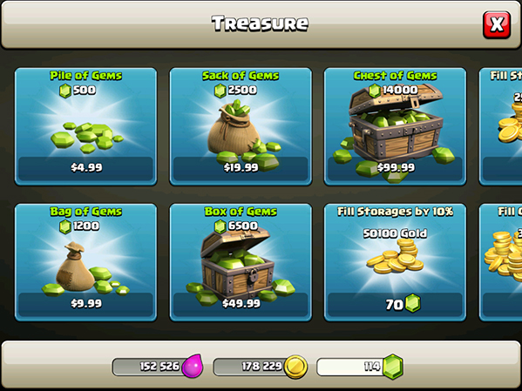
One problem with this is that it is available to and also often purposefully targeted at children.
This is where my three key words overlap.
Marketing games in 2018 is a huge undertaking, with so many ways to appeal to target audiences, so many platforms to reach out on, so many forms adverts can take, and so many different options for monetizing the game itself.
For years before this era of digital payments and games, gambling was something restricted to those aged eighteen and over, and although yes, the child would need a parent’s details or consent to make purchases like this, parents are often not fully aware of what their money is actually providing – except that it gives their child brief moments of happiness. Alternatively, details can remain saved on a system ready for quick and easy use after making a payment, there are many cases of children running up huge bills on micro-transaction games on their parent’s mobiles.

One child accidently spent £6000 on microtransactions using his father’s bank details, the father said he had linked his bank details to his iTunes account (something apple pushes for upon downloading) The father was used to his son making small purchases, and the son usually asked beforehand, but the son was enticed by the promise of a massive number of gems on the ‘Clash Royal’ store page. (Thubron, 2018). 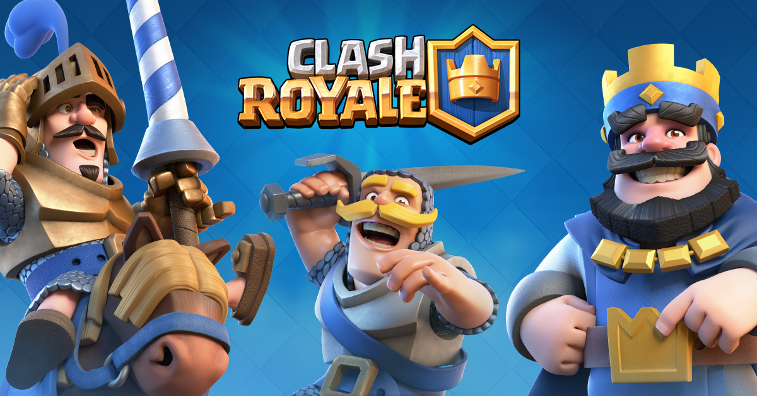
This is the same company as the game mentioned above ‘Clash of Clans’.
This is not a lone case, it is something that happens on an almost daily basis as a result of specifically targeting children with marketing.
My focus however is not on the morality of doing such things, its actually an amazing strategy employed by morally grey companies such as Supercell (the creators of the Clash games), and Electronic Arts.
However Supercell are actually a very interesting subject in terms of morality, in their game ‘Clash Royale’ during a battle you can use emotes, icons to express certain feelings. However, there is no option to turn these off permanently, and the emotions you can convey are limited. Along with the speculation that the matchmaking system is rigged for you to lose quite often. The intended effect is anger, in an attempt to encourage the purchase of gems and cards with real money in order for you to become stronger and lose less, which isn’t necessarily the case since, as you win games, you get matched with stronger and stronger opponents, so you are destined to lose a lot regardless of your equipment.
To clarify, these emotes allow people to actually bully others in no over exaggeration of the term. An opponent could destroy you in game – which will make you feel bad enough, then spam the ‘laughing’ and ‘wow’ emote ten times in a row just to kick you when you are down. Repeat this over the course of twenty games and it becomes psychological warfare.
Supercell has stated “We believe these strong emotions are integral to the core of the game” (Clash Royale, 2018) which may be the case, but it doesn’t account for vulnerable people playing the game.
The point I am striving towards is the importance of game content when marketing a game, as Clash Royale as an example is clearly marketed toward but not exclusively to children, the content of the game should not involve a strong basis on psychological warfare without a permanent option to disable potentially harmful content.
Content is equally important when it comes to the pre-game marketing, the adverts themselves. Adverts for games can be found on a games specific website, Youtube , facebook and on many thousands of random sites in the form of banner ads.
How to utilize the space you are allocated in terms of size and time is very important. An interview was conducted with Elisa Park an associate director of digital marketing for Wargaming , the company behind the multimillion dollar game and winner of the 2013 golden joystick award World of tanks – who when asked the question
What have you found to be the most effective approach for user acquisition?’
She responded with “Video performs very well for us. Since mobile ad units are limited by banner size, video incorporates details about the game that small units do not.” Which makes sense, given the huge amount of information you can fit into a tiny banner ad using a video. (TUNE, 2018)
This makes video content extremely cost effective, which is only amplified by the platforms Youtube and Facebook, where videos are free to be uploaded and hosted – viewed and shared.
Unlike in the past where you’d be forced to either advertise in comparatively boring print form, in newspapers etc , or pay a potentially massive sum of money to advertise on TV to insure decent viewership for a limited time. Now you can create your own viewership for free, easily disseminate your content via Youtube and Facebook, with the added benefit of no time limit – when your content is online, it’s online permanently.

Given the nature of games, and the masses of audiences that become exposed to the adverts for them, it is very important to note that, although a game may have a specific target market, there will undoubtedly be massive overlaps in audiences. I personally know many forty plus year old gamers, and a few over the age of sixty. It would be interesting to look deeper into how companies may attempt targeting these people for gaming adverts.

On that note, my proposed dissertation question would be (with some possible tweaking).
In relation to digital games in the modern day – What is the relationship between marketing and game content and how this effects people in the real world?

BIBLIOGRAPHY
Thubron, R. (2018). 11-year-old accidentally spends almost $7,500 on microtransactions using Dad's credit card. [online] TechSpot. Available at: https://www.techspot.com/news/68791-11-year-old-accidentally-spends-almost-7500-microtransactions.html [Accessed 10 May 2018].
Statista. (2018). Global box office revenue 2016 | Statistic. [online] Available at: https://www.statista.com/statistics/259987/global-box-office-revenue/ [Accessed 10 May 2018].
Wijman, T. (2018). New Gaming Boom: Newzoo Ups Its 2017 Global Games Market Estimate to $116.0Bn Growing to $143.5Bn in 2020 | Newzoo. [online] Newzoo. Available at: https://newzoo.com/insights/articles/new-gaming-boom-newzoo-ups-its-2017-global-games-market-estimate-to-116-0bn-growing-to-143-5bn-in-2020/ [Accessed 10 May 2018].
Ifpi.org. (2018). Global Music Report 2017. [online] Available at: http://www.ifpi.org/downloads/GMR2017.pdf [Accessed 10 May 2018].
Clash Royale. (2018). Emotes | Clash Royale. [online] Available at: https://clashroyale.com/blog/news/emotes [Accessed 10 May 2018].
Ukie.org.uk. (2018). The games industry in numbers | Ukie. [online] Available at: https://ukie.org.uk/research [Accessed 10 May 2018].
TUNE. (2018). An interview with mobile game marketing expert Elisa Park of Wargaming. [online] Available at: https://www.tune.com/blog/interview-mobile-game-marketing-expert-elisa-park-wargaming/ [Accessed 10 May 2018].

