

CRTICAL ANAYLSIS OF MANAGEMENT THEORIES RELEVANT TO WORK PLACE
STUDENT NUMBER: 1705024
SUBMISSION DATE: 11 JAN 2019

Table of content
Introduction …………………………………………………………………………………………………………………..3
Task one…………………………………………………………………………………………………………………………
Critical thinking models………………………………………………………………………………………..3
Value…………………………………………………………………………………………………………………….4
Belief.……………….…………………………………………………………………………………………………..5
Attitude…………………………………………………………………………………………………………………6
Organisational values…………………………………………………………………………………………...6
IKEA……………………………………………………………………………………………………………………….7
Amazon …………….……………………………………………………………………………………………………8
Conclusion………………………………………………………………………………………………………………10
Task two……………………………………………………………………………………………………………………………
Recommendations for amazon ……………………………..………………………………………………11
Conclusion…………………………………………………………………………………………………………….15
Reference list…………………………………………………………………………………………………………………...16

Introduction
In general, there are three important tools to improve the personal behaviours and performance in workplace, that will impact to improve the productivity and achieve a high success. These are values, beliefs and attitudes. These three tools can be applied to individuals and organisations. The report will mention these tools, and will explain the main traditional theories and modern ones. As well as this, the report will mention the RED models and Toulmin's model. This report will talk about organisations such IKEA concern to combined between the personal values, belief and attitude with the organisational values and attitudes. It will also discuss Amazon as a company.

Critical Thinking Models
The RED model is concerned with how to be a critical thinker in normal life even help to be critical thinking inside the organisation. By this model you can (R) recognise assumption, then (E) evaluate the argument, then (D) draw conclusions. According to Chatfield (Chatfield, 2018), critical thinking is setting our actively to understand what is really going on by using reasoning, evaluating evidence and thinking carefully about the process of thinking itself. Critical thinking skills is essential all kind of organisation the large even small one, because it is clearly and there is great connection between leaders and critical thinking by this tool will lead to improve and increase the ability to achieve high level performance the tasks.
The report will apply the CRAAP theory and testing.
CRRAP theory is evaluation the information by using CRAAP testing and this test is to list of questions to help to you to evaluate the information to find different criteria will be important.
C → currency: The timeliness of information.
R → Relevance: the important of your information you need.
A → Authority: the source of information.
A → Accuracy: the reliability truthfulness and correctness of the content.
P → purpose: the reason the information exists.
This testing developed by Share Blakeslee and her team in California state university (Csuchico.edu, 2010)

Values

What is personal values:
Important and lasting beliefs or ideas, shared by the members’ cultures about what is good or bad and describable or undesirable. Values have the major influence on a person’s behaviours and attitudes and serve as a broad guideline in all situation. Some common business values are fairness, innovation and community involvement (BusinessDictionary.com, n.d.). The examples of the personal values are:
- Dependability
- Commitment
- Open-mindness
- Health
- Love
- Creativity
- Honesty
- Efficiently
According John Bratton (Bratton, Grint and Nelson, 2007) values are collective ideas about what is right or wrong, good or bad, and desirable or undesirable in a culture. Values are important to help and guide our principles to achieve the life goals. These values guide our beliefs and attitudes that will impact in our behaviours. As will these values can help to be more easily to make decisions, everyone and every company had a hundred of decision every day, both can choose the right decision depend on and reflects the values and beliefs that direct towards a specific purpose, the purpose is satisfaction our individual (Valuescentre.com, 2013). Values can help us to predict others choices, and help to avoid misunderstanding and distrust (The values project, 2017). Help to pass the good quality to the next generation (our children) to make sure healthy, positive and heard worker’s community is formed. Like Respect, honest, forgive and believe in others (GUERRERO, 2014). From this point to ensure values are formed in early childhood, by the different kind of experience in different stage of our life that will influence and re-valued these values or in some time these values are changed.
That certainly, personal values - system is tend to be stable and fix, because it is part of your characters, but single values can be change if something big happens (Thum, 2018).

Beliefs
What are personal beliefs?

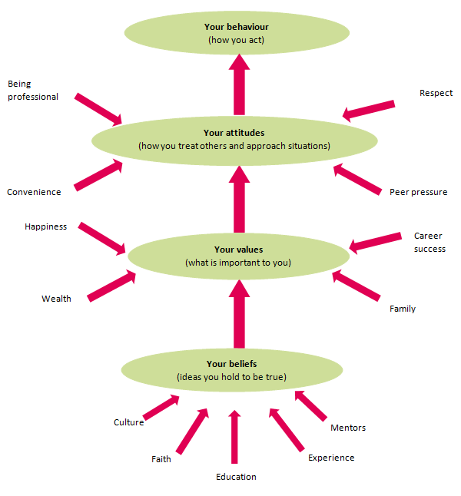
(Immigration Advisers Authority, 2017)

This diagram shows the sources of belief and the relationship between to result a behaviour and attitudes. Personal belief is an idea that person holds as being true. A person can base a belief upon certainties (e.g. mathematical principles) or matters of faith. Different sources in belief 1- a person’s own experiences 2- cultural social norms (religion) 3- educational or mentoring (Immigration Advisers Authority, 2017). Example: everyone has a belief for something, it is not necessary all have the same belief. Group of people believe Theresa May good as a prime minister, but others do not.
Some people believe in God and God created all the creatures, whereas some people do not believe in God. Different beliefs are based on different education, and different cultural backgrounds.

Attitudes

Personal attitudes:
According HNC (HNC HND BTEC Business core unit 3 organisations and behaviour, 2000)
attitude is a mental neural state of readiness, exerting a directive or dynamic influence upon the individual's response to all objects and situations with which is related.
Might influence attitudes to workplace or affecting in work, include the following.
1- Age. attitude in general less flexible with age
2- Race, culture or religion.
3- Lifestyle and interest

Organisational values
What is the organisational values?
The operating philosophies or principles that guide an organisation's internal-conduct as well as its relationship with its customers, partners and shareholders. Core values as usually summarized in the mission statement or in the company statement. These values are determined and focus the way treat the workers and shape our basic work ethics. The importance of business ethics. Every business has a special kind of values, A University might value intellect and depend on knowledge, educational, if we compare with Telecommunication company concern in services. So, different company have different code of ethics and valuing. But, any successful business should have
- Integrity and Ethics. Simply the two principles are translated in to doing the right, honest and fair, that lead a strong relationship between the employees, stockholders, and customers then that will impact positively to the organisation will get a good reputation in the market.
- 2- Respect: without respect between all members will affect negatively in the employees.
3- innovation: The successful business focus on being a head of their competitors and introducing new and unique ideas in workplace (innovation not imitation) (Workitdaily.com, 2015).

What are organisational attitudes?
Attitude is a way of thinking or feeling about something a certain state of mind at the time. That will impact in the behaviour of the workers like the attitude in actual job is a pay, salary, working condition, that will influence in workers in negative or positive way. If the workers believe they are not being paid enough they will act out behavioural (My Organisational Behaviour, 2011).

History of IKEA
It is global organisation owned by Ingvar Kamprad. This organisation was founded in Sweden 1943.
This organisation focused in flat- pack furniture chain has 361 stores, in over 40 countries and the employees more than 164000 workers.

Values of IKEA
The team and leaders of IKEA recognised the importance values in workplace and sharing these values in lifestyle.
These values include:
1- Togetherness
2- cost-conscious
3- Respect
4- simplicity.
As mentioned in Hellsten (Hellsten, 2000) these cores of values should ideally be conformed to by all employees within an organisation working successfully. IKEA management believed that everyone has something valuable to offer and we keen to have the same values workplace. Togetherness is the heart of IKEA culture (R, 2015). According to the Smart Business Trends, IKEA on of the companies with happiest employees and number two on Forbes best retail companies to work 2012.
IKEA management believed motivation tools is essential in any successful organisation, so they apply this tool in IKEA by give gifts, holiday party, and the main point the company respect all the member in the organisation, and allows its employees to make a mistake and learn from them. As well they believed the training, engagement and sharing the ideas, give opinions, and improve the other skills like communication skills, IT skills, hold meeting programs, that will help the workers to be more loyalty, and work more with happier in the organisation. There is a saying at IKEA company “That is ok to make mistakes in fact, that indicate it is a healthy way to learn and improve and you can get work as a team work. This way allows the employees a lot of freedom without of fear from mistakes, that make the employees feel happy and that will impact positively to achieve the performance in high level (Anderson, 2013). These cores of values should ideally be conformed to by all employees within an organisation working successfully, and IKEA company applied these core values. HR managers of IKEA in UK (Scott, 2017) said “As values driven organisation, we put people at the heart of IKEA business and we are committed to making a positive contribution to their live”. That is shows to treat their employees fairly by give 10,400 retail staff at least one week off. They aim to improve employee work-life balance. And the managers alert to design this offer to provide the benefit, fairly to the employee that make them feel happier, satisfied in work place. This initiative give a benefit to the employees like pension, annual bonus (Scott, 2017). Working with values and a strong organisational culture is profound part of IKEA company. Process of recruiting is essential to choose the candidate to fill the vacancy in the company and there is a strong connection between the interviews and the process of recruiting to now the right person in the right place by answering several questions. During the personal interview meet with the applicant can form an opinion on values and behaviours. By asking question like why you want to work at IKEA? how can you deal with absent people or what your childhood like? The key from these questions to find out behaviours and values in each applicant, and they try to match the values and behaviours with the role. So, during the interviews can get more information for the applicants not just the verbal, by facial expression and body language. According to Chatman (1989) the most successful recruitment is made when there is a match between the individual values and the organisation, which leads to a person - organisation fit.

But IKEA organisation treat the workers bad in some point. Reviews from staff and former staff said that “it is difficult for co-workers to take advantage of the opportunity that arise for you not in the inner article, workers find it difficult to progress”. Additionally, the management at IKEA have been accused of not caring about their staff and prioritising goals and products over staff wellbeing. One reviewer said “they are not bothered if they leave their workplace or stay”. Other reviewers say that it is a “Boring job, because is regular work without any creativity” (Indeed.com, 2014).

History of Amazon
Amazon organisation is one of the largest organisation in the world. It is started in 1995, it was the site that only sold books. Within a month of its inception the company had already shipped books to over 40 different countries. However, the organisation has treated the employees very poorly and have been described as treating their workers as robots. This has negative impact on the employees. There have been several reported incidents including 600 calls made to the police particularly the ambulance department sent to warehouse in Birmingham in the past three years. Some calls -outs to the site for electric shocks, that is indicated the employees did not have good and enough training how to use the electric machine or poor in health and safety inside the company. It is suggested that the line managers did not give enough advice to the employees. It is believed that eight people who had fallen unconscious worked long hours, without enough breaks to eat and drink. This will affect to the employee, causing anxiety and feeling unhappy, which puts them under pressure and stress. Many pregnant woman have told newspapers that they are forced to stand 10 hours a day to finish the job. Additionally, they pick, stow, pull heavy carts and walk miles that put the employees in too much pressure and unhealthy condition and environment as well to the unborn baby that could lead to miscarriage. Thus, Amazon organisation mention they will try to work hard to improve their program and are working to prevent future accidents (Butler, 2018).
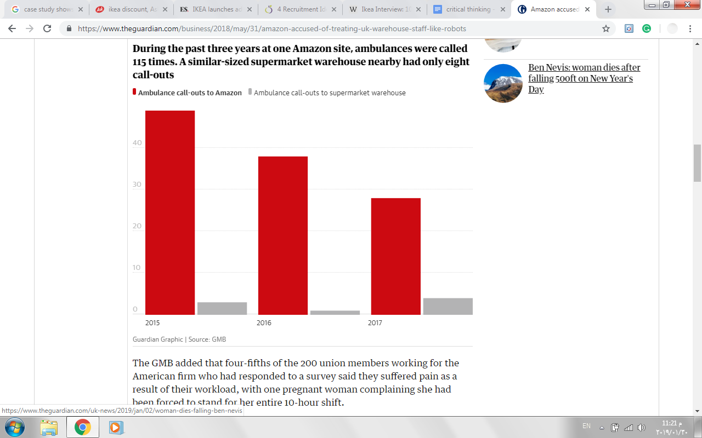
(Butler, 2018)
Amazon have been accused of treating their warehouse-staff-like-robots. By investigation undercover more than five weeks suggested the workers suffer mentally and physically when they try to meet the demand. Some of the employees work more than 55 hours a week. They would sleep on their feet, this bad treatment like a machine without respect the personal values, human right. This investigation mentions that Amazon workers left the organisation without income or support from the company. Talks about anonymous workers suffering accidents at work, injuries, and depression, and even eight of the workers trying to commit suicide. The National Council for Occupational safety and health mention in the last report in April 2018 in United States Amazon company as one most dangerous place to work (Western, 2018).

The main reason why Amazon is a successful organisation is the harsh and strict rules apply on employees. But such strategies will lead to an uncomfortable work and employees will be unhappy to meet the high demand in the workplace. Consequently, the employee will be suffering from high workload, depression and anxiety. It can be concluded so far that any successful organisation must deployed strict rules on employees, but such rules should match with new management theories, motivation and high level of training, employee engagement and group team spirit. Amazon did not recognise the personal values that should match with the organisational values to get good relationship that help to improve, stabilise the organisation and make both side happy. Amazon organisation still the one of the largest company in the world. Because the management in Amazon considers Snap Agency, that mean the company develop on data drive solution, that help our client for continuous growth

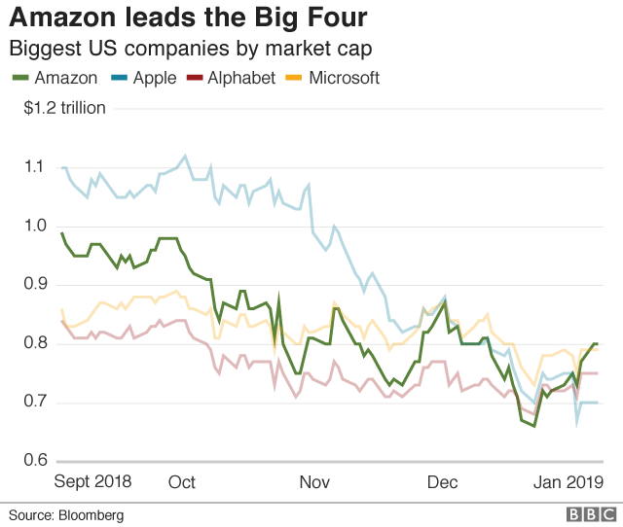
(BBC News, 2019)

The management spend more than eight years developing digital marketing to help increase the sale in all the world and the manager considers the innovation in technology is main tool to success in any organisation. Jeff Bezos considers Echo is one of the innovation technology was huge investment for e-commerce, over 22 million Echo unit s were sold in 2017 alone. the manager believes the customers is the important and essential part in any successful organisation, hence, they try to improve the customer service to make the customer happy. This commitment to the customers and by developing the tools used in track package, retune quickly or exchange the ordered items that make the customer happy, then will impact positively to the organisation and gain good reputation. Amazon -customer service has multiple awards for its dedication to prevent and swiftly addressing problem for customers. As well as manager’s concern in social media is another powerful tool help the e -commerce people can access world-wide easy to use in the comfort in their homes, that help to improve the sale then impact to increase the profit. The diversification is the one and important tool to improve and growth, Amazon started online books store, now offers everything from soup to nut, more than 3000 listing for vegetable soup. Now carries product in music, books, electronic, health and beauty… etc. The management believed Amazon good company for those who are hardworking, in this company give good opportunity to prove yourself, and become better person and more successful. In this company give a chance to learn, it might not be the happiest place to be in like most of company but it is give new things to learn. Working in Amazon give a great experience to help and grow (Snap Agency, 2018).

Conclusion
Business and values are inextricably linked, the main tool to keep the organisation stable and improve to match the personal values with the organisation's values that lead and help to company to growth successful and increases. If management not considers this factors that impact negatively to the company.

Task two: Management theory.

According to Mullins (Mullins and Christy, 2016) Taylor theory is the one of scientific management, Taylor is the father of scientific management, he believed that is the same way there is a best machine in each job, there is the best working method by which people should undertake their job, he believed to motivate their workers and obtain highest wages through working efficient and productively way. In this method of motivation, the employees are treated like a machine or report in workplace.
According to by Taylor (Expert Program Management, 2018) “What the workers want from employers beyond anything else higher wages. What employers want from workman most of all is low labour costs in manufacture.” That may affect in negative way to the employees, the reaction from the workers who find the work boring, regular job requiring little skills. Without any kind of creativity, that could make the employees unhappy in this unhealthy environment, they are monitoring and control closely all the time from the managers or supervisors because Taylor believed the employees naturally they take easy in work and try to be more slack whenever they could. So, Taylor encourage the managers to monitor the employees by breaking down each employee's job to be easy and more manageable bite-sized- tasks. Workers should be paid based on how much they product. Taylor believed the managerial control over the product process and remove the decision making from the employees. This scientific management called Taylorism and this still use today especially in many organisation need and concern in competitive in labour intensive industry keeping costs low as possible and high productive. Amazon organisation applied Taylor theory. As discussed in Task 1, the studies mention the majority of the employees are unhappy, but they force to work to gain money they need to live in basic conditions. In addition, if the employees in Amazon find new job with better condition in work and better opportunities they easily will leave the work. The employees are monitoring closely from the manager all the time. They gain the salary and paid certain in workhouse staff a piece rate basic how productive they are. Taylor believed employees not allow to think for themselves just need a simple task performance quickly as possible. that seen in Amazon company, employees need to finish the task quickly as possible, the workers should be paid for doing the job not for thinking. This exactly happen in Amazon, the employees worked around 8-10 hours a day just with simple task carrying the staff, packaging. Walking miles without any considers human right or personal values that called dehumanization, that will impact negatively for the employees. Then drive in negative way in the company, maybe not in the productivity but in reputation of the company. Both workers and company had a benefit. But it is the benefit for the organisation itself (Amazon) more than the workers because that industrial action in strikes in the last 100 years (Expert Program Management, 2018).

Recommendations for Amazon
Amazon organisation can improve the productivity, gain highly and more profit and make employees happier, more satisfied in workplace by applying other management theory like Maslow’s theory (hierarchy of needs theory) or (human motivation) is one of the most well- known and widely cited theories of motivation. This category in five stages of human needs, it is started to satisfied the lower level of needs before processing to meet the higher level of needs. The first need is the basic for human to live physiological needs like water, food, shelter. Second needs: the people desire to be safe, and secure. Third needs: we need friendship and company. Fourth needs: social recognition or esteem needs. Fifth needs: top most tip is self-actualisation (BBC News, 2013).
The chart below identifies the five stage of human needs.

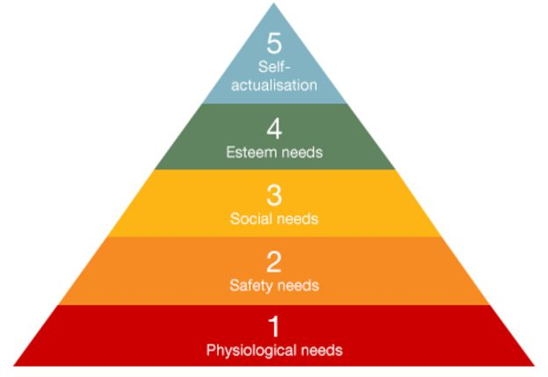
(BBC News, 2013).

Maslow (1943) believed everyone has desire to move forwards the level of self- actualisation. But before to reach this level that order to motivate someone especially if they are employees in the organisation as the manager must motivate them not by money, concern to create a healthy environment with share the ideas with the managers, employee engagement and decision making the last not the least training is essential for them to improve and high performance. Managers use Maslow's hierarchy to identify the needs of their staff and help them feel fulfilled and give them fancy job, better working condition and flexible working. So, if the manager in Amazon this motivation human need theory incurs the basic tool of motivation that lead the employees be happier and more satisfied will impact positively to the company. IKEA are an example of an organisation who have applied Maslow’s theory. In addition studies mention IKEA organisation one of the best known companies for its well -designed, sustainable home product offered of competitive price 2012 (Leppavaara ,2013) Because IKEA had a professional employers who believed in monetary incentive to the employees is the most powerful tool to motivate the employees with equally influenced and by having better working and healthy environment and good working condition. Lindners (Lindner, 2011) support Maslow’s theory and believed that money(salary) is best motivation tool to the employees but considers the others factors like interesting work good wages, full appreciation of work done job security good working conditions promotion and growth in the organisation .

One study (Leppavaara,2013)) using questionnaire among 200 employees at IKEA store, the question formulated and based on 10 motivated factors.
The result from the study mentions:
1- The employees have a highly motivated factors make them happy with interesting and healthy environment and better working condition includes better opportunity, promotion and career growth in the company and the main point the job security. Ensure dedication from employees and hence, high productivity, it's related to physical and safety needs. According to Smith (Smith, 1994) the role of motivation help the organisation to survive and make the employees more productive and to be more effective the managers need to understand what motivates employees within the context role they perform.
2- Good place to work. The result of the studies mention strongly agree IKEA is good place to work. Employees feel happy, its relate to physiological need. According Kovach (Kovach, 1987) money becomes less motivators factors, when employees become older, having better environment, healthy condition workplace and interesting work,
3- Mistake made sometime are accepted. Total of 71.4% of the response agree mistakes are accepted. That give a chance to employee to learn more, feel more confidence, related to esteem needs.
4- Opportunities for personal development. Many employees agree and feel that 60.1.%. respondents completely agree and 39,3 partially agreed this difference depend on group of age, that will give the employees more confidence, related to esteem needs in Maslow's theory.
5- Authority to make decision. Most employees mention and totally agreed they are given a chance of authority to make decisions. Employees feel happy, satisfied, feel values, related to self-actualisation, top of the hierarchy of Maslow's theory.
6- Skilled training provides confidence. Almost of the employees are agreed skills training are provided a confidence in workplace and lead to get high performance. That lead employees feel more confidence to do work, feel happy, related to esteem needs that lead to self-actualisation.
7- Satisfied with team spirit. Highly agreed there are a spirit of teamwork in IKEA workplace. Lead to share the work with others, share ideas that help to achieve the work. Related to social needs
8- Diverse perspective valued: The result of the questionnaire shows many of the employees strongly agreed with diverse perspective values but the perspective is difference between the department.
The result shows the employees in sale department (52.1%) feel more valued if compared to the logistic employees with (21%) agreed with that (Adhikari, 2013). One of the tool give a better sign and good reputation for the company to deal, treat equally between male and female in terms of gender representation in job roles. Author (year) shows that IKEA are a company that clearly identify fairly job between male and female, a shown from the chart above. IKEA management Believed in human right and personal values. In comparison with Amazon, the report suggests that Amazon management encourage and prefer the male to take the job over females. Because female need more breaks for look after the kids, more breaks in pregnancy and long breaks in maternity, thus, that will put more cost and expenses in the organisation. It could be argued from this, that Amazon do not recognize in human right or personal values (Expert Program Management, n.d.).

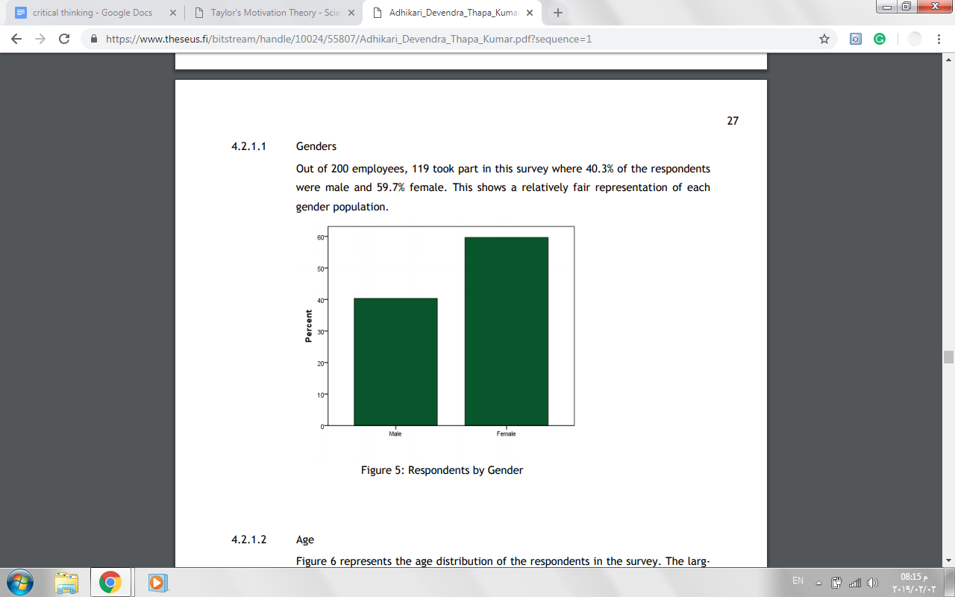
(Lindner, 2011)
The diagram shows the percentage of females over males are employed.

Conclusion
If any organisation use theory such as Taylor management theory without considering human rights and employees values, the management of the organisation should apply the new theories such as Maslow or Mayo’s to help and improve the organisation for the customer and employers.

Reference list
Adhikari, D. (2013). [online] Theseus.fi. Available at: https://www.theseus.fi/bitstream/handle/10024/55807/Adhikari_Devendra_Thapa_Kumar.pdf?sequence=1 [Accessed 10 Jan. 2019].
Anderson, C. (2013). Companies with the Happiest Employees - Smart Business Trends. [online] Smart Business Trends. Available at: http://smartbusinesstrends.com/companies-with-the-happiest-employees/ [Accessed 10 Jan. 2019].
BBC News. (2013). The pretty pyramid that beguiled business. [online] Available at: https://www.bbc.co.uk/news/magazine-23902918 [Accessed 10 Jan. 2019].
BBC News. (2019). Amazon becomes most valuable public firm. [online] Available at: https://www.bbc.co.uk/news/business-46793466 [Accessed 10 Jan. 2019].
BBC News. (2019). Amazon becomes most valuable public firm. [online] Available at: https://www.bbc.co.uk/news/business-46793466 [Accessed 10 Jan. 2019].
Bowen, R. and Radhakrishna, R. (1991). Job Satisfaction of Agricultural Education Faculty: A Constant Phenomena.. [online] Eric.ed.gov. Available at: https://eric.ed.gov/?id=EJ426630 [Accessed 10 Jan. 2019].
Bratton, J., Grint, K. and Nelson, D. (2007). Organizational leadership. Mason, Ohio: Thomson/South-Western, pp.43 - 45.
BusinessDictionary.com. (n.d.). Read the full definition.. [online] Available at: http://www.businessdictionary.com/definition/core-values.html [Accessed 10 Jan. 2019].
Butler, S. (2018). Amazon accused of treating UK warehouse staff like robots. [online] the Guardian. Available at: https://www.theguardian.com/business/2018/may/31/amazon-accused-of-treating-uk-warehouse-staff-like-robots [Accessed 10 Jan. 2019].
Chatfield, T. (2018). Critical thinking. 1st ed. London: SAGE Publication, pp.6 - 15.
Csuchico.edu. (2010). [online] Available at: https://www.csuchico.edu/lins/handouts/eval_websites.pdf [Accessed 10 Jan. 2019].
Expert Program Management. (2018). Expert Program Management. [online] Available at: https://expertprogrammanagement.com/2018/05/taylors-scientific-management/ [Accessed 10 Jan. 2019].
Expert Program Management. (n.d.). Expert Program Management. [online] Available at: https://expertprogrammanagement.com/2018/05/taylors-scientific-management/ [Accessed 10 Jan. 2019].
GUERRERO, P. (2014). 7 Important Values to Live by .... [online] Allwomenstalk. Available at: https://inspiration.allwomenstalk.com/important-values-to-live-by/ [Accessed 10 Jan. 2019].
Hellsten, U. (2000). TQM as a management system consisting of values, techniques and tools. [online] Emeraldinsight.com. Available at: https://www.emeraldinsight.com/doi/abs/10.1108/09544780010325822 [Accessed 10 Jan. 2019].
HNC HND BTEC Business core unit 3 organisations and behaviour. (2000). 1st ed. London: BPP Publishing Ltd, p.160.
HNC HND BTEC Business core unit 3 organisations and behaviour. (2000). 1st ed. London: BPP Publishing Ltd, p.160.
Immigration Advisers Authority. (2017). Personal beliefs, values, attitudes and behaviour - Immigration Advisers Authority Your tagline here. [online] Available at: https://www.iaa.govt.nz/for-advisers/adviser-tools/ethics-toolkit/personal-beliefs-values-attitudes-and-behaviour/ [Accessed 10 Jan. 2019].
Indeed.com. (2014). Ikea Careers and Employment. [online] Available at: https://www.indeed.co.uk/cmp/Ikea [Accessed 10 Jan. 2019].
Kovach, K. (1987). What motivates employees? Workers and supervisors give different answers. [online] Science direct. Available at: https://www.sciencedirect.com/science/article/pii/0007681387900826?via%3Dihub [Accessed 10 Jan. 2019].
Lindner, J. (2011). Understanding Employee Motivation. [online] Joe.org. Available at: https://www.joe.org/joe/1998june/rb3.php [Accessed 10 Jan. 2019].
Maslow, H. (1943). PsycNET. [online] Content.apa.org. Available at: http://content.apa.org/journals/rev/50/4/370 [Accessed 10 Jan. 2019].
Mullins, L. and Christy, G. (2016). Management & organisational behaviour. Harlow [etc.]: Pearson, pp.40 - 45.
My Organisational Behaviour Notes. (2011). Attitudes and Behaviour in Organisations - My Organisational Behaviour Notes. [online] Available at: https://www.myorganisationalbehaviour.com/attitudes-and-behaviour-in-organisations/ [Accessed 10 Jan. 2019].
R, H. (2015). 190 Brilliant Examples of Company Values. [online] The 6Q Blog. Available at: https://inside.6q.io/190-examples-of-company-values/ [Accessed 10 Jan. 2019].

References
Scott, K. (2017). Ikea UK gives retail staff one weekend off in every four to improve work-life balance. [online] Employee Benefits. Available at: https://www.employeebenefits.co.uk/issues/july-online-2017/ikea-uk-gives-retail-staff-one-weekend-off-every-four-improve-work-life-balance/ [Accessed 10 Jan. 2019].
Smith, G. P. (1994). Motivation. In W. Tracey (ed.), Human resources management and development handbook (2nd ed.).
Snap Agency. (2018). 7 Reasons Why Amazon Is So Successful. [online] Available at: https://www.snapagency.com/blog/7-reasons-why-amazon-is-so-successful [Accessed 10 Jan. 2019].
Snap Agency. (2018). 7 Reasons Why Amazon Is So Successful. [online] Available at: https://www.snapagency.com/blog/7-reasons-why-amazon-is-so-successful [Accessed 10 Jan. 2019].
The values project. (2017). [online] Available at: https://www.thevaluesproject.com/blog/why-are-values-important/ [Accessed 10 Jan. 2019].
Thum, M. (2018). Self-Reflection: How to Do It Right. [online] Myrko Thum. Available at: https://www.myrkothum.com/self-reflection-how-to-do-it-right/ [Accessed 10 Jan. 2019].
Valuescentre.com. (2013). Personal Values Assessment (PVA) | Barrett Values Centre. [online] Available at: https://www.valuescentre.com/our-products/products-individuals/personal-values-assessment-pva [Accessed 10 Jan. 2019].
Western, P. (2018). Amazon workers are being left homeless and unable to work. [online] Mail Online. Available at: https://www.dailymail.co.uk/sciencetech/article-6007629/Amazon-workers-left-homeless-unable-work-according-latest-investigation.html [Accessed 10 Jan. 2019].
Workitdaily.com. (2015). Work It Daily | Trusted, Easy-To-Use Career Support | Work It Daily. [online] Available at: https://www.workitdaily.com [Accessed 10 Jan. 2019].

