

Module: International Business Concepts
Module Code: LCMB7034
Company Selected: Aditya Birla Group
Name: Sachin Ashokbhai Japi
Student ID: 2430819
Lecturer: Akshay Narayanan
Term: 2

Table of Contents
1. Introduction to the Report 3
2. Benefits and Challenges of International Operations 3
2.1 Aditya Birla Group as an MNC/TNC 3
2.2 Character of Global Operations and Value Chain Analysis. 4
2.3 International Market Entry Modes. 6
2.4 Summative Critical Advantages of International Operations. 6
2.5 Major Issues of International Operations. 7
3. OLI Framework and Market Entry Strategy 7
3.1 Ownership Advantages 8
3.2 Location Strengths- Vietnam. 9
3.3 Internalisation Benefits. 10
3.4 OLI Effect on the Entry Mode Selection. 11
4. Cultural Differences and Market Entry Impact 12
4.1 Home Country vs Emerging Economy Cultural Comparison. 12
4.2 Effect of Culture on Business Performance and Success. 14
5. SOP Adjustment to be successful in the emerging economy 15
6. Conclusion 18
References 20

1. Introduction to the Report
Aditya Birla group is among the top multinational conglomerates in India, which has spread its operations in various fields which include metals, cement, textiles, financial services, chemicals, and telecommunications (Group, 2025). The group has a strong global presence with its operations running in more than 35 countries in Asia, Europe, Africa and the Americas, and has been able to do so with good financial performance and diversified business interests (Group, 2025).
This consultancy report aims at critically analyzing the international business strategy of Aditya Birla Group, in terms of the advantages and weaknesses of its international business, its internationalization strategies as per the OLI framework, and how cultural differences have influenced its performance in the emerging markets. The firm has been chosen by virtue of its robust international coverage, effective internationalization, and worthiness as an Indian multinational researching in some of the emerging economies. The report will be organized in such a manner as to offer a systematic review of its operations internationally, its strategic decision making, cultural aspect, and suggestions as to how it should conduct its operations to continue to be successful globally.

2. Benefits and Challenges of International Operations

2.1 Aditya Birla Group as an MNC/TNC
A Multinational Corporation (MNC) or Transnational Corporation (TNC) can be defined as a company that owns or manages the production or service facilities in more than a country and organizes its activity on the cross-national basis to attain the global efficiency and strategic advantage (Zharikova and Cherkesenko, 2021). These types of companies resort to foreign direct investment (FDI), work under the sub-units or under joint ventures and combine their global value chains, in various regions.
Aditya Birla Group is a multinational corporation and this is evident in the fact that it has a large international operations, diversified international investments, and openly integrated business structure (Aditya Birla Group, 2025a). The Group has its headquarters in India and operates in over 35 countries and employs over 180000 employees. It has multiple businesses in many industries such as metals, cement, textile, chemicals, carbon black, telecom and financial services. Its good transnational structure is evidenced by its major international subsidiaries including Novelis (aluminium), Ultratech Cement (global operations), Grasim Industries, and Aditya Birla Fashion and Retail.
The Group operates globally across Asia, Europe, North America, South America, Africa, and Australia, supported by extensive networks of production, research, and marketing facilities. It has established operational units in major economies including the United States, Canada, Brazil, Thailand, Indonesia, and several African countries (Aditya Birla Group, 2015). Evidence of its global footprint is reflected in its operations in over 35 countries and its employment base of more than 180,000 employees worldwide, highlighting the breadth of its international integration (Aditya Birla Group, 2025a). The Group’s sectoral diversification—covering metals, cement, chemicals, textiles, carbon black, telecom, and financial services—further underscores its extensive transnational presence. Its aluminium subsidiary Novelis alone operates 33 manufacturing facilities across 9 countries, while UltraTech Cement maintains over 100 plants globally, demonstrating deep value-chain internationalization. This combination of multi-regional production, cross-border managerial coordination, and globally dispersed R&D functions firmly positions Aditya Birla Group as a fully integrated multinational enterprise operating under a transnational business model, characterised by global efficiency, local responsiveness, and worldwide learning.

2.2 Character of Global Operations and Value Chain Analysis.
Efficient management of its global value chain that links its research, sourcing, production, marketing, distribution, and financial activities in different countries make the Aditya Birla Group to be successful in the international market (Acquaye et al., 2023).
Research & Development (R&D)
Innovation has been of utmost importance in ensuring the competitive advantage of Aditya Birla Group. The company has a big investment in metals, chemicals, cement and textile research and development. The product innovation, process optimization, sustainable materials, and energy efficiency are addressed by the R&D centres in India, Europe, and North America (Ghobakhloo et al., 2021). To illustrate, Novelis is a pioneer in the recycling and lightweighting technologies of aluminium used in the packaging and automotive industry worldwide. Such globalization in R&D boosts better product quality, minimizes production expenses, and improves technological dominance in the international markets.
Manufacturing & Production
Aditya Birla Group has large scale manufacturing plants in India, southeast Asia, Europe, North America, and Africa (Sahoo, 2024). Its aluminium, cement, carbon black and chemical plants are benchmarked in the world with regards to efficiency, environmental performance and quality standards. The multinational production structure provides the company with cost competitiveness, regional supply and capacity utilization (Kharub et al., 2022). The international manufacturing plants also help the Group to bypass the tariff barriers, meet the local content requirements and be nearer to the major customer markets.
Marketing & Sales
The Group adheres to both global and local market adaptation. Although such brands as Novelis and Ultratech Cement are based on the global standards of identity, products, pricing policies, and marketing campaigns are localised depending on the preferences of consumers, local construction practice, and local needs in the industry (Matey and Narkhede, 2021). The company has strong international sales networks, dealer relationships, and business-to-business relationships which allow the company to retain customer loyalty and increase customer market share in the global market. Brand recognition and competitive positioning are also increased through cross-border marketing activities.
Distribution & Logistics
The Group has a very complicated international system of logistics with shipping lines, ports, warehouses, inland transportation, and digital tracking systems. Distribution is also important and mostly efficient allocation of bulk products like cement, aluminium, chemicals and carbon black (Muñoz-Vélez et al., 2023). Aditya Birla Group minimizes lead times and transportation expenses by using regional hubs and strategically located manufacturing units. Dependence on global logistics networks, however, subjects the organization to port congestion, freight cost surges, and geopolitical upheavals.
Financial Operations
The international financial activities of the Group encompass international investment financing, foreign exchange management, treasury activities, capital allocation as well as the cross-border risk management (Wang, 2024). They are raised by domestic and international capital market, syndicated loans and bonds. The centralised financial system allows optimal capital utilisation and shields the firm against excessive currency risk. However, its exposure to foreign financials makes it vulnerable to the changes in interest rates, exchange rates and international regulatory compliance laws.
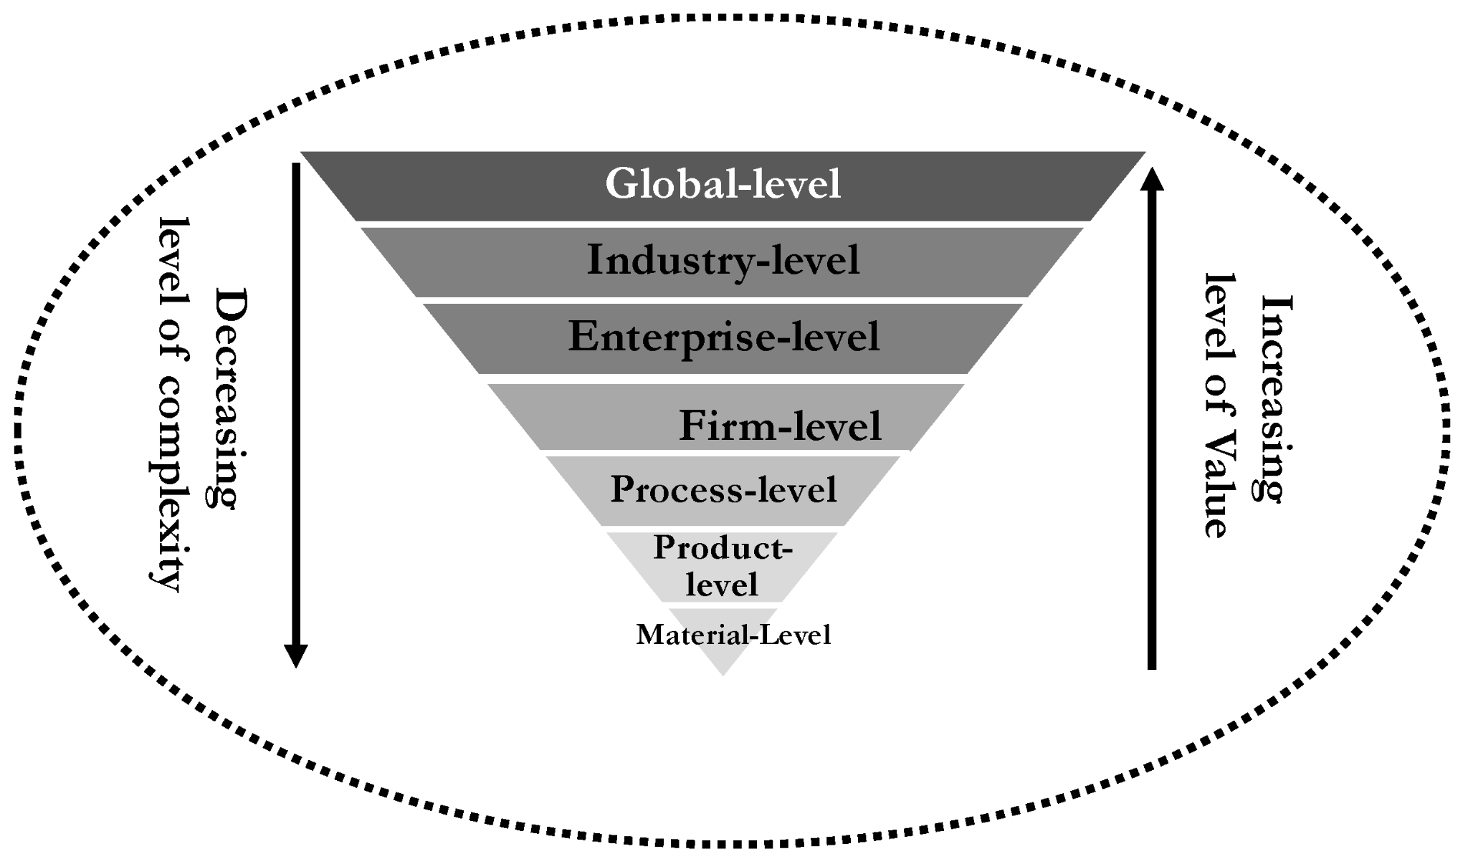
Figure: Global Value Chain Analysis
Source: (Acquaye et al., 2023)

2.3 International Market Entry Modes.
Aditya Birla Group employs various modes of international market entry based on sector needs, regulatory regulations, risk of market and investment goal (Viswaprasad et al., 2025).
Wholly Owned Subsidiaries
Aditya Birla Group frequently adopts the wholly owned subsidiary mode to exercise complete control over its foreign operations, technology transfer, and long-term strategic investments (Kuruppu et al., 2024). A key example is Novelis, acquired in 2007 for USD 6 billion, which today operates as a wholly owned subsidiary with 33 manufacturing facilities across 9 countries, making it the world’s largest rolled aluminium and aluminium recycling company. This demonstrates the Group’s preference for full ownership when technological capabilities and global integration are strategic priorities. Similarly, UltraTech Cement another core subsidiary operates over 100 manufacturing plants globally, including wholly owned units in the UAE, Bahrain, and Sri Lanka, while Grasim and other chemical and textile businesses maintain fully controlled plants across Asia and Africa (Aditya Birla Group Companies List). This evidence shows that the Group relies on wholly owned subsidiaries when it seeks total authority over technology standards, production quality, management systems, and profit retention. However, such a mode also requires substantial capital investments and exposes the firm to higher market and regulatory risks compared to shared-ownership entry structures (Giles, 2022).
Joint Ventures
One can utilize joint ventures where the regulatory barriers, political risks, or local market knowledge are involved. By collaborating with local companies, Aditya Birla Group can access established distribution connections, government connections and consumer information and share financial and operational risks.
Strategic Alliances
Another area where the Group has been involved is the formation of strategic partnership with international companies to share technology, to have sustainability and integrate their supply chain (Tarigan et al., 2021). Such non-equity alliances enable flexibility and minimize the entry risks and enhance the innovation abilities and global competitiveness.
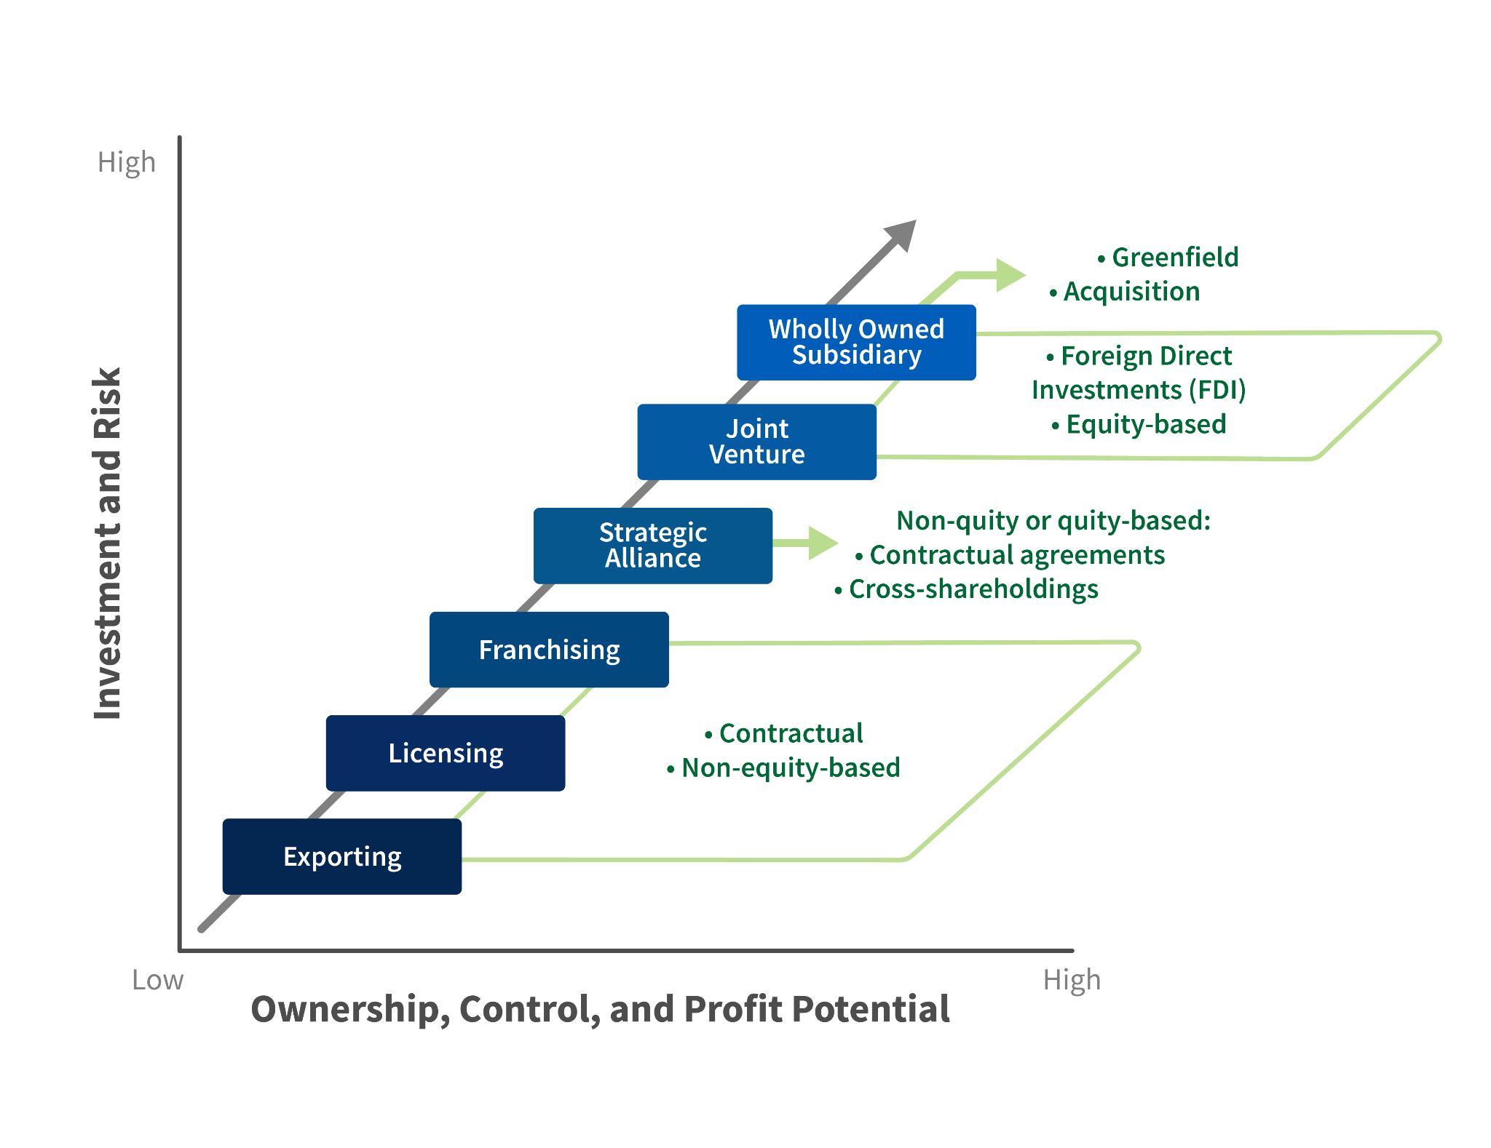
Figure: International Market Entry Modes
Source: (Giles, 2022)

2.4 Summative Critical Advantages of International Operations.
Market Expansion
Aditya Birla Group’s internationalization, operating in 35+ countries with 180,000 employees, enables entry into fast-growing markets in Asia, Africa and Latin America while sustaining demand in mature regions such as North America and Europe. This diversified global presence reduces domestic saturation risk and stabilizes long-term revenue flows (Aditya Birla Group, 2025a).

Revenue Diversification
The revenue streams of the Group are considerably stabilized because of the geographical and sectoral diversification (Xie et al., 2022). The slowdown in the economies of one region may be compensated by the increase in another region. The presence in more than one market increases financial strength and shareholder value by creating long-term stability of revenues.

2.5 Major Issues of International Operations.
Political and Regulatory Risks
Aditya Birla Group’s presence in over 35 countries exposes it to regulatory unpredictability, including abrupt tax revisions, FDI restrictions, environmental compliance tightening, and tariff shifts. Such volatility particularly in emerging markets—raises operational costs, delays approvals, and disrupts long-term capital planning, thereby weakening profitability and strategic stability (Bucheli et al., 2023).
Cultural Differences
Cross-border operations face managerial friction due to contrasting views on hierarchy, communication style, and work norms. Misinterpretation of indirect communication, high power-distance expectations, and collectivist behavior can reduce expatriate effectiveness, weaken team integration, and hinder decision-making efficiency. Without structured cultural adaptation systems, subsidiaries may experience productivity losses and employee disengagement.
Exchange Rate Fluctuations
Currency volatility remains a critical financial challenge. Depreciating host-country currencies diminish repatriated earnings, while appreciation raises input and labour costs, undermining competitiveness in globally priced sectors such as aluminium and cement. Even with hedging, forex instability affects cashflow reliability and complicates capital budgeting (Knight, 2025).

3. OLI Framework and Market Entry Strategy

3.1 Ownership Advantages
Aditya Birla Group’s ownership advantages stem from its strong global brand reputation, substantial financial resources, advanced technological capabilities, and experienced multinational leadership. These firm-specific assets enable efficient transfer of expertise, superior product quality, and economies of scale across international markets, giving the Group a sustained competitive advantage in metals, cement, textiles, chemicals, and related sectors (Collidu, 2023).
Brand Reputation
Aditya Birla Group has an established international track record of operational excellence, sustainability leadership and reliability in the various industries and operations it operates within the metals, cement, textile, chemicals and financial services sectors (Aditya Birla Group Story, 2025). The presence of the Group as an international brand, particularly with Novelis (aluminium) and Ultratech (cement), enables the Group to have an instant credibility in new markets such as Vietnam. High brand equity reduces the barriers to entry, increases the level of stakeholder confidence, and boosts relationship with local distributors, suppliers and government agencies.
Financial Strength
The vast financial resources that the Group possesses enable it to invest in large scale greenfield investments, as well as, to acquire domestic companies and to set up sophisticated R&D and manufacturing units abroad. Its diversified income streams in 35+ countries and in various segments minimizes strategic risk and enables it to expand capital intensive in the long term (Onabowale, 2024). It also increases its bargaining strength and the ability to survive fluctuation in the economy, so that, the company has a financial depth that helps it to fight in the emerging economies.
Technological Capabilities
Process innovation, sustainable materials, digital supply chains, recycling technologies, and advanced manufacturing systems are known in Aditya Birla Group. An example of this is the Novelis, which is a leading company in the world in terms of aluminium rolling and recycling technology. The technologies present competitive edge in the developing automotive, construction and packaging industries in Vietnam (Van Hoang et al., 2025). Equally, its cement production efficiency innovations and carbon reduction would be in line with the national sustainability objectives of Vietnam.
Managerial Expertise
The Group has a high quality of experienced global leadership that has experience in managing multicultural workforce and operating complex international value chains. Good governance structures, cross-border project management expertise and global HR systems assist the organization to adjust well to new markets (Wong Villanueva et al., 2022). The managerial skills will enhance the capacity of the firm to execute the global best practices in the operations, sustainability, and employee’s development of Vietnam.
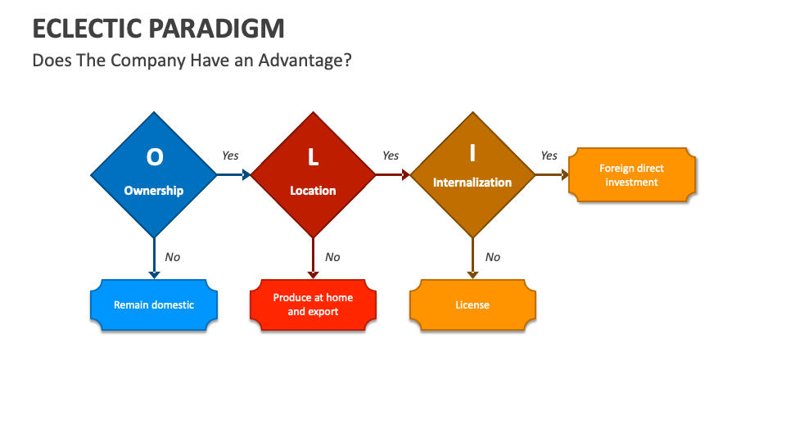
Figure 3: OLI Framework
Source: (Collidu, 2023)

3.2 Location Strengths- Vietnam.
Location advantages are those advantages that are country specific and they make Vietnam an attractive country to invest foreign direct investment (FDI). The rapid industrialization and geographical location and favorable investment climate in Vietnam is in line with the long global strategy of Aditya Birla Group.
Market Size and Growth
Vietnam is one of Southeast Asia’s fastest-growing economies, with a population of over 100 million, of which nearly 55 percent are middle-income consumers, creating a substantial demand base for metals, cement, chemicals, textiles and other products aligned with Aditya Birla Group’s portfolio (Vinh et al., 2024). Its GDP growth rate consistently ranges between 6–7 percent, driven by urbanization, manufacturing expansion, and strong FDI inflows. With a manufacturing sector valued at over USD 100 billion, Vietnam offers significant long-term market potential and strategic alignment with the Group’s expansion plans.
Availability and Cost of labor.
The country has a young and skilled workforce that is also cost-efficient and this is a major plus to labor intensive activities like textiles, chemical production, carbon black manufacturing and metal fabrication in Vietnam (Brown, 2024). The cost of labour is significantly low as compared to India and China, which gives a leverage in the operations of the Group and allows it to increase its cost competitiveness within the global markets (Đỗ, 2023).
Infrastructure Development
Vietnam has achieved a lot in terms of infrastructure with regards to ports, highways, industrial parks and special economic zones (Tang, 2023). These enhancements facilitate effective supply chain of raw materials, finished goods and exports. In the case of a conglomerate such as the Aditya Birla Group, where the logistics efficiency is the main priority, the infrastructure development of Vietnam will lead to the increase of production reliability and connectivity within the region.
Government Policies
The government of Vietnam has been encouraging foreign investment with tax incentives, land-use benefits, investment protection laws, and relaxed regulatory procedures (Vuong, 2025). Major priorities of the Group like metals, cement, chemicals and renewable materials fit perfectly on the industrial portfolio of the Group. Free trade agreements (CPTPP, RCEP, EU Vietnam FTA) also make it easier to enter markets, decrease tariffs and make Vietnam a strategic manufacturing location in Asia-Pacific and in the global markets.

3.3 Internalization Benefits.
Internalization benefits are associated with the fact that the firm prefers to manage its operations in foreign countries internally as opposed to outsourcing, licensing, or partnering (Banalieva and Dhanaraj, 2019).
Intellectual Property protection.
The central to the competitive advantage of the Group are technological assets, including metal recycling systems, carbon black formulations, specialty chemicals, and technologies of producing cement (Keskin et al., 2024). Internalisation protects these assets against imitation or abuse especially in markets where enforcement of intellectual property may be less enforced.
Quality and Cost Efficiency
The internalisation of key processes like manufacturing, research and development, and logistics enhances the quality control and the tight control of cost by the company (Shanmugamani and Mohamad, 2023). The internal oversight is beneficial in reducing the inefficiencies and also the international operations are subject to the international standards in terms of sustainability, safety, and governance. Internalization helps to develop quality based supply chain and effective manufacturing networks in Vietnam.
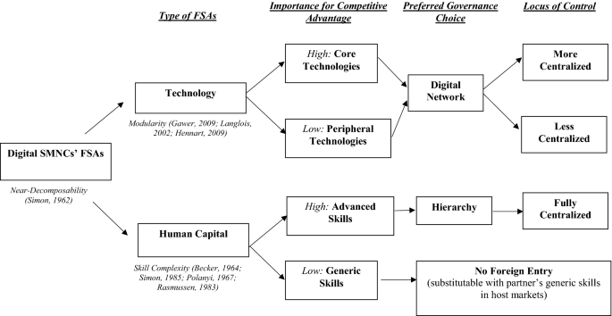
Figure 4: Internalisation Benefits
Source: (Banalieva and Dhanaraj, 2019)

3.4 OLI Effect on the Entry Mode Selection.
Fit Strategy between Ownership and Entry Mode.
The ownership advantages of Aditya Birla Group are strong and decisive in the determination of its preferred international entry strategy to Vietnam. The strong brand name, strong financial base, high technological competence and global management experience have given the Group the confidence and capability to venture into the foreign markets using high control mode (Szczepańska-Woszczyna and Gatnar, 2022). These merits ensure that a firm is not as reliant on the partners in the region and it can transfer its operational norms, quality frameworks and corporate principles to the host country itself. Consequently, Aditya Birla Group is structurally in the best position to pursue entry mode of complete ownership and strategic autonomy as opposed to shared ownerships like joint ventures.
Vietnam Conditions of Location and Structure of Investment.
The location benefits of Vietnam are very favourable, which favours entry mode that is based on direct investment. The fast economic growth, growing industrial base, improved infrastructure and proactive foreign investment policies (policies) provide the country with a favorable environment that is very conducive to capital intensive projects that require a long term (Sitepu and Tampubolon, 2024). Also, low-cost labour and entry to regional trade agreements is another enhancement that makes Vietnam more competitive as a manufacturing and exporting centre. These are the conditions that prompt Aditya Birla Group to invest heavily in greenfield investments or acquisitions as opposed to low risk, low reward entry modes. The predictability of the regulatory environment in Vietnam and the ease with which it is opened to foreign ownership also minimises institutional risks of full ownership strategies (Dat and Nguyen, 2023).
Final Entry Mode Justification Internalization Logic.
The best rationale in favour of wholly owned subsidiaries or acquisitions as the two entry modes preferred by Aditya Birla Group when entering Vietnam is internalization benefits. Through internalization, the company is able to secure the proprietary technologies, preserve high level of quality, and secure its intellectual property as well as ensuring complete adherence to the global sustainability and governance standards (Yan et al., 2022). Tighter integration with the global supply chains and financial systems of the Group is also achieved through internal control, which increases its operation efficiency and cost effectiveness. The acquisitions have the advantage of quick entrance into the market and direct integration with the local market, whereas the greenfield investment is a long-term strategic control and tailored operational design (Shapiro, 2025). Thus, considering the OLI lens, a hybrid entry mode, which involves both acquiring and expanding wholly, is the most strategically appropriate mode of entry of Aditya Birla Group in Vietnam.

4. Cultural Differences and Market Entry Impact

4.1 Home Country vs Emerging Economy Cultural Comparison.
The cultural framework created by Hofstede gives us good understanding of the basic cultural differences between India and Vietnam. Power distance is considered to be one of the most important dimensions, as it implies how much weaker members of the society tolerate unequal distribution of power (Sedita et al., 2022). India and Vietnam both contain rather high power distance cultures, as the hierarchical structures, decision-making relying on authority, and respect to older leadership are highly accepted in both countries. But Vietnam exhibits even more centralized control based on its socialist system of governance where India though a hierarchical country permits more discretion in managing and participatory leadership in contemporary corporate setups (Gulati, 2024).
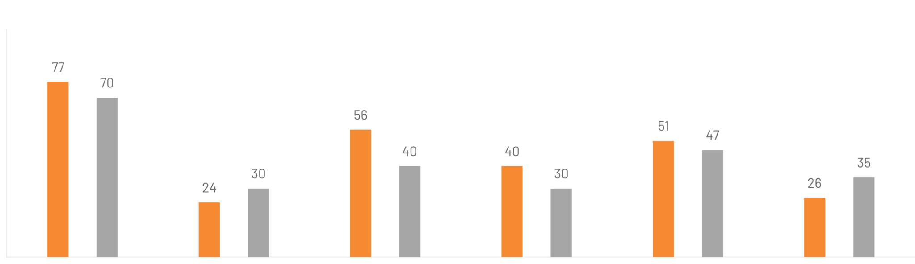
Figure 1: India and Vietnam Cultural Comparison
Source: www.theculturefactor.com, 2025
The individualism verses collectivism dimension shows that the two countries are highly collectivist. The social relationships, family ties and group loyalty are significant in the business relationships in India. On the same note, the Vietnamese culture highly emphasizes on community, harmony, and collective responsibility (Trang and Hung, 2025). Nevertheless, Vietnamese collectivism has got its earliest roots in Confucianism where conformity, social harmony, and group welfare remain in high regard even higher as compared to India. It means that the relationships and the network of trust are even more significant in Vietnam to do business successfully.
India in terms of uncertainty avoidance is moderate in its tolerance of unpredictability and risk thus providing more flexibility in making decisions and engaging in entrepreneurial behaviour (Bate, 2022). Vietnam on the other hand is more of uncertainty avoidance whereby people are more inclined to have rules organised procedures and consistency. This disparity implies that Vietnamese employees and business partners tend to desire well-structured operational systems, official policies and foreseeable workflow.
Traditionally, Indian managerial culture is a combination of hierarchy with the growing degree of participative management and decentralised decision-making within the multinational companies, in terms of the leadership style (Matyakubovna and Ozodbek, 2025). By comparison, the Vietnamese leadership expectations are more strictly hierarchical and the employees are highly obedient to the authority and the top management. Consequently, Aditya Birla Group should become more directive in its leadership style in Vietnam, at least at the initial phase of market penetration, and then gradually facilitate empowerment through training and cultural assimilation.
The culture of collectivism and high-context also affects negotiation practices in Vietnam. Vietnam has a relationship-based, indirect and patient business bargaining process (Madisa, 2025). Trust, reputation and long term commitment can be important factors than short term financial terms. Indian companies, though being also relationship based, are more adaptable and fast in their negotiations. Aditya Birla Group should therefore take a lot of time to earn the confidence of the Vietnamese stakeholders, governmental bodies and suppliers before anticipating commercial deals.
Cultural matters in human resource management entail meticulous localization of HR policies in the region. Performance based incentives, open communication and empowerment of employees are increasingly encouraged by Indian firms (Rizqulloh et al., 2024). But, Vietnamese employees are more concerned with job security, organizational stability, respect towards hierarchy and group success. Cultural sensitivity must thus be considered in performance evaluation systems, leadership development strategies and employee engagement strategies to prevent the resistance and disengagement.
Another aspect influenced by cultural differences is marketing communication. Indian marketing increasingly relies on emotional appeal, innovation and aspirational imagery, whereas Vietnamese consumers prioritise family values, trust, product quality and social harmony (De Mooij, 2021). Additionally, Vietnam’s linguistic landscape where Vietnamese is the primary language and English proficiency varies regionally requires localization of messaging, tone and customer-facing materials to ensure clarity and cultural resonance. Religion also shapes consumer expectations; Buddhism and Confucian values strongly influence attitudes toward modesty, respect, community orientation and ethical business behaviour. Consequently, promotional styles that are direct or aggressive may be ineffective. Aditya Birla Group must therefore tailor its branding, advertising content and communication channels to align with Vietnamese linguistic norms, cultural symbolism and religious sensitivities to strengthen acceptance and consumer connection in the market.

4.2 Effect of Culture on Business Performance and Success.
The cultural variations also have a long term effect on the work force integration, effectiveness of managers, and customer behaviour, which directly affect the business performance in Vietnam (Hoang and Bui, 2025).
The most important challenge to multinational firms is workforce integration. The variations in communication styles, perception of authority, teamwork and conflict resolution can be the first cause of misunderstanding between the employees of the Vietnamese and the Indian expatriate managers. Vietnamese workers are not fond of face-to-face communication, as they use indirect forms of communication and avoid losing face. Otherwise, it may lead to the inhibited workplace conflicts, less flow of feedback, and slower solutions of problems. Effective workforce integration therefore entails cross cultural training, inclusive leadership practices and development of local talent.
Cultural intelligence is also associated with managerial effectiveness. The Indian managers within Vietnam have to change their leadership styles to be compatible with the expectation of the people in terms of respect, communication and social hierarchy (Anh Vu et al., 2025). Inability to comprehend these cultural norms can decrease trust among the employees, power, and influence on decision implementation. Nevertheless, once the alignment between culture is reached, managerial effectiveness is heightened, as the employees are more loyal, less likely to leave the company, and more committed to it.
Lastly, collectivism, tradition, social influence are the major factors influencing customer behaviour and preferences in Vietnam. Price and functionality are not the only factors that determine the purchasing decisions because social approval, family preferences, and brand trust are also considered factors. This market will force Indian firms entering this market to focus on customer education, brand reputability and long term relationship building as opposed to short term maximization of sales. It is critical to change the product design, packaging, pricing and promotional messages to align with the expectations of Vietnamese consumers in order to achieve success in the market over the long term.

5. SOP Adjustment to be successful in the emerging economy
Adjustment 1: Human Resource/ Leadership Practices.
One of the most culturally sensitive international operation areas is the human resource management. Success in the expansion of Aditya Birla Group in Vietnam will be largely determined by the level at which the innovations of the company align its recruitment, training and leadership systems with the local cultural and institutional setting.
Recruitment Practices
The labour market in Vietnam is typified by a young, disciplined and well skilled work force that is on the rise. Nevertheless, there are high expectations of employees based on strong desire to work in stable, hierarchical and long-term organizational commitment. Aditya Birla Group will need to change its recruitment SOPs to focus on local hiring, especially of technical, supervisory, and middle managers (Dash, 2021). Over dependence on expatriates in India can cause the cultural gap and restrict the domestic uptake. The process of recruitment must be able to include some tests on cultural compatibility, teamwork orientation, and adaptability instead of just concentrating on the technical competence. The collaboration with Vietnamese universities, vocational education and training centres with industries would also enhance the workforce localization and the long-term talent development.
Training and Development
The training of SOPs should be restructured to deal with the building of technical capabilities as well as the cross-cultural integration. Relatively high uncertainty avoidance causes the Vietnamese employees to prefer the structured learning environment and the easily identified performance benchmarks (Cao et al., 2024). Thus, training programs are supposed to be formalized, routine based and have specific manuals on how to do them. Meanwhile, Indian expatriate managers ought to be given an intense cross-cultural training based on the Vietnamese social norms, power distance sensibilities, indirect communication, and conflict-avoidance attitudes. The leadership development programmes must also aim at instilling participative management over a period because a radical change in leadership structure to decentralized leadership might cause confusion and rejection.
Leadership Adaptation
The Vietnamese traditional organizations are strongly hierarchical based leadership with authority highly respected and hardly contested. The leadership SOPs in Aditya Birla Group whereby empowerment and performance-based autonomy are ever more endorsed need to be adapted with care and not transferred. To start with, managers in Vietnam ought to become more directive in their leadership style, which is clear, stable, and formulated supervision style. With time, the scheme of controlled empowerment can be implemented with the help of team-based decision-making and constant improvements programs. Such a culturally aware leadership development will increase trust, motivation of the employees and long term commitment to the organization.
Adjustment 2: Operational and Supply Chain Procedures.
The international competitiveness of Aditya Birla Group is dominated by operational efficiency and supply chain resilience. Nevertheless, the immature infrastructure, regulations, and supplier networks in Vietnam require country-level procedural fit.
Local Sourcing
Vietnam has affordable access to raw materials, semi- processed inputs, and industrial components. Aditya Birla Group ought to modify its sourcing SOPs to focus more on the development of local suppliers instead of depending more on imported materials. This change saves logistics costs, exposure to the risks of shipping disruption globally, and host-country legitimacy. Nevertheless, the potential in the local suppliers might not be up to the international quality standards. Hence, the Group must launch supplier development programmes in areas of quality certification, environmental compliance and digital integration.

Quality Control
Quality management is also one of the fundamental ownership strengths of Aditya Birla Group and should be safeguarded by having strict SOP implementation. The manufacturing ecosystem in Vietnam presupposes different levels of quality maturity, which requires the strict internal quality assurance system. The Group must adopt uniform international quality standards throughout the Vietnamese operations with the aid of on-going inspection, Six-Sigma techniques, and digital live monitoring. To prevent production defects, reputational risks, and regulatory non-compliance, it is important to train the local employees according to the global safety, sustainability and operational excellence standards (Basiru et al., 2023). The SOPs associated with quality have to be aligned to the Vietnamese industrial laws and international certification requirements as well.
Logistics Optimization
Vietnam logistics infrastructure has grown very fast although it is still unevenly distributed. The SOPs of logistics of Aditya Birla Group should hence concentrate on developing regional hubs, integrating multimodal transport, and tracking digital supply chain. The localisation of manufacturing facilities around ports, industrial areas and export belts will reduce delays in transport and costs of holding inventory (Cecil, 2024). Moreover, there has to be the introduction of contingency logistics planning that will deal with risks associated with port congestion, regulatory delays and also the changing freight costs. Such upgrades in procedures will enhance the reliability of the supply chain in the local and foreign markets.
Adjustment 3: Ethics, Adjustment, Marketing, and Governance Procedures.
The brand trust, social acceptance, and regulatory stability in the overseas markets are directly affected by marketing communication, ethical behaviors, and governance frameworks. These SOP areas are especially to be realigned in Vietnam.
Branding Adaptation
The consumer psychology of Vietnamese is highly collectivists, family-oriented, and has a long-term brand loyalty. Aditya Birla Group will therefore need to change their marketing SOPs to focus more on relationship-based branding as opposed to intensive promotion. Advertised messages ought to touch on reliability of the product, safety, social worth, and the contribution to the society (Rachmad, 2023). Brand acceptance will improve when corporate storytelling is used to emphasize job creation, sustainability efforts, and economic growth at the local level. Also, localization of language, symbols that are culturally sensitive, and conventional promotional strategies based on festivals should be incorporated into the communication plans.
Ethical Compliance
One of the fundamental internalization strengths of Aditya Birla Group is ethical standards which should not be compromised when it comes to expanding internationally. The regulatory enforcement environment in Vietnam is also still developing, which requires strong internal ethical SOPs. The Group needs to have stringent measures against corruption, open procurement procedures, environmental adherence measures and workplace safety enforcement systems. Training on employee ethics and whistleblower protection systems should be institutionalised to eliminate informal practices that might contravene the global values of the company (Lee and Liu, 2025). The global ethical consistency will save the Group the trouble of legal fines, negative publicity, and governance breakdowns.
Corporate Governance Alignment
The corporate governance SOPs should be such that they are in line with the global system of governance in Aditya Birla Group, and the local regulatory requirements in Vietnam. This will incorporate adherence to foreign investment laws, labour laws, shareholder protection policies and environmental reporting standards. At the board level, there should be put in place overseeing mechanisms to guarantee that Vietnamese operations adhere to global reporting, audit and risk management procedures. Simultaneously, the flexibility of decentralized governance is needed in order to enable local managers to adapt to the dynamism in the Vietnamese regulatory setting. An equitable system of governance that is operationally transparent, combining world control and local sensitivity will enhance strategic stability and transparency.

6. Conclusion
This consultancy report has presented an extensive appraisal of the international business strategy of Aditya Birla Group as well as a detailed observation of its activities as a multinational company and its possible expansion into Vietnam as an emerging market. The outcomes emphasize that the high level of internationalization through the strong presence of the Group, diversified portfolio, and integrated value chain has allowed it to realize the high level of internationalization advantages such as market expansion, diversification of revenue, economy of scale, and global brand awareness. Simultaneously, the report identifies such international risks as political and regulatory uncertainty, cultural issues, exchange rate volatility, operational complexity, and the disruption of the global supply chain.
The OLI framework analysis has shown that Aditya Birla Group has powerful ownership benefits of brand strength, financial resources, technology and global management skills. The high-growth rate of the economy, low-cost labour, and better infrastructure coupled with the favourable policies on FDIs is a positive location factor to Vietnam, whereas internalization benefits is a reason to adopt high-control entry mode which includes acquisitions and wholly owned subsidiaries.

References
Aditya Birla Group (2015). Aditya Birla Group | US. [online] adityabirla. Available at: https://www.adityabirla.com/businesses/countries/us/ [Accessed 29 Nov. 2025].
Aditya Birla Group (2025a). Aditya Birla Group. [online] adityabirla. Available at: https://www.adityabirla.com/en/.
Aditya Birla Group Companies List: Leadership Across Industries. (2025). Adityabirla. https://www.adityabirla.com/businesses/companies/
Aditya Birla Group Story (2025). Aditya Birla Group Story - A leading business conglomerate in India. [online] adityabirla. Available at: https://www.adityabirla.com/en/our-story/ [Accessed 29 Nov. 2025].
Anh Vu, T., Plimmer, G., Berman, E. and Ha, P.N., 2022. Performance management in the Vietnam public sector: The role of institution, traditional culture and leadership. International Journal of Public Administration, 45(1), pp.49-63. https://www.researchgate.net/profile/Geoff-Plimmer/publication/350563357_Performance_management_in_the_Vietnam_public_sector_The_role_of_institution_traditional_culture_and_leadership/links/67bff7e7207c0c20fa988793/Performance-management-in-the-Vietnam-public-sector-The-role-of-institution-traditional-culture-and-leadership.pdf
Acquaye, A.A., Yamoah, F.A., Ibn-Mohammed, T., Quaye, E. and Yawson, D.E. (2023). Equitable Global Value Chain and Production Network as a Driver for Enhanced Sustainability in Developing Economies. Sustainability, [online] 15(19), p.14550. doi:https://doi.org/10.3390/su151914550.
Banalieva, E.R. and Dhanaraj, C. (2019). Internalization Theory for the Digital Economy. Journal of International Business Studies, 50(8), pp.1372–1387. doi:https://doi.org/10.1057/s41267-019-00243-7.
Basiru, J.O., Ejiofor, C.L., Onukwulu, E.C. and Attah, R.U., 2023. Corporate health and safety protocols: A conceptual model for ensuring sustainability in global operations. Iconic Research and Engineering Journals, 6(8), pp.324-343. https://www.researchgate.net/profile/Rita-Attah/publication/388418888_Corporate_Health_and_Safety_Protocols_A_Conceptual_Model_for_Ensuring_Sustainability_in_Global_Operations/links/6797c5e6645ef274a449d2ff/Corporate-Health-and-Safety-Protocols-A-Conceptual-Model-for-Ensuring-Sustainability-in-Global-Operations.pdf
Bate, A.F., 2022. The nexus between uncertainty avoidance culture and risk-taking behaviour in entrepreneurial firms’ decision making. Journal of Intercultural Management, 14(1), pp.104-132. https://sciendo.com/pdf/10.2478/joim-2022-0004
Brown, P., 2024. Education, opportunity and the future of work in the fourth industrial revolution. British Journal of sociology of Education, 45(4), pp.475-493. https://orca.cardiff.ac.uk/id/eprint/169091/3/Ed%20%26%204IR%20BJSofE%20Pre-Publication%202024.pdf
Bucheli, M., Ciravegna, L. and Saenz, L.F., 2023. The octopus that shrank: A historical analysis of how multinationals address policy and contractual uncertainty in a global value chain. Strategic Management Journal, 44(13), pp.3289-3323. https://onlinelibrary.wiley.com/doi/pdf/10.1002%2Fsmj.3537
Cao, T.H.V., Chai, D.S., Nguyen, L.P., Nguyen, H.T.H., Han, C.S.H. and Park, S., 2024. Learning organization and employee performance: the mediating role of job satisfaction in the Vietnamese context. The Learning Organization, 32(7), pp.53-73. https://www.emerald.com/insight/content/doi/10.1108/TLO-09-2023-0177/full/pdf
Collidu (2023). Eclectic Paradigm. [online] Collidu.com. Available at: https://www.collidu.com/presentation-eclectic-paradigm.
Cecil, P., 2024. Cross-Border Supply Chain Optimization: Strategies for Managing International Operations While Maintaining Speed and Cost Efficiency. International Journal of Scientific Research and Management (IJSRM), 12(05), pp.6565-6588. https://www.researchgate.net/profile/Kuku-Oluwamayowa/publication/390666191_Cross-Border_Supply_Chain_Optimization_Strategies_for_Managing_International_Operations_While_Maintaining_Speed_and_Cost_Efficiency/links/67f8004c60241d51400ad2cb/Cross-Border-Supply-Chain-Optimization-Strategies-for-Managing-International-Operations-While-Maintaining-Speed-and-Cost-Efficiency.pdf
Dash, I., 2021. Human Resource Management I. http://biitm.dspaces.org/bitstream/123456789/317/1/HRM-1%20%28I-MBA%29.pdf
Dat, P.T. and Nguyen, K.Q.T., 2023. Foreign ownership and national governance quality affect liquidity risk–case in Vietnam. Cogent Business & Management, 10(2), p.2244752. https://www.tandfonline.com/doi/pdf/10.1080/23311975.2023.2244752
De Mooij, M., 2021. Global marketing and advertising: Understanding cultural paradoxes. https://www.academia.edu/download/8323021/590136127.pdf
Đỗ, T. U. (2023, April 6). Selecting The Best Manufacturing Destination: A Comparative Analysis Of China, Vietnam, And India. Rockhillasia. https://www.rockhillasia.com/post/selecting-the-best-manufacturing-destination-china-vietnam-and-india
Ghobakhloo, M., Iranmanesh, M., Grybauskas, A., Vilkas, M. and Petraitė, M., 2021. Industry 4.0, innovation, and sustainable development: A systematic review and a roadmap to sustainable innovation. Business Strategy and the Environment, 30(8), pp.4237-4257. https://www.researchgate.net/profile/Mohammad-Iranmanesh-2/publication/353677530_Industry_40_innovation_and_sustainable_development_A_systematic_review_and_a_roadmap_to_sustainable_innovation/links/6152eb72522ef665fb660742/Industry-40-innovation-and-sustainable-development-A-systematic-review-and-a-roadmap-to-sustainable-innovation.pdf
Giles, A. (2022). International Entry Modes. ecampusontario.pressbooks.pub. [online] Available at: https://ecampusontario.pressbooks.pub/globalmarketing/chapter/6-1-international-entry-modes/.
Group, A.B. (2025b). A Conglomerate in Action: What drives business at Aditya Birla Group. [online] adityabirla. Available at: https://www.adityabirla.com/media/stories/a-conglomerate-in-action-what-drives-business-at-aditya-birla-group/ [Accessed 29 Nov. 2025].
Gulati, P., 2024. RETHINKING GOVERNANCE FOR SOCIETAL PROGRESS: A LEGAL STUDY FOR REFORMS IN INDIAN ADMINISTRATIVE LAW. Panjab University Law Review, 63(1). https://pulr.puchd.ac.in/index.php/pulr/article/download/277/57
Hoang, L.V.P. and Bui, H.T.T., 2025. The impact of cultural identity and attitude-to-brands on customer loyalty in Vietnamese context. HO CHI MINH CITY OPEN UNIVERSITY JOURNAL OF SCIENCE-ECONOMICS AND BUSINESS ADMINISTRATION, 15(2), pp.105-127. https://journalofscience.ou.edu.vn/index.php/econ-en/article/download/3124/2161
Keskin, T., Yilmaz, E., Kasap, T., Sari, M. and Cao, S., 2024. Toward viable industrial solid residual waste recycling: a review of its innovative applications and future perspectives. Minerals, 14(9), p.943. https://www.mdpi.com/2075-163X/14/9/943
Kharub, M., Mor, R.S. and Rana, S., 2022. Mediating role of manufacturing strategy in the competitive strategy and firm performance: evidence from SMEs. Benchmarking: An International Journal, 29(10), pp.3275-3301. https://www.researchgate.net/profile/Manjeet-Kharub-3/publication/358033074_Mediating_role_of_manufacturing_strategy_in_the_competitive_strategy_and_firm_performance_evidence_from_SMEs/links/64a2f820c41fb852dd4b7756/Mediating-role-of-manufacturing-strategy-in-the-competitive-strategy-and-firm-performance-evidence-from-SMEs.pdf
Knight, F., 2025. Risk, uncertainty and profit. Bonhopai Books. https://cdn.gecacademy.cn/oa/upload/2022-03-10%2011-28-18-knight-uncertainty-and-profit.pdf
Kuruppu, S.C., Milne, M.J. and Tilt, C.A., 2024. Sustainability control systems in short-term operational and long-term strategic decision-making. Meditari Accountancy Research, 32(1), pp.234-265. https://papers.ssrn.com/sol3/Delivery.cfm?abstractid=4695784
Lee, C.W. and Liu, P.T., 2025. Employee Ethics and Corporate Governance: Evaluating Internal Whistleblowing Mechanisms. Journal of Applied Finance & Banking, 15(2), pp.35-55. http://www.scienpress.com/Upload/JAFB/Vol%2015_2_3.pdf
Madisa, M.K., 2025. The Impact of Culture on Negotiation Styles and Outcomes. https://www.researchgate.net/profile/Mayibongwe-Madisa/publication/391914603_The_Impact_of_Culture_on_Negotiation_Styles_and_Outcomes/links/682d6fab026fee1034f9a197/The-Impact-of-Culture-on-Negotiation-Styles-and-Outcomes.pdf
Matey, C. and Narkhede, S., 2021. Marketing Strategy Adopted by Cement Industry in India. RESEARCH JOURNEY, p.20. https://www.shriwaghmarebrothers.com/wp-content/uploads/2021/12/Special_Issue_269_C-SPKM_Sawantwadi.pdf#page=21
Matyakubovna, M.K. and Ozodbek, I., 2025. CORPORATE CULTURE AND LEADERSHIP STYLES: A COMPARATIVE ANALYSIS OF WESTERN AND EASTERN MANAGEMENT. JOURNAL OF MULTIDISCIPLINARY BULLETIN, 8(3), pp.126-133. https://sirpublishers.org/index.php/jomb/article/download/1073/2032
Muñoz-Vélez, M.F., Salazar-Serna, K., Escobar-Torres, D., Rojas-Manzano, M.A., Gómez-Gómez, A. and Maury-Ramírez, A., 2023. Circular economy: adding value to the post-industrial waste through the transformation of aluminum dross for cement matrix applications. Sustainability, 15(18), p.13952. https://www.mdpi.com/2071-1050/15/18/13952
Onabowale, O., 2024. Unveiling energy finance: Capital dynamics and market influence on financial achievement. International Research Journal of Modernization in Engineering Technology and Science, 7, pp.2582-5208. https://www.researchgate.net/profile/Oreoluwa-Onabowale-2/publication/388492057_UNVEILING_ENERGY_FINANCE_CAPITAL_DYNAMICS_AND_MARKET_INFLUENCE_ON_FINANCIAL_ACHIEVEMENT/links/679a9d1b4c479b26c9c0dac3/UNVEILING-ENERGY-FINANCE-CAPITAL-DYNAMICS-AND-MARKET-INFLUENCE-ON-FINANCIAL-ACHIEVEMENT.pdf
Rachmad, Y.E., 2023. Authenticity-Driven Engagement Theory. https://www.researchgate.net/profile/Yoesoep-Rachmad/publication/397273112_Authenticity-Driven_Engagement_Theory/links/690aa48aa404d65709a27937/Authenticity-Driven-Engagement-Theory.pdf
Rizqulloh, A.D.B., Kuncoro, W.A., Hidayati, R. and Lataruva, E., 2024. Improving employee performance quality through training and work life balance: literature review. Research Horizon, 4(6), pp.317-326. http://journal.lifescifi.com/index.php/RH/article/download/427/344
Sahoo, L., 2024. A Cost Management on Aditya Birla Fashion and Retail Ltd. http://biitm.dspaces.org/bitstream/123456789/1176/1/LIPSA%20SAHOO%20SIP-29.pdf
Sedita, S.R., Blasi, S. and Yang, J., 2022. The cultural dimensions of sustainable development: A cross‐country configurational analysis. Sustainable Development, 30(6), pp.1838-1849. https://onlinelibrary.wiley.com/doi/pdfdirect/10.1002/sd.2351
Shanmugamani, K. and Mohamad, F., 2023. The implementation of warehouse management system (wms) to improve warehouse performance in business to business (B2B). International Journal of Industrial Management, 17(4), pp.231-239. https://journal.ump.edu.my/ijim/article/download/10091/3054
Shapiro, C., 2025. Acquisitions to Enter New Markets. Journal of Economic Perspectives, 39(1), pp.53-76. https://pubs.aeaweb.org/doi/pdf/10.1257/jep.20241414
Sitepu, K. and Tampubolon, A.M., 2024. Government Policies and Foreign Direct Investment: Driving Sustainable Economic Growth and Development. Inspirasi & Strategi (INSPIRAT): Jurnal Kebijakan Publik & Bisnis, 15(1), pp.1-9. https://ejournal.isha.or.id/index.php/Inspirat/article/download/335/370
Szczepańska-Woszczyna, K. and Gatnar, S., 2022, September. Key competences of research and development project managers in high technology sector. In Forum Scientiae Oeconomia (Vol. 10, No. 3, pp. 107-130). https://ojs.wsb.edu.pl/index.php/fso/article/download/574/324
Tang, K., 2023. The political economy of special economic zones: the cases of Ethiopia and Vietnam. Review of International Political Economy, 30(5), pp.1957-1983. https://www.academia.edu/download/95396953/The_political_economy_of_special_economic_zones_the_cases_of_Ethiopia_and_Vietnam.pdf
Tarigan, Z.J.H., Siagian, H. and Jie, F., 2021. Impact of internal integration, supply chain partnership, supply chain agility, and supply chain resilience on sustainable advantage. Sustainability, 13(10), p.5460. https://www.mdpi.com/2071-1050/13/10/5460/pdf
Trang, N.M. and Hung, T., 2025. The Conflict Between Individual Freedom and Social Order in Vietnam Traditional Communities. International Journal of Social Science and Economic Research, 10(05), pp.1703-1720. https://mail.ijsser.org/2025files/ijsser_10__112.pdf
Van Hoang, D., Thi Hien, N., Van Thang, H., Nguyen Truc Phuong, P. and Thi-Thuy Duong, T., 2025. Digital capabilities and sustainable competitive advantages: the case of emerging market manufacturing SMEs. Sage Open, 15(2), p.21582440251329967. https://journals.sagepub.com/doi/pdf/10.1177/21582440251329967
Vinh, H.X., Van, L.H., Thao, N.T., Thao, N.T.P., Giang, L.T.H. and Nga, D.T., 2024. Middle-income traps: Experiences of Asian countries and lessons for Vietnam. Multidisciplinary Reviews, 7(5), pp.2024100-2024100. https://malque.pub/ojs/index.php/mr/article/download/1942/1190
Viswaprasad, R., Sunitha, K., Sri, S.D. and Parvataneni, N.S., 2025. Corporate Pathways to Sustainability through Resource Management in Indian Enterprises. Involvement International Journal of Business, 2(4), pp.218-229. https://ejournal.agungmediapublisher.com/index.php/iijb/article/download/158/121
Vuong, T.T.H., 2025. Tax Policy Reform for Sustainable Foreign Direct Investment Attraction in Vietnam: Aligning with the SDGs. Journal of Lifestyle and SDGs Review, 5(6), pp.e06969-e06969. https://sdgsreview.org/LifestyleJournal/article/download/6969/2984
Wang, X., 2024. Cross-border Asset Allocation Strategies and Global Capital Market Integration. Journal of Business and Marketing, 1(03), pp.121-125. http://www.stemmpress.com/uploadfile/202407/eff094056dec5da.pdf
Wong Villanueva, J.L., Kidokoro, T. and Seta, F., 2022. Cross-border integration, cooperation and governance: A systems approach for evaluating “good” governance in cross-border regions. Journal of Borderlands Studies, 37(5), pp.1047-1070. https://www.tandfonline.com/doi/pdf/10.1080/08865655.2020.1855227
Xie, Z., Liu, X., Najam, H., Fu, Q., Abbas, J., Comite, U., Cismas, L.M. and Miculescu, A., 2022. Achieving financial sustainability through revenue diversification: A green pathway for financial institutions in Asia. Sustainability, 14(6), p.3512. https://www.mdpi.com/2071-1050/14/6/3512
Yan, Y., Li, J. and Zhang, J., 2022. Protecting intellectual property in foreign subsidiaries: An internal network defense perspective. Journal of International Business Studies, 53(9), pp.1924-1944. https://link.springer.com/content/pdf/10.1057/s41267-021-00430-5.pdf
Zharikova, О. and Cherkesenko, K., 2021. Personnel management development issues in multinational corporations of the world economy. Economics & Education, 6(3), pp.45-51. http://www.baltijapublishing.lv/index.php/econedu/article/download/1546/1562

