Dementia Patient Tracking System Utilising the Application of the Internet of Things and
Wireless Sensor Networks

PROJECT PROPOSAL

Helen Frey | P131560
BSc Computing Portfolio

Supervising Lecturer: Dr Carlene Campbell

University of Wales Trinity Saint David
Research Methods: ACDA5004: Dr Mabrouka Abuhmida

Table of Contents
1. Introduction/Background to the Proposed Research 2
2. Related Work/Literature Review 2
“Development of a Shoe-Based Dementia Patient Tracking and Rescue System” 3
Summary 3
Evaluation 3
Conclusion 5
“Tracking System for Patients with Alzheimer’s Disease in a Nursing Home” 5
Summary 5
Evaluation 6
Conclusion 6
3. Project Proposal 6
4. Research and Development Methods Introduction 7
4.1 Research Methods 7
4.2 Validity, Generalisability, Objectivity and Reliability 7
4.3 Data Analysis and Evaluation 7
4.4 Risks and Limitations 7
4.5 Legal and Ethical Issues 9
Conclusion of Ethical Issues 9
5. Project Resources 9
6. Conclusion 9
Bibliography 10
7. Appendix I: Mind Map 11

Table of Figures
Figure 1: Gantt Chart for Project 6
Figure 2: Gantt Chart for Project (2) 6
Figure 3: Mind Map 10

Introduction/Background to the Proposed Research
Dementia is a term that describes symptoms associated with memory loss and other cognitive skills severe enough to hinder someone in the performance of everyday tasks. It is usually associated with Alzheimer’s disease as between 60-75% of dementia patients have this type. Other types of dementia include vascular and frontotemporal dementia [1],[2].
According to the World Health Organisation (WHO) in 2017 there were approximately 50 million people worldwide that suffer from dementia with another 10 million new cases each year and is the major cause of dependency amongst the elderly population [3].
Six out of ten dementia patients will wander and/or get lost. This can be caused by disorientation, confusion or because they believe they are in their ‘past’ and must ‘get to work’ or fulfil other obligations creating a lot of stress for caregivers. [4]
“Dementia has a physical, psychological, social, and economical impact, not only on people with dementia, but also on their carers, families and society at large.” [3].
The proposed research project aims to create a dementia patient tracking system utilising the application of the Internet of Things and wireless sensor networks to alleviate the burden on society. This project will include a simulation and a live experiment.
This proposal will have 6 sections:
- Section 1 will cover the background and introduce the study.
- Section 2 will highlight related work with a mini-critical literature review.
- Section 3 will set out the project proposal aims and objectives.
- Section 4 is research and development methods to be used.
- Section 5 are the project resources.
- Section 6 is the conclusion.

Related Work/Literature Review
Methods for tracking patients are currently being researched and the following papers are of interest:
- “Development of a Shoe-Based Dementia Patient Tracking and Rescue System” 2018 [5]
- “Tracking System for Patients with Alzheimer’s Disease in a Nursing Home” 2017 [6]

“Development of a Shoe-Based Dementia Patient Tracking and Rescue System”

Summary
In this paper the authors look at developing a system that will track patients in real time, using hardware placed in shoes that will connect with a gateway and cloud platform. The following functions will be incorporated [5].
- Real-time location tracking available for caregivers and relatives;
- Detection of system states that collects and records hardware information and location, remaining battery etc;
- Emergency warning system that will notify appropriate caregivers by email or alert when abnormalities are found
- Proactive rescue: once the patient is lost the shoe can use light or sound to inform people nearby that there is an issue and ask them for assistance.
It goes on to set out the component parts of the system as follows: a GPS receiver (GY-NEO06MV22), a Cotrex-M core microcontroller (STM32L011) and a long distance LoRa transmission module (SX1278) that are placed in a patient’s shoe. The battery is a 16450 with a 900mAh capacity. It is ‘calculated’ to have an operating time of 18 hours. To extend the operating time a piezoelectric module has also been incorporated in the design.
Data from the shoes is sent to the cloud using ‘Message Queuing Telemetry Transport’. The cloud contains the following:
- Application server to communicate with the gateway;
- Database server to store patients’ historical location data and physiological parameters, used for analysis purposes; and
- Web server to query the patient’s whereabouts and track them.

Evaluation
This theory-based paper focuses on the development of a shoe that can track dementia patients and rescue them if lost. The authors set out a theoretical approach to the question of how technology can be used to track and rescue lost patients.

The paper is divided into 3 sections: Section 1 introduces the issues faced by dementia patients’ caregivers when the patients wander and get lost. Section 2 provides an analysis of the proposed system and Section 3 suggests how the system can be implemented.
Section 1 introduces the reader to the problems that dementia patient caregivers are faced with and how many people suffer from dementia. The topic is well covered, and the research is based on reliable sources.
Section 2 sets out the functions that the shoe would have. The authors state that the system, having detected anomalies, will send an email or alerts but does not cover this in any depth as to how this would be achieved e.g. what is the alert?
The paper states that the “Gateway receives data from shoes within communication range” but the location of the gateway vis-à-vis the shoes is not stated. It also states that this information is sent ‘periodically’ but again no parameters are mentioned.
The paper suggests that ‘physiological parameters’ of the patients will be transmitted. However, the only parameter is the body temperature measured through the temperature sensor in the shoe.
One issue is of concern: the proactive mode which ‘remind the people around the elderly to take the initiative to help. This raises so many questions that have not been addressed (i) if you know where the patient is (via the tracking device on the shoe) why do you not just pick them up, why do you require assistance from random people around the patient? (ii) the ethical issues of informing passers-by that the person has dementia and requires assistance? What if the passer-by is not an upstanding citizen and uses that information to harm the patient? (iii) What about their right to medical privacy? (iv) if the patient starts hearing voices from their shoe, will they take it off and no longer be trackable?
Section 3 deals with the possible implementation of the system. This is a theoretical approach without any simulations. The data is from the manufacturers and no consideration is given to external influences.
The paper does not cover what size the database would need to be or how many people could use the system at any given time (both patients and users). It does not cover potential security issues either. There is a very brief mention in their conclusion that ‘due to the necessity of shoes’ this solution was proposed but does not elaborate further.

Conclusion
This paper starts as an interesting solution to a major problem however it lacks any proof of concept and is therefore difficult for the reader to evaluate the proposed design. Overall it does not question their concept and therefore does not answer any issues raised by the questions.

“Tracking System for Patients with Alzheimer’s Disease in a Nursing Home”

Summary
The paper starts with a strong abstract presenting an overview of the issue and the proposed solution [6].
The paper is divided into 5 sections. The Introduction deals with the issues faced by dementia patients and the impact that this has on caregivers. Section 2 gives an overview of the design and puts forward a conceptual framework. It details the overall components without going into detail of models. The device includes a microprocessor system, a GPS and uses Zigbee module and tags for both wearer and server.
It sets out the process of transmissions between the wearer and the server. The GSM module will activate if it detects that the designated range has been passed and send notifications coordinating with GPS. The server software deals with converting the data to a readable map location for the nursing home staff. A ‘panic button’ is enabled once outside the designated range for the patient to use which will continuously play a pre-recorded voice instruction.
Section 3 sets out results and discussions based on data collected through trials. Thirty trials were conducted for every set of criteria and location accuracy was randomly tested. The first set of results deals with baseline ranges and have concluded that 52 meters from the server was the average and was then implemented. All devices within the range were detected successfully.
GPS has an error range of $≥$ 7.8 meters so they have factored in 5 meters for accuracy. The next set of tests show 90% accuracy for out of range location. Response times were tested on disconnected devices and the result was 23.05489 seconds. Response times on connected devices was 1.971889 seconds.
Reliability tests using Cronbach’s alpha were calculated and found to be ‘Excellent’.
Section 4 covers a summary of the findings. The conclusions and recommendation are set out in section 5.

Evaluation
The paper documents the issues faced by caregivers of dementia patients and outlines their proposed tracking solution. The main findings are that they can accurately track patients within 52 meters of the server. Thirty trials per device were made which makes the average more accurate. The results are well considered and set out in a quantitative manner.
No security measures have been considered. They also have voice instructions (with the same issues as mentioned above) although do not inform the reader what intention is behind the instructions.
The limitations of the GPS system are taken into consideration when calculating their detection system and they changed their accuracy to 5 meters in response. Other limitations acknowledged are the size of the belt to be worn and is covered in the conclusions and recommendations.

Conclusion
Overall, this is a well thought-out and considered paper with rigorously documented experiments. The conclusions are balanced and based on observations. To improve the paper, it would have to include the component parts in detail so that the experiment could be replicated should the need arise.

Project Proposal
The aim of the project is: a dementia patient tracking system utilising the application of the Internet of Things and wireless sensor networks.
Aims and Objectives of the Project:
- Evaluate tracking systems relating to medical patients identified as having dementia.
- Identify the metrics required to ensure patients can be ethically tracked.
- Formulate, apply and analyse a simulation model for experimental purposes.
- Propose a physical solution based on the above experimental simulation.
- Develop and test the physical solution and compare results with experiments.

At the end of the study a literature review will have been made regarding the current tracking systems for dementia patients and the metrics for ethically tracking patients will be identified. A simulation model will have been created and experiments will be run to propose solutions. A physical solution-based experiment will be run based on the outcomes of the simulation to form the basis of a proof of concept. Conclusions will be drawn, and the results will be evaluated.

Research and Development Methods Introduction
This section will examine the research methods required to achieve the aims/objectives set out above. Risks, limitations and ethics will be considered. A Gantt chart will be created to set out critical timings.

4.1 Research Methods
The research strategy is via an experiment. As quantifiable observations on the experiment will be made then positivism will be the philosophy as it allows the researcher to measure data collection and interpret the results [7]. There will be a deductive approach as a theory will be presented and tested [8]. A cross-sectional timeline is envisaged as the project is a short-term observational study [9].

4.2 Validity, Generalisability, Objectivity and Reliability
The validity of an experiment basically asks the question: is this true/accurate? And
“refers to how well a scientific test or piece of research actually measures what it sets out to, or how well it reflects the reality it claims to represent” [10].
Generalisability in research is, for example, how an experiment of a small study group would work on the population of a country [11]. Objectivity is where the researcher seeks impartial results and can arrive at results without contaminating the outcome in any way. Reliability refers to the ability to recreate the experiment and achieve the same results [12]. The aims of this project are to be valid, objective, reliable and generalisable.

4.3 Data Analysis and Evaluation
There will be two experiments conducted. The first is a simulation and the second is a physical experiment. Data will be collected using a wireless sensor network from selected people wearing devices that monitor their whereabouts over a given area and alerts given when outside zone. This data’s reliability will be benchmarked against the simulation. The aims and objectives will be analysed, and a conclusion will be made as to whether it was possible to monitor people effectively and ethically.

4.4 Risks and Limitations
The potential risks and limitations are mostly time management which includes how to learn the required software/hardware. Volunteers (fellow students) to assist with the project on the live testing is thought to be enough at present but when their workload increases this may be an issue so the timing of the experiments will be critical.
A Gantt chart has been created to assist with the time management concerns. The timescales have built in contingency planning. This will be a useful tool to keep the author within the time constraints of the project.
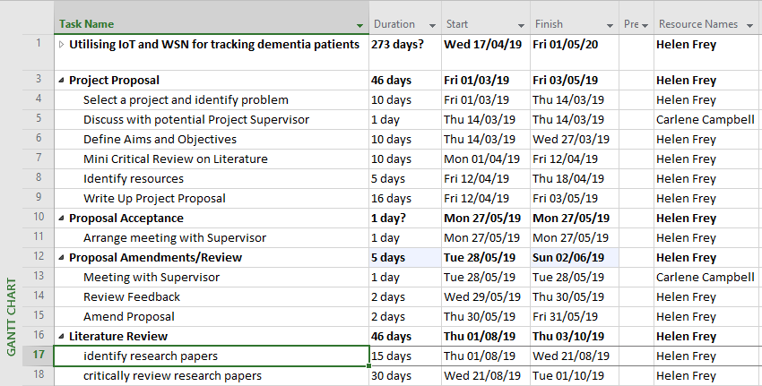
Figure 1: Gantt Chart for Project
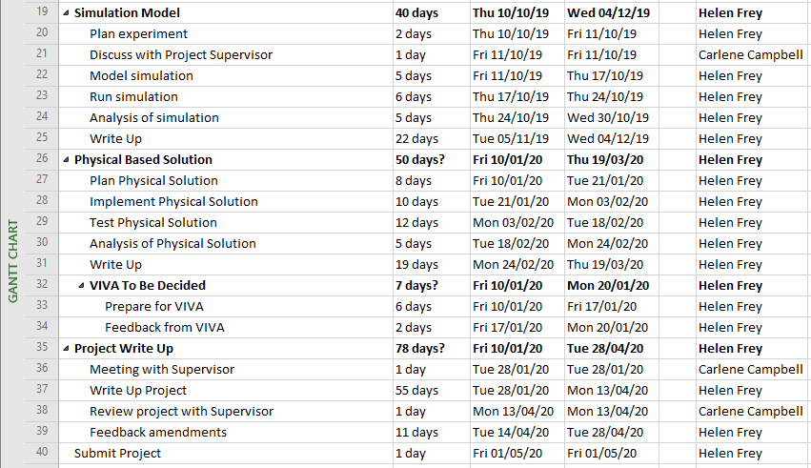
Figure 2: Gantt Chart for Project (2)

4.5 Legal and Ethical Issues
In a well-written paper by R. Landau and S. Werner on “the ethical aspects of using GPS for tracking people with dementia”[13] it was interesting to note that their recommendation was to
“maintain a balance between the needs of persons with dementia for protection and safety and their need for autonomy and privacy” [13].
The paper goes on to say that the protection of life and patient safety is the most important criteria which outweighs all other concerns. The benefits to the care-givers having less stress knowing that should the patient wander they can be found was to be immense [13].
The legal implications are limited since the participants in the experiment will only have numbers and no personal data will be held on them.

Conclusion of Ethical Issues
There will always be ethical issues whenever data is held on people, the more vulnerable the person the more issues will be created. It is the author’s opinion that overall the benefit outweighs the disadvantages for tracking patients with dementia that wander. However, the issue should not be one that is answered in one overarching statement but more one that needs to be considered every time the question is asked, “shall we track this patient?”.

Project Resources
Project resources will include, but will not be limited to, the following:
- Software: Netsim, Matlab, Word and Excel.
- Sensors to run the physical experiment with Cisco routers and switches

Conclusion
The initial section of the project is within the time frame and is starting to come together. There is always the possibility of unforeseen circumstances, but contingency planning has been included. It is impossible at this stage to plan some aspects as most of the above is hypothetical and will only become clear as work progresses.

Bibliography
[1] “Dementia | Symptoms, Diagnosis, Causes, Treatments.” [Online]. Available: https://www.alz.org/alzheimers-dementia/what-is-dementia?utm_source=google&utm_medium=paidsearch&utm_campaign=google_grants&utm_content=dementia&gclid=EAIaIQobChMIp4PM1dCx4QIVic13Ch0SlQ1VEAAYAyAAEgK3vPD_BwE. [Accessed: 02-Apr-2019].
[2] “Types of Dementia | BRACE.” [Online]. Available: https://www.alzheimers-brace.org/Pages/Category/types-of-dementia?gclid=EAIaIQobChMIzeWmktOx4QIV6JztCh3aYQrzEAAYASAAEgKUW_D_BwE. [Accessed: 02-Apr-2019].
[3] “Dementia.” [Online]. Available: https://www.who.int/news-room/fact-sheets/detail/dementia. [Accessed: 14-Apr-2019].
[4] “Wandering | Alzheimer’s Association.” [Online]. Available: https://www.alz.org/help-support/caregiving/stages-behaviors/wandering. [Accessed: 14-Apr-2019].
[5] H.-K. Wu, T.-W. Hung, S.-H. Wang, and J.-W. Wang, “Development of a shoe-based dementia patient tracking and rescue system,” in 2018 IEEE International Conference on Applied System Invention (ICASI), 2018, pp. 885–887.
[6] M. B. Mendoza, C. A. Bergado, J. L. B. De Castro, and R. G. T. Siasat, “Tracking system for patients with Alzheimer’s disease in a nursing home,” in TENCON 2017 - 2017 IEEE Region 10 Conference, 2017, pp. 2566–2570.
[7] “Positivism - Research Methodology.” [Online]. Available: https://research-methodology.net/research-philosophy/positivism/. [Accessed: 16-Apr-2019].
[8] “Deductive Approach (Deductive Reasoning) - Research-Methodology.” [Online]. Available: https://research-methodology.net/research-methodology/research-approach/deductive-approach-2/. [Accessed: 16-Apr-2019].
[9] M. S. Setia, “Methodology Series Module 3: Cross-sectional Studies.,” Indian J. Dermatol., vol. 61, no. 3, pp. 261–4, 2016.
[10] “Definition: Validity.” [Online]. Available: https://www.aqr.org.uk/glossary/validity. [Accessed: 16-Apr-2019].
[11] “Guide: Generalizability and Transferability.” [Online]. Available: https://writing.colostate.edu/guides/guide.cfm?guideid=65. [Accessed: 16-Apr-2019].
[12] “Definition: Reliability.” [Online]. Available: https://www.aqr.org.uk/glossary/reliability. [Accessed: 16-Apr-2019].
[13] R. Landau and S. Werner, “Ethical aspects of using GPS for tracking people with dementia: Recommendations for practice Attitudes toward people with disabilities View project Guardianship and supported decision making View project,” 2014.

Appendix I: Mind Map
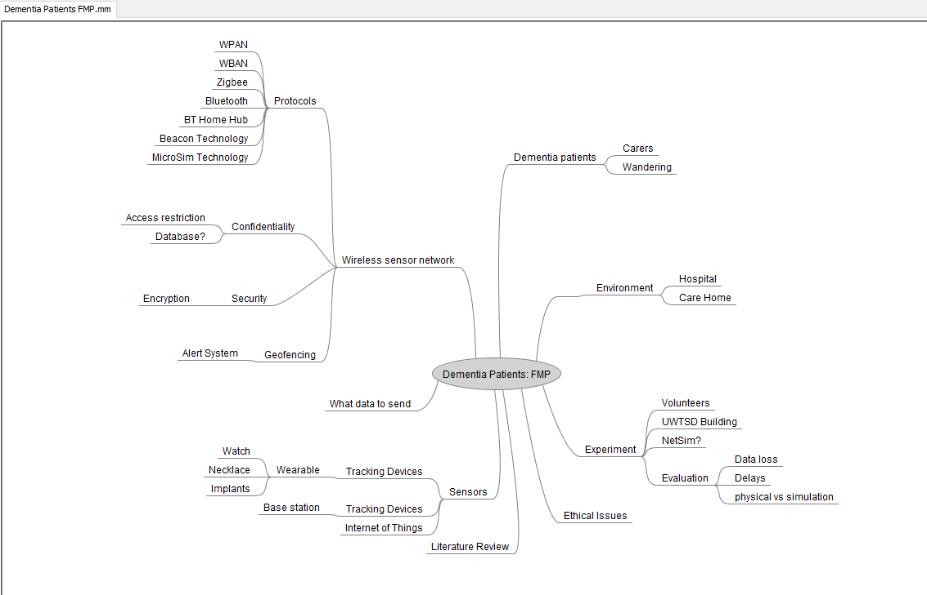
Figure 3: Mind Map

