Findings of a Material Selection investigation On A Piston Assembly
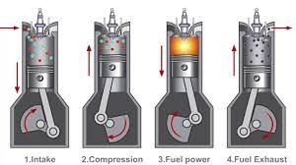
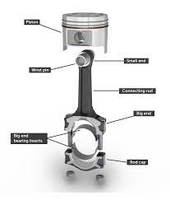



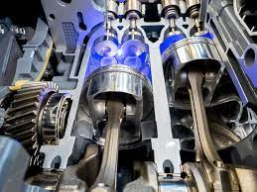

Table Of Contents
Page 1……………………………………Title page
Page 2……………………………………Table of contents
Page 3……………………………………Introduction
Page 4……………………………………Material Properties
Page 5……………………………………Material Selection
Page 6……………………………………Manufacturing Process
Page 7……………………………………Cost and Conclusion

Introduction
There are many processes within engineering that are argued to be as important as each other, such as quality of Design and manufacture. However, material selection is without a doubt the most important step of the entire engineering process of the product, if the wrong material is selected it can lead to many issues such as manufacturing yield, stress failure or just poor quality of the product, the list goes on.
This report is going to question, investigate and discuss what materials are best suited for use in a piston assembly in an engine depending on the purpose of the engine, whether it be for daily commuting or highly abusive motorsport. The purpose of this investigation is to allow the reader to gain an understanding of the reasons certain materials are used in certain engineering scenarios. This materials investigation will dive deep into selecting the best material to use depending on its properties, accessibility and cost. By the end of this report, all possible material types will be investigated and narrowed down to the single best option for each discipline of the pistons purpose.
Pistons have been used in engines of all kinds for many years, the process of manufacturing these vital components has changed greatly over the years. This report will discuss the manufacture of pistons, the benefits that it offers, and the challenges that the process presents.
The history of piston manufacture is an interesting one, as it has evolved over time to become the reliable and efficient form of power generation we know today. According to AJS Baker, piston manufacture began in the early 19th century with the development of the steam engine, which was used to power trains and ships. This technology was improved over the years, with piston designs becoming more sophisticated and efficient. By the early 20th century, the manufacture of piston engines had reached its peak, with increased use of high-strength materials and advanced manufacturing techniques.

Material Properties

Materials are defined by their properties, there are some definitions that will need to be understood before continuing. When looking at a piston assembly, the material must have specific properties to withstand the load applied by an engine during combustion. The piston rods will have to be made from a hard material to prevent bending as they undertake lateral load from the angular rotation of the engine. The higher the Rpm, the higher the load applied on the rod and the piston due to increase fuel loads, combustion pressure and crank rotation speed.

The rate of thermal expansion dependant on temperature is a very important property. If the rates between say the piston head and the block vary then the piston could expand to the point where it reduces the tolerances and begins scraping or even causing an engine seize, a catastrophic failure.
Research conducted by D.N. Assanis and E Badillo (1987) suggests that piston materials with high +thermal conductivity provide several benefits for engines. These materials allow heat to be transferred from the piston to the cylinder wall more quickly and efficiently, resulting in improved engine performance and fuel economy. Additionally, thermal conductivity can be used to reduce piston temperatures and the risk of detonation, increasing performance and engine longevity.

Most important
Important
Avoid
The importance of each property to the piston assembly is defined by the corresponding key:

Material Property | Definition
Ductility | Ability of a material to be drawn out to a wire
Thermal Conductivity | Rate of heat transfer
Hardness | Resistance to penetration or bending
Plasticity | Ability to permanently deform without rupturing
Fatigue | Repeated straining over time which causes the material to break
Brittleness | Ability to withstand permanent deformation
Corrosion Resistance | Ability to withstand deterioration when exposed to other elements
Electrical Conductivity | Conductivity of the material
Strength | Resistance to deformation under external load
Malleability | Ability of a material to be manipulated into other shapes
Elasticity | Ability to return to normal shape after being stretched or compressed
Wear Resistance | Ability to withstand wear caused by friction over time
Thermal Expansion | The action of the material expanding depending on temparature
Fig.1

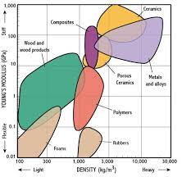
Material Selection
Fig. 2
Looking to Fig. 2, the density, which is used to measure strength, is plotted against the young’s modulus, the stress resistance of the types of material. From the graph the recommended use of material can be sourced. The higher the density and higher the youngs modulus, the more suited the material is to the piston assembly. From this a select few material types can be established as suitable:
- Metals and alloys
- Ceramics
Fig. 3
- Composites
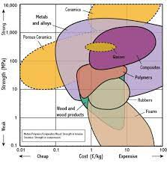
According to the university of Washington, ceramics excel in hardness, Wear, Brittleness, thermal conduction and chemical resistance. When comparing to , all of the most important properties are covered, except from Thermal expansion and strength which are arguably the two most important properties when it comes to a high revving performance engine. Hence ceramics are not as suitable match for a piston assembly than a metal and alloy, leaving composites, metals and alloys.
Fig. 4
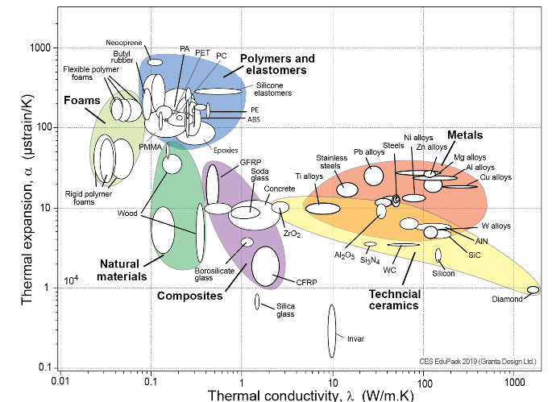
The graph that plots Thermal conductivity in kelvin against thermal expansion in strain/ kelvin. The graph compares most metal and ceramic types. From the graph it can be gathered that ceramics hold some equal and some less thermal conductivity properties than metals and alloys but are not as strong as stainless steels, cast irons and aluminium alloys.
From this it can be decided that the correct material to use is metals, those being aluminium, steel and cast iron. It can also be noted Ceramics are known for their strength and durability, making them ideal materials for many applications, including pistons. However, according to a study by M. Rosso in the Journal of Materials Processing Technology (2006), there are still physical limitations to the use of ceramics for piston manufacturing. The study found that ceramics are brittle, meaning that they are prone to cracking or shattering when subjected to high levels of stress. Also, ceramics can experience thermal shock and deformation when exposed to sudden changes in temperature. These physical limitations can be addressed through changes in the design of the piston and the use of coatings that are designed to reduce thermal shock and deformation. While ceramics can be a viable option for piston manufacturing, it is important to consider the physical limitations of the material before choosing it.

Manufacturing Processes
Fig.5
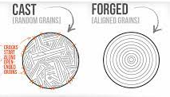
The impacts of manufacturing processes on piston quality are significant. According to H Bikas, P Stavropoulos, and G Chryssolouris (2016), “manufacturing processes such as forging, casting, and machining are used to produce pistons with desired quality characteristics” (p. 24). In particular, the forging process is used to create the desired shape of the piston, while casting is used to produce the desired material properties. Machining is then used to create the desired surface finish and dimensional accuracy, as seen in figure 5. Each process has a direct impact on the piston's quality, and therefore, it is important to understand how each process affects the final product. For example, improper forging may result in inconsistencies in the piston's shape, while improper casting may cause defects in the material properties. Furthermore, if the machining process is not properly executed, it could lead to surface roughness and dimensional inaccuracies. As a result, it is imperative for manufacturers to understand the impacts of the manufacturing processes on piston quality and to ensure that each process is properly executed to produce pistons of the highest quality.

Quality control plays a vital role in piston manufacturing as it ensures that all pistons meet the required specifications, and that the product is safe for use. According to G. Ostasz, K. Czerwińska, and A. Pacana, who studied the management systems in piston manufacturing, quality control is especially important in this kind of process since it is necessary to guarantee that the pistons work properly and meet all safety requirements (2020). Quality control involves making sure that the dimensions and performance of the pistons are within the standards established by the manufacturer, as well as verifying that the materials used comply with the allowable tolerances. The process also includes inspections and tests to ensure that the pistons meet the predetermined specifications. Quality control is a key element in the production process, as it can help identify and prevent any defects, resulting in better quality products. Moreover, it can help reduce the costs associated with the production process by eliminating any unnecessary waste and ensuring that the pistons are manufactured more efficiently. Quality control is thus an essential part of piston manufacturing, as it helps ensure that the pistons meet the desired quality standards.

The challenges of accessible steel and aluminium production have been an ongoing issue for many years, and it has become even more apparent in recent years due to the increase in demand for these materials. As B Meredig states (2017), this is an issue that needs to be addressed in order to ensure the sustainability of both steel and aluminium production. The main challenges that need to be addressed include the need to improve the efficiency of production processes, the need to reduce emissions, and the need to ensure that production is done in a safe and responsible manner. In order to address these challenges, it is necessary to invest in new technologies that can reduce the amount of energy needed for production, as well as develop new methods for recycling and reuse of materials. Additionally, it is important to ensure that production is done in an environmentally responsible manner, with the aim of reducing pollution in the environment.
Cost
According to a study conducted by Helmers and Marx (2012), materials such as titanium and aluminium are lightweight and thus help increase the performance of engines used in motorsports. However, they are expensive and complex to work with, limiting their practical use in everyday cars. On the other hand, materials such as cast iron and steel are cheaper and easier to manufacture, but they are also heavier, which reduces the performance of the engine in motor sports. Therefore, it is important to consider the advantages and disadvantages of the available materials when selecting an engine for motor sports or daily use. The study by Helmers and Marx (2012) highlights the importance of selecting the optimal material for a given application, as the wrong material can lead to decreased performance or increased cost. From Fig.3 it can be seen that ceramics come in at a higher strength than metals and alloys but are the same price / cheaper but it has already been established that ceramics are not suitable for a piston compared to a metal.

Conclusion
To conclude the report, forged aluminium is best suited in a motorsport environment as it is lightweight and highly durable compared to steel, allowing the engine to undergo more combustion and rev to a higher range, scraping more performance out of the engine. However forged aluminium is not cheap as the process is expensive compared to steel and cast iron. Hence steel and cast iron are best for use in daily commuting vehicles as it is cheaper to manufacture and highly durable when not being put under too much strain.

Reference List
- AJS Baker "Piston Ring Lubrication—Part 1: The Historical Development of Piston Ring Technology."https://asmedigitalcollection.asme.org/tribology/article-abstract/104/1/118/415241
- University of Washington; https://depts.washington.edu/matseed/mse_resources/Webpage/Ceramics/ceramicproperty.htm
- E Helmers."Electric cars: technical characteristics and environmental impacts. https://enveurope.springeropen.com/articles/10.1186/2190-4715-24-14
- P Stavropoulos., G Chryssolouris."Additive manufacturing methods and modelling
"https://link.springer.com/article/10.1007/S00170-015-7576-2
- K Czerwińska., A Pacana."Quality management of aluminum pistons with the use of quality control points."https://sciendo.com/downloadpdf/journals/mspe/28/1/article-p29.xml
- B Meredig. Industrial materials informatics: Analyzing large-scale data to solve applied problems in R&D, manufacturing, and supply chain."https://www.sciencedirect.com/science/article/pii/S1359028617300220
- DN Assanis."Transient heat conduction in low-heat-rejection engine combustion chambers. https://www.jstor.org/stable/44470827
- M.rosso 2006
https://www.sciencedirect.com/science/article/abs/pii/S092401360500419X

