Luke Savin - 1810328
1810328@student.uwtsd.ac.uk

Abstract
This report looks into the affect of white noice on ASK, PSK, QPSK and QAM. Each one was simulated in Simulink and tested at several different SNR to identify the amount of errors that occurred. The results show that the PSK was less susceptable to noise, whereas QAM preformed the worst.
OME – L5 – Digital Signals Processing and Communications
Contents
Abstract 0
List of Tables 1
List of Figures 1
Introduction 2
Background 3
ASK 3
PSK 3
QPSK 4
QAM 4
Simulation Models 6
Results 8
Discussion 9
Conclusion 10
References 11

List of Tables
Table 1: BER vs SNR 8

List of Figures
Figure 1: ASK waveform [2] 3
Figure 2: PSK Waveform [3] 4
Figure 3: QAM Waveform [5] 4
Figure 4: Bernoulli Binary Generator Parameters 6
Figure 5: AWGN Channel Parameters 6
Figure 6: ASK Simulink Model 7
Figure 7: PSK Simulink Model 7
Figure 8: QPSK Simulink Model 7
Figure 9: QAM Simulink Model 7
Figure 10: BER graph 8
Figure 11: Constellation Diagram of BPSK, QPSK and QAM [7] 9

Introduction

In the modern age of digital communication, information needs to be continuously transmitted and received without the information being changed or distorted. Large amount of information needs to transmit, therefore, requires high performing modulators to transmit the information accurately and without interruption.

This tends to happen from outside interference such as noise. If there is too much noise in the signal, then the information can be lost, or the wrong message is received.

Background

There are several techniques to send out a digital signal between the transmitter and the receiver. The most basic method involves modulating the carrier wave by changing either the Amplitude, Frequency or the Phase. These are known as Amplitude Shift Keying (ASK), Frequency Shift Keying (FSK) and Phase Shift Keying (PSK). From these three, this report looks at the ASK and PSK. The other two modulators that this report investigates are Quadrature Phase Shift Keying (QPSK) and Quadrature amplitude modulation (QAM). These two types of modulators are more complicated as they are able to send more data at a given time.

ASK

Amplitude Modulation (AM) is an analogue form of modulation where the amplitude is changed in the carrier signal, which is used for long-distance communication, e.g. Radios. However, ASK modulators transmits a carrier signal and data signal. The data signal is transmitted at a higher amplitude to the carrier signal, which can be represented in a binary form. For example, when a when no data signal is sent, it is defined as a zero, and ones for when it produces a data signal is produced. This type of modulation is also known as on-off keying (OOK). [1]. The figure below shows how the change in the data signal changes the carrier wave.

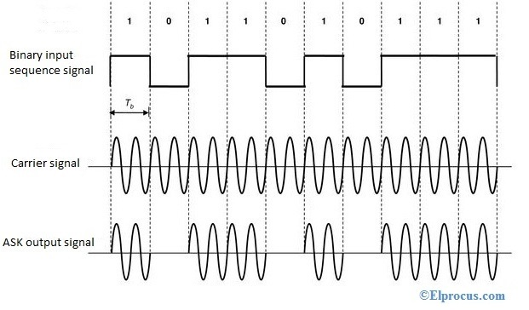
Figure 1: ASK waveform [2]

PSK

PSK modulation is very similar to ASK, but rather than a change in the amplitude to produce a binary signal, it requires a shift in the phase. When the carrier signal changes in phase of 180° it indicates either a one or a zero to be transmitted.

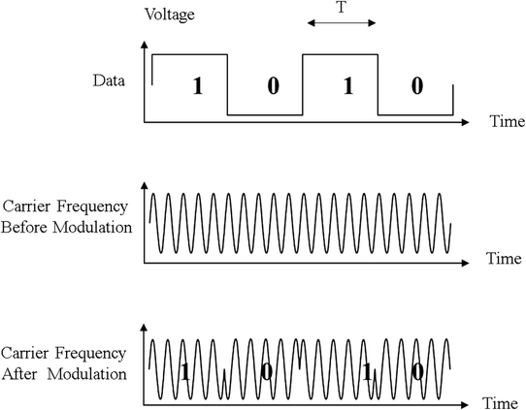
Figure 2: PSK Waveform [3]
PSK modulators are also known as Binary PSK (BPSK) as there only two phases to switch between. However, it is possible to increase the number of phases that it can shift too, to increase the number of bits that can be transmitted. These modulators are also known as Quadrature Phase-Shift Keying QPSK.

QPSK

QPSK uses the same principles as PSK, as it uses the change in phase to signify data. However, QPSK makes use of using two carrier signals that ‘have the same frequency but differ in phase by 90°’ [4]. Using two carrier signals instead of one means that QPSK can transmit two bits at a time. These two waves are referred to as I (In-phase) for the one that is 0° phase and Q (Quadrature) for the other. When the two I and Q carrier wave are applied together, four phase values can represent data value can be represented as 00, 01, 10, or 11

QAM

QAM is another form of quadrature modulation that uses two carrier signals, but unlike QPSK, the two signals are shifted 90° out of phase as one is Sine and the other Cosine. As in QPSK, the waves are known as the I and Q, which is able to carry a two-bit signal. To create the data in the signal

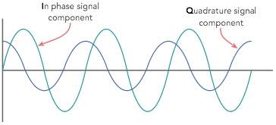
Figure 3: QAM Waveform [5]
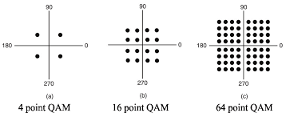

Simulation Models

To fully explore the effects of white noise on digital signals, several digital modulators were designed and simulated in a computer program known as MATLAB, which also made use of Simulink. Simulink allowed the design of the modulator and demodulator of each type of digital signal that was created in simple block diagrams. The advantage of using MATLAB and Simulink is that it has the capability of being able to adjust the parameters on each of the component blocks.

The four different digital modulators were built and tested for comparison. Two of the modulators that were used were ASK and PSK, which uses a binary signal, whereas the other two modulators that were simulated were QPSK and QAM, which uses a quadrative signal. To create the ASK and PSK, the modulator and demodulator were broken down into individual components. Were as the quadrative signals were made using specific block components.

To create each data signal, a Bernoulli Binary Generator was used. Using this produced random data bits of zeros and ones to replicate a real communication signal. This was used in each modulator set up, so the parameters stayed the same each time.
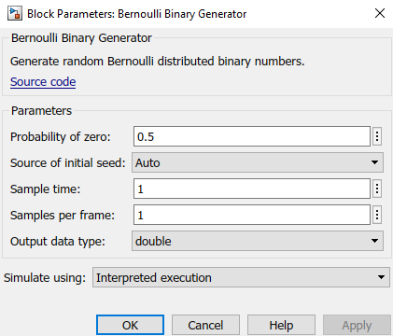
Figure 4: Bernoulli Binary Generator Parameters
To imitate the white Gaussian noise, the AWGN channel was added to the circuit. Figure 5 show the parameters that were applied. After the ten simulations, the SNR value was changed.
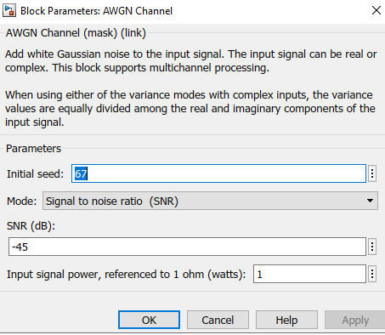
Figure 5: AWGN Channel Parameters
At the end of each run, the Error Rate and the number of Error Detection was recorded using the Error Calculation.

Figures … show the block diagrams for each of the modulator that was created in MATLAB.
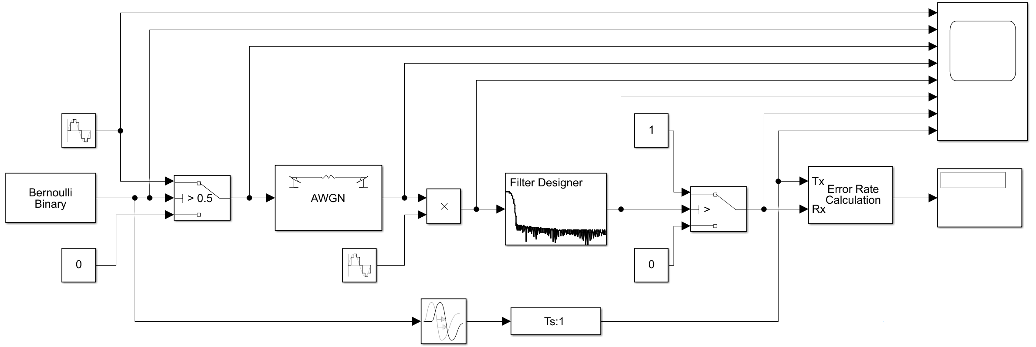
Figure 6: ASK Simulink Model
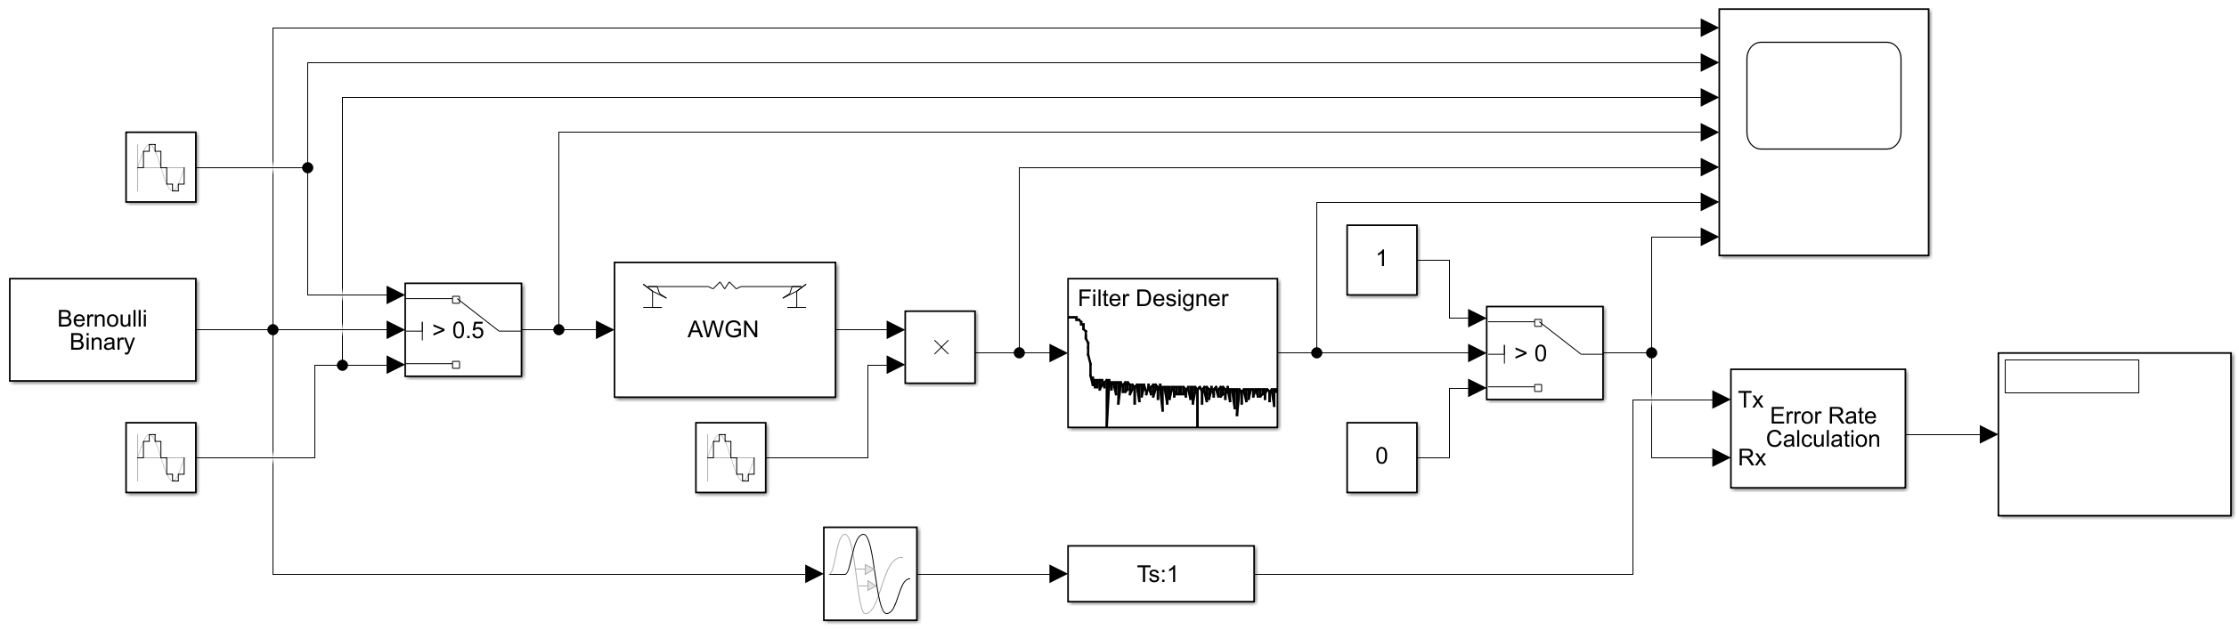
Figure 7: PSK Simulink Model
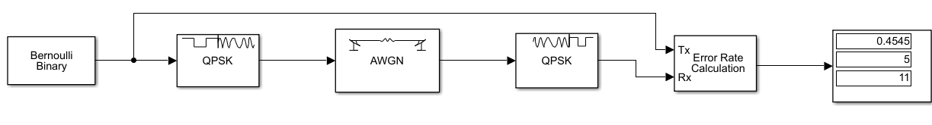
Figure 8: QPSK Simulink Model
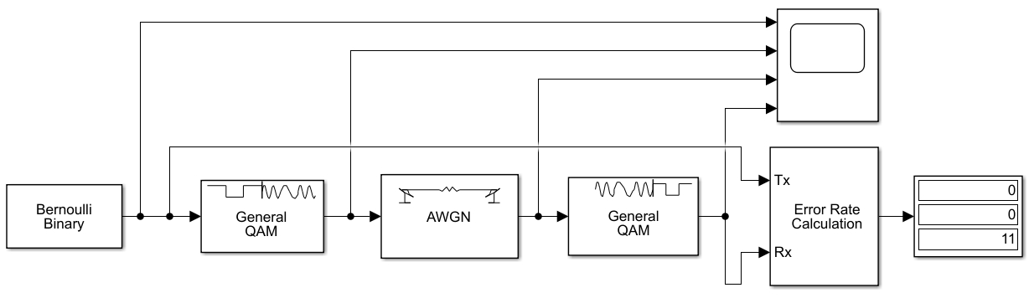
Figure 9: QAM Simulink Model

Results

Once all modulators were run at the varying SNR ten times, the results were collected, and the Bit Error Rate (BER) was calculated. This was done using the average number of bit errors that occurred in each simulation divided by the total number of bits, as shown in the formula below.
$BER= \frac{Number Of Errors}{Number of Bits }$ [6]
The table below shows the calculated BER of each the modulator. The full results can be found in Appendix A.
 | -50 | -45 | -40 | -35 | -30 | -25 | -20 | -15 | -10 | -5 | 0 | 5 | 10 | 15
ASK | 0.5273 | 0.5091 | 0.5182 | 0.4364 | 0.4455 | 0.4727 | 0.4273 | 0.3091 | 0.2273 | 0.1818 | 0.0636 | 0.0000 | - | -
PSK | 0.5000 | 0.4545 | 0.4727 | 0.4091 | 0.4455 | 0.3818 | 0.2909 | 0.2273 | 0.2000 | 0.0000 | - | - | - | -
QPSK | 0.6636 | 0.6455 | 0.6727 | 0.6455 | 0.6273 | 0.6455 | 0.6455 | 0.6636 | 0.5727 | 0.3455 | 0.1636 | 0.0273 | 0.0000 | -
QAM | 0.9182 | 0.9000 | 0.8909 | 0.8909 | 0.9273 | 0.8909 | 0.8818 | 0.9091 | 0.8364 | 0.7000 | 0.4182 | 0.1455 | 0.0545 | 0.0000
Table 1: BER vs SNR
Using the results that are shown in the table, the following graph was produced that plots the BER vs SNR.

Figure 10: BER graph

Discussion

After compiling the results together, it is clear to see that some clear trends occur. Out of all the modulator that was tested in this report, the PSK was less susceptible to the white noise and was able to transmit the majority of the data that was generated. PSK also managed to achieve 0 errors at -5dB whereas the as ASK, which was the second-best performing modulator, didn’t achieve 0 errors until it was tested at 5dB. QPSK and QAM were the most susceptible to noise and occurred more errors at the lower SNR and took longer to reach a point where there were 0 errors.

Both the PSK and QPSK performed better in the presence of noise compared to the ASK and QAM

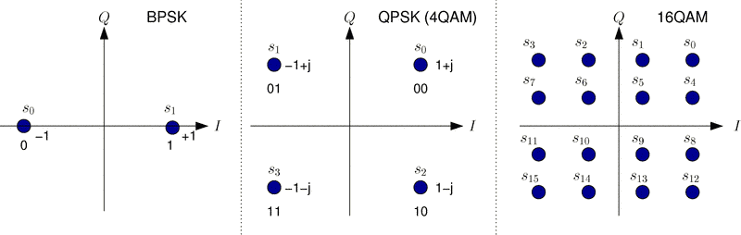
Figure 11: Constellation Diagram of BPSK, QPSK and 16QAM [7]

Conclusion

In this report, four digital modulators were simulated in Simulink to identify how the effects of white noise have on the signal. The results show that PSK was less susceptible to the noise as it has the most significant separation between the digital states of one and zero. However, if large amounts of data is needed to be transmitted, a quadrature modulator is required even though they are more affected by noise. The inclusion of a well-designed low pass filter can significantly reduce noise in a signal.

If the author of the report could revisit this investigation, they would run more SNR values and increase the amount of time they would run. The main issue the author had was lack of experience with the software. Having prior knowledge of how to build the modulator and knowing how to set up the parameters for each of the components would have significantly improved the outcome.

References

[1] | “Exploring communications technology,” OpenLearn, [Online]. Available: https://www.open.edu/openlearn/science-maths-technology/exploring-communications-technology/content-section-1.4. [Accessed 16 12 2020].
[2] | “Amplitude Shift Keying : Circuit Diagram, Working and Its Applications,” ElProCus - Electronic Projects for Engineering Students, [Online]. Available: https://www.elprocus.com/amplitude-shift-keying-ask-working-and-applications/.
[3] | S. Faruque, “Phase Shift Keying (PSK),” in Radio Frequency Modulation Made Easy, Springer, Cham, 2016, pp. 69-83.
[4] | C. Maxfield, “Electrical Engineering,” Amsterdam, Newnes, 2008, p. 872.
[5] | electronics notes, “What is QAM: Quadrature Amplitude Modulation » Electronics Notes,” Electronics-notes.com, [Online]. Available: https://www.electronics-notes.com/articles/radio/modulation/quadrature-amplitude-modulation-what-is-qam-basics.php. [Accessed 17 12 2020].
[6] | electronics notes, “What is Bit Error Rate: BER Definition & Tutorial » Electronics Notes,” [Online]. Available: https://www.electronics-notes.com/articles/radio/bit-error-rate-ber/what-is-ber-definition-tutorial.php. [Accessed 17 12 2020].
[7] | “Transmitter Simulink Study,” Faculty.jacobs-university.de, [Online]. Available: https://www.faculty.jacobs-university.de/jwallace/xwallace/courses/dsp/labs/01_sl_tx/. [Accessed 17 12 2020].

