University of Wales Trinity Saint David

Student Name: | Sobia Hussain
Student ID Number: | 2507361
Programme: | Certificate of Higher Education Skills for the Workplace (Health & Social Care)
Module Title: | Psychology in Health and Social Care
Module Code: | LCHS4009
Lecturer: | Wafa Nasir
Assignment Title: | Component 2
Submission Deadline: | Friday 24th July 2026, 10 am

Table of Contents
Task 1: Curriculum Vitae (CV) .................................................................................................. 4
Task 2: Personal Statement ...................................................................................................... 6
Task 3a: SWOT Analysis ........................................................................................................... 7
Task 3b: Personal Development Plan (PDP) ........................................................................... 8
Task 4: Critical Reflection (Gibbs Model) .............................................................................. 10
References ............................................................................................................................... 13

Task 1: Curriculum Vitae (CV)

SOBIA
sobia@gmail.com

PERSONAL PROFILE
Compassionate and dedicated individual seeking a Support Worker position within the health and social care sector. Currently studying towards a Level 4 Diploma in Health and Social Care, with a genuine commitment to promoting the dignity, wellbeing and independence of the people I support. A good listener with strong communication and teamwork skills, I remain patient, reliable and attentive to individual needs in every role I undertake, and I am eager to bring my growing knowledge of person-centred care into a rewarding Support Worker position.
KEY SKILLS
• Good listener, empathetic approach  • Strong communication skills  • Effective team worker  • Patient and caring nature | • Reliable and punctual  • Adaptable, quick learner  • Person-centred approach  • Attentive to individual needs
WORK EXPERIENCE
Shop Assistant (Cake Shop) (2020 – Present)
• Handled customer queries with patience, care and a friendly manner
• Maintained high standards of hygiene and quality control
• Built positive relationships with customers through active listening and clear communication

Waiter – Clipper Lounge (2015 – 2019)
• Attended to guests' individual needs with warmth, patience and close attention to detail
• Worked effectively as part of a team to ensure guests received attentive, timely service
• Communicated clearly and courteously with guests from diverse backgrounds
EDUCATION
Level 4 Diploma in Health and Social Care (Present)
University of Wales, Birmingham
ACHIEVEMENTS
• Successfully progressing through a Level 4 Diploma in Health and Social Care alongside work commitments
• Built positive, trusting relationships with customers, guests and residents through a patient and caring approach
CERTIFICATIONS
• Phlebotomy Certificate
HOBBIES AND INTERESTS
I enjoy painting and decorating, going shopping, going for walks and travelling.
REFERENCES
Ms Wafa Nasir
Email: W.nasir@uwtsd.ac.uk

Task 2: Personal Statement
I am a caring and dedicated Support Worker who has aspirations to join the health and social care industry in this capacity. In the long run, I hope to create a fulfilling career helping individuals lead independent lives while ensuring that their dignity, welfare and quality of life are taken into account. Currently, I am undertaking the Level 4 Diploma in Health and Social Care, which is giving me an understanding of person-centred practice, safeguarding, communication, equality, diversity and professionalism. Based on my education and experiences, I have attained the necessary skills and attitude to deliver safe, dignified and caring support to individuals with different needs.
My position as a Shop Assistant has played an important part in developing my outstanding interpersonal and communication skills. This is because every day, I have to deal with customers of varied nature, attending to their requirements in a professional manner. This has enabled me to understand the significance of listening skills, good communication skills and maintaining hygiene and safety standards. All this has played a key role in enabling me to stay calm during difficult times, solve problems effectively and establish trust relations.
I have previously worked as a Waiter at the Clipper Lounge, whereby I offered courteous service by collaborating with other employees within a busy setting. Through this work experience, I have learned the importance of working as a team, being organised and detailed in my work. In addition, I learned how to identify the needs of others and be able to respond quickly to their needs through courteous service. Such skills will help me to assist individuals in a person-centred manner.
The Level 4 Diploma in Health and Social Care I am studying has contributed to my knowledge of professional practices and increased my dedication towards offering person-centred care to people. I have acquired knowledge about safeguarding, confidentiality, communication and independence that are crucial for offering quality care. According to research, person-centred care has the ability to offer positive experiences, respect and good health to people (World Health Organization, 2023).
Apart from being academically oriented, I have also earned a Phlebotomy Certificate, proving my dedication to lifelong learning and development. I am a considerate, patient, and flexible person who enjoys acquiring new knowledge and taking up challenges. I am proud of myself for always being punctual, responsible, and respectful, and I understand the significance of being discreet and professional at all times. It is because of my positive approach and eagerness to learn that I can easily fit into any surrounding and cope with the changing demands of those I serve.

I feel I would add value to your organization since I have the necessary combination of customer service experience with appropriate education in health and social care, along with a desire to help people. Support workers who are compassionate and highly skilled contribute to the wellbeing and empowerment of people by improving their quality of life and making them independent (Skills for Care, 2024). I would love to further develop my skills while adding to your team by rendering excellent services that empower people to live a good and independent life.

Task 3a: SWOT Analysis

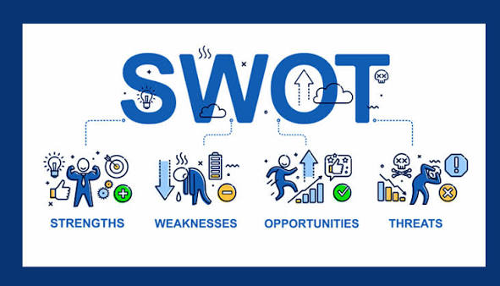
(HR, 2024)
Strengths
My biggest strengths include my communication skills, patience and building good relationships with diverse groups of people. Working as a Shop Assistant and Waiter helped me develop such skills as active listening, empathy and team working that are critical in providing person-centered care. The Level 4 Diploma in Health and Social Care course has increased my knowledge about such areas as safeguarding, dignity, equality and professional values and has taught me how to provide caring services (NICE, 2023).
Weaknesses
Even though I have very good transferable skills, I do not have much experience working within the healthcare and social care environment. There is also the aspect of confidence that needs to improve regarding managing difficult behaviors and recording the care process, as well as understanding medicines.
Opportunities
The completion of my Level 4 qualification, gaining work experience through working as a Support Worker and attending employer-based training will enhance my expertise. Having acquired the Phlebotomy Certificate will provide me with opportunities to increase my clinical expertise and eventually move on to higher positions within the caring sector. Professional development (PD) and workplace learning will assist me to gain specific skills (Skills for Care, 2024).

Threats

Health and social care environments are stressful due to physical and emotional challenges. Moreover, legislative changes, new organizational policies, and changing needs of the patients necessitate constant learning. The development of resilience, obtaining supervision, and updating my knowledge base will enable me to deal with such difficulties and provide safe health care (NHS England, 2022).

Task 3b: Personal Development Plan
In order to help myself become a successful Support Worker, there are three very realistic goals that I will achieve within the next two years, which will give me the necessary information and skill level required. My progress will be monitored through the feedback from my tutors, workplace supervisors and reflective practices (Skills for Care, 2024).

Development Goal | Actions | Timeframe | Monitoring and Evaluation
Successfully complete my Level 4 Diploma in Health and Social Care. | Attend all classes, complete assignments on time and seek regular tutor feedback to strengthen my understanding of person-centred care and professional practice (NICE, 2023). | Within 2 years | Monitor assignment grades, tutor feedback and successful completion of the qualification.
Gain practical experience and complete mandatory workplace training as a Support Worker. | Secure a Support Worker role and complete safeguarding, moving and handling, infection prevention and first aid training while learning from experienced colleagues (Skills for Care, 2024). | Within 12 months | Review training certificates, supervision records, probation reviews and manager feedback.
Improve confidence in supporting individuals with complex needs. | Complete CPD courses on dementia care, communication and managing challenging behaviour. Apply learning during daily practice and maintain a reflective journal to improve professional competence (NHS England, 2022). | Within 2 years | Evaluate progress through reflective practice, supervision meetings, annual appraisals and feedback from colleagues.

If I manage to reach the above goals, my competence, confidence and professional performance as a Support Worker will be enhanced. Through effective supervision, reflection and professional development, I shall be able to recognize my areas of weaknesses, give appropriate responses to criticisms and uphold high standards of person-centered care. It is through developing such competencies that I am set to take up greater duties and move forward in my career (Skills for Care, 2024).

Task 4: Critical Reflection Using Gibbs' Reflective Cycle
The Reflective Cycle by Gibbs (1988) can be applied in order to assess an experience and determine where one needs improvement from the professional point of view. This cycle was used by me to analyze my presentation for LCHS4009 Component 1 on Working in Teams in Health and Social Care, as well as to show my knowledge on teamwork.
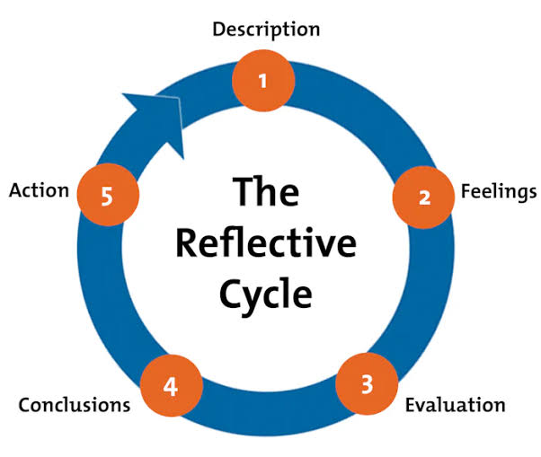
(Hughes, 2024)
Description
The purpose of my presentation was to highlight the significance of teamwork in health and social care and its application in practice in addition to demonstrating the role of collaboration in the delivery of person-centred care using stroke rehabilitation as an illustration. I explained the concept of interprofessional teamwork, its advantages and disadvantages as well as how I will collaborate with nurses, physiotherapists, occupational therapists and social workers in helping the patient recover. The lecturer gave verbal feedback after the presentation, saying that my presentation had a good speed and good delivery and that the stroke rehabilitation helped illustrate the connection between theory and practice. He also suggested that I should not depend so much on my notes, make more eye contact with the audience and include the model in my presentation since it was lacking.
Feelings
Before giving the presentation, I was feeling anxious as I needed to present the topic in an accurate manner. Even after preparing properly for the presentation, I still had some fears regarding how I would be able to deliver the presentation due to nervousness. As I was going ahead in the presentation, I felt much more confident as I had complete knowledge about the topic and I was also able to explain the example practically. Positive feedback about my pace of presentation boosted my confidence further.
Evaluation
Overall, I can say that the majority of the learning outcomes were achieved during the presentation. The necessity of cooperation was discussed with the aid of the up-to-date evidence, and the role of a Support Worker in the process of multi-professional healthcare was shown through the stroke rehabilitation scenario. It is evident that communication and collaboration positively influence the quality of the provision of healthcare services. Research shows that teamwork facilitates communication and ensures patient safety and coordination of care; thus, the presented information was evidence-based (Ingels et al., 2023). However, according to the lecturer's evaluation, several weaknesses could be observed.
Analysis
This experience taught me that a successful presentation demands both correct knowledge and confident delivery. My well-paced presentation indicated that I was prepared for it, and the example helped people to grasp the concept of teamwork. As Wei et al. (2022) claim, communication plays a crucial role in collaborating with other individuals in health and social care. Moreover, I realised that making eye contact would increase my confidence level and engage the audience. Reflective practice allows specialists to analyse their performance and work on the improvement in the future. This is why reflective practice plays a vital role in professional development (Health and Care Professions Council, 2023).
Conclusion
The presentation increased my knowledge of team work and built my confidence to deliver professional information. I was able to explain the concept of team work through an example and I have been able to convey the key elements of team work effectively. There are still some things that need to be improved such as reliance on notes and eye contact.
Action Plan
For any future presentations, I am going to work on practising with cue cards instead of using notes to enhance my confidence while at the same time maintaining eye contact. Prior to any presentation, I am going to use the checklist of assessment in order to ensure that all the elements have been included, such as the reflective model. I am also going to practise in front of peers or members of my family and receive their constructive criticism in order to enhance my presentation skills. Receiving feedback and carrying out reflection on a regular basis is crucial in my professional development (Health and Care Professions Council, 2023; Wei et al., 2022).

REFERENCES
Health and Care Professions Council (2023) Standards of proficiency. London: HCPC.
Ingels, C., Van den Broeck, K., Dierckx de Casterlé, B. and Maenhout, B. (2023) ‘Interprofessional collaboration in healthcare: Factors influencing team effectiveness and quality of care’, Journal of Interprofessional Care, 37(6), pp. 915–923.
National Institute for Health and Care Excellence (NICE) (2023) People's experience in adult social care services: improving the experience of care and support. London: NICE.
NHS England (2022) Our NHS People Promise: Delivering together. London: NHS England.
Skills for Care (2024) The state of the adult social care sector and workforce in England 2024. Leeds: Skills for Care.
Wei, H., Sewell, K.A., Woody, G. and Rose, M.A. (2022) ‘The state of the science of interprofessional teamwork in health care: A scoping review’, Journal of Interprofessional Care, 36(4), pp. 588–600.
World Health Organization (2023) Framework on integrated, people-centred health services. Geneva: World Health Organization.

