

Programme: BA (Hons) Leadership and Management Skills for the Workplace
Module: Managing Business Information
Module code: LCLM 5004
Lecturer: Dr Oluwaseun Adegbite
Assignment Title: (Component 2) Individual report- Information Systems Improvements
Submission deadline: 21st November 2025 (14:00)
Student name: Miss Mumtaz Aziz
Student ID: 2324051

Contents
How to Overcome Operational Challenges and Redemption Strategies. 3
Introduction 3
Evaluation of Existing Systems 4
Recommended Solution 5
Inventory Tools- 6
CRM Tools 6
Reporting Tools 7
Compliance Tools 7
System Integration Tools 7
Explanation of how the system will improve operations, data management, and decision-making. 8
Operations: 8
Data Management 8
Decision-Making 8
Financial Implications 9
Implementation Plan 9
Further Implementation Plan 10
Potential Challenges 11
Conclusion. 12
References. 13

How to Overcome Operational Challenges and Redemption Strategies.

Introduction
In contemporary society, numerous businesses are focused on growth and establishing firm roots within their operational environments. The strategic adoption of business information systems plays a pivotal role in facilitating this development (Vaxman, 2023). For this, certain requirements are needed for the success of the business. The seniors too explore ways to improve their operational skills, which supports the development at ways to improve their operational skills, which aids the growth of their business strategies. What are operational challenges?
Well, as stated in Alberto, (2025), stated, “in the dynamic landscape of modern business, operational challenges have emerged as a critical area of focus for organisations striving for efficiency and effectiveness. Operational challenges encompass a wide array of issues that can hinder an organisation’s ability to achieve its objectives, ranging from supply chain disruptions to workforce management dilemmas. The management of these challenges is not merely a reactive measure; it is a proactive approach that requires a deep understanding of the underlying processes and systems within an organisation.”
The older era consisted of strategies that made business lacking in efficiencies and knowledge in the growth of a business and how to make work life more streamlined, and there is a saying ‘more is less’ by working out a method of keeping a record and work setting, out to be more automated, in return, can set the business to grow further and expand.
However, in some modern business systems, they struggle with operational challenges within their teams. This is due to outdated and lagging information systems, which are causing major setbacks for the new opportunities to grow further and beyond. The manager requested the I.T consultant investigates the list of key challenges that are affecting performance and hindering the growth net of the company, to analyse the issues arising from the outdated systems and to provide a modern streamlined approach for a new information system that will also aid in the smooth transitioning from old to new.
The operational challenges have been identified as 5 key elements, which are;
  - Inventory Discrepancies
  - Dis-engagement from CRM systems, (Customer Relationship Manager)
  - In-efficiency in reporting
  - Regulatory non-Compliance breaches and,
  - Lack of system integration across the departments
These issues threaten a company’s ability to scale sustainably, to maintain customer trust, to ensure compliance standards are being met and monitored, and to further respond to market dynamics.
inventory tracking system, stock discrepancies between physical stores and online orders, and delays in order fulfilment. An outdated customer relationship management (CRM) system is creating, decision-making to be slow and inefficient. Sales reports are manually compiled using spreadsheets, which is not fully compliant with data protection regulations like GDPR and the lack of integration across departments.

Evaluation of Existing Systems
The following table demonstrates the inefficiencies and gaps that are causing some companies to move slowly and creating a gap between progress and success rates.
Table 1: Current System Operations.
Current systems | Description of usage | Inefficiencies’
Inventory and sales data. | Excel-based tracking and manual reconciliation across stores and online platforms. | Lack of real-time updates leads to overstocking, understocking, and refund-triggering stockouts.
CRM, Customer relations. | Multiple disconnected databases with limited functionality. | Inability to track purchase history or preferences undermines loyalty and support.
Reporting flow | Spreadsheet-based sales reports are compiled weekly. | Slow Decision-Making: Manual reporting delays strategic responses and forecasting accuracy.
Security and protection | Basic password protection without role-based access or encryption. | Absence of audit trails and consent tracking violates GDPR principles (ICO, 2023).
Department tool allocation | Each team uses standalone software with no API connectivity. | Operational Bottlenecks: Manual data transfers between departments waste time and increase error rates.

These gaps collectively hinder a business's agility, customer satisfaction, and regulatory standing.

Recommended Solution
The following chart shows a four-category list of tools that can be used for a business setup, with a bracketed brief description for each tool.

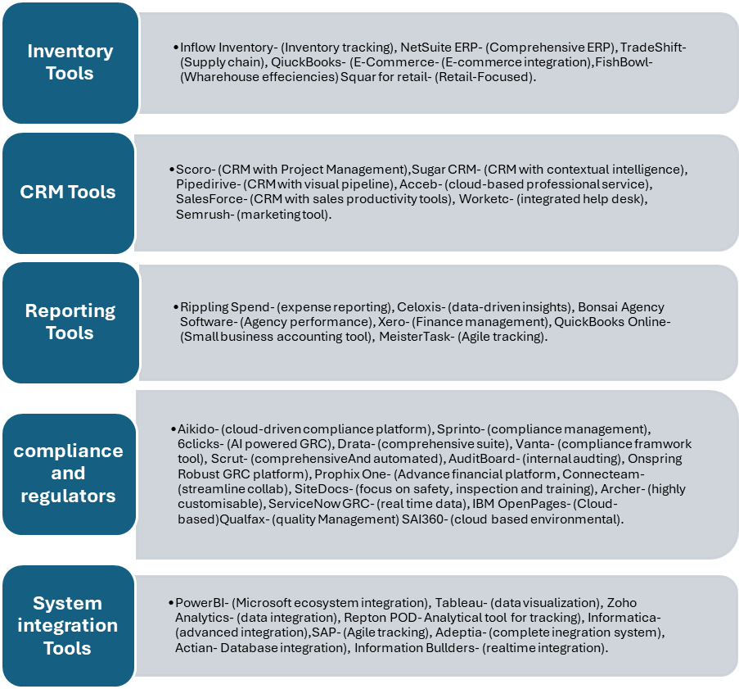
Figure 1: Different Types of Tools.

Proposed System: An Integrated - Retail Management System (RMS)
To address these challenges, companies. should implement a cloud-based, integrated Retail Management System comprising:
• Inventory Management
• Customer Relationship Management (CRM)
• Point-of-Sale (POS) Integration
• Business Intelligence (BI) & Reporting
• Data Security & Compliance Controls
Recommended platforms include NetSuite, Salesforce Retail Cloud, and Microsoft Dynamics 365, which offer modular scalability and proven retail performance (Gray, 2025; HubSpot, 2025).
The following tools are strongly recommended for the challenges,
Inventory Tools- NetSuite ERP (comprehensive system)- Mid-market scaling profitability and reaching wider audiences, offering a free-flowing connection amongst information gathered from finance, inventory, stock, order management and CRM credentials, speeds up month-end, minimises risk of spreadsheet duplication, and helps support scaling with ongoing transaction growth. real‑time reporting shortens decision cycles and reduces reconciliation time as the business scales.
- Sales Binder (multi-location)- One of the key points to this tool is it offers a low cost and faster deployment process for stock control over several located branches as it supports multi location and can be accessed at different place, this secures the risk of stock discrepancies that may arise and simplifies the transaction overheads to have location aware tracking, improves fulfilment accuracy also simplifies report structure.
CRM Tools- Sugar CRM (Contextual intelligence)- Case summarisation software that enables sales and service teams to streamline workflows and prioritise higher value work, reducing time spent preparing for calls and increasing win rates through contextual recommendations.
-Salesforce (Sales productivity)- An extensive automation approach, ecosystem delivery and scalability opportunities, to improve the quality and quantity of sale production and enterprise governance integration, automates lead routing, forecasting and activity capture to raise seller productivity.
Reporting Tools- Google Analytics 4 (GA4)- (Data and reporting)- Enables customizing reports, aids segmentation, real time reporting options, explorational features, integration with other google tools which helps with streamlining.
-Data Box (complete system)- More than 120 built in tools or extensions to help customize a better and stronger workflow, also includes Google Analytics 4, can provide real data delivery within minutes, visualization dashboards, templated dashboards included, import data and reporting tools enablement, KPI reporting tools, Benchmark against peer companies to compare performance factors, live performance date. (Stojanovic, 2024)
-Celoxis (Data-driven)- Provides project, resource and financial views in one PPM system; improves forecast accuracy and reduces rework through integrated time tracking and automated metrics, ties project plans to actuals, resource utilization and cost data so PMs make evidence‑based prioritization
-Xero (finance management)- Cloud accounting with bank feeds and reporting reduces bookkeeping friction and gives near real‑time cash visibility for small to medium firms.
Compliance Tools- 6Clicks (AI Powered GRC)- AI‑assisted mapping and automation reduce compliance overhead and improve vendor and control management across multiple frameworks.
-Scrut (Comprehensive and automated)- Automated evidence collection, framework mapping and audit readiness, cutting manual effort and time to audit while improving control visibility for cloud‑native teams.
System Integration Tools- Tableau (data visualization)- Strong connector library and interactive storytelling enable analysts and leaders to explore and communicate insights rapidly across the organization, helping leaders spot correlations, anomalies and high‑impact opportunities that are not apparent in spreadsheets. (Ayuya, 2024)

- Information Builders (Real time data)- Real‑time data pipelines reduce latency between operational systems and analytics, enabling timely actions and automated processes, enabling operational automation (e.g., dynamic inventory reallocation) and faster, data‑driven responses to market changes.

Explanation of how the system will improve operations, data management, and decision-making.
Operations:
More centralised transactional flows to reduce work being duplicated, orders, inventory movement and finance entries flow through a single platform (ERP-Enterprise Resource Planning/CRM- Customer Relationship Management/PPM- Project Portfolio Management), cutting reconciliation time and manual handoffs. So, less time wastage and resources being used. Faster fulfilment and fewer stockouts through location‑aware inventory and automated reorder triggers. Streamlined compliance and audit readiness from automated evidence collection and mapped out controls, reducing time spent on gathering evidence manually.
Data Management:
Consolidate data. The tools will help towards organizing the information collected, used and stored in ease of accessibility, which in return will make it easier with less conflicting reports or repetitive data being stored. Better data quality and lineage: automated syncs, validation rules and controlled master data reduce errors and enable trustworthy analytics. (TheKnowledgeAcademy, 2025b)
Decision-Making:
Real‑time dashboards and alerts provide leaders with timely KPIs and anomalies, enabling faster corrective action. Helps to maintain and regulate a healthier algorithm for work purposes
• Contextual CRM insights and predictive signals prioritise high‑value opportunities and reduce time wasted on low‑impact activities.
• Project and resource visibility ties investment to outcomes, PMs can reallocate capacity and stop low‑value work earlier, improving ROI. Can aid in forecasting future decision-making skills to enable steps in a positive direction for the company or organisation.
Goals: reduce manual reporting by 50%, eliminate reconciliation spreadsheets, improve stock accuracy to 98 percent, and achieve audit readiness for critical frameworks within 12 months.
Financial Implications:
- One‑off implementation & migration (mid): £190,000
- Annual recurring licences & hosting (mid): £130,000
- Annual support & operations (mid): £90,000
- Year 1 total (mid): £410,000
- Year 2+ recurring run rate (mid): £220,000
These figures assume: 100–250 users across sales, finance, operations; moderate customisation; phased ERP migration rather than “big bang.” Adjust up for heavy custom development, extensive data migrations, complex integrations, or enterprise‑grade SLAs and security requirements.

- Assess & design (Phase 1): £25,000 (consultancy, design workshops, criteria assessments)
- Pilot & quick wins (Phase 2): £40,000 (Sales Binder/GA4/Databox setup, training)
- Scale & integrate (Phase 3): £90,000 (ERP/CRM implementation, middleware, data migration)
- Optimise & govern (Phase 4/5): £35,000 (PPM rollout, GRC automation, Tableau dashboards)
- Training, change management & contingency (Phase 5): £30,000

Total Phase Budget: £220,000 one‑off (remaining recurring licences as above).

Implementation Plan
Next is a diagram that shows how the implementation process should flow.
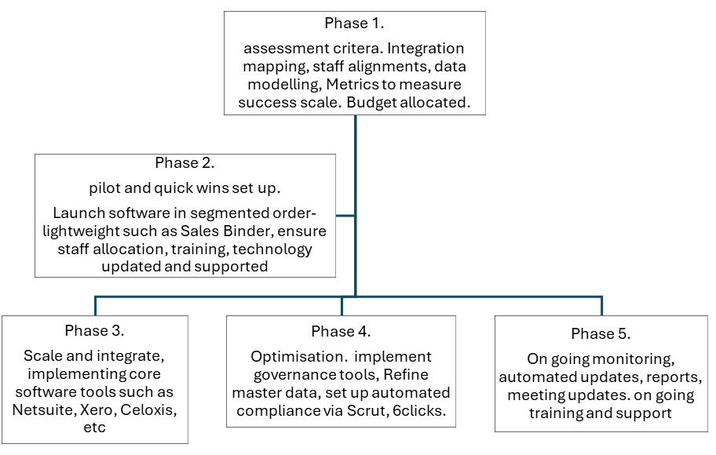
Figure 2: Phased Approach 1-5 to introducing a new information system.
Further Implementation Plan:
- Appoint executive sponsor, project lead, IT lead, data steward and business process owners.
- Security measures and requirements are in accordance with compliance regulations and GDR.
- A proof trial to ensure the software is readily set up and available.
- A mapping tool to aid in seeing which new tool will replace the old.
- Financial mapping and budgeting, including ongoing training, support and any future forecast with a contingency plan appointed if required.
- A visual dashboard showing a timeframe of scalability for this project and a projection of any forthcoming developments.
- Reporting guidance should be adhered to at all times. Capture reporting requirements, KPIs and regulatory controls that must be supported. Collect feedback, measure KPIs, iterate.
- Training support in place for staff to have a deeper understanding of the software and what is required to make scalability rise, also regular briefings to maximise the potential growth. Role‑based training (hands‑on workshops, quick reference guides, recorded sessions).
- Define authoritative owners and policies for updates. Also, ensure automation is set up and checked periodically.
- Deploy systems for one business unit or location; validate processes, performance and data flows.
- Roll out by functional area or region with rollback plans.
- Freeze source data where required, perform final reconciliations, switch to new workflows, and monitor closely. Track issues in a log and prioritise fixes.
- Establish data governance board, cadence for KPI reviews and versioned change control for integrations and reports.

Potential Challenges:

- Data quality surprises: mitigate with early cleansing sprints and throttled data migration.
- Resistance to change; mitigate via visible executive sponsorship, early super‑user engagement and quick wins to demonstrate value.
- Cost and scope creep: enforce a minimum viable product for each phase and use a change control board to enhance control over financial overhauls.
- Compliance and privacy: align data flows with regulatory needs (data residency, retention, consent) and gain controls into design, this can be time-consuming data work, mitigation: early data profiling sprint and fixed‑price migration tranches.
- Vendor lock‑in or hidden licence costs - mitigation: negotiate term caps, review TCO to be at 3–5 years.
- Budget overruns from parallel running systems - mitigation: staged cutovers, decommission plan with ROI triggers.
- Ensure encryption for data security measures, as a transfer of data, infringement can cause problems.

Conclusion.
Implementing the recommended stack - quick inventory and analytics wins followed by staged ERP/CRM, PPM and automated compliance will reduce manual work, improve data integrity and accelerate evidence‑based decisions. A phased rollout with strong governance, role‑based training and robust integration architecture mitigates most risks. Start with low‑effort, high‑impact pilots (Sales Binder, GA4, Databox) to build momentum and prove value before migrating core operations onto an integrated ERP and enterprise analytics platform.
To ensure success, it is critical to appoint a cross-functional leadership team, including an executive sponsor, project lead, IT lead, data steward, and business process owners. Their alignment will drive accountability and strategic clarity. A proof-of-concept trial should validate software readiness, while a mapping tool will clarify legacy-to-new system transitions. Financial planning must encompass training, support, and future scalability, with contingency buffers built in to absorb unexpected costs.
Security and compliance must be embedded from the outset, aligning with GDR and regulatory frameworks. Encryption protocols and data residency controls should be designed into the architecture. Reporting guidance must be rigorously followed, with KPIs and regulatory metrics captured, reviewed, and iterated upon. A visual dashboard will help stakeholders monitor scalability timelines and anticipate future developments.
Training should be role-based and continuous, combining hands-on workshops, reference guides, and recorded sessions, to foster adoption and reduce resistance to change. Deployments should begin with a single business unit to validate performance and data flows, followed by, phased rollouts with rollback plans. Source data should be frozen where necessary, reconciled, and transitioned to new workflows with issue tracking and prioritised fixes.
Finally, establishing a data governance board, cadence for KPI reviews, and versioned change control will ensure long-term sustainability. By addressing risks such as data quality, cost creep, and vendor lock-in early, the organisation can maintain control and deliver a scalable, secure, and future-ready digital transformation.

References.

Alberto (2025) What is Operational Challenges Management?, Business Case Studies. Available at: https://businesscasestudies.co.uk/what-is-operational-challenges-management/. [ Accessed on 11 Oct 2025]
Ayuya, C. (2024) 10 Best Reporting Software and Tools of 2024, TechRepublic. Available at: https://www.techrepublic.com/article/reporting-software/.
[Accessed on 15 Oct 2025]
Crawford, H. (2025) Best Inventory Management Software of 2025 - NerdWallet, NerdWallet. Edited by R. Lane. Available at: https://www.nerdwallet.com/business/software/best/inventory-management-software?msockid=01fa311c26126d600bd22411279c6c51
(Accessed: 10 Nov 2025).
Expert Panel (2025a) 19 Common Challenges Businesses Face When Trying To Scale Operations, Forbes. Available at: https://www.forbes.com/councils/forbesbusinesscouncil/2025/05/02/19-common-challenges-businesses-face-when-trying-to-scale-operations/.
[Accessed on 11 Oct 2025]
Gray, P. (2025). 22 Best CRMs With Inventory Management Reviewed. [online] CRO Club. Available at: https://croclub.com/tools/best-crm-inventory-management/
[Accessed 19 Oct. 2025].
HubSpot (2025). 7 Best CRMs for Retail Businesses in 2025. [online] HubSpot Blog. Available at: https://blog.hubspot.com/marketing/best-crm-for-retail
[Accessed 17 Oct. 2025].
Initus (2025). Integrating POS Systems with Inventory Management and CRM Software in Retail. [online] Initus.io. Available at: https://initus.io/blog/integration/integrating-pos-systems-with-inventory-management-and-crm-software-in-retail/ [Accessed 14 Oct. 2025].
ICO (2023). Guide to the UK General Data Protection Regulation (UK GDPR). [online] Information Commissioner’s Office. Available at: https://ico.org.uk/for-organisations/uk-gdpr-guidance-and-resources/ [Accessed 22 Oct. 2025].
Sigma Solve (2025). How to Choose the Right CRM System for My Retail Store? [online] Sigma Solve INC. - Leverage our Technology Consulting to Empower your Business : Hire an Enterprise Solutions Expert. Available at: https://www.sigmasolve.com/blog/how-do-i-choose-the-right-crm-system-for-my-retail-store/. [Accessed on 20 Oct. 2025]
Stojanovic, F. (2024) 8 Best Reporting Tools in 2024, Databox. Available at: https://databox.com/best-reporting-tools.
[Accessed on 17 Oct 2025]
team, H.E. (2023) 11 Practical Solutions to Overcome Operational Business Problems - HogoNext, HogoNext. Available at: https://hogonext.com/11-practical-solutions-to-overcome-operational-business-problems/.
[Accessed on 13 Oct 2025]
TheKnowledgeAcademy (2025a) Top 13 Compliance Tools You Must Know, Theknowledgeacademy.com. Available at: https://www.theknowledgeacademy.com/blog/compliance-tools/.
[Accessed on 27 Oct 2025]
TheKnowledgeAcademy (2025b) Top 25 Data Management Tools in 2025, Theknowledgeacademy.com. Available at: https://www.theknowledgeacademy.com/blog/data-management-tools/.
[ Accessed on 25 Oct 2025]
Vaxman, A., 2023. Eight steps for finding the right information systems for your growing business. Forbes. [online] Available at: https://www.forbes.com/councils/forbesbusinesscouncil/2023/04/04/eight-steps-for-finding-the-right-information-systems-for-your-growing-business/ [Accessed 13 Nov. 2025].

