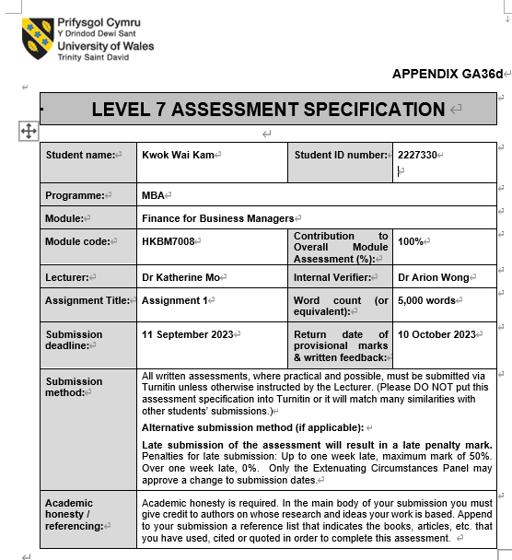

New Investment Plan of
Lukook Jewellery

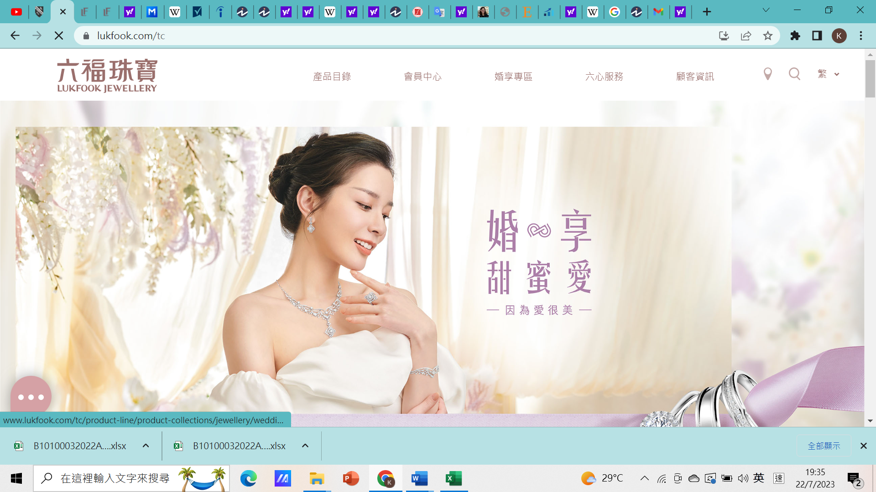

Kami, Kwok Wai Kam
2227330

11th Sept 2023

Executive Summary

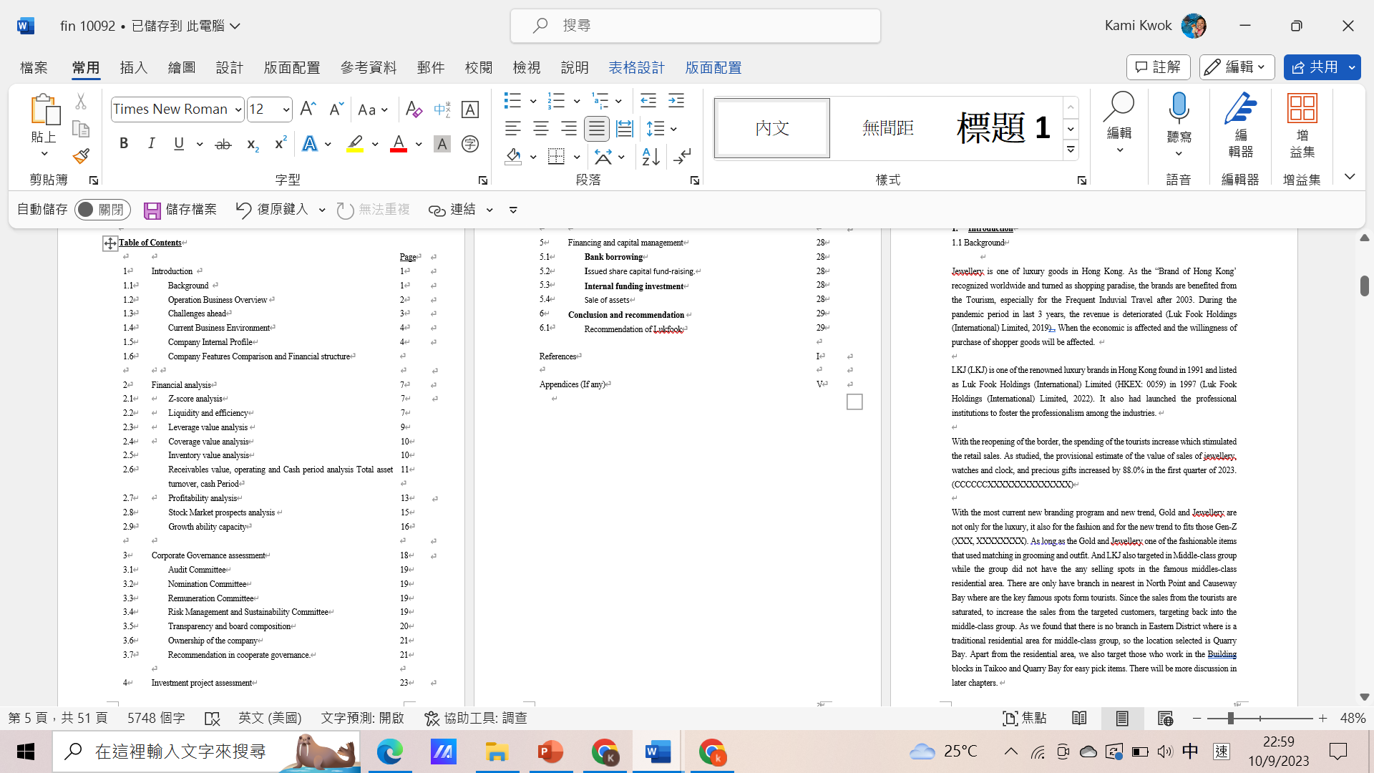

- Introduction
  - Background

"Brand Hong Kong" that is a confidence as shopping paradise and it is welcome by tourism, especially China since 2003. In epidemic period, revenue decrease (Lukfook Group (International) Co., Ltd., 2023). When the economy is sluggish, shoppers’ willingness to buy is affected.

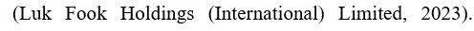
Listed in 1997 named Hong Kong Luk Fook Holdings (International) Limited (HKEX: 0059, Lukfook Jewellery (LKJ) found in 1991 positioned as renowned luxury brands. . It also had launched the professional institutions to foster the professionalism among the industries. 7

As borders reopen, tourist spending increases which stimulating the retail in sales. Sales of jewellery, watches and luxury gifts are initially estimated to grow 88.0% in the first quarter of 2023, research shows. (CCCCCCXXXXXXXXXXXX)

With the most current new branding program and new trend, Gold and Jewellery are not only for the luxury, it also for the fashion and for the new trend to fits those Gen-Z (XXX, XXXXXXXX). As long as the Gold and Jewellery one of the fashionable items that used matching in grooming and outfit. And LKJ also targeted in Middle-class group while the group did not have the any selling spots in the famous middles-class residential area. There are only have branch in nearest in North Point and Causeway Bay where are the key famous spots form tourists. Since the sales from the tourists are saturated, to increase the sales from the targeted customers, targeting back into the middle-class group. As we found that there is no branch in Eastern District where is a traditional residential area for middle-class group, so the location selected is Quarry Bay. Apart from the residential area, we also target those who work in the building blocks in Taikoo and Quarry Bay for easy pick items. There will be more discussion in later chapters.
  - Operation Business Overview

LKJ found by the Chairman, Mr., Wong Wai Sheung and Ms. Pauline Yeung, the champion of “Miss Hong Kong Pageant” in 1987. She had been an icon of LKJ for years till 2019. The image of dignified, elegant, smart, and well-educated, a more privileged icon had been footprinted in the mind of the customers. LKJ sponsored the competitions since 1993 and the special icon presented the new woman in this era. Brave, confident, independent, and strong, complementing femininity. The brand targets the mid-to-high-end class who are more willing to spend money on clothing.

Licensing, retailing, and wholesaling, retailing are the major sources of the revenue. The branches located mainly in Eastern Asian countries over 2900 shops. Apart from direct selling the gold and jewellery in their self-operating shops, there are also franchised shops especially in Mainland China to sell the products. LKJ had penetrated the mainland China in 1994, the branches more than 165 till 31 March 2023. There are increasing needs in Gold in the brand of Hong Kong Brand. Besides, there are also branches in Europe area and southeast Asia other than China.

Other than selling the products of gold and jewellery, LKJ is recognized institution to verify and proof the jewellery. Identification services for diamonds, emerald gemstones and jewelry provided by China Gemological Laboratory Co., Ltd. provides while Professional training in jewelery appraisal provided by the Victoria Gemological Institute Limited. This certification is to prove the value of the jewelry launched by Lukfook Group. It also has a training institution to provide employees with corresponding knowledge.

LKJ has a property investment in Hong Kong and China. According to annual report, there are around 10% from the total assets are the investment properties in Hong Kong and China, total has 11 properties for whole lease out.

As at year ended in 2023, the rental income is $ 62.244 million as compared with 2022 is 55.491 million So, the difference in incomes is not too much concentration in the profit in table 1.
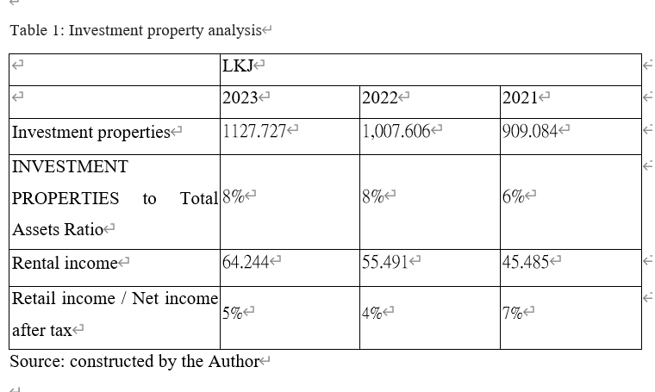

1.3 Challenges ahead

The number of tourists stay steady as 2018 in average of 200000 per months after the re-opening of the border from China. It had been an importance source of income as mentioned in annual report. Other than that, ccc(cXXXXXc) revealed that the impulse of the spending for locals are low. Locals are preferring to travel after release the travel restrictions with 3 years-long locked in Hong Kong, especially Hongkonger are travel lovers who travel (XXXX) or prefer to have a short trip to have spending in Shenzhen. (XXX). These trends will affect the atmosphere of spending in Hong Kong. There might be useful when the stimulus vouchers launched last year (XXX). However, it just has a slight increase showed in the revenue.

1.4 Current Business Environment

As the time of covid-19, the cities are locked down and the countries restricted tourists to travel. The economic had a big hit ever on this century. As the Jewellery is one of the shopper goods that the tourists, while the new trend of the tourists changed to experience in different cultures and experiences in Hong Kong. So, the traditional way depends on the spending of tourists which no longer sustain.

The sales growth rate had been decreased to only 2% in 2023 and recorded a decrease 6% in 2022, while in 2022 is 14.9 % in 2021 and 14.7% in 2020 before the epidemic.
As mentioned in previous section, the sales from the market of China sharing nearly half of the whole group in 5,392 million in 2023 while more than half of the whole group as 57.1% in 2022. It shared 59.9% of the sales revenue of the whole group in 2021 which revealed that the importance of the China market for the whole group instead of local markets.

There is a chance to discover another way of sales.

1.5 Company Internal Profile

As on 31 March 2023, there are 6,000 employees which remain the same as 2022. There is 1:2.3 ratio in male to female in 2022. And it is more than 90% are middle management to front line staffs with 8% is the top management of the company. The workforce is energetic as more than 50 % aged below 39 years old and even in top management is one out of 4 from the segment aged below 59 years old. LKJ regularly review the remuneration and benefits in order keep competitive in the market. With providing training to their employees, to equip them with the qualification which align with the government assurance course in QF2 in Advanced jewellery knowledge certificate courses, High-quality service and jewellery knowledge certificate; and to further foster their ability courses in Coach-style leadership skills courses for shop managers are launched.

Throughout the markets, there are two competitors have similar structure with LKJ. These are Chow Tai Fook (CTF) and Tse Sui Luen (TSL) in the same jewellery industry which will always use in comparison to LKJ. These are the summary of the comparison of the listed companies:

1.6 Company Features comparison and Financial structures
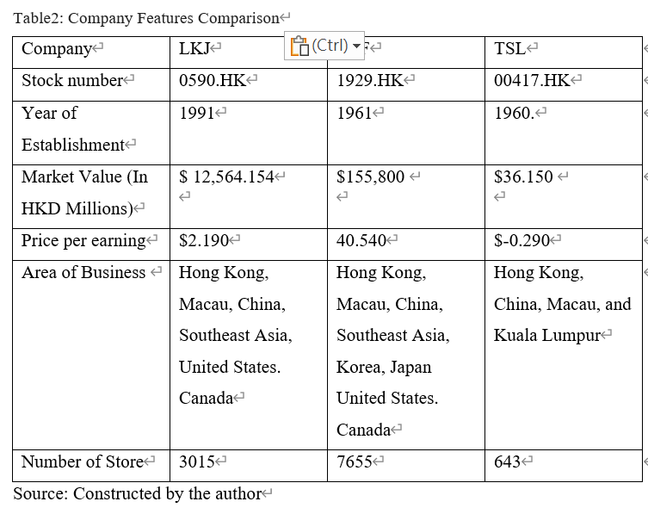
Increasing demands in the use of financial analysis tools to control the overall conditions of financial status and make their investment decisions. Peterson and Fabozzi stated (1999) useful information can be provided by the financial statements in evaluating the company's future. By analyzing the current situation of these companies and assess risks, future predictions can be made through the annual financial reports.

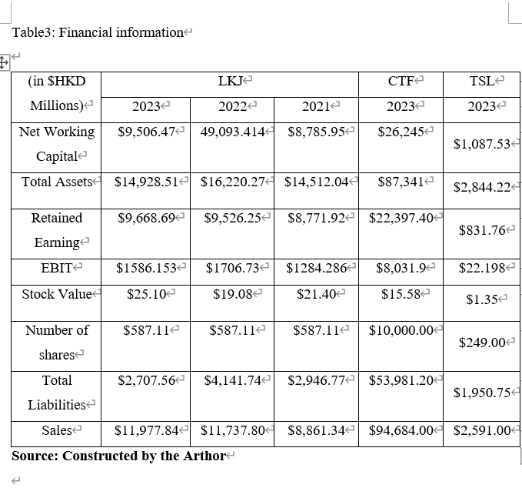

- Financial analysis

2.1 Z-score analysis

Extreme Forecasting Models should be useful to analyze the healthiness of the company in the financial statements. The well-known models are the Altman Z-score model (XXXX). Below 1.81 in the score shows the company has a higher chance to go bankruptcy while it falls below 2.99, that falls in dangerous gray area. While the score is above 2.99, that is less likely to go bankruptcy. Friedlob and Schleifer (2003) explained if the 5 scores ​​(A-E) in the ratio also valued low, the companies are unlikely to avoid the chance of bankruptcy.
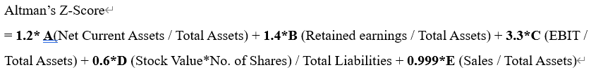
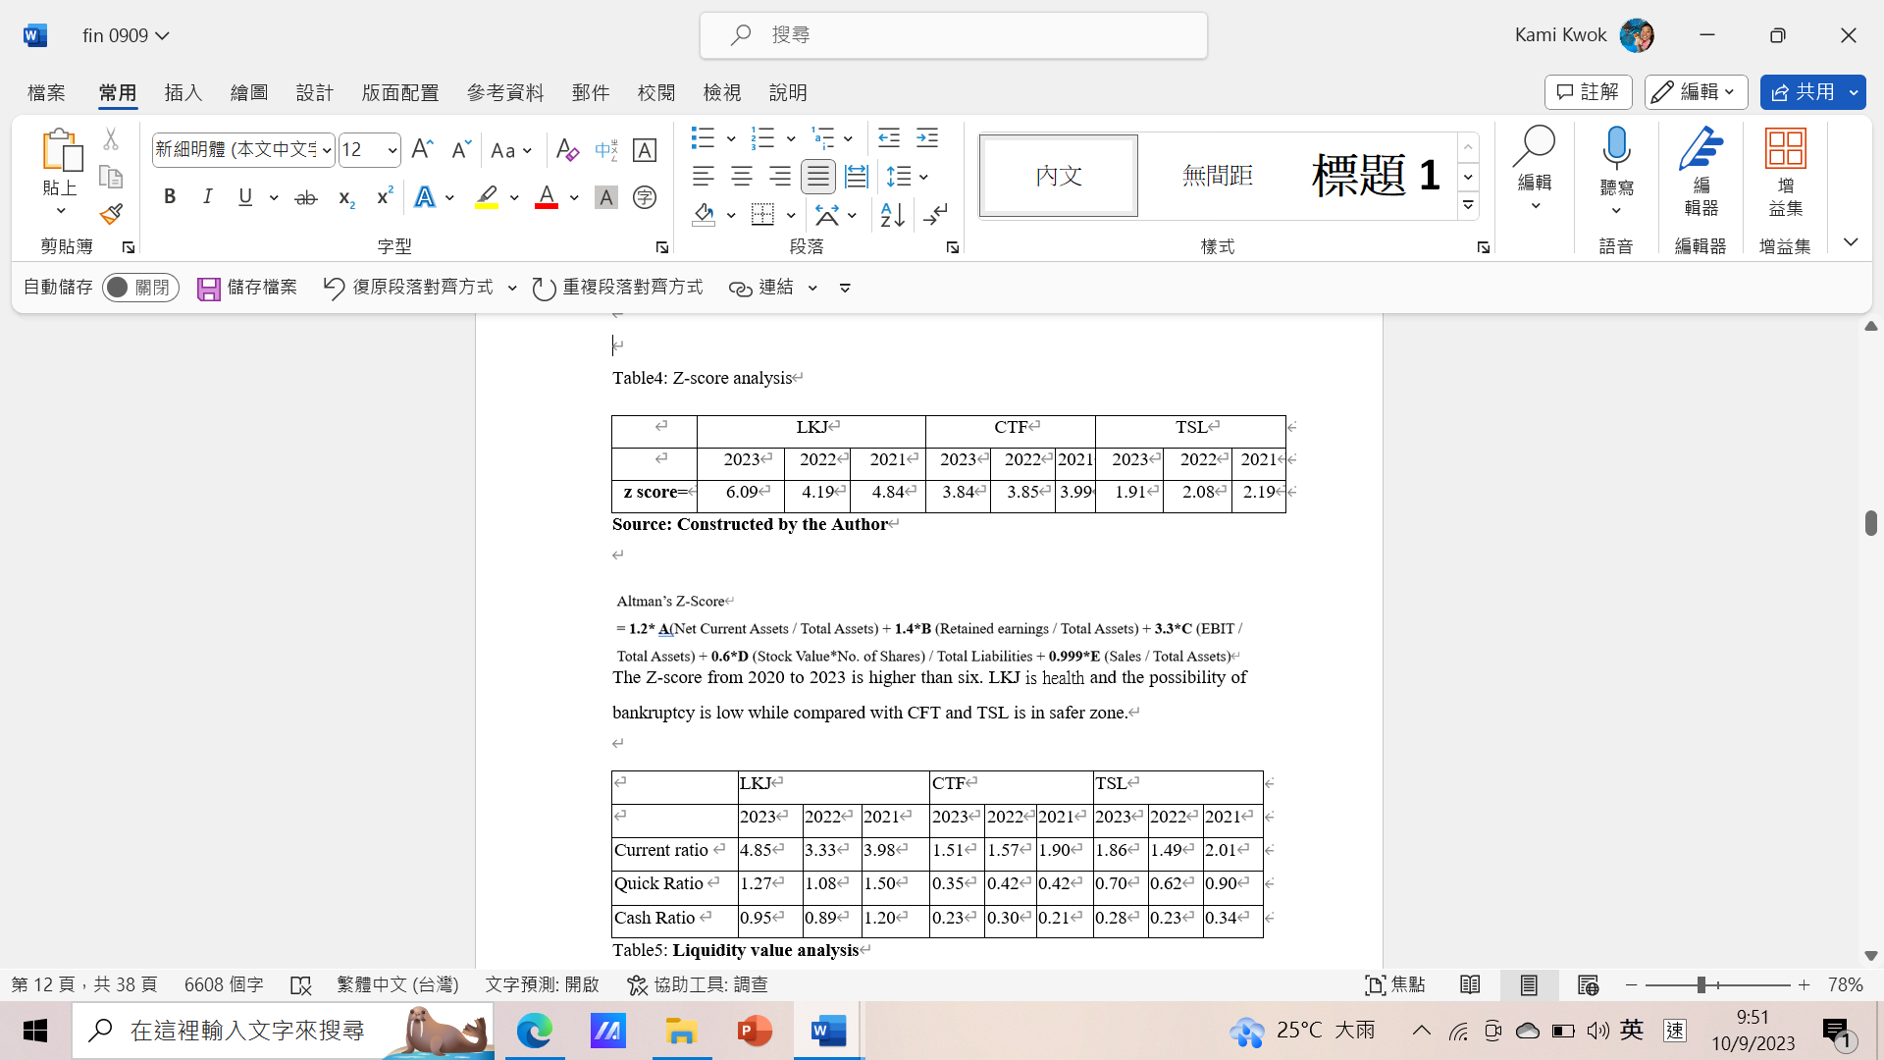

The Z-score from 2020 to 2023 is higher than six. LKJ is health and the possibility of bankruptcy is low while compared with CFT and TSL is in safer zone.
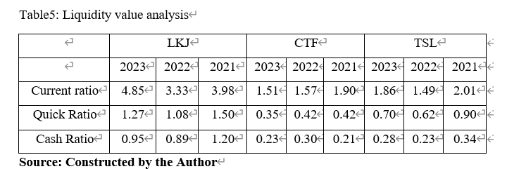
Current Ratio – Mohammed and Kim-Soon (2012) explained the company’s ability to repay its debts next year depends on its current ratio which measures financial liquidity, a high ratio can indicate that the company has a good liquidity position. Even compared to other companies, LKJ has a good liquidity position. Improved from 3.98 in 2021 to 4.85 in 2023. (table 5)

Quick Ratio - Warrad (2014) mentioned that performance in liquidity can be measured more accurately. A difficulty converting into cash quickly to pay the short-term liabilities showed in low ratio. LKJ has good liquidity performance compared to CTF and TSL.

Cash Ratio – Ismail (2016) explained the ratio shows the company's ability to use cash and investments to pay its current liabilities. LKJ's is not changed profoundly between 2020 and 2022. Although the cash ratio has declined compared with 2020, its ability to pay current liabilities is not strong compared with CTF and TSL.

After overall analysis, LKJ in the above the ratio is better than the industrial standard level.
2.2 Leverage value analysis
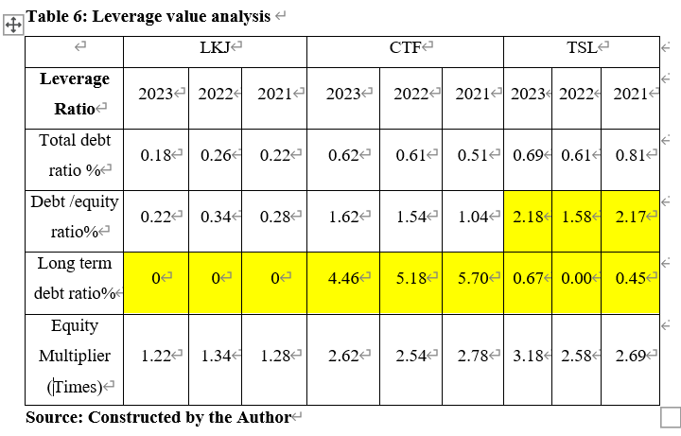 Total Debt Ratio –It shows the portion that financed by creditors to total assets (Nindiani and Arylyn, 2019). The company is financially risky while the ratio is high. Looking at the three listed companies, LKJ is still more competitive than other companies, however declined from 2022 to 2023.

Debt/Equity – The ratio of borrowed funds increases when the amount increases. When a company relies on debt financing, its capital should decrease, and creditors face considerable risk which implied the company may not be able to repay). LKJ is between CTF and TSL. Therefore, LKJ suggested not borrow money to invest in operating their business.

Long-term debt ratio - A lower value indicates that the company has a lower degree of debt capitalization and less financial pressure to repay long-term debt. LKJ declined between 2021 and 2023, while other companies saw significant growth. I believe it was affected by the epidemic.

Equity Multiplier - A low index means company can pay its asset with more equity and less debt (investopedia, 2022). It shows the average of the Equity multiplier is 1 in LKJ, 2.5 in CTF， 3 in TSL in the table 6. It shows LKJ has a good use of the assets.

2.3 Coverage value analysis
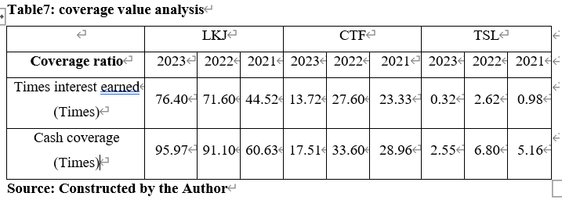
Time to Earn Interest – Farah and Amin (2021) mentioned it measures the number of times a company can pay interest charges. Compared to the other two companies, LKJ can cover interest payments in all years. In 2022, there have been about 27 times in CTF which is far apart from LKJ.

Cash Coverage – A company can pay all the debt by earned profits or its capital. As shown in Table 7, LKJ's value is 95.97 times its liabilities payable, and its value is much better than CTF and TSL.

2.4 Inventory value analysis
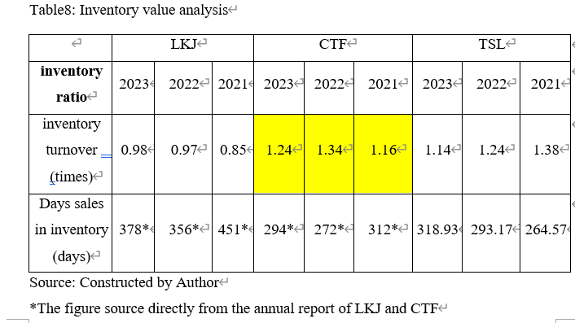
Inventory Turnover - Times that inventory sold and replaced in a certain period. Sold quickly to increase profits will shows as High value means (Amanda, 2019). Compared with peers, LKJ’s valuation is low at 0.98, which is not good enough even for CTF and TSL. It may be affected by the epidemic and Hong Kong's economic downturn.

Day’s Sales in Inventory – Bagais and Aljaaidi (2021) mentioned the average number of days that company needs to take in conversion of inventory into revenue. LKJ about a year to complete the sale of its inventory. Compared with CTF and TSL, the inventory completed sales is about half of LKJ’s.

2.5 Receivable value, operating and cash period analysis
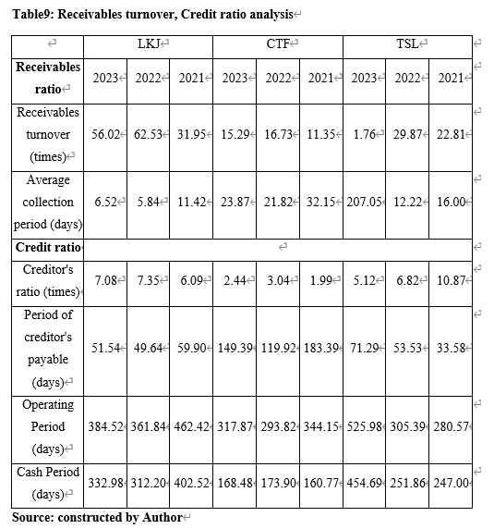

Receivable Turnover – A measurement in times that the ability of accounts receivable can converted into cash during a specific period which showed in number of times a company collects accounts receivable each year (Purwanti, 2019).4 LKJ is 56.02 times per year in Table9.

Average Collection Period - The time takes for a company to receive payment after a product is sold. When period short revealed low in the probability of bad debt. LKJ used 6.52 days showed in Table 9. When compared with other 2 companies, LKJ is still fewer days to receive the payment.

Period of Credit
Longer period needed in the same industry means postponed paying its creditors. Table 9 shows that the company is. LKJ is 51.54 days shorter than CTF and TSL. If the days become shorter, the credit rating should get a better rating.

Operating period -
LKJ’s operational period increased from 2021 to 2023 and decreased a little bit in 2022. Compared with CTF and TSL l, LKJ nearly a double as long as CTF but shorter than
TSL in the aboved Table.

Cash period -
The days that the company needs to keep cash in maintaining the operation. LKJ has 332 days to maintain the company operation which is longer than the CTF but shorter than TSL as showed in Table9.

2.7 Profitability analysis

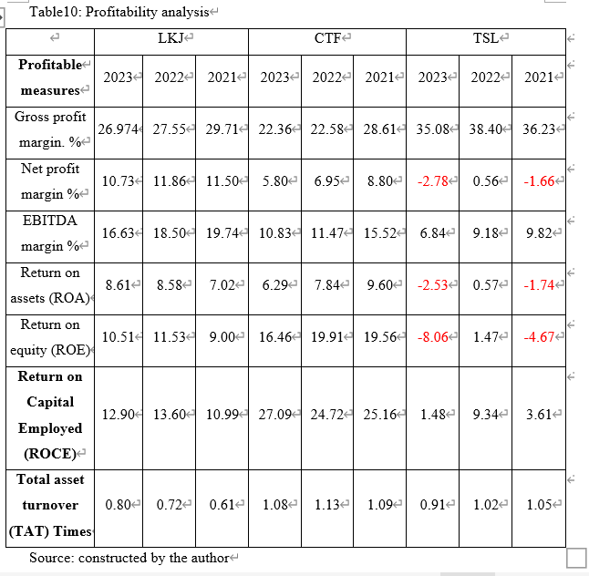

Gross Profit Margin - The higher the rate, the profitable of the company. LKJ can keep the steady gross profit rate from 2020 to 2022 as compared to CFT but lower than TSL.

Net Profit Margin - Only by better controlling income, costs, expenses and taxes can achieve high net profits and ensure sufficient funds for survival and development.. LKJ still has a change the net profit margin from 11.86% in 2021 to 10.73% in Table10, however, the ratio is fewer than LKJ almost a half. LKJ had a good use of the financial reflects the attempt to control costs in the pandemic.

EBITDA margin – The higher value in earnings, the more stable of the busimess. LKJ has a stable value of EBITDA margin in 2021 to 2023 and similar to TSL.

Return of Assets – The efficiency of the company using its assets to generate profits (Strouhal et al, 2018). Profits used more effective and efficient, ROA goes higher. However, LKJ has a low rate of ROA in 2021, but it improved on years to 8.61 in 2023 showed in Table10 but it shows the better profit productivity among the competitors.

Return of Equity – It reflects the wellness in utilization of the investments in the company (Purnamasari, 2015). Compared with the three companies, LKJ has a lower rate in 2020, but the investment generate more profit than TSL.

Total asset turnover -Firms that use their assets to generate revenue are relatively efficient (Sunjoko and Arylyn, 2016). CTF's business operating efficiency is higher than LKJ and TSL. The value in 2023 is 1.08, which is higher than LKJ in 0.8 and TSL in 0.91. This may indicate that LKJ and TSL are has a large amount of fixed assets.

2.8 Stock Market prospects analysis
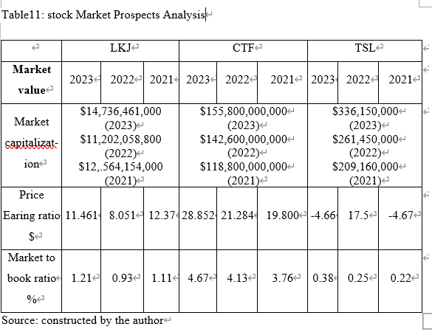

Market Capitalization -
Most investors take advantage of stock prices to increase the wealth generated by companies (measured by market capitalization) (Joshi and Hanssens, 2004). TSL is more valuable than other in from 2021 to 2023. There are decrease in 2021 to 2022 for LKJ and CTF, but the stock values increase in 2023. It shows the effects of the cofid-19 time. However, LKJ is the lowest stock values among the companies.

PE ratio - An investment strategy that indicates market predictions of future growth and risk (Wu, 2014). A high P/E ratio reflect investors' expectations of high future growth rates, or that the company's stock is overvalued. LKJ ratio is much higher than TSL but lower than CFT.

Market to book ratio -
A company is considered overvalued if its market value is higher than its book value per share, vice versa. In comparison, LKJ is same value as book value in 1. It showed that CTF is undervalued in 2021 to 2023 while TSL is overvalued. This ratio gives investors and analysts to do comparison between a public company's true value and investors' speculative value.

2.9 Growth ability capacity

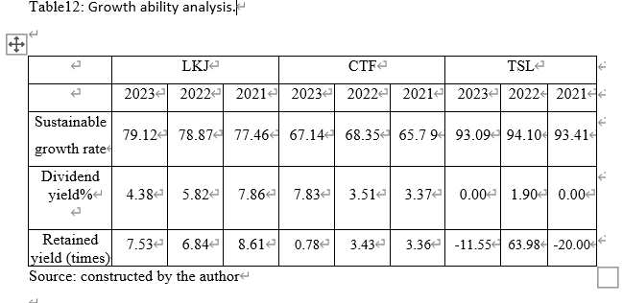Sustainable growth rate – assumes that the company can fund its growth opportunities using retained earnings and new debt (Chen et al., 2021). The LKJ's Sustainable growth rate is higher, but lower than its competitors. LKJ's average interest rate is at an industry-leading level. LKJ continues to maintain a higher interest rate, and internally generated funds can be expanded to new products or other products while TSL rating nearly 100%.

Dividend yield-
Once shareholders have invested their money, it should be paid out to shareholders to maximize their wealth (Azhagaiah and Priya, 2008). As Compared to CTF, LKJ has a poor dividend yield while good performance when compared to TSL. It would be th effects of the COVID-19.

Retained yield -LKJ is based on retained earnings and profit after tax. Increased by 0.68% from 2022 to 2023 and indicator exceeded CTF by 6.74 times more and 19.08 more in TSL. LKJ needs to pay dividends to shareholders to gain shareholder support; also needs to keep some reserves to grow the business. The rate of return remained at a reasonable level as the sales revenue grows at 2%.

3. Corporate Governance
Corporate governance is a set of rules, practices and procedures designed to enhance efficiency and achieve the long-term success of the Company (XXXX) by reducing misconduct and avoiding risks, thereby safeguarding the interests of all stakeholders. There are 3 committees under corporate governance. The Audit Committee was established to review the Company's financial information and oversee the reporting system and internal control procedures to ensure appropriate reporting and adequate internal controls. The Remuneration Committee is responsible for making recommendations on the remuneration policy and structure for all directors and senior management. To review the structure, size and composition of the Board and to consider the succession of directors and other senior management is the role of nomination committee.

Table 13: structure of Lukfook Jewellery
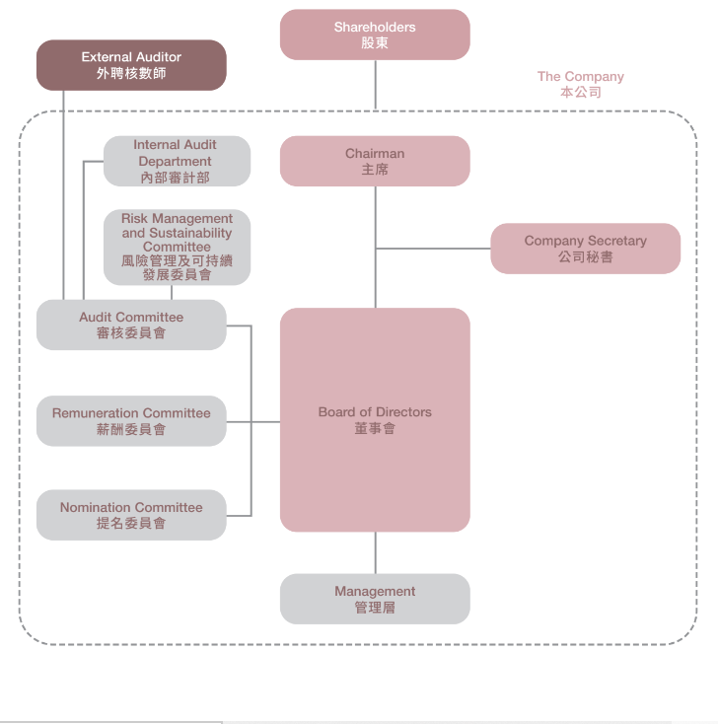
Source:

As shown in the Table 13, leading the Board of Directors in formulating strategies and achieving goals, and ensures that all directors are fully aware of issues arising in Board meetings and receive sufficient, complete and reliable information is the role pf the chairman. CEO is given the authority and responsibility to run the company's business and implement company. strategy to achieve business result. Board of Directors leading the 3 committees to form and control the operations of the company which will be discuss in next section. Besides, board of directors guiding the top management to run the business.

3.1 Audit Committee
This committee is to do risk management that governance the procedures of the group not to invove in those interest -risking activites to all the stareholderd. Committee members are independent non-executive directors. Regular preparation of financial statements and examining financial judgments beforehand, and to monitor and review the external auditor’s performance.

3.2 Nomination Committee
Considering succession planning for directors and senior management, identifying p呎professional and qualified board members and assessing the independence of independent non-executive directors. Regular reviewing the structure, size and composition of the Board in skills, knowledge, diversity and experience, and providing recommendations to the Board, to achieve balance and appropriate qualifications for the Board.

3.3 Remuneration Committee
Providing the recommendations on remuneration policies and structures for above the Board and management level staff to ensure that the competitive Remuneration for qualified individuals.

3.4 Risk Management and Sustainability Committee
It provides a systematic and standardized approach to the risk management process and implement the internal control system as an integral part of corporate governance. The goals include establishing and improving a risk management system to ensure the identification and assessment of risks. Manage risks to the achievement of corporate objectives to advise and assist the Board on the strategy and implementation of the Group's sustainable development and the assessment of associated risks.

Table 14: Risk Management Framework
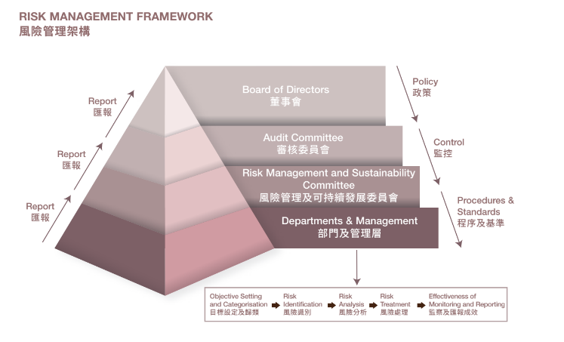
Source:

3.5 Transparency and Board composition
The board of directors consists of 12 directors, including 4 executive directors, 4 non-executive directors and 4 independent non-executive directors. There are more non-executive directors than executive directors, in order to balance and strike for the interests of shareholders and the group. There are 1/4 of the director and 1 to top management are from the ame family. Even though the group explore the relationship within the Wong’s family. However, public may concern the family can control over of the company, as hidden information can transfer under the table resulting lack of transparency.

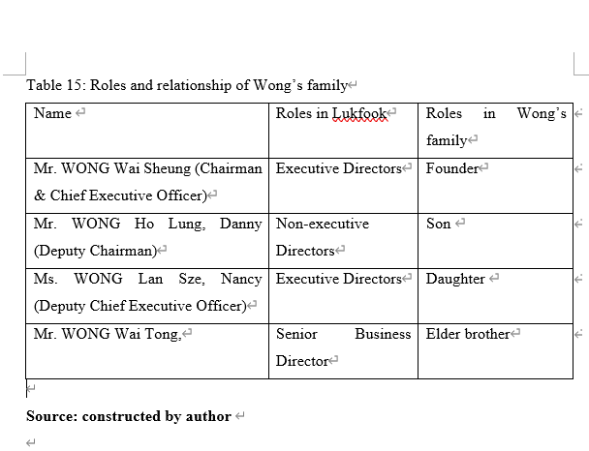
3.6 Ownership of the company

Besides, the majority of the shares are owned by the Wong’s family as showed in the report. It revealed in the annual report, more than 46% of the shares hold by the wife of the CEO which have been clearly stated in the transparency part. And there rest of the fund is holding by the foundation also owned by the Wong’s family.

3.7 Recommendation in cooperate governance

- Public interest at risk. It is known that LJK is the grown from a family business, while it goes public and liable to its shareholders. It is a risk on the interest of the public as the entire family can control the operation of the company because there are assumptions that the hidden information may exposure under the table and cannot reach a consensus internally. This is a lack of transparency. Thus, the recommendations are the board should be only involved half of Wong’s family members and hired other professional. This can eliminate the concerns of the public by the board members can examine and monitor each other.

- It is known that the family would like to control their own business. However, for the sustainability of the business, the major ownership of the business should be release. (XXXXXX). Besides, public may afraid of the family will control the business through the selling and purchase of the shares that affect the shares price resulted the loss of the minority shareholders. This will greatly decrease the willing of the public to have the shares. Thus, it will affect the portion of the investments.

4. Investment Project Appraisal

LKJ plans this year to open a new branch in the Eastern district. The retail shop area of 1000 square meters, the company program rent store for long-term use, the property used for 50 years. The funds3.9 million (for 2023 turnover) Greenwald, Kahn & Sonkin, 2005) stated use a different financial ratio in evaluating the investment assessment.

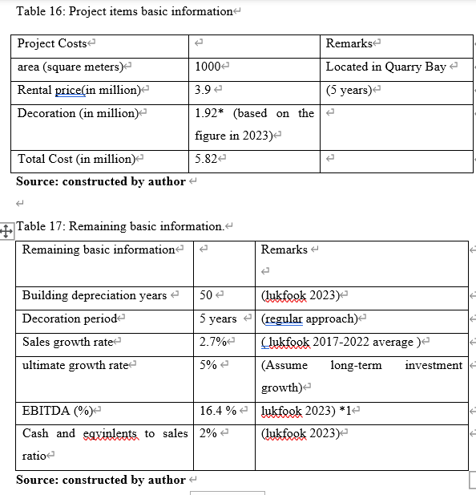

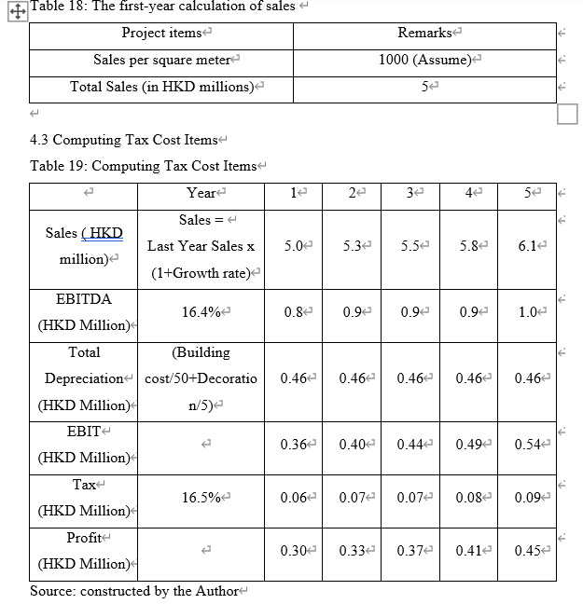
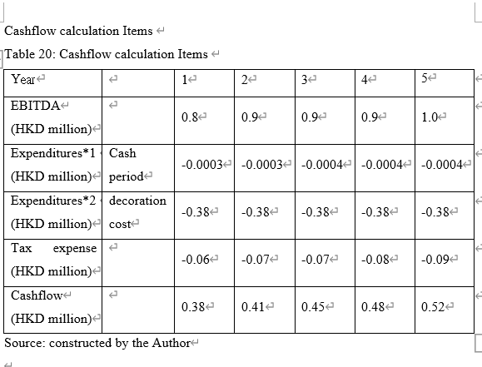Note 1)Working capital the first year calculation => annual direct sales x (cash and equipvents to sales ratio/total number of shops)
Working capital for the rest calculation =>the previous year working capital x(1+Sales growth rate)
Note 2) assumption for expenditure to pay for the annual decoration cost, about 1.92 million/5 year = 0.4 million per year
Note 3) Cashflow after 5 years, using the assumption the ultimate growth (Appendix 8

calculation of NPV / PBP / IRR / PI / ARR
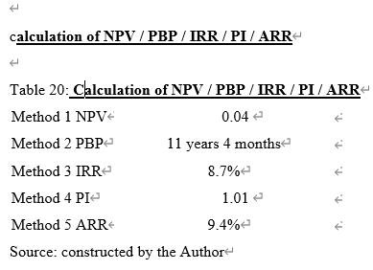
Although the cash flow are negative in the first 5 years, however it comes to profit when the projects in 27th year with assuming the inflation rate is 2.3%. (XXXXXXXXXXXX). And it is expected 2.3 % is the same in coming years.

Net Present Value (NPV)
Several different criteria are using in economic benefit measurement and decision-making for the project evaluation, Marchioni & Magni (2018) stated Net Present Value (NPV) is defined as the most dependable tool. The effectively measures the growth of investor value, In this new project, the NPV is 0.04 million HKD In Table 20, this positive value is accepf i gurefor the investment

Payback period (PBP)
Payback period calculates the duration of time to offset the initial investment's cost while it ignores the cash flow beyond the date. That should be to apply a cutoff date while using this measurement. (Dai et al, 2022). This project will take around 11 Years 4 months to recover the initial cost, the period is medium due to this project requiring running 27 years instead of 50years.

Internal rate of return (IRR)
IRR is commonly used to analyze individual items while NPV is preferable as more compatible. However, NPV is sometimes favored by investors because calculate the cash flow of investment costs and the amount of reinvests. Furthermore, IRR is also used in provides the answer in percentage form and is easy to understand (Arshad, 2012). The IRR of this project is 8.7% in Table 20, and the value is not high, so it is more inclined to evaluate the NPV value. However, if the IRR is high enough, then evaluation may be worthwhile.

The profitability index (PI)
It is an important metric that illustrates the costs and benefits of a project in terms of revenue. At this value, a measurement of 1 is considered the minimum value, with higher values ​​being better. John, Dabas, & Naseem (2014) stated that it is not worth to investi in the value is less than 1. For this project of establishing a new sales store, the PI is 1.01, which is a positive value, so LKJ should start running this project based on the strategic of the company.

Accounting rate of return (ARR)
The accounting rate of return is to use the capital cost of the project to evaluate the annual average net rate of return of the investment project. Normally the practice will choose a project with a high rate when the project is beneficial. The rate of return in the ideal project. This project has a value of 9.4 % and is suiTablefor investment.

Which one is better? Why

5. Financial Management of Funding
LKJ has now committed an extra 5.82 million HKD (or X% of the total assets in 2023) to plan the outlet store for the new projects. The advantages and disadvantages of LKJ’s financial management methods will be discussed.

  - Bank borrowing
LKJ can find preferred banks to borrow money for the project. The initial cost of this project is not very large. Therefore, they can easily borrow funds from banks. Banks can offer loans with p(CCCC) of 8.7% p..a.As studied through the financial statement, there are no long-term liabilities, this method would be used. The funds are not too much and do not have much impact on liquidity.

  - Issued share capital fund-raising–
This is also one of the ways to increase funds for this new project. They can conduct a secondary public offering to the public. The move is good news for the company while the percentage ownership declines as the shareholder base grows in the perspective of initial investors as acquired their shares through an IPO. Shareholding ratios are affected by dilution. The price of the stock and the attitude of the original investors will be negatively affected.

  - Internal funding investment –
Internal retained earnings and cash are also the sources of funding. According to the annual reports from 2020 to 2023, the retained earnings and cash are both positive Generally, the cash ratio should be above less than 10%. When the cash ratio is low, companies will face risks such as being unable to pay loan interest on time, repay debts, and fail to meet financial needs in daily production operations and emergencies. Therefore, LKJ may be taking risks if they use internal funds to make further investments.

  - Sale of assets
LKJ has investment property which rate in total assets which below 10 % within 3 years and it is not significant. And it initial investing cost is just 5.82 million, if sell for the investment property, there will be not significant changes in all to total assets ratio. Besides the rental sale on the net income after tax also rate below 10% which will not increase the pressure of the profitability.

In conclusion, sell in investment properties to increase the funding would be a better choice to gaining fund within big changes in other financial conditions. Especially in the liquidity and the Profitable.

6. Conclusion and Recommendation
As a result, the project will be process. The project management will be used in oversee the project. Gantt charts is a popular management tool which is easily to understand and easier to manage. It can provide an efficient way to present basic data and workflows (Wilson, 2003). Therefore, the project manager will manage different tasks and work with different parties based on the Gantt chart.

6.1 Recommendation of Lukfook

As board approval was required in open the sore in selected location in Quarry Bay. The plan is to align with the targeting market in middle-class level. There are two types of market would like to attract: one is those who live in those traditional middle-class residents and the executives who work in the blocks of commercial quarters that need to have an ad-hoc jewellery to match their outfit for a better glooming for a sudden meeting. By increase in the selling channel with its outstanding image, it is believed that there will be attractive in an ad-hoc and personalized experience in Quarry Bay. Therefore, the first step is to rent a suiTable store in mid-Oct-2023. In the meanwhile, the fund needed to obtain in selling the properties to be approval from the board of directors. And there may be need some time to negotiate with the purchaser on the process and the fund may takes time to obtain as the process and the procedures in acquisition around 2 and a half months.

As there are easy to find a suiTable location now as there are many vacant stores, so at least two months are needed to obtain the store in the market. (XXXX). As LKJ have a nominated renovation contractor, it will take one month and a half to finish the decoration and renovation works. Finally, the time period would be align with the fund obtaining process.

Since the effect of post COVID era and the effects of immigrants wave is still affecting the local market, it is not easy to hire skilled employees from outside. This location is used for a quick sales and pick-and-go experience shop, and used to have skilled will be more suiTable than new fire. So arranging the current staffs in the other operating stores. As the store select is just around 1000 sq ft is not large in size, so there are only 12 staffs in operations.

The project manager needs to coordinate the various tasks in the project and work with different departments to make the project run smoothly within 3 months to catch up with the 4th quarter sales trend which before the occasion of Christmas. The tasks should complete on time fix to the schedule. In addition, certain risk management should cbe applied for any delay or any crisis may arise. There should be certain solutions should be by communicating with corresponding.
Gantt Chart

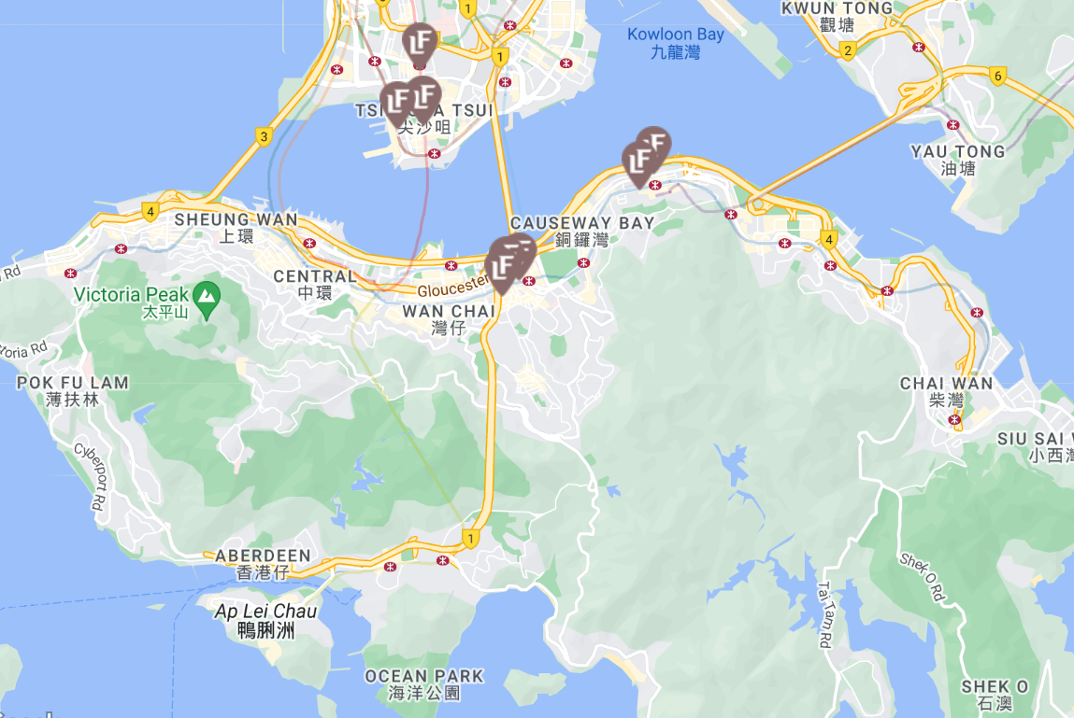
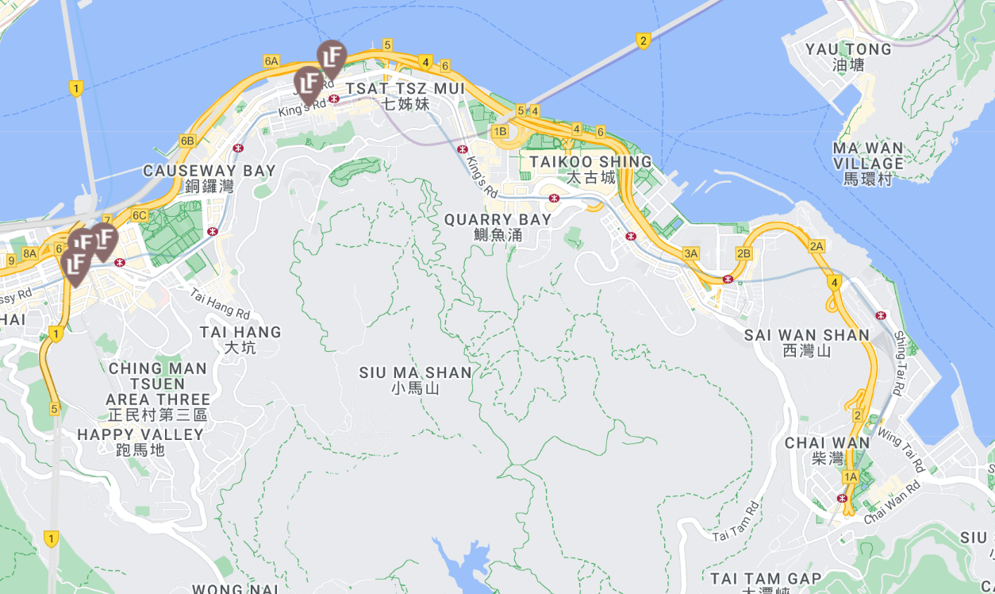

Reference
Appendix A
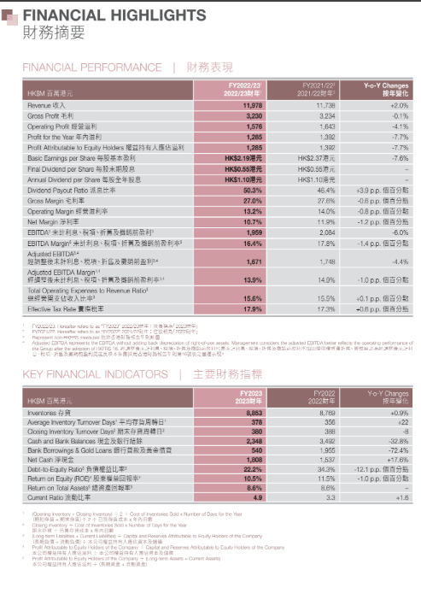

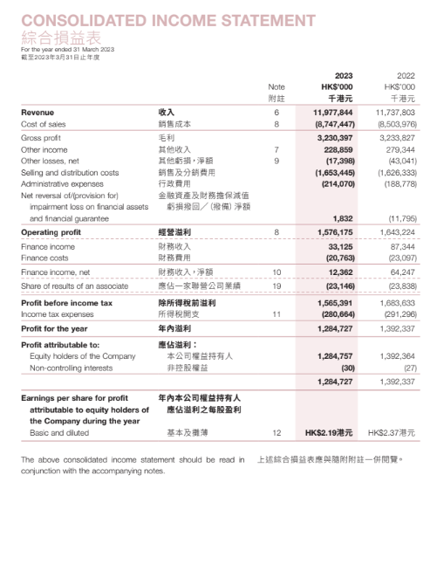

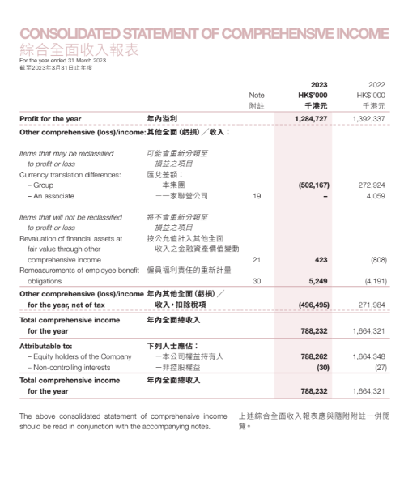
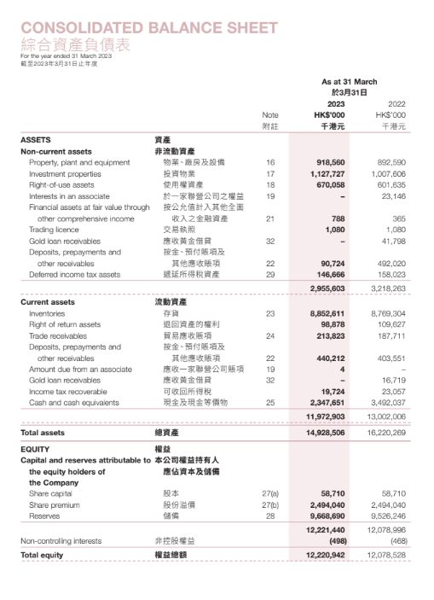
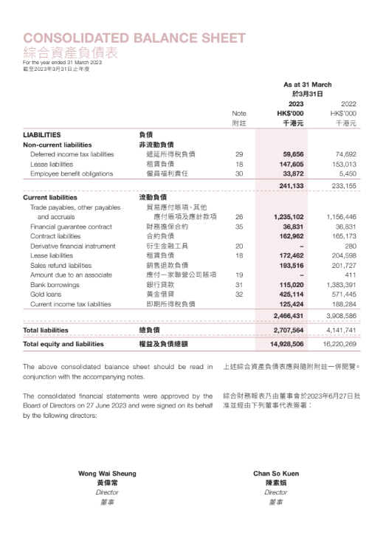
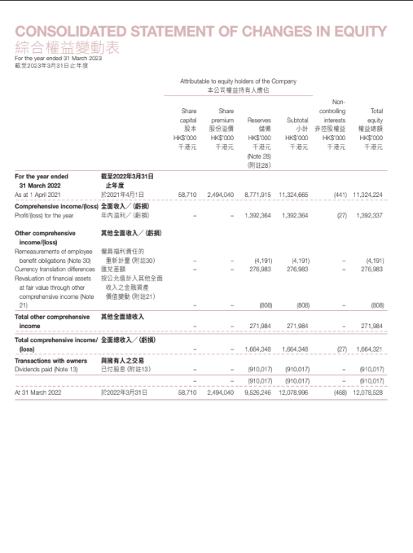

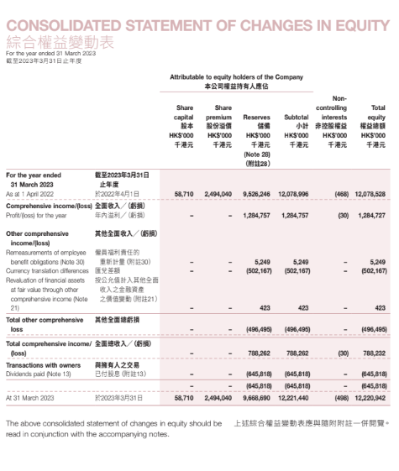

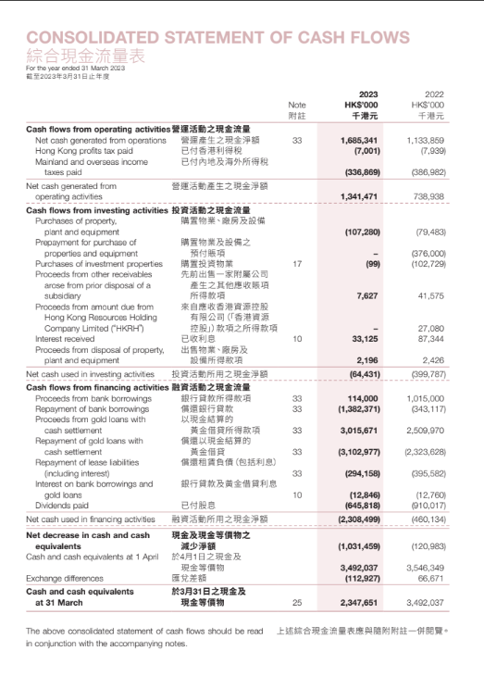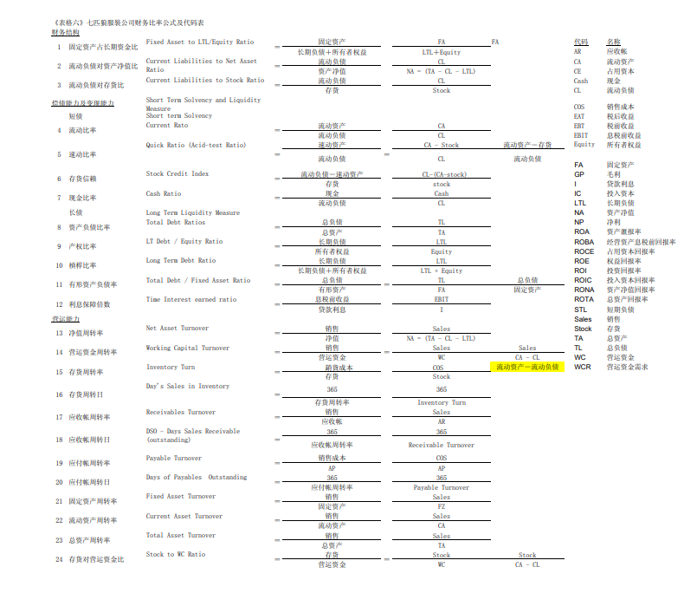
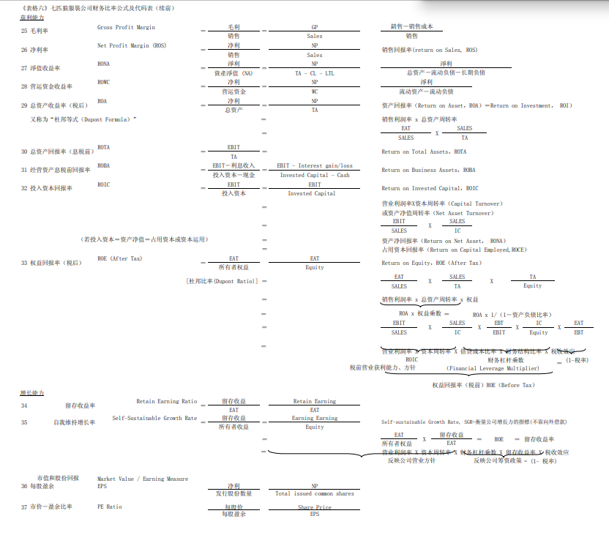

Calculation for new investment project
Yr | Cashflow in/(out) | PV of cashflow | CUM Cashflow |  | Profit
0 | (5.82) | (5.82) | (5.82) |  | 0
1 | 0.38 | 0.35 | (5.44) |  | 0.30
2 | 0.41 | 0.35 | (5.03) |  | 0.33
3 | 0.45 | 0.35 | (4.58) |  | 0.37
4 | 0.48 | 0.35 | (4.10) |  | 0.41
5 | 0.52 | 0.35 | (3.57) |  | 0.45
6 | 0.54 | 0.33 | (3.04) |  | 0.46
7 | 0.55 | 0.31 | (2.49) |  | 0.47
8 | 0.56 | 0.29 | (1.93) |  | 0.48
9 | 0.57 | 0.27 | (1.35) |  | 0.49
10 | 0.59 | 0.26 | (0.76) |  | 0.50
11 | 0.60 | 0.24 | (0.16) |  | 0.51
12 | 0.61 | 0.23 | 0.45 |  | 0.52
13 | 0.63 | 0.21 | 1.08 |  | 0.54
14 | 0.64 | 0.20 | 1.72 |  | 0.55
15 | 0.66 | 0.19 | 2.38 |  | 0.56
16 | 0.67 | 0.18 | 3.06 |  | 0.57
17 | 0.69 | 0.17 | 3.74 |  | 0.59
18 | 0.70 | 0.16 | 4.45 |  | 0.60
19 | 0.72 | 0.15 | 5.17 |  | 0.61
20 | 0.74 | 0.14 | 5.91 |  | 0.63
21 | 0.75 | 0.13 | 6.66 |  | 0.64
22 | 0.77 | 0.13 | 7.43 |  | 0.66
23 | 0.79 | 0.12 | 8.22 |  | 0.67
24 | 0.81 | 0.11 | 9.03 |  | 0.69
25 | 0.83 | 0.10 | 9.86 |  | 0.70
26 | 0.85 | 0.10 | 10.70 |  | 0.72
27 | 0.86 | 0.09 | 11.57 |  | 0.74

