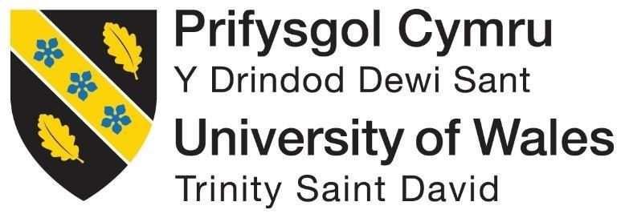

NAME: STANIMIR PETROV ILIEV
STUDENT NUMBER: 1915932
MODULE CODE/ COD Y MODIWL: LCBB4004
MARKETING FUNDAMENTALS
ASSESSMENT: 1

Background on Calvin Klein
Calvin Klein is a fashion lifestyle brand which has bold, sensual, and progressive ideas which can be recognised in a worldwide manner. Having a modern and also minimalist approach in sectors of design and authentication of culture the company has resonated over the masses in over 50 years. The company has been founded in New York in 1968 and it elevates the essentials in a globally iconic status. Calvin Klein Jeans, Calvin Klein Performance, Calvin Klein Underwear is a global household name and has global recognition as well. Each of the brands of the company contains a distinct identity, and position and it also contains a distinct place in the market with its various apparels with unique variations in them. The company specialises in leather, home furnishings, perfumery, jewellery, and also ready to wear clothes as well. The company contains substantial market share in the retail and as well as commercial lines and also the haute contour garments. The company’s growth is one of a kind and it has grown in a steady manner all year round, by 1971 the company has introduced blazers, sportswear, and lingerie in the women’s collection. In 1992, the company almost faced bankruptcy, however the company was able to keep up with the help of its popular underwear and fragrance lines. In the early 90s the company launched a new form of men’s underwear known as boxer briefs which quickly became famous and it was termed as one of the greatest apparel designs of the century. In 2002 the company had been acquisitioned by Philip Van Heusen and the parent company announced the launching of new men’s sportswear for rivalling the Ralph Lauren’s collection in the market. In 2020 the company announced that it has cut ties with animal usage products and it does not use animal skins, and it has banned the use of exotic animal skins as well in its products. The company has followed into the footsteps of being a sustainable company along with fulfilling its sales in an overtly manner.
Calvin Klein Products
Calvin Klein has a long range of products and apparels for all age groups. The company designs its products for both genders and focuses on being clean and diverse in its product segment.
Calvin Klein Jeans- this is line of clothing focusing on the jeans aspect of both men and women. The denim wear line has been licensed to Warnaco Group till 2044.
Calvin Klein Underwear- this contains the underwear collection by the Warnaco Group. The group has been acquired by Philip Van Heusen in 2013.
Fragrances- the company has various lines of colognes and perfumes including Obsession, Eternity and more. The fragrance license has been bought by Coty Inc a fragrance leader in the market from the previous owner of Unilever.
Calvin Klein Watches and Jewellery- the watch segment of the company was launched in 1997 and the jewellery line in 2004. The company’s apparels are just as famous as its line of clothing. Along with the jewellery and watches the company also sells bags, handbags and more. The apparels are designed based on the clothing designs so that they are matched as follows.
The company has a large number of brands operating under its name and the parent company of Calvin Klein is planning on adding more brand lines in order to catch the youth. The company is planning to enter the sustainability area and make cloths better in quality and cheaper in prices.
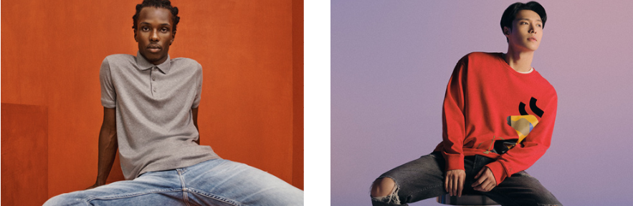
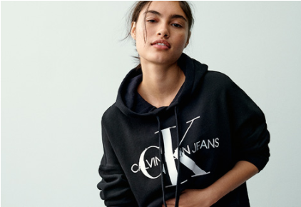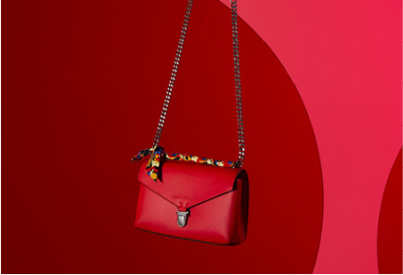
Website: https://www.calvinklein.com/hk/en/jeans/
Branding strategy of Calvin Klein
It is important for making good use of market segmentation as it helps in making use of customer needs, and also with the main aim of building long term relationships with the customers. In its demographic segmentation the company mainly targets the upper middle class youth, and business executives. The company also targets those who have learnt to live in a certain lifestyle, and are also fashion centric but not price sensitive. This helps the company to splurge into fashion and sell them new designs without reducing the cost. The brand position of the company is selling rich and quality products for the urban youth and also the high end business executives. As the brand has expanded over the years into new horizons and new geographies, the company has invested in development of an efficient supply chain which helps it to take care of its business needs. The brand image of the company is kept as a constant rate, with the help of distinctive marketing strategy. People having intimate modern, iconic and classy style are pulled towards the brand. Furthermore the brand also describes itself as one of the authentic and genuine brand which is famous for its minimalistic and classic style of clothes for its customers. The brand name has increased over the years and most of the earnings of Calvin Klein comes from the overseas sales in various countries. The customers of Calvin Klein mostly consist of the younger generation, particularly men and women aged between 15-40 years. The company has created a stronger brand over the years and it has become a household name over few decades. The company also faces stiff competition in the international market due to many brands at similar levels.
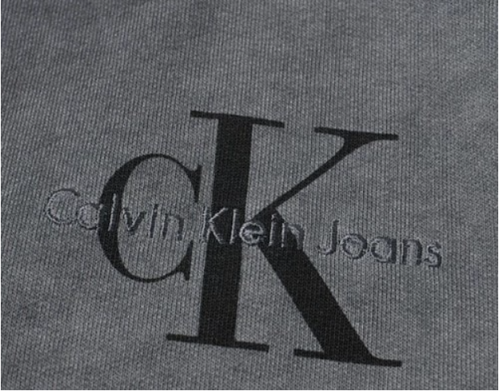
Website: https://www.marketing91.com/marketing-strategy-of-calvin-klein/
Customization Offers and Services
Calvin Klein has unveiled its new collection of #MYCALVINSCYSTOM. This is for the first time that the company has started to offer, a chance for the customers for customizing their iconic Calvin Klein underwear styles with a variety of bold colours, statement making various phrases and also bold patches. For kicking of the release of the customization services, Bella Hadid and Shawn Mendes has offered in the accompanying campaign. The company will also offer a wide range of colour options across the Calvin Klein underwear styles for both men and women. The customization offer of the company is currently available on its website and it starts at USD 28 and USD 34 for women and men respectively. The plan of the company is to make the products more personal for the customers as they will be able to personalise as their own. The company will also bring in more customizable options in other segments as well. It is also worth to notice that, such customizable gives the company an edge over the rivals as they will also be forced to think of new options to compete with Calvin Klein. The services of customization are currently present only in USA and it is planned to release in other parts of the world at a later date. Europe will be one of the first foreign continents to start the customization offers and it will help the company open into a bigger field of its own. The customization services and offers is a unique position of the company in the market as it is willing to have a unique special supply chain for its customers.
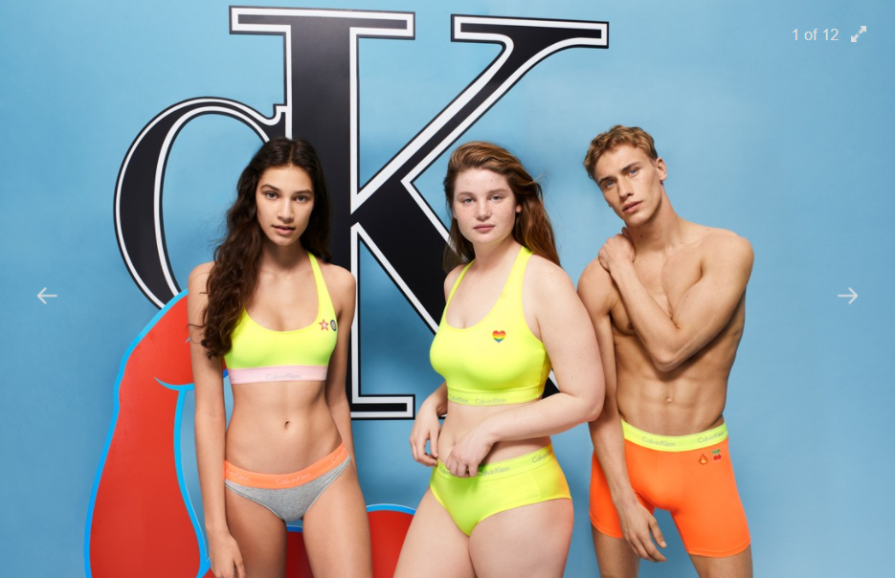
Website: https://hypebae.com/2019/6/calvin-klein-mycalvins-custom-underwear-bella-hadid-shawn-mendes
Calvin Klein Promotion Strategy
In 2015, Calvin Klein spend more than 320 million USD, in a global aspect for its advertisement and marketing of the brand in various countries. With the family of Kardashians and Jenners family featuring the “MyCalvin” campaign, it has helped the company shed a strong message of highlighting the importance of the family. Furthermore with Justin Bieber also endorsing the brand has helped the company to attract more youths to the centre stage. With the #IAMWOMEN campaign it has helped the company to start women empowerment programs and it has also introduced various perfume ranges and also drawing certain inspiration from various identity of femininity as well as aspirations. The brand has also constant communication with its customers with the help of various newsletters and emails which helps in increasing the brand loyalty among the customers. The company has also widespread followers on Instagram and Facebook, furthermore the campaigns of the company has helped it to target the desired audience, this has helped it to increase the sales of the company in various countries.
Celebrity Endorsements
The company believes heavily on celebrity endorsements and it also communicates with large number of celebrities so that they are able to endorse it to large section of the society. This strategy works as a charm as celebrities have large followers, and people often try to follow their celebrities and wear similar clothes endorsed by them. The celebrity endorsements, started for Calvin Klein in 1992 with Mark Wahlberg, and the actor appeared in successful campaigns, and it also inspired the future of the celebrity driven advertisements. The company spends large amount of money in advertisements as it has helped it to send positive message across various sections of the society. The customers are young and often follow the trends which makes it possible for the company to earn profits every year.
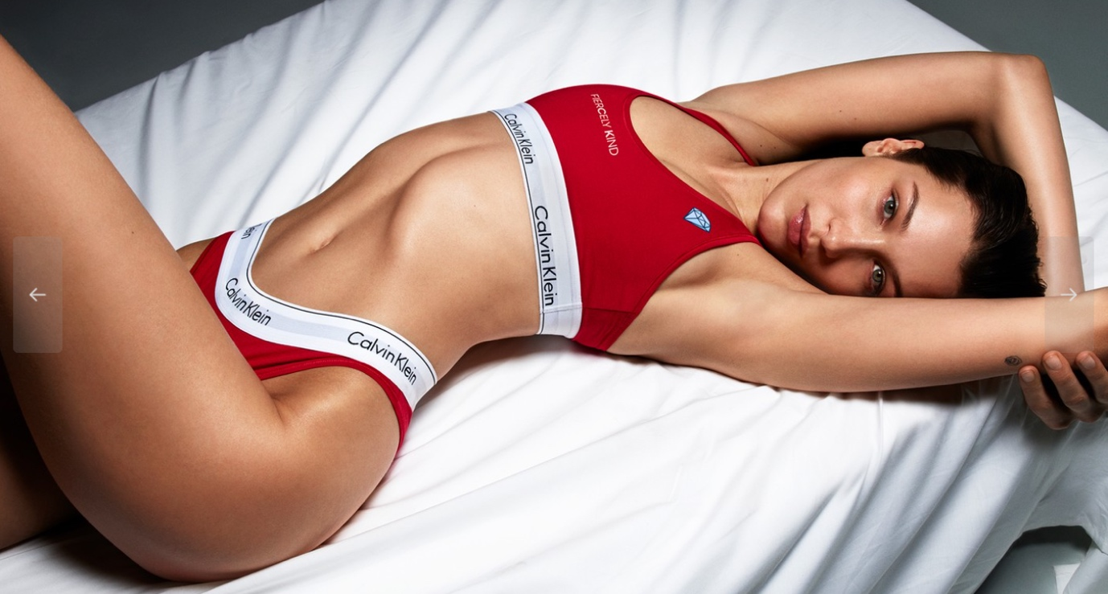
Website: https://www.aol.com/article/entertainment/2019/02/19/celebrity-calvin-klein-ads-shawn-mendes-justin-bieber-kardashians/23671982/
Pricing Strategy
The pricing of Calvin Klein products is on the higher side of the market and the company sells its products and targets the upper middle class and higher sections of the society. The company has various levels of pricing the black label pricing range is expensive than the white label brand. The competitors of Calvin Klein include Giorgio Armani, Ralph Lauren, Hugo Boss, Tommy Hilfiger and more. Calvin Klein tries to keep lower prices as compared to its competitors so that, it is able to have a higher market share in different countries. Because of the competitive pricing, it has helped the company to earn the loyalty of the customers and also lead the company to offer up new products in the price range as well. The new services for the company include personalized items of underwear for both men and women. The company also follows a skimming pricing strategy, in the marketing mix in which the products earn huge margin but these are sold in lesser quantities as compared to the popular ones. The pricing strategy of Calvin Klein not only includes skimming but also segmentation, targeting, positioning and more. The company has learnt from its past experiences and understands the market in a better way. This has helped it to keep the prices low and also competitive in the international market. The company also offers its products online where customers are able to get discounts making it popular than ever.
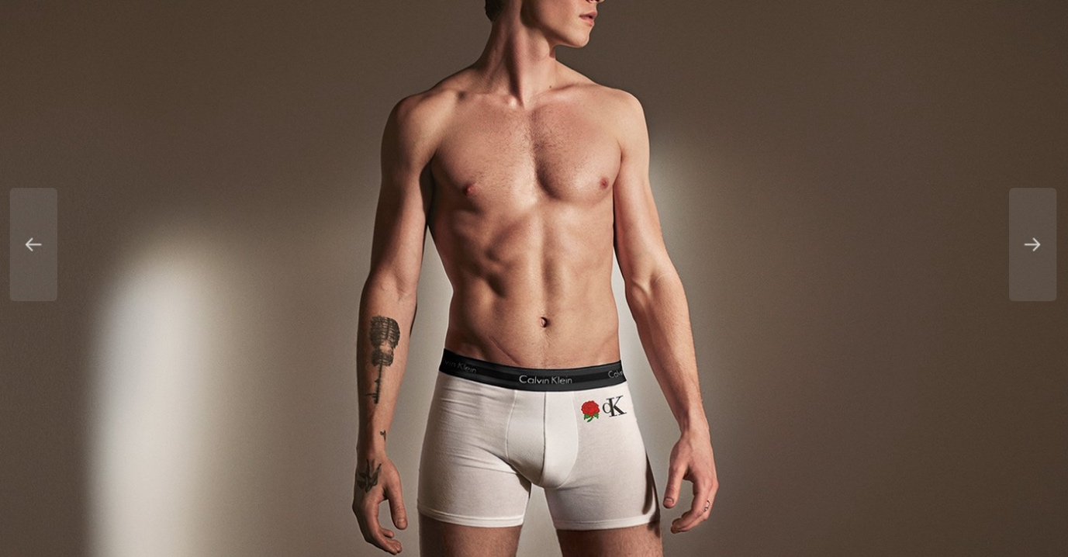
Website: https://www.mbaskool.com/marketing-mix/products/17411-calvin-klein.html

References
Aol.com. 2019. AOL is now a part of Verizon Media. [online] Available at: <https://www.aol.com/article/entertainment/2019/02/19/celebrity-calvin-klein-ads-shawn-mendes-justin-bieber-kardashians/23671982/> [Accessed 5 February 2021].
Bhasin, H., 2018. Marketing strategy of Calvin Klein - Calvin Klein Marketing strategy. [online] Marketing91. Available at: <https://www.marketing91.com/marketing-strategy-of-calvin-klein/> [Accessed 5 February 2021].
Creative Blog on Indian brands, Marketing and Advertising. 2019. History & Marketing Strategies of Calvin Klein - Brandyuva.in. [online] Available at: <https://brandyuva.in/2019/08/marketing-strategies-of-calvin-klein.html> [Accessed 5 February 2021].
Mowatt, R. and Mowatt, R., 2019. Bella Hadid Debuts Calvin Klein's #MYCALVINS Customizable Collection. [online] HYPEBAE. Available at: <https://hypebae.com/2019/6/calvin-klein-mycalvins-custom-underwear-bella-hadid-shawn-mendes> [Accessed 5 February 2021].
Team, M., 2020. Calvin Klein Marketing Mix (4Ps) Strategy | MBA Skool-Study.Learn.Share.. [online] MBA Skool-Study.Learn.Share. Available at: <https://www.mbaskool.com/marketing-mix/products/17411-calvin-klein.html> [Accessed 5 February 2021].

