BMSW4010
Learning in the Digital Era

Individual reflection

Student Name : Natalie Skalkosova
Student ID : 2212439

Lecturer’s name : Christian Felices
Table of Contents
Introduction 3
Gibb’s reflective writing 4
The skill I have recently learned from the module 6
Referencing & paraphrasing 6
Time management 8
Presentation skills 9
Team-working skills 10
Conclusion 11
References 12

Introduction
Reflective writing helps students to improve their learning and experience over a fixed period. This report discusses Gibb’s reflective writing model and describes how Gibb’s reflective writing module helps the student to develop their learning and experience. This report also discusses some skills which I have learned after completing this course module. The learned skills are mentioned below and discuss their importance in career development (Sapienza et al, 2016).

Gibb’s reflective writing
Gibb’s reflective writing model describes the model by which an individual can describe the learning from an event. The reflective writing module is developed in 1988 by Graham Gibb. Gibb’s reflective writing model consists of six steps and these steps are described briefly in the below part.

Figure: Gibb’s reflective writing model (Sharp et al., 2017).
Description: This stage describes what is the brief facts of the events. Who was involved in the event and what is your role in the event and what are other people’s roles in the event? The description stage describes the overall facts related to my course module (Sapienza et al, 2016).
Feelings: Feelings are thoughts about events. This event describes what were you thinking and felt about the event. The feelings stage considers the factors of the event occurring. Feelings describe what you feel at the event occurring time. What are the factors which influence the events occurring time and known or perceived difficulties related to the timing, location, and others things?

Evaluation: The evaluation stage concerns the outputs of the events. In the evaluation stage, describe what was good or bad. In this phase, individuals try to measure the facts and analyze the facts to measure whether it is right or wrong. In this stage, the facts are analyzed from positive perspectives and negative perspectives. both perspectives try to find out the output of the events (Sharp et al., 2017).
Analysis: The analysis stage measures the overall performance and tries to describe the actual events. The analysis events describe the total output of the event and analyze output from different perspectives. In this stage measure what sense is made by the events. This stage also measures what is the other sense this stage can measure and describe people’s roles from different perspectives (Spence et al., 2015).
Conclusion: The conclusion stage makes clear and concise sense of the events. In this stage describe your actual role and what other role you can play. In the conclusion, the stage describes what I have actually done in the event and what can I have differently done in the event.
Action plan: The action plan describes the future activity regarding the events. This part describes what will be done in the future and what are the consequences of the event. In this stage describe what I have done in the future. The action plan described the action which I have done in the future if similar events have occurred (Tyler, 2016).

The skill I have recently learned from the module

Referencing & paraphrasing
Referencing is the process of including the author’s name, journal name, and date of publishing the journal when we use some quotes from a source. During the completion of my course module, I then learn the referencing style and know how to use the reference in the journal. Referencing style is most popular for publishing and writing new articles and journals. During the course module completion process, I wrote various articles and journals and use references in my writing (Maund et al., 2017).
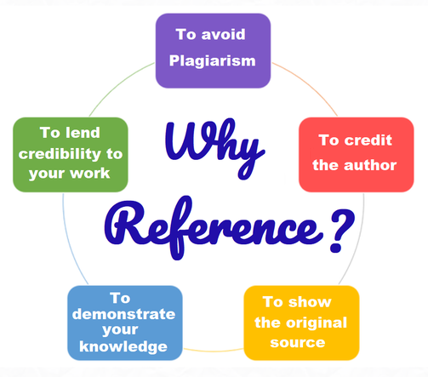
Figure: Importance of referencing (Tyler, 2016).
To avoid plagiarism, I use references in my writing. Referencing helps to reduce the level of plagiarism in the writing. Plagiarism means using other writing in my writing module. When I use quotes from a well-known article, I want to give credit to the original author. By using the reference, I can give credit to the author. By using the reference, I can show the original author’s name and the source of the article and journals. By using the reference, I can demonstrate my knowledge in the writing. Finally, using references I can lend creditability to my work (Miazga et al., 2020).
Paraphrasing is the process of reforming a sentence and writing the sentence in a new way. The paraphrase style does not change the original meaning of the sentence and uses synonyms of the word to express meaning. During the graduation period, I learn how to paraphrase the sentence and how to write the sentence in a new way without changing the meaning of the sentence. I use paraphrase to avoid plagiarism in my writing. I use paraphrase to report ideas and information which belong to someone else. By using paraphrase, I form an alternative quotes system in my writing (Miazga et al., 2020).
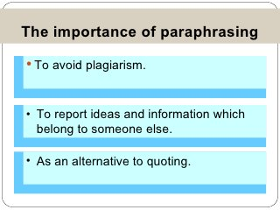
Figure: Importance of paraphrasing (Maund et al., 2017).

Time management
Time management skills refer to the skills by which completing a task predetermines time and performing the work effectively and efficiently. Time management skills are used in the process of achieving goals and objectives. During the graduation period, I achieve the time management skills to perform my responsibilities timely. Time management skills allow me to complete my task effectively and efficiently. Here I give some tips for time management skills (Morgan, 2017). The short details of the occurrences are described in this step. Who participated in the event, what was your role, and what were the roles of the other participants? The description stage provides an overview of the key details pertaining to my course module (Sapienza et al, 2016).
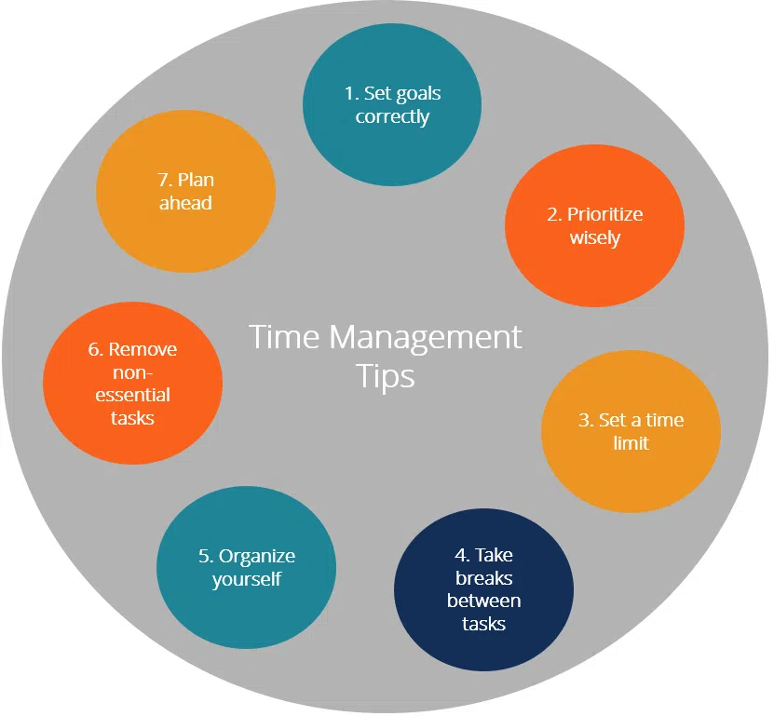
Figure: Time management tips (Morgan, 2017).
To achieve time management skills, first I need to set goals and prioritize the work wisely. After that, I need to set a time limit for every task and take breaks between the works to perform effectively. Feelings express how you are feeling at the moment of the occurrence. What are the variables that affect the timing of events and any actual or perceived challenges relating to timing, location, and other things? The most important thing is I need to organize myself before maintaining the time. I need to remove the non-essential task from the set of tasks. The final thing is I need to prepare a plan to move ahead (Petersons et al., 2016).

Presentation skills
Presentation skills are the most needed skills during the graduation period. This skill is necessary for me in my professional life. During the graduation period, I achieve my presentation skills properly and give presentations in the classroom properly. The analysis events summarise the event's overall output and examine it from several angles. Assess how the events make sense at this point. This stage evaluates the other sense in which it may evaluate and define the functions of individuals from many angles (Spence et al., 2015). Here, I gave some techniques of the presentation skills which I have learned in the course module (Sapienza et al., 2015).
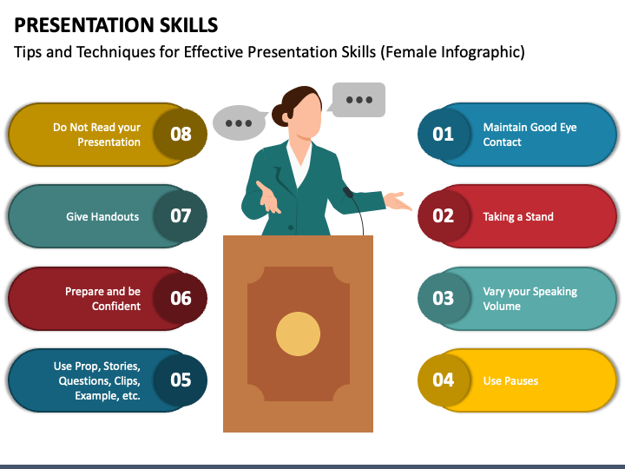
Figure: Presentation skills (Ellison, 2015).
To make a better presentation, I need to maintain good eye contact with the audience. I need to take a stand with the argument or topics. I need to speak up and slow down my voice with time. I need to pause the delivery of the speech. You must care about your presentation so that your speech is not like that just reading your presentation slides. Give a proper handout to the audience. Finally, you need to be confident in your style and topics (Kuznar et al., 2020).

Team-working skills
Team working skills are must necessary for the student and I achieved these skills during the graduation period. In the description describe what happened in the event. Referencing is most necessary for writing a literature review in a journal or project paper. Team working skills are necessary for people in both academic and professional life. I can collaborate with other students and perform my rules effectively and efficiently in the group. Here some teamwork skills are mentioned (Ellison, 2015).
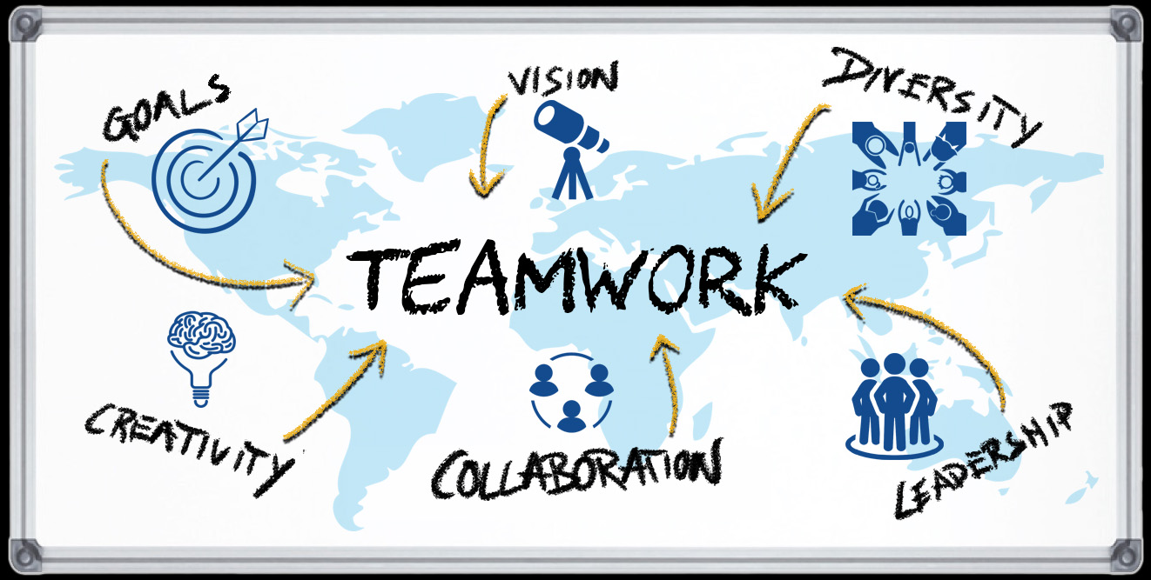
Figure: Team-working skills (Sapienza et al., 2015).
Team working skills required having aligned goals and objectives. Team-working skills are required to have a collective vision to achieve. There is diversity exist in teamwork and need to manage that diversity among the team member. This section outlines what will be done going forward and what the effects of the event will be. Describe my actions in the future at this point. The action plan specified what I would do in the future if the same circumstances arose (Tyler, 2016). The team leader needs to have leadership capability to give proper direction to the team member and achieve the goals and objectives. String collaboration is required in teamwork and creativity must be encouraged in the team performance (Gillespie et al., 2018).

Conclusion
Reflective writing refers to the writing style by which individuals can understand their improvement and develop some criteria of development techniques. Gibb’s reflective writing model helps to explain the experience which is learned during an event. The description describes the facts of the events. By using the paraphrase style, the sentence formation is changed, and the use of a complex or compound sentence combines the meaning of multiple sentences. Presentation skills are basic skills for the student. Team-working skill helps me to perform group work and group presentation properly (Gallagher, 2013).

References
Ellison, D., 2015. Communication skills. Nursing Clinics, 50(1), pp.45-57.
Gallagher, K., 2013. Skills development for business and management students: Study and employability. Oxford University Press.
Gillespie, D.J. and Schiffman, R., 2018. A critique of the Shannon-Weaver theory of communication and its implications for nursing. Research and Theory for Nursing Practice, 32(2), pp.216-225.
Kuznar, L.A. and Yager, M., 2020. The Development of Communication Models, Quick Look. Joint Staff J39, Strategic Multi-layer Assessment Washington, DC United States.
Maund, A., Schriek, M. and Tinkler, P., 2017. Certificate in Higher Education: Skills for the Workplace Student Yearbook.
Miazga, M. and Królikowska, J., 2020. Assessment of Security of Water Supply for Benissa Municipality, Spain Employing the Shannon-Weaver Model. Rocznik Ochrona Środowiska, 22.
Morgan, Peter., 2017. The Business Student′ s Guide to Study and Employability. Sage.
Petersons, A. and Khalimzoda, I., 2016, May. Communication models and common basis for multicultural communication in Latvia. In SOCIETY. INTEGRATION. EDUCATION. Proceedings of the International Scientific Conference (Vol. 4, pp. 423-433).
Sapienza, Z.S., Iyer, N. and Veenstra, A.S., 2015. Reading Lasswell's model of communication backward: Three scholarly misconceptions. Mass Communication and Society, 18(5), pp.599-622. Sohagh
Sapienza, Z.S., Veenstra, A.S., Kirtiklis, K. and Giannino, S.S., 2016. The transmission model of communication: Toward a multidisciplinary explication. ETC: A Review of General Semantics, 73(4), pp.321-341.
Sharp, E.A., Weaver, S.E. and Zvonkovic, A., 2017. Introduction to the special issue: Feminist framings of sexual violence on college campuses. Family Relations, 66(1), p.7.
Spence, S. and Hyams-Ssekasi, D., 2015. Developing business students’ employability skills through working in partnership with a local business to deliver an undergraduate mentoring programme. Higher Education, Skills and Work-Based Learning, 5(3), pp.299-314.
Tyler, S., 2016. Studying for your Future Employability: A business student’s guide. Routledge.

