Data Handling & Business Intelligence
Component 1: Coursework: Individual Report
Student Number:
2333125@student.uwtsd.ac.uk
Narcis Grecu

Contents
Introduction 1
Trends in BI, DW, and DM 1
Data Warehousing in the Organisation Applications 2
Data Mining Techniques 3
Predictive Analysis 4
Ethical and Data Security Considerations 5
Reporting and Dashboard Solutions 5
Conclusion 7
References 8

Introduction
The process of collecting data and utilizing it to make data-driven decisions is known as Business Intelligence (Al-Okaily, Ping and Al-Okaily, 2021). This essay discusses the processes of business intelligence at Sainsbury’s plc. The company is one big supermarkets in the UK that runs multiple stores across the country. As a retailer, the company offers a wide range of products including food stuffs and groceries, clothing, digital offerings, and general merchandise (Sainsbury plc, 2025). The retail sector in the UK is increasingly competitive as ecommerce has lowered the barrier to entry by eliminating the need for brick and motor stores to start a retail business (FBX Capital, 2025). This essay discusses the trends in business intelligence at Sainsbury’s plc and how uses data warehousing to improve its data management. Moreover, the essay discusses how data mining and predictive analysis can be used at the company for its business advantage. Finally, the essay addresses ethical considerations and the reporting solutions that the company can use to ensure effective and ethical data collection, warehousing, and analysis.

Trends in BI, DW, and DM
Business Intelligence (BI) encompasses the technological processes that gather and analyze business data for purposes of improving the decision making processes (Al-Okaily, Ping and Al-Okaily, 2021). The current trends in BI technologies have evolved to include real-time BI where businesses can gather data as it emerges such as the Microsoft Power BI. On the other hand, a data warehouse is a repository that contains past and current data about a business as acquired from different sources (Rana, 2024). There are different architectures in the data warehousing including the Kimball’s DW Architecture, which uses dimensional tables to simplify the process of retrieving data from the user’s end-point.
The current prevalent trend in data warehousing is cloud warehousing where companies such as Snowflake and BigQuery provide services. Cloud warehousing involves storing large volumes of data on cloud platforms for purposes of scalability for companies that cannot afford the physical infrastructure required to host large volumes of data. Cloud warehousing is an important trend for businesses as the technology allows companies to pay for the amount of servers they use and increase they cost of storing their data as the business scales (Ahmadi, 2023). Cloud warehousing is efficient in enabling data consolidation as the cloud infrastructure have the capacity to consolidate data from different business departments such as sales, employee performance, and customer service systems.
Data mining is the process of extracting useful data from large unstructured data using statistical methods and machine learning techniques. The process of data mining is important in business intelligence as it provides the data that is used by businesses to make decisions (Gheisari et al., 2022). The integration of artificial intelligence in data mining has enabled businesses to extract large volumes of useful data from large unstructured data sets as AI techniques such as machine learning are able match different but related data points to create data points that can be used to predict business performance and make decisions accordingly.

Data Warehousing in the Organisation Applications
Data warehousing is the process of collecting, storing, integrating, and managing large amounts of data from different data points for purposes of using the data to make data-driven decisions . Data warehousing helps businesses have easy access to data when they need to analyse it, make queries, and use it for business reporting (Ahmadi, 2023).
At Sainsbury’s Plc, data warehousing is essential for data access and efficiency as the company works with large amounts of data. For example, the company collects data from different data points including transaction data, product and inventory data on its offerings, customer data, workforce data, and data from the external business environment, among other data points. In light of this, the company needs modern data warehousing to manage its data effectively. Sainsbury’s Plc has invested in different data warehousing technologies by partnering with companies that have specialised in cutting edge data warehousing technologies. For example, the company has partnered with Amazon Web Services (AWS) as a key partner in data warehousing (Clark, 2019).
AWS is the world leader in data warehousing and storage, and is responsible Sainsbury’s Bank cloud data warehousing and data analytics. AWS has improved Sainsbury’s Bank’s data access and efficiency as the bank consolidated all its data into AWS using Amazon S3, hence improving access to its data. In addition, the use of AWS services has improved efficiency using AWS Glue, which automates cataloging and cleaning of data in preparation for analysis (Irani, 2023) Moreover, using AWS Redshift, the data warehousing technology provided by AWS enables efficiency by enhancing faster and more powerful analytics as the technology has powerful and speedy data query for complex data.
Data warehousing at Sainsbury’s UK has enhanced decision making processes at the company. The retailer has partnered with Microsoft Azure, which is a world class data warehousing technology developed by Microsoft (Microsoft UK, 2024). Salisbury’s UK signed a five-year contract with Microsoft Azure for purposes of utilizing the power of AI, data analytics, and machine learning that Azure brings to the retailer’s data ecosystem The partnership with azure has improved decision making at the company by enabling real-time insights from the data collected from the company’s important data points such as customer service.
Sainsbury’s Plc has also partnered with Google Cloud Platform (GCP) to improve its data warehousing processes. Through Google Cloud, the retailer is able to make better business decisions by taking advantage of GCP’s ability to perform predictive analytics and use machine learning techniques to streamline data (Bourne and Bourne, 2025). The predictive analytics availed by Google Cloud Platform enables the retailer to make data-informed decision making processes. In addition, the retailer uses the platform for data reporting as it has the capacity to collect and streamline data in ways that it can be easily presented to executives for decision making.

Data Mining Techniques
There are different data mining techniques that organisations use to extract important data from its operations for purposes to using the structured data to make decisions. The two data mining techniques that are relevant to Sainsbury’s Plc are clustering and association rule mining because of the type and volume of data that the retailer produces. Clustering is the process of data mining where data points with related attributes are grouped together (Oyewole and Thopil, 2022). The technique is relevant to Sainsbury’s Plc as the company has use for clustering its data for purposes of effective decision making. For example, clustering can be used at the retailer to mine data on customer segments as it provides different products and services that attract distinct customer groups. Using clustering as a data mining technique, the company can mine data on customer purchase frequency, shopping habits, types of services purchased, and age demographics. Using data on such segments, the company can use the data for marketing services to target the right customers. The common platforms that provides clustering as a data mining technique include some of the partners that Sainsbury’s Plc has such as Microsoft Azure and BigQuery ML operated by Google Cloud Platform.
The second data mining technique of Association Rule Mining involves finding relationships between events or items within a large set of unstructured data (Dol and Jawandhiya, 2023). The data mining technique is relevant to Sainsbury’s Plc as the company collects large volumes of data which is unstructured. Using the association rule mining, the company can use the technique to find relationships between events such as purchasing related products by customers. For the retailer, association rule mining is important as it helps in personalizing product recommendations based on the relationships found from the data mining techniques. For example, when the company uses the technique to determine that customers who buy bread also buy milk, it can recommend milk to customers who purchase bread. The technique is availed to Sainsbury’s Plc to conduct this technique is Snowflake, which is a data mining and warehousing service.

Predictive Analysis
Predictive analysis is the process of predicting future trends based on current data. Sainsbury’s Plc has a number of platforms it can use to conduct predictive analysis including Power Bi, excel, SPSS, AND excel among others (Maruf et al., 2022). Power Bi was developed by Microsoft and offers features such as an interactive dashboards, data visualisation, and ML-enabled analytics. It is highly usable as it uses drag-and-drop user interface and can be integrated into Sainsbury’s Plc as the organisation already uses Azure, which is a Microsoft ecosystem. Another option available to the company is SPSS, which is provided by IBM Company. SPSS offers advanced statistical features that can be used to process data and predict future trends (Maruf et al., 2022). The usability of SPSS is, however, restricted to people with knowledge on statistics and data analysis. In relation to integration with the Sainsbury’s Plc’s ecosystem, SPSS cannot be directly integrated with the company’s current ecosystem as it will require the introduction of IBM cloud. Given the features and the usability of the two discussed platforms, the essay recommends that Sainsbury’s should use Power Bi to conduct predictive analysis as it offers features that are relevant to its data needs, can be used by people without deep knowledge on data science, and can be readily integrated into its current data management ecosystem.

Ethical and Data Security Considerations
As a company that operates in the UK, Sainsbury’s Plc is subject to all the provisions of the General Data Protection Regulation (GDPR) and other regulations that govern the collection and usage of data from the public. The company is expected to comply with data regulations such as appointing a data protection officer, conduct a privacy assessment in its databases, and enable all the necessary rights such as access to the data, restriction of data from unauthorized individuals, and the erasure whenever necessary (Laurer and Seidl, 2020). On data ownership, the company should understand that it does not legally own any personal data collected from customers as the GDPR only recognises it as a controller and a processor of the data. Moreover, pursuant to all data protection laws in the UK, the company can only collect personal data with the full informed consent of its customers (Wolff and Atallah, 2021).
The company has a further legal obligation to be transparent to all people from whom it collects data by informing them on how the data will be used and the purpose of its collection. Another important ethical and data security consideration is the safety controls that Sainsbury’s is legally obligated to implement. Internally, the company is expected to implement measures such as authentication to grant access only to the employees with the authority to use the data for the purposes it was collected. Externally, the company is expected to implemented safety measures such as firewalls that protect the data against possible breaches from external unauthorized parties.

Reporting and Dashboard Solutions
The endpoint of any data analysis process is the reporting process where data scientists use dashboards to present the findings, trends and reports. There are two main options available for Sainsbury’s Plc in terms of reporting and dashboard solutions are Power Bi and Tableau. Power Bi is owned and operated by Microsoft Plc and offers value for real-time sharing and decision making through its user-friendly dashboard shown below (Appendix One).
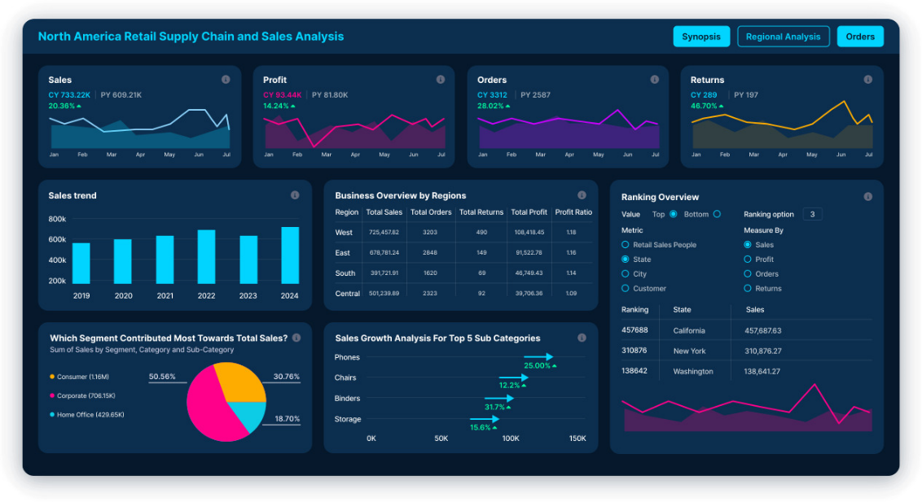
The Power Bi dashboard updates in real-time as data collected in real-time comes in, which is essential for decision-making as it enables executives to account for current data (Zamil, Mohiuddin and Mamun, 2024). The platform can help Sainsbury’s Plc make decisions on important KPIs including sales growth, market share acquisition, and supply chain management.
On the other hand, Tableau is owned and run by Tableau Software LLC, and offers reporting and dashboard solutions. The platform is effective at data visualisation and analysing user-driven data reports (Zamil, Mohiuddin and Mamun, 2024). The platform’s real value to Sainsbury’s will, therefore, be in relation to the company’s ability to report trends on customer behavior such as purchase trends and product preferences. Furthermore, the platform is useful in presenting data on important customer trends such as conversation rates using its dashboard features such as interactivity, customisation, connectivity to live data, and collaboration as shown in the image below (Appendix Two).
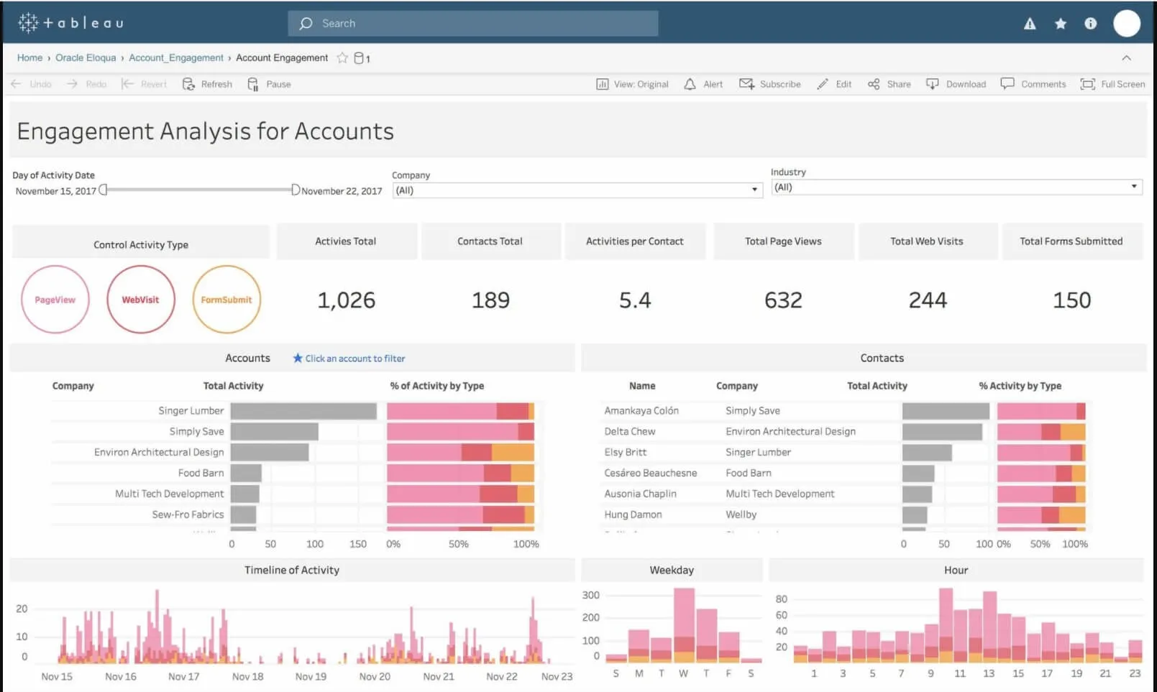

Conclusion
Business Intelligence to Sainsbury’s Plc has been shown to be vital by the different sections of the essay. The company is positioned to take advantage of the current trends in business intelligence, data warehousing, and data mining by working with companies that are the best in the world such as Google Cloud, Microsoft Azure, and Amazon AWS. The investment that Sainsbury’s Plc has done in business intelligence has vastly improved the company’s business performance as it has enabled the use of data in an efficient way to make data-driven decisions. Strategically, BI is important for the long-term financial sustainability as it offers the company the ability to make decisions that generate more financial income such as targeted advertising, data-driven recommendations, and allocation of funds. The essay recommends that Sainsbury’s Plc should enter into contracts with AI companies in order to take advantage of the developments in AI in the retail sector.

References
Ahmadi, S. (2023) 'Elastic data warehousing: Adapting to fluctuating workloads with Cloud-Native technologies,' Journal of Knowledge Learning and Science Technology ISSN 2959-6386 (Online), 2(3), pp. 282–301. https://doi.org/10.60087/jklst.vol2.n3.p301.
Al-Okaily, A., Ping, T. and Al-Okaily, M. (2021) 'Towards Business Intelligence Success Measurement in an Organization: A Conceptual study,' Journal of System and Management Sciences [Preprint]. https://doi.org/10.33168/jsms.2021.0210.
Bourne, J. and Bourne, J. (2025) Sainsbury’s looks to Google Cloud for machine learning as retail cloud case studies continue to climb. https://www.cloudcomputing-news.net/news/sainsburys-looks-google-cloud-machine-learning-retail-cloud-case-studies-continue-climb/.
Clark, L. (2019) Sainsbury’s Bank moves data to AWS cloud with Teradata UDA. https://www.computerweekly.com/feature/Sainsburys-Bank-shifts-data-to-AWS-cloud-with-Teradata-UDA.
Dol, S.M. and Jawandhiya, P.M. (2023) 'Classification Technique and its Combination with Clustering and Association Rule Mining in Educational Data Mining — A survey,' Engineering Applications of Artificial Intelligence, 122, p. 106071. https://doi.org/10.1016/j.engappai.2023.106071.
FBX Capital (2025) 'The Rise of E-Commerce: Transforming UK retail,' FBX Capital, 19 January. https://fbxcapital.co.uk/e-commerce-transforming-the-uk-retail-sector/.
Gheisari, M. et al. (2022) 'Data mining Techniques for web mining: A survey,' Artificial Intelligence and Applications, 1(1), pp. 3–10. https://doi.org/10.47852/bonviewaia2202290.
Irani, B., (2023) Modern Data Architecture on AWS. Packt Publishing.
Laurer, M. and Seidl, T. (2020) 'Regulating the European Data‐Driven Economy: A case study on the General Data Protection Regulation,' Policy & Internet, 13(2), pp. 257–277. https://doi.org/10.1002/poi3.246.
Maruf, A.A. et al. (2022) 'A SYSTEMATIC REVIEW OF THE ROLE OF SQL AND EXCEL IN DATA-DRIVEN BUSINESS DECISION-MAKING FOR ASPIRING ANALYSTS,' American Journal of Scholarly Research and Innovation, 01(01), pp. 249–269. https://doi.org/10.63125/n142cg62.
Microsoft UK (2024) Sainsbury’s and Microsoft collaborate to power up customer and colleague experience with AI - Microsoft UK Stories. https://ukstories.microsoft.com/features/sainsburys-and-microsoft-collaborate-to-power-up-customer-and-colleague-experience-with-ai/.
Oyewole, G.J. and Thopil, G.A. (2022) 'Data clustering: application and trends,' Artificial Intelligence Review, 56(7), pp. 6439–6475. https://doi.org/10.1007/s10462-022-10325-y.
Rana, N.M. (2024) 'Overview of Data Warehouse architecture, Big Data and Green computing,' Journal of Computer Science and Technology Studies, 5(4), pp. 213–217. https://doi.org/10.32996/jcsts.2023.5.4.22.
Sainsbury plc (2025) About us. https://corporate.sainsburys.co.uk/about-us/.
Wolff, J. and Atallah, N. (2021) 'Early GDPR penalties: Analysis of implementation and fines through May 2020,' Journal of Information Policy, 11, pp. 63–103. https://doi.org/10.5325/jinfopoli.11.2021.0063.
Zamil, M.H., Mohiuddin, M. and Mamun, M.N.H. (2024) 'BUSINESS INTELLIGENCE SYSTEMS IN FINANCE AND ACCOUNTING: A REVIEW OF REAL-TIME DASHBOARDING USING POWER BI & TABLEAU,' American Journal of Scholarly Research and Innovation, 03(02), pp. 52–79. https://doi.org/10.63125/fy4w7w04.

Appendices
Appendix One
Appendix Two

