

Adrian Thomas – 1708738 Unilever
Lecturer – Gareth Jones- WTSD Programme - B.Eng. EEE PT
Research & Development methods
Literature review and presentation

Declaration of Conformity

The work of this report completed under the supervision of Gareth Jones. I declare that this report is the product of my own work and is not being submitted for any other degree etc.

Signed : A.Thomas

Date: 12/12/2017

Abstract

This report is aimed at providing information on the types of electric bicycle that are currently available on the market. Types of motor, battery and motor position will all be discussed as well as the benefits and draw backs to each type of system

The report is aimed at pedal assisted electric bicycles and although fully electric bikes are available the report will focus purely on the pedal bicycle with electric assistance.

Table of Contents
Introduction 4
What is an E-Bike? 5
How does an E-Bike differ from a Conventional Bicycle? 5
Components used in an E-Bike 6
Battery 6
Motors 6
Controller 6
Pro & cons of each type of drive system 8
Hub mounted 8
Mid mounted 9
Motor position summary 10
E-Bike Range 10
Conclusion 11
References 12

Introduction

The aim of conducting the following research is to find out what E-bicycles are currently for sale on the market, what technology they use and what are the pros & cons of the various systems.

Investigation will be carried out as to which environment are best suited to various types of E-Bike, what are the most commonly way they are constructed and what range and charging time these cycles have.

At the end of this report the reader should be able to clearly see the benefits and downsides of each type and how best they would suit desired applications

What is an E-Bike?

In the basic sense, an E-Bike is a bicycle with an electric motor and a battery to power the motor. These bicycles still use a conventional pedal system but these work in conjunction with an electrical motor to assist the rider, they are not designed to work solely when climbing hills etc but will provide the rider with some useful extra power in the case of a crank/mid mounted system however in the case of a hub mounted system the motor can work solely with the use of a twist throttle or via different modes, the only issue with this system is that is limited to 6KPH via European law as of January 2016 when using the throttle only system

How does an E-Bike differ from a Conventional Bicycle?

An E-Bike is constructed in much the same way as a regular bicycle however the structure is stronger to take the extra weight of the battery pack/electric motor/controller. Due to all the added components and strengthening E-Bikes weigh more than conventional bikes a typical E-bike can weigh more than 20kg, conventional lightweight bicycles weigh 10kg + [1]

Components used in an E-Bike

The main components used in an E-bike are the motor, battery and controller

Battery
Generally, lithium batteries are used because they offer the best compromise of performance and weight over old-style lead acid or NiMh batteries. Lithium based batteries also offer far greater charging cycle capacity for example a lead acid battery has a charge cycle life of approx. 120 cycles, a lithium based battery is far greater at 800>100 cycles [2]
Typically, battery voltages range from 12v to 36v and currents ranging from 10 to 60 amps [1] and are best charged overnight to prolong the life of the battery.

Motors
There are two types of motors, brushed and brushless. Brushless are more commonly used now as there require very little maintenance compared to a brushed version.

The other variation in the hub motors is direct drive or geared. Direct drive has the advantage of being very reliable and quite however the need to be quite big and heavy to generate the required torque. Geared hub motors on the other hand are smaller and lighter and due to the gearing provide very good torque, the only downside to this system is that they are a lot louder than direct drive and are more prone to failure due to them having more moving parts inside them [2]

Controller
The motor controller plays a vital role within the e-bike system and would be near impossible for it to work without it. The main function of the control is to interoperate the torque demand and supply adequate power to the motor to satisfy the requirements. The other functions of the controller are main to protect the system, these would include low voltage from the battery, overtemperature and overcurrent all of which will limit performance and could have fatal effects on the motor. It will also shut down the motor when the user applies the brakes so that there isn’t a conflict between the brakes and motor. [3]
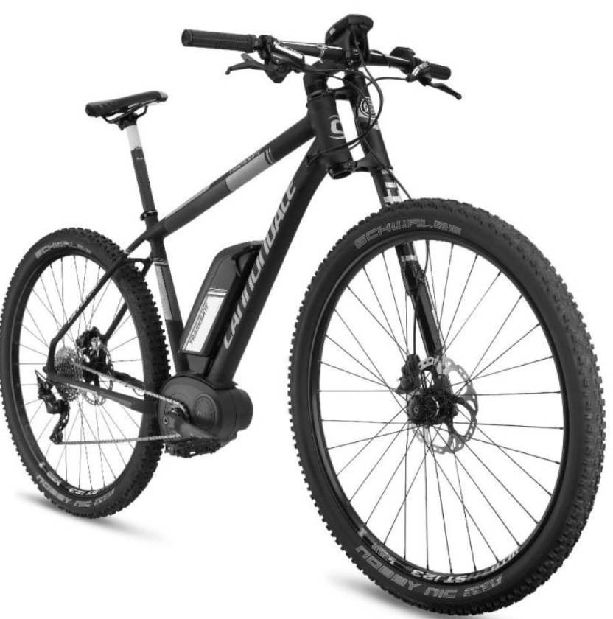MTB 1
Mid mounted motor and battery

There are two main types of E-Bike the only difference in the two being the position of the e-motor. There are hub mounted versions where the electrical motor fits inside the wheel hub, these are generally fitted to the rear wheel however the can also be fitted to the front or both. The other common system used is a Mid or crank mounted system. This type of system uses an electric motor connected directly to the crank.

Pro & cons of each type of drive system

Hub mounted
With this set up the motor is mounted directly in the wheel hub so can power the bicycle independently from the chain/pedal assembly. This system can use a throttle base or a torque demand switch which will assist the rider when peddling, in this case the more effort the rider applies the more power is applied to the motor. These systems also come with various power setting from sport to eco which will alter the level of assist, obviously the more assistance that is used the greater the drain on the battery and therefore a reduction in battery charge time.
These motors can be mounted in either the front or rear wheels. The advantage of a front hub mounted motor is that it an all-wheel drive feel with the motor driving the front wheel and the rider driving the back wheel however, there is more of a tendency for the front wheel to spin with this set up since there is not so much weight over the front end. [4]
Rear hub mounted motors are capable of handling greater power outputs since the frame is structure to suit this application. Rear hub system can also use torque assist where the front hub setup cannot as it is not connected to the drive system, due to the very fact that rear hub motor is integrated with the drive system i.e. chain/sprockets etc they are more difficult to install as a result. [4]
In summary, rear hub mounted system provide a more conventional riding style and can assist the rider through torque sensing but are generally more difficult to maintain. Front hub mounted systems are less complex to maintain but provide some riders with an alien riding experience which is not desirable, they also provide less torque than the rear hub set up.
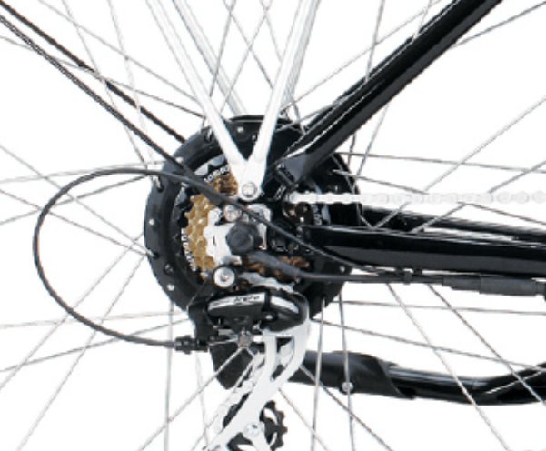

Mid mounted
In this set up the motor is mounted directly to the frame at the crank, these systems has several advantages. Due to the motor being attached in the centre of the frame weight distribution better. Also, due to them being attached to the crank the standard gearing system is retained so the rider is able to shift gears and keep the motor in its most efficient rpm range when climbing hills etc. This system can also use higher gear ratios and therefore provide higher top speeds on flat ground. Tyre changes and wheel maintenance is also easier with this set up since there are no motors to worry about in the wheels.

The down sides to this set up is the increased wear on drive components since the motor is driving the chain to the rear wheel. This system also works best when the rider wants a conventional feeling bicycle i.e. one where the gear system and pedals are used. If a rider wants greater assistance and less selecting of gears/peddling then the hub mounted system may be best for this application.
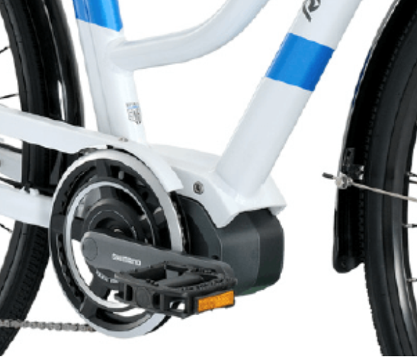

Motor position summary
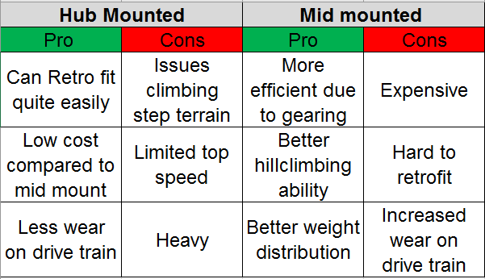

Mid mounted set ups a good option as can be seen the only downsides being that they are hard to retrofit, can be expansive and they do increase wear on the drive train components. However, hub mounted set ups have the advantage of being cheaper, easier to install and less wear on the drive train, some riders also prefer the feeling of a hub mounted system. [5]

E-Bike Range

This is an area which is hard to be specific as there are lots of variables to consider. These variables include, rider weight, type of terrain that the bike is being used on, battery power (aH), how hard the rider is pedalling so therefore how much assistance the motor is adding, Tyre pressures, age of the battery since it deteriorates over time. What can be said is that the range figures that the manufactures claim should give a rough guide but as with car fuel economy manufactures figures are normally conducted in a controlled laboratory environment and therefore don’t always indicate real world figure A typical range for an E bike would be approx. 50 miles [6]

Conclusion

Hopefully from reading this report it can be seen how an E-bike is constructed and what different motor setups are most commonly used, the pro’s & cons of each setup and the merits of both systems.
In the end it will come down to the riders personal preference, budget and the type of use that the bike is intended for. As technology evolves and battery technology improves E-bikes will become more common as the range gets better and the cost becomes cheaper.

References

[1] | Unknown, “http://www.electric-bicycle-guide.com,” Unknown Unknown Unknown. [Online]. Available: http://www.electric-bicycle-guide.com/electric-bicycle-weight.html. [Accessed 01 December 2017].
[2] | E.-B. direct, “E-Bikes direct,” [Online]. Available: https://www.e-bikesdirect.co.uk/learn-more/bike-buying-guide/. [Accessed 01 December 2017].
[3] | s. i. electronics, “instructables.com,” Unkown, Unkown Unkown Unkown. [Online]. Available: http://www.instructables.com/id/DC-Motor-Controller-for-Electric-Bicycle/. [Accessed 03 December 2017].
[4] | M. Staff, “https://momentummag.com,” 8 September 2016. [Online]. Available: https://momentummag.com/types-of-ebikes/. [Accessed 03 Decmeber 2017].
[5] | Unknown, “https://www.ebikingnow.com,” 18 February 2017. [Online]. Available: https://www.ebikingnow.com/blog/mid-drive-vs-hub-drive. [Accessed 03 December 2017].
[6] | A. J. Cyclist, “http://electricbikeblog.com,” 15 Janurary 2016. [Online]. Available: http://electricbikeblog.com/how-to-figure-out-electric-bike-range/. [Accessed 03 December 2017].
[7] | J. Beach, “http://www.bikeradar.com,” 22 October 2016. [Online]. Available: http://www.bikeradar.com/gear/article/electric-bikes-explained-47315/. [Accessed 01 December 2017].

