
Reflective report on Professional Career development- January 2022 Cohort

Student Name: Alina Olaru
Student Number:2123361
Lecturer: Melanie Squire
Contents
Content page…………………..………………………………………………………………………………..…1
1.0 Terms of Reference…………………………………………………………………………………….….3
- Procedure ……………………………………………………………………………………….……………3
- Introduction…………………………………………………………………………………….……………4
4.0 Main findings…………………………………………………………………………………………..…….7
4.1 My knowledge about Professional Career Development ………………………………9
4.2 Challenges I came across, Learning and Growth strategies to control them ……20
4.3 Learning application in my career development field……………………………………..21
4.4 Research I found…………………………………………………………………………………………….21
4.5 My SMART goal……………………………………………………………………………………………...13
4.6 Applying SWOT analysis and other models into my Smart goal………………………14
4.7 Employability skills applicable to my goal………………………………………………….7
4.8 Personal Development Plan …………………………………………………………………….22
4.9 Learning styles questionaries- reflections, learning applies …………………….17
5.0 Conclusions…………………………………………………………………………………………….25
6.0 Reference List…………………………………………………………………………………………28
7.0 Appendices……………………………………………………………………………………………29

Executive Summary

In this report I am going to show different strategies in professional career development in order to help students to progress in their jobs, aspire for higher positions or simply to do better in their current position. It can also be used as a guide for managers on how to support or to keep under surveillance their employee’s professional development.

Guide outline
- Set your goal- based on your aspirations create a vision of your future profession.
- Identify abilities – Demark the skills needed for targeted job
- Self-assessment - asses your strengths and weaknesses related to your target
- Personal Development Plan- Set a professional extension on your goals that relates your development needs.
- Implementation- Act and stay focused on your development plan.

1.TERMS OF REFERENCE
This reflective report has been requested by my Lecturer Melanie Squire in relation to Component 1 assessment of the Professional Career Development module as part of the Level 4 Skills for the Workplace Program. The report introduces different strategies for personal and career development to create a stronger professional society.

2. Procedure
To create this report, I have put into practice all the knowledge I have accumulated during the lectures so far and I went through all the power points from Moodle. I have also accessed different academically journal, books, online journals as a source of inspiration and information.

3. INTRODUCTION
This report will examine my learning experiencing in the lectures about Professional Career development and Employability skills. I will explain the process of learning and developing new skills to improve myself as a person with a focus on career advancement.
Do not delay in taking decisions that have impact on your career. Do not wait for an auspicious day to come; for completing an academic activity, for settling down, and for any other reasons. Pursuing a career will always have uncertainties. Self-management helps to reduce the uncertainties (Risha, n.d.).
Professional career development and employability skills help students to achieve self-awareness, which is required to learn about strengths and weaknesses, to apply new concepts, skills in order to accelerate their career progress.

‘’A set of goals, reflections and personal attributes that make a learner more likely to gain employment and be successful in their chosen occupation’’ (Yorke and Knight; 2004)

Employability skills- According to Dr Peter Hawkins, (1999, p9) to be employed is to be at risk, to be employable is to be secure.
Employability skills is another important topic that I have been familiarized with during the lectures which teaches me how to be ‘’employable’’ for my dream job and how to be efficient along with other team members to handle my job performance and career success.
Employers expect students in this field to own well improved employability skills, so they can be an immediate contribution to the job when they are hired. To Graduate Employability is the key for Higher Educations and the first step in achieving my goal.

Understanding others emotions, as well as our own, is vital for a well-functioning SOCIETY. (Irberkish Faltash,2019)

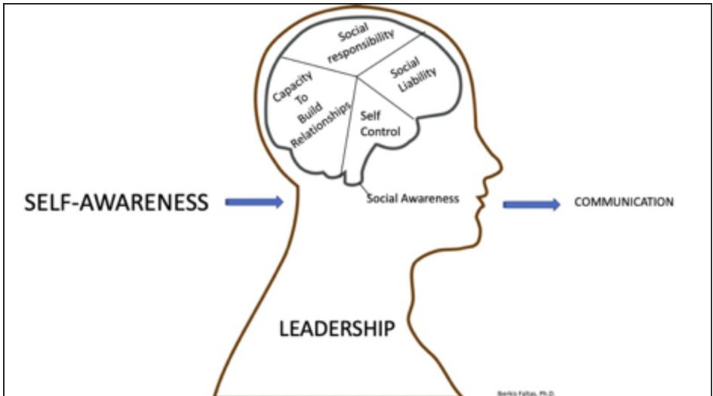

4.Findings

4.1 Employability skills
Employability skills are the main skills that make any individual employable. Alongside with a good computer work skill and good technical knowledge and computer understanding employers usually have a set of keys that they expect from an employee.
Such as: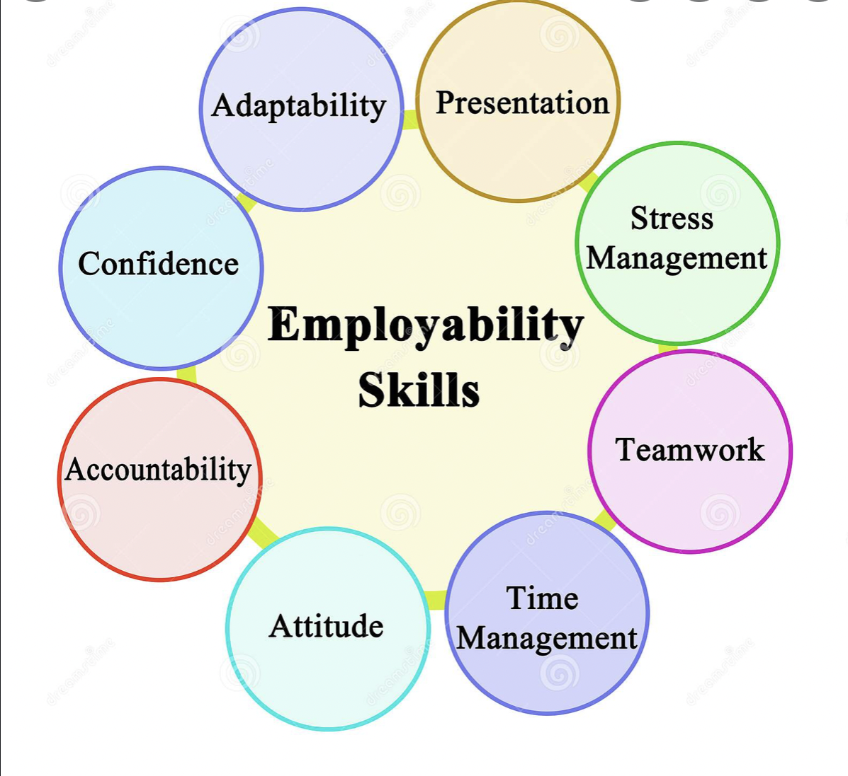

SELF AWARENESS
Self-awareness is the capability to see the weak sides in us but still being able to concentrate on the problem to get it solved. Self-awareness helps me understand my strengths and weaknesses and help me get over my emotions.
Who looks outside, dreams, who look inside, awakes. (Jung, 2019)
According to the lectures self-awareness is major on my needs as I need to identify my wishes and preferences but also reflect on my personality characteristics positive and negative to stay focus on the advancement of my strengths and weakness.


JOHARI WINDOW
We studied about Johari window and what role plays in my life that can help me identify what I know about my own person and what’s other people’s opinion about myself. It has at base a framework that helps increase self-awareness and understanding of people around us.

The Johari Window has 4 quadrants:
1. Open space: Known to you and known to others
2. Blindspot: Unknown to yourself but known to others
3. Hidden area: Information about yourself that you choose to hide from others.
4. Unknown area: Unknown to yourself and unknown to others. (Luft and Ingham ,1955)
I use Johari window as my personal development guide trough self-reflections.
Open area
During my career and development aspirations I discuss with my manager, family and friends. I am trying to grow good qualities as a person and as a worker. These currently include:
  - Improving my employability skills
  - Gaining experience from feedback
  - Increase my confidence
  - Improving Leadership qualities
The blind spot
  - Gives the opportunity of getting feedback at work and personal life
  - Gain awareness into how I can improve in my job
  - Build good relationship with my colleagues
  - Demonstrate to my manager that I am willing to improve my personal development
The hidden area
In this area I decide how I present myself in front of others
  - In interviews to show the employer I am the best candidate for the position
  - Build relationship with my cookers sharing more about myself helps to build trust and inter-professional relationship
  - Greeting new colleagues: so, I can show that I am there to support them.
The Unknown
I love provocations, to discover my potential by putting myself trough many activities and challenges that I think I cannot face. Usually, I step into an unknown zone to cultivate a growth mindset skill, to see where the opportunity takes me.
Workers want the chance to progress in their careers, ‘’opportunity is the top reason why 39 percent of employees are engaged.’’ Digoxin, 2017)
During the lectures we learned about SMART and SWOT which links perfectly with the unknown zone as it helps me to discover myself, to find out what my strengths and weakness are. SMART is a reflective tool; every letter describes a part of my goal.

4.5 SMART goal
By setting goals I am giving myself a target to aim for. A SMART goal helps to guide us on how to set a goal in order to be achievable.
SMART is the initialism that stands for S-specific, M-measurable, A-achievable, R-realistic and T-timely. A SMART goal includes all these guidelines to help you focus on your goal and increase the chances on achieving your dream goal.
SMART goals are:
Specific- Clear, defined, precis.
Measurable- With specific standards that measure the progress to aim the goal.
Achievable- Accessible and not impossible to achieve.
Realistic- Realistic in being reachable
Timely- Time bound in order to be motivation.
The SMART technique helps push us further, help us to organize and reach our set goals.
Referee to Appendix: My SMART goal
4.6 SWOT ANALYSIS
SWOT analysis is a strategic management technique that provides assessments tools used to help a person or a company identify strengths, weaknesses, opportunities and threats related their business, goal setting or competition. This plan of action is used to evaluate the risk, competition, performance before setting a goal. It allows decision makers to identify where the organisations stands and where they need to improve. This strategy helps them to be a proactive player in the market and remain competitive at the same time. A company which fallows SWOT analysis has more chances to success rather than wasting time or efforts trying to expand a market that would not develop or has been destroyed by another competitor.
SWOT analysis is a square segmented into four quadrants, each of them dedicated to an element of SWOT.
Referee to Appendix: Personal SWOT analysis.
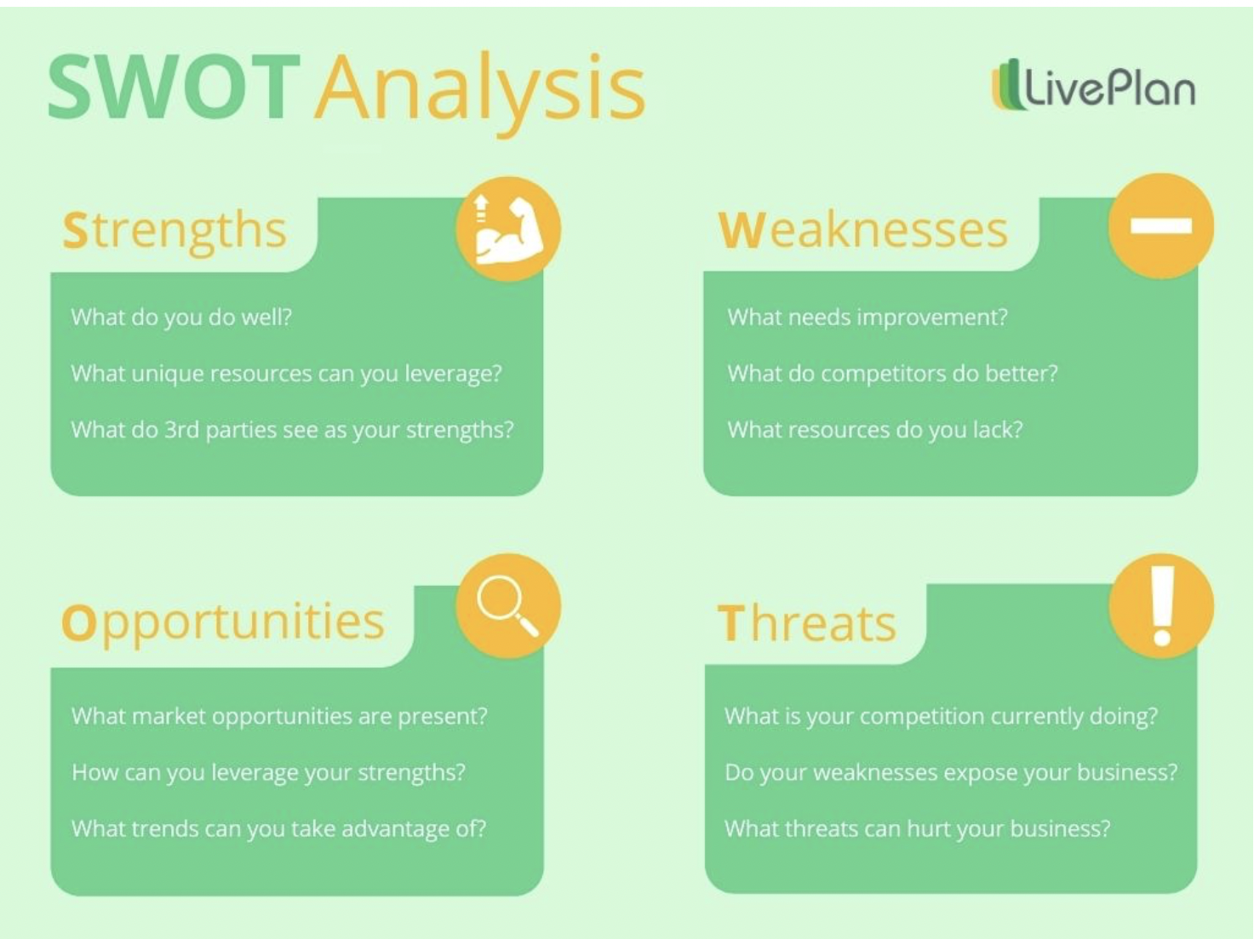
4.9 Learning styles questionnaires – reflections, learning applies
I enjoyed week two of lectures as we have been introduced to Personality Profiling and Learning styles. This week’s lectures opened my mind and encouraged me to look closer in directing my learning style. Fleming and Mills (1992) innovated VARK learning style. VARK simply describe the natural chosen way to learn. V-visual, A-aural, K-kinesthetic, R-read and write
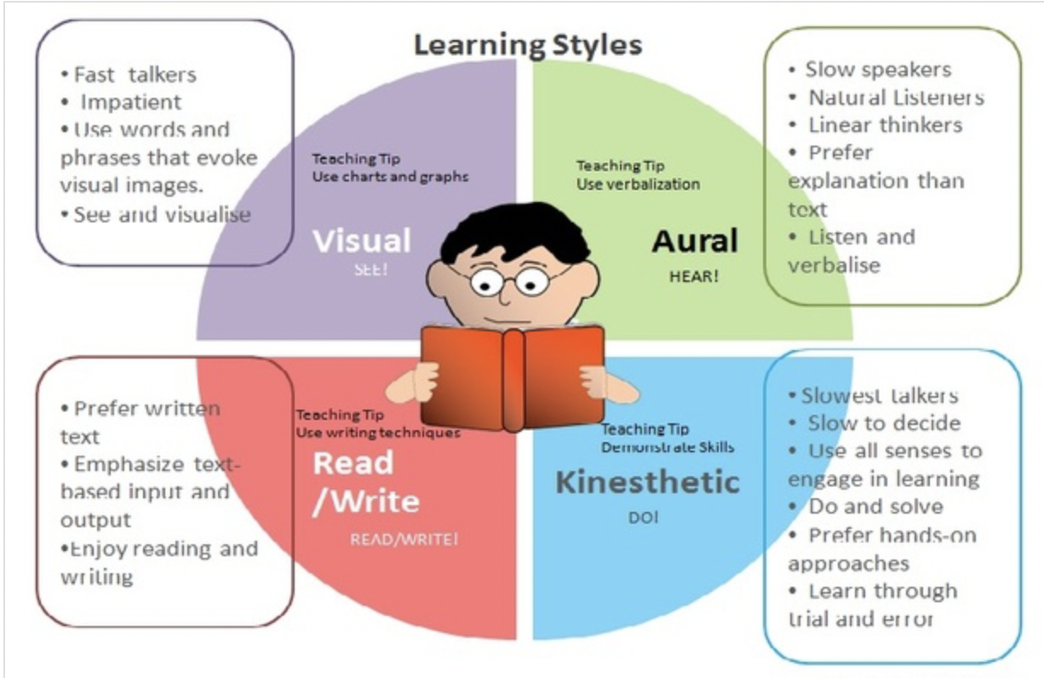

After doing the questionnaires my result from VARK learning style came out as I am a visual learner and I wasn’t surprised at all as everything that has pictures or diagrams straight away sticks into my mind. I will be using this learning style to organize my assignments better by creating graphs and charts to organize the information in order to an easy and understandable. I like to be a perfectionist, to take my time and do the job properly at work, but some employers want the job to be done ASAP if it’s 80% correctly, I must learn to adapt to this sort of enquiries in a way not to affect my psychological status and professional relations which in the future leads on behavioral and attitudinal problems.
Another learning style that Kolb’s cycle. It is presented as four stages which leads us to a concrete experience at the end. This gives you a starting point, but it’s argued that we can begin from any point. Kolb’s argue that for new knowledges we must progress through all stages.
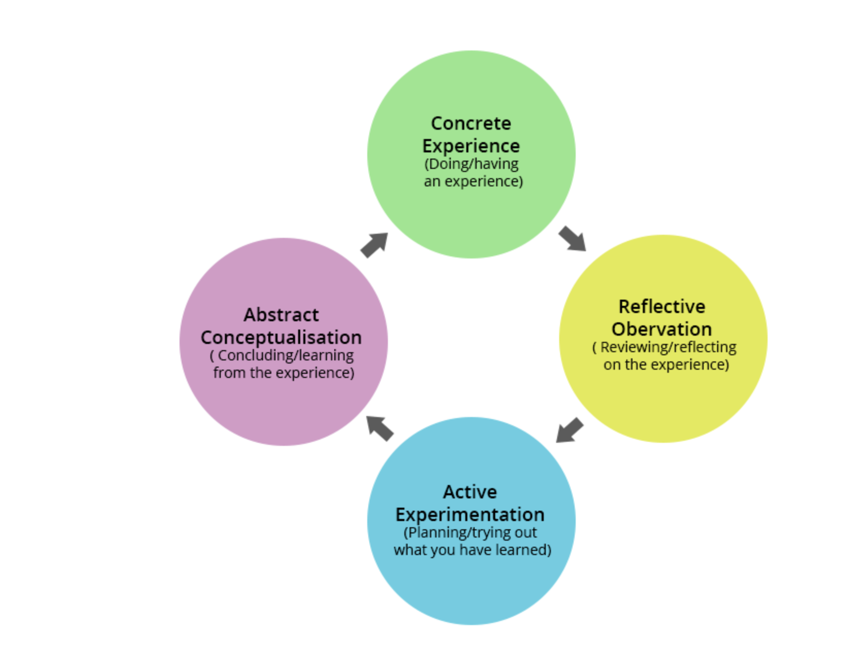

4.2 Challenges I face, learning and development strategies to control them
It has been a while since I was a student last time especially that I have never been a student in the United Kingdom. Due to low vocabulary sometimes, I struggled expressing my point of view and because of the large amount of information accumulated I am overwhelmed sometimes. I have become more familiar with my personality traits, I got over these fears and focus more on my professional career development and on how to succeed to reach my goal.
I must put into practice the Vark and Myers-Briggs questionnaire to develop analytical skills by learning how to observe more, practice finding step by step plan before putting into practice. Try to find a relation between two different options, play analytic games and find resources for new ideas and visualize all the possible way.

4.3 Learning applications in my career development
My plan is to put everything I have learned into practice as this will make a good start in my career development. I can use Johari window to increase my inter-personal skills and I will try being more opened with others to be able to receive feedback which is necessary to self-rate the situation. Feedback is the key to success because if I receive it, I can go back to see what holds me back but also it might be helpful to discover my hidden potential.

4.4 Research I found
The process of learning is assimilation of concepts that might be applied in various situations. To increase the development of new concepts, experience are essentials (Kolb, 1984, p38). Experience followed by reflections can often lead you to success or to determine a failure in life. Oppressive learning blended with real life job experience is the key to success. By following this plan am I am going to succeed in my career.

Development  Objective | Specific Actions | Barriers and how  They will be  removed | Support required | How I will know when I have achieved the objectives
Personal Development Plan

1.To promote my photography more | 4 hours a week for promoting  Write down the plan by end of may  Watch YouTube videos how to make flyers and different advertising procedures.  Adaptability  Continue to develop my website at least 1 hour a week. | Being a mom and have a full-time job makes it harder for me to find additional time for promoting.  Distractions  To find a a nursery for the baby ASAP to allow me have time for it.  Keep my sight firmly on promoting 30 min after work. | To ask my family or friends to help me put different promotions flyers trough peoples letter boxes once a week  to receive advise from a professional to help me get more engagement | I will consider it achieved when I will have more clients, and this will be my full-time job and main source of income.
3.improving photography skills | To do more courses photography to allow me to progress as the technology and styles change day by day  To specialise as newborn photographer by summer | Financial difficulty  To earn more than spend every week. | To find a professional by April to take the necessary courses from to perform better. | When I will find my work in journals and magazines

5.Conclusions
To conclude the above founding’s, everything I have learned so far has already a positive impact on me. I have learned about factors and methods which helps me improve my development as a student and as an employee. Based on VARK questionnaire that has been done I found that I am a visual learner this will help to improve my self-awareness and how I should act on unexpected unpleasant situations moreover, I realised that feedback is the key on getting to know myself which will lead me to different conclusions and measurable actions which I cand use to improve my career.

References

Digoxin, L (2017, November 15). These are the most critical components to Career Development.
Retrieved October 21, 2019 from Chief Learning Officer: https://www.chieflearningofficer.com/2017/11/15/critical-components-career-developement/

Faltas. I. (2019) Self-Awareness We Must Learn How to Listen to Ourselves Before Learning How to Listen to Others. London. pp23-35.

Fleming, N.D & Mills,C. (1992). Helping student understand how they Learn’’The Teaching professor,Vol. 7 No. 4, Magma Publications, Madison, Wisconsin, USA

Hawkins (1999) ’’Delivering employability skills in the Lifelong sector’’, p9.

Jung, (2019) Memories, dreams, reflections : an autobiography. London: William Collins. p17.

Kolb, D. A. (1984). Experimental learning: Experience as the source of learning and development (vol. 1). Englewood Cliffs, NJ: Prentice-Hall.

Luft, J. and Ingham, H. (1995) The Johari Window, a graphic model of interpersonal awareness, Proceedings of the western training laboratory in group development. Los Angeles: UCLA

Risha, R (n.d). Career Development in HRM. Retrieved October 22, 2019, from Economics Discussion: http://www.economicsdiscussion.net/human-resource-management/career-developement-in-hrm/31801
Yorke M. (2004)’’ Emending employability into the curriculum. Evidence- informed pedagogy and the enhancement of student employability’’, pp.157-170.

7.0 Appendices

SMART goal
Specific - My goal is to have my own photography business by 2022.
Measurable – if I get to spend more time promoting my work in social media, I could get more clients. Evaluate monthly my progress by reports.
Achievable – as long I don’t get distracted too much from my daily activities, I can make a big progress in getting my name known by many people in the area.
Realistic- I am sure I can set this business by next year because I am very creative and ambitious with few years of experience working as a freelance in my spare times, I love working with people and capture their unforgettable memories into my pictures.
Time Bound- If I can get this business set up in about 7 months, I will finally work on my dream job. Being my own boss and work according to my own timetable is also a big part of my goal.

SWOT ANALYSIS
Strengths
- I am talented and creative
- I have the right equipment
- Very keen eye for details
- Good people skills
- Aptitude for business
- Networking skills
- Final words

Weaknesses

- A lot of competition in the area and I think I don’t advertise enough as I have another job
- I don’t have a professional studio to do the indoor photography
- Potential financial issues that might stop me to buy better or additional equipment’s
- I am a mom which is hard for me to focus totally in photography at the moment

Opportunities

- There are many markets in photography which allows photographers to do their main loved type and style (new-born, events, portraits etc)
- There will always be a new camera, lenses, courses to help improve the qualities of work.
- People will always want to keep their memories alive.

Threats

- People know how to make their name heard by promoting themselves in every way possible
- A lot of competition in the area
- Because new trends that comes up very quote often there will be needed a lot of investment which can be very pricey
- Health. It might be moments when you get ill, but you must make your customers happy with your work and attendance.
- Theft and Damage

