Appendices

Appendix 1: Consent form and information letter for parents………………..……………2
Appendix 2: Observation Schedule for lesson 1……………………………………………4
Appendix 3: Interview Questions for lesson 1…………………………….…………………6
Appendix 4: Observation Schedule for lesson 2……………………………….……………8
Appendix 5: Interview Questions for lesson 2………………………………………………10
Appendix 6: Observation Schedule for lesson 3……………………………………………12
Appendix 7: Interview Questions for lesson 3………………………………………………14
Appendix 8: Reflection Model for lesson 2………………………………………….………16
Appendix 9: Reflection Model for lesson 3…………………………………………….……18

Appendix 1
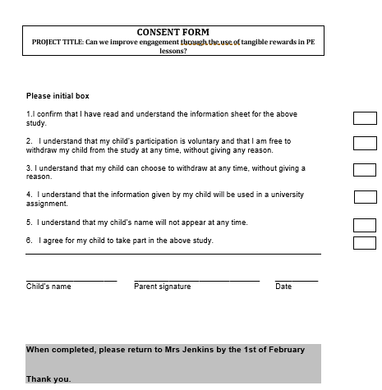

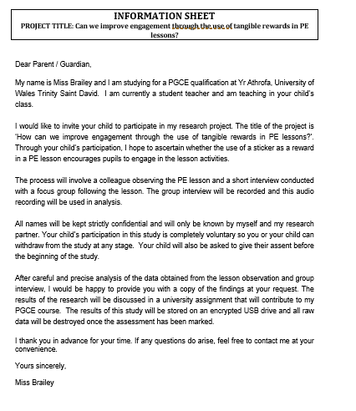

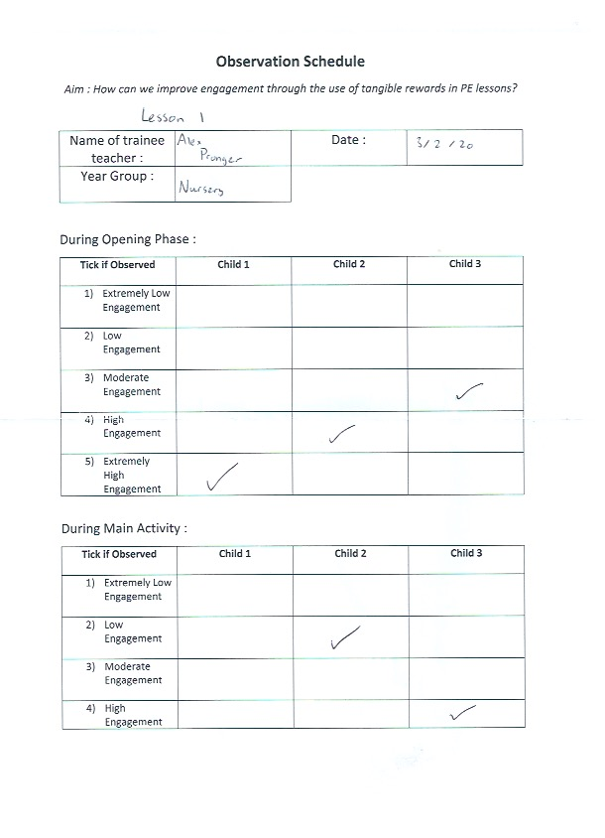
Appendix 2

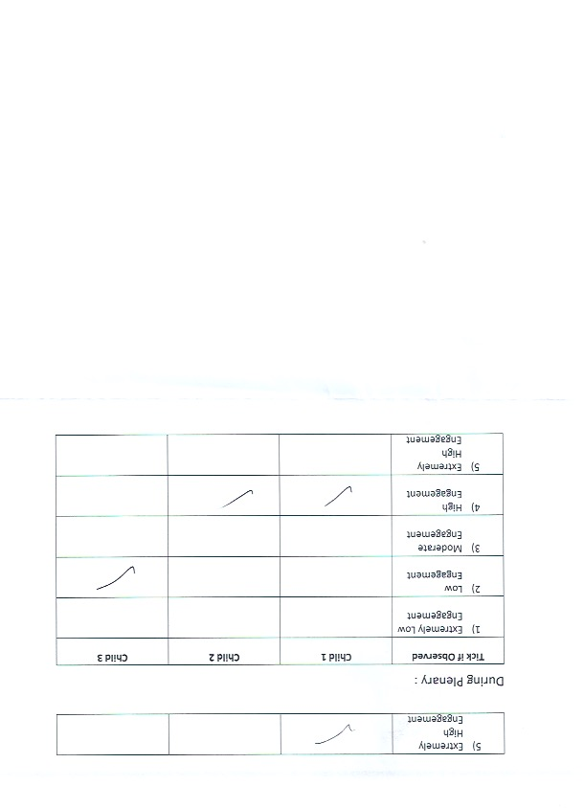

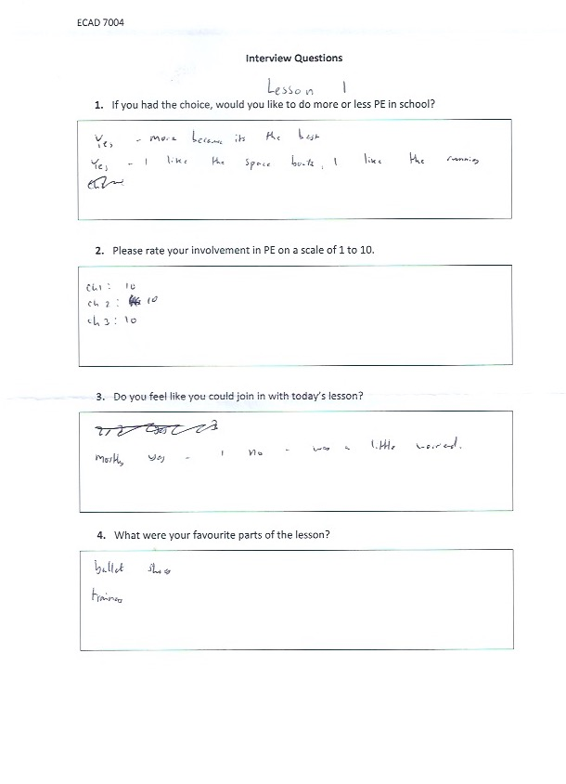
Appendix 3

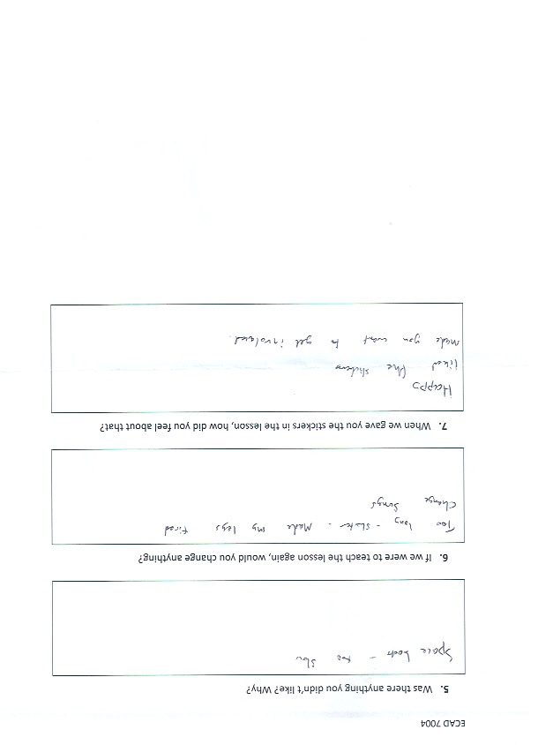

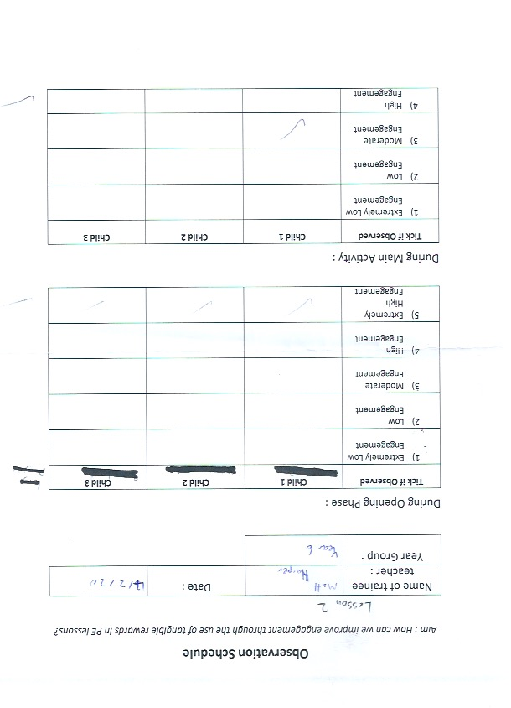
Appendix 4

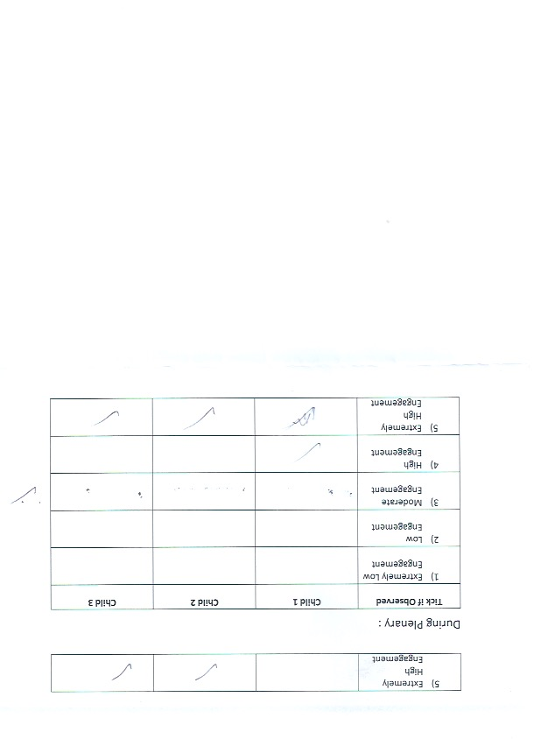

Appendix 5
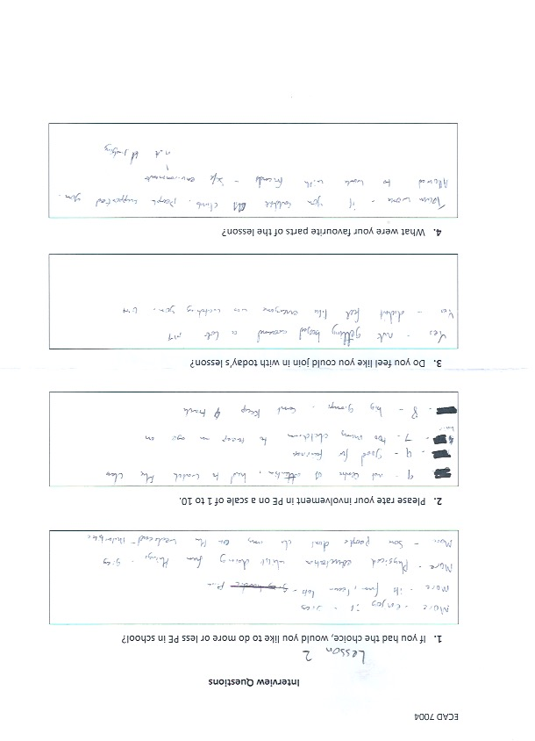

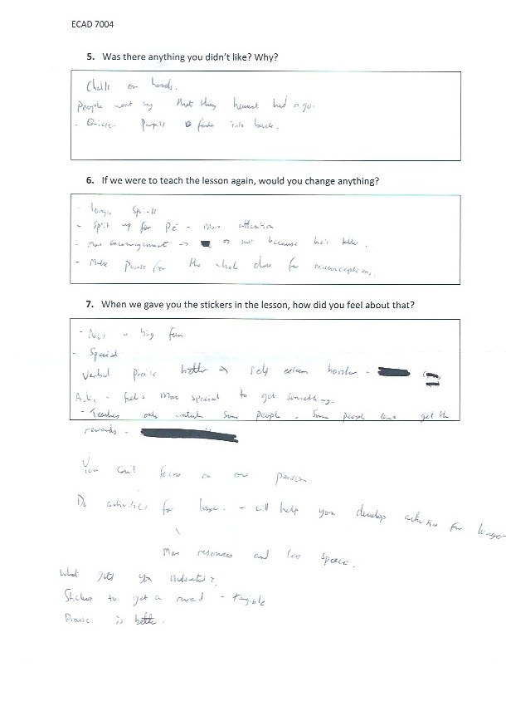

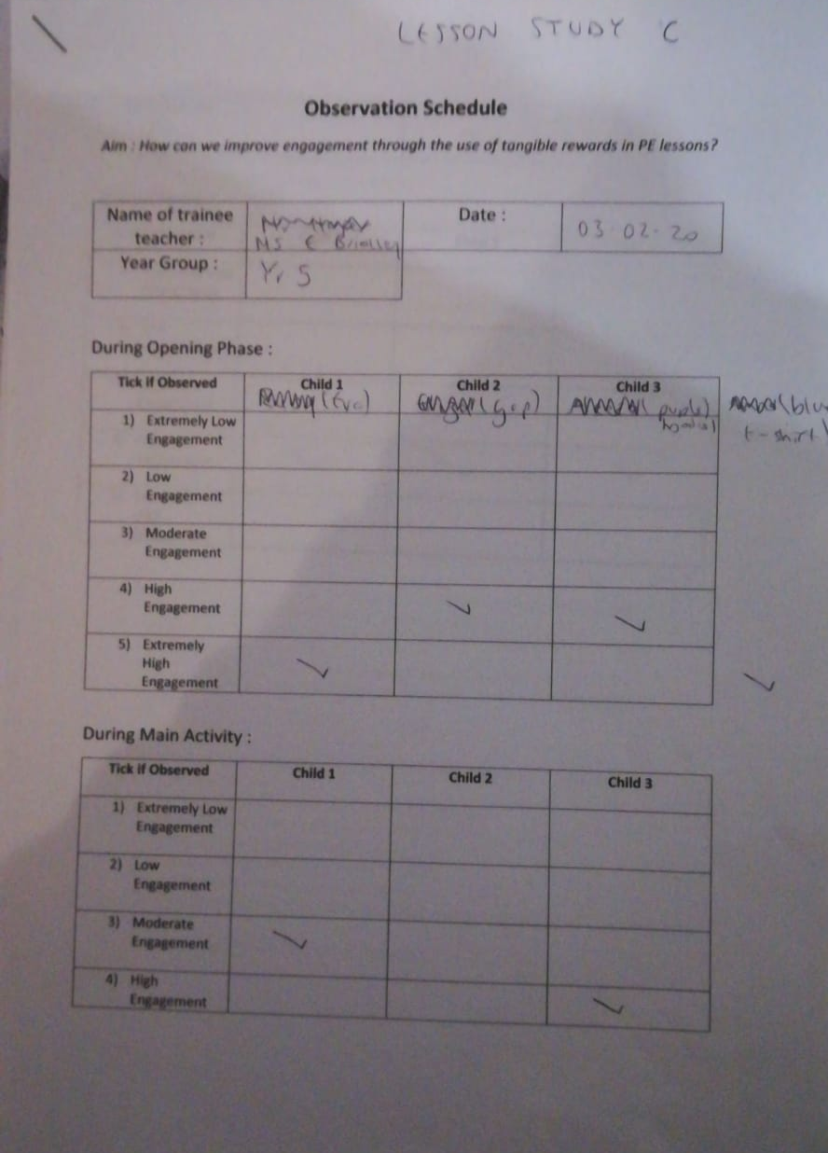
Appendix 6

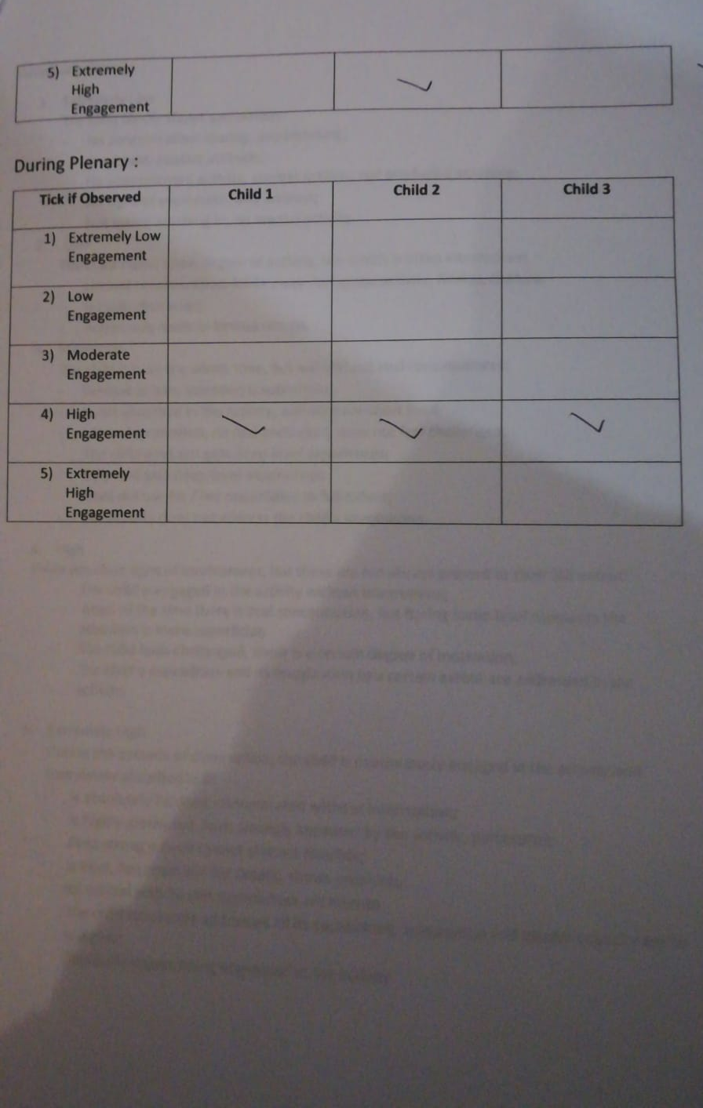

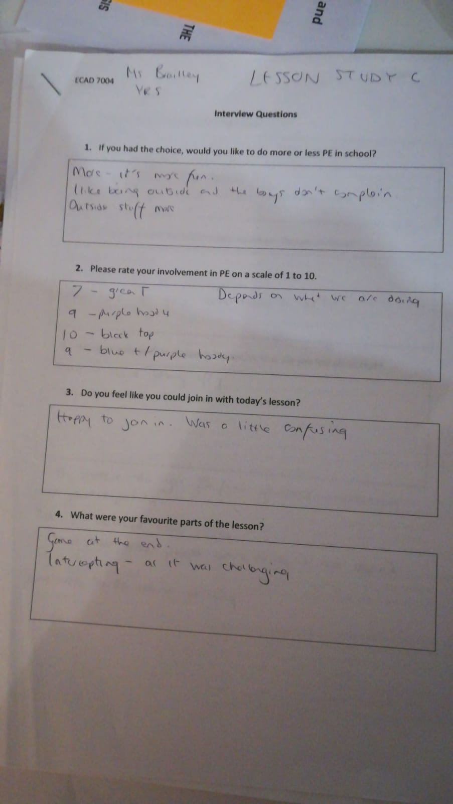
Appendix 7

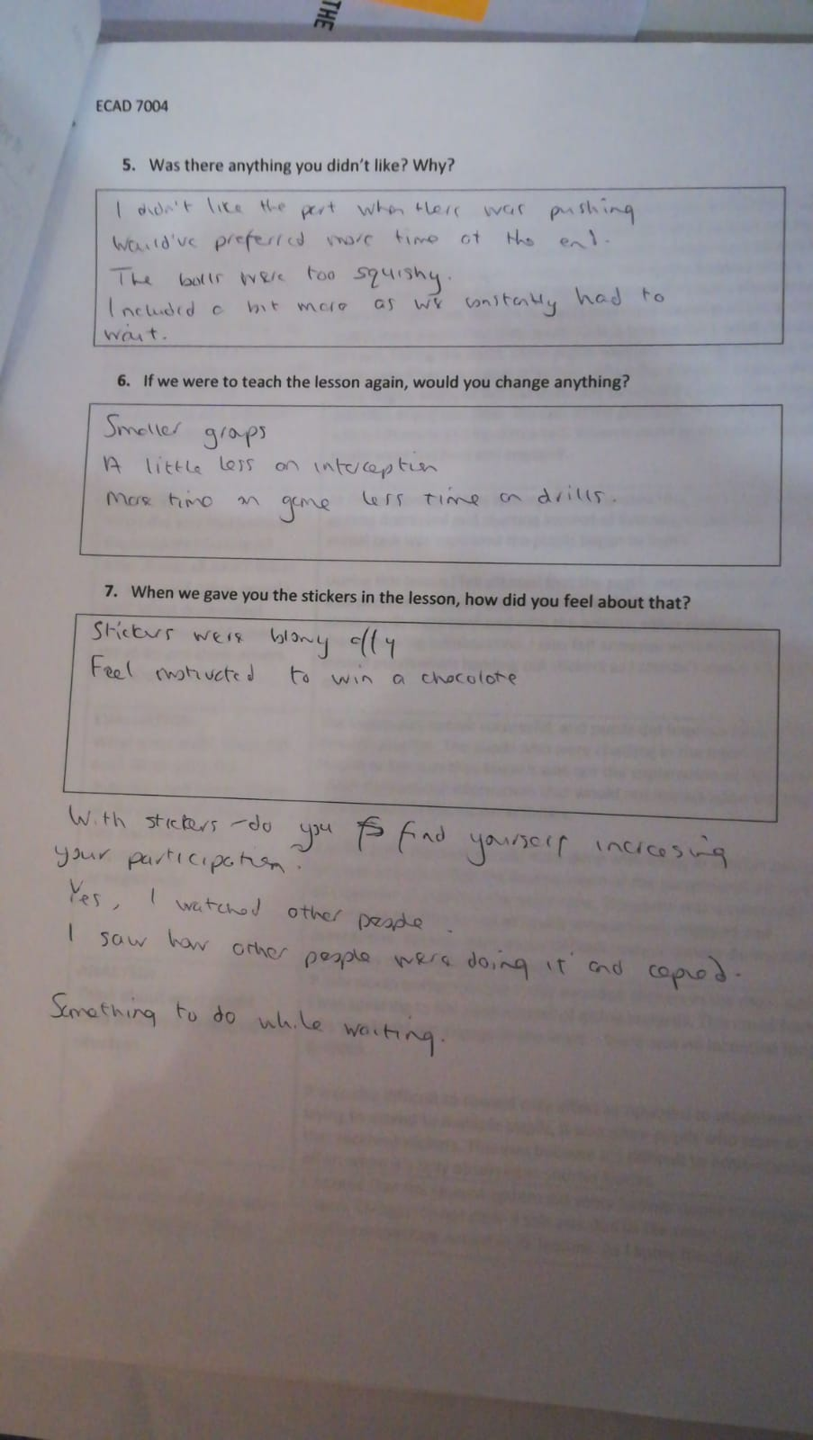

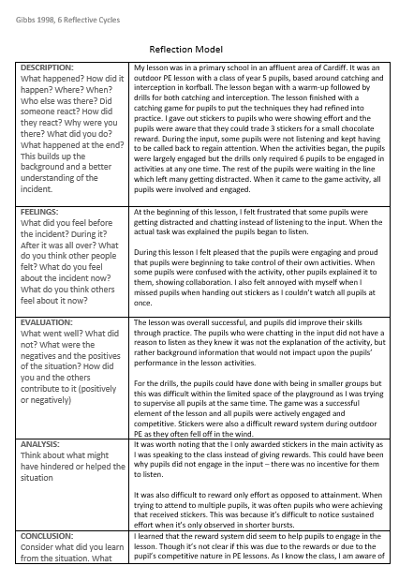
Appendix 8

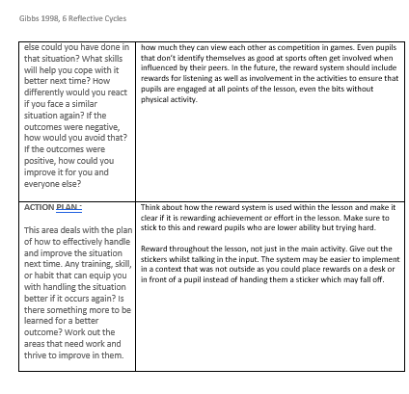

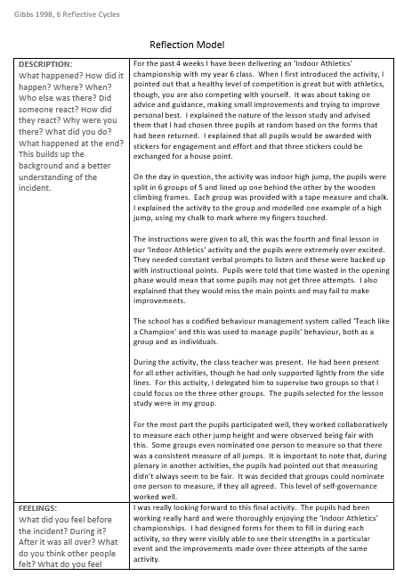
Appendix 9



