Richard Kinsey
75359@pembrokeshire.ac.uk
HNC Applied Computing –
Academic & Employability skills
Assignment

Contents
Assessment Part 1 2
Presentation - Overview 2
Presentation - Key skills learnt 3
Presentation - Analysis 3
Skills Evaluation 3
Skills Evaluation – Strengths & Weaknesses 4
Skills Evaluation – Results 5
Action Plans 6
Time Management and Self-Organisation 8
E-Portfolio 9
Conclusion 10
Assessment Part 2 11
Looking after your data 12
Disaster recovery scenarios 12
Back-up Action Plan 13
Evaluation 13
Ransomware 14
References & Bibliography 14
Appendix 15

Assessment Part 1

Presentation - Overview

As part of the Academic & Employability Skills module students were asked to prepare a presentation to give an outline of who they are including their interests and some details about their personality.
This student started by describing their interests and hobbies, focusing on the water and winter sports they enjoy and then went on to talk about their love of travel and places they have visited. They went into some detail about the previous career as a chef and then talked about why they left that career to do what they do now, working in recruitment. The presentation finished using information from the completed ’16 Personalities’ personality test to talk about their strengths and weaknesses and their personality more generally.

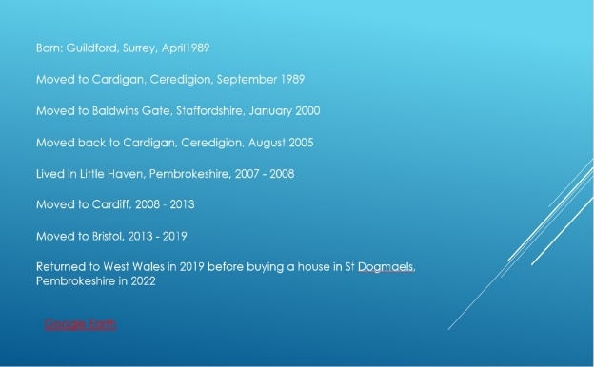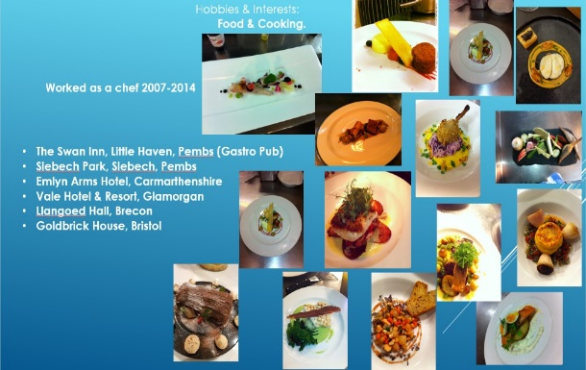
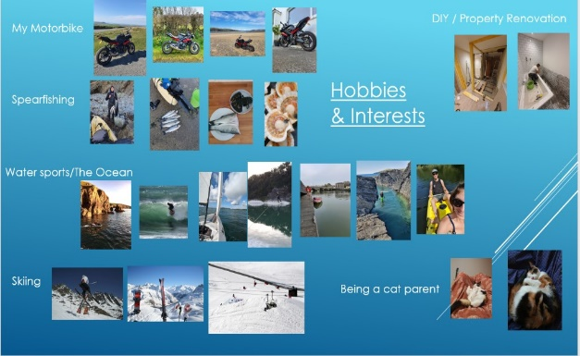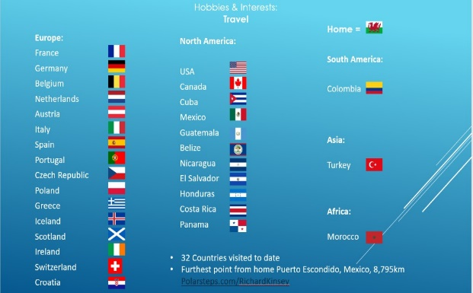
Figure 1-4 – slides from presentation

Presentation - Key skills learnt

- Speaking clearly and confidently
- Pace of speech and cadence
- Structure & Coherence
- Utilising PowerPoint
- Engaging an audience

Presentation - Analysis

Delivering a presentation was an enjoyable experience that encouraged some self-reflection on aspects of life that are enjoyed and the students’ personal journey through life to date. Overall, the presentation went well however self-analysis and peer feedback suggested that there was room for improvement. A lot of information was given orally, suggesting a strength in public speaking, however the audience may have benefited from having some more information represented visually as additional PowerPoint slides. The student utilised links to external websites, such as Google Earth and an interactive quiz. These additional sources were beneficial in that they added layers of engagement and interest however they did perhaps take away from the general ‘flow’ of the verbal presentation, so it is worth considering if the additional sources offered a net benefit. Overall audience engagement was good; however, it was noted that the student should remember to address and make more eye contact with their audience.

Skills Evaluation

Successful learning in a higher educated environment is multi-faceted and requires an understanding and incorporation of a number of key skills and techniques. Some of these key skills include self-awareness and self-analysis such as reflection, critical thinking for application of comprehension and understanding, presentation and referencing, action planning and goal setting and then finally evaluation.
Reflection promotes critical thinking and continuous improvement; a key aspect of reflection is reflective thinking [1]. This is an abstract idea that encourages an individual to think about their thinking process, it encourages self-analysis and through this better self-awareness, through this an individual can tailor learning to suit their own ways of understanding and from this they can formulate more effective action plans goals.
In the book “Make it Stick” Peter Brown et al talk about the importance of mixing up learning techniques to aid with understanding, backing up their findings with scientific evidence [2] This is important so that deep understanding is gained from learning, not just the ability to recite memorised information.
Employees look for a number of generic skills in prospective employees and these will often be transferable across any type of role or position they include communication, motivation, leadership, reliability, common sense, and the ability to learn on the job, teamwork, self-management, emotional Intelligence, analytical skills, and administrative skills. A reliable source of information for job seekers is the Indeed.com website where more information on these skills can be found [3].

Skills Evaluation – Strengths & Weaknesses

The ’16 personalities’ website is an online personality test that uses a variety of questions to help identify personality type. It is quite in depth and allows a user to gain an understanding of some of personal traits, something which can be difficult to do purely by self-analysis. The user can combine the results with their own thoughts about their own personality to help identify some key skills and weaknesses.
A further step this student took was to complete a job suitability/career suggestion test via the job personality website [4] this identified the student as “realistic and enterprising” which they felt somewhat aligned with their personality test results. Whilst the results of this test were quite limited it did suggest two jobs that would fit their profile which they have thought about to themselves in the past as jobs that they would enjoy, interior design and website design. It also suggested a cook/chef as “…an excellent example of a realistic and enterprising profession” this student was a chef for 7 years!
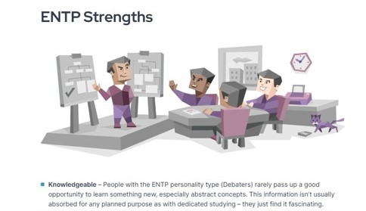
Figure 5 – personality strength
Weaknesses
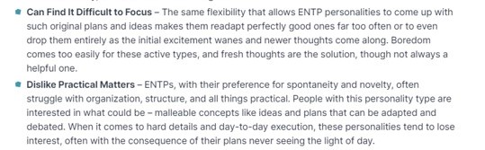
Figure 6 – Personality Weakness
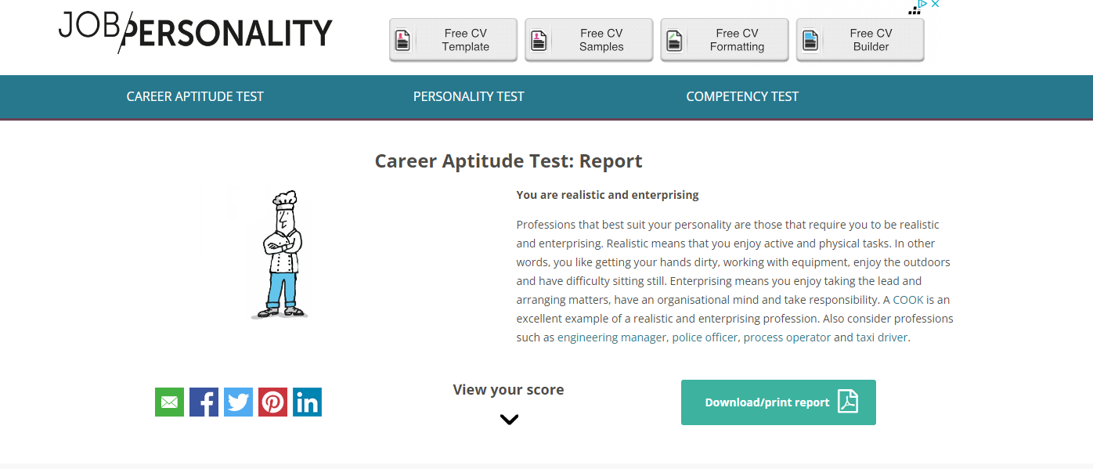
Figure 7 – Career test report

Skills Evaluation – Results

The student feels that one of their key personal traits is a desire for knowledge; to learn new things and to gain a greater understanding of how things work or why certain things are how they are. For example, they avoid fiction and only ever tend to read non-fiction as they enjoy learning new things, particularly about history and economics. Part of their motivation to return to higher education was this desire for knowledge and education. The personality test had this to say about their personality type “People with the ENTP personality type rarely pass up the opportunity to learn something new…” [5]
The personality test identified one of their weaknesses as possibly struggling with focus, and this is something they can relate to as they do find they will often chase a new idea or inspiration, leaving the motivation to follow through on the previous idea behind. However, they did disagree with the weakness of a “dislike for practical matters” as they are very practical person and get incredibly involved with DIY and property renovation and mechanics.
In summary the personality and career tests were beneficial in helping the student evaluate their strengths and weaknesses and confirmed that their life choices to date seem to align with their personality traits.

Action Plans

Short Term Goals
- Successfully complete year 1 of the HNC with distinction grade
- Research data analytics related skills and upskill in these areas
- Complete House Renovation project by end of summer 2024
- Learn the basics of SQL and python coding

Long Term Goals
- Finish HNC course and make a career change into data analytics fields ideally within financial technology, blockchain or cryptocurrency industries

Skill or Goal | Type of Skill | Activities | Date/Duration | Description | Complete By | Completed (Y/N)
Complete HNC year 1 | Academic | Attend Lectures | Ongoing | Aim to attend all lectures with minimal absences | June 2024 | N
Data analytics  Increase Employability | Professional  Professional | Submit assignments  Complete Power BI web-based tutorials  Revamp CV and complete e-portfolio | Ongoing (min 2 hours per week)  Ongoing (aim for at least 1 hour a week)  Ongoing | Work through all ongoing assignments  Identify relevant material via sources such as YouTube and Udemy  Update CV and create e-portfolio to highlight new skills and tailor to future career preferences | See assignment submission date  Aim for spending 20 hours and evaluate at this point.  June 2024 | N  N  N
House Renovation | Personal | Choose new kitchen | Ongoing | Consider options; Wren, LBS, Ikea etc | September 2024 | Y
 |  | Order steel beam |  |  | April 2024 | Y
 |  | Book in electrician |  | Get quote/confirm dates | April 2024 | Y
SMART goals are goals that are Specific, Measurable, Achievable, Realistic, and Timely. [6]
Goal | Attend Lectures
Specific | Attend all college lecture with minimal absences. Important to keep up to date with class work and assignments.
Measurable | Be recorded present through the remaining lectures (approximately 10)
Achievable | Easily achievable allowing for any illness and holidays
Realistic/Relevant | Yes, highlighted one absence due to holiday abroad
Timely | All lectures will be completed by May/June, the end of the academic year.
Goal | Submit Assignments
Specific | Submit all assignments on time for each of the 3 modules being studied.
Measurable | 3 assignments to be submitted by their specific hand in dates (22nd April 9th May 10th May)
Achievable | Focusing on a few hours per week for each assignment with completion at least 7 days prior to submitting so that there is time to review
Realistic/Relevant | Yes, as long as worked at gradually and not left to last minute
Timely | Dictated by hand in dates.
Goal | Complete 'Power BI' tutorials
Specific | Work through all the Power BI tutorials provided by Microsoft
Measurable | 5 tutorials to work through
Achievable | Focusing on completing one tutorial per week
Realistic/Relevant | Yes, the tutorial will give a greater understanding of the software package and will aid in completion of the assignment
Timely | To be started immediately until completed
Goal | Increase Employability
Specific | Revamp CV and create e-portfolio
Measurable | Completed when CV has bene updated an e-portfolio has been made
Achievable | Must be completed as part of assignment
Realistic/Relevant | Yes, an updated CV and e-portfolio will be important to secure a role in a new job sector
Timely | To be started immediately until completed

Time Management and Self-Organisation

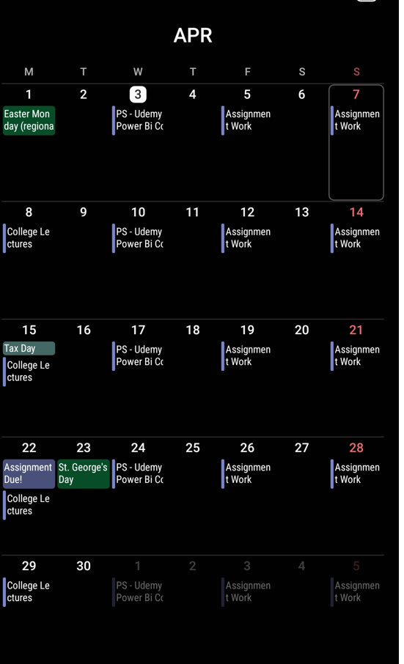
Managing time and being organised are a core aspect of being productive and this translates into desirable academic and employability skills. Being organised can help manage stress levels and may also offer a greater sense of general well-being, as it allows time to focus on achievements of the past, as well as aims for the future. allowing for greater self-reflection.
Figure 8 – Calendar screenshot

This student utilises their outlook and android calendars to stay on top of things as well as creating dedicated time slots in their week to complete certain tasks. For example, in the screenshot there are entries for college courses and when time should be spent on activities such as assignment work and other course related activities. The student finds that having preset time allotments for specific tasks means that they can progressively work through the tasks required for successful completion.

E-Portfolio

An e-Portfolio can be a way to showcase a range of skills and experiences in a concise and stylistic way and introduces any potential employer of client who may be interested in what you do or who you are.

This portfolio design was chosen as the simplistic design and layout makes the information provided clear to the reader.

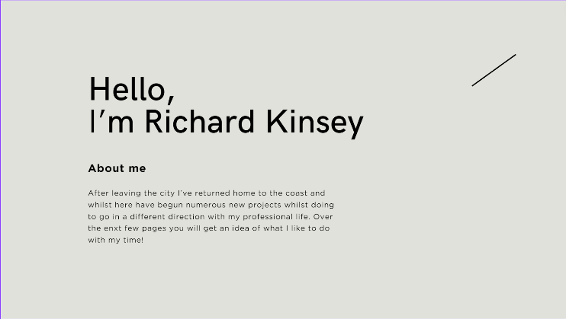
A brief introduction is given in the ‘about me’ section. Here the information provided gives an insight into who the author is and may allow the reader to connect with their personality, before moving on to the professional and personal skills. This is a key part where the author can tell a ‘story’ to connect with their audience.

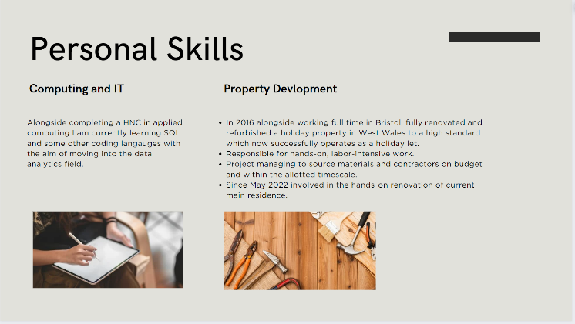
The personal skills section outlines some professional and personal skills and interest that the author has, allowing the reader to decide if these skills might be relevant for their purposes.

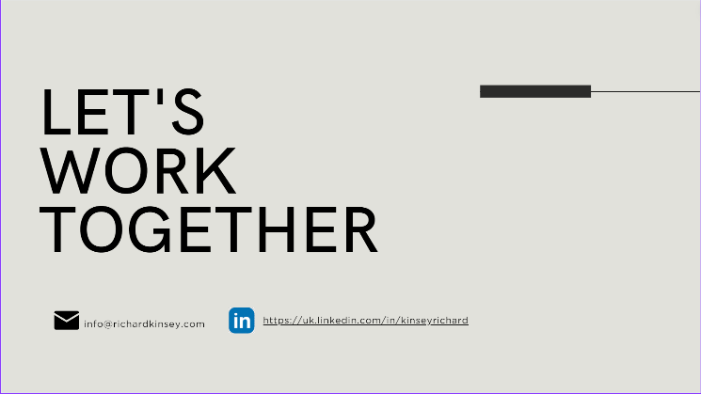
This final page offers a call to action and relevant contact information, such as an email address. Here the author has also included a link to their professional LinkedIn page. (see appendix for full CV).
Figure 9-12 E-Portfolio

Conclusion

The study of topics in the areas of academic and employability skills has led the student to consider several new ways to learn, retain information and how to present their personal and professional skills in a way that engages an audience. The tasks in the module encouraged the student’s self-reflection in number of areas.
Presenting does not come naturally to lots of people, so the task of the presentation encouraged the student to think about their personal story i.e. who they are, what they have done etc and how to present this in an engaging way. Through this process the student self-reflected on the things they have achieved so far in life, what they enjoy doing in their free time and their plans for the future. This self-reflection has positive effects in terms of well-being, as the student was able to focus on their achievements to date and to see their professional and personal development over time. It also focused them on their future. The feedback given allowed them to think about how they engage with an audience when verbally presenting information in a face-to-face scenario.
Gaining an understanding of their personality traits allowed the student to think about how they approach the tasks in their life, both personal and professional. Knowing their strengths and weaknesses has allowed them to think about areas that need more attention to improve on and the tasks they excel at naturally. This in turn means that they can be more efficient with their time, choosing where to spend it more wisely, and which areas to focus on for self-development.
Identifying goals is one thing but making them measurable and attainable is a great skill that can allow them to come to fruition more easily. The process of breaking down goals into SMART objectives was beneficial to this student as it gave a structured path to follow in the achievement of their goals. As with all techniques and practices whilst they may provide benefit in some areas, it might mean that there are drawbacks in others. Forbes highlights some of these drawbacks in a recent article [7] the main point being that be drilling down on very specific goals we may forget to step back and look at the whole picture of what we are trying to do or achieve.
Throughout this course and module, the student has been forced to address their time management. The student has found that by setting dedicated times in their week to complete specific tasks they are able to stick to deadlines and progressively work through what needs to be done without things getting on top of them. This system also gives the flexibility so that if something does come up that clashes with a time slot that has been allocated to a task it can be moved or adjusted as needed, as long as it is then completed at another time.
Reflective thinking is a topic that through the module the student has become more aware of and is interested in exploring the ideas around this area in more detail. As part of the “Smarter Study Skills” series the author Kathleen McMillan has authored a book “How to improve your critical thinking & reflective skills.” This seems like an informative book to start exploring these ideas further.

Assessment Part 2

Looking after your data

The “in 3 different places” backup strategy refers to storing electronic data in three separate places, on two different media types with at least one copy kept off site (at a different geographical location), to protect against data loss. [8]
An example of a strategy employing this rule would be saving to a desktop computers hard drive, a removable external drive, and a cloud storge drive, such as OneDrive. If the one or even two of these storages failed there would still be access to the data. For example, if there was a fire and both the desktop computer and external hard drive were lost. To further improve protection multiple geographical sites should be used for each storage location.
As a student a personal and practical application of this would be to save their work both on their personal computer, to an external hard drive and on the cloud, such as OneDrive. Another fail safe would be to email the work to themselves so that there is another ‘cloud’ save in their emails.

Disaster recovery scenarios

- Flood/Water Damage
- Fire/Heat Damage
- Power surge/outage
- Hardware failure
- Cyber attack
- Failed Backups

In his article “8 Disaster Recovery Scenarios to Test” Dale also adds the scenario of ‘workforce interruptions’ such as “…terrorist activity…. transport stoppages…worker strikes…” [9]
The students back up strategy should offer data protection in any of the disaster scenarios above, as it follows the three different places rule. Having backups on the cloud, via OneDrive, a personal email account and college email account will protect against any physical disasters, such as fir or water damage, either at the student home or college.
In the event of hardware failure, which could be either the student’s workstation or external hard drive back up, they would still have the cloud backups available to them.
Should there be a malfunction or error in saving to cloud and/or email then the student would have their files available to them on their local workstation and external hard drive.
In the event of cyber-attack, which could in theory compromise access to OneDrive, emails and delete saved work from a workstation, then the student would still have access to their work on their external hard drive. It is worth noting that this would only be potentially compromised in a cyber-attack should it be connected to the device being attacked at that specific moment in time, so it is not completely fail safe.
In any of these scenarios the back-up strategy should be adequate, and the process of restoring things would be straightforward, involving moving the files from the available source back on to the new hardware that had been compromised.

Back-up Action Plan

Action to take | When? | Description
Autosave to cloud  Save to workstation | Constantly  Constantly | Set Word etc to automatically update to OneDrive using the ‘autosave feature’  Use ‘save’ and ‘save as’ to keep current document up to date.
Email saved work to email accounts  Save files to external hard drive | After each study session  Weekly/on completion of a specific piece of work | Email most recent saved files to personal and college email accounts  Back up recent files/completed work to external hard drive

Evaluation

In any disaster recovery planning scenario, a thorough risk analysis should first be carried out to identify the most prominent risk so that the most likely threats can be identified and then planned for accordingly. Once the threats and/or risks have been identified then and an effective plan can be put in place. With the student’s back up strategy in place they should be protected in the most likely disaster scenarios that they have identified.
Ther are a number of hardware and software tools available to aid with disaster recovery and can include cloud-based recovery tools such as AWS Backup or software such as Veeam. Large business may also benefit from ‘replication and failover’ tools, these will create identical copies of a businesses’ systems between different geographical locations and will automatically switch if the case of failure. Examples of these tool include ‘Oracle Data Guard’ which can be beneficial in that they reduce downtime and data loss.
‘DRaaS’ or disaster recovery as a service is and an end-to-end cloud-based service which help simplify and automate disaster recovery processes, with it all ‘under one roof.’ More information on these specific areas can be found in the LinkedIn article [10]

Ransomware

The National Cyber Security Centre describes ransomware as “Ransomware is a type of malware which prevents you from accessing your device and the data stored on it, usually by encrypting your files. A criminal group will then demand a ransom in exchange for decryption.” [11]
Ransomware is a type of software designed to block access to a computer system or files until a sum of money, or ransom, is paid. It typically encrypts files on the victim's system and demands payment for the decryption key. Ransomware attacks can have devastating effects on individuals, businesses, and even government organizations, causing data loss, financial damage, and reputational harm.
In terms of disaster recovery, it might be important to consider the threat of ransomware and what actions need to be taken to mitigate this threat and what can be done do worth through the consequences of a ransomware attack.
Regular data backups and having a robust back up strategy is critical for dealing with ransomware attacks, as this will allow the user to restore their data without having to contemplate paying the ransom.
The student has identified ‘cyber-attack’ as a disaster scenario and ransomware would fall into this category. Therefore, by having a back-up action plan in place the student has taken measures to protect themselves. Should either their personal or college workstation come under attack, the work they have saved both on the cloud, their emails and external hard drive should not be harmed. Even if the ransomware was able to spread to their email or external hard drive it is very unlikely to effect multiple email accounts, an external hard drive (that is mostly kept disconnected for a ‘live’ device) and their OneDrive account, all at the same time. The National Cyber Security Centre is a great resource for learning more about cyber security and malware, more information about how to mitigate ransomware attacks can be found here [12]

References & Bibliography

[1] | E. A.-K. a. P. Rezaie, “What is reflective thinking?,” 4 November 2019. [Online]. Available: https://www.open.edu/openlearn/mod/oucontent/view.php?id=51386&section=2. [Accessed 19 February 2024].
[2] | P. C. Brown, H. L. R. III and M. A. McDaniel, “Mix Up Your Practice,” in Make it Stick: The Science of Successful Learning, Harvard University Press, 2014, pp. 46-66.
[3] | Indeed Editorial Team, “The top 10 employability skills that will help you get any job,” 7 September 2023. [Online]. Available: https://uk.indeed.com/career-advice/finding-a-job/employability-skills. [Accessed 19 February 2024].
[4] | “Job Personality,” Jobpersonality, 2024. [Online]. Available: https://jobpersonality.co.uk/. [Accessed 2 December 2023].
[5] | “16 Personalities,” NERIS Analytics Limited, [Online]. Available: https://www.16personalities.com/. [Accessed 29 November 2023].
[6] | C. Team, “SMART Goals,” CFI Education Inc., 2024. [Online]. Available: https://corporatefinanceinstitute.com/resources/management/smart-goal/. [Accessed 03 April 2024].
[7] | R. W. Kimberlee Leonard, “The Ultimate Guide To S.M.A.R.T. Goals,” Forbes.com, 4 May 2022. [Online]. Available: https://www.forbes.com/advisor/business/smart-goals/. [Accessed 10 April 2024].
[8] | F. LLOYD-DAVIES, “The Backup Rule Of Three Is A Simple Way To Remember Backup Best Practice,” Acronyms, 16 January 2018. [Online]. Available: https://www.acronyms.co.uk/blog/backup-rule-of-three/. [Accessed 11 March 2024].
[9] | D. Shulmistra, “8 Disaster Recovery Scenarios to Test,” 9 September 2020. [Online]. Available: https://www.linkedin.com/pulse/8-disaster-recovery-scenarios-test-dale-shulmistra. [Accessed 12 April 2024].
[10] | S. R. Chandra Skhar Murthy, “What tools and tech do you use for disaster recovery and business continuity?,” 1 March 2024. [Online]. Available: https://www.linkedin.com/advice/0/what-tools-tech-do-you-use-disaster-recovery-business. [Accessed 14 April 2024].
[11] | “A guide to ransomware,” NSCS, [Online]. Available: https://www.ncsc.gov.uk/ransomware/home. [Accessed 15 April 2024].
[12] | “Mitigating malware and ransomware attacks,” NCSC, 9 September 2021. [Online]. Available: https://www.ncsc.gov.uk/guidance/mitigating-malware-and-ransomware-attacks. [Accessed 15 April 2024].

Appendix

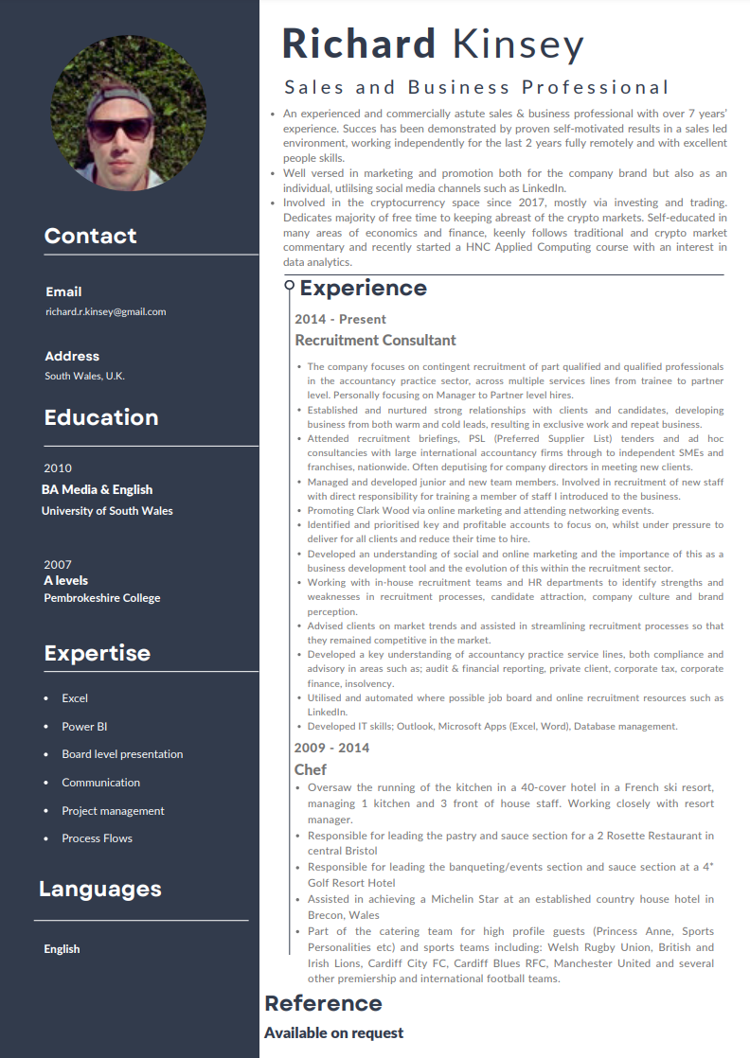
Figure 13 - CV

