Chapter 3: Methodology

Introduction
Chapter 2 fulfilled the first objective stated, that is:
- To critically review further existing literature of the topic of audit quality and individual influences upon it.
It was established that while there have been some studies around this area, they were all limited by other factors such as their age or the country the study was carried out in.
This chapter will start towards fulfilling the second objective:
- To conduct primary research on perceptions of working auditors and analyse the results.
In order to guide the process of selecting the most appropriate means to collect results the research “onion” will be used (Saunders, et al., 2016).

The Research Onion
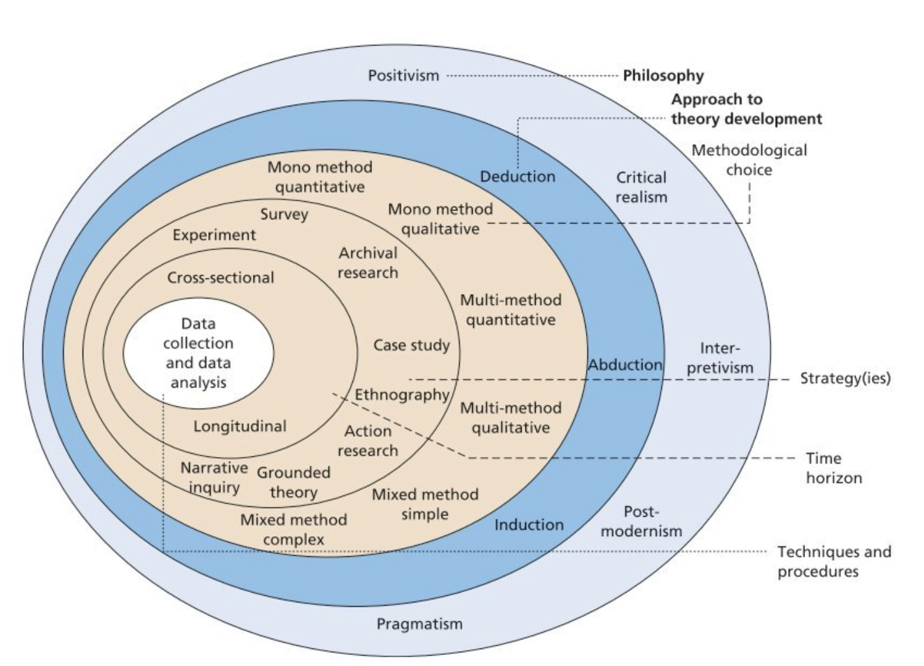
The purpose of the research onion is to aid researchers to consider all possibilities as they lay out their research.
Figure 1 - The Research "Onion" (Saunders, et al., 2016, p. 124)

Philosophy
The philosophic approach this research takes will be an Interpretivism based one. This school of research philosophy takes a socially constructed ontological view of reality. Using the subjective meanings that already exist in society and are part of the culture and language of said society (Goldkuhl, 2012), Interpretivism allows for subjective views from participants and understands that each person interprets their own reality. It allows, through contextualisation, the researcher to examine the reasons behind an action or belief in terms of the agents reasoning rather than laying down an external framework into which things are slotted neatly (Matta, 2015).
As this works’ goal is to examine perceptions, Interpretivism is also a good fit in it’s epistemological approach, as it “focuses on narratives, stories, perceptions and interpretations” (Saunders, et al., 2016, p. 136) and allows for a wide range of possible research methods.

Approach to Theory Development
Of the three approaches suggested by the onion, Abductive is perhaps the least applicable in this case, as it merely infers possible answers to questions through “a kind of guessing” (Walton, 2001, p. 143). The deductive method has it’s origins in traditional scientific research and builds upon existing research to incrementally expand upon mans’ understanding of reality (Saunders, et al., 2016). Deductive theory crafting starts with a tentative theory or hypothesis, often based upon existing observations and prior research, and then tests the hypothesis and revises the theory in line with results and tests again, et cetera (Woiceshyn & Daellenbach, 2018). Thus, working from a broad theory and honing it down to a point and drawing a specific, final conclusion from it. The inductive process arose as a reaction to the rigid and inflexible nature of deductive research and the reasoning that humans and societies are not, by their very nature, not inanimate research subjects and results must allow for this flexibility (Saunders, et al., 2016). As such, inductive reasoning moves from specific observations and patterns and then generalises to assess applying these to broader populations (Woo, et al., 2017).
For the purposes of this research, the inductive method is deemed most appropriate as the nature of the question is such that treating auditing professionals as unthinking automata is not suitable. Particularly in the area of audit quality which may give rise to conflicting opinions such that there is no single clear theory that deductive research would aim to unearth.

Methodological Choice and Strategies
Mingers (2015, p. 323) suggest that mixed-methods research has been gaining ground and is becoming the norm in areas of business research. He acknowledges that the business environment is not made up of separate, distinct building blocks that can be picked apart to get at the morsels of behaviour inside but rather a more complex system that must be treated with a more flexible, holistic approach lest research only consider aspects of a complex situation without seeing the whole picture (Ibid.). McCartan & Robson (2016) point out that while quantitative research leads one to being able to label inputs and outputs or a process and take a more systematic approach to problems. Where-as qualitative approaches can be more general and looks at a range of linked causation. For this research, a limited form of mixed-method research will be used. This will take the form of a survey to be completed by accountants, mixed quanitative closed questions accompany open questions to allow for deeper explanation of their views, if the participant wishes.

Time Horizon
Both the time restricted nature of this study and the strange sort of hibernation many businesses have briefly found themselves plunged into due to the pandemic mean that any attempt at a longitudinal study is not a terribly suitable approach. The way that the proposed agenda for change in audit industry regulation has been suspended during the crisis combined with the treacle like business environment suggest any longitudinal study attempting to study a change or development in the industry would not be likely to find things different from the beginning to the end of the study unless the timescale was at least a year, if not longer (Saunders, et al., 2016). While cross-sectional studies may encounter slight problems due to these strange times, a snap-shot of attitudes at present should still prove valuable.
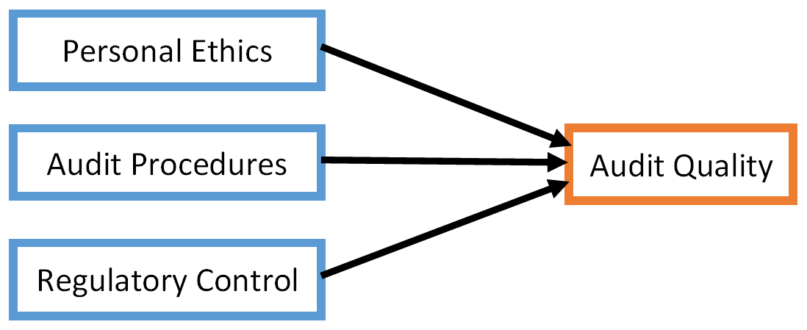
Of the three types of survey identified by Jackson, et al. (2015), factual, inferential and exploratory; inferential will be used. This style of survey looks into relationships between dependent variables and predictor variables. In this case it can be hypothesised that the predictors of personal ethics, audit procedures and regulatory control will be held by auditors to have some sway over the dependent variable of final audit quality (See fig. 2).
Figure 2 - Predictors and the dependent variable.

Data Collection
The survey will be hosted on Google Forms and a link to it will be distributed through email, the internet being the only practicable method under current contact and travel restrictions. The use of Google Forms has a number of advantages. As due to Google’s ubiquity people are undoubtedly familiar with them and are likely to have carried out online surveys in the past there is a good possibility that they will have encountered Google Forms previously. The use of an existing website is also helpful in that they assist in good practice through the use of templates and pre-existing styles of questions. Google is skilled at providing clear and simply designed webpages that are adept at highlighting what is important on the page; this design work will aid in making the survey appear non-threatening and appealing. An important feature of the website is also that it will provide an excel spreadsheet to download at any point containing all data gathered, allowing simple processing to proceed apace on completion of the survey period.
The survey begins with a routine series of demography questions, to allow for possible connections to be drawn between factors such as age and experience in the job and their beliefs around audit quality. Following these questions are a series of questions using the Likert scale style. Cook, et al. (2001) discuss the merits of using more variables than the now standard five (Strongly agree, agree, undecided, etc.) so as to allow for greater score variance to arise. While their findings did show that a nine variable scale allowed for a good range of variance and that a graphic scale allowed for wider still variance they did conclude that the reliability differences may be small. Due to this, and the common nature of five point Likert scales this survey will remain with the conventional five so increase familiarity for surveyees and ease their filling in of the survey to maximise response rate.
Care must be taken when designing the structure and wording of any survey. As respondents are doing so voluntarily and donating their time to assist, surveys must be easy to use and engaging (Haslam, 2014). Shaughnessy, et al. (2011) advise that while starting with demographic questions is appropriate for interviews, for self-administered questionnaires they can have the effect of causing the subject to lose interest or answer carelessly when they do reach the meat of the questionnaire. They suggest instead to open with the matter in question, varying the format of questions and ending with the demographic questions in order to maximise engagement.
Similar attention must be paid to the wording to avoid biasing subjects. For example, Madson (2005) ably demonstrated this through two sets of surveys asking about the same topics with differently worded statements to be rated on a Likert scale. When one subset of respondants were given the statement “I oppose raising taxes” they rated it an average of 2.88 on a 7 point scale with 1 being strongly agree and 7 strongly disagree. The other subset were given “I would be willing to pay a few extra dollars in taxes to provide high-quality education to all children” and again, were broadly in favour scoring an average of 2.18. Due to this, the contents of the survey will be carefully neutral in their wording to avoid this bias.
Alongside the care paid to avoiding bias, there is an ethical duty to survey respondants, who must be respected and valued for their voluntary contribution ot this research. Participants must be made aware of the purpose of the study and that they need not answer if they so wish. This will be achieve with an opening consent declaration, that if declined immediately ends the survey.

Conclusion
In summation, this chapter has recorded the decision making process used to select the method of research to fulfil the second research objective.
- To conduct primary research on perceptions of working auditors and analyse the results.
Using this methodology, a survey has been created, see appendix 1.

References
Cook, C., Heath, F. & Thompson, R. L., 2001. SCORE RELIABILITY IN WEB- OR INTERNET-BASED SURVEYS: UNNUMBERED GRAPHIC RATING SCALES VERSUS LIKERT-TYPE SCALES. Educational and Psychological Measurement, 61(4), pp. 697-706.
Goldkuhl, G., 2012. Pragmatism vs interpretivism in qualitative information systems research. European Journal of Information Systems, suppl. Special Issue: Qualitative Research Methods, 21(2), pp. 135-146.
Haslam, S. A., 2014. Research Methods and Statistics in Psychology. 2nd ed. London: Sage Publications.
Jackson, P. R., Easterby-Smith, M. & Thorpe, R., 2015. Management and Business Research. 5th ed. London: Sage Publications.
Madson, L., 2005. Demonstrating the Importance of Question Wording on Surveys. Teaching of psychology, 32(1), pp. 40-43.
Matta, C., 2015. Interpretivism and Causal Explanations: A Case from Educational Research. Philosophy of the Social Sciences, 45(6), pp. 543-567.
McCartan, K. & Robson, C., 2016. Real World Research: A Resource for Users of Social Research Methods in Applied Settings. 4th ed. Hoboken, NJ: John Wiley & Sons.
Mingers, J., 2015. Helping business schools engage with real problems: The contribution of critical realism and systems thinking. European Journal of Operational Research, 242(1), pp. 316-331.
Saunders, M. N. K., Lewis, P. & Thornhill, A., 2016. Research methods for business students. 7th ed. Harlow: Pearson.
Shaughnessy, J. J., Zechmeister, E. B. & Zechmeister, J. S., 2011. Research methods in psychology. 9th ed. New York: McGraw-Hill.
Walton, D., 2001. Abductive, presumptive and plausible arguments. University of Windsor, 21(2), pp. 141-169.
Woiceshyn, J. & Daellenbach, U., 2018. Evaluating inductive vs deductive research in management studies. Qualitative Research in Organizations and Management, 13(2), pp. 183-195.
Woo, S. E., O'Boyle, E. H. & Spector, P. E., 2017. Best practices in developing, conducting, and evaluating inductive research. Human Resource Management Review, 27(2), pp. 255-264.

Appendix 1:

