

BA BUSINESS MANAGEMENT
Assignment 2

Module: Data Handling & Business Intelligence
Code: LCBB5000
Lecturer: Dr Anupam Mazumdar
Name: Silvia Bounegru
Student ID: 2132530

SUBMITTED ON THE 1st SEPTEMBER 2023

Essay:
Data Analysis and Visualisation

Table of Contents
Introduction 5
Part 1 5
Part 2 9
Conclusion 17
References 18

Introduction
According to Surma (2011), An information system that gathers, explores, interprets, and analyzes data is called a business intelligence system which helps companies streamline and rationalize their decision-making process. The value of business intelligence tools lies in their ability to provide actionable insights based on data. Business intelligence tools enable businesses to identify trends, gain a deeper understanding of customer behaviour, and make informed decisions based on their analysis of data more efficiently.
This analysis will be carried out for the purpose of analysing and visualizing the data. This assignment consists of two parts that will be evaluated. The first part consists of an analysis and visualization of the Hotel Reservation dataset. A variety of functions in MS Excel will also be used to assess the practical aspects of the tasks. In addition, appropriate charts will be produced. In part 2, the Student_Score dataset will be analysed and visualized. Additionally, different data mining and text mining methods will be used in this context. This assignment will also discuss the advantages and disadvantages of software such as MS Excel and SPSS.

Part 1
A table has been prepared to determine if the average price for all types of room reservations has declined or increased between 2017 and 2021.

Year | Overall Average price
2017 | 90.05
2018 | 106.45
2019 | 101.78
2020 | 105.34
2021 | 101.23

In order to determine this average price, it was examined all reservations made from 2017 to 2021 for all types of rooms. In order to evaluate the overall average price of 2017 based on the given data, the given formula has been used: =AVERAGEIF(J2:J36276, "2017", Q2:Q36276).
The replication method has also been used for other years. Using this time-dependent data, the following line graph was produced:

The chart indicates that the average price has increased over the years from 2017 to 2021 and is expected to increase further in the future. In 2017, the average price of room reservations was approximately 90.05 GBP, which increased significantly in 2018 to reach 106.45 GBP. The rate fell to 101.78 GBP in 2019 but increased to 105.34 GBP in 2020. As a result of the pandemic period, the average price for booking hotel rooms in 2021 fell to 101.23 GBP, but this price is significantly higher than 2017's, indicating that hotel room prices have increased.
LOOKUP/VLOOKUP/XLOOKUP are the MS Excel functions used for the statistical analysis of data. LOOKUP function is used to find a value corresponding to a similar cell reference of a row or column. LOOKUP function can be used as a vector form as well as an array form (Microsoft Support, 2023). If we are looking for the type of room reserved by an entity, the LOOKUP function will be used to identify the room type associated with that booking ID. For booking ID INN00010, the type of reserved room has been determined to be Room Type 1. The MS Excel function used in this context is =LOOKUP(V2,A2:A36276,H2:H36276).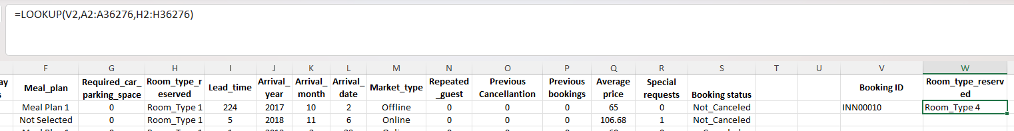

Using the VLOOKUP function, things can be found in a table or a cell range by row. This function works much similarly to the LOOKUP function. Based on the particular cell reference, the VLOOKUP function helps to determine the corresponding value of the same row from another column (Microsoft Support, 2023). If the average reservation price of the booking ID INN00010 is to be checked, =VLOOKUP(V2,A2:R36276,17,FALSE) function has been used to get the desired results. The average hotel price of this booking id was 133.44 GBP. This is helpful in assessing that the average hotel prices charged for different types of hotel rooms are not consistent for all customers.
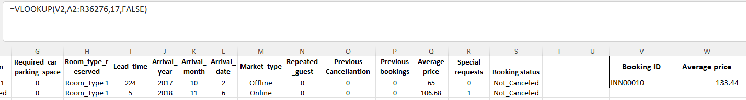

XLOOKUP is considered a more refined version of VLOOKUP, by which a range or an array is searched and the item corresponding to the first match is returned. The difference between VLOOKUP and XLOOKUP is that XLOOKUP produces the actual match by default and if there is no match, then the approximate match is returned. Here, the arrival year of the booking ID INN00001 has been found by using the function =XLOOKUP(A2,A2:A36276,A2:A36276) which gives the result 2017 for the ID - INN00001.
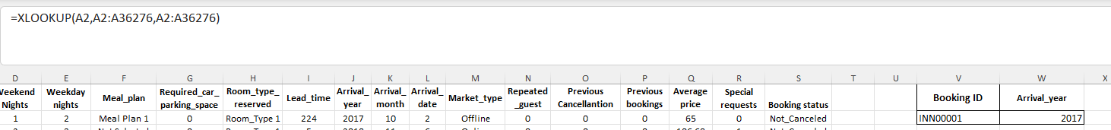
The 'IF' function is also used for data analysis in MS Excel. Here, the mean of average reservation prices is 103.4233 GBP which has been evaluated in cell V26. Now, it is to be checked that the demand will be high if the average price is greater than 103.4233 and the demand will be low if the average reservation price is less than 103.4233 GBP. So, for booking ID INN00001, the demand was low as the average room price was less than 103.4233. For Booking ID INN00002, the demand was high as the average price was higher than 103.4233 GBP. The following figure illustrates how the IF function can be used to determine the nature of room demand.
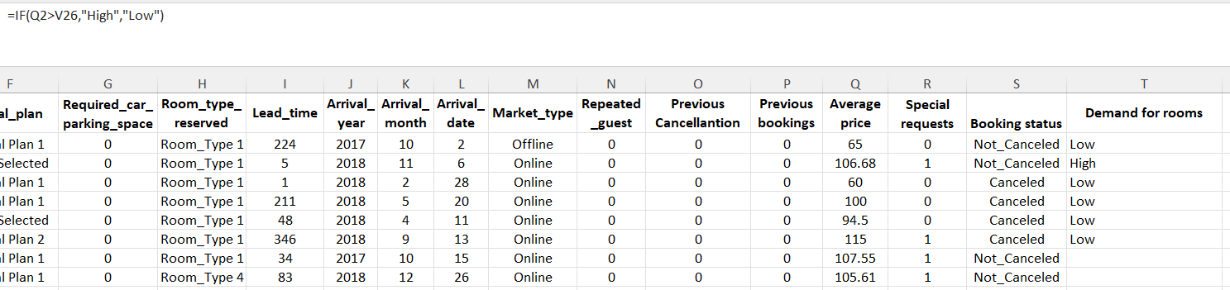

Additionally, it is important to note that lead time affects the average hotel price as well. Lead time is the number of days between a customer's hotel booking and his arrival time at that hotel. It is often observed that when the lead time is long, the average reservation price for a hotel room increases as well. As a result, there is a significant relationship between these two variables that will be discussed below.
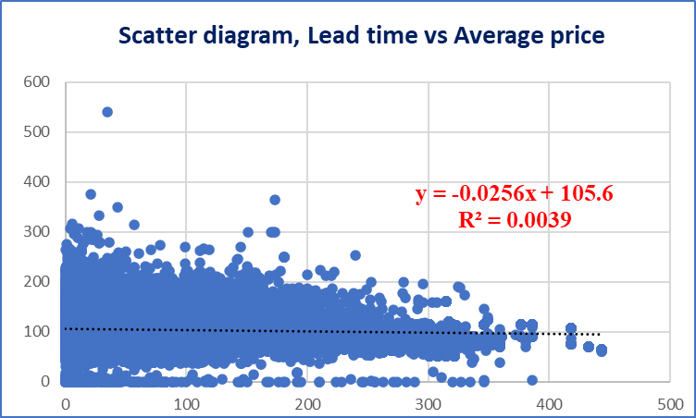
This scatter plot above shows the association between the lead time and average price for the reservation of hotels. This means when the lead time increases, the average price tends to fall, which also denotes that the average price for the reservation of hotels is not affected significantly by the lead time. The model has a 0.0039 goodness of fit which entails that only 0.39% of the total variation in average price is explained by the lead time. There are other relevant factors such as room time, years, booking time, etc. that are considered factors of average price for hotel reservations.

Part 2
For the second task, SPSS software will be used to analyze the data. The results will be presented in charts and tables that showcase the findings. This will help us to gain a better understanding of the data and draw more accurate conclusions. SPSS, or Statistical Package for the Social Sciences, is a computer program used for analyzing data sets. It can be used to create charts and tables, as well as to run statistical tests on data. Using SPSS, the school research Student Score consisting of 2133 students will be analysed. In order to better understand the data, specific data such as gender and lunch have been coded in this program.

- The number of Male and Female students in the class
The frequency analysis has been conducted to analyse the number of males and females enrolled in the school. In the given sample, there are 2133 students in total, out of which 1077 students are male, and 1056 students are female. The following table and chart depict this difference between the male and female students in a more descriptive way:
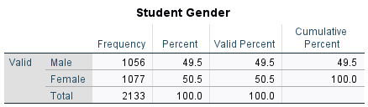

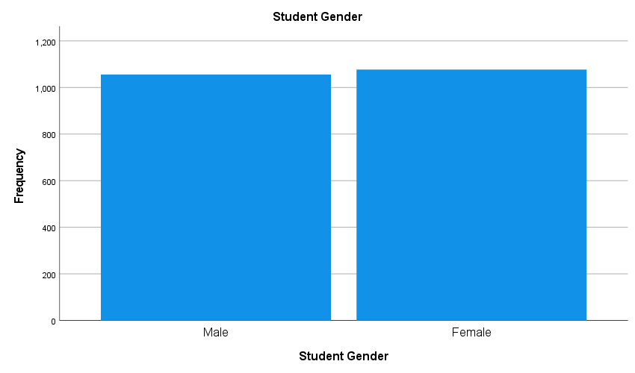

- The number of students qualified and not qualified for reduced/free lunch.
For the purpose of answering the requirement above, the same frequency analysis was used. Based on the analysis, 918 students qualify for reduced or free lunch, while 1215 students do not qualify for these benefits. Following is a table and graph showing the results:
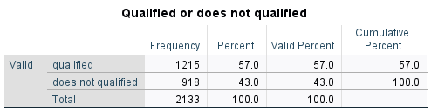

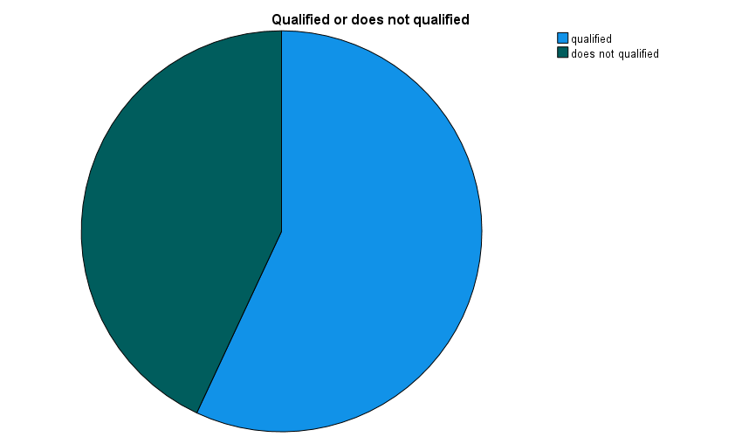

The pie chart above shows the findings from the data analysis. The green area of the pie depicts the number of students who have not qualified while the blue area shows the opposite.

- The Mean and Median of students who qualified and not qualified for reduced/free lunch
In order to calculate the mean of a data set, the number of values can be divided by the number of values in the set and the median is the middle value (or midpoint) in a data set ordered from least to greatest (Almond, 2023). Below are the statistics of the mean and median shown in the table.
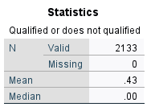

Based on the present dataset, the mean is 0.43, indicating that, on average, a relatively high proportion (43%) of students are qualified for a reduced/free lunch. A median score of 0.00 indicates that 50% of students have a qualification score of 0 or lower. Therefore, the middle value in this dataset is zero.
- The Mean and Median differences of students Pre-test and Post-test scores

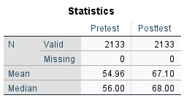

As can be seen from the mean data, the pretest showed an average score of 54.96 and the posttest showed an average score of 67.10. Based on these results, it can be concluded that students' scores improved from the pretest to the posttest on average. Similar to the mean, the median values illustrate increasing values from the pre-test 56.00 to 68.00 in the post-test scores.

- Clustering of Scholl Score dataset
According to Wikitechy (2021), Clustering is machine learning, and statistical analysis, as it helps identify meaningful patterns in data and group similar objects together. This makes it easier to analyse large datasets and draw insights from them.
The analysis below will be based on the clustering of students' Postest scores.
I have classified the data set into three clusters using k-means clustering analysis.
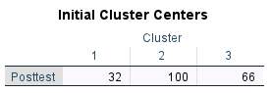

A limit of 7 iterations was imposed on the k-means algorithm to limit the number of attempts necessary to achieve convergence.
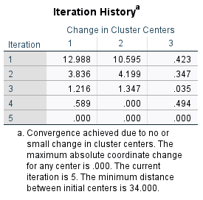
Following the iteration of the algorithm, the final result is presented below:
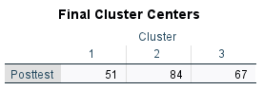
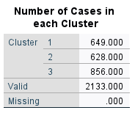

The table of final cluster centers represents the central points for the Posttests variable of each cluster:
- Cluster 1 – The center point is 51.
- Cluster 2 – The center point is 84.
- Cluster 3 – The center point is 67.
The analysis of the number of cases in each cluster reveals that the distribution of the data points is fairly equal across the three clusters, which indicates that the clustering was successful and no data points were incorrectly allocated in the process.

- Data and Text Mining Methods
The five most common data mining methods are - clustering, regression, decision tree analysis, data classification, and data visualization. Regression is a statistical method that shows the degree of linear relationship between two variables. Regression between two variables can be positive, negative, or no relation. For data planning and modelling, regression analysis is used so that the values of a variable can be predicted on the basis of other variables. One practical example of regression analysis is the assessment of sales in comparison to the advertisement expenditure of a business. Another useful method is Data Classification analysis, by which relevant data is retrieved and classified into different classes. Algorithms are applied to classify new data. One real-world example of data classification is Outlook email, in which certain algorithms are used for the characterization of an email in terms of its legitimacy or spam mail. Clustering analysis is considered to be similar to data classification analysis, as the data objects are collected in clusters under this data mining method. The classes are discovered in the form of the highest degree of association between the data objects. One real-world example of clustering analysis is the creation of customer profiling (Precisely, 2021).
Decision-Tree Analysis is used to outline the potential results, expenses and consequences of a decision visually. For quantitative data analysis and decision-making based on quantitative data, decision-tree analysis is a useful data mining tool. In the management of a new project, this analysis is used frequently (Morgan et al. 2003). Data Visualization is the method in which data is represented through various graphs such as statistical charts, plots, animations, infographics, etc. Data relationships that are complex and insights driven by data are communicated by these visual displays. The understanding of the nature of data gets easier under this process. Weather maps can be considered as a real-world data visualization tool to present the temperature and other aspects of weather (Barkwell et al. 2018).
The most common text mining techniques are - Information Extraction, Information Retrieval, Information categorization, Information clustering, and Summarization. Under information extraction analysis, text data is extracted, such as the extraction of meaningful words from a document. There is feature extraction in which some new features are developed. Mathematical operations are used in this context. Another is the feature section, in which the dimensions of the datasets are reduced. Information retrieval is about processing the available text documents and structuring text data. Relevant patterns associated with a given set of text documents are extracted. The information categorization process refers to categorizing the text data according to certain entities, locations, organisations, etc. In this context, Machine learning tools and deep learning methodologies are used for the categorisation of text data. In text clustering, textual documents are grouped automatically into clusters. This grouping is made based on the similarity in the contents of the text data. For text summarisation, a condensed version of a text document is created in which the main points of the data document are captured (GeeksforGeeks, 2021).
- MS Excel vs SPSS
MS Excel | SPSS
Advantages:  i. In MS Excel, entering data is an easy process. Also, a lot of quantitative information can be inserted in MS Excel. Filtering data is easy as well.  ii. Calculations, statistical analyses, and graphical projections of data can be done easily. There are various MS Excel functions that can be used for this purpose. For example, the mean value can be evaluated using the function =AVERAGE(Column range).  iii. MS Excel is very reliable in terms of storing important data. The data collected in the spreadsheets can be kept safe by putting passwords and being digital data, these data cannot be written off as well.  iv. Different data of different variables can be stored in different spreadsheets of a single MS Excel file. This makes the entire process more practical and easily accessible for the user.  Disadvantages:  i. File size restrictions are imposed by MS Excel. Data and growth are significant primary issues. There are other technical issues with the software that are seen often.  ii. The functions of MS Excel cannot be used if one doesn't have complete knowledge about it. The wrong implication of functions leads to various mistakes regarding the evaluation and analysis of the data. For example, the VLOOKUP function cannot be used in all references  iii. The autofill feature of MS Excel is not rapid and often needs changes. MS Excel functions do not always work with autofill features. This makes the entire process lengthy and is prone to errors as well. | Advantages:  i. Every piece of information can be extracted with the help of SPSS software. This is useful for the descriptive and inferential statistical analyses of data.  ii. There is a data mining manager in SPSS that is useful for conducting smart searches. Hidden data can be extracted using decision trees that are used for more critical data analysis.  iii. There is a report generator feature in SPSS. Using this feature, reports can be prepared based on the analysis of the data. Texts, charts, tables, and results of statistical analyses like correlation, regression, inference, etc. are included in the report.  iv. Algebraic, arithmetic, and trigonometric operations are performed in SPSS, unlike MS Excel (Evalcommunity, 2023).  Disadvantages:  i. When the dataset is large, SPSS software cannot be used for statistical analysis. There are technical constraints therefore other tools like MS Excel, SAS, etc. Software is used for the statistical analyses of large datasets.  ii. SPSS is very expensive software. After purchase, it is to be renewed regularly unlike other software like R, SAS, etc. Therefore, a lot of costs are taken into account when installing and using SPSS software.  iii. Production of graphs in SPSS is not a simple process like MS Excel. Also, the user faces difficulties while editing the charts in SPSS.  iv. Data visualization techniques in SPSS are limited compared to other software.  v. SPSS accounts for the misinterpretation of results as well. Menus are not complete, hence some options are operated using syntax as well (SurveySparrow, 2022).

Conclusion
The Hotel_Reservation dataset and the Student_Score dataset have been analyzed in this report. Graphs and relevant MS Excel functions were used to analyze the nature and trends of the Hotel_Reservation dataset. Using SPSS software, descriptive statistics have been used to analyze the Student_Score dataset in part two. An analysis of the Hotel_Reservation dataset has been conducted to determine the factors affecting the average price of hotel rooms as well as their relation to lead time. Additionally, descriptive statistics have been presented for the two variables. Using the Student_Score dataset, relevant questions have been answered in the second part.
Analysing data sets enables us to identify key patterns and trends in the data, which can then be used to inform our decisions. It also allows for deeper insights into how decisions affect various outcomes. When decision-makers understand the relationships between data points, they are able to make more informed decisions that are more closely aligned with their goals.

References
- Surma, J. (2011) Business Intelligence. Making decisions through data analysis. Available at: https://www.perlego.com/book/403108/business-intelligence-pdf (Accessed: 29 August 2023).
- Barkwell, K.E., Cuzzocrea, A., Leung, C.K., Ocran, A.A., Sanderson, J.M., Stewart, J.A. and Wodi, B.H., (2018, July). Big data visualisation and visual analytics for music data mining. In 2018 22nd International Conference Information Visualisation (IV) (pp. 235-240). IEEE.
- Evalcommunity. (2023) Utilizing SPSS (Statistical Package for the Social Sciences). [online] Available at: https://www.evalcommunity.com/career-center/using-spss-in-monitoring-and-evaluation/#:~:text=SPSS%20provides%20an%20efficient%20and.
- GeeksforGeeks. (2021). Text Mining in Data Mining. [online] Available at: https://www.geeksforgeeks.org/text-mining-in-data-mining/.
- Microsoft Support. (2023). LOOKUP function [online] Available at: https://support.microsoft.com/en-au/office/lookup-function-446d94af-663b-451d-8251-369d5e3864cb#:~:text=Use%20LOOKUP%2C%20one%20of%20the [Accessed 20 July. 2023].
- Microsoft Support. (2023). VLOOKUP function - Microsoft Support. [online] Available at: https://support.microsoft.com/en-us/office/vlookup-function-0bbc8083-26fe-4963-8ab8-93a18ad188a1#:~:text=For%20example%2C%20%3DVLOOKUP(A [Accessed 20 Jul. 2023].
- Almond, N. (2023) What are mean median mode range? definition, examples &amp; practice question for Primary School, Third Space Learning. Available at: https://thirdspacelearning.com/blog/what-is-mean-median-mode/ (Accessed: 01 September 2023).
- Morgan, J., Daugherty, R., Hilchie, A. and Carey, B., (2003). Sample size and modeling accuracy of decision tree-based data mining tools. Acad Inf Manag Sci J, 6(2), pp.77-91.
- Precisely (2021). Data Mining Techniques: Top 5 to Consider. [online] Precisely. Available at: https://www.precisely.com/datagovernance/top-5-data-mining-techniques.
- SurveySparrow. (2022). What is SPSS? Definition, Features, Types, and Use Cases. [online] Available at: https://surveysparrow.com/what-is-spss/#:~:text=Limitations%20of%20Using%20SPSS [Accessed 19 July. 2023].
- Wikitechy (2021). Clustering in Data Mining [Online] https://www.wikitechy.com/tutorial/data-mining/clustering-in-data-mining#:~:text=What%20is%20Clustering%20in%20Data%20Mining%20%3F%201,a%20cluster%20can%20be%20considered%20as%20one%20group.

