

Student name: | Diya Ganguly | Student ID Number: | 2013048
Programme: | DBA-Doctor of Business Administration
Module: | Strategic Change and Organizations
Module code: | LCDB7005 | Contribution to Overall Module Assessment (%): | 50%
Lecturer: | Prof. Amare Desta | Internal Verifier: | John Paul Okeke
Assignment Title: | Assessment 1 | Word count (or equivalent): | 4000 + 10%.

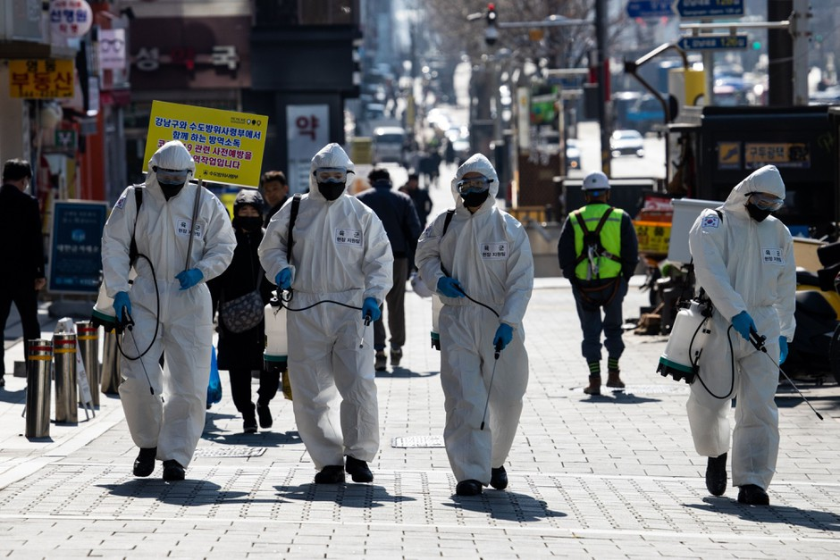(Source: Google,2020)

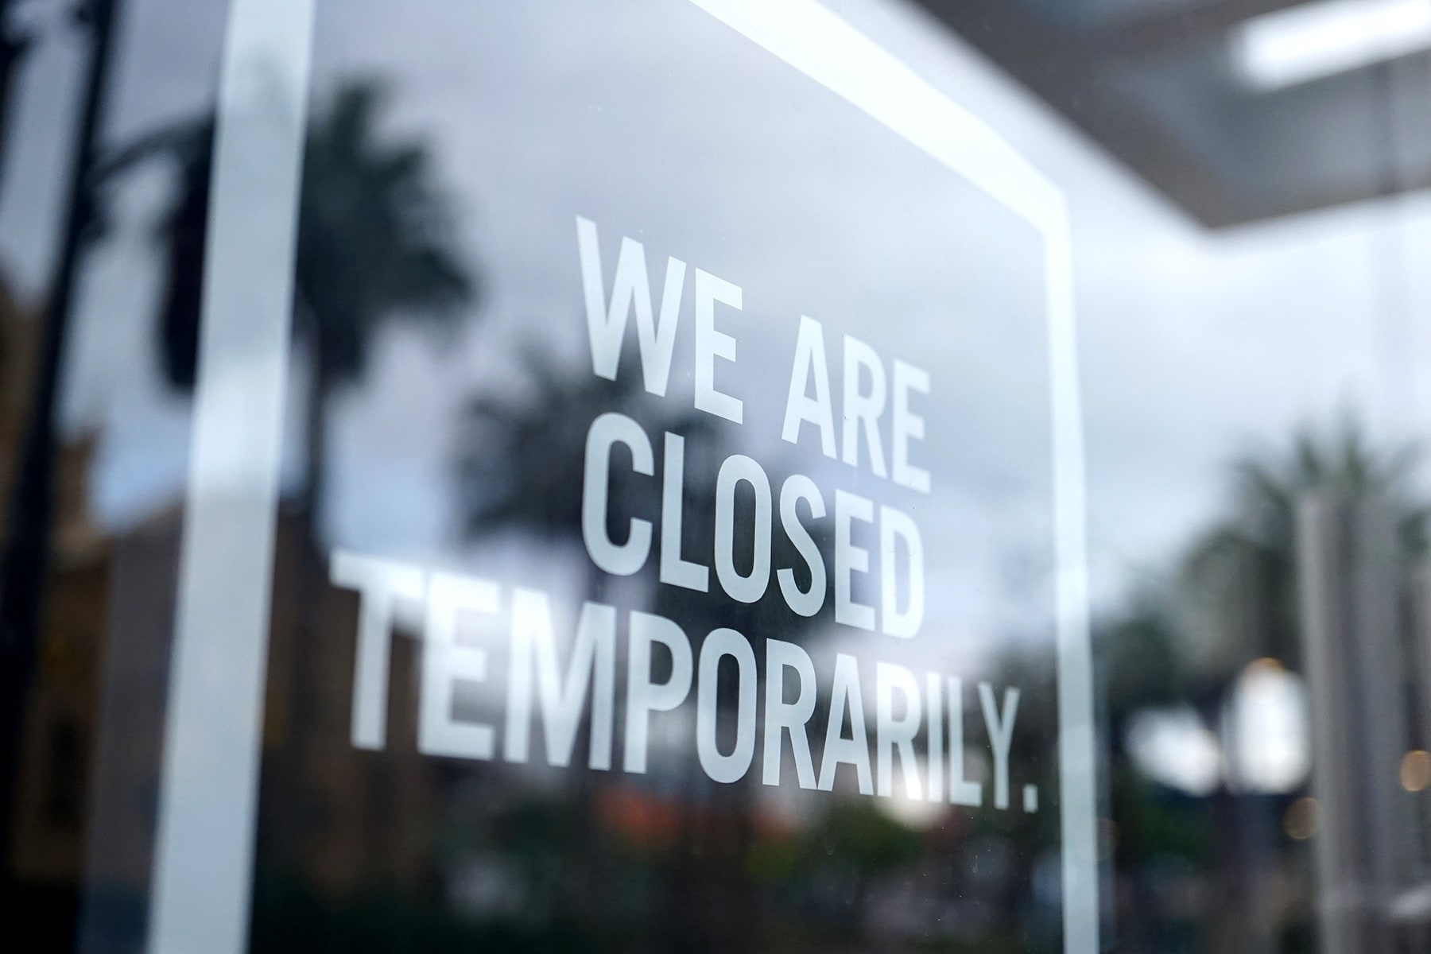
(Source: WebMD, 2020)
TABLE OF CONTENTS-

Introduction
A revolutionary change in work culture- the hybrid-remote-office work model
How feasible remote working is for blue-collar job holders- The impact felt by individuals that remote work leaves behind?
Innovation in remote team working environment
How travel in the New Normal Era will look like- Collapse or Thrive?
New trend of Virtual Travel - Examining the growth of virtual reality in the travel space
What happens to the Academic flying in the new normal era?
Life in the new normal- The genesis of self-sufficient resilient communities
A new reckoning for metropolitan lifestyle
Conclusion
References

Simon J. Breakwell, the CEO of AA, UK in his interview to BBC has suggested that the Covid-19 crisis will transform the way we live, work and travel. I as a first year student of doctorate of business administration programme strongly agree with this statement and in the following report I will critically elucidate how work, travel and life would look like in the post Covid era.
Unlike countless history’s great tragedies, the Covid-19 health pandemic never astounded us with one catastrophic event. Instead, the lethal virus before anyone could anticipate, quietly snaked its way around the world in the most unexpected ways. Our realities slowly shifted at first, and before we could foresee it, the global pandemic took over completely. From devastating millions of human lives to catastrophic economic damage, Covid-19 has hit the world hard, so hard that quite literally; life as we know it came to a standstill since it first surfaced in November 2019. While some have evolved out of it after a yearlong unprecedented battle but unfortunately there a quite a few nations, even the most developed ones are still trying to grapple the repercussion of this crisis. (Andrews, 2020, p.93-99)
Like many G7 nations, United Kingdom too had to bare a vicious brunt of this pandemic. As the deadly infection started spreading and quickly grew into a global health crisis, the world was introduced to stringent lockdown measures. From the borders being closed to restrict non-essential travels to non-essential businesses being mandated to temporarily shut down, the economic growth began to nosedive.
According to the World Bank (2020) Needless to say, the year 2020 saw a historically damaging decline in GPD globally. In UK alone the GDP declined by 9.9 % during the first lockdown in 2020, which is considered the steepest drop since 1948. The magnitude of the economic downturn caused by the pandemic is unprecedented and economically dreadfully damaging .Thus, to adapt to the ‘New Normal Era’ we will need to transform the way we work, live and travel, as suggested in his interview to the BBC by Simon J. Breakwell, CEO of the Automobile Association UK.
Similar thoughts have been globally echoed by industry experts from the field of business, politics, public health etc. This incontrovertibly suggests Covid-19 has been reshaping our world- potentially for a long haul. Thus, to live, work and thrive in the post pandemic future, one would need to innovate, communicate, connect, and create. (The World Bank, 2020)
This pandemic has provided a once in a generation opportunity to re-imagine everything about how companies are run, how we do our day-to-day jobs, time we spend in commuting to work, how we communicate with others at work and outside work, the value we put on our jobs, the life we live, the amount of quality time we spend with your loved ones and what freedom our job guarantees us. In the following sections we will decode the revolutionary change that is going to unfold in our work and personal lifestyle.
A revolutionary change in work culture- the hybrid-remote-office work model
With lockdown being the common formula shared across nations for curbing the rate of Covid-19 infection, most companies like the Siemens, American Express, and Nike, who employees a large workforce had no alternative but to shift to remote working. (Kelly, J. 2020)
From employee perspective, this shift has been very consequential; in fact a game changer for several white collar professionals as this has allowed such professionals to move past decades of 9-5 office work orthodoxy. In fact, a recent a study conducted by employment experts predicted that most knowledge workers (largely from the higher education quartile) will never want to go back to the old way of working as with remote working there’s an opportunity to freeing oneself from inefficient processes to unnecessary bureaucracy practices. Businesses and organizational heads who recognised this need for hybrid remote office model and acted earlier, have sustained, in fact, thrived in some scenarios, despite the scaring economic recession caused by the pandemic. This was and is the chance for leaders who believes they can do better and can move faster. Flexibility is the key ingredient for any successful business, thus agile leaders who digitally transformed their physical stores or services to virtual ones drove engagement, achieved organizational agility, maintained alignment, connected, and empowered teamwork across all locations and organizational sectors. To add further, such businesses had and potentially continue having the competitive advantage over others in the market in this post pandemic new era of work. (Kinder et al. 2020)
How feasible remote working is for blue-collar job holders- The impact felt by individuals that remote work leaves behind?
As hybrid or remote work model becomes enormously popular among white collar professionals amid this upheaval, one wonders what to the workers or local businesses that remote jobs leave behind. According to the Office for National Statistics (2021) more than 60% of the workers, in the UK alone can’t work remotely. As multinational companies or mega corporate chains like HSBC Holdings, Google, JP Morgan are closing down their physical office spaces to transform into first world digital headquarters, there has been a significant decline in the daily commuters or business travels posing a knock-on-effect on those whose jobs support and earn a living wage by serving these office commuters and physical businesses. These jobs, which include the transportation, cleaning and maintenance, retail and beauty, food and bakery service sectors, are now disappearing like a whirlwind leaving many unemployed in such dire times. As these jobs are often low in payment and performed by individuals with limited professional skills and education, disappearance of such jobs will make the vulnerable further vulnerable unless a safety net is shored up by their leaders, employers, or the government to protect, support and empower them. (Kelly, 2020)
To protect such workers, it’s key to map out the benefits made available to the employers. For example, the furlough schemes introduced in the UK- which provides covid-19 job retention grants to employees whose work have been stopped temporarily. With the help of this scheme the furloughed employees can claim 80% of their wages and stay employed. Also, there are mainstreet lending programs facilities for eligible borrowers or business owners to maintain payroll and retain employees, amidst the economic crisis.
Large corporations like Walmart, which employer’s 1.5 million workers have introduced a new policy called emergency employee leave program (The New York Times, 2020). Under this scheme any employee who gets infected at work or falls under the mandated quarantine rule either by the national government laws or Walmart, these employees will be entitled to two weeks of paid leave. If such workers or associates are unable to return to work after those paid two weeks, additional payment replacement offers are also made available for up to 26 weeks for both full and part-time hourly workers. Such schemes not only provide financial cushion to the workers but also improves their sense of loyalty, belongingness, and accountability towards the company. (Verge, 2020)
Tech giants like Apple are also not behind in introducing such innovative employee retention schemes as it officially confirmed that it will allow its employees, including hourly workers, unlimited paid leave if contracted with covid-19 and put under mandatory quarantine by the officials. (Peters. J, 2020)
The ride-hailing apps like Uber and Lyft have also put their support packages in place to support their employees. Most of their employees who solely rely on front-end works and customer interaction are at remarkably high risk of Covid-19 interaction. (Diaz, J. 2020). Thus, these ride-sharing companies have now adopted a generous strategy to provide funds for drivers affected by Covid. For instance, Uber drivers diagnosed with the virus or otherwise impacted by Covid restrictions would be able to receive compensation for up to fourteen days to make up for the lost revenue. Benefits of such schemes are multidimensional as it not only helps employees having a financial safety net but also reflects on the ethos of the company who perhaps are reframing and reinventing their trading operations to keep both their customers and employees safe, and ultimately playing their part towards the bigger national responsibility of curbing the Covid infection rates. (Diaz, J. 2020)
Innovation and change in the remote working in team environment-
With remote work, there’s absence of a physical workspace and spontaneous in person human interactions that often sparks novel ideas and promotes team synergy; it leaves team heads with the potential question of how to innovate at work in absence of face-to-face team interactions.
The two key ingredients for innovation are reciprocal trust and sense of social belongingness among team members. This is where the challenge lies, as remote working teams have to now think of a way to build mutual trust around micro-interactions that occur within a digital space for a virtual team who are connected by couple of wires and cables. New technology can help bridge this gap, as in today’s date and time with AI or artificial intelligence, teams can still be in touch and work together. For example- Microsoft Teams, Zoom, Google Meet, Aula etc are popular apps for virtual meets, even to an extent of conducting online lectures to global conferences or business summits (The Verge, 2020)
AI is more powerful than one imagines, even to an extent that AI assistant can help remote teams in managing projects, training employees, on boarding new employees, conducting hassle-free online webinars, reviewing employee performances to preparing annual budget reports.
For example- Monday.com, ProProfs Project, Kissflow, Asana, Hive and ProofHub are project management and online collaboration tools that allows teams to work remotely by easily sharing the workflows, effectively setting the custom roles, to ensure everyone within the team knows what they are supposed to do and when. Also, it helps in engaging and keeping the remote teams on track with their designated tasks. There’s also a possibility of creating subtasks and hand it over to the right team members from the same dashboard views which then allows the designated managers to track the progress report for each task and of each team members through timesheets. These powerful AI tools can easily mitigate the gap in creative performance when team members are working from home (Kashyap, V. 2020)
Connecteam is another super interactive all-in-one employee management app that allows organizations to manage remote teams effectively in click of a button. Whether it’s keeping virtual teams on the same page, creating schedules or dispatching jobs/tasks and engaging employees, the Connecteam app can do it all. It is a simple yet an effective integrated platform that all employees can use regardless of how tech-savvy they might actually be (ProofHub, 2020). As far as training and development is concerned, AI assistant offers a solution too. For instance, the TalentLMS app is an effective learning management system for training remote workers. From online content creation to delivering online trainings, it can be useful. The best part is with few clicks a full-fledged online training event or course can be created as it supports multiple file types and multimedia and is suitable for experienced to budding professionals (The Guardian Lab, 2020)
So, the question now is can these powerful tools successfully replicate the innovative spark to connect the team for driving innovation and synergy? Experts say, technology exits, and these new AI tools are certainly powerful enough to improve the remote work experience and drive innovation among remote working team. However, it’s the willingness of organizations to implement it and provide sufficient resources and trainings to harness that collective energy when teams are shifting from physical workspace to remote working environment. In fact a recent study published by the University of Cologne refutes the commonly perceived notion around remote working and suggests that remote working is unlikely to be less innovative when organizations embrace the necessary technology and digital transformations to support their remote working teams (Willmes, C. et al., 2010)
Nigel Davis, CEO of digital workspace Claromentis, also resonate the same thoughts as he believes his company has found digital solutions to support teams to innovate at work when team members are working apart. The productivity levels can be maintained simply by adopting online project management tools to encourage online employee performance. This can also help in removing the potential barriers which prevents the team from getting started with this new remote working model. For instance, the app Coggle is a digital tool that helps in creating mind maps and flow charts for stimulating creative thinking and solving problems when staffs are working apart. Then there is an app called Brainsparker that even supports in cognitive de-cluttering by generating random prompt cards to overcome mental blocks and spark fresh thinking to innovate and create. Hence remote working is just as likely to engender ‘creative thinking’ or ‘eureka moments’ such as those take place around physical teams and physical workstations. (The Guardian, 2020)
Remote working in fact proves the notion that anyone can have a good idea- It’s usually the extroverts or outgoing self-confident personalities that shine in traditional office workings but with remote working that changes, as it offers opportunities for different personality types to lead and shine. Also given that inclusivity and diversity of workforce are the building blocks of innovation, remote working could offer greater opportunities to different genders, to the neuro diverse populations and to individuals with physical disabilities who on previous occasions were often excluded from the traditional working model. Also, with work from home model, when the company hiring processes are no longer restricted by geographical boundaries, it will offer greater opportunities to enhance the diversity of workplace, ultimately promoting global collaborations and upliftment of different communities. (Bishop, K., 2020)
With such drastic changes in work, it’s fair to anticipate our lifestyle will also gradually witness some changes. Especially if remote working is to become the new norm, where does it leave travel and tourism, as with traditional office working people often plan vacations and travel abroad to take a break from their day-to-day usual business routines? So, with more flexibility and less time lost in commute, will people still experience the same level of burnout that will urge them to step out of home for a blissful vacation? Or will remote work turn out to be a doom for the travel industry when multiple restrictions are levied on all kinds of unessential movements? So, the next part of our report will focus on how travel will look like in the post Covid-19 world.
How travel in the New Normal Era will look like- Collapse or Thrive?
The collective effort to save lives for bringing the virus under control meant economic catastrophe for the travel industry that profits from people leave their houses for a break. However, with closed borders, international travel restrictions, cancelled sports and festive events, home quarantine norms etc implemented on a mass scale globally, the wound inflicted on the travel industry has been disastrous. In fact, it hasn’t stooped bleeding the industry yet.
Richard Fain, the chief executive of Royal Caribbean Cruises, in his TV interview quoted that travel industry will boom post pandemic. He predicts tourism will grow but not by reverting to what it was but by adjusting to a new normal era where all travel related activities, everything we do will have changed. Mr Fain recalled the USA 9/11 terrorist attack, and how it drastically impacted travel industry in US, however the industry bounced back when the ‘new normal’ eventually just became the normal. A similar phenomenon is expected to be seen in the post pandemic world. As countries and states are reopening, airlines are reinstating routes and travellers are on boarding flights, despite the remaining risks, travel may look quite different in countless ways. Even after Covid, travellers might still be expected to follow covid-19 protocols. This includes having a travel card or Covid-19 passport, travelling with sanitizers and face coverings, physical distancing from large gatherings and even undergoing two-three-week quarantines. Hence travel may look different quite different in many ways. (The Guardian Lab, 2020)
A year on from the first lockdown, and like many, even the experts are wondering what travel has become. From avoiding confined spaces with strangers to standing on ferries with masks on, we have seen it all during the Covid-19 period. The interesting question, however, is to ask is it the new normal? For instance, after following the norms of social distancing for a year, will we not be anxious to be surrounded by people in plane or stand on top of each other during the rush hours in a train? Will it seem usual for us to see hundreds of faces hurrying past without practicing any covid-19 protocols? The answer is no in most instances, as such images of packed stadiums, or crowded train stations seems historical now, as we have been repeatedly advised to stay at home to save lives. From politicians to celebrities or from TV news channels to social media platforms were incessantly flooded with the same instruction of stay at home to protect lives. This specific instruction is now conditioned to our brain, so much so that our brain associates safety with staying at home now. (CNBC, 2021)
It’s been encoded to long term memory systems, which is hard to pluck off just like that. This is a classic example of classical conditioning in behaviourism, as our behaviour (i.e., to follow safety norms) now is shaped by a specific stimulus (i.e., our brain been repeatedly exposed to Covid norms/guidelines). More specifically, once a human brain is conditioned to follow a particular behaviour, the extinction of such behaviour is going to be awfully hard to achieve, even in the absence of the initial stimulus which in the first place conditioned or induced the new pattern of behaviour (i.e., people will subconsciously follow the covid-19 norms/guidelines even when such rules aren’t necessary to follow). Hence people will talk about things bouncing back to normal, forgetting that they themselves are what is no longer normal, as their brains now are conditioned to behave differently. So, with anticipations of things getting back to normal, people will gradually step out and travel again. Some might risk going all out and travel abroad like pre-Covid times whereas many will adapt to new forms and trends of travelling that’s now emerging in the post Covid era. To specify, a new trend has been clearly spotted in the traveller’s behaviour. This is associated with exploring the local adventures than targeting the far-flung destinations. There has been a vivid realisation among travel enthusiasts now that there are destinations closer to home or local attractions that are equally fascinating and can be achieved at a fraction of the cost, in both finances and carbon. For ex- when considering a nice swim in the blue waters, most people in England pictures a holiday in Spain, Bali, Maldives, or Virgin Islands, without even considering the local destinations like Celtic Deep where one can free-dive with sharks in the Irish Sea or the mesmerizing swimming destinations off the lizard peninsula in the Cornwall or even the beautiful white-water rivers like Tay, which is located in some of the wildest environments in the British Isles. (Sky News, 2020)
With covid-19 happening, most travellers these days are restricted to their own home countries, the tourism industries must focus on picking up the interests of locals or home traveller’s, who might be more responsive to saving the livelihoods of their local people or businesses. For instance, London is the most visited city in the world, which attracts 15 million international visitors annually and supports 226, 00 jobs. (BBC,2021)
With borders being closed, no doubt it’s going have a damaging impact on the city’s economy but to some extent, a few businesses and jobs can be saved if locals start exploring the beauties of their own city which are now not jam packed by tourists. Let’s say London has around eight hidden islands on the Thames River, which can be easily explored by the Londoners even with the social distancing rules in place. Also, with locals, people from the surrounding towns must be encouraged to attend local events like London’s annual Thames Tide-Fest festival, which can be somehow continued with covid-19 restrictions in place, as most parts of these festivals are celebrated in the open air or outdoor settings. (BBC, 2021)
Also, within the country, more active holidays can be promoted which can include bird watching in the Yorkshire coast, or joining mobile hostels across Scotland, or customised women only trips in the Brecon Beacons which includes yoga to running, hiking and cycling. Thus, travel companies might have to rethink of alternatives strategies that wherein they not only direct their attentions to fly customers abroad but locate or promote the existing exotic locations within the country that will bring in a wealth of good quality travel experience and enthusiasm within the customers. In fact this might even encourage customers to look for adventures on their doorsteps which can be availed at fraction of a cost compared to far-flung holidays, especially when there are multiple risks attached to travelling abroad it’s better to be safe than sorry. So, the idea is to ease back and promote local tourism by paying attention to local food, culture, and festivities to try in our own little ways to offset the economic catastrophe the local businesses have suffered during the covid-19 era. (BBC, 2021)
New trend of Virtual Travel - Examining the growth of virtual reality in the travel space
The pandemic turbo-accelerated the trend of virtual travel, which pre-Covid was seen as a bit of a gimmick or as an inexpensive alternative designed to give a mere whiff of the real experience. However, during Covid, many travel enthusiasts, especially the young couples has seen a potential in trying out virtual travels. For example, with use of artificial intelligence, there are now online shopping trips to African safaris, Morocco’s Majorelle garden, the fascinating architectures of Vatican, to some of the world-famous yoga retreats and much more. Tech giants like Google now have partnered various museums around the world to produce uplifting high-definition sophisticated virtual tours for their treasured collections. Another tech company called Zoom, has also invested on similar virtual reality projects. National parks like Yosemite in California are also producing impressive virtual travel experiences to reach out to their online audience and for the ones whose travel is incomplete without the flight boarding experience, the Dutch carrier KLM now has a solution to offer with their virtual reality aero-tours and headsets, where one can certainly expect a sensory uplift. So, it’s fair to say when there is a will there’s a way. (Peck. C., 2020)
To be price, there are alternative ways to keep the tourists engaged, but the question is too what extent the travel industry can revitalise their brand strategies to harness the maximum capital out of these virtual reality tours. The revenue earned through it might be vastly different to what it was before, but with the paid subscription model, the tourism industry can keep up the running costs until things get better and who knows, may be such virtual tours are the millennial’s new found treasure just like Netflix. Who would have thought the over-the-top (OTT) technology platforms like Netflix, Amazon Prime, and Disney plus would one day take over the traditional cinema malls or theatres? In fact these platforms are so popular now, that not only it holds a billion-dollar valuation but also has successfully conditioned people to watch movies from the safe confines of their living rooms than going down the traditional routes of experiencing a movie in a cinema theatre. (Gupta, G. et. al. 2020)

What happens to the Academic flying in the new normal era?
Research studies shows that the academics do a lot of flying both professionally and personally, as these knowledge workers often have the approved budget for vocational or have higher incomes. One of the perks of having such jobs is the whole conference culture, where’s it’s expected to be flying all over the places. Precisely there’s a strongly establishes norms and people are quite resistant to change or give up such additional job benefits. However, there’s been a massive shift during the covid-19 period, as many academics now are adapting to both hosting and attending virtual conferences. (BPS, 2021)
On the flipside, this has shown that a lot of our physical travel can be replaced by virtual alternatives, which not only resolves the issue of no-travel during Covid but also tackles the bigger international concern of climate change, as the airline industry is the biggest contributors to growing air pollution levels and global warming concerns. (BPS, 2021)
This also gives an opportunity to the climate change agencies and associated government institutions to work in close association with companies to reduce employee’s resource uses, with an aim to promote or reward the low carbon choices made within their procedures and practices.
Life in the new normal- The genesis of self-sufficient resilient communities
The new decade has ushered in new challenges and we can be certain these challenges are to stay for quite some time now. The after-effects of months of lockdown and the economic crisis caused by it, has devastated thousands of businesses, be it big or small. As we think of a new normal era, and try to bounce back out of this crisis, it’s fair to assume that this pandemic will shape the way we work, live and the way we perceive life in cities.
It's undoubtedly an awkward feeling to see our favourite and buzzing metro cities transforming into hostile hotspots, where the risk of infection contraction is the ultimate. Being confined to our homes for months due to extensive covid-19 lockdowns, no wonder our homes feel smaller and humdrum than before and our cities are more palpable than ever. Does this mean our cities are in for a change? If so, it’s never too early to begin pondering how this pandemic will shape our future urban interactions (Zeljic, S.A., 2021)
A new reckoning for metropolitan lifestyle
There are already predictions from global subject matter experts regarding an anti-urbanism turn, as many are escaping an exorbitant urban life, simply because economic recession has hit the city dwellers the hardest. The rapid speed at which the physical businesses or retail stores closing, there is no denying that there will be further depopulation and regression of our urban cities. And with death of our cities, it’s going to be the low-income population who’s going to be the most affected, bearing the ultimate brunt of the economic crisis that is yet to unfold.
On the flipside, Covid-19 has shown how resilient we are as a community. The way communities, cultural and economic institutions have responded to the unprecedented Covid-19 crisis, offers key insights on how we can address inequality and support more inclusive development in cities. It also offers a glimpse into an urban future where local places, culture, customs, businesses and neighbourhoods can be celebrated to promote community welfare.
Rise of Polycentric cities- The social politicians wants to encourage more self-sufficient communities, where people instead of rushing from one place to another in permanent state of anxiety will live in cities with shops, parks, community leisure centres, health clinics, schools and even workplaces are just a walk or bike ride away. This approach is based on four major principles- diversity, density, proximity and uniquity which allow individual living within the city with six basic social functions of working, supplying, caring, learning, living, and relishing. For example- 15-minute city of Paris, Melbourne’s 20-minute neighbourhood are revolutionary ideas in the urban infrastructure and living. These cities successfully introduce the idea of hyper proximity to address the needs of city dwellers. (Zeljic, S.A., 2021)
Such cities may be more densely populated but it’s also more people friendly promoting greater work-life balance. Hence, this is a revolutionary approach that will not only transform lifestyles but how we work, live, travel or operate within our ecosystem.
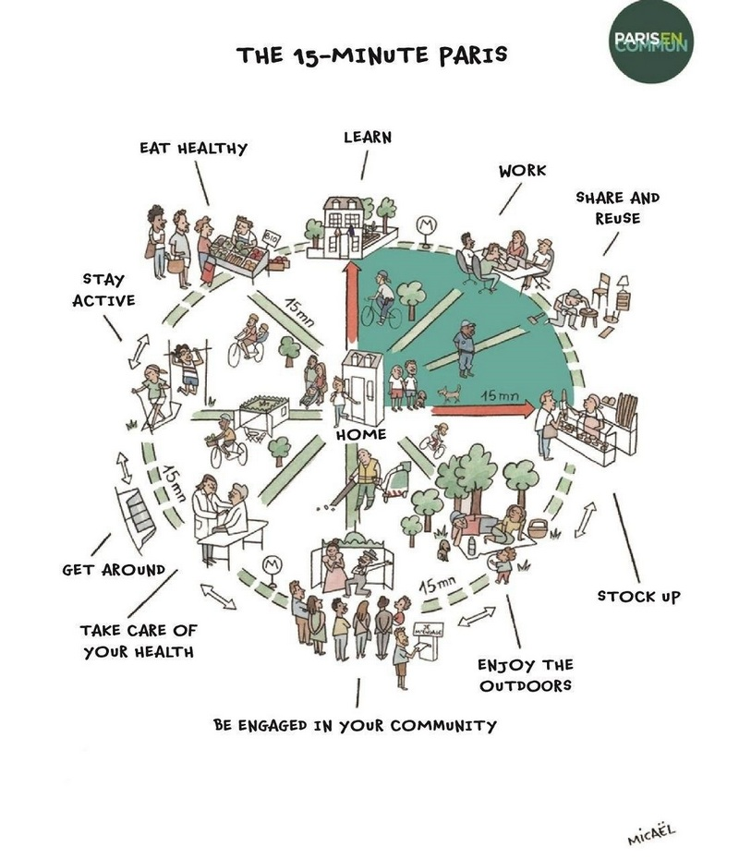Picture Source: 15 Minutes City, Four Communications (2018)
Reference list;-
The World Bank (2020) Covid-19 to Plunge Global Economy into Worst Recession since World War II Available at: https://www.worldbank.org/en/news/press-release/2020/06/08/covid-19-to-plunge-global-economy-into-worst-recession-since-world-war-ii [Accessed: 15 March, 2021]
Andrews, H. (2020) Tourism and COVID-19.Anthropology in action, 27(2), pp.93-99.London, England: Berghahn Books and Journals [Accessed: 12 March, 2021]
Kelly. J.(2020) The ‘Hybrid Model’ Of Working Remotely And In The Office Could Create Big Expenses For Companies And Give Rise To Two Classes Of Employees, Forbes. Available at: https://www.forbes.com/sites/jackkelly/2021/02/22/the-hybrid-model-of-working-remotely-and-in-the-office-could-create-big-expenses-for-companies-and-give-rise-to-two-classes-of-employees/?sh=248f87ee1bde [Accessed: 21 March, 2021]
Diaz. (2020) Life in the new normal Available at: https://www.nytimes.com/2020/03/01/upshot/coronavirus-sick-days-service-workers.html?action=click&module=RelatedLinks&pgtype=Article[Accessed: 10 March, 2021]
Benes, J. and Diepeveen, W. J. (1985) ‘Flexible planning in construction firms’, Construction Management & Economics, 3(1), p. 25. DOI: 10.1080/01446198500000003[Accessed: 12 March, 2021]
Tabby Kinder & George Hammond, (2020) Deloitte to close 4 UK offices amid pandemic shift to remote working. FT.com, pp.FT.com. London: The Financial Times Limited [Accessed: 17 March, 2021]
Office For National Statistics, (2021) Corona virus and home working in the UK Available at: https://www.ons.gov.uk/employmentandlabourmarket/peopleinwork/employmentandemployeetypes/bulletins/coronavirusandhomeworkingintheuk/april2020 [Accessed: 21 March, 2021]
Gupta, Garima & Singharia, Komal, 2021. Consumption of OTT Media Streaming in COVID-19 Lockdown: Insights from PLS Analysis. Vision, 25(1), pp.36–46. New Delhi, India: Sage Publications
The New York Times (2020) Walmart, Uber and Others Tweak Sick-Leave Policies as Coronavirus Spreads Available at: https://www.nytimes.com/2020/03/11/business/new-sick-leave-policy.html [Accessed: 21 March, 2021]
Jones, K. (2020) Remote working: Preparing for the long-term workplace shift. Benefits PRO, New York : ALM Media Properties, LLC. [Accessed: 17 March, 2021]
Peters, J. (2020) Tech giants will keep paying hourly staff even if they are asked to stay home due to Coronavirus, The Verge Available at: https://www.theverge.com/2020/3/6/21168395/coronavirus-tech-hourly-workers-pay-amazon-google-facebook [Accessed: 21 March, 2021]
Willmes, C. et.al. (2010) Internet Based Distribution And Visualization Of A 3d Model Of The University Of Cologne Campus Available at: https://www.researchgate.net/profile/Christian-Willmes/publication/228455847_Internet_based_distribution_and_visualization_of_a_3D_model_of_the_University_of_Cologne_Campus/links/09e41507d62cf89c84000000/Internet-based-distribution-and-visualization-of-a-3D-model-of-the-University-of-Cologne-Campus.pdf [Accessed: 17 March, 2021]
Bishop, K. (2020) We're embracing tech during lockdown The Guardian Available at: https://www.theguardian.com/technology/2020/apr/24/remote-learning-classroom-technology-coronavirus [Accessed: 27 March, 2021]
Hargrave, S. (2020) Digital Transformation: how modern technology can accelerate the next generation of tech leaders The Guardian Lab Available at: https://www.theguardian.com/technology-at-pwc-our-human-story/2020/jun/04/digital-transformation-how-modern-technology-can-accelerate-the-next-generation-of-tech-leaders [Accessed: 23 March, 2021]
CNBC (2021) Travel changed after 9/11; Here’s how it will look after the Covid-19 pandemic finally recedes Available at: https://www.cnbc.com/2020/05/10/heres-how-travel-will-change-after-the-covid-19-pandemic-recedes.html [Accessed: 23 March, 2021]
Sky News (2020) Coronavirus : 'The new normal' - What life might look like in the near future Available at: https://news.sky.com/story/coronavirus-what-might-our-new-normal-look-like-when-the-uk-lockdown-is-eased-11979256 [Accessed: 23 March, 2021]
British Psychology Society (2021) The Academic Flying 27(2), p.20-21. London, England: The Science Council [Accessed: 23 March, 2021]
Zeljic,S.A., (2021) Sustainable Urban Growth Available at: https://www.gensler.com/blog/polycentric-cities-new-normal-manila-finance-centre [Accessed: 27 March, 2021]

