
Youth Work Practice 2: Developing Practice

Freepik(2015)

Aberystwyth, Ceredigion community profile
Introduction
A community profile offers an overview of the social, economic, and geographical characteristics of a specific area. It helps practitioners gain a better understanding of the environment in which young people live (Hawtin and Percy-Smith, 2007). According to Hawtin and Percy-Smith (2007), community profiles can help identify and highlight factors that address young people's needs, recognise available services, and reveal emerging trends. This community profile will focus on the town of Aberystwyth in Ceredigion, West Wales, primarily in the Aberystwyth town centre and Penparcau area. Aberystwyth is a coastal and rural community that is home to families, young people, and a large student population. The report will explore Aberystwyth's geographical and social features, utilise public information and incorporate the lived experiences of young people in the community. We will identify the area's strengths and needs and conclude with recommendations aimed at improving opportunities for young people and enhancing their overall community experience.

Geographical Overview of Aberystwyth
- Location
Aberystwyth is a picturesque town situated between the Cambrian Mountains and Cardigan Bay. The landscape features hills, valleys, the sea, and rock pools. It is located in Ceredigion, approximately 55 miles from the nearest city, Swansea, and 180 miles from London. Using the British National Grid, Aberystwyth has an easting of 258382 and a northing of 281709 (Get The Data, 2025). Understanding the social and geographical environment in which young people grow up is crucial to effective youth work practice, as these factors significantly influence their development, access to support, and opportunities (Jeffs and Smith, 2005).
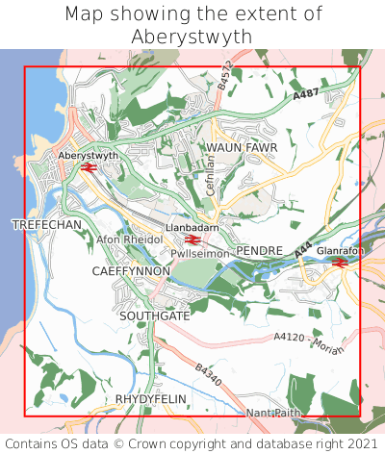 (Get The Data, 2025)

- Population and Demographics
According to Brinkhoff (2021), Aberystwyth has a population of approximately 10,709 people. Brinkhoff further states that the 2021 Census categorises this population as follows: 50.01% female and 49.99% male. The largest age group in Aberystwyth falls within the 18- to 64-year-old range. Over the last 150 years, Aberystwyth University has employed more than 2,000 staff members and welcomed around 6,000 students from various nationalities (Aberystwyth University Web Team, 2019). Additionally, Aberystwyth is a bilingual town, with both Welsh and English widely spoken (Ceredigion County Council, n.d.).

- Services and Facilities
Aberystwyth offers a range of services for young people, including secondary schools like Penglais School and the Welsh-medium school Penweddig. There are also primary schools, such as Plascrug School and Llwyn Yr Eos School (Ceredigion County Council, 2024). In addition to its educational facilities, Aberystwyth provides healthcare services through Bronglais Hospital, which serves the surrounding areas of Ceredigion and includes both an emergency unit and a minor injury unit (Hywel Dda University Health Board, n.d.). Aberystwyth boasts a vibrant town with unique shops, a variety of places to eat, and a mile-long Victorian promenade. Residents can also explore the remains of the town's castle. Furthermore, the National Library of Wales, located in Aberystwyth, houses historic books and hosts exhibitions (Jones, 2019). Transport in Aberystwyth plays a significant role in shaping the young people's access to education, social and leisure opportunities. According to Tfw.wales (2025), connecting Aberystwyth to destinations such as Birmingham, Cardiff, and a range of other areas is made easy with its two-platform train station.TrawsCymru (n.d.) also provides bus links in and around Aberystwyth and the wider area. They support young people by introducing a one-pound single bus fare for those aged 5 to 15, effectively making travel more affordable and accessible for them.
Fact file
- Population: 10,709
- Location: Coastal town in Ceredigion, West Wales.
- Key assets: Beach, promenade, castle ruins, university.
- Young people: A large student and youth population due to the university.
- Languages: Welsh and English are spoken.

- Young people: large student and youth population due to the univirtsty
- Languages: welsh and English spoken

Voices of young people
This section explores the experiences of two young individuals from Aberystwyth, who have graciously shared their thoughts and feelings about their community. Both have given permission for their insights to be used.
- Marcus, a 14-year-old male
- Courtney, a 16-year-old female
Their insights will provide a deeper understanding of how young people experience life in the community.
- Positive experiences
Marcus described Aberystwyth as a safe place to live. He felt the town was easily accessible to him, whether by walking or using public transport. Living just outside the main town in Penparcau, Marcus can reach the town centre on foot. However, he often chooses to take a bus, noting that buses run frequently. Marcus enjoys spending time at the castle park, which offers a large grassy area for playing football and socialising. He also mentioned the arcade on Aberystwyth’s seafront as a popular spot for him and his friends, especially on rainy days. According to Marcus, the arcade is affordable—just a few pence is enough to play the penny machines, and sometimes you might even win more than you spend.
- Challenges and boredom
Courtney expressed a different perspective on Aberystwyth, describing it as quite boring, particularly for teenage girls. She feels there is very little to do in the area. While she mentioned that the beach is “lush” during the summer, she finds it unappealing in the winter months, which leaves her feeling bored.
To find more engaging activities, Courtney often travels by train to Telford, despite the journey taking over two hours. She believes Telford offers more opportunities for young people, such as ice skating and shopping, and feels there are generally more things to do there compared to Aberystwyth.
- Challenges and needs
While Aberystwyth offers some assets for young people, such as its promenade, arcade, and castle park, both Marcus and Courtney highlighted several challenges and needs within the area.
A key issue identified is the absence of youth clubs or structured activities for young people. Both Marcus and Courtney noted that even if youth clubs were available, they felt it was not considered “cool” to attend.
Opportunities for young people in Aberystwyth are often reduced during the winter months. Many activities that Marcus enjoys are outdoors and therefore not available when the weather is poor.
Courtney expressed feeling unsafe walking from her home in Penparcau to the town centre. She attributed this to the presence of drug users in her area and the lack of visible authority figures, which contributes to her sense of insecurity.
Both boredom and a lack of diverse activities were recurring issues. Courtney highlighted that local facilities do not meet the needs of some young people. Her regular travel to Telford for activities such as shopping and ice skating illustrates the gap in opportunities within Aberystwyth. 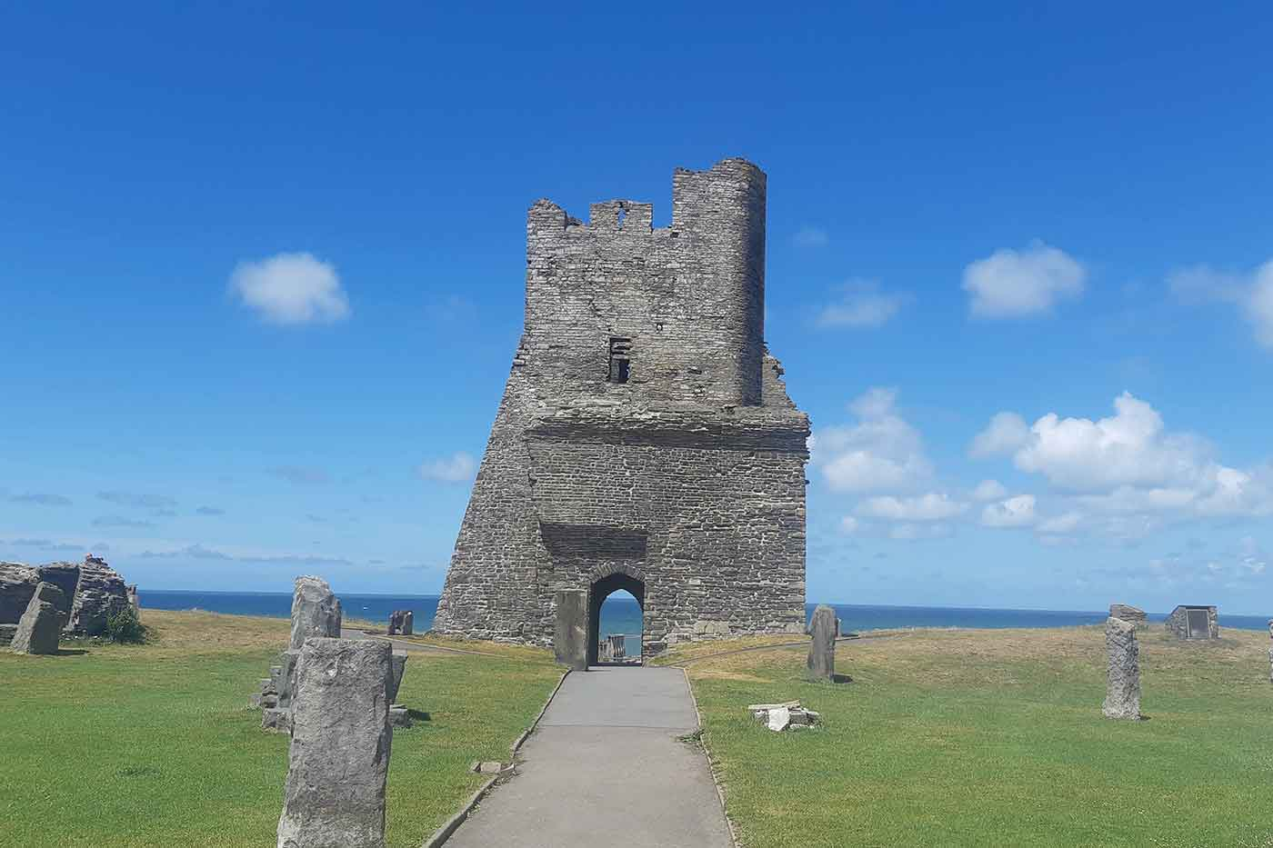
Aberystwyth Castle runins (Mustafa Natalwala, 2022)

- Recommendations for practice
Based on the geographical and lived experiences of the young individuals, Marcus and Courtney, the following recommendations aim to enhance opportunities and improve the well-being of young people.

- Develop youth-led, affordable, and safe spaces for young people.
Work with young people to design and tailor activities during the winter months. Conduct research and engage with schools to create a 'cool' environment for youth. Providing a range of activities, such as music nights, sports evenings, and pop-up events, will help reduce the stigma around attending a youth club.
- Strengthen outreach and targeted engagement in Penparcau.
Given the safety concerns expressed by young people, investment is needed in outreach work. According to the 2021 Census Area Profiles, Penparcau faces significant challenges, with 55.5% of households experiencing deprivation and 39.7% of individuals being economically inactive (Ceredigion County Council, n.d.). Outreach workers could improve the local community by organising pop-up events and workshops to begin building a more positive reputation through increased participation.
- Create a youth advisory panel for Aberystwyth and the local area
By introducing a youth-led panel in Aberystwyth, local issues such as services, community safety, and youth activities will be directly addressed by the young people themselves. This approach not only empowers and engages youth but also aligns with the Youth Work National Occupational Standards and the principles and purposes of Youth Work in Wales (CLD Standards Council Scotland, 2019).
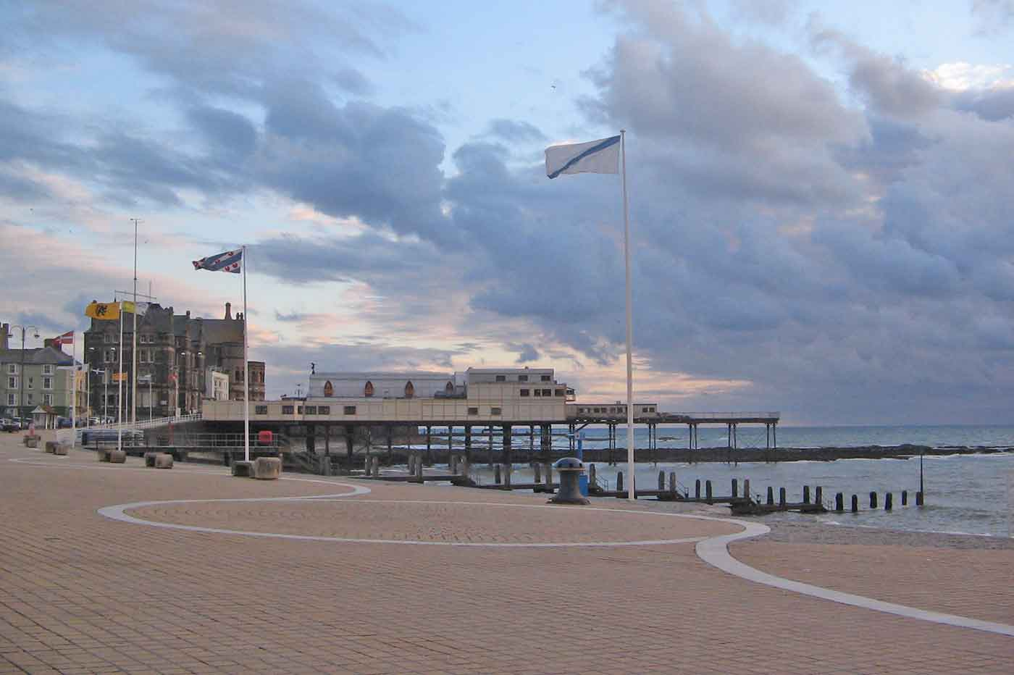
Overall, these recommendations aim to benefit the young people and their communities. The following conclusion will summarise the findings from this community profile.

Aberystwyth's Promenade (Mustafa Natalwala, 2022)
To Conclude
In conclusion, this community profile highlights both the strengths and challenges faced by Aberystwyth. It is evident that Aberystwyth offers valuable assets for young people, such as a vast amount of outdoor space, a beach, and affordable activities like the arcade. However, not all young people share the same positive perspective, some expressed their challenges during the winter months in Aberystwyth, particularly local concerns around safety and substance use, which contribute to a feeling of unsafety.
The recommendations proposed are aimed directly at addressing these concerns and needs. By increasing youth-led activities, improving safety, and expanding outreach youth work, we can empower young people and their community to use their voices and create a more positive environment.
Overall, the findings show that Aberystwyth has a solid foundation on which youth workers can build. Further research, investment, and planning in youth work are vital, and involving young people will be key to achieving success.

Reference List

Aberystwyth University Web Team (2019). Aberystwyth University - University of the Year for Teaching Quality 2019. Aber.ac.uk. Available at: https://www.aber.ac.uk/en/ (Accessed 24 November 2025).

Brinkhoff, T. (2021). City Population - Population Statistics in Maps and Charts for Cities, Agglomerations and Administrative Divisions of all Countries of the World. www.citypopulation.de. Available at: https://www.citypopulation.de/ (Accessed 24 November. 2025).

Ceredigion County Council (n.d.). Census 2021 - Ceredigion County Council. www.ceredigion.gov.uk. Available at: https://www.ceredigion.gov.uk/resident/census-2021/.

Ceredigion County Council (2024). Secondary Education - Ceredigion County Council. Ceredigion.gov.uk. Available at: https://www.ceredigion.gov.uk/resident/schools-education/school-information/ceredigion-schools/secondary-education/ (Accessed 24 November 2025)

Freepik. (2015). Strong tree Photos - Download Free High-Quality Pictures | Freepik. Available at: https://www.freepik.com/photos/strong-tree (Accessed 13 December 2025).

.
Get The Data (2025). Aberystwyth. Getthedata.com. Available at: https://www.getthedata.com/aberystwyth/where-is-aberystwyth (Accessed 24 November 2025).
Hawtin, M. and Percy-Smith, J. (2007). Community profiling : a practical guide. Maidenhead: Open University Press/Mcgraw-Hill Education.

Hywel Dda University Health Board (n.d.). Home. Hywel Dda University Health Board. Available at: https://hduhb.nhs.wales/.

Jeffs, T. and Smith, M. (2005). Informal education : conversation, democracy and learning. Nottingham England: Educational Heretics Press.

Jones, L. (2019). Insider guide to Aberystwyth | Visit Wales. Visitwales.com. Available at: https://www.visitwales.com/destinations/mid-wales/ceredigion-cardigan-bay/insiders-guide-aberystwyth (Accessed 24 November 2025).

Mustafa Natalwala (2022). Aberystwyth Top Attractions - 12 Things to Do in Aberystwyth. Wide World Trips. Available at: https://www.wideworldtrips.com/things-to-do-in-aberystwyth/ (Accessed 13 December 2025).

Tfw.wales. (2025). Visiting Aberystwyth | Transport for Wales. [online] Available at: https://tfw.wales/places/destinations/aberystwyth (Accessed 3 Dec. 2025).
The Youth Work National Occupational Standards (2019) NOS Ref Relevant NOS title. Available at: https://cldstandardscouncil.org.uk/wp-content/uploads/CombinedYouthWorkNOS.pdf (Accessed 13 December 2025).

TrawsCymru (n.d.). Homepage | Transport for Wales. tfw.wales. Available at: https://tfw.wales/.

Wasel Chemij (2018). Aberystwyth Transport (Train, Car, Bus, Maps) and Weather. Aberystwythguide.org.uk. Available at: https://aberystwythguide.org.uk/aberystwyth_transport_weather_map.shtml (Accessed 24 November 2025).

