

Component 2
Service improvement report of Shrewsbury and Telford hospital

MSc Public Health and Social Care in Practice

Module Title: Quality Assurance and Service Improvements
Module code: LCHS7006

Student name: Talaviya Hemanshi Rameshbhai
Student Number: 2430270
Lecturer’s name: Dr Fahad Khan

Words: 3297

Table of Contents
1. Introduction 4
1.1 Background 4
1.2 Purpose 5
2. Shrewsbury and Telford Hospital NHS — Maternity scandal issue 5
2.1 Issue Evaluation 5
2.2 Theory Applications 6
2.2.1 Donabedian model 6
2.3 Model applications 7
2.3.1 Root cause analysis 7
2.3.2 SWOT 9
2.4 Development of effective evidence-based recommendations 10
2.4.1 PDCA (Plan-Do-Check-Act) 10
2.4.2 Lewin’s model 11
3. Recommendation 11
3.1 PDCA application 11
3.2 Implementation of Lean 12
3.3 Six Sigma 13
3.4 Benchmark 14
4. Conclusion 14
Reference list 16

1. Introduction

1.1 Background
The case study mainly focuses on the maternity care issues and scandal at Shrewsbury and Telford NHS Trust Hospital in England, which has been one of the most concerning patient-safety scandals in the UK. The trust showed negligence, and they conducted unethical and unsafe patient practices in the maternity care from 1970 to 2019 as per the report of Ockenden in 2022 (Ockenden Report, 2022). During this time, hundreds of mothers and newborns were subjected to avoidable injuries because of the lack of clinical supervision, absence of risk evaluation, and adherence to evidence-based standards (Ockenden Report, 2022). The enquiry disclosed over 200 instances of still births, neonatal deaths, maternal deaths and brain damage, most of which were due to repetition of clinical errors and complications escalation (Ockenden Report, 2022). Employees exhibited ineffective communication, dismissive behavior, and lack of sympathy to mothers and families, which were the causes of emotional trauma and long-term psychological impacts (Ockenden Report, 2022). On a system level, there were chronic safety lapses in clinical governance, audit processes, leadership, and lack of compliance with policy. Past experience was not taken into account, and the audit results were not applied to eliminate the risks, and the threats remained unaddressed.
The Shrewsbury and Telford Hospital NHS Trust experienced some very serious issues regarding its maternity section, and those issues were closely related to the failure of the quality of services, especially care for the newborns. The lack of quality issues created huge injury to the patients (BBC News, 2022). The Guardian, (2022) report said the governance failure was the major reason behind the quality compromise and all the audit reports, risk assessment reports or incident reports were neglected or they didn't respond. This was a lack of accountability that enabled unsafe practices to continue over decades. BBC News, (2024) highlighted ineffective behaviour and culture of the staff as another significant problem, which was characterized by dismissive attitudes, the absence of compassion, and inefficient communication with mothers and families. These failures in behaviour led to delays in escalation, poor management of complications and emotional traumatisation of patients.
Another example of non-observance of clinical guidelines in the Trust was the recurring non-observance of evidence-based protocols in dealing with labour management, foetal monitoring, and emergency responses (BBC News, 2022). This was a direct contribution to avoidable cases of stillbirths, neonatal mortality and brain injuries. One of the most critical organisational weaknesses was the unwillingness to learn about the mistakes (The Guardian, 2022). Near-misses and adverse events were not analysed and they were not used to enhance practice. The system had incomplete safeguards to provide patient safety combined with poor leadership and teamwork among multidisciplinary teams (BBC News, 2024).

1.2 Purpose
The main purpose of this report is to provide a suitable recommendation to improve the quality and service for maternity and childcare as per the identified issue. Issue evaluation develops a synthesis issue to tackle the current challenges effectively with proper precautions. By using some theoretical framework and model application, it identifies the current issue experience by the Shrewsbury and Telford hospital in the UK. Evaluation of the issue develops a suitable action plan to change the operating process of Shrewsbury and Telford hospitals for better quality of care.

2. Shrewsbury and Telford Hospital NHS — Maternity scandal issue

2.1 Issue Evaluation
As per the current performance evaluation of Shrewsbury and Telford hospital, it has been revealed that there is no proper clinical governance practice followed by the organisation, which is a major loophole (Siddiqui, 2021). As per, Dereziuk et al. (2023), It is essential for an organisation to develop a strong clinical governance practice to avoid any critical incidents. Strict governance practices ensure that the healthcare organisation adheres to all the legal and ethical principles. The leader of the organisation is following an autocratic leadership approach, which does not collect the relevant information from the healthcare professionals and staff to improve the process (Elshenawy and Aslanpour, 2024). High disparities and the controlling power of the leader create an operational gap (Naz et al., 2022).
Rationale
Following a particular safety measurement for maternity care is essential for an organisation. Every healthcare organisation is liable for the safety and security issues (Abdelsalam Elshenawy and Aslanpour, 2024). Integrating the advance practice in the healthcare setting improves the governance practices that are lacking in this organisational (Chen et al., 2023). There are no advance health care services available in this organisation, which creates a major communication gap to offer health care services on time.

2.2 Theory Applications

2.2.1 Donabedian model
The Donabedian model is applied to evaluate the current health care quality of Shrewsbury and Telford hospitals (McCullough et al., 2023). This theory develops a clear understanding of the healthcare system, which is followed by the organisation to offer services for maternity care (Tossaint-Schoenmakers et al., 2021). As per, Yang et al. (2025), This theory has three independent dimensions to assess the healthcare quality: structure, process and outcomes. Structure indicates the resources available in the organisation to offer services. Process refers to the interaction across all the departments, and outcomes refer to the results or care which offered to the patient.
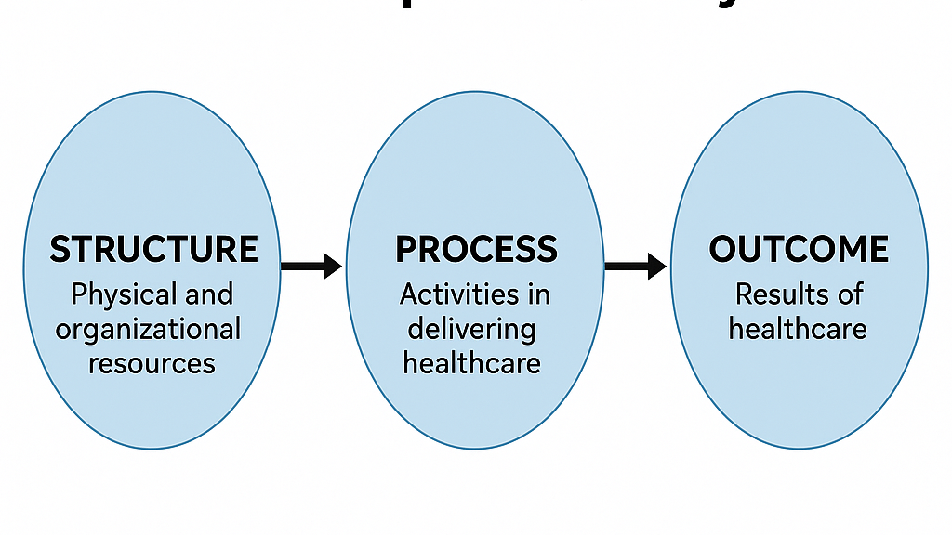
Figure: 1: Donabedian’s Model
(Source: Zahoor, 2025)
Structure – Structure is involved with the current facilities of the organisation and the staffing system (Tossaint-Schoenmakers et al., 2021). The current data revealed that for a long period, the healthcare organisation has not recruited any efficient healthcare professional or young carer. To uplift the capabilities of the existing healthcare professionals, there are no training or skill development opportunities offered by the company, which creates a major skills gap to offer high quality services to the patient (Naz et al., 2022). To boost the performance of the employee, it is essential for ban organisation to offer training and skills development programs (Yang et al., 2025). Shrewsbury and Telford Hospital is following a cost-cutting approach, which does not offer these career opportunities to the staff (Setyaningrum, Sriatmi and Arso, 2024). For a long time, Shrewsbury and Telford hospitals have been working with old machinery and requirements. There has been no advancement noticed in the last 5 years, which is a major reason to meet the patient’s needs.
Process – Process consists of interaction between the service provider and the service user (McCullough et al., 2023). The communication channel of the organisation is very poor, which does not allow for informing the patient on time (Guta, 2022). Across all the departments, there is no consistency maintained by the administrative body, which increases the dissatisfaction rate of healthcare professionals and patients (Tossaint-Schoenmakers et al., 2021). The patient does not get any proper information regarding doubts or queries.
Outcomes – This dimension of the Donabedian model is based on the above two dimensions. As the first two dimensions failed to meet the standards. It creates a loophole to offer high quality service care to the patient (Yang et al., 2025). Lack of communication and high employee turnover rate increase the maternity care-related issues (neonatal death, brain injury, poor maternity care, etc) (Tossaint-Schoenmakers et al., 2021).

2.3 Model applications

2.3.1 Root cause analysis
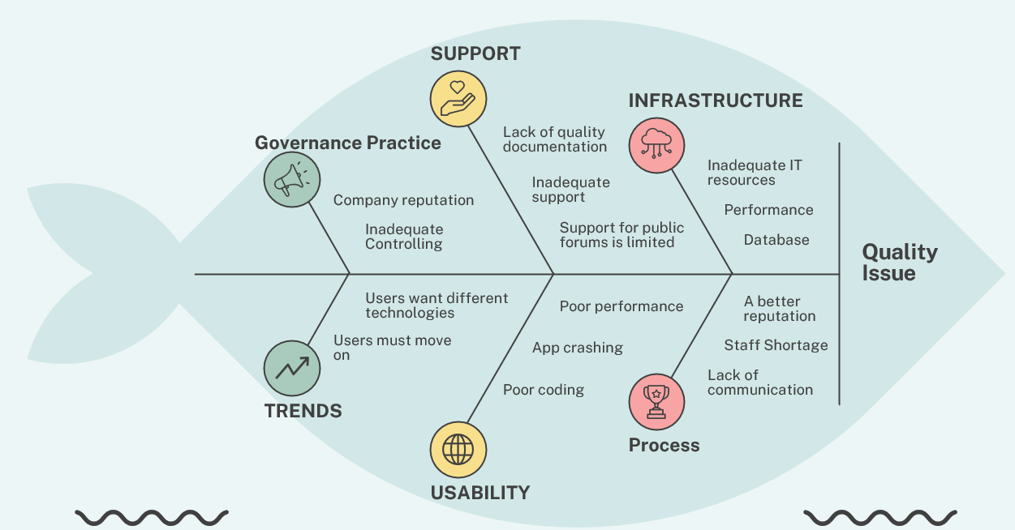
Figure 2: Fishbone diagram
(Source: self-developed)
- Governance practice- The major loophole of the organisation is associated with governance practices. Shrewsbury and Telford hospital follows a hierarchical structure in the workplace, which creates a major gap among the employees to maintain proper coordination (Abdelsalam Elshenawy and Aslanpour, 2024). Strict controlling behaviour of the leader does not allow for research or investigate (Elshenawy and Aslanpour, 2024). There is no creative or innovative approach followed by the healthcare staff due to this strict controlling behaviour.
- Support – The support system of the organisation should be strong and integrated (Dereziuk et al., 2023). There is no proper support provided to the employees in the workplace to execute their plans. Patients are also facing issues due to this lack of integrity. There is no documentation process followed by Shrewsbury and Telford hospitals, which creates a major ethical gap. Record training is a vital part of the healthcare sector. Currently, the other organisation is using an advanced system for documentation and record keeping, whereas Shrewsbury and Telford hospitals do not emphasise this factor (Siddiqui, 2021).
- Infrastructures – For a long time, Shrewsbury and Telford hospitals have not integrated any advance system in the workplace. To offer high quality service, it is important to buy an advanced system which is not available in this organisation. For critical care, Shrewsbury and Telford Hospital is not prepared (McCullough et al., 2023).
- Process management – Process management issues in Shrewsbury and Telford hospitals include workforce shortage, inefficient optimisation of clinical workflow and high staff burnout (Tossaint-Schoenmakers et al., 2021). Shrewsbury and Telford hospitals do not have a proper patient scheduling system to maintain the standard.
- Trends – Following the global or national trends in the organisational practice is highly essential (Yang et al., 2025). The leader has failed to meet the global trends to meet the standard of quality services.
- Usability – As per. Naz et al. (2022), The main attraction of a healthcare organisation is based on the advance system and infrastructure, which is missing in Shrewsbury and Telford hospitals. Telemedicine services are not available for remote care, which creates a gap in service offerings.

2.3.2 SWOT
SWOT analysis is a stae5aeaguc framework which a identify the current capabilities of the organisation (Abdelsalam Elshenawy and Aslanpour, 2024). This framework identifies the future threats and opportunities that the managing committee can take the measurements on time to prevent any fencelike, legal or reputational damage in the market (Elshenawy and Aslanpour, 2024).
Strength  - Committed to improvement  - Strong staff engagement initiatives  - Hospital transformation programme (HTP)  - Accessibility and infrastructure | Weakness  - Historical quality and safety concerns  - Workforce constraints  - Financial pressure  - Operational performance issues
Opportunities  - System-wide collaboration  - Infrastructure investment  - Improved patient communication  - Technological developments | Threat  - Demographics and geography challenge  - Regulatory scrutiny  - Staff retention and morale  - External financial climate
Table 1: SWOT analysis
Shrewsbury and Telford Hospital is currently undergoing through significant transformation program. The above analysis identified that the company requires investment in infrastructure development. The organisation has the capability to invest in the betterment of the operational practices and technical systems. Improving the organisational position in the UK market is totally dependent on the decision to follow the market trends and opportunities (Dereziuk et al., 2023). Along with the hospital committee must develop a robust security policy to strengthen the data privacy and data security system (Siddiqui, 2021). There are several allegations already lodged regarding this issue.

2.4 Development of effective evidence-based recommendations

2.4.1 PDCA (Plan-Do-Check-Act)

Figure 3: PDCA (plan-do-check-act)
(Source: self-developed)
PDCA is a 4-step continuous change model which can be followed by the organisation to improve the health care services (Peças et al., 2021). By following this 4-step model, there is a probability of improving the service and care system over time (Salameh et al., 2025). It is an action plan which requires adequate resources (physical, financial and human). The managing committee requires conducting a meeting with the NHS to get adequate funds to recruit new human resources to enable an integrated care approach for quality improvement (Chen et al., 2023). As per the identified problem in the above section, and to identify an opportunity, the action plan is developed, which can be implemented on a small scale to check the quality implementation and progress.

2.4.2 Lewin’s model
Initiation of a new plan in an organisation requires following the change model. The change model provides the framework to execute the strategic decision in the organisational practices successfully (Amina, Kassem and Sleem, 2022). Kurt Lewin's change management model consists of 3 steps- unfreeze, change and refreeze. Below, it provides the broad details of the application of this framework.
- Unfreeze – This is the first step of the Lewin model where the organisational leader is required to announce the current issue experience by the organisation through open discussion (Goenka et al., 2024). Organising a meeting ensures that all the healthcare professionals and staff are aware of the issue and change initiatives (Memon, Shah and Khoso, 2021).
- Change – A new integrated care system channelised by the organisational to improve the quality of care. The leader provides all the adequate support (technical, human and financial) to initiate the change.
- Refreeze– The leader collects the opinion from the staff regarding the concern area for the betterment of the organisational practices. As per, Endrejat and Burnes (2024), Open discussion identifies the issue and opportunities to successfully upgrade the acre system through creativity and innovation.

3. Recommendation

3.1 PDCA application
The cycle of Plan-Do-Check-Act (PDCA) can be employed in order to systematize enhancement of safety and quality of maternity services in Shrewsbury and Telford Hospital NHS Trust (Tamher, Rachmawaty and Erika, 2021).
- Plan: Within the first 1or 2 months, the Trust is to carry out a comprehensive gap analysis to determine priority risks that may include poor foetal monitoring, communication failures and non-adherence to clinical guidelines (Kuspranoto and Yudono, 2025). A Quality Improvement team which should consist of obstetricians, midwives, risk managers and patient family members should be developed. They should develop a standard care roadmap and arrange compulsory training.
- Do: Within the period of months 3-6, the Trust ought to test the new guidelines in some of the maternity units, introduce regular safety huddles and incident-reporting checklists. Emergency obstetrics simulation and training must be implemented in every shift to standardize the development of skills (Tamher, Rachmawaty and Erika, 2021).
- Check: Since the months 6-8, the QI team is to assess the changes in terms of clinical indicators such as CTG interpretation accuracy, escalation times, audit compliance and patient-experience feedback (Kuspranoto and Yudono, 2025). Regular review of the dashboard and auditing reports should be checked to measure progress and improvement.
- Act: Within 9 to 10 months some effective interventions will be taken and make standard for every unit (Tamher, Rachmawaty and Erika, 2021). The current policies regarding care will be revised and modified and staff ability should be evaluated, and regular monitoring should be integrated with the governance system.

3.2 Implementation of Lean
Ahmed et al., (2024) said Lean strategy of quality improvement will also contribute to the improvement of quality with minimised waste, efficiency of working processes and increased patient safety within 12 months.
- The Trust must start with Value Stream Mapping (VSM) to map the whole maternity care process between admission and postnatal discharge to identify the bottlenecks like wasting time, unnecessary duplication of documentation and unproductive communication between midwives and obstetric teams by 2 months (Marin-Garcia et al., 2021).
- After these steps have been identified, the Trust can apply the concept of the 5S (Sort, Set in order, Shine, Standardise and Sustain) in the clinical areas to arrange equipment, simplify the emergency trolley layouts by 3 months (Campbell, 2022).
- The implementation of standardised work protocols regarding such tasks like foetal monitoring, medication administration and escalation will decrease variation and allow safer care. Lean also promotes the use of visual management, including real-time digital dashboards showing staffing, patient acuity and current risks, and making decisions fast (Ahmed et al., 2024).
- It is necessary to have daily huddles of the Lean during the shift changes to monitor the progress, talk about the risks and allocate the resources effectively.
- Also, the implementation of the concept of continuous small improvements which is also known as Kaizen, will enable the frontline personnel to report on the problems and suggest solutions on a regular basis (Ojo, Feldman and Rampersad, 2022). With the inclusion of Lean thinking in leadership, governance and daily activities, the Trust can establish a culture of continuous improvement, minimize unnecessary delays and overall patient safety in maternity services (Ahmed et al., 2024).

3.3 Six Sigma
The six-sigma model can be proposed to improve the quality of care of the organization. The model follows five stages (DMAIC) which are proposed below:
Define | Measure | Analyse | Improve | Control
The issues of misinterpretation of CTG delayed escalation process and poor documents processes have been identified so for improvement in the overall process quality, measurable goals should be applied for example, the escalation delay should be measured by 30% within the next month (Ahmed et al., 2024). | In this stage, the different data must be collected and to collect data, it will require 2 to 3 months, the data such as the incident reports, audit reports, and emergency response time should be well reviewed. Then based on the current situation, the gaps should be identified (McDermott et al., 2022). | In this stage, the proper root-cause analysis should take place (Ahmed et al., 2024). The root-cause analysis should be done using proper tools and techniques to identify the basic reasons of the issues to improve the process. | Based on the identified issues, proper training should be arranged. Through the training, the skills and knowledge should be improved by 50% within the next 6 months. There should be standard protocols, and they should use structured communication tools. Then the simulation-based emergency drilling can improve the overall process (Ahmed et al., 2024). | In this stage, real-time dashboard reviewing must be required with experts, and they should arrange monthly review meetings about the process quality. Competency reassessment is required and continued monitoring is required (McDermott et al., 2022).
Table 2: Six sigma table

3.4 Benchmark
Benchmarks | Current situation | Where we are | What we want to achieve
Incident learning along with clinical governance | Weak risks are not escalated and poor monitoring. | Fragmented clinical governance and inconsistency | Transparent governance structure with timely escalation of risk management (Dilawar and Hood, 2025).
Proper reviewing process with necessary auditing aspects | Audit reports are ignored. | There was no corrective measures based on the reports. | Responsive audit cycle and immediate action taken (Affandi, Hermawan and Alvianda, 2023).
Safety aspects with proper leadership | Dismissive behavior and lack of compassion. | Poor workplace culture and lack of safety. | Safety-focused and open organizational culture (Ahmed et al., 2024).
Healthcare policy adherence | Guidelines are not followed, inconsistency (The Guardian, 2022). | Less alignment and fail to meet national maternity standards. | Evidence-based guidelines and consistent clinical practices.
Table 3: Benchmark table

4. Conclusion
Shrewsbury and Telford Hospital NHS Trust have been faced with an incident related to their maternity section. The maternity section faced systematic negligence. They failed in many aspects in taking care of the newborn babies and other motors in their maternity unit. Due to their negligence and lack of facility and infrastructure, many newborn babies face stillbirth issues, even the neonatal morality has been seen in this organisation. Many motors of the children faced health as well as mental health issues due to the negligence. Even after bringing this matter to higher authority, they ignored the audit reports and didn’t take any action and as per the report there were 200 cases of stillbirth, brain injury and neonatal death in the hospital.
From the analysis and root cause analysis it has been found that the dismissive staff behaviour towards the patients, ignorant behaviour and leadership failure is one of the reasons behind the scandal because the leadership didn’t focus much on the audit reports and try willingly tried to cover the matter so there were no whistleblowers. The Donabedian model also shows that there are huge issues regarding the quality of their safety process. The entire system or process operating in the maternity unit was very poor. The quality of care, the use of instruments, and the monitoring quality are all poor and due to the poor quality of care, all these incidents happened.
The recommendations are provided for better quality improvement of the process by application of the PDCA tool, Lean and Six sigma tools and all these tools and their stages are proposed to be implemented. Overall, the recommendations are to regular monitoring of the system, providing training to the staff, improvement of the leadership approach and behaviour towards the staff and adherence of the guidelines to secure the patients.

Reference list
Abdelsalam Elshenawy, R. and Aslanpour, Z., (2024). SWOT Analysis and Insights into the Health Research Authority Approval Process for COVID-19 Antimicrobial Stewardship Research in UK Secondary Care: Advocating Think Ethics. https://uhra.herts.ac.uk/id/eprint/12028/1/SWOT_Analysis_and_Insights_into_the_Health_Research_Authority_Approval_Process_for_COVID-19_Antimicrobial_Stewardship_Research_in_UK_Secondary_Care-_Advocating_Think_Ethics_.pdf
Affandi, H., Hermawan, R. and Alviananda, T., (2023). Assessment of Coal Handling Facility using the Swiss Cheese Model: A Case Study of Fire Incident in Coal-Fired Power Plant.https://rpsonline.com.sg/proceedings/esrel2023/pdf/P096.pdf
Ahmed, S., Hawarna, S., Alqasmi, I., Mohiuddin, M., Rahman, M.K. and Ashrafi, D.M., (2024). Role of Lean Six Sigma approach for enhancing the patient safety and quality improvement in the hospitals. International Journal of Healthcare Management, 17(1), pp.52-62.https://www.researchgate.net/profile/Selim-Ahmed/publication/365772190_Role_of_Lean_Six_Sigma_approach_for_enhancing_the_patient_safety_and_quality_improvement_in_the_hospitals/links/6384b50e7b0e356feb92bac5/Role-of-Lean-Six-Sigma-approach-for-enhancing-the-patient-safety-and-quality-improvement-in-the-hospitals.pdf
Amina, A., Kassem, A. and Sleem, W., (2022). Applying Lewin's change management theory to improve patient's discharge plan. Mansoura Nursing Journal, 9(2), pp.335-348. https://journals.ekb.eg/article_295591_2e01c440a7769101b9fd53066f06f65c.pdf
BBC News, (2022). Shrewsbury maternity scandal: Repeated failures led to deaths. Available at: https://www.bbc.com/news/uk-england-shropshire-60925959 [Accessed on 26th November 2025]
BBC News, (2024). Trust ignored maternity scandal families - midwife. Available at: https://www.bbc.com/news/articles/c3ggny1kk74o t [Accessed on 26th November 2025]
Campbell, M., (2022). Applying 5S in Healthcare. In International Examples of Lean in Healthcare (pp. 15-28). Productivity Press.https://www.taylorfrancis.com/chapters/edit/10.4324/9780429346958-2/applying-5s-healthcare-murdina-campbell
Chen, J., Cai, W., Lin, F., Chen, X., Chen, R. and Ruan, Z., (2023). Application of the PDCA cycle for managing hyperglycemia in critically ill patients. Diabetes Therapy, 14(2), pp.293-301. https://link.springer.com/content/pdf/10.1007/s13300-022-01334-9.pdf
Dereziuk, A.V., Yaremyna, I.V., Holovchanska-Pushkar, S.E. and Baidiuk, I.A., (2023). Efficiency improvement of health care institutions activities using SWOT-analysis. Reports of Vinnytsia National Medical University, 27(1), pp.160-165. https://reports-vnmedical.com.ua/index.php/journal/article/download/1119/1072
Dilawar, S. and Hood, M., (2025). Redefining Safety: Strategic Incident Management in Modern Healthcare. International Journal of Digital Health and Telemedicine, 1(1).https://www.wr-publishing.org/index.php/ijdht/article/download/222/222
Elshenawy, R.A. and Aslanpour, Z., (2024). SWOT Analysis and Insights into the Health Research Authority Approval Process for COVID-19 Antimicrobial Stewardship Research in UK Secondary Care: Advocating Think Ethics. https://researchprofiles.herts.ac.uk/files/62491426/SWOT_Analysis_and_Insights_into_the_Health_Research_Authority_Approval_Process_for_COVID-19_Antimicrobial_Stewardship_Research_in_UK_Secondary_Care-_Advocating_Think_Ethics_.pdf
Endrejat, P.C. and Burnes, B., (2024). Draw it, check it, change it: reviving Lewin's Topology to facilitate organizational change theory and practice. The Journal of Applied Behavioral Science, 60(1), pp.87-112. https://journals.sagepub.com/doi/pdf/10.1177/00218863221122875
Goenka, A., Mundkur, S., Nayak, S.S., Shetty, A., Thomas, J., Balakrishnan, J.M., Sekaran, V.C. and Dsouza, B., (2024). Improving the emergency services using quality improvement project and Donabedian model in a quaternary teaching hospital in South India. BMJ Open Quality, 13(1). https://bmjopenquality.bmj.com/content/bmjqir/13/1/e002246.full.pdf
Guta, N.M., (2022). Application of Donabedian quality-of-care framework to assess quality of neonatal resuscitation, its outcome, and associated factors among resuscitated newborns at public hospitals of East Wollega zone, Oromia, Western Ethiopia, 2021. BMC pediatrics, 22(1), p.605. https://link.springer.com/content/pdf/10.1186/s12887-022-03638-y.pdf
Kuspranoto, A. and Yudono, M.A.S., (2025). The Application Of The Plan-Do-Check-Action (PDCA) Cycle Concept In The Safety Lock System On 3-Crank Patient Bed. Fidelity: Jurnal Teknik Elektro, 7(1), pp.97-104.https://fidelity.nusaputra.ac.id/article/download/288/165
Marin-Garcia, J.A., Vidal-Carreras, P.I. and Garcia-Sabater, J.J., (2021). The role of value stream mapping in healthcare services: A scoping review. International journal of environmental research and public health, 18(3), p.951.https://www.mdpi.com/1660-4601/18/3/951
McCullough, K., Andrew, L., Genoni, A., Dunham, M., Whitehead, L. and Porock, D., (2023). An examination of primary health care nursing service evaluation using the Donabedian model: A systematic review. Research in nursing & health, 46(1), pp.159-176. https://onlinelibrary.wiley.com/doi/pdf/10.1002/nur.22291
McDermott, O., Antony, J., Bhat, S., Jayaraman, R., Rosa, A., Marolla, G. and Parida, R., (2022). Lean six sigma in healthcare: a systematic literature review on motivations and benefits. Processes, 10(10), p.1910.https://www.mdpi.com/2227-9717/10/10/1910
Memon, F.A., Shah, S. and Khoso, I.U., (2021). Improving Employee's Engagement in Change: Reassessing Kurt Lewin's Model. City University Research Journal (CURJ), 11(1). https://www.researchgate.net/profile/Sobia-Shah/publication/382591683_Improving_Employee's_Engagement_in_Change_Reassessing_Kurt_Levin_Model/links/66a402364433ad480e7ec714/Improving-Employees-Engagement-in-Change-Reassessing-Kurt-Levin-Model.pdf
Naz, S., Saleem, S., Islam, Z.S., Bhamani, S. and Sheikh, L., (2022). Obstetric triage improvement process using the Donabedian model of quality care: a quality improvement initiative. BMJ Open Quality, 11(2), p.e001483. https://bmjopenquality.bmj.com/content/bmjqir/11/2/e001483.full.pdf
Naz, S., Saleem, S., Islam, Z.S., Bhamani, S. and Sheikh, L., (2022). Obstetric triage improvement process using the Donabedian model of quality care: a quality improvement initiative. BMJ Open Quality, 11(2), p.e001483. https://bmjopenquality.bmj.com/content/bmjqir/11/2/e001483.full.pdf
Ockenden Report, (2022). Available at: https://www.ockendenmaternityreview.org.uk/wp-content/uploads/2022/03/FINAL_INDEPENDENT_MATERNITY_REVIEW_OF_MATERNITY_SERVICES_REPORT.pdf [Accessed on 26th November 2025]
Ojo, B., Feldman, R. and Rampersad, S., (2022). Lean methodology in quality improvement. Pediatric Anesthesia, 32(11), pp.1209-1215.https://onlinelibrary.wiley.com/doi/abs/10.1111/pan.14439
Peças, P., Encarnação, J., Gambôa, M., Sampayo, M. and Jorge, D., (2021). Pdca 4.0: A new conceptual approach for continuous improvement in the industry 4.0 paradigm. Applied Sciences, 11(16), p.7671. https://www.mdpi.com/2076-3417/11/16/7671
Salameh, W.E.M.K.B., Mohammad, A.A.S., Alshurideh, M.T., Alolayyan, M.N., Hunitie, M.F.A., Rababah, M.W., Haija, A.A.A., Al-Hawary, S.I.S., Alzyoud, M. and Al-hawajreh, K.M., (2025). Evaluation of applying the PDCA cycle on medication administration in the emergency departments. In Intelligence-Driven Circular Economy: Regeneration Towards Sustainability and Social Responsibility—Volume 2 (pp. 319-330). Cham: Springer Nature Switzerland. https://www.academia.edu/download/121641175/d7d48494_99c3_4cb4_a68d_0f61b3ffd3b8.pdf#page=323
Setyaningrum, D., Sriatmi, A. and Arso, S.P., (2024). Patient Satisfaction on Hospital Outpatient Service Quality Based on the Donabedian Model. Journal of Public Health for Tropical and Coastal Region, 7(3), pp.229-234. https://ejournal2.undip.ac.id/index.php/jphtr/article/download/24229/11976
Siddiqui, A., (2021). SWOT analysis (or SWOT matrix) tool as a strategic planning and management technique in the health care industry and its advantages. Biomedical Journal of Scientific & Technical Research, 40(2), pp.32035-32042. https://www.academia.edu/download/94724847/BJSTR.MS.ID.006419.pdf
Tamher, S.D., Rachmawaty, R. and Erika, K.A., (2021). The effectiveness of Plan Do Check Act (PDCA) method implementation in improving nursing care quality: A systematic review. Enfermería Clínica, 31, pp.S627-S631.https://www.sciencedirect.com/science/article/pii/S1130862121001716
The Guardian, (2022). Shropshire maternity scandal: 300 babies died or left brain-damaged, says report. Available at:https://www.theguardian.com/society/2022/mar/26/shropshire-maternity-scandal-300-babies-died-or-left-brain-damaged-says-report [Accessed on 26th November 2025]
Tossaint-Schoenmakers, R., Versluis, A., Chavannes, N., Talboom-Kamp, E. and Kasteleyn, M., (2021). The challenge of integrating eHealth into health care: systematic literature review of the Donabedian model of structure, process, and outcome. Journal of medical Internet research, 23(5), p.e27180. https://www.jmir.org/2021/5/e27180/
Yang, J., Liu, F., Yang, C., Wei, J., Ma, Y., Xu, L., Xie, J. and Wang, J., (2025). Application of Donabedian Three‐Dimensional Model in Outpatient Care Quality: A Scoping Review. Journal of Nursing Management, 2025(1), p.6893336. https://onlinelibrary.wiley.com/doi/pdf/10.1155/jonm/6893336
Zahoor., (2025). Donabedian’s Model for Health care Quality Management. Available at: https://www.linkedin.com/pulse/donabedians-model-health-care-quality-management-muhammad-zahoor-qldsf [Accessed on: 26.11.2025]

