

Student name: Mirela Filipova
Student ID: 2114282

Module name: Changemakers: Building your Personal Brand for Sustainable Employment Assignment title: Online Portfolio
Module code: BMHP5015
Lecturer name: Ogochukwu Agunenye

Introduction

This paper will cover my curriculum vitae and my cover letter for Podiatrist Assistant in NHS Princess Royal Hospital (NHS, 2019a). In addition, we will propose a broadcast appearance on a topic of interest to patients with diabetes.
It is an opportunity for me to highlight my qualifications for the position I am applying for, as well as my enthusiasm for and dedication to the field. My passion and commitment to my job are both exceptionally high, and I embrace every task with eager anticipation. I want to learn as much as possible so that I can take with confidence task life throws at me. I am aware of the obligations that will fall upon my shoulders if I decide to pursue this line of work. I am confident in my ability to serve more individuals because my typical approach in any situation is to face a challenge with optimism. I am certain that I will show to be an asset in this position due to my enthusiasm, background, and planned training. I promise to work hard to meet all the high standards set by my patients and my colleagues.
With my proposal to the TV show, I hope to educate more people living with diabetes and the people who care for them. With proper education and information, I hope to protect patients from future foot injuries, and with proper care, these problems would be less unpleasant.

Curriculum Vitae is a written summary of your education, accomplishments, and experience, typically presented to prospective employers or award committees. (National Careers Service, 2022).
‌
Name: Mirela Filipova
Contact: 07510049492
Address: 27 Westway
SW209LX London
Email address: miraveleva@gmail.com
To secure a position as a Podiatrist Assistant in a reputable healthcare organization where I can apply my knowledge, skills, and experience to provide exceptional patient care and contribute to the success of the practice.
Professional Experience
Health Care Assistant in Wexham Park Hospital Gastroenterology department (National Health Service, 2023).
05/2018- 08/2021.
- Helping patients with their morning routines.
- Blood pressure check, blood sugar check.
- ESG.
- Transporting patients to various departments for ongoing examinations and procedures.
- Urine test, taking a swab.
- Maintain records as per hospital regulations.
- Specific work with alcohol and drug dependent patients. And not only that, but mainly the work was with severe abstinence.
- One to one special assistance
Certifications
- Basic Life Support (BLS)
- Infection Control and Prevention
- HIPAA Compliance
- Equality and Diversity
- Moving and Handling
- Safeguarding Adults
- Safeguarding Children (LTD, 2018).

Podiatrist Assistant, Princess Royal Hospital Haywards Heath 2021-Present
• Assist the podiatrist in examination, diagnosis, and treatment of patients with foot and lower limb problems
• Provide patient education on foot care and preventative measures
• Prepare and sterilize equipment and maintain a clean and safe environment for patients
• Assist in surgical procedures, including nail surgeries, excisions, and biopsies
• Manage patient records and appointments using electronic health records
Clinical Placement, Crawley Hospital Crawley 2021-2022
• Observed and assisted in podiatry procedures, including wound care, gait analysis, and biomechanical assessments
• Worked with patients with a variety of foot and lower limb conditions, including diabetes, arthritis, and sports injuries
• Conducted patient assessments and developed treatment plans under the supervision of experienced podiatrists
• Participated in multidisciplinary team meetings and contributed to patient care discussions
Skills
• Knowledge of podiatry procedures, including examination, diagnosis, and treatment of foot and lower limb conditions
• Ability to assist in surgical procedures and maintain a sterile environment
• Understanding of patient education and preventative measures for foot care
• Proficient in using electronic health records and managing patient records
• Strong communication skills and ability to work effectively in a team environment
• Ability to work under pressure and manage time effectively
Certifications
- Basic Life Support (BLS)
- Infection Control and Prevention
- HIPAA Compliance
- Equality and Diversity
- Moving and Handling
- Safeguarding Adults
- Safeguarding Children (LTD, 2018).

Future Career Ambitions
As a Podiatrist Assistant, my ultimate career goal is to become a licensed podiatrist. To achieve this, I plan to continue my education and training by pursuing a Doctor of Podiatric Medicine degree (National Institute for Health and Care Excellence, 2022).
I am committed to ongoing learning and growth in the field of podiatry and am I excited to work with experienced podiatrists to gain valuable experience and skills.
References: Available upon request.
Personal skills
Briefly about me - I am an outstanding communicator and team player. I do my work in accordance with the policies of the hospital. Listening, body language, kindness, negotiating, problem solving, persuasion, clarity, and honesty are some of my other soft skills. I am very experienced in the field of information technology.
Education
Certificate of Higher Education Level 4 University of Wales Trinity Saint David London October 2021-2022
Bachelor of Science “Health and Social Care “level 5/6 University of Wales Trinity Saint David London October 2022-Present.

Cover Letter
A cover letter is a document you send together with your curriculum vitae (traditionally as the front cover) Smith (2019).

Mirela Filipova
miraveleva@gmail.com
07512131466
London SW209 LX
To:
Charlotte Mcadams
Human Resources Manager
144 Southway
London NF547FN

Dear Mrs Mcadams,

Re: Application for Podiatry Assistant Reference Number SCT 6789234 on NHS jobs.com

Please find attached my resume in support of my application for the above position.

My name is Mirela Filipova. Please accept this letter as my formal application for the position posted on your company website -Job ID SCT 6789234. I am confident that my experience and skills that I have in this field, would be a great match for this position.
I am writing to express how interested I am in joining the Podiatry Team at Princess Royal Hospital and your Office team generally, and I have included my résumé for your consideration (National Careers Service, 2019). My enthusiasm for giving quality treatment to patients includes, different types of dressings, offloading field, and special shoes/boots support. We do all of this thing in order to prevent any future problems such as Charcot foot which is an actual problem that can affect the foot in people with neuropathy (nerve damage with numbness) (National Institute for Health and Care Excellence, 2022). The bones of the foot become very fragile and can start to break or dislocate in response to very minor forces even in response to the forces which occur with standing or walking. Or any infection as osteomyelitis what is an infection that usually causes pain in the long bones in the legs (Diabetes Uk, 2021). My familiarity with podiatrist procedures, also involved what patients need debriding, importance to choose proper dressings and to regularly check temperature of both feet. And my dedication to furthering my education and professional development, I think that I would be an asset to your team. I am familiar with the values of the NHS. Our values are to put patients first, take pride in what we do, respect others, strive to be the best, act with integrity. I just completed my education in podiatry, and during that time, I was able to get great expertise in a variety of podiatric treatments, as well as patient care and medical administration (novaphar, 2014).
Throughout my training, I had the chance to work with seasoned podiatrists, from whom I gained a significant amount of knowledge about the significance of doing exhaustive examinations, making accurate diagnoses, and developing effective treatment strategies. In addition, I have experience assisting in a variety of surgical operations, and as a result, I am aware of how critical it is to keep the operating theatre clean. It excites me to be working as a podiatrist assistant because, it will allow me to keep expanding my skill set and provide patients the best possible treatment. I am especially curious about your practise because it has a well-deserved reputation for offering individualised care and keeping up with the most recent developments in both technology and treatment methods (NHS, 2019a). I have no doubt that I would be able to thrive in this fast-paced atmosphere and make a positive contribution to the practice's overall success.
In addition to my experience with podiatrist operations, I am dedicated to maintaining a development program and continuously expanding my knowledge base. Every month I have one goal to achieve and in the end of the current I put a tick "this is done" (https://www.facebook.com/studiobinderapp, 2019). In the long run, I want to work in the medical field of podiatry, therefore I intend to continue my study and get the necessary training. Working as a podiatry assistant at your clinic will enable me to get experience that would be of great value to me and help me move closer to achieving my professional objectives (National Institute for Health and Care Excellence, 2022).
I am positive that the combination of my education, work experience, and dedication to furthering my education and career make me an outstanding candidate for the position of Podiatry Assistant at your clinic. I am grateful that you are taking my application into consideration. I would be grateful for the opportunity to elaborate on my qualifications in more detail.

Your Sincerely: Mirela Filipova

TV pitch is the writer's proposal for a television series educates producers, networks, and executives. Excellent proposals describe genre and tone succinctly and convey the writer's series direction (https://www.facebook.com/studiobinderapp,2019).
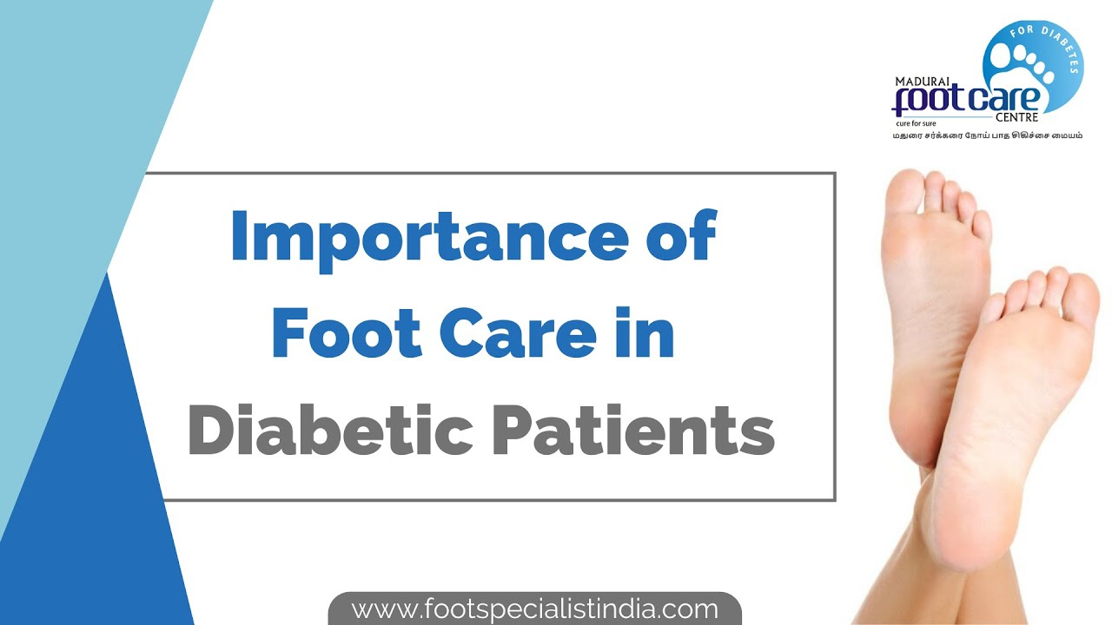
(novaphar, 2014)

Dear ITVX Television (Google, 1998).
I would like to suggest that you include this important topic in your show - "Help for our health"(Rodger, 2022).
My name is Mirela Filipova, and I am work in Princess Royal Hospital as Podiatrist Assistant since 2021. Every day, I saw a lot of my patient who is suffering from diabetic disease, and all the consequences and how much has cost them to support their health condition (Diabetes Uk, 2021).
‌
I am writing to you today to propose a TV series on an incredibly important and relevant topic - Diabetic foot care, specifically in the context of the NHS and health and social care (NHS, 2019).
As you are undoubtedly aware, diabetes is a growing concern worldwide, with over 463 million adults diagnosed with the disease in 2019 alone. In the UK, approximately 3.9 million people are living with diabetes, and this number is only set to rise. One of the most significant complications of diabetes is the impact it can have on the feet, with diabetic foot ulcers and infections being responsible for around 135 amputations every week in England alone.
Despite the severity of this issue, there is a significant lack of awareness around diabetic foot care, both among healthcare professionals and the general public. That is why I believe that a TV series on this topic is not only necessary but also timely and highly relevant.
The proposed series would aim to educate viewers on the importance of diabetic foot care and provide practical advice on how to prevent and manage foot ulcers and infections. It would also explore the impact of diabetes on the wider healthcare system, looking at the resources and funding required to provide adequate care to those living with the disease (NHS, 2019a).
In terms of format, the series would consist of six episodes, each focusing on a different aspect of diabetic foot care. Episode titles could include "Prevention is better than cure: practical tips for foot care," "The role of podiatrists in diabetic foot care," and "The cost of diabetes: a look at the economic impact of the disease."
One of the unique selling points of this series is that it would be highly relevant to a wide range of audiences. Not only would it be of interest to those living with diabetes and their families, but it would also be highly informative for healthcare professionals, policymakers, and anyone interested in the wider implications of diabetes on society (NHS, 2019b).
In terms of production, we have a highly experienced team of producers, directors, and writers, who have worked on a range of successful TV series in the past. We also have a network of healthcare professionals and patient groups who have agreed to be involved in the production, providing expert insights and personal stories.
Finally, I believe that this series could be highly beneficial for your company, not only in terms of the potential for high viewing figures but also in terms of your corporate social responsibility. By supporting this project, you would be contributing to the wider goal of improving healthcare outcomes for those living with diabetes, a cause that is undoubtedly of great importance (novaphar, 2014).
Thank you for taking the time to read my proposal, and I look forward to discussing it further with you.

Sincerely, Mirela Filipova

References

Diabetes Uk (2021). Diabetes UK - Know diabetes. Fight diabetes. [online] Diabetes UK. Available at: https://www.diabetes.org.uk/ .
Google (1998). Google. [online] Google.com. Available at: https://www.google.com .
https://www.facebook.com/studiobinderapp (2019). StudioBinder: Project Management for Video Professionals. [online] StudioBinder. Available at: https://www.studiobinder.com/ .
LTD, F. (2018). Online Training Courses | 14 Day Free Trial | Flexebee. [online] www.flexebee.co.uk. Available at: https://www.flexebee.co.uk/ .
National Careers Service (2019). Explore careers | National Careers Service. [online] Service.gov.uk. Available at: https://nationalcareers.service.gov.uk/ .
National Careers Service (2022). CV Sections | Careers Advice | National Careers Service. [online] nationalcareers.service.gov.uk. Available at: https://nationalcareers.service.gov.uk/careers-advice/cv-sections .
National Health Service (2023). NHS. [online] NHS. Available at: https://www.nhs.uk/ .
National Institute for Health and Care Excellence (2022). NICE | The National Institute for Health and Care Excellence. [online] NICE. Available at: https://www.nice.org.uk/ .
NHS (2019a). Health Careers. [online] Health Careers. Available at: https://www.healthcareers.nhs.uk/ .
NHS (2019b). We’re here for you. [online] NHS. Available at: https://www.nhs.uk .
novaphar (2014). Diabetes and foot care. [online] Nova Pharmacy. Available at: https://www.novapharmacy.com.au/all-health-topics/other/diabetes-and-foot-care/ [Accessed 6 Mar. 2023].
Rodger, J. (2022). This Morning doctor says nine unusual symptoms could actually be cancer. [online] BirminghamLive. Available at: https://www.birminghammail.co.uk/news/showbiz-tv/itv-morning-doctor-says-nine-23848680 [Accessed 7 Mar. 2023].
Smith, J. (2019). Cover letters | Prospects.ac.uk. [online] Prospects.ac.uk. Available at: https://www.prospects.ac.uk/careers-advice/cvs-and-cover-letters/cover-letters .
‌

