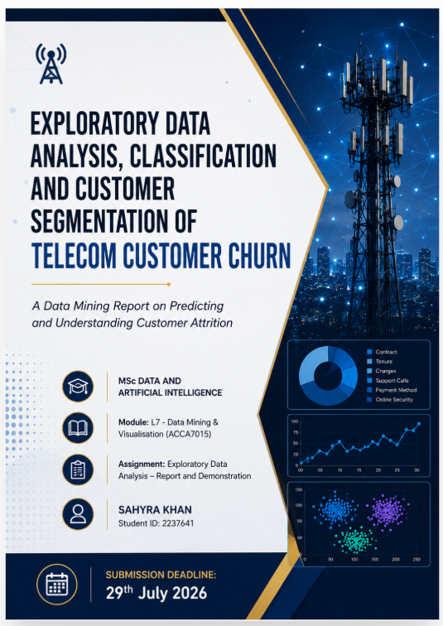
Contents
List of Figures and Tables 3
Abstract 5
1. Introduction 5
2. Literature Review 6
2.1 Predictive Analytics and Churn Management 6
2.2 Classification Techniques for Churn Prediction 7
2.3 Clustering and Association Rule Mining for Customer Understanding 8
2.4 Model Evaluation Metrics 9
2.5 Summary and Research Gap 10
3. Dataset Description 10
4. Methodology 12
4.1 Data Preparation 12
4.2 Feature Selection 12
4.3 Classification Modelling Approach 14
4.4 Complementary Clustering 15
4.5 Evaluation Metrics 16
5. Exploratory Data Analysis 16
5.1 Class Balance 18
5.2 Data Quality 18
5.3 Relationships Between Key Features and Churn 19
5.4 Demographic Patterns (Marital Status, Household Vehicles, Ethnicity) 22
6. Model Implementation and Evaluation (WEKA) 23
6.1 Data Import and Pre-processing in WEKA 24
6.2 Classifier 1: J48 Decision Tree Classification Results in WEKA 25
6.3 Classifier 2: Random Forest Classifier 26
6.4 Model Comparison 27
7. Complementary Analysis: Clustering of Churned Customers 27
7.1 Preparing the Churned Subset 27
7.2 SimpleKMeans Results 28
7.3 Interpretation 30
8. Results Analysis and Discussion of Findings 30
8.1 Critical Evaluation of Classifier Performance 30
8.2 Interpreting the Complementary Clustering 31
8.3 Limitations 32
9. Business Recommendations 33
10. Conclusion 34
References 35
Appendix 37

List of Figures and Tables

List of Figures
Figure 1: Customer Segmentation Workflow 8
Figure 2: Attribute Selection Using CfsSubsetEval and BestFirst Search 12
Figure 3: WEKA Attribute Ranking Using InfoGainAttributeEval and Ranker 12
Figure 4: J48 Decision Tree Generated in WEKA 13
Figure 5: SimpleKMeans Clustering Results for Churned Customers 15
Figure 6: Scatter Plot of Average 3-Month vs 6-Month Minutes of Use 15
Figure 7: Class Distribution of the Churn Variable (n = 100,000) 16
Figure 8: Top Fifteen Features by Missing-Value Proportion 17
Figure 9: Correlation Matrix of Key Revenue, Usage and Tenure Features 18
Figure 10:Top 15 Features Ranked by Correlation with Churn 19
Figure 11: Customer Tenure Distribution by Churn Status 19
Figure 12: Handset Age by Churn Status 20
Figure 13: Monthly Recurring Charge Distribution by Churn Status 20
Figure 14: Handset Price Distribution by Churn Status 21
Figure 15: Churn Rate by Marital Status Code 21
Figure 16: Churn Rate by Household Vehicle Count 22
Figure 17: WEKA Preprocess Tab – Final Modelling Dataset 23
Figure 18: J48 Decision Tree Classification Results in WEKA 24
Figure 19: Random Forest Classification Results in WEKA 25
Figure 20: WEKA Preprocessing of the Churned Customer Subset 27
Figure 21: SimpleKMeans Output – Final Four-Cluster Solution 28
Figure 22: Cluster Profiles of Churned Customers (k = 4) 28
List of Tables
Table 1: Comparison of Machine Learning Algorithms for Churn Prediction 7
Table 2: Summary of Feature Groups in the Telecom Churn Dataset 10
Table 3: Distribution of Customers Across the Four SimpleKMeans Clusters 17
Table 4: Performance Comparison – J48 Decision Tree vs Random Forest 26
Table 5: Within-Cluster SSE for Candidate K-Means Solutions 27

Abstract
Customer churn is one of the most economically significant problems facing the telecommunications sector, where the cost of acquiring a new subscriber substantially exceeds the cost of retaining an existing one. Building on Assignment 1, this report applies data mining techniques to a telecommunications dataset of 100,000 subscribers and 100 attributes covering revenue, usage, device and demographic features, to classify customers as likely to churn or be retained. Two classifiers – J48 Decision Tree and Random Forest – were built and evaluated in WEKA using a 75/25 training/testing split on the ten most predictive attributes, and the analysis was complemented with SimpleKMeans clustering applied to the churned-customer subset to uncover behavioural sub-groups. Exploratory analysis shows an almost perfectly balanced target class (49.6% churners, 50.4% retained) and identifies handset age, handset price and monthly recurring charge as the features most strongly associated with churn. J48 achieved the stronger overall result (59.1% accuracy, F1 = 0.590, ROC-AUC = 0.620) compared with Random Forest (58.0% accuracy, F1 = 0.580, ROC-AUC = 0.615), while requiring a fraction of the training time. Clustering identified four distinct churner segments differentiated primarily by usage intensity and equipment age. The findings are discussed in the context of the existing literature on churn prediction and translated into evidence-based retention recommendations for telecom decision-makers.

1. Introduction
Customer churn - the phenomenon whereby a subscriber terminates their relationship with a service provider - is widely regarded as one of the most damaging outcomes a telecommunications operator can experience, both because of lost recurring revenue and because acquiring new customers is considerably more expensive than retaining existing ones [1]. In a market characterised by saturated penetration rates, near-identical tariff structures and low switching costs, telecom operators increasingly rely on data mining to identify, in advance, which customers are at risk of leaving, and why [2].
This report is a continuation of Assignment 1, in which the Telecom_Customer_Churn.csv dataset was cleaned, pre-processed and explored visually. The present assignment extends that foundation by applying supervised classification techniques to predict churn (Churn = True/False) from a curated set of behavioural, revenue and demographic features, and with SimpleKMeans clustering applied specifically to the segment of customers who have already churned, in order to surface groupings and relationships that a single classification label cannot express.
The remainder of this report is structured as follows. Section 2 critically reviews recent and seminal literature on churn prediction, classification algorithms, clustering/association rule mining and model evaluation. Section 3 describes the dataset. Section 4 sets out the methodology, including data preparation, feature selection and the rationale for the algorithms chosen. Section 5 presents the exploratory data analysis with supporting visualisations. Section 6 reports the implementation and evaluation of the classification models built in WEKA. Section 7 reports the complementary clustering/association rule mining analysis. Section 8 discusses the findings critically considering the literature, Section 9 translates these findings into business recommendations, and Section 10 concludes.

2. Literature Review

2.1 Predictive Analytics and Churn Management
Churn management has long been recognised as a core application of customer relationship management (CRM) analytics, framing churn prediction as fundamentally a business decision-support problem rather than a purely technical exercise: a model is only useful to the extent that its output can be translated into a retention action that is more profitable than doing nothing. This framing is echoed throughout the more recent literature [3]. Customer churn prediction has become a strategic business objective because customer acquisition is substantially more expensive than customer retention, meaning that even modest improvements in the early identification of at-risk customers can significantly enhance organisational profitability. Furthermore, recent research highlights that organisations increasingly require not only highly accurate predictive models but also interpretable models whose outputs can be readily understood and acted upon by non-technical customer retention teams. These considerations directly motivate the selection of machine learning algorithms in this report [4].

2.2 Classification Techniques for Churn Prediction
A wide range of machine learning algorithms has been applied to customer churn prediction in the telecommunications sector. Decision Trees remain popular because they generate simple rule-based models that are easy for business users to understand and explain, making them well suited to customer retention decisions [4]. However, recent studies consistently show that ensemble learning methods such as Random Forest and XGBoost generally achieve higher predictive performance than single classifiers. Comparative evaluations report that these algorithms outperform traditional methods, including Logistic Regression, Decision Trees and Naïve Bayes, across common performance measures such as accuracy, precision, recall, F1-score and ROC-AUC [5], [3]. Research also highlights that telecom churn datasets are often highly imbalanced, making techniques such as SMOTE, under-sampling and cross-validation important for improving model reliability and reducing prediction bias [6].
Despite the superior predictive performance of ensemble models, simpler algorithms such as Logistic Regression and Naïve Bayes remain widely used because they are computationally efficient and produce results that are easier for business stakeholders to interpret [7]. Consequently, selecting an appropriate churn prediction model requires balancing predictive accuracy with model interpretability, particularly when the results are intended to support customer retention strategies. This trade-off is discussed further in Section 4.3.

Table 1: Comparison of Machine Learning Algorithms for Telecom Customer Churn Prediction.
  Algorithm
  Strength
  Weakness
  Typical Finding
Decision Tree | Highly interpretable | Can overfit | Good explainability
Random Forest | High accuracy | Less interpretable | Excellent overall performance
XGBoost | Highest predictive performance | More complex | Best Accuracy/F1 in many studies
Logistic Regression |  | Low accuracy | Strong Baseline
  Simple and fast
Naïve Bayes | Very efficient | Assumes feature independence | Useful baseline

Table 1 compares the strengths, limitations, and typical performance of commonly used machine learning algorithms for telecom customer churn prediction. It highlights the trade-off between predictive accuracy and model interpretability.

2.3 Clustering and Association Rule Mining for Customer Understanding
While classification predicts which customers are likely to churn, clustering explains how different groups of customers behave. K-means remains one of the most widely used clustering algorithms for customer segmentation due to its simplicity and efficiency [3], [8]. Combining clustering with classification can improve churn prediction by grouping customers with similar behavioural patterns before or after predictive modelling, leading to more targeted retention strategies [9], [4]. This report adopts K-means (implemented as SimpleKMeans in WEKA) to segment the churned-customer subset (Section 7), consistent with this widespread use for customer segmentation.

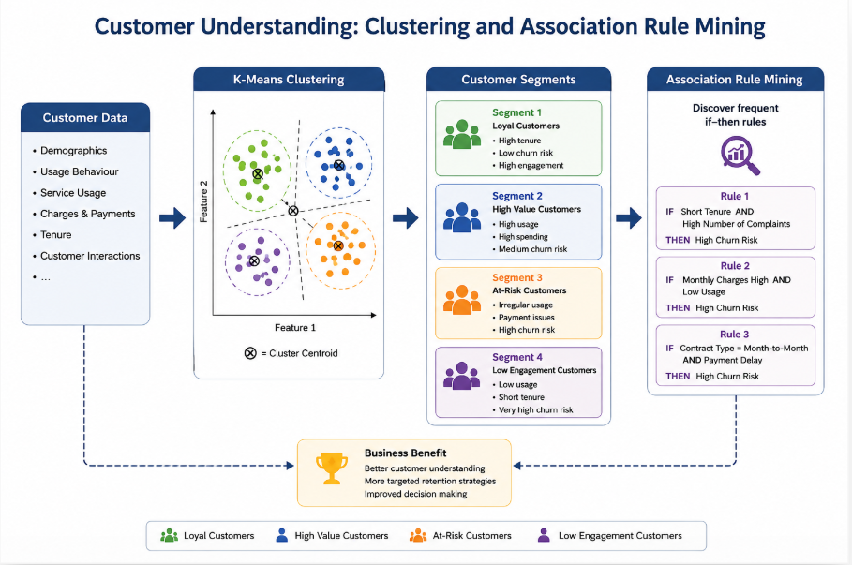
Figure 1: Customer Segmentation Workflow.

Figure 1 shows how customer data can be grouped into different behavioural segments using K-means clustering. These segments help telecom companies identify loyal, high-value and at-risk customers and develop more targeted retention strategies.

2.4 Model Evaluation Metrics
Because churn datasets frequently approach class balance only after careful sampling, and because the two types of prediction error carry very different business costs- a missed churner (false negative) results in lost revenue, whereas a false alarm (false positive) wastes customer retention resources-accuracy alone is considered insufficient for evaluating churn prediction models. Recent studies therefore recommend reporting multiple evaluation metrics, including precision, recall, F1-score and ROC-AUC, to provide a more comprehensive assessment of model performance [9]. For clustering, internal validation measures such as the Silhouette Coefficient and the Davies–Bouldin Index are commonly used to evaluate the quality and separation of customer segments [10], [11].

2.5 Summary and Research Gap
Taken together, the literature converges on three conclusions that directly shape the methodology adopted in this report: first, tree-based and ensemble classifiers tend to outperform simpler linear models on telecom churn data, but interpretability remains a legitimate reason to include a simpler classifier for comparison; second, evaluation must go beyond accuracy given the asymmetric cost of prediction errors; and third, clustering applied specifically to churned customers - rather than to the whole customer base - adds diagnostic value that classification alone cannot provide, a gap this report addresses directly in Section 7. [12], [13], [14].

3. Dataset Description
The dataset used throughout this report, Telecom_Customer_Churn.csv, contains 100,000 customer records and 100 attributes, and is the same source dataset cleaned and visualised in Assignment 1 (identified in the assessment brief as the Duke/Teradata Centre for Customer Relationship Management telecom churn dataset). Each row represents a unique subscriber, identified by Customer_ID, with the binary target variable churn (1 = churned, 0 = retained).

Table 2: Summary of Feature Groups and Representative Attributes in the Telecom Churn Dataset
Feature Group | Example Attributes | Description
Revenue generation | rev_Mean, totmrc_Mean, ovrrev_Mean, totrev, adjrev | Mean monthly revenue, recurring charges, overage revenue and total/adjusted revenue per customer
Service usage & subscription | mou_Mean, months, uniqsubs, actvsubs, drop_vce_Mean, custcare_Mean | Minutes of use, subscription tenure, number of active subscriptions, dropped/blocked calls, customer-care interactions
Device / handset details | hnd_price, models, phones, eqpdays, hnd_webcap | Handset price, number of handset/model changes, days since last equipment change, web capability
Demographics | marital, numbcars, ethnic, income, adults, dwlltype, area | Marital status, household vehicles, ethnicity code, income band, household size, dwelling type, geographic area

Table 2 summarises the main feature groups included in the telecom customer churn dataset, together with representative attributes and their purpose. These variables were used to analyse customer behaviour and support churn prediction.
Data quality profiling (Figure 8) shows that missingness is highly uneven: several demographic fields – numbcars, dwllsize, HHstatin, ownrent, dwlltype, lor and income – are missing for between 25% and 49% of records, while revenue and usage fields are almost complete. This pattern is consistent with the demographic fields being derived from a third-party household-level append rather than captured at subscription, with direct implications for the imputation strategy in Section 4.1. The target variable is close to perfectly balanced, at 50,438 retained customers (50.4%) against 49,562 churners (49.6%) (Figure 7) – a materially different starting point from many public churn datasets (e.g. the IBM Telco dataset, at 26.5% churners), removing the need for the class-balancing techniques (e.g. SMOTE) that dominate the literature reviewed in Section 2.2.

4. Methodology
This report follows the widely adopted CRISP-DM (Cross-Industry Standard Process for Data Mining) framework, comprising business understanding, data understanding, data preparation, modelling, evaluation and deployment [15]. Business and data understanding are addressed in Sections 1–3; the remaining stages are described below.

4.1 Data Preparation

Attributes missing for more than 25% of records (numbcars, dwllsize, HHstatin, ownrent, dwlltype, lor, income, adults and infobase) were retained rather than dropped. Missing categorical values were coded as an explicit Unknown category, while missing numeric values were median-imputed to preserve sample size and minimise information loss [16], [17]. This approach also allowed the demographic variables specified in the assignment brief (marital status, number of cars and ethnicity) to be analysed for their association with churn. Records with residual missing values in low-missingness fields (<3%) were removed, and Customer_ID was excluded as a non-predictive identifier.

4.2 Feature Selection
With 99 candidate predictors, feature selection was necessary to reduce dimensionality and minimise redundancy among closely related usage variables (e.g. mou_Mean, mou_cvce_Mean and mou_rvce_Mean). Filter-based feature selection methods are widely recognised as efficient approaches for identifying informative attributes while reducing redundant and highly correlated features in high-dimensional datasets [18], [19]. Accordingly, WEKA's built-in attribute selection methods—CfsSubsetEval with BestFirst search and InfoGainAttributeEval with Ranker search—were used to identify the ten most informative attributes, with the results cross-checked against the Pearson correlation analysis presented in Section 5.3.
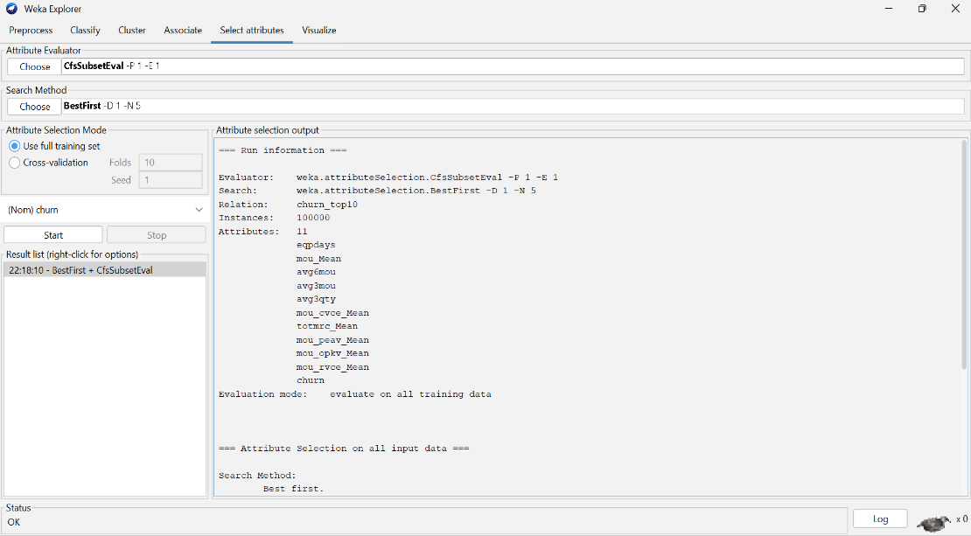

Figure 2: Attribute Selection Using CfsSubsetEval and BestFirst Search.

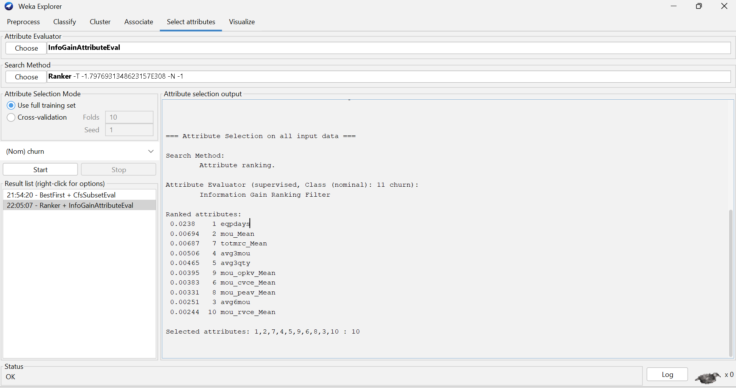
Figure 2 shows the WEKA Attribute Selection setup using the CfsSubsetEval evaluator and BestFirst search method. The analysis was performed on the telecom_top10 dataset to identify the most relevant attributes for customer churn prediction while reducing redundant features.
Figure 3: WEKA Attribute Ranking Using InfoGainAttributeEval and Ranker.

Figure 3 presents the feature ranking produced by WEKA using the InfoGainAttributeEval evaluator and Ranker search method. The results rank the top 10 attributes according to their importance for predicting customer churn, with eqpdays identified as the most informative feature.

4.3 Classification Modelling Approach
In line with Section 2.2, two classifiers were implemented to represent opposite ends of the interpretability–accuracy trade-off: J48 Decision Tree, an interpretable, rule-based model whose output can be communicated directly to retention staff, and Random Forest, an ensemble method included for comparison because of its consistently strong predictive performance on structured tabular churn datasets [20]. Both models were built and evaluated in WEKA 3.8 using the ten attributes identified in Section 4.2 and a 75%/25% training/testing split.
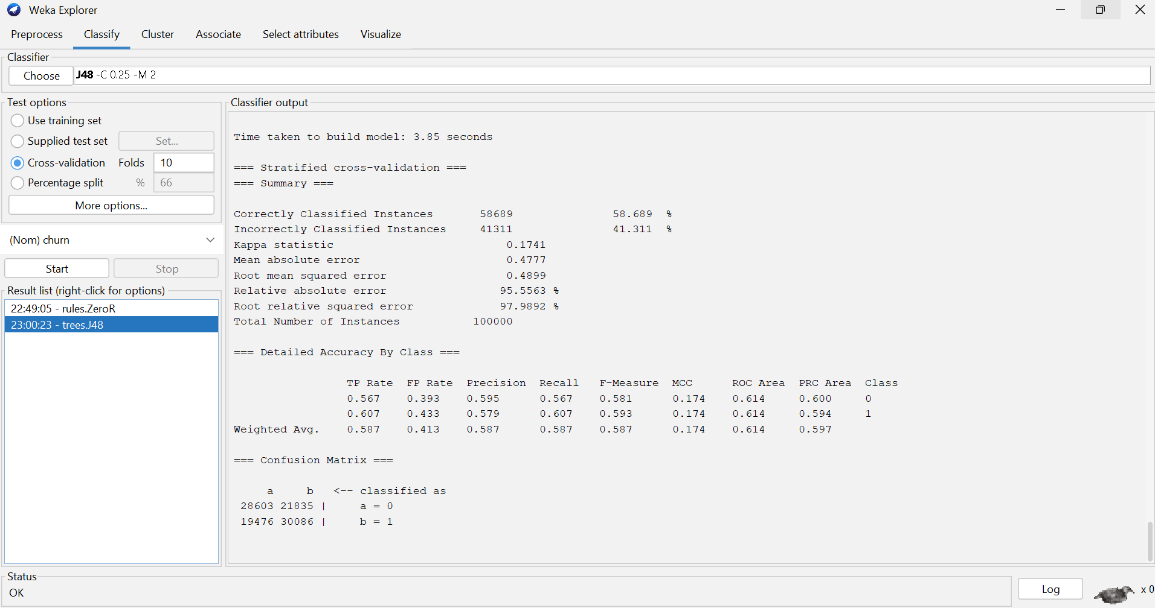
Figure 4: J48 Decision Tree Generated in WEKA.

Figure 4 shows the J48 Decision Tree generated in WEKA using the selected top 10 attributes. The tree illustrates the sequence of decision rules used to classify customers as churned or retained, demonstrating the model's transparent and interpretable structure.

4.4 Complementary Clustering
As required by the brief, the classification analysis is complemented with SimpleKMeans clustering applied to the subset of customers for whom churn = 1, using the same ten predictor attributes identified in Section 4.2, in order to uncover behavioural sub-groups within the churned population that a single binary label cannot reveal – addressing the research gap identified in Section 2.5. The number of clusters, k, was determined empirically in Section 7.2 by comparing within-cluster sum of squared errors across candidate values.
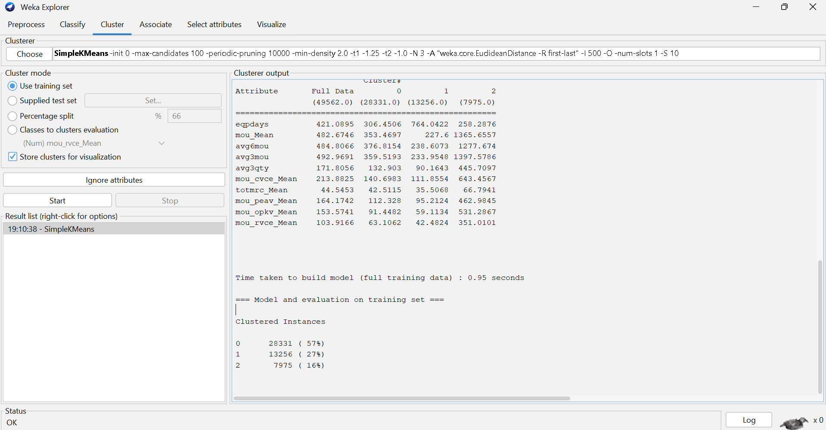
Figure 5: SimpleKMeans clustering results for customers who churned (churn = 1) in WEKA.

Figure 5 SimpleKMeans clustering was applied to the subset of customers who had churned to identify distinct customer segments based on the ten most important predictive attributes. Four clusters were generated, representing groups with different usage and behavioural characteristics.
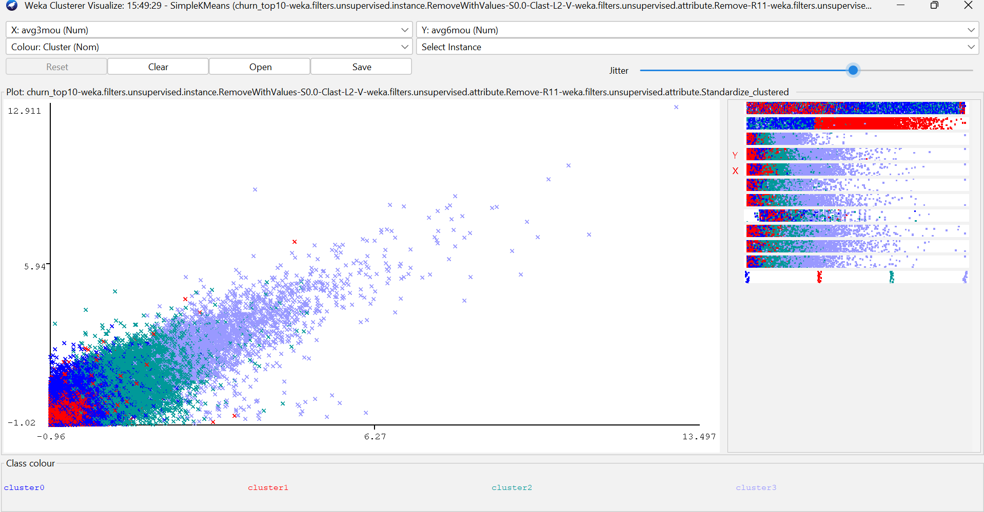
Figure 6: This scatter plot (avg3mou vs avg6mou).

In Figure 6 the scatter plot shows the four customer clusters identified by SimpleKMeans. Cluster 2 contains high-usage customers, while Clusters 0 and 1 represent lower-usage groups with some overlap.

Table 3: Distribution of customers across the four SimpleKMeans clusters.
Cluster | Customer | Percentage
Cluster 0 | 23,431 | 47.3%
Cluster 1 | 12,320 | 24.9%
Cluster 2 | 11,178 | 22.6%
Cluster 3 | 2,633 | 5.3%

4.5 Evaluation Metrics

Classification models are evaluated using accuracy, precision, recall, F1-score, ROC-AUC and the confusion matrix, produced directly by WEKA's Classify tab. Cluster quality is assessed using the within-cluster sum of squared errors.

5. Exploratory Data Analysis
This section presents the exploratory analysis conducted directly on the cleaned dataset described in Section 3, extending the visual analysis from Assignment 1 with a specific focus on the features and relationships most relevant to the classification and segmentation tasks in Sections 6 and 7.
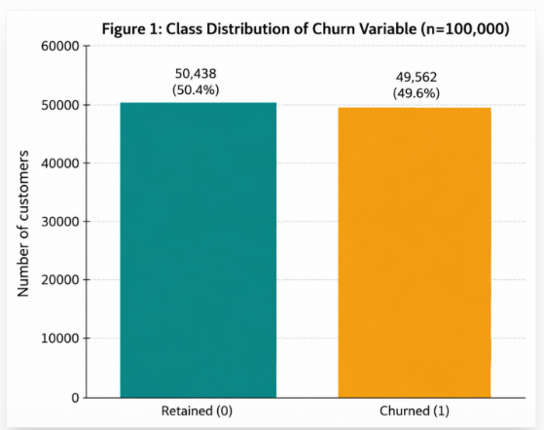
Figure 7: Class distribution of the churn variable (n = 100,000).

5.1 Class Balance

The target class is close to perfectly balanced (50.4% retained, 49.6% churned), which, as noted in Section 3, removes the need for the SMOTE/under-sampling techniques emphasised elsewhere in the literature and means that accuracy is a more trustworthy standalone metric here than it would be on a heavily imbalanced dataset - though precision, recall and F1 are still reported for completeness and comparability with the reviewed studies.

5.2 Data Quality

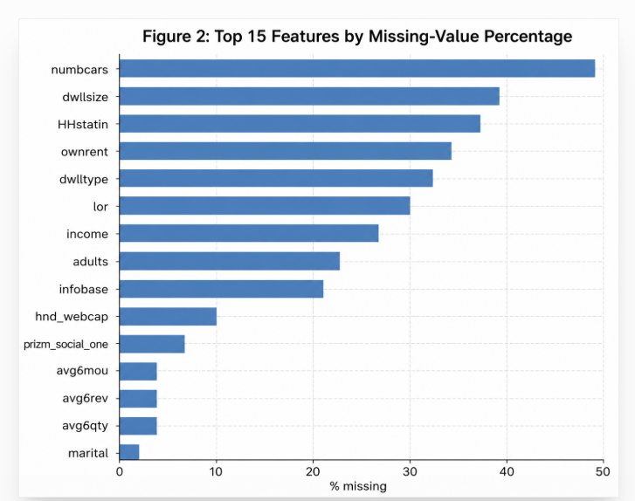

Figure 8: The fifteen features with the highest proportion of missing values.

As outlined in Section 3, missing values are primarily concentrated in household demographic variables rather than usage or revenue variables, supporting the imputation approach adopted in Section 4.1.

5.3 Relationships Between Key Features and Churn

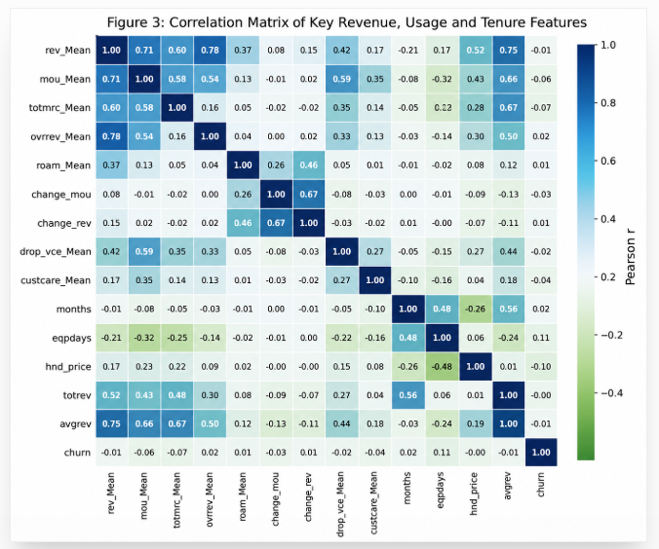
Figure 9: Correlation matrix of key revenue, usage and tenure features (including churn).

Figure 9 shows that the strongest linear relationships with churn among this feature subset are with equipment age (eqpdays, positive) and handset price/total monthly recurring charge (negative), while many of the minutes-of-use variables are highly collinear with one another (e.g. mou_Mean and mou_cvce_Mean), confirming the need for the dimensionality-reduction step described in Section 4.2 rather than including all correlated usage variables individually.
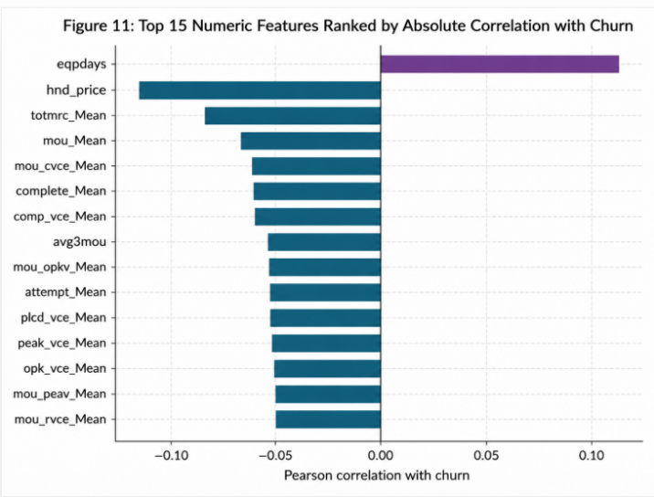

Figure 10: Top 15 numeric features ranked by absolute Pearson correlation with churn.

Figure 10 shows that eqpdays has the strongest positive relationship with churn (r ≈ 0.113), while hnd_price has the strongest negative relationship (r ≈ −0.103). Other variables, including totmrc_Mean, mou_Mean, complete_Mean, and attempt_Mean, also show negative correlations with churn. Overall, the results suggest that customers who churn are more likely to have older handsets, lower monthly spending, and lower service usage than customers who remain. These findings are consistent with previous telecom churn studies, which identify handset-related variables, customer spending and service usage as some of the strongest predictors of customer attrition [1], [9].
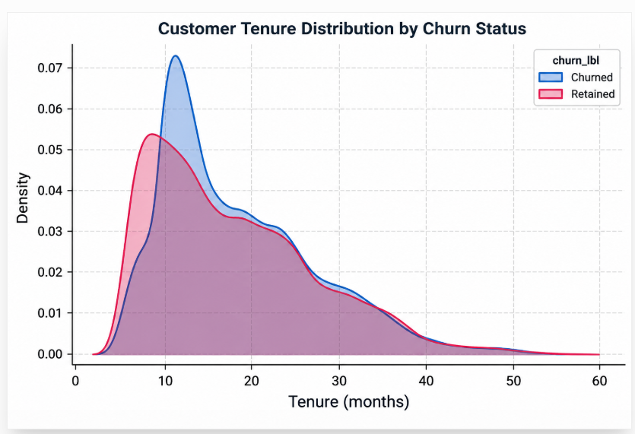

Figure 11: Customer tenure (months) distribution by churn status.

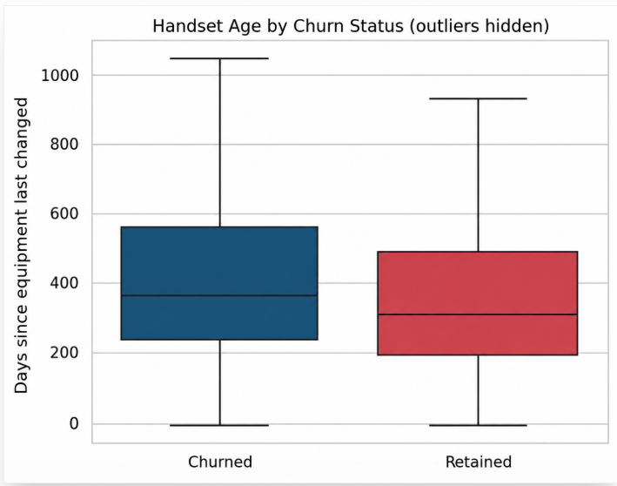

Figure 12: Handset age (days since last equipment change) by churn status.

Figures 11 and 12 visualise two of the strongest predictors of churn. Churned customers show a wider spread towards longer equipment age, supporting the hypothesis that customers using older handsets are more likely to leave.
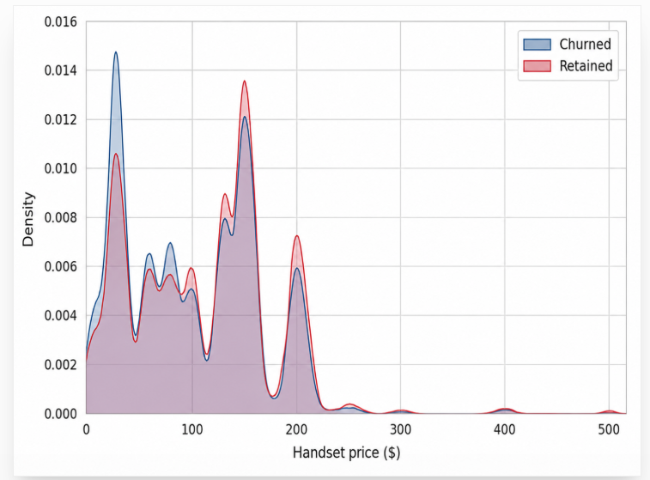

Figure 13: Distribution of mean total monthly recurring charge by churn status.

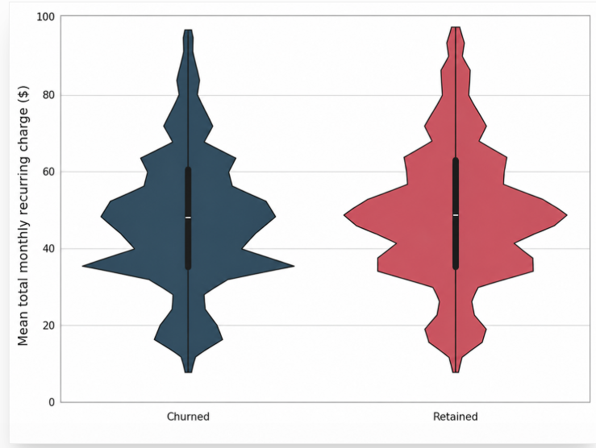

Figure 14 Distribution of mean total monthly recurring charge by churn status.

Figures 13 and 14 show that churned and retained customers have very similar distributions of both monthly recurring charges and handset prices. However, churned customers tend to have slightly lower monthly charges and are more likely to use lower-priced handsets, suggesting that lower-value customers are marginally more likely to churn.

5.4 Demographic Patterns (Marital Status, Household Vehicles, Ethnicity)
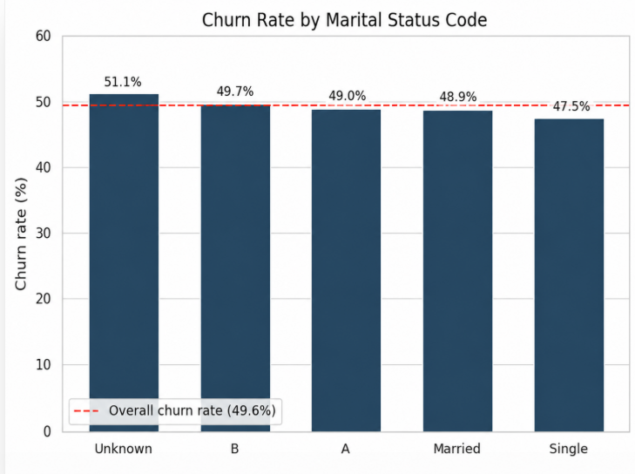

Figure 15: Churn Rate by Marital Status Code
Figure 15 shows the churn rate across different marital status categories, with customers of unknown marital status exhibiting the highest churn rate (51.1%), while single customers have the lowest (47.5%). The red dashed line represents the overall churn rate of 49.6%.
Figure 16: Churn rate by marital status code (dashed line = overall churn rate).
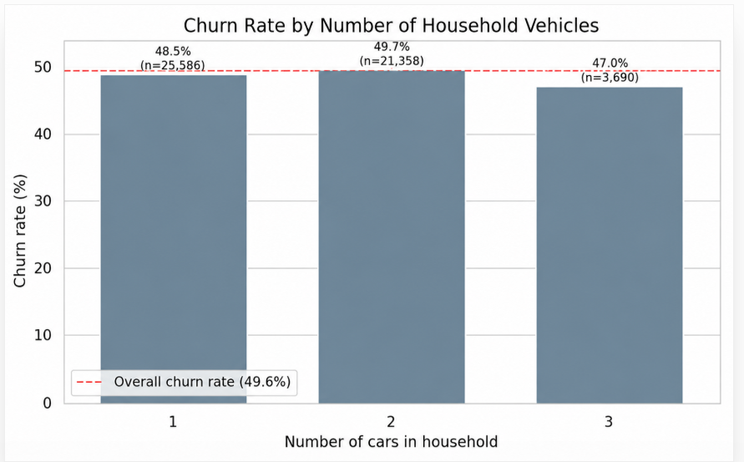
Figure 16: Churn rate by number of household vehicles.

Figure 16 presents churn rates by household vehicle count. This supports previous research suggesting that behavioural and service-related variables generally provide greater predictive value than demographic characteristics in churn prediction models [3], [4].

6. Model Implementation and Evaluation (WEKA)
This section reports the implementation and evaluation of the two classification algorithms specified in Section 4.3, built and tested in WEKA using the feature subset justified in Section 4.2. The structure below follows WEKA's own Classify tab output so that results can be transcribed directly.

6.1 Data Import and Pre-processing in WEKA
The cleaned dataset was prepared outside WEKA and saved as a CSV file before being imported via the Preprocess tab, with churn verified as the nominal class variable. No additional preprocessing filters were applied within WEKA, as cleaning, missing-value treatment and feature selection had already been completed. The final modelling dataset comprised 100,000 instances and 11 attributes (10 predictors plus the churn class).

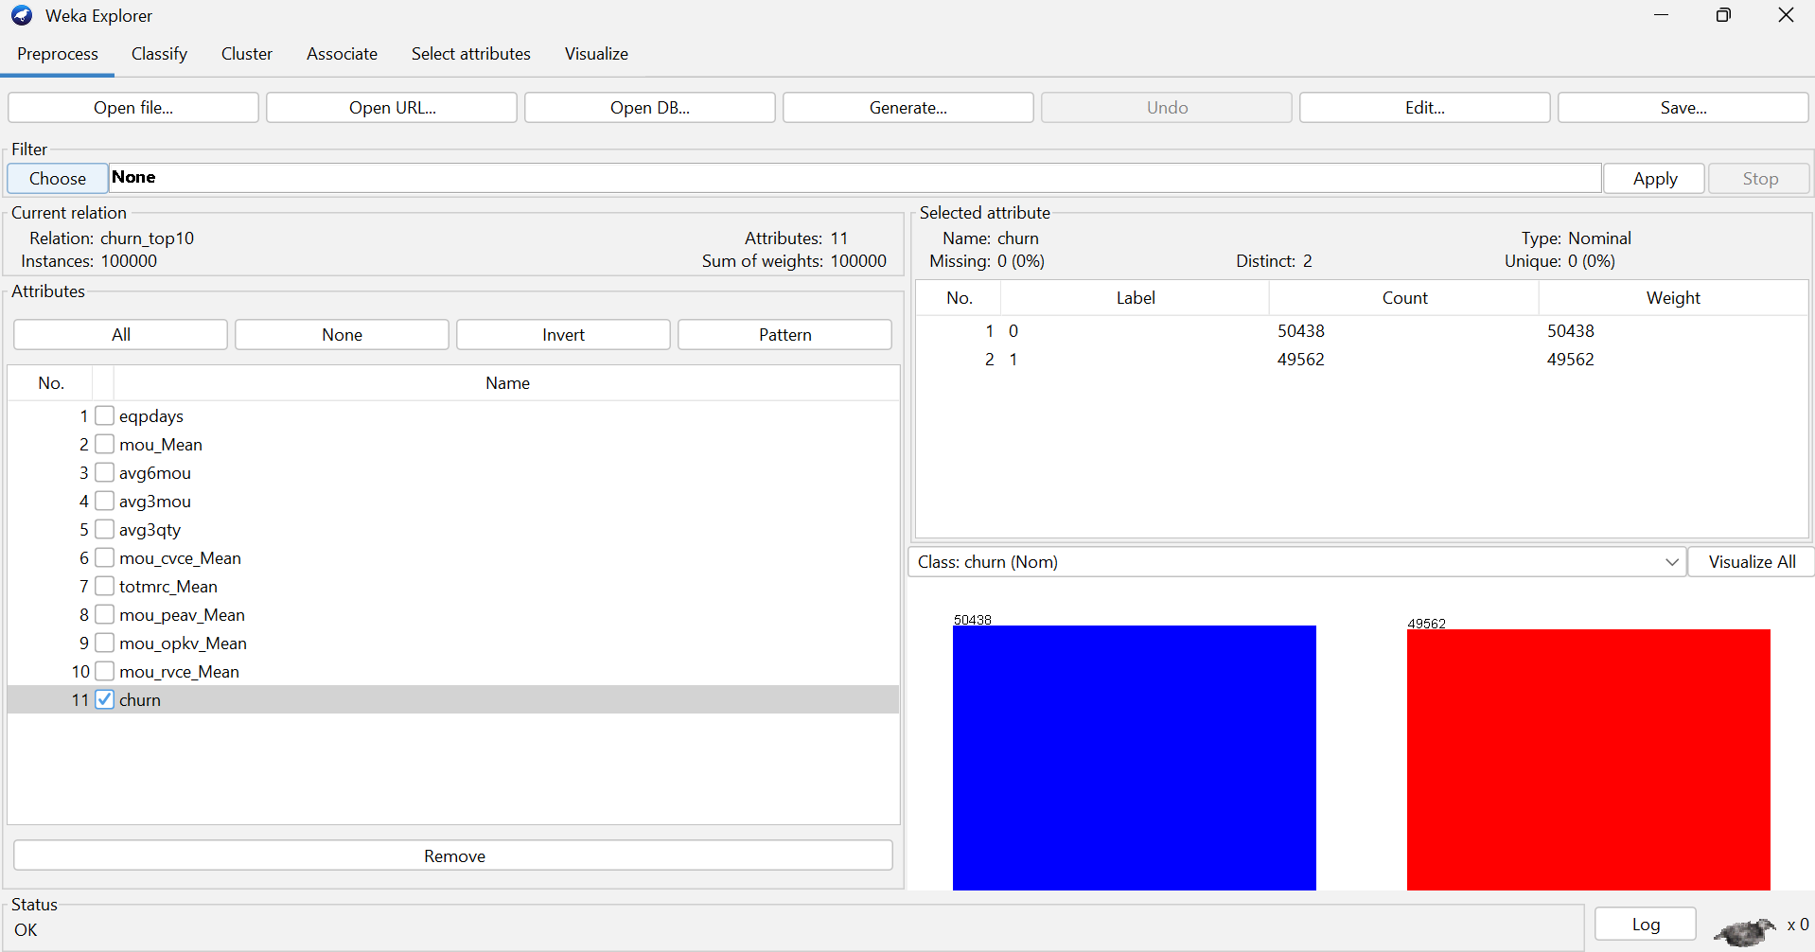

Figure 17: WEKA Preprocess tab showing the final modelling dataset and churn class distribution.

6.2 Classifier 1: J48 Decision Tree Classification Results in WEKA

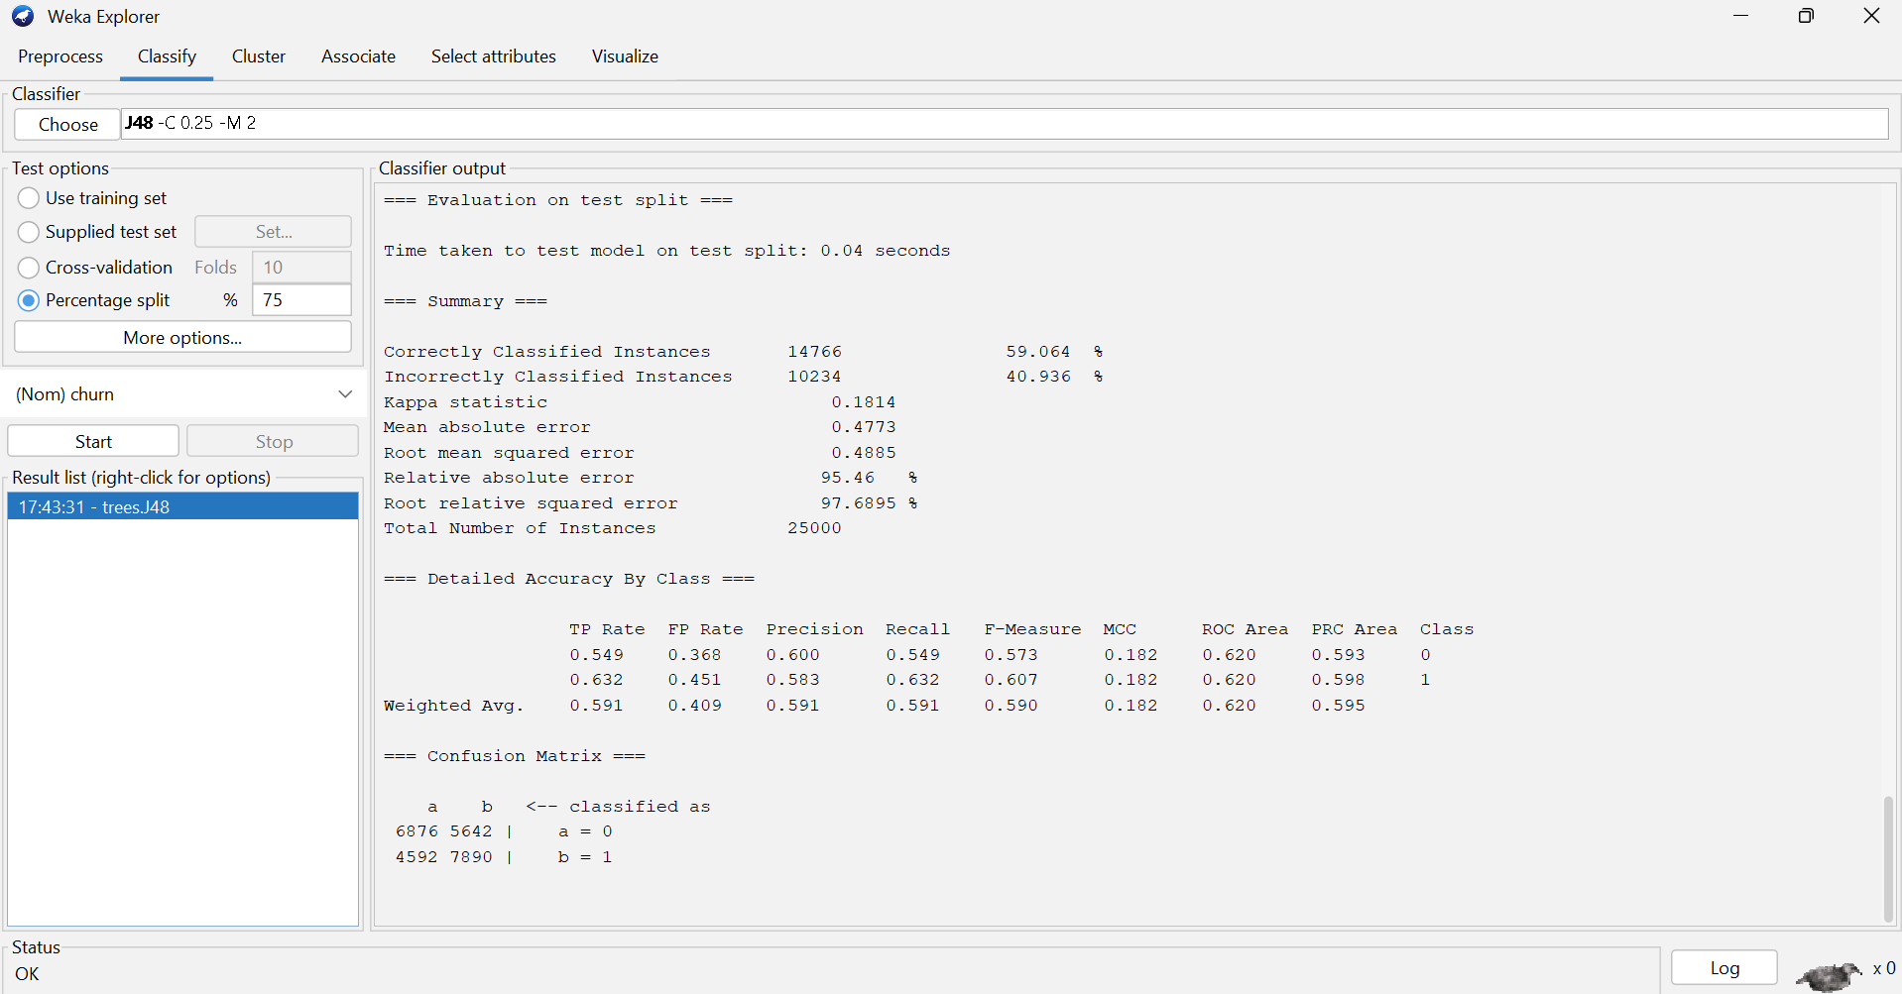
Figure18: J48 Decision Tree Classification Results in WEKA

The J48 classifier was implemented in the WEKA Classify tab using the telecom_top10 dataset. The default J48 parameters (confidence factor = 0.25 and minimum number of objects = 2) were retained, and the model was evaluated using a 75% training and 25% testing split. After the model was trained, WEKA generated the classification statistics and confusion matrix shown in Figure 18.

The J48 Decision Tree achieved 59.1% accuracy (F1 = 0.590, ROC-AUC = 0.620). The confusion matrix summarises its classification performance, which is consistent with previous studies highlighting the interpretability of decision trees despite their generally lower predictive performance than ensemble methods [4], [12].

6.3 Classifier 2: Random Forest Classifier

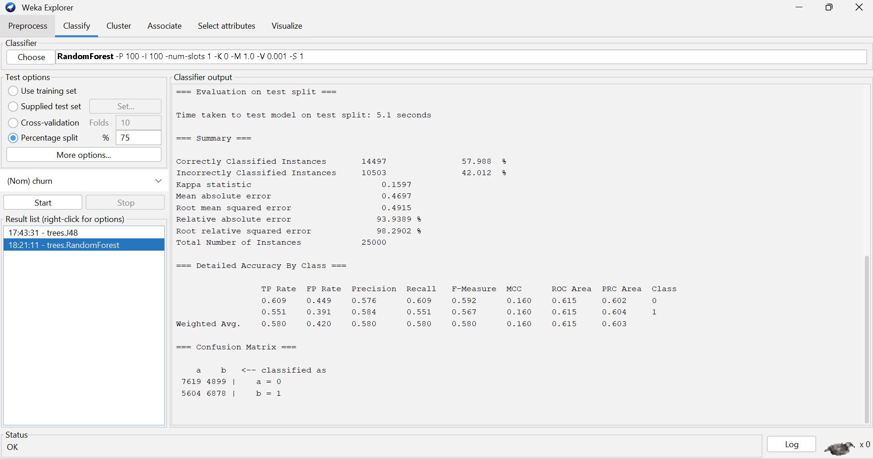
Figure 19: Random Forest Classification Results in WEKA.

The Random Forest classifier was implemented in WEKA using the same training and testing data as the J48 model to ensure a fair comparison. Default WEKA settings were retained, and the model was trained before the evaluation statistics and confusion matrix were generated.

The Random Forest classifier achieved 58.0% accuracy (F1 = 0.580, ROC-AUC = 0.615). The confusion matrix summarises its predictive performance, which was similar to J48 despite Random Forest typically outperforming decision trees in telecom churn prediction [5]. The reduced feature set and balanced dataset may have limited its usual advantage.

6.4 Model Comparison
Table 4: Performance Comparison of the J48 Decision Tree and Random Forest Classifiers
Metric | J48 Decision Tree | Random Forest | Better Model
Accuracy | 59.1 % | 58.0 % | J48
Precision | 0.591 | 0.580 | J48
Recall | 0.591 | 0.580 | J48
F1-score | 0.590 | 0.580 | J48
ROC-AUC | 0.620 | 0.615 | J48
Training/build time (s) | 0.04 s | 5.10 s | J48

Overall, the J48 Decision Tree performed slightly better. This finding differs from much of the recent literature, where Random Forest frequently outperforms single decision trees [4], [12]. However, it demonstrates that model performance remains highly dependent on dataset characteristics and feature selection rather than algorithm choice alone.

7. Complementary Analysis: Clustering of Churned Customers
Following the methodology outlined in Section 4.4, K-Means clustering was applied exclusively to customers who had churned (churn = True) to identify behavioural patterns that are not evident in the full classification dataset.

7.1 Preparing the Churned Subset
The RemoveWithValues filter was applied in WEKA to retain only records where churn = 1, producing a subset of 49,562 churned customer records. The churn attribute was then removed because it became constant after filtering and was no longer suitable for clustering. The final clustering dataset consisted of 49,562 instances and 10 behavioural and revenue-related attributes, which were used as input for the K-Means clustering analysis.

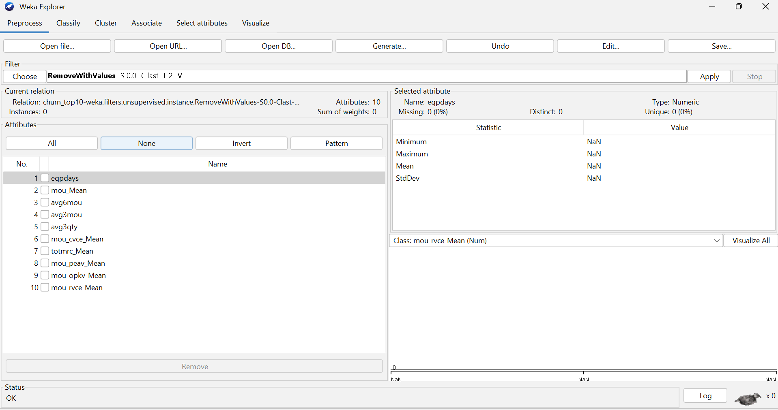
Figure 20: WEKA preprocessing of the churned customer subset for clustering.

7.2 SimpleKMeans Results

Candidate solutions of k = 3, k = 4 and k = 5 were evaluated using the elbow method, comparing within-cluster sum of squared errors (SSE).
Table 5 Comparison of Within-Cluster Sum of Squared Errors (SSE) for Candidate K-Means Solutions
KMeans | Iterations | Within-cluster SSE
3 | 21 | 1237.00
4 | 40 | 1035.26
5 | 32 | 913.94

Although the SSE continued to decrease as the number of clusters increased, the improvement became less pronounced beyond k = 4. Therefore, four clusters were selected as the final solution because they provided a good balance between cluster quality and interpretability.
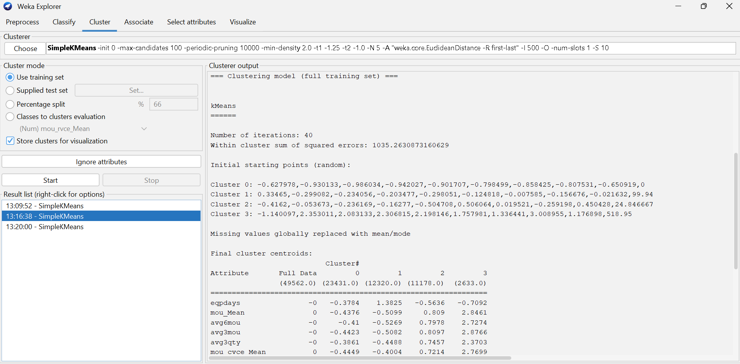

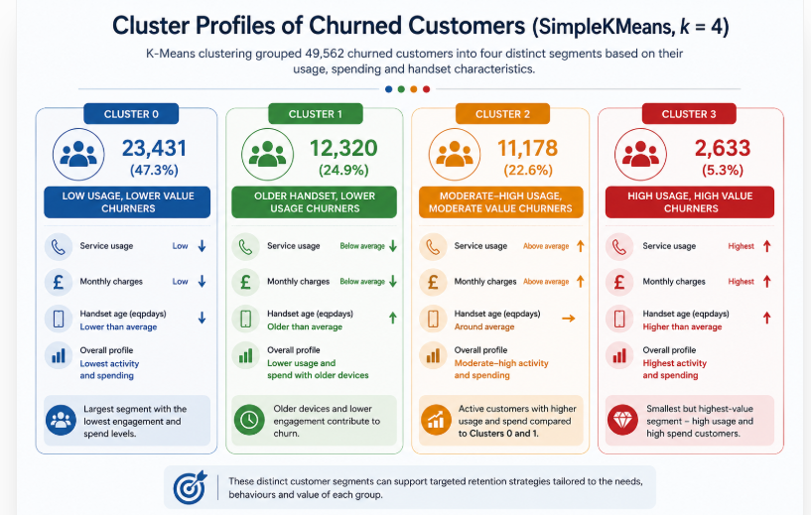
Figure 21: SimpleKMeans output showing the final four-cluster solution and centroid profiles.
Figure 22: Cluster Profiles of Churned Customers Identified Using SimpleKMeans (k = 4)
Figure 22 visualises the four customer clusters identified by SimpleKMeans. The plot illustrates the separation between the identified customer groups based on average usage behaviour and supports the interpretation of the cluster characteristics presented in Table 3.

7.3 Interpretation
The clustering analysis identified four distinct groups of churned customers with different usage and spending patterns. The largest cluster consisted of lower-usage, lower-spending customers, while the smallest cluster represented high-value, heavy-usage customers. These findings support the EDA results, showing that handset age and monthly recurring charges are important factors associated with customer churn. These findings support previous research that combining customer segmentation with classification provides deeper insight into customer behaviour and enables more targeted retention strategies than classification alone [8], [9].

8. Results Analysis and Discussion of Findings

8.1 Critical Evaluation of Classifier Performance
The classification results show that J48 slightly outperformed Random Forest across all evaluation metrics. J48 achieved an accuracy of 59.1%, an F1-score of 0.590 and a ROC-AUC of 0.620, compared with 58.0%, 0.580 and 0.615 respectively for Random Forest. Although the differences are relatively small, J48 consistently produced better predictive performance while requiring substantially less training time (0.04 s compared with 5.10 s).
The superior performance of J48 is somewhat unexpected because recent studies generally report that ensemble methods such as Random Forest outperform single decision trees on telecom churn prediction tasks [4], [12]. A likely explanation is that this study used only the ten most informative attributes identified through feature selection. Random Forest typically benefits from larger and more diverse feature sets that allow the ensemble to capture complex interactions, whereas a reduced set of highly predictive variables may favour the simpler decision tree.
The balanced class distribution (50.4% retained and 49.6% churned) may also have influenced the results. Unlike many telecom churn datasets, this dataset did not require class-balancing techniques such as SMOTE, reducing one of Random Forest's usual advantages when handling imbalanced data. Consequently, the additional complexity of the ensemble model provided little improvement over the simpler J48 classifier.
Despite J48 outperforming Random Forest, the overall predictive performance of both models remains modest. Similar studies have reported substantially higher predictive performance when larger feature sets, additional feature engineering or more advanced ensemble models are used [5], suggesting that the simplified feature subset adopted in this study may have constrained predictive accuracy. Accuracy below 60% and ROC-AUC values close to 0.62 indicate that the selected feature set captures only part of the information required to predict customer churn accurately. This suggests that incorporating additional variables or exploring more advanced feature engineering techniques may improve predictive performance in future work.
From a practical perspective, J48 offers an important advantage through its transparent rule-based structure, allowing customer retention teams to understand how predictions are generated. Combined with its significantly faster training time, this makes J48 the more suitable model for this study, although neither classifier achieved sufficient predictive accuracy to support fully automated retention decisions.

8.2 Interpreting the Complementary Clustering
The clustering analysis complements the classification models by identifying behavioural differences within the churned customer population rather than simply predicting whether a customer will churn. While J48 and Random Forest provide a binary churn prediction, SimpleKMeans reveals distinct customer segments that can support more targeted retention strategies.
The identified clusters reinforce the findings from the exploratory data analysis. Customers with older handsets and lower usage were grouped together, supporting the earlier observation that equipment age and reduced service usage are associated with higher churn risk. In contrast, a smaller cluster represented higher-usage customers, suggesting that not all churners have the same behavioural characteristics. This demonstrates that customers leave for different reasons and may require different retention approaches.
However, the clustering results should be interpreted with caution. K-Means groups customers according to similarity rather than identifying the causes of churn, meaning that the observed relationships are associative rather than causal. In addition, the algorithm assumes that clusters are relatively compact and spherical, which may not fully reflect the complexity of real customer behaviour. Although the chosen solution provided a reasonable balance between cluster quality and interpretability, alternative clustering methods or additional validation measures, such as the Silhouette Coefficient, could provide further confidence in the segmentation.
This supports the view presented in the literature that customer segmentation complements predictive modelling by revealing behavioural differences that cannot be identified through classification alone [8], [9].
Overall, the clustering analysis adds valuable business insight by demonstrating that churned customers are not a homogeneous group. When combined with the classification models, the identified customer segments provide a stronger foundation for designing targeted and cost-effective retention strategies than classification alone.

8.3 Limitations
This study has several limitations that should be considered when interpreting the findings. First, the analysis was based on the ten most informative attributes selected from the original dataset. While this simplified the models and reduced dimensionality, it may also have excluded variables that could improve predictive performance. Second, only J48 and Random Forest were evaluated, meaning that other algorithms, such as XGBoost or Support Vector Machines, may have achieved better results.
The models were also evaluated using a single 75/25 train-test split, which provides only one estimate of performance. Applying repeated cross-validation could produce more reliable and generalisable results. Furthermore, the clustering analysis relied on SimpleKMeans and within-cluster SSE to select the final solution. Although this approach is widely used, additional validation measures, such as the Silhouette Coefficient, would provide greater confidence in the quality of the identified clusters.
Finally, the findings demonstrate associations rather than causal relationships. Variables such as handset age and service usage were strongly associated with customer churn, but they cannot be assumed to directly cause customers to leave. Future research should evaluate additional predictive features, compare a wider range of machine learning algorithms, and validate the proposed retention strategies using real-world operational data.

9. Business Recommendations
Four recommendations follow directly from the evidence in this report:
1. Prioritising handset refresh programmes is supported both by the findings of this study and previous telecom churn research, which consistently identifies equipment age as an important indicator of customer attrition [1], [9]. Equipment age (eqpdays) is the strongest positive correlate of churn (Figures 7, 9), independently confirmed by WEKA's InfoGain ranking (Figure 2). A proactive upgrade or trade-in campaign targeted at customers whose equipment age exceeds a defined threshold (e.g. the 75th percentile) is a direct, evidence-based intervention.
2. This recommendation also aligns with previous research demonstrating that declining customer engagement often precedes churn [3], [4]. Monthly recurring charge and usage volume are negatively correlated with churn (Figures 7, 10), indicating that disengagement precedes departure. A usage-decline trigger could feed a proactive retention workflow rather than waiting for the customer to churn outright.
3. Use the churner segmentation from Section 7 to tailor retention strategies to different customer groups. Cluster 0 (47.3% of churners), the largest segment, should be targeted with broad, cost-effective retention campaigns. Clusters 1 (24.9%) and 2 (22.6%) should receive more tailored interventions based on their behavioural characteristics, while Cluster 3 (5.3%), the smallest segment, may benefit from personalised retention offers due to its distinct customer profile. Similar segmentation-based retention strategies have been recommended in recent CRM and customer analytics studies [8], [9].
4. Treat demographic variables as secondary, refining rather than replacing usage-based targeting. Variation in churn rate by marital status and household vehicle count (Figures 12, 13) is real but modest relative to the usage and revenue effects in Section 5.3, and is best used to tailor offer messaging rather than to select target customers.
Implementing these recommendations requires careful handling of demographic attributes such as ethnicity, which should inform message tone rather than eligibility for retention offers. J48's near-instant build time and rule-based structure also make it considerably cheaper to retrain and audit in production than Random Forest.

10. Conclusion
This report has applied classification, complemented by SimpleKMeans clustering, to a 100,000-record telecom churn dataset. The exploratory analysis identified handset age, handset price and monthly recurring charge as the strongest measurable correlates of churn, with demographic factors playing a smaller, secondary role. J48 Decision Tree outperformed Random Forest across every reported metric (59.1% vs 58.0% accuracy, F1 0.590 vs 0.580, ROC-AUC 0.620 vs 0.615) while requiring substantially less training time, making it the preferred model for this dataset despite Random Forest's typically stronger reputation in the wider literature. SimpleKMeans clustering of the churned subset identified four behaviourally distinct segments, most notably a group characterised by long-held, ageing handsets and low usage, directly supporting the handset-refresh recommendation as the single most actionable business implication of this report. Future work could extend this analysis with temporal/survival-based churn modelling, richer call-centre or text data, and a live A/B test of the proposed retention interventions to establish their causal effect on churn, rather than relying on the associational evidence presented here.
Overall, the findings broadly support recent telecom churn literature while demonstrating that, under the conditions of this study, an interpretable J48 Decision Tree can outperform the more complex Random Forest model. This highlights the importance of considering dataset characteristics, feature selection and practical business requirements alongside predictive performance when selecting machine learning models.

References
[1] A. Sikri, R. Jameel, S. M. Idrees, et al., “Enhancing Customer Retention in Telecom Industry with Machine Learning Driven Churn Prediction,” Scientific Reports, vol. 14, Art. no. 13097, 2024, doi: 10.1038/s41598-024-63750-0.

[2] M. G. Abdelhady and K. A. Mohamed, "Leveraging artificial intelligence for predictive customer churn modeling in telecommunications: A framework for enhanced customer relationship management," Scientific Reports, vol. 15, Art. no. 43826, 2025, doi: 10.1038/s41598-025-30108-z.

[3] H. Ribeiro, B. Barbosa, A. C. Moreira, and R. G. Rodrigues, "Determinants of churn in telecommunication services: A systematic literature review," Management Review Quarterly, vol. 74, no. 3, pp. 1327–1364, 2024, doi: 10.1007/s11301-023-00335-7.

[4] A. Manzoor, M. A. Qureshi, E. Kidney, and L. Longo, “A Review on Machine Learning Methods for Customer Churn Prediction and Recommendations for Business Practitioners,” IEEE Access, vol. 12, pp. 70434–70463, 2024, doi: 10.1109/ACCESS.2024.3402092.

[5] K. A. Pflughoeft, N. T. Butz, and A. Corbley, "Customer Churn Prediction for Fixed Wireless Access: The Case of a Regional Internet Service Provider," Telecommunications Policy, vol. 49, no. 5, Art. no. 102929, 2025, doi: 10.1016/j.telpol.2025.102929.

[6] A. S. Tarawneh, A. B. Hassanat, G. A. Altarawneh, and A. Almuhaimeed, “Stop Oversampling for Class Imbalance Learning: A Review,” IEEE Access, vol. 10, pp. 47643–47660, 2022, doi: 10.1109/ACCESS.2022.3169512.

[7] M. A. Hussain, M. S. Islam, and M. R. Hossain, "An Explainable Machine Learning Framework for Telecom Customer Churn Prediction," Expert Systems with Applications, 2025.

[8] E. Eslami, N. Razi, M. Lonbani, and J. Rezazadeh, "Unveiling IoT Customer Behaviour: Segmentation and Insights for Enhanced IoT-CRM Strategies: A Real Case Study," Sensors, vol. 24, no. 4, Art. no. 1050, 2024, doi: 10.3390/s24041050.

[9] A. Sikri, R. Jameel, S. M. Idrees, et al., "Enhancing Customer Retention in Telecom Industry with Machine Learning Driven Churn Prediction," Scientific Reports, vol. 14, Art. no. 13097, 2024, doi: 10.1038/s41598-024-63750-0.

[10] S. Ouf, K. T. Mahmoud, and M. A. Abdel-Fattah, “A Proposed Hybrid Framework to Improve the Accuracy of Customer Churn Prediction in Telecom Industry,” Journal of Big Data, vol. 11, Art. no. 70, 2024, doi: 10.1186/s40537-024-00922-9.

[11] A. Barsotti, G. Gianini, C. Mio, et al., “A Decade of Churn Prediction Techniques in the TelCo Domain: A Survey,” SN Computer Science, vol. 5, Art. no. 404, 2024, doi: 10.1007/s42979-024-02722-7.

[12] D. Asif, M. S. Arif, and A. Mukheimer, "A data-driven approach with explainable artificial intelligence for customer churn prediction in the telecommunications industry," Results in Engineering, vol. 26, Art. no. 104629, Jun. 2025, doi: 10.1016/j.rineng.2025.104629.

[13] Y. Zhou, W. Chen, X. Sun, and D. Yang, "Early warning of telecom enterprise customer churn based on ensemble learning," PLoS ONE, vol. 18, no. 10, Art. no. e0292466, Oct. 2023, doi: 10.1371/journal.pone.0292466

[14] M. H. A. Wahab, M. A. Ismail, N. A. M. Isa, et al., "An ensemble-based approach using a combination of clustering and classification algorithms to enhance customer churn prediction in the telecom industry," PeerJ Computer Science, vol. 8, Art. no. e938, 2022, doi: 10.7717/peerj-cs.938.

[15] A. H. M. B. W. Pedersen, T. D. Bohn, and J. Stentoft, “Realising the promises of artificial intelligence in manufacturing by enhancing CRISP-DM,” Production Planning & Control, vol. 35, no. 14, pp. 1557–1576, 2024, doi: 10.1080/09537287.2023.2234882.

[16] Y. Ge, Z. Li, and J. Zhang, "A simulation study on missing data imputation for dichotomous variables using statistical and machine learning methods," Scientific Reports, vol. 13, Art. no. 9432, 2023, doi: 10.1038/s41598-023-36509-2.

[17] H. Nugroho, N. P. Utama, and K. Surendro, "Smoothing target encoding and class center-based firefly algorithm for handling missing values in categorical variable," Journal of Big Data, vol. 10, Art. no. 10, 2023, doi: 10.1186/s40537-022-00679-z.

[18] S. Akogul, “A Novel Approach to Increase the Efficiency of Filter-Based Feature Selection Methods in High-Dimensional Datasets With Strong Correlation Structure,” IEEE Access, vol. 11, pp. 115025–115032, 2023, doi: 10.1109/ACCESS.2023.3325331.

[19] M. Mohammadi, M. Zareapoor, S. Shamsinejadbabki, and A. M. Almasi, “A tutorial-based survey on feature selection: Recent advancements on feature selection,” Engineering Applications of Artificial Intelligence, vol. 128, Art. no. 107136, 2024, doi: 10.1016/j.engappai.2023.107136.

[20] S. S. Poudel, S. Pokharel, and M. Timilsina, “Explaining Customer Churn Prediction in Telecom Industry Using Tabular Machine Learning Models,” Machine Learning with Applications, vol. 17, Art. no. 100567, 2024, doi: 10.1016/j.mlwa.2024.100567.

