I declare that this assignment is all my own work and that I have acknowledged all materials used from the published or unpublished works of other people. All references have been duly cited.

Future Logistic Information Systems: Should the British military adopt a new strategy to introduce the next inventory system?

JUSTIN JAMES HOGG

Word Count -15971

“It is not the strongest of the species that survive, nor the most intelligent, but the one most responsive to change”.
Charles Darwin (1809-1882) English Naturalist

ABSTRACT

Problem: As part of the MoD’s logistics services modernisation programme Future Logistics Information Services (FLIS) will replace Management of the Joint Deployed Inventory (MJDI). The MoD’s change strategy used to implement MJDI at the end 2012, focused heavily on the hard implementation of an Information System (IS) change rather than the end user. Having observed the intricacies and problems that manifested during the MJDI implementation, this case study examined whether the implementation strategy through the perceptions of the end user was fit for purpose to determine if it was an appropriate strategy to introduce the FLIS.

Methodology: The research focused on the implementation of MJDI and examined how the logistic end user community experienced the implementation to determine whether the MoDs implementation approach was an effective strategy. The research combined both quantitative and qualitative data to form a mixed methodology. This was achieved by exploring soldiers, sailors and marines’ experiences operating MJDI at two separate periods from two different groups of end users. The first set of data was recorded through a quantitative based survey conducted by the British Army Headquarters Logistic Support Branch in 2014, just over a year after the implementation; the second set of data was compiled by the author in 2018 through a series of qualitative questionnaires, which provided a varied range of end user reaction and opinion. Both forms of research encouraged end users to express their opinions and sentiments regarding the new system, how it affected unit business and their professional competence within the logistic setting. The research also studied other successful IS implementations within both the private and public sector and examined what human factors were employed and how they impacted positively on the implementation.

Findings: The data unraveled and revealed the end users’ candid assessments relating to the post MJDI implementation, in particular: unit logistic performance; end user competency; conversion training; and customer support. The evidence revealed the implementation of MJDI was effective however, the end users were not considered pre-implementation. Consequently, there was significant amount of angst and confusion in the early periods leading to the inefficient operation of MJDI, yet over the course of another four years the end users capability and knowledge increased considerably.

TABLE OF CONTENTS
ABSTRACT iii
TABLE OF CONTENTS v
LIST OF TABLES viii
LIST OF FIGURES viii
LIST OF APPENDICES viii
GLOSSARY OF TERMS ix
1. INTRODUCTION 1
1.1 Background 1
1.2 Purpose 2
1.3 Location and scope of the research 2
1.4 The aims and objectives 2
1.5 Structure of the study 3
2. LITERATURE REVIEW 5
2.1 Introduction 5
2.2 The structure of the literature review 5
2.3 Information System Implementation 6
2.3.1 Direct 7
2.3.2 Parallel 8
2.3.3 Pilot 8
2.3.4 Phased 8
2.3.5 Problems 8
2.3.6 Success factors 9
2.4 Project Management 11
2.4.1 Agile methodologies 12
2.4.1.1 Crashing 12
2.4.2. Sequential methodologies 12
2.4.2.1 Waterfall 12
2.4.3 Process based methodologies 13
2.4.3.1 Lean 13
2.4.4 Project Management Institute methodology 14
2.4.4.1 PMBOK 14
2.4.5 Change management methodology 15
2.4.5.1 XPM 15
2.4.6 Other methodologies 15
2.4.6.1 PRINCE2 15
2.5 Change Management 16
2.5.1 Kotter 8-Step process change plan 17
2.5.2 Lewin 3-Step change model 18
2.5.3 McKinsey 7S model 19
2.5.4 Problems 20
2.5.5 Success factors 21
2.5.5.1 Planning 21
2.5.5.2 Establishing a vision 21
2.5.5.3 Communication 22
2.5.5.4 Employee engagement 22
2.5.5.5 Information System Success Model 22
3. RESEARCH AND METHODOLOGY 24
3.1 Introduction 24
3.2 Research approach 24
3.3 Data collection 25
3.4 Quantitative research 25
3.5 Qualitative research 26
3.6 Triangulation 26
3.7 Primary data 27
3.8 Secondary data 28
3.9 Data analysis 29
3.10 Ethics 29
3.11 Limitations 29
4. FINDINGS AND ANALYSIS 31
4.1 Introduction 31
4.2 Research objective 1 31
4.2.1 Unit logistic performance 32
4.2.2 End-user competency 34
4.2.3 Conversion training 36
4.2.4 Customer support 38
4.3 Research objective 2 40
4.3.1 System functionality 40
4.3.2 End user know-how 41
4.3.3 Training 42
4.3.4 System literature and guides 43
4.4 Research objective 3 44
4.4.1 Case Study 1 Lufthansa 44
4.4.2 Case Study 2 LG 46
4.4.3 Case Study 3 HRMC 48
5. CONCLUSION 53
5.1 Introduction 53
5.2 Research objective 1 53
5.3 Research objective 2 54
5.4 Research objective 3 55
5.5 Concluding Summary 56
6. RECOMMENDATIONS 59
6.1 End user involvement 59
6.2 Training 59
6.3 Help tools 59
6.4 Further research 59
7. REFERENCES 61
8. BIBLIOGRAPHY 72
9. APPENDICES 74

List of Tables
Table 1 Training effectiveness by functional area 36

List of Figures
Figure 1 DLIS IT solution 7
Figure 2 PM methodology spectrum 11
Figure 3 Key Activity PMBOK PM processes 14
Figure 4 XPM vs Waterfall method comparison 15
Figure 5 PRINCE 2 process map 16
Figure 6 Dimensions of leadership model 17
Figure 7 Kotter 8-Step process change plan 18
Figure 8 Lewin change model 18
Figure 9 McKinsey 7S change model 19
Figure 10 Kubler-Ross change curve 20
Figure 11 DeLone and McLean updated IS Success model 23
Figure 12 Triangulation method 27
Figure 13 Advantages/disadvantages of primary and secondary data 28
Figure 14 Ease of MJDI on unit business 32
Figure 15 Effectiveness of MJDI on unit business 33
Figure 16 Ease of MJDI on unit business by capability 33
Figure 17 End user competencies by rank 34
Figure 18 End user competencies by trade specialisation 35
Figure 19 Training effectiveness 37
Figure 20 Coverage of system guides 39
Figure 21 Usefulness of system guides 39
Figure 22 LGE e-HR change vision 47
Figure 23 HMRC ICT environment 48
Figure 24 HMRC digital vision 49
Figure 25 ITIL lifecyle model 49
Figure 26 RPA outcomes 51

List of Appendices
Appendix 1 Trial questionnaire form 74
Appendix 2 Qualitative questionnaire template 76
Appendix 3 British Army HQ survey 79
Appendix 4 British Army HQ survey response breakdown 81
GLOSSARY OF TERMS
AA – All Arms
BA – British Army
CM – Change Management
CSF – Critical Success Factor
DLIS – Defence Logistic Information Systems
ERP – Enterprise Resource Planning
FLIS – Future Logistics Information Services
HF – Human Factors
HR – Human Resources
IS – Information System
LogIS – Logistic Information System
LSS – Logistic Supply Specialist
MA – Material Accountant
MJDI – Management of the Joint Deployed Inventory
MoD – Ministry of Defence
PM – Project Management
QM – Quartermaster
RAF – Royal Air Force
RN – Royal Navy
RLC – Royal Logistic Corps
SC – Supply Chain
SCSI – Supply Chain Supplementary Instruction
UAA – Unit Application Administrator
UPK – User Productivity Kit

- INTRODUCTION

Future Logistic Information Systems: Should the British military adopt a new strategy to introduce the next inventory system?

The premise of this chapter is to provide the research theme, context and background information to enable the reader to understand the motives and significance behind why the study was conducted. The chapter offers an overview of the subject area, including the aims and objectives to be achieved. It also outlines the reasons why the MoD implemented MJDI and the intended effect on the military supply system.

1.1 Background
The continued development of IT influences the British Army (BA), Royal Navy (RN) and Royal Air Force’s (RAF) prospects in retaining their high level capabilities from intelligent information systems to cutting edge hardware. (McNamee, 2016) All three services submit business cases for projects in order to secure funding to see their strategies become reality, which senior MoD staff must decide, which are accepted, declined or delayed due to funding availability. In this particular case, MJDI was a Tri-Service submission requiring approval from all three Services. The main logistic interaction during current military operations encompass the restocking of equipment and fuels, as well as important planning and tactical decisions, all of which are supported by Enterprise Resource Planning (ERP) software. (McNamee, 2016) MJDI is a bespoke Inventory IS held on the British military’s ERP system along with other capabilities such as product lifecycle management, purchasing, asset tracking, customer relationship management, equipment order processing, financial, human resources, and decision support systems. MJDI is a inventory system, which manages the entire operating stock forward of the British military’s primary stock holding depots, held in sub-unit accounts scattered across the UK and around the world. The premise behind MJDI’s introduction was to provide a single system networked across UK Defence bases as well as operational theatres, to establish a coherent ‘Command and Control’ inventory management structure with stock planning and control mechanisms. (MoD, 2007) This offers military commanders improved capability to plan, prepare and sustain operations more precisely and optimise support to operations by enabling informed logistic decision making. MJDI brought the supply staff of all three military Services — BA, RN and RAF—together into one contiguous inventory management system, providing a new set of joint processes supported by a single IT system. MJDI delivers shared transactional procedures across the three Services whilst providing real time visibility of stock to enable informed planning should it be required to be redeployed across combat zones, mainland UK or other military bases around the world. The system replaced the main inventory systems of the BA, RN and RAF subsequently, providing the means to implement a policy of unification “across many disciplines that were hitherto carried out on numerous separate legacy Log IS.” (MoD, p1 2013)

1.2 Purpose
The overall purpose of this research was to find empirical evidence to determine if the MJDI hard IS implementation strategy would be appropriate to use for the implementation for FLIS. The focus of the study was aimed at the human factors in particular, the end user All Arms (AA) logistic staff and Logistic Supply Specialists (LSS) experiences and opinions. The research analysed how end users regarded MJDI in 2014 just over a year since the implementation and again in 2018. This enabled the author to compare and contrast the data to determine the effectiveness of the implementation strategy at two different periods in time. In addition, the research explored recent successful implementations adopted by private and public organisations to provide alternative implementation strategies the British Military could adopt if the findings indicated the MJDI implementation strategy was not fit for purpose. In answering the research objectives it is hoped the results of this study will provide supplementary evidence that could be considered when the British military embarks on their FLIS implementation.

1.3 Location and scope of the research
The quantitative data was drawn from responses from the BA Headquarters Logistic Support Branch MJDI survey. Through formal questionnaires the qualitative part of the research targeted a small group of AA and LSS end users within 3 Commando Brigade. The end users then conveyed their viewpoints in relation to unit business and professional competence within a similar scope of topics to the survey that was conducted initially. This captive audience was purposely selected and is therefore not necessarily representative of the British military’s logistic community as a whole.

1.4 The aims and objectives
The research question can be stated as follows:

Should the British military adopt a new strategy to introduce the next inventory system? The hypothesis to be tested is:

H₀: The British military’s current IS implementation model strategy is fit for purpose.
H_{0A}: The British Military’s current IS implementation model strategy is not fit for purpose.
To assist with testing the hypothesis, the following research objectives were formed:

- Ascertain amongst the end-user community if they deemed the implementation experience of MJDI to be effective and suitable.

- Establish how effective MJDI is operating four years after implementation.

- Identify successful implementation strategies that could be used as an alternative strategy to introduce their FLIS.

1.5 Structure of the study
The other parts of this study will comprise the following:

Part 2 – Literature review An exploration of established literature on the themes of IS Implementation, Project Management (PM) and Change Management (CM). The literature review will scope both academic and industry concepts and models.

Part 3 – Research and Methodology A complete depiction of the contrasting kinds of research approaches widely known and methods used during the research.

Part 4 – Findings and Analysis The applied methodology structure, as portrayed in Part 3 reveal both qualitative and quantitative data to answer the research objectives of this study.

Part 5 – Conclusion The findings were examined and compared with the purpose of completing the study and proving or disproving hypotheses H₀ and H_{0A}.

Part 6 – Recommendations Potential study in this area was identified and detailed.

2. LITERATURE REVIEW
2.1 Introduction
The previous section provided a background focus for this paper. The main emphasis of this chapter is to broaden understanding to help the reader gain a wider understanding of the topics that relate to the research question “Should the British Military adopt a new strategy to introduce the next inventory system?” Like many organisations in the UK, the British military are incorporating a succession of change, primarily because of the boundless advances in technology and global market trends. This leads to organisations exploiting those developments such as, e-business and e-commerce, believing they will help them achieve even greater success and efficiency, strengthening their position in their respective markets. (D’Ortenzio, 2012) However, to support these technological advances organisations have recognised they do not automatically translate into success. Their daily operations and workforce structures need to be modified to accommodate the technological changes. These changes on employees can be complex for organisations. They can go through a roller coaster of emotions when experiencing change, influenced by numerous and wide-ranging factors. Consequently, organisations are investing more resources into project and change management and the overarching implementation, to ensure their workforces can adapt their modus operandi. By doing so, organisations consider their workforce will adapt quicker and easier to managing those organisational innovations. The Literature Review’s emphasis is focused on three key themes.

- Information system implementation
- Project management
- Change management

2.2 The structure of the literature review
The literature review has been structured to review the following:

- IS Implementation: To better understand whether the British military uses an effective strategy to implement an inventory information system, it must be understood what a recognised implementation strategy consists of in order to compare and contrast.

- Project Management: To understand the various project management methodology practices that enables an organisation to realise specific goals and achieve specific success criteria.
- Change Management: To understand the various change management methodology practices that allow an organisation to implement, so that the enduring benefits of change are realised. Particularly on employees and how they, as individuals and teams, transition from the present state to the future one.

2.3 Information system implementation
To give perspective to this study, it was necessary to explain and define Information System implementation and how change is achieved. Rouse (2015, para 1) states that:
“Implementation is the carrying out, execution, or practice of a plan, a method, or any design, idea, model, specification, standard or policy for doing something. As such, implementation is the action that must follow any preliminary thinking in order for something to actually happen.”
Implementations of information systems are carried out in phases. The number of phases varies according to the organisation, type of system and the organisation’s implementation strategy. Commonly though they range from four to six phases. These phases include planning and selection; system analysis; system design and system implementation; and operation. (Reddy, 2009) As the thesis focused on the latter of these phases the Literature Review reviewed those aspects accordingly. IS implementation incorporates many pieces of a jigsaw to enable the product or service to become operational including, analysis; installation; configuration; system tailoring; operation; testing; systems integration; staff training; delivery and workplace fine-tuning. Describing IS, Valacich and Schneider (2010, p.8) define Information Systems as, “combinations of hardware, software, and telecommunications networks that people build and use to collect, create, and distribute useful data, typically in organisational settings.” As the second decade of the 21st century comes to a close, new technology is redefining how organisations employ the latest market-leading IS systems more and more than relying on employing traditional large scale workforces. “E-Commerce has come along way since it began in the 1970s. It started out as an almost non-existent business model and is now one of the most frequent business practices being exercised in the modern area.” (Pando 2018) According to Watson (2018) E-commerce has transformed business practices, he argues, “Electronic commerce is more than ordering goods from an on-line catalogue. It involves all aspects of an organisation’s electronic interactions with its stakeholders, the people who determine the future of the organisation. The need to improve awareness and deliver up-to-date information for operational planning and resource allocation has persuaded senior military staff to invest in their existing Defence Logistic Information Systems (DLIS) infrastructure for future operations. Figure 1 depicts the function of a DLIS IT solution unifying capabilities and operational requirements. According to (Pannu, 2012) “…most logistics transformation programmes aim to improve the efficiency and effectiveness of support delivered to their military services. For this, various militaries desire to have a harmonised and integrated IT infrastructure to enable the quick transmission of accurate information.” Subsequently, these changes will provide Armed Forces with higher output, simplified practises and smarter information, contributing to their overall operational capability.

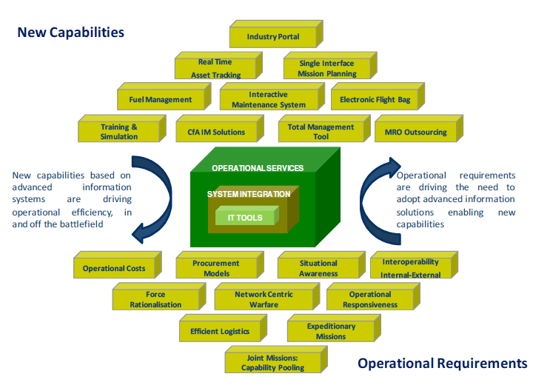
Figure 1 DLIS IT Solution
Source: Pannu (2012)

The type of organisation and the system being implemented will dictate the implementation approach chosen. Below are four prominent models that highlight the foundations in understanding implementation processes.

    - Direct
This is an approach where the old system is switched out for the new version. It is regarded as highest-risk model; with this method, an organisation cannot return to the previous system once the implementation is complete. However, it may be required if an organisation has little time.

    - Parallel
The parallel approach takes the new and previous systems and operates them side-by-side until the designers are content that the new system is ready to take over. It is the safest approach because if the new system has issues the organisation can revert to the earlier system as a safety net. However, it is deemed the most expensive approach and staff must operate both systems, which might increase staff working hours.

2.3.3 Pilot
This approach permits elements of an organisation to operate the new system whilst the remainder of the organisation continue to use the existing model. The element that works with the new system is recognised as the pilot. Once the designers and key stakeholders are content that the new system is working as envisaged, the remainder will migrate to the new system. In essence, the Pilot approach is a blend of the parallel and direct approaches. This method is also less costly than the parallel approach, as only a small part of the organisation is operating both systems for a limited amount of time.

    - Phased
This approach involves introducing only specific modules of a new system one after another. Only when each module is passed fit for use will the organisation move onto the next module. The risk is limited to the implemented module only and the phased approach is not as costly as the full parallel method. However, expenditure can rise significantly if the new system includes many phases. Consequently, the phased approach can be fraught with problems and costly because of the numerous stages involved.

2.3.5 Problems
Research into IS based project implementation success (Gheorghiu (2006); Reharjo (2016)) reveal approximately 70-80% of all IS implementations do not succeed. Lientz and Rea (2000) believe the implementation of a new information system can give rise to a complex organisational setting. According to Arvidsson (2014) there are three fundamental challenges that organisations need to overcome if they are to achieve a successful outcome. Firstly, alignment between strategic intent and system capabilities; secondly, implementing the system; and finally integrating the system and processes to ensure the first challenge is accomplished. Beaumaster (1999) highlights issues such as minimal collaboration between staff, managers, and departments, a lack of executive support and worker opposition to the implementation. IS implementation can at times be chaotic, which can destabilise organisations. Lientz and Rea (2000) point out threats can be significant for all stakeholders; problems can effect equipment acquisition, testing, documentation, training, installation and changeover from the existing system. Yet following the results of an implementation success survey of 2,200 executives on behalf of McKinsey and Company, it was found the “best implementers” were those with the necessary amount of staff with the appropriate skill sets as:

“Each person’s role is well defined, and expectations and responsibilities are aligned to the resources available; employees’ duties lie solidly within their areas of specialty or are appropriate for their skill levels.”

(Lefort et al. 2015, para 18)

According to Taylor (2015) not engaging the end user is a recipe for eventual disaster. He asserts “you need to tick three boxes to get the smoothest of transitions to the new way of doing things and the fastest acceptance of this change.”
• User – Fear/Exposure
• User – Experience/Simplicity
• User – Profit/Gain/Extras
Whilst Schmidt, et al. (2001) contends that depriving end users of participation throughout the implementation leads to inconsistencies regarding the hierarchy’s and the end user’s IS requirements thus, inefficiencies and conflict may ensue. Although, management may perceive the involvement of the end user as unnecessary and trivial to the overall strategic outcome, there are many that believe it can enhance an organisation’s chances of implementation success. Segars and Grover (2005) maintain that including the end user in the implementation assists an organisation with developing their operations by making known all the unknowns that may materialise. These end user issues could have repercussions for an organisation if they were not taken into consideration. Likewise, Barki and Hartwick (1989) later develop their philosophy, believing that replacing an IS and allowing the system to dictate processes and operations will lead to inefficiencies and dysfunction throughout the organisation.

2.3.6 Success factors
Critical Success Factors (CSF) methodology has become the go-to methodology to assist organisations in dealing with the complexities of IS implementation (Umble et al. (2003). In particular, the below factors are accepted by many — for example Laudon and Laudon (2012); Rockart and Treacy (1982); Howell (2009) — and are considered to be critical in ensuring a successful implementation for organisations.
- Executive contribution: The role of executives is to foster a positive setting to enable the implementation and fulfilment of the target goals. It is incumbent on the executive level that they are involved in the implementation from the outset, making decisions where necessary, and not merely onlookers.

- Management acumen: Although it is the executives who set out the plan, it is the managers who are accountable for the accomplishment—or not—of the implementation. Therefore, ensuring the management has the appropriate knowledge, skills and experience to implement the project is vital.

- Implementation end state: It is vital all stakeholders recognise what the implementation is trying to achieve and how the implementation will change and affect the organisation from top to bottom in the future. A good comprehension of how and why the organisation is changing will influence stakeholders’ decision-making and planning methods to ensure the implementation is accomplished successfully and the organisation realises the benefits.

- Business processes: These are an array of interconnected tasks designated by management, executed by the stakeholders using the organisation’s resources. Once completed, they enable an organisation to generate a product or service in order to achieve their goal. However, introducing a new IS will not see an organisation achieve their strategic goals alone. The organisation requires an overhaul of their business processes, dictated by the engineering of the new system. (Hammer and Champy, 1993) How people perform certain tasks and the order in which they perform these tasks will change from system to system, and the changes must be adopted to allow the new IS to function effectively and efficiently.

- Progress dashboards: This refers to having full visibility of progress and data throughout each stage of the implementation. The dashboards detail the progress of the project against the fixed milestones and targets.

2.4 Project Management
All organisations act to change their current setting depending on either 1. An operational approach, looking to create competitive market gains leading to increased profits or market share or 2. An innovative or project approach investing capital and resources predicated on the research of a new position, where areas in the market are untapped. (Prabhakar, 2008) In order for an implementation to succeed, many organisations employ a PM model to enable their change vision to come to fruition. For example, undertaking a thesis is a form of PM where the purpose is to test a theory based on a research problem. The objective is achieved by a succession of tasks, such as, defining the problem; choosing a methodology; collecting and analysing data; and revealing the results. Therefore, outlining and then executing all of the required tasks to complete the thesis would achieve the project. A PM model identifies and outlines to management how to achieve the change using a prearranged set of objectives of scope, expenditure, time, standard, and employee approval. (PMI, 1987) There are many different types of PM models that span the spectrum of PM methodology. (See Figure 2) According to Wysocki (2007) projects will naturally differ, no implementation methodology is recognised as the best; they all have pros and cons relevant to the organisation. Organisations come in many forms such as, type, size, and industry. Organisations are better off developing their knowledge of what the various methods offer as opposed to seeking out a one-size-fits-all model. Le Cren (2016)

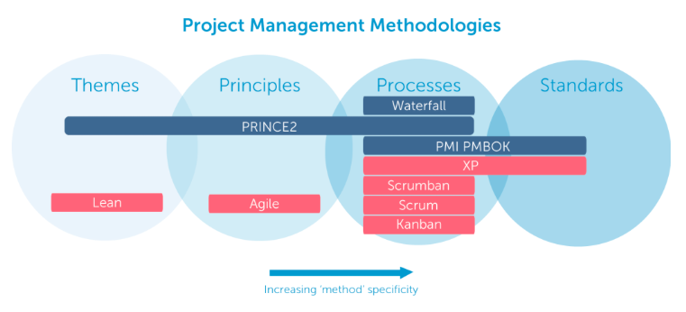
Figure 2 PM Methodology spectrum
Source: Aston (2017)
Below are examples that span the PM methodology spectrum in understanding PM approaches.
2.4.1 Agile

Agile methodologies are most appropriate for ventures that are iterative an incremental. The Agile methodology framework is based on a series of requirements and solutions, providing a way for developers and groups to produce enhanced outcomes in an accelerated timeframe, through a series of brief, iterative, shared meetings.

2.4.1.1 Crashing
This method is aimed at cutting the time it takes to complete phases within an uncertain plan. The Crashing method is put to use when an organisation decides to drive their activities concurrently (where they overlap), but the strategy has not generated sufficient time on the overall project timetable. With Crashing resources are integrated into the project for the lowest financial outlay possible. Subsequently, expenditure and programme compromises are calculated to conclude which option provides the best degree of time saving for the least amount of cost. (Monnappa, 2018) Crashing PM is becoming more popular in recent times as more and more ventures do not have a fixed path, whether it is because of the emergence of recurrent new technologies or shifting philosophies where an organisation’s needs become fluid. However, Crashing is costly due to additional resources being associated to the project. (Monnappa, 2018) Yet Mrsic (2017) believes that in spite of the chaotic nature and increased costs, Crashing can still contribute to success as the method allows organisations to manage the unknown and unpredictable by adapting as it occurs. Ajani (2002) concurs, he believes Crashing suits organisations that are looking for a project manager who can deliver implementations successfully and ahead of time, leading to a great investment for the organisation and an enhanced reputation for the project manager.

2.4.2 Sequential

Sequential methodology focuses on activities that manifest into an end state which are completed in order. Sequential methods are typically the easiest to comprehend. These methods are ideal for projects such as buildings and technology where plans can be easily imitated for future use.

2.4.2.1 Waterfall
The Waterfall model is the conventional approach for handling projects and one that is easiest to comprehend. This method evaluates the undertakings necessary for an implementation by offering a method where everything is closely managed and scrutinised until the tasks are completed. Each activity must be concluded in order before the succeeding activity can commence that result in the complete change. This method is a perfect system for changes involving tangible objects such as, company fixtures or technology hardware where plans can be simply be repeated for future change. (Wrike, 2018) The premise of the Waterfall model is that it is not complex, but predictable and linear, with distinct boundaries making it simple to create a strategy and carry it out without too many deviations. (DeCarlo, 2004) However, Wysocki (2007) believes the Waterfall model follows a specified plan that is developed before the project is initiated and is founded on the notion that the ambition is clearly defined from the beginning. Subsequently, any modifications in the clients’ desires or requests will disturb the arrangement of activities, making the strategy problematic to administer. Consequently, this can lead to a gap between perception and reality. Freeman (2010) makes a similar claim when discussing task-based PM techniques. He asserts, “in the Traditional model plans and estimates are typically made once, in a ‘big bang,’ front-loaded approach, and the rest of the project is spent adjusting to reality.”

2.4.3 Process based
These methods are not explicitly PM methodologies but are tools, which can be employed as part of a wider PM methodology. Process based models focus on activities as a collection of processes, which through completion permit organisations to plan and execute PM deliverables.

2.4.3.1 Lean
The Lean method is predicated on efficiency and eradicating waste. The Lean method is more appropriate for organisations that want to generate efficiencies in their business processes. (Muslihat, 2018) The Lean method evolved from the manufacturing industry in Japan based on waste - The three Ms.

- Muda - eradicating waste,
- Mura - eliminating variations,
- Muri - removing overload.

Lean switches the emphasis of PM from developing technologies and assets to enhancing the project’s flow through complete value streams that involve technologies, assets, and departments to customers. (Aston, 2017) The Lean method achieves this by “eliminating bottlenecks, focusing on customer value, and continually improving processes.” (Bonnie, 2014) Consequently, through the execution of the Lean method organisations become adept at cutting assembly time processes and slashing expenditure. (Muslihat, 2018)

2.4.4 Project Management Institute
Project Management Institute (PMI) methodology is another approach that is not a recognised standalone PM system. Developed and managed by the PMI, the model is formulated to enable organisations to delineate their projects into the five separate process groups.

2.4.4.1 Project Management Body of Knowledge (PMBOK)
PMBOK is a collection of processes and knowledge areas accepted as best practice irrespective of the type of project be it construction, software, engineering, automotive. (Haughey, 2013) Established by the Project Management Institute (PMI) as a set of processes (see Figure 3), initiating, planning, executing, controlling, and closing; provides organisations the parameters and best practices, outlining everything from the lifecycle to PM strategies and ideas. (PMI, 2017) PM traditionalists maintain PMBOK is simply a recognised set of standards and conventions for managing projects and not an actual PM methodology. (Wrike, 2018) For example, an IKEA instruction manual is not a means for designing furniture, but merely offers the acknowledged processes required to construct the furniture.

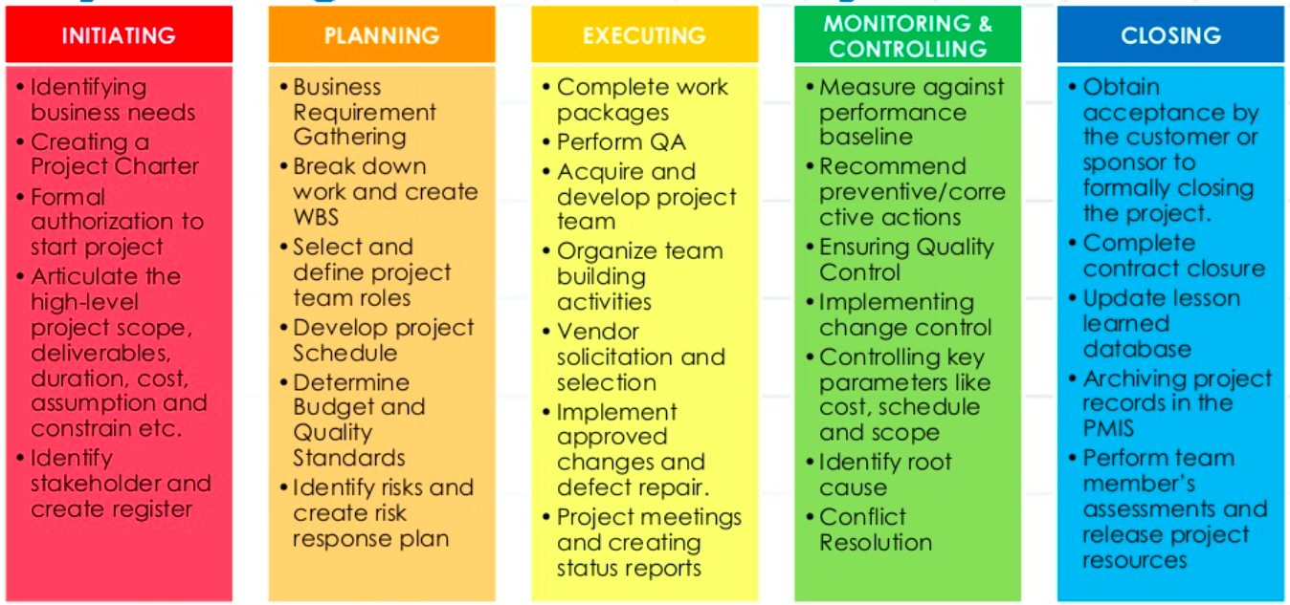
Figure 3 Key Activity PMBOK PM processes
Source: Reharjo (2016)

2.4.5 Change management
Change management methodologies focus on the risk of PM ventures and mitigating the threats, if they transpire.

2.4.5.1 Extreme Project Management (XPM)
XPM is the reverse of the Waterfall method (See Figure 4) as it provides a technique to oversee considerable change and still move forward to project completion using an ever-changing course. It’s the perfect way to manage projects that have a short timeline of anywhere from a few weeks to mere days. (Wrike, 2018) According to Mrsic (2017), “XPM methods are carried out in turbulent environments where it’s difficult to estimate the speed of the project and obstacles you will encounter. On extreme projects, things are unpredictable, planning is chaotic and just-in-time, and the entire project development is messy”. XPM allows organisations to modify the venture blueprint, finances, and planned outcomes to suit the shifting requirements, irrespective of whereabouts the project is along the journey. (Bonnie, 2014)

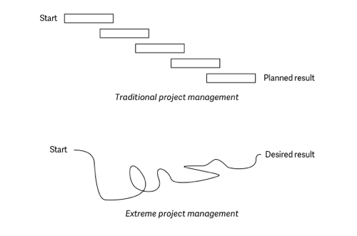
Figure 4 XPM vs Waterfall method comparison
Source: Mrsic (2017)

2.4.6 Other methodologies

2.4.6.1 Projects IN Controlled Environments (PRINCE2):
This method has become the staple PM method for UK Government Department IS project life cycles, although it is now employed more widely in private the sector too. (McClinton, 2018) PRINCE2 is based on seven individual processes (See Figure 5) to assist in the management and governance of projects (Karamitsos, et al. 2010) The PRINCE2 model forcefully maintains impetus of the project to realise the projected benefits against anticipated expenditures whilst decreasing the threat. (Barker, 2013) Organisations are most vulnerable at the commencement of a project and at the end. (Prabhakar, 2008) This is due to the influence stakeholders have on the definitive features of the plan's product. Similarly, when mistakes occur early in the project they tend to inflate costs as the project ensues. Project results are established by attained benefits versus the cost outlay, and PRINCE2 scrutinises cost vs benefit in each stage. Therefore, benefits are weighed against the cost, and a successful project delivers outweighed benefits than cost. (Priyanka, 2016)
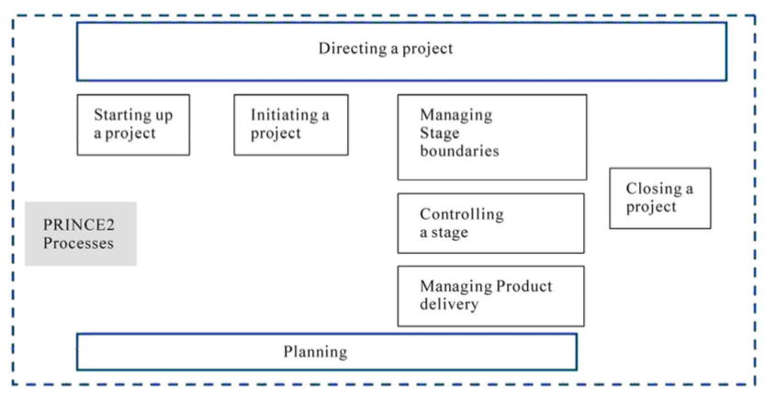
Figure 5 PRINCE 2 Process Map
Source: Karamitsos, et al. 2010)

2.5 Change management
(Moran and Brightman, 2001, p.66) define CM as the, “process of continually renewing an organisation’s direction, structure, and capabilities to serve the ever changing needs of external and internal customers.” CM has become a far more essential facet of organisational success in recent times. The complexity and frequency of change that organisations will experience in the 21st century will be both varied and regular. (Mullins, 1999) “Today’s change management movement has arisen in response to the difficulty companies have had in making constant, rapid improvement a routine aspect of work.” (Schaffer, 2017) Mintzberg, et al. (1999) believe organisational culture affects numerous characteristics of strategy, contending that the most decisive trait is the manner in which individuals are employed, trained, mentored, connected and benefit from the organisation. The employees of an organisation are the ones who work with a specific product or service and encounter customers daily, so have garnered valuable experience. The secret to effective CM is identifying what is causing the problem and the choosing the most appropriate CM system to deliver the transformation to ensure effective CM can transpire (McCalman et al. 2012). Cassidy (2006) posits that a well-designed plan is fundamental in ensuring an organisation can achieve their CM objectives. McCalman et al. (2012) later develop their thinking and believe that CM is not just about choosing the most appropriate solution to deal with the issue—be it technical, structural or people orientated—but also about integrating all aspects to produce a successful CM outcome. Webster (2012) supports this approach, contending that CM is not straightforward as there are often several systems to integrate as well as multifaceted organisational and cultural challenges that must be tackled such as the workforce’s cultural behaviour. Webster (2012) later develops his thinking, positing, “Change has to be embedded in the very culture of the organisation if it is to stick.” Bagozzi et al. (2002) believe workers favour stability, they have become accustomed to their practices and are in their comfort zone consequently, they approach change unenthusiastically. Whilst Cameron and Green (2015, p.4) posit,
“Successful management of change needs to develop the ability to handle both multiple leadership and management paradoxes.”

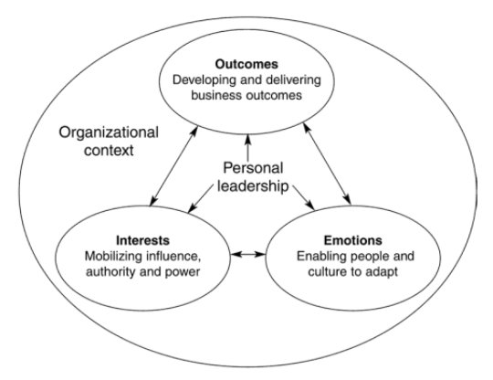
Figure 6 Dimensions of leadership model
Source: Cameron and Green (2015)
There is a range of models and systems available for implementing change in both the public and private sectors. Below are three prominent models of change that highlight the foundations in understanding the change processes.
2.5.1 Kotter 8-step process change plan
This model developed by John Kotter, is based on an 8-step process. (See Figure 7) If an organisation wants to bring about change, the model assists by answering 3 main questions: Where do you start? Whom do you involve? How do you see it through to the end? (Mindtools 2017) The steps are broken down into the following: create urgency, form a powerful coalition, create change vision, communicate the vision, remove obstacles, create short-term wins, build on the change, and anchor the change in organisational culture.
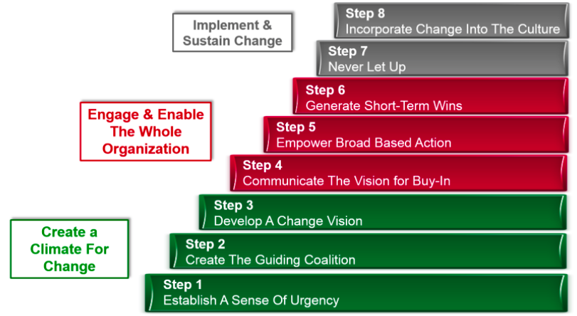
Figure 7 Kotter 8-Step Process Change Plan
Source: Kotter (2012)

    - Lewin 3-Step change model
Kurt Lewin’s model is predicated on people preferring an environment where they feel assured. (See Figure 8) This model is intended to sway workers to accept change while reducing the implications on the organisation triggered by staff resistance to change. The model is founded on 3 levels of bringing about a transformation: Unfreeze, Change, and Freeze. The methodology is aimed at doing away with existing customs and behaviours that are not applicable but continue to be executed, and replacing them with new processes and procedures (Mintzberg et al. 1999).

Figure 8 Lewin Change model
Source: Mindtools (2017)

2.5.3 McKinsey 7S model
This model uses 7 components that are separated into 2 classifications: hard and soft. (See Figure 9) All the elements are interconnected; components are very hard to resolve and express but, have a significant role to play. The model enables an organisation to ascertain what needs to be changed and identifies whether the organisation’s customs and processes are aligned to permit it to achieve successful change. The seven components are:

(Hard) (Soft)
Strategy Shared Values
Structure Skills
Systems Style
Staff

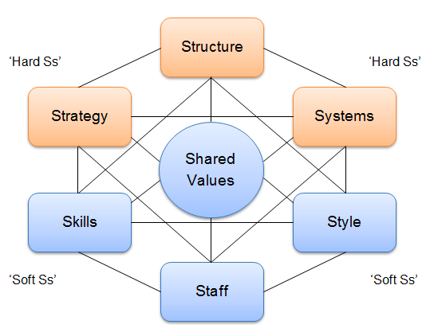
Figure 9 McKinsey 7S Change model
Source: Jurevicius (2013)

2.5.4 Problems
Many studies have been conducted to understand the causes behind CM failure (Cooper and Zmud 1990). The reasons are various and wide-ranging and can include change in job content; user expectations; amplified workloads; the absence of knowledge and training; resistance to change; no end-user involvement and an inadequate interaction between managers and staff. Joshi (1991) contends that user resistance is one of the primary reasons why CM strategies fail. Any form of change created naturally leads to resistance in the organisation. Doppler (2008) takes the user-resistance argument further by positing that organisations who discount user resistance increase their chances of facing complications that affect their entire CM strategy. Markus (1983) in his book “Power, Politics, and MIS Implementation” maintains that there are three types of user resistance: systems, individuals and communication. Resistance in systems can materialise due to the intricacy of complex IS such as, difficult user processes and poor ergonomics for the end user. Whereas resistance in people occurs due to various reasons including: upbringings; traits; interests; and insecurities. Kubler-Ross (2011) argues that people experience change by going through five stages of grief. (See Figure 10) Consequently, only once they have reached the fifth stage will people accept change, allowing organisations to accomplish change successfully. Shaw (2015) believes “the goal is to ensure you understand the impact that change will have on your employees and that you keep the transition as smooth as possible. Allow proper time for adaptation and be transparent about how change will improve your company and benefit your employees.”
Resistance also manifests itself in communication issues arising from social interactions such as changing authority in dealings and remodelling department roles and responsibilities.

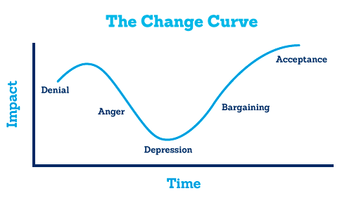
Figure 10 Kubler-Ross Change Curve
Source: Shaw (2015)

Human factors contribute to the development and set-up of IS and should be taken into account as part of the project strategy (Widdowson and Carr 2002). People possess an array of skills and limitations and those projects where they have not been considered when implementing change have been the least successful (HSE, 2017). Organisations need to be mindful of the components that simplify or hinder workers in executing their roles and responsibilities. Norris et al. (2012) posit that the design of the workplace, tools and procedures should be centred around the employees’ abilities and characteristics i.e. around how people process information, converse, and make judgements, as opposed to presuming people will automatically adjust to the changes that have been put in place. Organisations that disregard the significance of human factors may see this having a negative impact on the workforce, such as an increase in mental health concerns. (Widdowson and Carr, 2002)

2.5.5 Success factors
Most organisations will list different reasons or strategies, which enabled them to achieve change successfully. However, they generally all fall into the same categories, the main ones being the following:

      - Planning
The most fundamental aspect of any change plan is that that the organisation needs to have a strong and valid motive for the change process. It is pointless generating a challenging environment if the rewards turn out to be negligible to the organisation (Australian Institute of Business, 2017). The plan, as a minimum, must include a timetable, costs, work breakdown structure and resource apportionments, and leave some flexibility for the actual implementation process. Rigby (2011) argues that exciting philosophies are worthless if they are incompetently planned or implemented. The plan must be convincing and goals quantifiable, and attainable, with clear expectations of the outcomes. Change cannot be tackled exclusively from a strategic and fiscal perspective. The change plan must consider the intricacies and culture of the organisation, whilst using the knowledge, skills and experience of personnel to effect successful change (HEC, 2016).

      - Establishing a vision
“The vision provides a purpose and reason for change and describes the desired future state. Together they provide the ‘why’ and ‘what’ of the planned change.” (Cummings and Worley (2009, p.164) Producing a simple vision of what the change will create will help workers to grasp what the organisation intends. It is essential to communicate prudently the logic and motivation for the change to the whole organisation, in order to generate a collective understanding on the need for the change (Grover and Kettinger, 2000; Holt et al. 2007). The vision must be publicised at a well-timed juncture, ensuring the main facets of the change are announced, along with aspects that will continue to exist, using all communication means available. (Kotter, 2012) According to Hawking et al. (2005) a clear appreciation of the requirement by the entire organisation to implement a change was recognised as the key success factor in ERP implementation. This notion is further supported by the AIB (2017) who suggest that a strong path influences a workforce to be more accepting of change.

      - Communication
Graetz and Smith (2005) posit that it is essential that organisations communicate so all levels of the workforce can comprehend the change. The AIB (2017) believes that the most significant factor in transforming an organisation is first and foremost making the workforce aware of the change and other various factors, from the key stakeholders including shareholders and customers to floor workers. Goodman and Truss (2004) take the communication success factor a step further by contending that communication needs to be mutual. There must be involvement from the bottom up to enable the executives to appreciate how well the workforce have embraced the change vision and where resistance may be harboured. Although, Kotter (2012) believes that executives ought to play the biggest role in the change communication, they must epitomise the change in their everyday routine, language, behaviour and duties.

      - Employee engagement
Kotter (2012) contends that workers who are permitted to contribute to a change strategy are more devoted to supporting the change, and more forthcoming with pertinent information that should be incorporated into the change plan. This is supported by McCalman et al. (2012) who argue, “one of the most fundamental steps in achieving the successful implementation of change is to obtain a shared perception amongst those affected.” Consequently, they are likely to have valuable knowledge and proposals of benefit to the project team (AIB, 2017). However, this does not necessarily guarantee change will now materialise; new customs and practices must be performed continually for an extended period of time before the culture really changes. (Webster, 2012) Involvement must start with proper training to assist in employees making a worthy contribution (Grover and Kettinger, 2000). Whereas, strong employee engagement that develops only towards the end of the project will see an upsurge in greater employee resistance to the change. (Holland and Light, 1999)

2.5.5.5 Information System Success Model (ISSM)
Succeeding Davis et al. (1989) DeLone and McLean (1992) fashioned the ISSM. The ISSM incorporates six interconnected dimensions in which success is determined when implementing a new IS. DeLone and McLean (2003) created the updated ISSM in 2003, with some subtle changes. (See Figure 11) The ISSM model highlights and depicts the associations of six pertinent dimensions of IS success: information, system, service, system use/usage intentions, user satisfaction, and net system benefits.

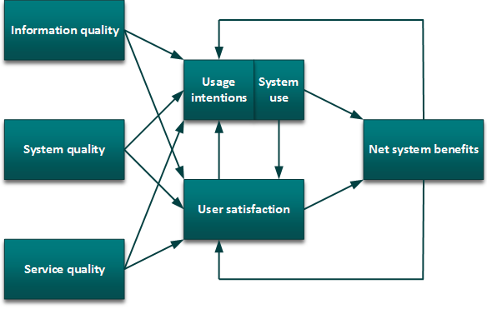
Figure 11 DeLone and McLean updated ISSM
Source: DeLone and McLean (2003)

3. RESEARCH AND METHODOLOGY
3.1 Introduction
The purpose of Part three was to establish the most suitable research approach using methods discussed in Part 2 to answer the research objectives. The research methods that were most apt as a framework for the study were discussed, followed by the techniques used to gather the data to investigate the outcomes to the research objectives. Finally, confirmation of how the data was compiled, created and delivered, in order to establish conclusions in Part 4 the findings and analysis.

3.2 Research approach

The goal of this research was to critically evaluate the MJDI implementation. The research was broken into two phases. Phase 1 focused on answering research objectives 1 and 2 to determine if the MJDI implementation strategy was successful using end user evidence post implementation (2014) and four years later in 2018. Phase 2 was focused on research objective 3 to provide alternative successful implementation strategies, should the evidence from phase 1 reveal that the MJDI implementation was not successful. Many different research methods exist that could have been used as an appropriate methodology to deliver worthy research on IS implementations such as descriptive, analytical, applied, fundamental, quantitative, qualitative, conceptual and empirical, with other methodologies a mixture of those previously indicated (Orlikowski and Baroudi, 1991) In this instance, a case study method was applied through comment and views from the MJDI end user. Case studies evaluate many forms such as people, actions, and strategies, which are considered through single or multiple approaches. (Thomas, 2011) The case study, which was the most fitting for this research, was retrospective. A retrospective case study research helped ascertain why and how the implementation outcomes transpired. A case study approach lets the author set aside the quantitative results and appreciate the behavioural settings through the participant’s viewpoint, by combining both quantitative and qualitative data. (Tellis, 1997) Johansson (2003) posits, case study methodology combines independent approaches with the aim of revealing a case from separate positions: to triangulate by mixing systems. This has allowed each research approach to assist the author in answering each research objective independently. Several studies on mixed methods research have been established such as Bryman, (2006) and Tashakkori and Teddlie (1998). Mixed methodology is defined as “an approach to research in the social, behavioural and health sciences in which the investigator gathers both quantitative (closed-ended) and qualitative (open-ended) data, integrates the two, and then draws interpretations based on the combined strengths of both sets of data to understand research problems.” (Creswell, 2014, p.2) Conversely, there are opponents to the validity of case studies; Guba and Lincoln (1981), proclaim that case studies are manipulated by the author; therefore the data offered is skewed to the author’s agenda or their sentiments which consequently, prejudices deductions lacking thoroughness and impartiality. However, case studies are regularly used and provide unconventional benefits that other research methodologies may not uncover. (Eisenhardt 1989) In spite of the above opposition the research and methodology has been based on a case study using mixed methods; this led to form conclusions to the research objectives separately, and in turn triangulation was used to answer the main research question.
3.3 Data collection
The author concedes that one form of research method would not be sufficient to test the hypothesis. Therefore, data was sought through three distinct means. First, quantitative data was acquired from a British Army Headquarters Logistic Support Branch MJDI survey and analysed to answer Research Objective 1 - Ascertain amongst the end-user community if they deemed the implementation experience of MJDI to be effective and suitable. The survey was set up as a link on the MJDI homepage, encouraging end users to express their views between February and May 2014. Second, qualitative data was obtained through a questionnaire undertaken by designated LSS and AA end users performing significant roles, located within the author’s working unit. This enabled data to be analysed to answer Research Objective 2 - Establish how effective MJDI is operating four years after implementation. Finally, the remaining data was obtained from carefully chosen business reports and records’ pertaining to their recent IS implementations that have since been published. This enabled the author to carry out mini case studies on each implementation strategy to conduct analysis and deductions in answering Research Objective 3 - Identify successful implementation strategies that could be used as an alternative strategy to introduce their FLIS.
3.4 Quantitative research
The quantitative research for this study provided a far greater set of numerical data adding to the validity. The data provided feedback on an array of subjects relating to MJDI’s implementation across a large community of end users throughout the British military. The research centred on MJDI’s system functionality, end-user competency, training and literature and guides pre-migration, during migration and post migration. By establishing extensive numerical trends, it provided additional credibility to the results of the analysis. According to Newman and Benz, (1998, p.2) they posit, “Most quantitative research approaches regardless of their theoretical differences, tend to emphasise that there is a common reality on which people agree.” Othman (2011) concurs, contending that quantitative data is amassed under predefined circumstances to negate the likelihood that other variables could account for the associations proposed. Whilst Frankfort-Nachmias and Nachmias (1992) believe the advantage of quantitative study is that it allows explicit conditions to be established, subsequently, the research can be repeated, assessed and accurately linked with similar research.

3.5 Qualitative research
Grady (1998) offers the following definition of qualitative research stating, “One way of defining qualitative research is by its primary data collection strategies. The three main data-collection strategies for qualitative research are interviews, observations and document analysis.” Goodwin and Goodwin (1996) contend that qualitative research is steadfast and grows during the investigation as the author can change the data collection approaches and selected groups. Newman (2013) citing Babbie (1986) agrees arguing that a key benefit of qualitative research is flexibility, comprehensive examination, and the ability to discover a range of social dynamics. However, there is resistance to qualitative methodologies. Schaffir and Stebbins (1991) contend that researchers are vulnerable through not being able to distinguish all of the facets that affect the investigation, consequently, it will affect the researcher’s suppositions. For this study the qualitative research embodied a social component, despite the designated LSS and AA end-user participant group being relatively small. However, the contributors did possess a wide range of military experience from a newly trained LSS to a very experienced Quartermaster (QM) with over 30 years’ service. This offered a varied assortment of participants to ensure the responses were unprejudiced and balanced. A test questionnaire form (Appendix 1) was developed and dispersed to a cohort of LSS working in the author’s unit to establish whether the questionnaire was suitable. After refining the test questionnaire thirty questionnaire forms were prepared and compiled, (Appendix 2) using different forms of communication (email, phone, and face-to-face) allowed the author to expedite the data collection phase, which enabled the author to move quickly to the analysis phase.

3.6 Triangulation
The author used triangulation (See Figure 12) to combine the findings of the research objectives. Cresswell (2009, p.213) defines Triangulation as, “collecting both quantitative and qualitative data and then comparing the two databases to determine if there is convergence, differences or some combination.” By comparing the findings of the research objectives permitted the author to form conclusions to answer the research Question. Yin (1994) is an advocate of the triangulation approach asserting that by employing separate methods to assemble data, the research will provide different types of information that supplement each another. Goodwin and Goodwin (1996) contend that incorporating multiple methods is the most effective technique to combine data. Cresswell (2009) concurs positing, that blending different systems as part of a multi-method methodology such as triangulation enhances the weight of the conclusions. Patton (2001, p.555) makes a good analogy when discussing the value of triangulation, “Knowing a single landmark only locates you somewhere along a line in a direction from the landmark, whereas with two land marks you can take bearings in two directions and locate yourself at the intersection.”

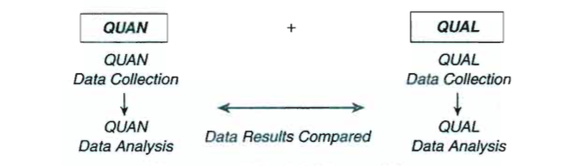
Figure 12 Triangulation Method
Source: Cresswell (2009)

3.7 Primary data
Primary data collection was obtained for the purpose of answering research objective 2. Salkind, (2010, p.1095) defines primary data as, “an original data source, that is, one in which the data are collected first hand by the researcher for a specific research purpose or project. Primary data can be collected in a number of ways. However, the most common techniques are self-administered surveys, interviews, field observation, and experiments.” There are many advantages and disadvantages to using both primary and secondary data. (See Figure 13) Bryman (1988) believes secondary data limitations are strengths for primary research. For example, the credibility in data is more accurate when conducting one-on-one primary research, as opposed to the large-scale gathering of anonymous secondary data and the ensuing data analysis. Although, by conducting primary data research it can attract significant time and cost.

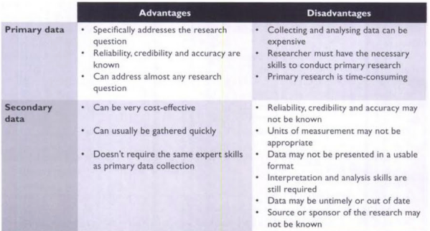
Figure 13 Advantages/Disadvantages of primary and secondary data
Source: Morgan and Summers (2005)

3.8 Secondary data
Secondary data collection was obtained for the purpose of answering research objectives 1 and 3. Blakie (2004, p.18) defines secondary data as, “sources of data and other information collected by others and archived in some form. These sources include government reports, industry studies, archived data sets and syndicated information services as well as traditional books and journals found in libraries.” Patzer (1995) posits, secondary data is most commonly employed as the basis to establish a platform and context to the overarching investigation. Bryman (1988) concurs positing, utilising secondary data may assist the researcher to develop their understanding, helping to tailor the research more precisely. Goodwin (2012) posits, using secondary data can be far less costly than devising a primary research study. Furthermore, when studies need to be concluded hastily, secondary data can offer a speedy solution. Bryman (1988) develops his thinking further, arguing that secondary data can also uncover aspects of the study that were not originally considered, permitting the researcher to redirect the emphasis of primary data collection onto those areas. Just as benefits exist for the use of secondary data, so do cons. “In secondary research the analyst enters the picture after the data collection effort is over.” (Stewart and Kamins, 1993, p.3) Patzer (1995) also argues, without extensive study the researcher cannot be sure of the efficacy of the research. Consequently, the research might not be as credible. However, the principal benefits of using secondary data for the author in this research study relate to time and expenditure.
3.9 Data analysis
IS implementation success today acknowledges the significance of the human factor such as the end user effect. As a key consideration in the outcome IS implementation success human factors were aligned to performance and output, which MJDI delivers such as, system functionality and end user competency. Acknowledging the end user affect allowed the author to use certain aspects of the DeLone and McLean (2003) ISSM to be used for evaluating IS implementation success. The below four dimensions were used in which to examine the data.

- System quality
- User satisfaction
- Intention to use
- Information quality

For Research Objective 1 and 2 conclusions were drawn on the end users’ responses. Consequently, their positive and negative feedback during the two periods of implementation helped to evidence a relationship using the DeLone & McLean (2003) ISSM.

3.10 Ethics
Consent was attained on completion of the questionnaire forms for all members for research objective 2. This was explained to all participants prior to them taking part; therefore no misleading methods was used. This guaranteed that participants could withdraw from providing data at any time. The questionnaire forms did not require personal details of the participants, ensuring anonymity. All completed questionnaire forms were stored in a locked filing cabinet where only the author had access, and was destroyed once the required data was examined.

3.11 Limitations

The primary research was predicated on the British Military’s LogIS efficiency and effectiveness. However, owing to time and workload of the researcher’s full-time employment, the qualitative primary research was constructed on the data of a limited number of participants within the researcher’s unit only, which may diminish the strength of the study.

4. FINDINGS AND ANALYSIS
4.1 Introduction
Part 4 examined the data for each research objective independently, in order to make impartial deductions about each outcome. The research findings were acquired from three different types of data. For research question 1 quantitative data was acquired through the British Army Headquarters Logistic Support Branch. The survey was developed to help senior officers understand how MJDI and end users were performing since the system implementation. The survey was conducted between the months of February and May 2014 targeting a large volume of MJDI end users. For research objective 2 the author developed and delivered a qualitative questionnaire in Mar 2018 based on similar categories used for research objective 1. A combination of British Army LSS, Royal Marine and Royal Navy AA personnel were selected within the author’s working unit to participate. For research objective 3 the author selected three different organisations that managed an IS implementation successfully, in recent times. The data was gathered using their own corporate reports and other online publications.

4.2 Research objective 1
Ascertain amongst the end-user community if they deemed the implementation experience of MJDI to be effective and suitable.
The survey questions were focused on four facets that aligned with corresponding aspects of the ISM:

Data Research ISM Model

Unit logistic performance > System quality
End-user competency > User satisfaction
Conversion training > Intention to use
Customer support > Information quality

In total there were 1,314 replies from participants from an estimated 8,000 users across all three Services (MoD, 2014). This revealed that just over 17% of end users responded to the survey. The breakdown of end users was divided into two categories: Material Accountant (MA) and Unit Application Administrator (UAA). The UAA is recognised as a senior LSS or AA, and ensures that the system and unit account is operating effectively. The MA is recognised as being more junior in rank and possesses less supply experience and therefore performs the day-to-day processes associated with the overarching unit account.
The survey revealed that 57% of participants were MAs and 43% UAA. (See Appendix 4) Of the participants, 35% were LSS and 65% AA trained personnel. The survey revealed the biggest share of respondents who contributed was the Combat (Cbt) capability with 28% of participants; followed by the Combat Support (CS) capability with 23%; Combat Service Support (CSS) with 20%; and those not in the Army’s ‘Order of Battle’ making up the remainder of the share including Training Establishments (Trg Estb) 13%; Garrisons 10% and Regional Command Support HQs (Comd Sp) 6% respectively.

4.2.1 Unit logistic performance
When questioned on the ease of MJDI on unit business, the survey revealed that 50% of end users deemed MJDI to be either much harder or harder, (See Figure 14) whilst only 25% found MJDI easier or much easier and the remainder judging MJDI to be as useable as the previous system.

Figure 14 Ease of MJDI on unit business
Source: MoD (2014) British Army HQ survey

Regarding the effectiveness of MJDI, the survey revealed that 36% of end users judged MJDI to be less effective (See Figure 15) whereas, only 31% felt MJDI to be more effective, with the remainder deeming no change.

Figure 15 Effectiveness of MJDI on unit business
Source: MoD (2014) British Army HQ Survey

When breaking down the responses of ‘ease’ by capability there was a significant difference in responses between the CS, CSS and Garrison versus the Cbt, Comd Sp and Trg Estb categories. Figure 16 reveals the Cbt, Comd Sp and Trg Estb capabilities attracted the highest share of participants who deemed MJDI to be ‘much harder’ and the least share of participants who deemed MJDI to be ‘easier’.
Figure 16 Ease of MJDI on unit business by capability
Source: MoD (2014) British Army HQ Survey

The evidence revealed a negative outlook with half of participants deeming MJDI harder or worse than the previous system. Meanwhile a third of participants felt the system was the same as the previous version and another third deeming MJDI less effective or worse. Consequently, the author concluded that participants’ regarded MJDI a poorer system than their previous one. In addition, there was an inferior degree of understanding within organisations where there was a lack of LSS personnel. This was because AA trained personnel are employed in an auxiliary position as opposed to their primary employment, and do not have the supply chain knowledge and experience of their LSS counterparts. Furthermore, it was concluded Formation HQs did not recognise the complexity of MJDI’s operating system would impact greater on units whose key logistic staff were AA trained personnel. AA trained personnel were used to operating a simpler and more basic inventory system (Unicom) at 1st Line units to accommodate their limited knowledge and experience in supply chain operations. However, MJDI was much more clever and thus, LSS trained personnel were able to assimilate MJDI processes much easier than AA trained end users.

4.2.2 End user competency
When questioned about the individuals’ competency on MJDI the survey statistics revealed that no more than 60% of virtually all ranks felt they had an acceptable level of competence. (See Figure 17) The statistics also reveal junior end users (Pte - CSgt) as having a higher degree of competence than their senior counterparts. It is concluded that this was due to spending more of their working hours operating MJDI.
Figure 17 End user competencies by rank
Source: MoD (2014) British Army HQ survey
Similarly, the survey found that less than 50% of LSS and AA end users deemed themselves to be ‘quite competent’ at using MJDI with only 10% ‘very competent’. (See Figure 18) The data revealed LSS personnel having a larger share of who were ‘quite’ competent. It was concluded RLC LSS personnel are career logisticians and have a more in-depth understanding of logistic theory and practice as opposed to AA-trained personnel, who have completed a course based on the rudimentary aspects of supply. As a result, LSS trained personnel were marginally more competent than their AA counterparts.
Figure 18 End user competencies by trade specialisation
Source: MoD (2014) British Army HQ survey

The evidence revealed that nearly all participants expressed they had only ‘some’ competence or were ‘quite’ competent with the majority of those coming from the Pte to CSgt ranks. In addition, less than half of LSS and AA felt they were quite competent and less than 10% ‘very competent’. The premise behind any training package is to enable users to become more proficient and increase their leave of knowledge. Yet the results revealed that only 10% deemed themselves as ‘very competent’ and less than 50% of users indicated they were only quite competent. Consequently, the author concluded there was a lack of understanding amongst end users. Although there was a higher degree of competence LSS over AA trained personnel, the author concluded RLC LSS personnel are career logisticians and have a more in-depth understanding of logistic theory and practice and would be expected to assimilate information better due to their experience.
4.2.3 Conversion training
It was found that 82% of the end users had received the mandatory one-week conversion training, with the remainder being trained as part of their logistic school trade training. Table 1 reveals that all of the training modules received a particularly low amount of ‘highly effective’ comments, with ‘commodities’ attracting the lowest amounting to 37 votes and the highest ‘issues’ only attracting 171 votes which amounts to 13% of the overall share. However, the highest share of votes for every module was seen in the ‘generally effective’ category. In addition, of the 16 different training modules, only 25% saw a higher degree of negative comments against positive ones, (James/Jobs, commodities and provisioning) receiving the worst overall negative feedback. The remainder 75% revealed a higher ratio of positive to negative comments. Although, of those 12 categories 3 of them had only a minor difference from positive to negative difference of 5% or less.

Trg Subject | Totally Ineffective | Generally Ineffective | Slightly Ineffective | Neg Total | Generally Effective | Highly Effective | Pos Total
James/Jobs | 350 | 202 | 319 | 871 | 403 | 40 | 443
Commodities | 180 | 181 | 356 | 717 | 559 | 37 | 596
Provisioning | 154 | 193 | 347 | 694 | 560 | 60 | 620
Entitlements | 128 | 182 | 346 | 656 | 596 | 62 | 658
Non-Codified | 113 | 169 | 354 | 636 | 628 | 50 | 678
Dues | 117 | 183 | 313 | 613 | 625 | 75 | 700
Unit Config | 102 | 208 | 287 | 597 | 678 | 39 | 717
Stocktaking | 119 | 161 | 302 | 582 | 638 | 94 | 732
Local MIS | 280 | 145 | 145 | 570 | 505 | 44 | 549
Alerts | 81 | 174 | 303 | 558 | 678 | 78 | 756
Loans | 83 | 147 | 324 | 554 | 661 | 99 | 760
Storage | 54 | 152 | 326 | 532 | 727 | 55 | 782
AinU | 58 | 134 | 281 | 473 | 746 | 95 | 841
Demands | 54 | 131 | 280 | 465 | 729 | 120 | 849
Receipts | 41 | 100 | 264 | 405 | 750 | 159 | 909
Issues | 43 | 90 | 250 | 383 | 760 | 171 | 931
Table 1 Training effectiveness by functional area
Source: MoD (2014) British Army HQ survey

When participants were asked about the effectiveness of the conversion training they were asked to elect the effectiveness over four different periods. (1, 3, 9 and 12-month stage) When analysing the training effectiveness, responses indicated a honeymoon period effect with a combined ‘more effective’ and ‘much more effective’ total reaching more than 30% at the 1-month stage. However, at the 3-month stage the effectiveness reduced to just over 20%. At the 6-month stage effectiveness showed an upward trend, but the effectiveness only reaches the initial levels at the 12-month stage. (See Figure 19)

Figure 19 Training effectiveness
Source: MoD (2014) British Army HQ survey

The evidence revealed that participants found the training modules easy to comprehend and relate them to the operating system, with the majority of modules attracting positive comments as opposed to negative. It is concluded the conversion training was generally effective but not an excellent product, but sufficient to meet the purpose of the conversion training. When participants expressed their views on the effectiveness of the training at different points in time. At the 1-month point circa 30% felt the conversion training was effective, However, a smaller share felt the same at the 3-month stage, only at the 12-month period did participants perceive their training to be more effective. The author concluded once end users became immersed in the routine operation of MJDI did they realise the conversion training modules only touched upon the basic aspects and allowed end users to understand and carry out simple processes and only through trial and error did their knowledge improve.

4.2.4 Customer support
With the introduction of MJDI, the system had four main resources to which end users could refer to when seeking to understand the correct practices and processes.
- MJDI Portal - Essentially a webpage, which acted as a dashboard for users to seek out a wide range of information and resources including contact numbers and template forms.
- User Guides - Detailed in printed form the end-to-end specific transactions for every process.
- User Productivity Kit (UPK) - Provided the end user with an application based on a “understand it, see it, perform it” model to allow the end user to practice the processes before carrying them out on a live system.
- The Supply Chain Supplementary Instruction (SCSI) The SCSI was developed by Army HQ Logistic Support Branch to align the prescriptive processes and practices with MoD supply chain policy in order to operate MJDI correctly and effectively. (This resource was not introduced during the implementation, but much later with the first version promulgated through Formation HQs at the end of 2013).

The survey revealed that all the resources were accessible with the end user indicating that over 80% of respondents had seen the MJDI portal, user guides and UPK respectively. (See Figure 20) However, every resource attracted a small percentage whereby participates indicated the resource was ‘not known’ to them with the MJDI Portal, User Guides both 2%; UPK 4% and the SCSI 7% respectively. The survey uncovered end users that had not seen or used the resources - MJDI portal 8% and the User Guides and UPK with 14% and SCSI 33%. Although, the majority of participants had seen and exploited the resources, there was a significant share that had not. The author concluded there was lack of exposure of customer support capability amongst end users. The SCSI attracted a much lower level of exposure due to being published not long before the survey was conducted and the entire community had not yet had opportunities to see or use the resource.

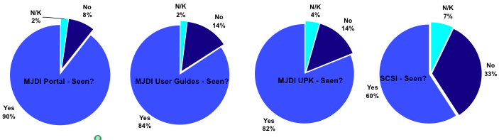
Figure 20 Coverage of system guides
Source: MoD (2014) British Army HQ survey

When questioned on the quality of user help resources the data revealed that most end users either thought the resources to be either ‘some’ or ‘quite’ useful. (See Figure 21) The combined responses of ‘very’ and ‘quite’ attracted no more than 50% of the share for the MJDI portal, with the User Guides, UPK and SCSI attracting only a slightly higher share. According to the BA HQ Logistic Support Branch they posit, “there was an underlying conflict between information on the system and it’s process.” (MoD, 2014) Subsequently, the participants deemed the level of resource usefulness pretty mediocre. “There have been multiple requests by users for routine function specific flowcharts at Army unit level, particularly where not covered in generic training (Conversion courses) and publications (user guides) – e.g. clothing, ammunition etc.” (MoD, 2014) Consequently, the author concludes the resources were not aligned and concise enough to assist end users in understanding and executing system processes within the framework of Defence Supply Chain policy, which led to dissatisfied perception of resources.
Figure 21 Usefulness of system guides
Source: MoD (2014) British Army HQ survey
4.3 Research objective 2
Establish how effective MJDI is operating four years after implementation.

The data for research object 2 was obtained from twenty-nine questionnaires completed by a combination of Royal Logistic Corps LSS, Royal Marine and Royal Navy AA trained personnel. The participants possessed a wide range of military experience across a range of ranks and positions comprising of a QM, three Warrant Officers, five Senior Non-Commissioned Officers (SNCO) and a combination of twenty Junior Non-Commissioned Officers (JNCO) and Privates or equivalent rank. The AA trained personnel are all employed within the unit’s first line accounts. They comprised of a QM who is the custodian for the Unit’s 1st line accounts, one Warrant Officer who oversees and assures the QM department operations, one SNCO who maintains one of the Regiment’s sub-unit accounts, two JNCOs who manage the unit clothing and unit equipment sub-accounts and three Marine or Navy equivalent ranks who conduct the warehouse functional duties for the fuel, lubricants, rations and miscellaneous equipment sub-unit accounts. The LSS are all employed to support the operation of the two independent 2nd line accounts. The personnel included two Warrant Officers who both independently regulate the operations and account integrity of their respective independent 2nd line accounts. Four SNCOs who all supervise different operations within the 2nd line accounts including, provision control and accounts; stocktaking and reconciliation; combat supplies and warehouse operations, seven JNCOs and eight Privates who conduct various transactional duties in support of the 2nd Line account operations such as filing, backloading of stores, receipts and issues duties. The questions were based on the end user’s perceptions of MJDI in 2018 based on similar categories to research objective 1 that align across to the DeLone and McLean (2003) ISS Model.

Data Research ISS Model

System Functionality > System Quality
End-user know-how > User Satisfaction
Training > Intention to Use
System Literature and Guides > Information Quality

4.3.1 System functionality
The responses to questions regarding the operation and functionality of MJDI from participants indicated a positive tone. Question 1 asked, “Overall, how would you rate MJDI?” All of the twenty-nine responses considered MJDI to be either ‘good’ or ‘very good’. Question 2 asked, “Which of the following words would you use to describe MJDI?” Participants deemed MJDI to be ‘reliable’ in twenty-seven instances with two deeming MJDI ‘useful’. Question 3 asked, “How do you feel MJDI contributes towards the overall logistic functionality?” one response stated, “All in all when logging in for the first time I did have a sense that I knew what to do and how. I personally noted that within 2 days of using MJDI I was carrying out our day-to-day routine work relatively effortlessly which proves that MJDI is effective.” Another response noted, “Most daily print-offs now give you the option to print or archive, so when they contain no information at all it’s not a waste of paper.” Question 4 posed, “How do you feel about the user interface of MJDI?” one response was, “I think it is easy to understand what MJDI does; and it is a very good system.” Another response stated, “The processes and steps required to complete a task are straightforward.” The responses to questions 1 and 2 regarding MJDIs system functionality implied a positive tone amongst the participants. Responses for questions three and four further reinforce the upbeat viewpoints for MJDI of participants regarding the straightforwardness of processes. Consequently, the author concluded that participants deem MJDIs system functionality to be reliable and effective.

4.3.2 End user know-how
When participants were asked about their knowledge, skills and experience on MJDI. The questionnaire revealed twenty-two participants deemed themselves as ‘very’ confident and seven ‘extremely’ confident, when asked about their confidence in performing their roles and responsibilities. When questioned on their ability to navigate around MJDI Question 7 revealed twenty participants’ rated their ability ‘very well’ and nine participants ‘extremely well’. When asked “How do you feel about having the necessary skills to fulfil your role on MJDI?” one participant commented, “I have been able to learn the system processes and have even provided temporary ‘work around’ solutions to enable other units to continue to run their accounts while a permanent solution is provided/programmed in to the system.” Another respondent stated, “I feel my level of competency is very good through time spent on the system and problem solving.” Question 9 asked, “What functions are particularly good or bad (if any) and why?” a respondent indicated, “Stocktaking, Dues and Provisioning are robust and effective, but the Hand-held Device functionality is not present yet and has been promised for the last 18 months.” Another commented, “The ability to print to PDF and suppress printing where the output contains no data eases the management burden.” The responses to questions 6 and 7 regarding participants’ ability to operate MJDI again revealed positive feedback amongst the participants with 76% ‘very confident’ and 24% ‘extremely confident’ in performing their tasks. Responses for questions eight and nine further strengthened the participants’ opinions with evidence suggesting their skills have evolved leading to end users conjuring up work-around and problem solving solutions. Consequently, the author concluded that participants have a strong understanding of their roles and responsibilities.

4.3.3 Training
When asked how they rated the MJDI training, twenty-one of the respondents deemed the training to be ‘very good’, six ‘good’ with one judging the training to be ‘fair’ and one respondent deeming the training “excellent” respectively. Question 12 asked respondents, “How well has the training prepared your for your role on MJDI?” One respondent believed the training prepared them “somewhat well” for their role with MJDI, twenty-five deemed the training prepared them ‘very well’, three thought the training ‘extremely well’. On instructor standards, the courses seem to be well covered. When asked, “How do you feel about the level of instruction and knowledge imparted during the training packages?” one participant stated, “Overall the instructors were very knowledgeable personally passing on stuff that has been learnt using MJDI on the 'live' system.” Another noted, “The training was well structured and well delivered, despite a few issues with the training server.” Yet the training courses are not the finished article. Question 14 asked, “How do you feel about the MJDI training accurately reflecting the actual operating system processes?” one respondent replied, “Generally the training was good given the limited time to deliver the course. There was too much to take in and it only dealt with the perfect world, i.e. not if you encountered a problem.” Another respondent stated, “The course needs to be much longer, and more time spent on unit configuration and the whole system needs to be explained in more depth.” When participants were questioned, “What extra training (if any) do they believe would help them in their current role?” there was evidence that further work is needed to make training more effective. One respondent answered, “More real life scenarios and lots more practice.” Another participant stated, “I think it may be more effective to run a live account on the training system so you could have went through your daily routine, then onto any further tasks required. This would have given a feeling of more responsibility.” Training and the instruction are now provided through only the LSS and AA trade courses. Consequently, the author concluded that participants have a good opinion for the training in helping them understand their roles and responsibilities. The responses to question 11 revealed 73% of participants’ deemed the training to be of a ‘very good’ standard. Whereas Question 12 revealed 86% of participants deemed the training prepared them ‘very well’, 4% ‘somewhat well’ and 10% ‘extremely well’ for MJDI respectively. Positive responses from questions 13, 14 and 15 respectively underpinned responses from questions 11 and 12. However, there was a number of comments that emphasised the training was not the finished article. Therefore, the author deemed the training requires further refinement to better support students to enable them to increase their knowledge.

4.3.4 System literature and guides
When questioned on how good the software tools were in meeting their requirements (Question 16), sixteen participants indicated the software tools met their requirements ‘very well’, eleven participants deemed the requirements were ‘useful’ and two ‘Extremely well’. Similarly, when questioned on how they rate the current customer-support capability (Question 17), nineteen participants deemed customer support ‘very good’ and Ten ‘good.’ Question 18 asked, “How do you feel about the online literature?” one participant commented, “UPK has been the main learning tool which I feel is excellent, I am learning all the time.” Another respondent stated, “The UPK is extensively utilised, however the information in user books are only relevant if they are up-to-date.” When asked, “What are your thoughts on the MJDI Help Desk facility?” (Question 19) (A resource within the MJDI portal established in 2014 by Army HQ Logistic Support Branch) a respondent replied, “Would be good if anyone can contact the desk and not just the SNCOs as they are not always here.” Another commented, “Generally this system is far better.” Although much of feedback by respondents was positive, there were some comments that were less supportive of the system literature and guides resources. Question 20 asked, “What customer support opportunities (if any) do you believe would help you to perform your role better?” One response was, “I feel the knowledge I have gained has been 90% but it only shows you how the system is supposed to work and not how to sort your errors.” Another response stated, “The added benefit of Management Information System (MIS) at strategic level is not seen by the user community.” Consequently, the author concluded that participants considered the system literature and guides to be of above average standard with 55% believing the tools met the requirement ‘very well’, 38% ‘useful and 7% ‘extremely well’ respectively. Elsewhere, 66% of participants felt the customer support capability to be ‘very good’, and the remaining 34% ‘good’. Yet, there were some less positive comments the on particular facets of customer support such as the MJDI Help Desk, which only accepts liaison from SNCOs and above. In addition, the UPK provides only a dogmatic approach to processes and doesn’t offer solutions if those processes were not followed correctly. Therefore, the author deemed the software to be much improved but still requires further refinement to support end users.

4.4 Research objective 3
Identify successful implementation strategies that could be used as an alternative strategy to introduce their FLIS.

4.4.1 Case study 1 – Lufthansa Technik
Background
Lufthansa Technik deals in the provision of maintenance, repair, overhaul (MRO), and modification services for airlines companies. Their main service provides civilian airline companies with the continuous and unbroken dependability and disposal of their aircraft. To enable their successful output Lufthansa Technik employ over 26,000 staff working with thirty-five affiliates to ensure 1,700 planes are inspected everyday around the world, including head of state and VIP aircrafts. (Redhat.com, 2018)

Problem
Due to the twenty-four hour, seven day-a-week operating window that the airline industry now operates, airline companies and traveller expectations are extremely demanding. Where planned flights are delayed or cancelled, it impacts the airline economically as airlines compete mainly on price, turnaround times and cost. Lufthansa is faced with the enduring challenge to decrease their overheads through product and process optimisation.

Solution
Lufthansa Technik believed predictive analytics was central to inhibiting MRO disruptions by serving airlines with data to enable them to better arrange and schedule maintenance activities. Thus, they employed Red Hat – a company who develop open source solutions for organisations, to create a hybrid cloud infrastructure based on enterprise open source software to construct an IS platform in support of their development and operations.

Implementation
An incremental but systematic implementation methodology was developed around a principal ‘lean’ model to bring about the change. “Starting with an experimental phase with selected pilot projects and supported by external consultants, it gradually developed a differentiated lean structure covering numerous product divisions.” (Homann and Stracke, 2013, p.5) Lufthansa’s lean method was centered on the notion that only a synchronised and even status of the technical system, management structure and end users will create the projected outcomes. (Homann and Stracke, 2013) The lean methodology was presented in a top-down style however, the leading contribution of concepts derived from the end users. To dispel end user doubts and inform them about the lean methodology, they established a ‘change story’ that proposed a course and a vision of what Lufthansa was intending to do. This tactic was acknowledged well by staff as the message offered clarity on the project objectives. (Homann and Stracke, 2013) The executives empowered management to involve the end users to contribute to the development of ideas and innovation. The guiding principles of company policy include continuous improvement, encouraging creative thinking and rewarding innovative ideas from the workforce. Lufthansa developed a core commitment to the importance of training and the delivery of the essential tools and means such as a training package on ‘lean’ techniques for employees and a ‘lean academy’ in fortifying process expertise. (Lufthansa-technik.com, 2017) This approach enabled them to produce innovations frequently, in order to establish feedback early in the process. This led to the innovation of the AVIATAR system a holistic platform offering a variety of digital products and services. Thorsten Pohl, architect and product owner for the AVIATAR system stated, “If we had infrastructure that was set up manually and wanted to change something, we had to wait for the person who implemented it.” (Redhat.com, 2018)

Results

Through these open source software innovations Lufthansa are now able to deliver a pioneering digital system that assists the world’s airlines optimise their operations including:
- Faster application work flows with self-service capabilities, automation, and agile Development Operations processes.

- Greater flexibility through improved integration between internal infrastructure and third-party solutions.

- Anticipates significant savings for participating airlines on MRO operations— equating to millions of euros.
Consequently these enhancements, such as the AVIATAR system Lufthansa can make changes without service disruption and quickly adapt to shifting demand. Subsequently, Johannes Hansen Senior Director of application development of AVIATAR, Lufthansa-Techik claims. “We are taking out a huge chunk of those costs” (Redhat.com, 2018)

4.4.2 Case Study 2 LG Electronics
Background
LG Electronics (LGE) is a successful global electronics manufacturer operating in four key markets mobile communications; digital appliances; displays; and media. LGE employ in excess of sixty-four thousand staff across seventy-six international affiliates around the globe. The company established sales of US$14.1 billion and an operating profit of US$ 1.03 billion for the first quarter of 2018. (LGNewsroom.com, 2018)

Problem
LGE’s existing Human Resource (HR) system was problematic, time consuming, and expensive to combine HR data for worldwide company reports. This led to unproductive management practices consequently, it affected the ability of HR departments to perform their roles effectively. For example, the HR system didn’t allow for self-service options for staff to update their details, view salary statements, track performance goals and submit leave applications.

Solution
LGE updated their existing HR service to an e-HR system to support the HR Shared Service Center (SSC) to expedite the administration of their HR activities. The e-HRs intended purpose was to support the SSC more efficiently by aligning and amalgamating with their present internal portal. By optimising HR practices it would deliver a solitary source of access for all staff and company records. The system allowed for automated labour-intensive processes and decentralised routine practices to managers and end users. (Pan, 2008)

Implementation
LGE adopted a continuous phased methodology when they implemented their e-HR upgrade by selecting divisions that needed the modernisation the most. This enabled LGE to concentrate on business process enhancement in stages. During the launch of the project LGE shared its change vision underlining its policy, processes, and system. (See Figure 22) LGEs experience with Oracle technology enabled them to settle on a solution quickly. They appointed Oracle to develop a solitary unified system that amalgamated all their existing HR modules for identical practices across all of its international subsidiaries. To manage the implementation a project team comprising of thirty-five staff was established. Ten came from LGE, twenty from LG CNS and five from Oracle. Some contractors also joined the team at various stages during the implementation, but changed frequently as the implementation proceeded. LGE personnel managed the progress and enablement of the project and LG CNS personnel were primarily accountable for the IS development in collaboration with Oracle. (Seth, 2018)

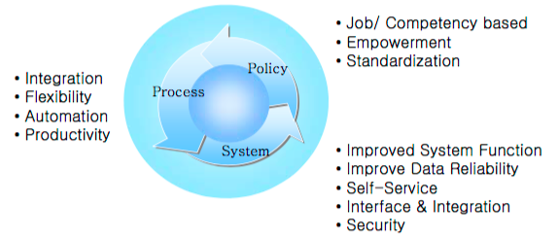
Figure 22 LGE e-HR change vision
Source: Pan (2008)

Carried out over five deliberate stages with defined goals, the ERP solution permitted LGE to alleviate the risks by updating their HR departments one region at a time. This strategy was designed to ensure there was a uniform platform, service, and management structure in all LGE branches. However, the project was no pushover for example, the e-HR processes did not differentiate between different employee cultures such as US, which required self-regulation, whereas Korean required comprehensive management of work and backing from the HR centre, which put a strain on departments.
Results
With an enhanced e-HR management structure LGE managers can now gather information from all over the globe, their HR strategies now align with their business goals leading to increased employee satisfaction. (Yi, 2016) This allows for streamlined education for routine tasks through best practice platforms and online lessons, leading to time and cost savings (Yi, 2016) Chief Human Resource Officer LGE in 2010 Mi Jung Kang believes, “the result has seen a significant improvement in efficiency, a better understanding of our HR processes, and dramatic cost savings.” (Anup, 2010)

4.4.3 Case Study 3 HMRC
Background
Her Majesty’s Revenue and Customs (HMRC) are the UK Government’s tax, payments and customs department. The HRMC operates one of the biggest IT infrastructures in Europe supporting more than fifty million customers. HMRC staff manages six hundred systems and 5,000 servers, which sees throughput of 2.3 billion transactions requiring 500TB of data. (Miller 2012)

Problem
In 2005 the amalgamation of Inland Revenue and HM Customs & Excise led to many duplicate systems, with various ones still existing. HMRC has an extremely multifaceted IT environment where aging systems run along side contemporary systems (See Figure 23). In addition, their primary tax systems were originally intended to administer products and not clients, consequently large product silos have developed. Silo products refer to departments, units or processes that do not possess the means or reason to operate in a unified manner.
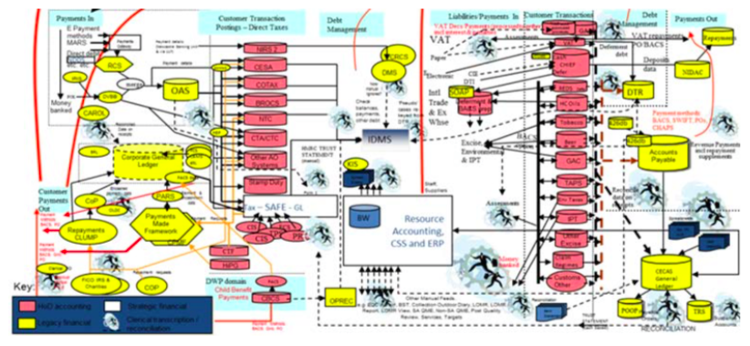
Figure 23 HMRC ICT environment
Source: NAO (2013)

Solution
HMRCs vision in overhauling their existing IT estate was to re-engineer their systems so the bulk of their IT functions could operate on ‘virtual infrastructure environments’ held on product cloud services, without having to replace them leading to increased outlay. (HMRC, 2016) One initiative HMRC invested in was Robotic Process Automation (RPA) technology to help automate laborious clerical jobs, and connect digital services and systems to enable end-to-end processing, with minimal IT development work.

Implementation
HRMCs vision focused on four key areas - customers, staff, compliance and systems (see Figure 24)
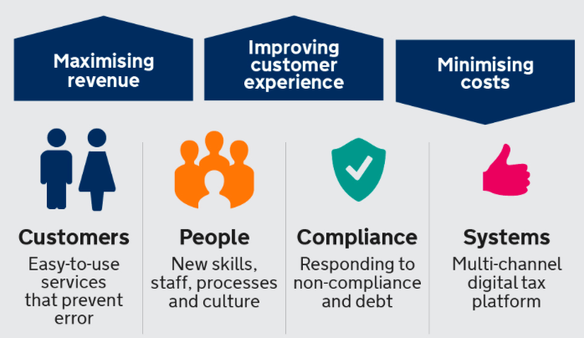
Figure 24 HMRC digital vision
Source: HMRC (2014)

HRMC delivered change through a number of initiatives.

- Early engagement - A year before the implementation the HMRC and lead suppliers engaged to develop the project strategy. This allowed time for a detailed implementation methodology to be devised, reducing the impact on routine operations. (Axelos, 2012)

2. Instigating Information Technology Infrastructure Library (ITIL) change processes - Each of the five stages is focused on a specific phase of a service's lifecycle (See Figure 25). ITIL allowed the HRMC to focus on IT service management. “Using a lifecycle system takes a holistic view of services and eliminates silo functions.” BMC.com (2018)

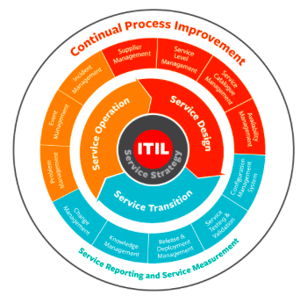
Figure 25 ITIL lifecyle model
Source: BMC.com (2018)

3. Professional development – HMRC and external software engineers aligned their teams with the latest standards and qualifications in IT service management. In addition, to support the HMRCs growing digital capability a recruitment drive was established to recruit subject matter experts, promising graduates and trainees to establish flexible high-quality multi-skilled units.

4. Change management assurance - The HMRC established an advisory board to formalise the acceptance of IS changes before any reform could take place.

5. Customer Support - HRMC ensured their contractors provided a life support capability to enable the smooth transition of major reform to guard against problems occurring post implementation. Ensuring accountability was upheld until the exit criteria was realised, only then was the service was passed to HRMC.
Results
HMRC saw a £8.2 million per annum fall in IT running costs, due to the following initiatives:
- A new payment system that replaced four legacy services.
- Retirement of a twenty-five year old legacy service.
- Consolidating other services.
- Enhancing end user roles across the forty-eight services.
- Updating technology across the entire IT landscape.
HMRC’s employee professional development improved “By April 2011, all managers were members of the British Computer Society (BCS), and over 90% had achieved Professional status.” Elsewhere, end user customer satisfaction survey revealed “highest-ever overall score of 4.33 out of 6, and the IT Service Centre itself achieved 4.85” (Axelos, 2012) Results from the Robotic Process Automation (RPA) initiative saw a significant reduction in practices for end users, productivity and cost for the organisation. (See Figure 26) Mark Holl (2016) Digital Programme Manager for Paperless HMRC commented, “We've reduced staff ‘clicks’ from 66 down to only 10 clicks. Cutting up to 2 minutes per call.”
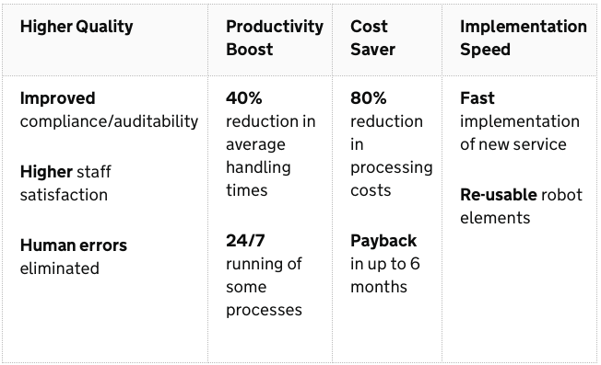
Figure 26 RPA outcomes
Source: Holl (2016)

5. CONCLUSION
5.1 Introduction
This research looked to establish if the British military should adopt a new strategy for their FLIS based on the implementation strategy of MJDI. This study was carried out predominately using the viewpoints and experiences of logistic trained personnel within the British military via questionnaires and a survey as a method of data collection to ascertain the end users’ understanding of the MJDI implementation strategy. Another primary objective of the case study was to identify both alternative private and public sector successful IS implementation strategies that could used if the findings proved that the MJDI strategy was not fit for purpose. The author envisaged the conclusions would provide a better understanding of whether the British military’s current IS implementation strategy was effective or a different strategy would be worth considering when the FLIS implementation occurs. The investigation explored IS implementation using the end users opinions and thoughts against the DeLone and McLean ISS Model. The author decided the combination of qualitative and quantitative data in a mixed methodology best supported the study. Choosing qualitative and quantitative data allowed the author to use triangulation by blending controlled questionnaires of selected personnel, with the survey results of 1,314 participants from the BA HQ Logistic Support Branch MJDI survey. By exercising a mixed methodology, the author obtained distinct information, providing data sets that answered research objectives independently. Dovetailing the qualitative data with quantitative data which the delivered sufficient evidence to establish the relevance of the outcome of research objective 3. To carry out the research, quantitative data obtained from a BA HQ MJDI survey, provided the data for research objective 1; this was complemented by a sample group of specifically designated LSS and AA trained personnel responded to a qualitative questionnaire on their thoughts and opinions of MJDI to answer research objective 2; additionally, qualitative literature was collated and examined in mini case studies to establish alternative successful private and public sector IS implementation strategies to answer research objective 3. Based on the research questions and findings of this study, the following conclusions were formulated and are presented below:

5.2 Research objective 1 – Ascertain amongst the end-user community if they deemed the implementation experience of MJDI to be effective and suitable.

The quantitative data indicated that the end user found the system functionality and processes difficult to comprehend due to the multi-layered structure. The majority of end users thought MJDI to be harder to use than the previous system. Furthermore, end users judged MJDI less effective in contributing towards unit output than the previous system. The complexity of MJDI was amplified within the end user’s competency with virtually all ranks feeling they had a low level of competence. Coupled with insufficient conversion training modules meant the end user struggled to carry out their daily tasks effectively. The participants initially considered the conversion training adequate, however, as they became familiar with the complexity and scope of the system this level reduced, only after twelve months did participants express having similar levels to when they first started. The customer help tools were also lacking in quality and depth, which only amplified the end user’s angst. Although 80% of participants had seen the MJDI portal, User Guides and the UPK, they were not impressed with the quality of the tools. Around 40% of respondents rated the different resources only as ‘quite useful’ and just 20% respondents found the UPK ‘very useful’. These findings lead the author to postulate based on the participants’ evidence at the time of study the implementation strategy was not effective or fit for purpose.

5.3 Research objective 2 – Establish how effective MJDI is operating four years after implementation.

The feedback from participants responding to the questionnaires revealed a stark contrast to the findings to the data revealed in research objective 1. Comments from the participants were very positive throughout. For example, when asked to rate MJDI all participants agreed MJDI was ‘good’ or ‘very good’. One participant commented, “I think it is easy to understand what MJDI does and it is a very good system” The positive trend continued when participants were canvassed on the functionality. One participant commented “All in all when logging in for the first time I did have a sense that I knew what to do and how.” On the subject of end user competency 76% of participants expressed they were ‘very confident’ and 24% ‘extremely confident’ in performing their tasks. Elsewhere, participants’ responses continued to portray an upbeat sentiment. When asked if they have the necessary skills, one respondent stated “I have been able to learn the system processes and have even provided temporary 'work around' solutions to enable other units to continue running their accounts while a permanent solution is provided/programmed in to the system.” Whilst another remarked, “I feel my level of competency is very good through time spent on the system and problem solving.” When end users were canvassed about the training, 73% of participants’ deemed the training to be of a ‘very good’ standard. Participants’ responses also indicated that the training had improved since the initial implementation. When asked to comment on the level of instruction, virtually all of the remarks were positive. For example, one response stated, “Overall the instructors were very knowledgeable personally passing on stuff that has been learnt using MJDI on the 'live' system.” Another commented, “The training was well structured and well delivered, despite a few issues with the training server.” However, the training aspect of MJDI did have some negative feedback for example, one respondent replied, “There was too much to take in and it only dealt with the perfect world, i.e. not if you encountered a problem.” Another respondent stated, “The course needs to be much longer, and more time spent on unit configuration and the whole system needs to be explained in more depth.” In terms of end-user guides and literature, the end-user reaction was strong, 66% of participants felt the customer support capability to be ‘very good’, and 34% deeming the training ‘good’. When questioned about how well they perform to meet their requirements, the common response was ‘very well’. Likewise, when probed about the online literature one participant commented, “UPK has been the main learning tool which I feel is excellent, I am learning all the time.” Another participant remarked, “Generally this system is far better,” when questioned on the MJDI Help Desk facility. The participants who took part in the research practically all responded with positive views. These findings lead the author to postulate there has been a significant improvement across all aspects of MJDI in the ensuing years since the IS was introduced.

5.4 Research objective 3 – Identify successful implementation strategies that could be used as an alternative strategy to introduce their FLIS.
All three strategies presented routes to IS implementation success. However, what was clear is that all three organisations chose different methodologies, yet there were similarities in aspects of their approaches in order to realise their success. Lufthansa Technik opted to pursue a pilot IS implementation. The PM was centred on a process-based methodology focusing on activities to generate efficiencies in their business. Using the lean method Lufthansa executed the PM in a top-down style where the leading contribution of concepts derived from the end users. This approach enabled them to execute an incremental CM style, which facilitated continuous improvement by encouraging creative thinking and rewarding innovative ideas from the workforce to achieve system efficiencies. LGE pursued a phased IS implementation approach by introducing specific modules of the e-HR system from one region to another, only when each was passed fit before moving onto the next region. The PM was centred on a process-based methodology focused on continuous improvement, where they implemented their e-HR upgrade by selecting divisions that needed the modernisation the most. Using the continuous improvement method LGE concentrated on their business process enhancement in stages to support the SSC by aligning and amalgamating with their present internal portal. This approach enabled them to execute an incremental CM style similar to Lufthansa. Carried out over five deliberate stages with defined goals, that permitted LGE to alleviate the risks by updating their HR departments one region at a time. HMRC employed a parallel IS implementation due to the vast amount of servers and systems that were in use. They elected to use an agile PM strategy, which focused on four key areas - customers, staff, compliance and systems. This allowed for a series of requirements and solutions such as re-engineering their existing systems, so the bulk of their IT functions could operate without having to replace them leading to increased outlay. This approach enabled them to execute a transformative CM approach based on five change initiatives including: early engagement; business process reengineering: improved employee professional development skills: change management governance and a distinct customer support objectives. Although each organisation employed different implementation methods, the author postulates what underpinned their success was their acknowledgement to recognise the importance of the end user implementation process. For example, Lufthansa executives empowered management to involve the end users to contribute to the development of ideas and innovation. Whilst LGE personnel managed the progress and enablement of the project and were primarily accountable for the IS development. Elsewhere HMRC aligned their teams with the latest standards and qualifications in IT service management whilst promising graduates and trainees opportunities to establish high-quality multi-skills.

5.5 Concluding summary
The aim of this study was to establish if the British military’s current inventory LogIS implementation model was effective or whether the use of a different implementation strategy would enhance the BAs next FLIS. The hypothesis tested was:
H₀: The British Military’s current IS implementation model strategy is fit for purpose.
H_{0A}: British Military’s current IS implementation model strategy is not fit for purpose.
This problem extended to form three Research Objectives.

- Ascertain amongst the end-user community if they deemed the implementation experience of MJDI to be effective and suitable.

- Establish how effective MJDI is operating four years after implementation.
- Identify successful implementation strategies that could be used as an alternative strategy to introduce their FLIS.

To answer the research question, “Should the British military adopt a new strategy to introduce the next inventory system?” The analysis of research objective 1 confirmed that MJDI was not well implemented at the beginning of its infancy. However, research objective 2 established MJDI now operates effectively as senior commanders anticipated it to be. Research objective 3 confirmed that all three implementations could offer the British military a suitable alternative strategy for implementing the FLIS if required. Although, no particular organisation’s strategy was deemed the more appropriate. However, there were aspects that all three encompassed which the British military ought to consider in particular, the complete integration of the end user in the IS implementation; comprehensive training; open and two way communication networks; and credible customer support tools. Thus, the author concludes that the evidence of research objective 1 and 2 supports the H₀ hypothesis. Had the evidence in research objective 2 revealed a similar outcome to research objective 1 the author would have concluded the evidence to support H_{0A}. This would have given more significance to research objective 3 supporting the alternative hypothesis.

6 RECOMMENDATIONS
6.1 End user involvement
The British military must recognise and involve the end user into the implementation of any new system from the outset. The end user has a myriad of subject-matter experience that should be considered in shaping how the change will be brought about. Doing so may reduce the frictions and issues that could manifest later in the project or, worse still, once the change has occurred.

6.2 Training
End users would be better served if training for the FLIS were conducted at unit locations on a live system. Software developers alongside LSS instructors should oversee the unit staff from the system’s very first use until they can demonstrate that they can carry out all the processes and functions correctly and consistently. Additionally, where end users missed the training for courses or operations, they should have the opportunity to compete a comprehensive standard training course, similar to what LSS and AA would receive on their logistic upgrade courses. This would allow personnel who missed the original training to be competent in using the system, as opposed to getting incorrect advice or instruction from colleagues.

6.3 Help tools
The end user should have to complete online type courses prior to beginning their training to ensure that they start with adequate knowledge and understanding of the system and its processes. Additionally, customer support tools should be regulated and verified for their accuracy, currency and usability prior to being released.

6.4 Further research
Further research of other government departments that have implemented or are implementing LogIS is advocated such as HMRC. This would permit the project team to consider what advantages and disadvantages manifested, enabling them to implement and avoid the best and worst aspects of other implementations. Additionally, the following topics could offer supplementary research opportunities:

- Should the MoD invest in the leading LogIS hardware and software available as opposed to reengineering business processes of the existing system?

- Should the MoD’s inventory be owned and managed by contractor logistic support organisations and staff, thereby taking the problem away from the military units?

7. REFERENCES
Anup, C. (2010) LG Electronics: HR management by Consolidating on a Single Global HRMS. [online]. Available from: https://www.slideshare.net/Creative_Anup/hrms-lg [Accessed 24 Jul 2018].

Ajani, S. A. (2002) Extreme Project Management: Unique Methodologies – Resolute Principles – Astounding Results [online]. Lincoln, Nebraska: Writers Club Press Available from https://books.google.com.au/books?isbn=0595213359 [Accessed 22 Oct 2017].

Arvidsson, V. (2014) Information systems use as strategy practice: A multi-dimensional view of strategic information system implementation and use. The Journal of Strategic Information Systems. 23 I(1), pp. 45-61.

Aston, B. (2017) 9 Project Management Methodologies Made Simple. [online]. Available from: https://thedigitalprojectmanager.com/project-management-methodologies-made-simple/ [Accessed 4 Jul 2018].

Australian Institute of Business (AIB) (2016) 7 Key Factors for Successful Change Management. [online]. Available from: http://aib.edu.au/blog/organisations-culture/7-key-factors-successful-change-management/? [Accessed 4 Nov 2017].

Axelos (2012) Managing Successful Change - IT Service Transformation at HMRC. [online]. Available from: file:///Users/JJH/Desktop/HMRC/Managing%20Successful%20Change:%20IT%20Service%20Transformation%20at%20HMRC.webarchive [Accessed 25 Jul 18].
Babbie, E. (1986) Observing ourselves. Belmont: Wadsworth.

Bagozzi, R. Gurnao-Canli, Z. and Priester, J. (2002) The Social Psychology of Consumer Behaviour. Buckingham: Open University Press. [online] Available from: https://books.google.com.au/books?isbn=0335207227 [Accessed 2 Nov 2017].

Barker, S. (2013) Brilliant PRINCE2: What you really need to know about PRINCE2. [online]. Available from: https://books.google.com.au/books/about/Brilliant_PRINCE2.html?id=maUDAAAAQBAJ&redir_esc=y [Accessed 27 Apr 18].

Barki, H. and Hartwick, J. (1989) Rethinking the concept of user involvement.
MIS Quarterly [online]. 13 (1), pp.53-63. Available from: https://dl.acm.org/citation.cfm?id=70962 [Accessed 28 Oct 2017].

Blaikie, N. (2004) Analyzing Quantitative Data: From Description to Explanation [online]. Available from: https://books.google.com.au/books?isbn=1446223655 [Accessed 8 Nov 2017].

Blatchford, P. (2005) A multi-method approach to the study of school class size differences. International Journal of Social Research Methodology [online] 8 (3), pp.195-205 Available from: www.tandfonline.com/doi/pdf/10.1080/13645570500154675 [Accessed 12 Nov 2017].

Bryman, A. (1988) Quantity and Quality in Social Research [online]. London: Unwin Hyman. https://books.google.com.au/books/about/Quantity_and_Quality_in_Social_Research.html?id=jDaIAgAAQBAJ&redir_esc=y [Accessed 8 Nov 2017].

Cameron, E. and Green, M. (2015) Making Sense of Change Management: A Complete Guide to the Models, Tools and Techniques of Organizational Change [online]. London: Kogan Page Ltd Available from: https://www.koganpage.com/download?id=2597 [Accessed 3 Nov 2017].

Cassidy, A. (2006) A Practical Guide to Information Systems Strategic Planning. 2nd edition. [online] Boca Raton: Taylor & Francis Group. Available from: https://books.google.com.au/books?isbn=0849350735 [Accessed 2 Nov 2017].

Chang, E. Prior, D.D and Gottwalt, F. (2014) Towards an Integrated System for Army Logistics Management. [online]. Available from: https://www.army.gov.au/sites/g/files/net1846/f/aaj_vol13-2_chang.pdf [Accessed 3 Apr 2018].

Cooper, R.B. and Zmud, R.W. (1990) Information technology implementation research: A technological diffusion approach. Management Science [online]. 36 (2), pp. 123-139. Available from: https://econpapers.repec.org/article/inmormnsc/v_3a36_3ay_3a1990_3ai_3a2_3ap_3a123-139.htm [Accessed 3 Nov 2017].

Cresswell, J.W. (2014) A Concise Introduction to Mixed Methods Research. [online]. Thousand Oaks: Sage Publications Ltd. Available from: https://books.google.com.au/books?isbn=1483359050 [Accessed 8 Nov 2017].

Cresswell, J.W. (2009) Research Design: Qualitative, Quantitative, and Mixed Methods Approaches [online]. Thousand Oaks: Sage Publications Ltd. Available from: https://books.google.com.au/books?isbn=1452239754 [Accessed 11 Nov 2017].

Cummings, T.G. and Worley, C.G. (2009) Organisation Development and Change. [online]. Stamford: Cengage Learning. Available from https://books.google.com.au/books?isbn=0324421389 [Accessed 4 Nov 2017].

Davis, D. D; Bagozzi, R. P; Warshaw, P. R. (1989) User Acceptance of Computer Technology: A Comparison of Two Theoretical Models. Management Science 35(8), 1989, pp 982-1003. [online]. Available from: https://pdfs.semanticscholar.org/ba06/44aa7569f33194090ade9f8f91fa51968b18.pdf [Accessed 25 Apr 18].

DeCarlo, D. (2004). eXtreme Project Management: Using Leadership, Principles, and Tools to Deliver Value in the Face of Volatility. San Francisco: Jossey-Bass [online]. Available from: https://books.google.com.au/books?isbn=0787974099
[Accessed 21 Oct 2017].

DeLone, W.H. and McLean, E. R. (1992) Information systems success: The quest for the dependent variable. Information Systems Research, 3, 1 60–95.[online]. Available from: https://pdfs.semanticscholar.org/a041/45f1ca06c61f5985ab22a2346b788f343392.pdf [Accessed 25 Apr 18].

DeLone, W. H. and McLean, E.R. (2003) The DeLone and McLean Model of
Information Systems Success: A Ten-Year Update. Journal of Management Information Systems / Spring 2003. Volume 19, No. 4, pp. 9–30. [online]. Available from: http://eli.johogo.com/Class/p7.pdf [Accessed 11 Jul 2018].

DeVault, G. (2017) Advantages and Disadvantages of Quantitative Research [online] Available from: https://www.thebalance.com/quantitative-research-advantages-and-disadvantages-2296728 [Accessed 11 Nov 2017].

Doppler, K. (2008) Dynamics of Organizational Change and Learning. [online]. Chichester: John Wiley & Sons Ltd. Available from: https://books.google.com.au/books?isbn=0470021144 [Accessed 28 Oct 2017].

D’Ortenzio, C (2012) Understanding Change and Change management Processes. [online]. Available from: http://www.canberra.edu.au/researchrepository/file/81c02a90-6a15-91ae-c7a2-ff44c96d60b2/1/full_text.pdf [Accessed 24 Apr 18].

Eisenhardt, K.M. (1989) Building theories from case study research.
Academy of Management Review [online]. 14 (4), pp. 532-550. Available from: https://www.jstor.org/stable/258557?seq=3#page_scan_tab_contents [Accessed 9 Nov 2017].

Frankfort-Nachmias, C. and Nachmias, D. (1992) Research Methods in the Social Sciences. 4th Edition. New York: St. Martin's Press.

Freeman, R. (2010) Comparing traditional and agile project management estimation techniques. Tech Decision Maker [online]. 8 September. Available from: https://www.techrepublic.com/blog/tech-decision-maker/comparing-traditional-and-agile-project-management-estimation-techniques/ [Accessed 21 Oct 2017].
Gheorghiu, F. (2006) Why companies fail on the way to implementing project management methodology. Project Management Today 8(10): 1-7.

Goodman J. and Truss C. (2004) The Medium and the message: communicating effectively during a major change initiative. [online]. Taylor and Francis online. Journal of Change Management [online]. 4 (3), pp. 217-228 Available from: https://www.tandfonline.com/doi/abs/10.1080/1469701042000255392[Accessed: 4 Nov 2017].

Goodwin, J. (2012) SAGE Secondary Data Analysis [online]. London: SAGE publications Ltd. Available from: https://books.google.com.au/books?isbn=1446275949 [Accessed 15 Nov 2017].

Goodwin, W. and Goodwin, L. (1996) Understanding Quantitative and Qualitative Research in Early Childhood Education. New York: Teachers College Press [online]. Available from: https://books.google.com.au/books?hl=en&lr=&id=jceIE5e5ZCcC&oi=fnd&pg=PR7&dq=Goodwin,+W.+and+Goodwin,+L.+(1996)+Understanding+Quantitative+and+Qualitative+Research+in+Early+Childhood+Education.&ots=cZRWCbOMiL&sig=FpbWGinlffAaVKInBO5z3IxhJ_E#v=onepage&q&f=false [Accessed 10 Nov 2017].

Grady, M.P. (1998) Qualitative and Action Research: A Practitioner Handbook. Bloomington: Phi Delta Kappa. [online]. Available from: https://books.google.com.au/books?hl=en&lr=&id=JOr3-A3-LbwC&oi=fnd&pg=PA1&dq=Grady,+M.P.+(1998)+Qualitative+and+Action+Research:+A+Practitioner+Handbook.&ots=hBUPRaiCO4&sig=F0-D9JpSgaRfzOLUMR-hEmvnlQo#v=onepage&q=Grady%2C%20M.P.%20(1998)%20Qualitative%20and%20Action%20Research%3A%20A%20Practitioner%20Handbook.&f=false [Accessed 10 Nov 2017].

Graetz, F. and Smith, A. (2005) Organising Forms in Change Management: The Role of Structures, Processes and Boundaries in a Longitudinal case analysis. Journal of change management [online] 5 (3) pp. 311-328. Available from: https://www.tandfonline.com/doi/abs/10.1080/14697010500226723 [Accessed 4 Nov 2017].
Grover, V. and Kettinger, W.J. (2000) Business Process Change: A Reflective View of Theory, Practice and Implications. In Zmud, R.W. (ed.) Framing the Domains of IT Management: Projecting the Future Through the Past. Cincinnati, OH: Pinnaflex Educational Resources. pp. 147-172.
Guba, E. and Lincoln, Y. (1981) Effective Evaluation. San Francisco: Jossey-Bass.
Hammer, M. and Champy, J. (1993) Reengineering the Corporation: A Manifesto for Business Revolution. Harper Business, New York. [online]. Availale from: https://www.amazon.com/Reengineering-Corporation-Manifesto-Revolution-Essentials/dp/0060559535 {Accessed 28 Jun 18].
Harvard Business Review (2012) HBR Guide to Project Management. Boston: Harvard Business Review Press. [online]. Available from: https://books.google.com.au/books?isbn=1422187292 [Accessed 21 Oct 2017].

Harvard University (2017) The Literature Review: A Research Journey [online] Available from: https://guides.library.harvard.edu/literaturereview [Accessed 30 Jun 2017].

Haughey, D. (2013) Project Management Body of Knowledge (PMBOK) [online]. Available from: https://www.projectsmart.co.uk/pmbok.php [Accessed 2 Jul 2018].
Hawking, P., Foster, S. and Stein, A. (2005) ERP II and Change Management: The Real Struggle for ERP Systems Practices. In L.K. Lau, (ed.) Managing business with SAP: planning, implementation and evaluation. Hershey: IGI Publishing, pp. 179-197.
HEC (2016) Change Management: What are the Key Success Factors? [online] Available from: https://execed.hec.edu/en/news-resources/news/change-management-what-are-the-key-success-factors [Accessed 4 Nov 2017].

Hershauer, J.C. and Ruch, W.A. (1978) A Worker Productivity Model and Its Use at Lincoln Electric. [online] Available from: https://pubsonline.informs.org/doi/pdf/10.1287/inte.8.3.80 [Accessed 4 Mar 2018].

HMRC (2016) HMRC Information Technology Strategy. [online]. Available from: https://hmrcdigital.blog.gov.uk/wp-content/uploads/sites/20/2016/02/HMRC-IT-Strategy-20161.pdf [Accessed 23 Jul 18].
HMG (2011) Government ICT Strategy - Strategic Implementation Plan. {online]. Available from: https://assets.publishing.service.gov.uk/government/uploads/system/uploads/attachment_data/file/266169/govt-ict-sip.pdf [Accessed 23 Jul 18].

Holl, M (2016) Robotics and people make a great combination. [online]. Available from: https://hmrcdigital.blog.gov.uk/2016/09/22/robotics-and-people-make-a-great-combination/ [Accessed 24 Jul 18].

Howmann, B. and Stracke, S. (2013) Work Organisation and Innovation - Case Study: LHT, Germany. [online]. Available from: https://www.google.com.au/url?sa=t&rct=j&q=&esrc=s&source=web&cd=2&ved=0ahUKEwjx6KCgn6_cAhUP5rwKHf5sDHwQFggzMAE&url=https%3A%2F%2Fdigitalcommons.ilr.cornell.edu%2Fcgi%2Fviewcontent.cgi%3Farticle%3D1254%26context%3Dintl&usg=AOvVaw3nSsRhjGa4ph-nX_2kIWDg [Accessed 24 Jul 2018].

HSE (2017) Human Factors: An Introduction to Human Factors. [online] Available from: http://www.hse.gov.uk/humanfactors/introduction.htm [Accessed 30 Oct 2017].
Holland, C.P. and Light, B. (1999) A Critical Success Factors Model For ERP Implementation. IEEE Software [online]. 16 (3), pp. 30-36. Available from: https://www.researchgate.net/publication/221407270_A_Critical_Success_Factors_Model_for_Enterprise_Resource_Planning_Implementation [Accessed 5 Nov 2017].
Holt, D.T. Armenakis, A.A., Feild, H.S. and Harris, S.G. (2007) Readiness for Organizational Change. The Journal Of Applied Behavioural Science, 43 (2), pp. 232-255
Howell, M.T. (2009) Critical Success Factors Simplified: Implementing the Powerful Drivers of Dramatic Business Improvement. Boca Raton: Taylor and Francis Group. [online]. Available from: https://books.google.com.au/books?isbn=1439811202 [Accessed 28 Oct 2017].

Johansson, R. (2003) Case Study Methodology. Keynote speech from: Methodologies in Housing Research [online]. Stockholm, 22–24 September 2003. Royal Institute of Technology. Available from: http://www.psyking.net/htmlobj-3839/case_study_methodology-_rolf_johansson_ver_2.pdf [Accessed 9 Nov 2017].

Joshi, K. (1991). A model of users' perspective on change: The case of information systems technology implementation. MIS Quarterly [online]. 15 (2) pp. 229-242. Available from: https://www.jstor.org/stable/249384?seq=1#page_scan_tab_contents [Accessed 3 Nov 2017].

Jurevicius, O. (2013) McKinsey 7s Model [online]. Strategic Management Insight. Available from: https://www.strategicmanagementinsight.com/tools/mckinsey-7s-model-framework.html [Accessed 3 Nov 2017].

Karamitsos, I., Apostolopoulos, C. and Bugami, M. (2010). Benefits management process complements other project management methodologies. [online]. Available from: https://file.scirp.org/pdf/JSEA20100900010_34435139.pdf [Accessed 27 Apr 18].

Kothari, C.R. (2004) Research Methodology: Methods and techniques. Delhi: New Age International. [online] Available from: https://books.google.com.au/books?isbn=8122415229 [Accessed 9 Nov 2017].

Kotter, J. (2012) The 8-Step Process for Leading Change. [online] Available from: https://www.kotterinc.com/8-steps-process-for-leading-change/ [Accessed 3 Nov 2017].

Kubler-Ross, E. (2011) Death and Dying. New York: Scribner. [online]. Available from: https://books.google.com.au/books?isbn=1451664443 [Accessed 3 Nov 2017].

Laudon, K. C. and Laudon, J.P. (2012) Management Information Systems: Managing the Digital Firm 12th edition. Harlow: Pearson Education Ltd. [online] Available from: http://dinus.ac.id/repository/docs/ajar/MIS_KC_Laudon.pdf [Accessed 28 Oct 2017].

Le Cren, M. (2016) Project Management: Methodologies and Styles. [online]. Available from: https://blog.azendoo.com/top-project-management-methodologies-and-styles/ [Accessed 20 Oct 2017].

Leforte, F., McMurray, D. and Tesvic, J. (2015) Secrets to implementation success [online] Available from: https://www.mckinsey.com/industries/consumer-packaged-goods/our-insights/secrets-to-implementation-success [Accessed 22 Oct 2017].

LGnewsroom.com (2018) LG Announces First-Quarter 2018 Financial Results. [online]. Available from: http://www.lgnewsroom.com/2018/04/lg-announces-first-quarter-2018-financial-results/ [Accessed 22 Jul 2018].

Lientz, B.P. and Rea, K.P. (2000) On time Technology Implementation: How to Achieve Implementation Success with Limited Time and Resources. London: Academic Press.

Lufthansa-technik.com (2017) Integrated Management Manual of the Lufthansa Technik Group: Aviation Safety – Quality – Environmental Protection – Occupational Health & Safety. [online]. Availble from: https://www.lufthansa-technik.com/documents/100446/101423/LHT%2BGroup%2BManagement%2BManual%2B052017/16bdcb8a-4e48-4f19-b388-fa7f1fa9313d [Accessed 22 Jul 2018].

Markus, M.L. (1983) Power, Politics, and MIS Implementation. Communications of the ACM 26 (6), pp. 430–444.

Mindtools (2017) Lewin's Change Management Model:

Understanding the Three Stages of Change [online]. Available from: https://www.mindtools.com/pages/article/newPPM_94.htm [Accessed 3 Nov 2017].
McCalman, J. Paton, A.R. and Siebert, S. (2012) Change Management: A Guide to Effective Implementation. 3rd Edition. London: SAGE Publications Ltd. [online] Available from: https://books.google.com.au/books?hl=en&lr=&id=HA0FQOWx8ngC&oi=fnd&pg=PR5&dq=McCalman,+J.+Paton,+A.R.+and+Siebert,+S.+(2012)+Change+Management:+A+Guide+to+Effective+Implementation.&ots=DVuhVnQm1a&sig=gKnVcRP6ymPY83zpycSpEA56V68#v=onepage&q&f=false [Accessed 2 Nov 2017].

McClinton, P. (2018) Project Management Methodologies: A Review of the Literature. [online]. Availble from:

http://www.academia.edu/7055300/Project_Management_Methodologies_A_Review_of_the_Literature [Accessed 26 Apr 18]
McNamee, M. (2016) Defense ERP 2.0. [online]. Available from: https://home.kpmg.com/xx/en/home/insights/2016/03/the-case-for-outsourcing-defense-erp.html. [Accessed 27 Apr 18].

Miller, K. (2012) Our vision: HMRC's IT Strategy. [online]. Available from: https://hmrcdigital.blog.gov.uk/2016/02/12/our-vision-hmrcs-it-strategy/ [Accessed 23 Jul 18].

Mintzberg, H. Quinn, J. B. and Ghoshal, S. (1999) The Strategy Process: Revised European Edition. Harlow: Pearson Education Ltd.

MoD (2007) MJDI Acceptance Strategy. MoD SP-08-02-01.

MoD (2013) Management of the Joint Deployed Inventory (MJDI) Business Processes Version 3.1

Monnappa, A. (2018) Project Management Learning Series: Fast Tracking versus Crashing. [online]. Available from: https://au.simplilearn.com/fast-tracking-vs-crashing-article. [Accessed 27 Jun 18].

Moran, J.W. and Brightman, B.K. (2001) Leading Organizational Change.
Career Development International [online]. Available from: http://psycnet.apa.org/record/2009-20264-006 [Accessed 20 Oct 2017]

Morgan, M.J. and Summers, J (2005) Sports Marketing. Southbank: Thomson. [online] Available from: https://books.google.com.au/books?hl=en&lr=&id=R-Kn3jVW39gC&oi=fnd&pg=PP10&dq=Morgan,+M.J.J+and+Summers,+J+(2005)+Sports+Marketing&ots=9s0PtNWk_g&sig=WJTt2QGE1Gdd3ML1q3yaoameao - v=onepage&q&f=false [Accessed 15 Nov 2017].

Mrsic, M. (2017) Extreme Project Management XPM. ActiveCollab [online]. Available from: https://activecollab.com/blog/project-management/extreme-project-management-xpm [Accessed 22 Oct 2017].

Mullins, L.J. (1999) Management and Organisational Behaviour. London: Financial Times Professional Limited.

Muslihat, D. (2018) 7 popular project management methodologies and what they’re best suited for. [online]. Available from: https://blog.zenkit.com/7-popular-project-management-methodologies-and-what-theyre-best-suited-for-8f2c790267f6 [Accessed 16 Jul 2017].

NAO (2013) The HMRC VAT service: the impact of legacy ICT. [online]. Available from: https://www.nao.org.uk/wp-content/uploads/2013/08/10185_HMRC-VAT-service-the-impact-of-legacy-ICT-case-study.pdf [Accessed Jul 23 18].

Newman, I. and Benz, C. (1998) Qualitative-quantitative Research Methodology: Exploring the Interactive Continuum. Illinois: SIU Press [online]. Available from: https://books.google.com.au/books?isbn=0809321505 [Accessed 10 Nov 2017].

Newman, D.M. (2013) Sociology: Exploring the Architecture of Everyday Life. London: SAGE Publications. [online]. Available from: https://books.google.com.au/books?isbn=1483323390 [Accessed 10 Nov 2017].

Norris, B., Currie, L. and Lecko, C. (2012) The importance of applying human factors to nursing practices. Nursing Standard. 26 (32), pp.36-40.

Orlikowski, W.J. and Baroudi, J.J. (1991) Studying information technology in organizations: Research approaches and assumptions. [online]. Massachusetts Institute of Technology and New York University. Available from: http://citeseerx.ist.psu.edu/viewdoc/download?doi=10.1.1.103.107&rep=rep1&type=pdf [Accessed 9 Nov 2017].

Othman, S. (2011) Qualitative vs. Quantitative Research. SORM [online]. Available from: http://shayaaresearch.blogspot.com.au/2011/04/qualitative-vs-quantitative-research-v.html [Accessed 11 Nov 2017].

Pan, S.L (2008) LG Electronics, Inc.: Implementing an e-HR System – Teaching Notes. [online] Available from: https://aitcs.comp.nus.edu.sg/wp-content/uploads/2011/02/LG-ES006-Teaching-Note.pdf [Accessed 22 Jul 2018].

Pando, A. (2018) How Technology Is Redefining E-Commerce. [online]. Available from: https://www.forbes.com/sites/forbestechcouncil/2018/03/06/how-technology-is-redefining-e-commerce/#58735ab562e3 [Accessed 12 Dec 2018].

Pannu, A. (2012) Defence Logistics Information Systems: Information Systems’ Driven Capabilities Redefining Logistics. [online] Available from:
www.frost.com/prod/servlet/cio/263377405 [Accessed 26 Oct 2017]

Patton, M.Q. (2001) Enhancing the Quality and Credibility of Qualitative Analysis. Health Services Research [online]. Available from: https://www.ncbi.nlm.nih.gov/pmc/articles/PMC1089059/ [Accessed 12 Nov 2017].

Patzer, G.L. (1995) Using Secondary Data in Marketing Research. Westport: Quorum Books. [online]. Available from: https://books.google.com.au/books?isbn=0899309615 [Accessed 12 Nov 2017].
PMI Standards Committee (1987) Project Management Body of Knowledge (PMBOK) Drexel Hill, PA: Project Management Institute.
PMI (2017) PMBOK Guide – Sixth Edition [online]. Available from: https://www.pmi.org/pmbok-guide-standards/foundational/pmbok [Accessed 2 Jul 2018.
Prabhakar, G. P. (2008) Projects and Their Management: A Literature Review [online]. Available from: http://eprints.uwe.ac.uk/14461/1/1290-3887-1-PB.pdf [Accessed 27 Apr 18]

Priyanka, A. (2016) Critical Evaluation of Prince2 and Agile Project Management Methodologies for a complex project. [online]. Available from: https://www.ijecs.in/index.php/ijecs/article/download/2726/2517/ [Accessed 27 Apr 18].
Reddy, S.S.S (2009) Literature Review [online]. Available from: http://shodhganga.inflibnet.ac.in/bitstream/10603/170876/4/chapter%203_%20s%20s%20%20reddy.pdf [Accessed 24 Apr 18].

Redhat.com (2018) Lufthansa Technik Builds a Digital Foundation with Red Hat.
[online]. https://www.redhat.com/en/success-stories/lufthansa-technik [Accessed 27 Jul 18].
Reharjo, C. (2016) IT Project Management - Aligning PMBOK Processes and SDLC. [online]. Available from: https://www.slideshare.net/CrysanthusRaharjoPMP/it-project-management-aligning-pmbok-processes-and-sdlc [Accessed 29 Jun 2018].

Rigby, G. (2011) From Vision to Exit: The Entrepreneur’s Guide to Building and Selling a Business. Petersfield: Harriman House Ltd.
Rockart, J. and Treacy, M. (1982) The CEO goes on-line. Harvard Business Review. (January-February) pp. 84-88. [online] Available from: https://hbr.org/1982/01/the-ceo-goes-on-line [Accessed 28 Oct 2017].
Rouse, M. (2015) Implementation [online]. Available from: http://searchcrm.techtarget.com/definition/implementation [Accessed 19 Oct 2017].

Salkin, N.J. (2010) Primary Data Source. In Encyclopaedia of Research Design [online]. Available from: http://methods.sagepub.com/reference/encyc-of-research-design/n333.xml [Accessed 12 Nov 2017].

Schaffer. R.H. (2017) All Management is Change Management. Harvard Business Review [online]. Available from: https://hbr.org/2017/10/all-management-is-change-management [Accessed 2 Nov 2017].

Schaffir, W.B. and Stebbins, R. (1991) Experiencing fieldwork. Newbury Park: Sage Publications.

Schmidt, R., Lyytinen, K., Keil, M. and Cule, P. (2001) Identifying Software Project Risks: An International Delphi Study. Journal of Management Information Systems [online]. 17 (4) pp. 5-36. Available from: https://dl.acm.org/citation.cfm?id=1289670 [Accessed 28 Oct 2017].

Segars, A.H. and Grover, V. (2005) An empirical evaluation of stages of strategic information systems planning: patterns of process design and effectiveness. Journal of Information and Management [online]. 42 (5) pp. 761-779 Available from: https://dl.acm.org/citation.cfm?id=1709336 [Accessed 28 Oct 2017].

Seth, S. (2018) LG: A case study of successful Enterprise Resource Planning. [online]. Available from: https://www.investopedia.com/articles/investing/111214/lg-case-study-successful-enterprise-resource-planning-system.asp [Accessed 28 Jul 2018].

Shaw, G. (2015) 4 change management models for your small business. National Leasing [online]. 2 September. Available from: https://www.nationalleasing.com/en/blog/entry/4-change-management-models-for-your-small-business [Accessed 3 Nov 2017].

SmartSheet (2017) Which (of the Numerous) Change Management Models and Methodologies is Right for Your Organization [online]. Available from: https://www.smartsheet.com/which-numerous-change-management-models-and-methodologies-right-your-organization [Accessed 4 Jan 2018].

Stewart, D.W. and Kamins, M.A. (1993) Secondary Research: Information Sources and Methods. London: SAGE Publications [online]. Available from: https://books.google.com.au/books?isbn=0803950373 [Accessed 12 Nov 2017].

Strauss, A.L. (1987) Constant Comparison: Qualitative analysis for social scientists. New York: Cambridge University Press.

Tashakkori, A. and Teddlie, C. (1998) Mixed Methodology: Combining Qualitative and Quantitative Approaches. Thousand Oaks, CA: Sage [online]. Available from: https://books.google.com.au/books?hl=en&lr=&id=qtW04-pRJZ0C&oi=fnd&pg=PR9&dq=Tashakkori,+A.+and+Teddlie,+C.+(1998)+Mixed+Methodology:+Combining+Qualitative+and+Quantitative+Approaches&ots=6g8opC7aoO&sig=Gx3MVJjJPO_4yTxAGPdOUKpFurw#v=onepage&q=Tashakkori%2C%20A.%20and%20Teddlie%2C%20C.%20(1998)%20Mixed%20Methodology%3A%20Combining%20Qualitative%20and%20Quantitative%20Approaches&f=false [Accessed 8 Nov 2017].

Taylor, P. (2015) End User Involvement. [online]. Available from: https://www.projectmanagement.com/blog-post/13538/End-User-Involvement [Accessed 19th Dec 2018].
Tellis, W. (1997) Introduction to Case Study. The Qualitative Report [online]. 3 (2) Available from: http://www.nova.edu/ssss/QR/QR3-2/tellis1.html. [Accessed 19th August 2014].

Thomas, D. and Hodges, I. (2010) Designing and Managing Your Research Project: Core Skills for Social and Health Research. London: SAGE Publications

Thomas, (2011) A Typology for the Case Study in Social Science Following a Review of Definition, Discourse and Structure. Qualitative Inquiry. 17, 6, 511-521
Turner, J.R. (2008) The handbook of project-based management: leading strategic change in organizations. 3rd ed. [online]. New York: McGraw-Hill. Available from: http://213.55.83.214:8181/Management/02949.pdf [Accessed 4 Nov 2017].
Umble, E.J., Haft, R.R. and Umble, M.M. (2003) Enterprise Resource Planning: Implementation Procedures and Critical Success Factors. European Journal of Operational Research [online]. 146 (2), pp. 241-257. Available from: http://fumblog.um.ac.ir/gallery/645/4372-Enterprise%20resource%20planning-%20Implementation%20procedures%20and%20critical%20success%20factors%20(1).pdf [Accessed 28 Oct 2017].

Valacich, J. and Schneider, C. (2010) Information 4e Systems Today: Managing in the Digital World. 4th Edition. Harlow. Pearson.

Watson, R. T. (2018) Electronic Commerce: The Strategic Perspective. [online]. Available from: https://opentextbc.ca/electroniccommerce/chapter/introduction/ [Accessed 15 Dec 2018].

Webster, M. (2012) Kotter’s 8-Step Change Model [online]. Available from http://www.leadershipthoughts.com/kotters-8-step-change-model/ [Accessed: 2 Nov 2017].

Widdowson, A. and Carr, D. (2002) Human factors integration: Implementation in the onshore and offshore industries [online]. Available from: http://www.sciencedirect.com/science/article/pii/S2212827115009452 [Accessed 5 Nov 2017].

Wysocki, R.K. (2007) Effective Project Management: Traditional, Adaptive, Extreme [online] Available from: https://www.wiley.com/en-au/Effective+Project+Management%3A+Traditional%2C+Adaptive%2C+Extreme%2C+4th+Edition-p-9780470042618 [Accessed 21 Oct 2017].

Wysocki, R.K. (2010) Adaptive Project Framework: Managing Complexity in the Face of Uncertainty. Boston: Pearson Education. [online]. Available from: https://books.google.com.au/books?isbn=0321700619

[Accessed 21 Oct 2017].

Yi, J. (2016) LG case study. [online]. Available from: https://prezi.com/jxze7sqnqql_/lg-case-study/ [Accessed 21 Jul 2018].

Yin, R.K. (1994) Case Study Research: Design and methods. 2nd Edition.
Thousand Oaks: Sage publications Inc.

8. BIBLIOGRAPHY

Brown, R.B (2006) Doing Your Dissertation in Business and Management: The Reality of Researching and Writing. London: SAGE.

Buckley, R. and Caple, J. (1996) One to One Training and Coaching Skills. 2nd edition. London: Kogan Page.

Carnall, C.A. (1991) Managing Change. London: Routledge.

Deal, T.E. and Kennedy, A.A. (1988) Corporate Cultures: The Rites and Rituals of Corporate Life. London: Penguin Books Ltd.

Drucker, P. (1995) Managing in a Time of Great Change. New York: Truman Talley Books.

Goldratt, E.M. and Cox, J. (1993) The Goal: A Process of Ongoing Improvement. Aldershot: Gower.

Handy, C.B. (1993) Understanding Organisations. London: Penguin.

Hofstede, G. and Hofstede, G.J. (2004) Cultures and Organisations: Software of the Mind. 2nd edition. London: McGraw-Hill.

Kotter, J.P. and Heskett, J.L. (1992) Corporate Culture and Performance. New York: Maxwell Macmillan International.

Levin, P. (2011) Excellent Dissertations! Maidenhead: Open University Press.
Mintzberg, H. and Quinn, J.B. (1991) The Strategy Process. New York: Prentice Hall.

Oakland, J. (1995) Total Quality Management: The Route to Improving Performance. Oxford: Butterworth-Heinemann.

Parsloe, E. (1995) The Manager as Coach and Mentor. London: Institute of Personnel Development.

Saunders, M., Lewis, P. and Thornhill, A. (2012) Research Methods for Business Students. Harlow: Pearson.

Schein, E.H. (1997) Organisational Culture and Leadership. San Francisco: Jossey-Bass.

Senior, B. and Swailes, S. (2010) Organisational Change, Harlow: Pearson Education.

Sliverman, D. (2010) Doing Qualitative Research: A Practical Handbook. 3rd edition. London: SAGE.

Swetnam, D. (2000) Writing Your Dissertation: How to Plan, Prepare and Present Successful Work. 3rd edition. Oxford: How To Books.

9. APPENDICES
Appendix 1
Trial Questionnaire Form
Date:

Position Held:

Military/Civilian/Contractor:

Unit Organisation:

Part/Full time:

MJDI Qualifications:

1. What is your opinion of the MJDI portal?

2. What did you think of the training?

3. After completing the training how well did it prepare you for using MJDI?

4. What is your opinion of the MJDI user guides?

5. What is your opinion on the User Productivity Kit (UPK)?

6. What is your opinion on the Army HQ Supply Chain Supplementary Instruction (SCSI)?

7. How do you feel about the role and responsibilities you have to perform using MJDI? - Explain

8. What are your thoughts about the logistic practices and processes of MJDI - Explain

9. How would you rate MJDI as an Information System?

10. How well do you think MJDI was delivered into service?

Appendix 2

QUALITATIVE QUESTIONNAIRE TEMPLATE

Date:

MJDI Role:

LSS/AA

OFFR/SNCO/JNCO/PTE

Location:

Q1 Overall, how would you rate MJDI?

☐ Excellent ☐ Very Good ☐ Good ☐ Fair ☐ Poor

Q2 Which of the following words would you use to describe MJDI? Select all that apply.

☐ High Quality ☐ Reliable ☐ Useful ☐ Unreliable ☐ Poor Quality

Q3 How do you feel MJDI contributes towards the overall logistic functionality? Comment below.

Q4 How do you feel about the user interface of MJDI? Comment below.

Q5 How do you feel about MJDI increasing unit logistic production? Comment below.

Q6 How confident are you at performing your roles and responsibilities on MJDI?
☐ Extremely Well ☐ Very Well ☐ Somewhat well ☐ Not so well ☐ Not well at all

Q7 Overall, how would you rate your ability to navigate your way around MJDI?

☐ Extremely Well ☐ Very Well ☐ Somewhat well ☐ Not so well ☐ Not well at all

Q8 How do you feel about having the necessary skills to fulfil your role on MJDI? Comment below.

Q9 What are your thoughts regarding the workbook tool to analyse trends and data? Comment below.

Q10 What functions are particularly good or bad (if any) and why? Comment below.

Q11 Overall, how would you rate the MJDI training?

☐ Excellent ☐ Very Good ☐ Good ☐ Fair ☐ Poor

Q12 How well has the training prepared your for your role on MJDI

☐ Extremely Well ☐ Very Well ☐ Somewhat well ☐ Not so well ☐ Not well at all

Q13 How do you feel about the level of instruction and knowledge imparted during the training packages. Comment below.

Q14 How do you feel about the MJDI training accurately reflecting the actual operating system processes? Comment below.

Q15 What extra training (if any) do you believe would help you in your current role? Comment below.

Q16 How well do the accompanying software tools (User Guides/UPK/SCSI) meet your needs?

☐ Extremely Well ☐ Very Well ☐ Useful ☐ Unreliable ☐ Poor Quality

Q17 How well do you rate the customer support?

☐ Excellent ☐ Very Good ☐ Good ☐ Fair ☐ Poor

Q18 How do you feel about the online literature (User guides/UPK/SCSI) accuracy. Comment below.

Q19 What are your thoughts on the MJDI Help Desk facility? Comment below.

Q20 What customer support opportunities (if any) do you believe would help you to perform your role better?

Appendix 3

British Army HQ Survey Questionnaire

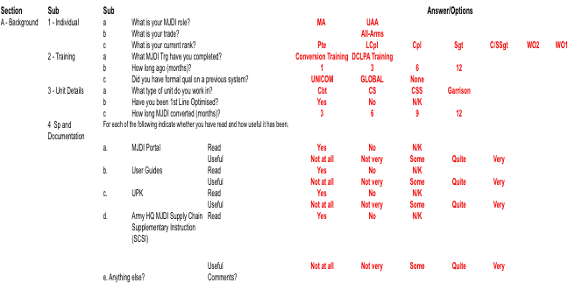

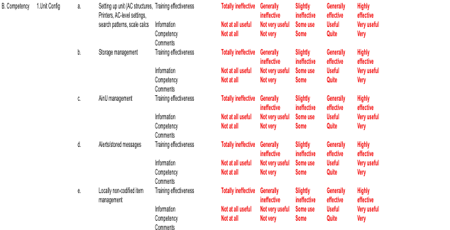

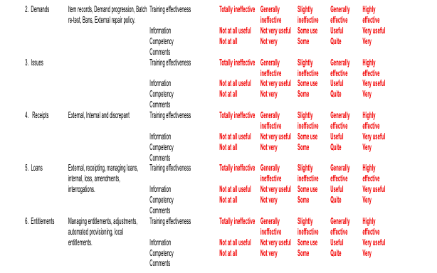

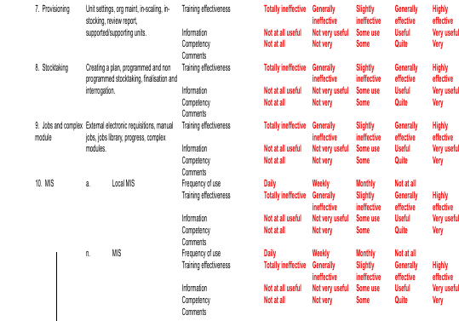

Appendix 4

British Army HQ survey response breakdown

