

Program: BA (HONS) Leadership and Managements Skills in the Workplace
Module: Project Management
Module code: LCLM5003
Module Lecturer: Doreen Amundam
Assignment Title: A program portfolio
PART A: Poster
Part B: Feedback
Part C: Program Management Plan

Student Name: Stancu Petre
Student Code: 2330348

Table of Contents

- Presentation of Poster
- Feedback from the poster Presentation
- A project Management Plan

Project management Plan

- Introduction
- Project Description
- Scope
- Work Breakdown Structure (WBS)
- Quad Chart
- Gantt Chart
- Stakeholder Involvement
- Resource Allocation
- Risk Analysis
- Conclusion
- References

PART A: POSTER
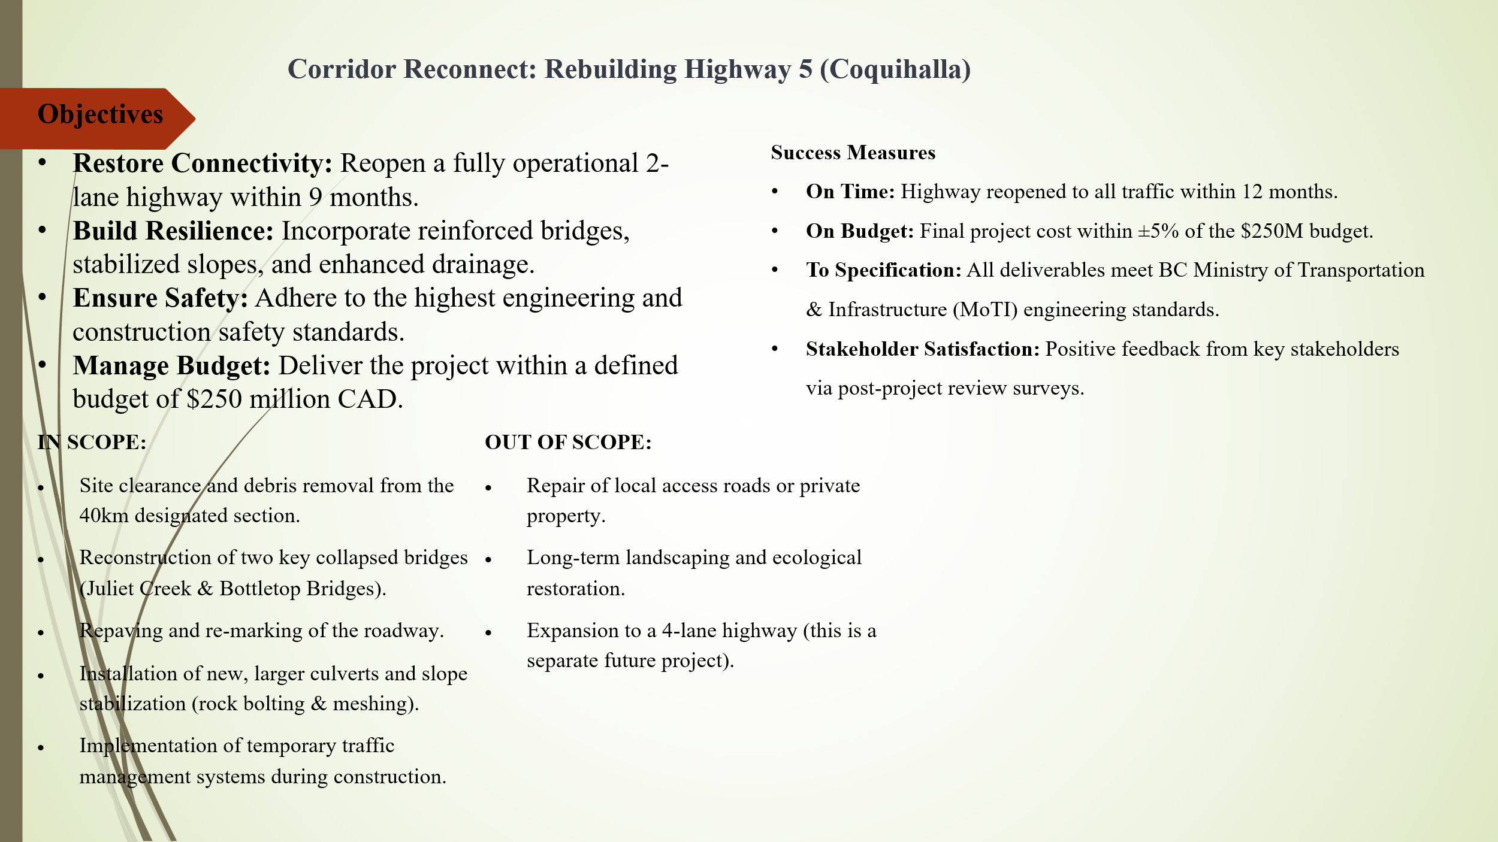

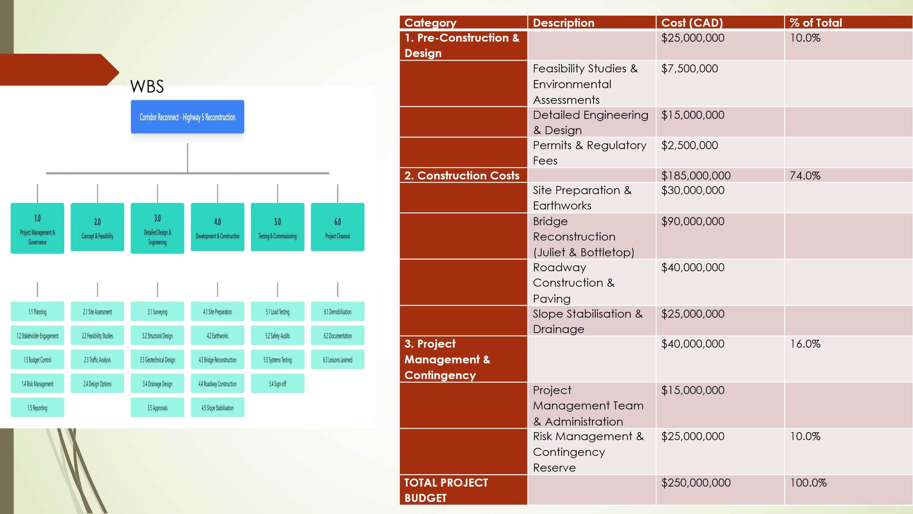

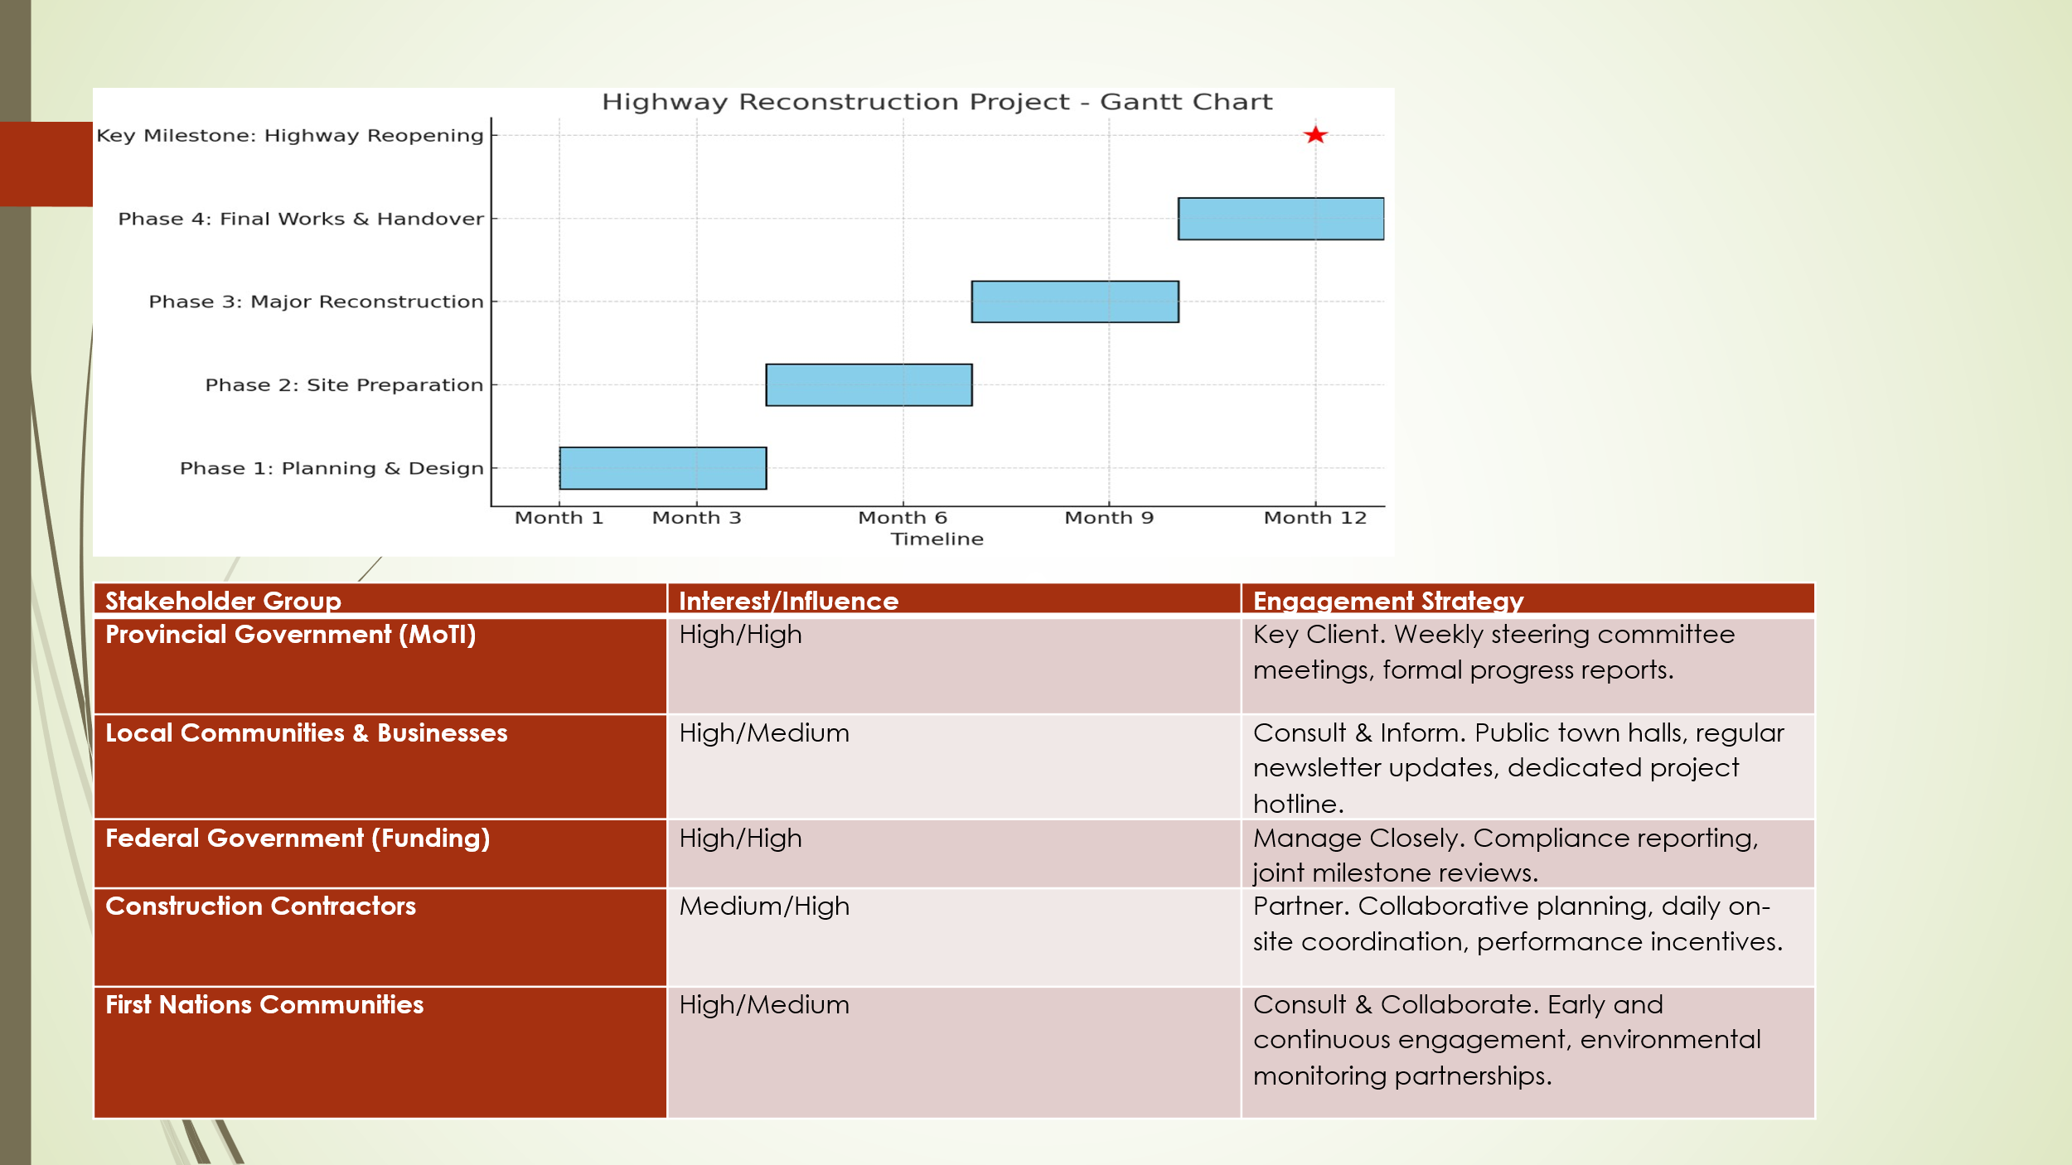

PART B: FEEDBACK

Poster presentation Evaluation Form

student number -2330348

Content/Score | 1 | 2 | 3 | 4 | 5
Introduction/project description |  |  |  | x
Quad chart (Purpose, stakeholders, desired result, measurement) |  |  | x
Work breakdown structure and resources allocation |  |  |  |  | x
Presentation/Professionalism |  | x

What you did well | WBS
What needs improvement | Presentation/Professionalism

Reflection Copy 2 – Personal and Developmental Tone
It has been a very illuminating experience to get the feedback of my tutor and peers. I was happy to know that introduction and description of my project were good aspects of my poster presentation. I had put much effort in creating a clear background, reason and purpose in my project such that anyone who has no knowledge on the subject matter will easily get to know the purpose and value of my project. The constructive response to this aspect has encouraged me to ensure that the final project plan is characterized by this level of clarity and cohesion.
Conversely, I observed that the Strengths sections of the Quad Chart and Evaluation were less strong. Dwelling on this, I understood that my Quad Chart was not able to reflect each of the four key elements in a balanced way. I was too concerned about describing the purpose and stakeholders but failed to explain how the desired results were going to be measured. In the last submission, I will redo this part with clear performance indicators and an objective assessment of how the project goals are related to the project outcomes. My visual aids will include Gantt charts and stakeholder matrices, as well, to make it more powerful and understandable.
Concerning the Evaluation, I am able to note that my first version was not analytical but descriptive. I failed to provide enough strategies of monitoring project success or lessons learned. In the future, I will use a systematic methodology based on principles of monitoring and evaluation (M&E). This will entail the establishment of such criteria as effectiveness, efficiency, impact and sustainability that will be backed by quantitative data and qualitative feedback. I would also create a brief assessment schedule to indicate how and when the findings will be assessed.
The other valuable lesson I learnt among my peers was related to presentation flow and engagement. Even though my professional presentation skills have been praised, I could also work on making the poster look more dynamic and easy to read. I will increase the use of visuals, minimize the level of text, and use the same formatting in sections.
In general, the feedback has helped me to have a more critical and improvement-oriented approach to my project. I have also learned that project communication cannot be successful only in describing the idea, but it is also important to organize the idea logically and analyze it effectively. I have come to realize the importance of ensuring that goals, the results and measurements are aligned to each other. These insights will be included in my final project plan, which will produce a more sophisticated, evidence-based, and visually attractive product that will show analytical and professional development.

PART C: A Project Management Plan

1. Introduction
Climate change has made infrastructure resilience and disaster recovery critical issues in the priorities of current governments because the frequency and effects of extreme weather events are increasing. The Bridge to Recovery project is a fast response project created by the Transportation Division in the Regional District as a result of a disastrous collapse of a very important bridge due to extreme flooding. The project aims at restoring secure vehicular access within the strict timeframe of seven months and a budgeted amount of CAD 18 million. It is not only a reconstruction initiative but a projection on how to develop the bridge in the future so that it is stronger against any form of natural disasters but the implementation process remains transparent to the local communities affected at all the implementation levels.
The given Project Management Plan (PMP) offers an excellent guideline in the organization, construction, and control of the Bridge to Recovery project. It uses globally accepted project management strategies of Project Management Body of Knowledge (PMBOK) and PRINCE2 models to enable strong accountability, efficiency, and risk management (Axelos, 2023). The PMP delineates the project scope, the project work breakdown structure (WBS), the quad chart, project schedule, stakeholder engagement plans, resource allocation plans, and risk management mechanisms to ensure the project is delivered successfully. All these are closely coordinated towards the overall objective of reopening the bridge within seven months in full compliance to the CSA S6 in the Canadian highway bridge design code, and the highest standards of safety, quality and fiscal discipline.

2. Project Description
The Bridge to Recovery project is devoted to the reconstruction of the lost bridge of 40 metres which used to be an important transport node in the region as well as providing emergency assistance and agricultural logistics to the local population. It resulted in significant mobility problems and economic losses, which is why its recovery is critical. The new bridge will be a single-span steel bridge construction that can withstand a flood event, as per the requirements of the Canadian Infrastructure Report Card by the Engineering Canada (Engineering Canada, 2022). The Regional District Transportation Division will provide the oversight, and the design will be primarily done by the Engineering Canada. Building will be done on a competitively tendered contract by a contractor who complies with provincial general and safety standards, and ensures both technical and financial integrity.
It has fourfold goals: to reestablish secure vehicular access in seven months, resilience via climate-adaptive designing, engage the local communities in an open environment, and keep financial control within ±3% of the CAD 18 million budget (Wilson, 2020). The ultimately achieved success will be measured using performance indicators, such as delivering on time, staying within a budget, achieving structural certification in CSA S6, having no major safety incidents, and having more than 90% community satisfaction based on post-completion surveys (Patel and Kim, 2021). In addition to removing significant damaged infrastructures, the project demonstrates the best practices of sustainable, resilient, and community-based project management, establishing a precedent of climate-adaptive recovery projects in Canada.

3. Scope
The project scope must be clearly stated to make sure that all deliverables are realistic and achievable within the budget, time, and resource limits (Kerzner, 2022). The Bridge to Recovery project consists of a number of core activities in it, including the demolition and safe removal of the collapsed bridge, design and construction of a new 40 metre single-span steel bridge, and reconstruction of 500 metres of approach roads on each side. Other activities in-scope comprise installation of guardrails and scour protection of bridge abutments as well as detailed geotechnical and environmental survey. Nonetheless, the upgrade of the whole connecting highway, compensating the losses of businesses in the course of the outage, and long-term flood reduction measures in the region are not the focus of this project, as they are not within its immediate mandate.
The major deliverables of the project include a single span steel bridge that is fully operational and certified, restructured approach roads to the standards of MoTI, safety structures like guardrails and scour protection, and comprehensive environmental and structural reports. The project works have a set of constraints such as a budget limit of CAD 18 million, a restricted season construction period, a set of regulatory environmental permissions before siting works, and so on (Project Management Institute, 2021). Among the major assumptions, there are favourable weather conditions, the issuance of the permits in a timely fashion, and the involvement of the stakeholders. This clear scope gives the project control structure and focus, as well as makes it measurable and aligned to the scope management principles of PMBOK.

4. Work Breakdown Structure (WBS)
A Work Breakdown Structure (WBS) is used to divide the project into manageable parts and, therefore, perform scheduling, budgeting, and control of progress (Nicholas and Steyn, 2020).
Phase | Description | Estimated Cost (CAD) | % of Total
1. Pre-construction & Design | Feasibility studies, environmental assessments, engineering design, permitting | 1,800,000 | 10%
2. Construction | Site preparation, bridge reconstruction, roadway paving, safety installations | 13,320,000 | 74%
3. Project Management & Contingency | Administration, supervision, contingency fund, risk management | 2,880,000 | 16%
Total |  | 18,000,000 | 100%
Table 1. Work Breakdown Structure
It is a structured system that defines and allocates sub tasks and tasks having clear and specific performance goals to increase accountability and performance monitoring. The WBS also determines all deliverables of the project with the critical path and overall goals by following a step-by-step approach, which ensures a logical sequencing of the activities and completion of the work on time. The approach would encourage openness, resourcefulness, and proper coordination of project teams, which in the end would facilitate the successful and timely completion of the Bridge to Recovery project.

5. Quad Chart
Quad Chart gives a summarized graphical overview of the goals of the project, stakeholders, deliverables, and performance indicators, which ensures the simplicity and compatibility of all parties (Axelos, 2023).
Quadrant | Details
Purpose | Restore safe transportation access by constructing a resilient 40m single-span steel bridge.
Stakeholders | Regional District, Engineering Canada, Local Community, Ministry of Forests, Farmers’ Association, Emergency Services.
Desired Results | Flood-resistant bridge, improved approach roads, and enhanced community connectivity.
Measurement | Completion ≤8 months, cost within ±3%, compliance with CSA S6 standards, >90% stakeholder satisfaction.
Table 2. Quad Chart – Bridge to Recovery
It can be used as a good means of communication when reviewing progress and also assists the executive to make a decision by showing key information in the project in a glimpse. Implementing this tool into the management system helps the project to enhance the PRINCE2 principle of quantifiable benefits as each milestone will be directly related to operational priorities and quantifiable results. This is a visualization that is well structured, which increases transparency, accountability and simplifies strategic control in the project lifecycle.

6. Gantt Chart
The Gantt chart shows the chronology of the project, the interdependence of tasks, and the overlapping stages, which allows to plan the project and coordinate the resource activities effectively during the eight months of work.
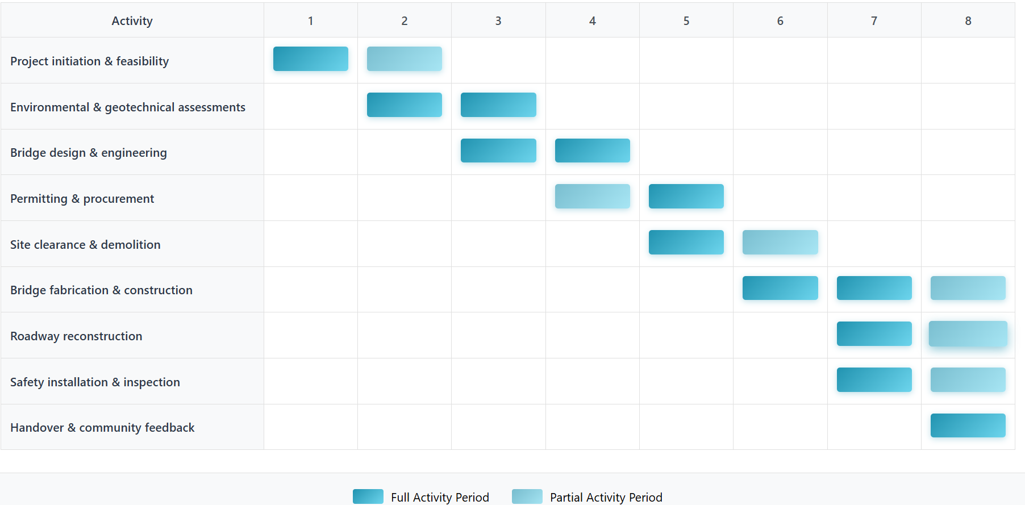
Table 3. Simplified Gantt Chart (Months 1–8)
The project is designed to minimize delays and maximize the productivity of the workflow by allowing activities like design, permitting, and material procurement to run concurrently (Lock, 2021). Moreover, the use of prefabricated steel parts considerably reduces the time spent on-site assemblies, which decreases the construction risks and construction costs. This combined scheduling process will improve the pace of work, provide the opportunity to keep the work in accordance with key milestones, and provide the delivery of the Bridge to Recovery project on time and within the required cost and quality boundaries.

7. Stakeholder Involvement
Stakeholder engagement will also be needed to make sure that the Bridge to Recovery project will stay community-driven, transparent, and sensitive to the needs of the local community. According to Wilson (2020), consultation is not enough to ensure genuine engagement, as active collaboration is particularly crucial in projects related to the public infrastructure, which directly influences the livelihoods and safety of the local people. The stakeholder approach of the project focuses on the two-way communication, inclusivity, and accountability, which means that every affected party will be engaged in the process and the results development.
The high interest, medium influence local community and residents are reached by bi-weekly liaison meetings, community newsletters and an on-site information kiosk that gives real-time updates and feedback opportunities. The funding authority, which has high influence and interest and is also the Regional District, is briefed on a fortnightly basis, provided with budget progress reports and is involved in reviewing of milestones approvals. To distribute construction logistics in a manner that will cause minimal interference to farming, the Local Farmers Association is consulted. Safety planning also actively engages emergency services in ensuring access to services throughout construction phases and the compliance with environmental and land-use regulations is maintained through the regulatory framework of the ministry of Forests. This planned interaction mechanism facilitates trust, ownership, and long-term community backing of the successful delivery of the project.
Stakeholder Group | Interest/Influence | Engagement Strategy
Local community | High/Medium | Empower and collaborate through liaison groups and updates.
Regional District | High/High | Manage closely; transparent reporting and budget tracking.
Local Farmers’ Association | High/Medium | Partner and involve in logistics and scheduling.
Emergency Services | Medium/High | Consult on detour and safety planning.
Ministry of Forests | Medium/High | Keep satisfied through compliance reporting and briefings.
Table 4. Stakeholder Engagement Strategy
This methodical approach guarantees ongoing communication and interest alignment and is in line with the PMBOK stakeholder management process (Burke, 2021).

8. Resource Allocation
Meredith et al. (2020) indicate that successful resource management incorporates material, financial, and human elements in the effort to deliver cost-effective implementation without reduction of quality.
Resource Type | Description | Allocated Budget (CAD) | Responsible Unit
Financial | Overall project fund | 18,000,000 | Regional District Finance
Human Resources | Engineers, supervisors, skilled labour | 7,200,000 | Engineering Canada & Contractors
Materials | Steel, concrete, guardrails, aggregates | 5,400,000 | Procurement Division
Equipment | Cranes, excavators, testing systems | 3,000,000 | Logistics Department
Contingency | 3% risk reserve | 540,000 | Project Risk Fund
Administration & Overheads | Communication, legal, compliance | 1,860,000 | Project Administration
Table 5. Resource Allocation Summary
The Bridge to Recovery project resource plan is a plan that will make the best use of all the resources available by proper coordination of labour, equipment and materials. The use of prefabrication principles enables saving time spent on site work and machinery costs, which enhance the efficiency. Moreover, risk reserves integrated into the financial system enable the project to accommodate the unplanned costs without compromising on the time or quality of delivery, thus being both economically prudent and operationally sound.

9. Risk Analysis
Risk management is a very important part of the success of the Bridge to Recovery project because of its strict time schedule and vulnerability to environmental factors (Public Safety Canada, 2022). The risk strategy of the project is developed based on the principles of the Canadian Infrastructure Resilience Framework and ISO 31000 to maintain the systematic, proactive approach towards the identification, evaluation, and reduction of the possible threats.
Risk Type | Description | Likelihood | Impact | Mitigation Strategy
Extreme Weather | Heavy rainfall delaying works | High | High | Flexible scheduling; temporary shelters and pumps
Supply Chain Delays | Late material delivery | Medium | High | Multiple suppliers; local sourcing
Cost Escalation | Inflation or design change | Medium | Medium | Fixed-price contracts; 3% contingency fund
Safety Incidents | Worker injury or traffic accident | Low | High | PPE enforcement; daily safety briefings
Community Concerns | Access disruption or noise complaints | Medium | Medium | Communication plans; dust suppression
Environmental Breach | Non-compliance with approvals | Low | High | Early assessments; independent audits
Technical Defects | Fabrication or design flaw | Low | High | Peer design reviews; quality assurance testing
Table 6. Risk Register
The project steering committee is informed of all the major risks, and the risk register is assessed on a bi-weekly basis to ensure that risks are under constant management (Hillson and Simon, 2020). Such a mechanism of early detection and response facilitates early corrective actions, saving the confidence of the people, and the integrity of the project schedule.

10. Conclusion
The Bridge to Recovery project is a good example of how present-day project management principles can be applied in a real-life situation with a time constraint and an infrastructure problem. Depending on the PMBOK and PRINCE2 models, the project incorporates management of the scope and proper stakeholder involvement as well as overall risk management in each stage of implementation. Its success is greatly dependent on smooth coordination between design teams, contractors as well as local community whereby technical accuracy is related to public demands (Hillson and Simon, 2020). The application of prefabricated materials, concurrent scheduling, and involvement of the stakeholders are some of the best strategies that reflect the proactive and responsive management style that is befitting complex public works.
Moreover, flood-resistant design and environmental safety of the bridge are not just the guarantee of the renewal of the important connectivity, but also the improvement of the resilience of the region in the long term. The project is a synergy of innovation and sustainability and as such, it can be viewed as the emerging trend of responsible infrastructure development, balancing technical excellence, financial prudence, and social accountability. The Bridge to Recovery is a brilliant model of what a best practice would be nowadays, showing that a properly-run project can leave a long-term and, at the same time, future-proof infrastructure that would bring value in the long-term perspective.

11. References
Axelos (2023) Managing Successful Projects with PRINCE2, 7th edn. London: The Stationery Office.
Burke, R. (2021) Project Management: Planning and Control Techniques, 6th edn. Chichester: Wiley.
Engineering Canada (2022) Canadian Infrastructure Report Card: Focusing on Climate Resilience. Canadian Society for Civil Engineering.
Hillson, D. and Simon, P. (2020) Practical Project Risk Management: The ATOM Methodology, 3rd edn. Newtown Square, PA: Project Management Institute.
Kerzner, H. (2022) Project Management: A Systems Approach to Planning, Scheduling, and Controlling, 13th edn. Hoboken, NJ: Wiley.
Lock, D. (2021) Project Management, 12th edn. London: Routledge.
Meredith, J.R., Mantel, S.J. and Shafer, S.M. (2020) Project Management: A Managerial Approach, 10th edn. Hoboken, NJ: Wiley.
Nicholas, J.M. and Steyn, H. (2020) Project Management for Engineering, Business, and Technology, 6th edn. London: Routledge.
Patel, R. and Kim, J. (2021) ‘Rapid-Response Infrastructure Reconstruction: Methodologies for Post-Disaster Recovery’, International Journal of Project Management, 39(5), pp. 512–525.
Project Management Institute (2021) A Guide to the Project Management Body of Knowledge (PMBOK Guide), 7th edn. Newtown Square, PA: PMI.
Public Safety Canada (2022) National Disaster Mitigation Program: Case Study on Resilient Infrastructure. Government of Canada Publications.
Wilson, T.H. (2020) Stakeholder Management in Public Infrastructure Projects: From Consultation to Collaboration. London: Routledge.

