
Master of Business Administration
International Business pathway


Contemporary employability skills
Assessment 1: Individual report. Weight: 50%
Module name: FINANCIAL MANAGEMENT
Module code: LCMB7002_LON
Lecturer name: DR SHENGFENG MEI

Student name: HARSH DIPAK KUNDALIYA
Student ID: 2535226

Word count: 5000 APPROX
Submission date: 13/08/2026

Financial Performance, Working Capital Management, Strategic Restructuring and Investment Appraisal of InterContinental Hotels Group PLC (IHG)

Table of Contents
1. Introduction 6
2. Financial Health Check 6
2.1 5-Year Financial Overview 6
2.2 Profitability Ratio Analysis 8
2.2.1 Operating and Net Profit Margin Trends 8
2.2.2 ROA Improvement and ROE Interpretation 8
2.3 Liquidity Analysis and Industry Benchmarking 9
2.4 Efficiency / Asset Management Analysis 9
2.5 Gearing and Solvency Analysis 10
2.5.1 Leverage and Capital Structure Risk 10
2.5.2 Interest Coverage and Debt-Servicing Capacity 10
2.6 Investment / Shareholder Analysis 10
2.7 Cash-Flow Ratio Analysis 11
2.8 Overall Financial Health Diagnosis 11
3. Working Capital Management Analysis 12
3.1 Current Working Capital Position 12
3.2 Cash Operating Cycle 12
3.3 Working Capital Problems 13
3.4 Working Capital Improvement Strategy 13
3.4.1 Receivables Management and Credit Control 13
3.4.2 Supplier Terms and Payables Optimisation 14
3.4.3 Treasury Management and Liquidity Buffer 14
3.5 Short-Term vs Long-Term Financing 14
4. Strategic Financial Restructuring Plan 15
4.1 Need for Financial Restructuring 15
4.2 Alternative Restructuring Options 15
4.2.1 Debt Refinancing and Maturity Management 15
4.2.2 Selective Asset Optimisation and Divestiture 16
4.2.3 Cash Retention and Shareholder Distribution Restraint 16
4.3 Impact on Shareholder Value 16
4.4 Impact on Debt Structure and Financial Flexibility 16
4.5 International and Ethical Considerations 17
4.5.1 Currency, Taxation and International Financial Risk 17
4.5.2 Macroeconomic and Geopolitical Risk 17
4.5.3 ESG Investment and Stakeholder Responsibility 17
5. Investment Appraisal and Capital Budgeting 18
5.1 Investment Appraisal Framework 18
5.2 Payback Period 18
5.3 Accounting Rate of Return 18
5.4 Net Present Value 19
5.5 Profitability Index 19
5.6 Internal Rate of Return 20
5.7 Overall Investment Decision 20
5.8 Non-Financial Risk Assessment 21
5.9 Capital Rationing 22
6. Critical Reflection on AI Usage 23
6.1 Tool Disclosure 23
6.2 Critical Evaluation of AI Output 23
6.3 Contribution Analysis 24
6.4 Ethical and Professional Reflection 24
7. Conclusion 25
References 26
Appendices 29
Appendix A — Five-year income-statement data 29
2021 29
2022 30
2023 31
2024 32
2025 33
Appendix B — 5-year balance-sheet data 34
2021 34
2022 37
2023 40
2024 43
2025 46
Appendix C — Five-year cash-flow data 49
2021 49
2022 50
2023 51
2024 52
2025 53
Appendix D — Ratios 54
Appendix E — Graphs/Charts 55
Appendix F — Working-capital 56
Appendix G — Project A appraisal 57
Appendix H — Project B appraisal 57
Appendix I — Project C appraisal 57
Appendix J — Capital-rationing calculations 58

1. Introduction
InterContinental Hotels Group PLC (IHG) is a multinational publicly traded hospitality corporation whose operations are mainly franchised and operated hotels. Its asset-light model allows it to grow and achieve revenue via fees with comparatively lower ownership of physical hotel property, which impacts the interpretation of inventory, fixed-asset efficiency and working-capital ratios. This report examines the financial performance of IHG between FY2021 and FY2025 in terms of profitability, liquidity, efficiency, gearing, shareholder returns and cash flow, then looks at the working-capital management, financing and restructuring options, and Projects A-C. The analysis addresses the question of whether or not the improved operating performance has come with adequate financial flexibility to enable disciplined value-creating investment.

2. Financial Health Check

2.1 5-Year Financial Overview
Indicator | 2021 | 2022 | 2023 | 2024 | 2025
Revenue | 2,907 | 3,892 | 4,624 | 4,923 | 5,189
Operating profit | 494 | 628 | 1,066 | 1,041 | 1,198
Profit before tax | 361 | 540 | 1,010 | 897 | 1,074
Profit for year | 265 | 376 | 750 | 628 | 759
Total assets | 4,716 | 4,216 | 4,813 | 4,748 | 5,345
Current assets | 2,066 | 1,678 | 2,129 | 1,869 | 2,049
Current liabilities | 1,624 | 1,544 | 2,190 | 1,928 | 2,100
Total debt | 3,264 | 2,823 | 3,592 | 3,688 | 4,607
Shareholders’ equity | (1,481) | (1,615) | (1,950) | (2,312) | (2,741)
Operating cash flow | 636 | 646 | 893 | 724 | 898
The 5-year trend of IHG shows a significant recovery of the company after the pandemic, but also an expanding gap between operating performance and balance-sheet risk. Revenue increased by 78.5% from $2,907m in 2021 to $5,189m in 2025, while operating profit more than doubled from $494m to $1,198m. The 2022 recovery was characterised by rebounding travel demand with the removal of restrictions, whereas 2023 benefited from ongoing demand and investment in the brands, loyalty, digital capabilities and sustainability (IHG, 2022). Statutory operating profit relaxed in 2024, as statutory result figures continued to grow with RevPAR and system growth, in part due to the statutory results not being consistent with the reportable-segment profitability. By 2025, the growth in operating profit was again regained through RevPAR, system expansion, ancillary fees and cost productivity, but total debt had also hit $4,607m.
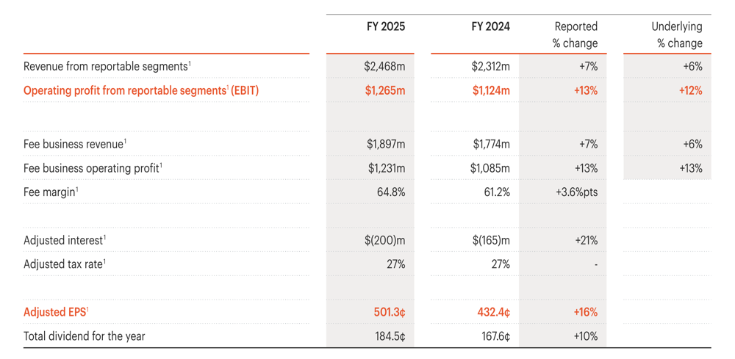
Figure 1: Financial overview (2025)
(ihgplc.com, 2025b)

2.2 Profitability Ratio Analysis

2.2.1 Operating and Net Profit Margin Trends
Materially increased profitability over the period. The operating margin decreased a little in 2022 to 16.14% as compared to 16.99% in 2021, which means that the starting recovery in revenues was not proportionally reflected in the operating profit. It then increased sharply to 23.05% in 2023, moderated to 21.15% in 2024 and recovered to a five-year high of 23.09% in 2025. IHG credited the revenue growth, operating leverage, cost efficiencies and growing ancillary fee streams to the 2025 improvement, with the margin of fees rising to 64.8% (IHG, 2025). Net margin also increased, but not as much as revenue and increased from 9.12% to 14.63%, with a peak of 16.22 in 2023.
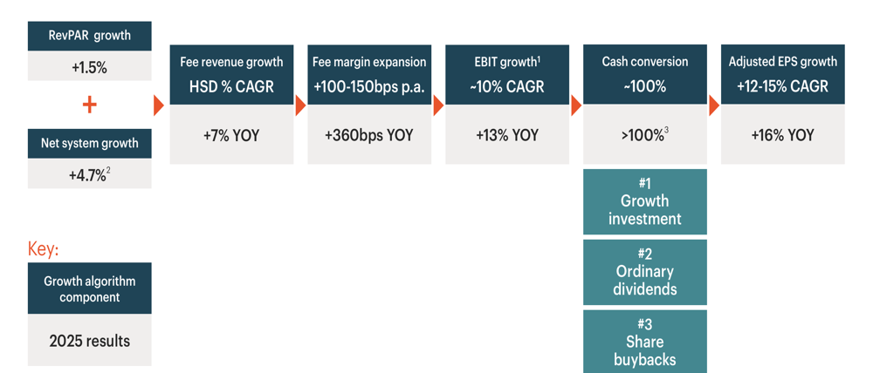
Figure 2: IHG Growth Algorithm and FY2025 Performance Drivers
(ihgplc.com, 2025a)

2.2.2 ROA Improvement and ROE Interpretation
There was an improvement in the ROA from 5.62 in 2021 to 14.20 in 2025, which shows that the company is generating profits at a rather impressive rate, given the reported asset base. Fairfield and Yohn (2001) conclude that the fluctuation in the asset turnover and profit margin has useful information in the interpretation of variation in profitability, and hence they suggest that the improvement of the margin in IHGA and asset efficiency should be interpreted as a whole in addition to profitability. ROE is less telling: the equity of the shareholders was negative in FY2021-FY2025 and thus the negative denominator makes the interpretation of ROE as the efficiency of shareholders' returns unconventional.

2.3 Liquidity Analysis and Industry Benchmarking
The current ratio fell from 1.27 in 2021 to 1.09 in 2022 and below unity from 2023, ending 2025 at 0.98.
Measure | IHG | Hilton | Marriott | Peer average | IHG–peer
Current ratio | 0.98 | 0.66 | 0.43 | 0.55 | +0.43
Quick ratio* | 0.97 | 0.66 | 0.43 | 0.55 | +0.42
Cash ratio | 0.54 | 0.20 | 0.04 | 0.12 | +0.42
Hilton stated that it had current assets of 2,996m and current liabilities of 4,508m in the year 2025, and Marriott had $3,584m and $8,398m of current assets and current liabilities, respectively (Hilton Worldwide Holdings Inc. (, 2025). IHG thus enjoys better accounting liquidity as compared to these two close asset-light peers even though it has a sub-one current ratio. This analogy questions an automatic finding that a current ratio less than one always indicates poor liquidity. Nissim and Penman (2018) believe that financial ratios are better when analysed as a whole when operating and financing structures are considered and not used as independent ratios.

2.4 Efficiency / Asset Management Analysis
As of 2025, the total asset turnover was 0.97×, up by 0.35 times since 2021, indicating that with the same amount of reported assets, each dollar generated 0.97 times the revenue. The turnover of fixed assets at the same time went up to 35.06× compared to 21.22x. These exceptional numbers, however, are in part due to the IHG paradigm instead of to the fact that better operational management is being exercised: the capital needed by franchised hotels to grow the system is less than that needed by full-fledged hotels, but the collection of fees can be increased as the system grows. In line with the latter, Märklin and Bianchi (2021) discover that an increased asset-light intensity does not necessarily yield better returns or risk-adjusted performance in hotel firms, thus supporting the idea that a small physical-asset denominator should not be considered to have financial superiority. The days of receivables went up to 45.78 in 2023 as compared to 50.10 in 2021 but went up to 49.10 in 2025; the disclosed proxy of credit sales is the total revenue.

2.5 Gearing and Solvency Analysis

2.5.1 Leverage and Capital Structure Risk
Total debt represented 69.21% of assets in 2021, briefly declining to 66.96% in 2022 before increasing to 74.63% in 2023, 77.67% in 2024 and 86.19% in 2025. Debt to Equity is mathematically negative since IHG records negative equity; such a sign would be misleading to the economy to be interpreted as low gearing.

2.5.2 Interest Coverage and Debt-Servicing Capacity
Times interest earned improved from 3.55× in 2021 to 5.19× in 2022 and 9.27× in 2023 before moderating to 6.47× and 6.14× in 2024 and 2025, respectively. This seeming contradiction has financial significance: it is not possible to evaluate solvency with the help of a single leverage ratio. By 2025, IHG operated at an 898m operating cash flow, a new 1.5bn syndicated credit facility, a net debt-to-adjusted EBITDA ratio of 2.5x and was also able to remit over 1.1bn to shareholders.

2.6 Investment / Shareholder Analysis
Basic EPS increased from 145.4 cents in 2021 to 490.9 cents in 2025, despite a temporary decline from 443.8 cents in 2023 to 389.6 cents in 2024. IHG also indicated a dividend to be paid in 2025 amounting to 184.5 cents per share, generating an EPS/DPS dividend-cover proxy of about 2.66x. However, the metrics on shareholders are to be viewed in conjunction with capital structure: high dividends and buybacks are accompanied by the negative value of the book equity and the increase in debt.

2.7 Cash-Flow Ratio Analysis
There was an increase of net operating cash flow in 2021 from 636m to 898m in 2025, but the cash-flow-to-debt ratio was about 0.19x in both years compared to 0.25x in 2023. The growth of debt thus was sufficient to absorb a large part of the increase in absolute cash generation. The margin of cash flow also decreased, as course-basis free cash flow rose by 584m to 821m, but the margin decreased by 20.09% to 15.82%.
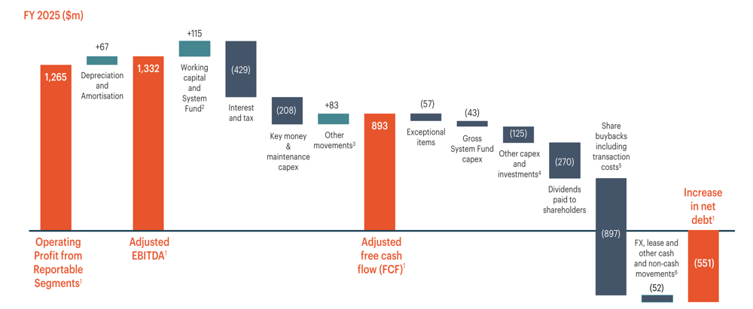
Figure 3: Strong FCF conversion at 115% of adjusted earnings
(ihgplc.com, 2025a)

2.8 Overall Financial Health Diagnosis
Area | 2025 position | Principal implication
Profitability | Strong | Supports selective investment
Liquidity | Tight | Preserve liquidity headroom
Efficiency | Strong | Monitor receivables/payables
Gearing | Elevated | Protect financial flexibility
Shareholder | Strong EPS | Discipline capital returns
Cash flow | Cash-generative | Prioritise debt capacity

3. Working Capital Management Analysis

3.1 Current Working Capital Position
IHG deteriorated to a significant degree in terms of working-capital position in FY2021–FY2025. Net working capital declined from +$442m in 2021 to +$134m in 2022, before becoming negative at −$61m in 2023, −$59m in 2024 and −$51m in 2025. The movement means that the position of a current-asset buffer has been changed by the position of short-term liabilities slightly greater than current assets. Negative working capital, however, should not necessarily be taken to mean that the company is in financial distress. IHG has a highly cash-generative, predominantly asset-light, and fee-based business model, which makes it less reliant on inventories and hotel property ownership (IHG, 2025). Baños-Caballero, García-Teruel and Martinez-Solano (2014) find an inverted U-shaped association between the working-capital investment and the firm performance, with the implication that overabundance of liquidity can annihilate value, as inadequate liquidity can raise financing risk.

3.2 Cash Operating Cycle
Cash operating cycle gives more evidence of the dynamics of changing short-term financing. It is only in 2025 that the inventory days amounted to 2.39 days, which proved the claim of financial insignificance of inventory to the asset-light hospitality model of IHGA. Receivable days improved from 50.10 days in 2021 to 45.78 days in 2023, before deteriorating to 49.10 days in 2025. The greater trend was in payable days, which declined to 49.21 days as compared to 81.86 days. Consequently, the cash operating cycle changed from −28.76 days in 2021 and −37.13 days in 2022 to −14.23 days in 2023, −4.16 days in 2024 and +2.28 days in 2025. IHG has thus shifted its focus from taking in large amounts of operating financing in the form of timing of payments to slightly financing the operating cycle itself. Deloof (2003) proves that the policies of receivables, inventory and payable are materially related to corporate profitability, but the cause and effect between delays in payments and performance should be taken with a grain of salt.

3.3 Working Capital Problems
The current and quick ratios decreased to less than one as of 2023; the cash ratio decreased to about 0.54 as of 2025; working capital was negative; and the cash cycle was positive. However, in 2025, IHG generated 898m of net operating cash flow, indicating that the Group still generates a high level of internal liquidity (IHG, 2025). The threat is that poorer working-capital efficiency and increasing financing commitments increasingly diminish the availability of headroom to invest, shareholder distributions and unanticipated shocks.

3.4 Working Capital Improvement Strategy

3.4.1 Receivables Management and Credit Control
To begin with, IHG needs to cut down on the number of days in receivables by centralising owner and franchisee account monitoring and automated collections, risk-based credit controls and expedited dispute resolution. A reduction of the collection time to or less than the 2023 level would free up cash without having to issue more debt. Nonetheless, too tight credit conditions might harm relations with owners of hotels; in this regard, credit controls must be based on counterparty risk instead of applying standard conditions.

3.4.2 Supplier Terms and Payables Optimisation
Second, the terms with the suppliers should be optimised, and not blindly applied. To reduce the cash cycle and maintain liquidity, restoring some of the significant reduction in the payable days would be beneficial, but excessive deferral of payments to the suppliers would shift the financial load to the suppliers and disrupt service quality. This is a trade-off in line with the perception that a working-capital position, which maximises value, is an optimum, but not a minimum (Baanos-Caballero, Garcia-Teruel and Martinez-Solano, 2014).

3.4.3 Treasury Management and Liquidity Buffer
Third, treasury ought to enhance rolling cash forecasts, geographic cash pooling and currency matching. Lastly, committed liquidity must give a buffer of contingency and should not only be based on the cash balances at the reporting date.

3.5 Short-Term vs Long-Term Financing
Factor | Short-term finance | Long-term finance
Examples | RCF, overdraft, trade credit | Bonds, long-term debt, retained earnings
Flexibility | High | Lower
Refinancing risk | Higher | Lower
Rate exposure | Often variable | Can be fixed
Best use | Temporary liquidity | Structural funding
The short-term finance is supposed to mainly cover short-term or seasonal liquidity needs. Custodio, Ferreira and Laureano (2013) discover that, in the context where structural financing requirements exist, overreliance on short-term funding would not be appropriate given that shorter debt maturity would result in corporate vulnerability to credit and liquidity shocks. However, IHG has a significant contingency capacity: the $1.5bn committed revolving credit facility matures in December 2030, and has no financial covenants, whereas S&P and Moody rated the Group with BBB and Baa2 respectively with stable outlooks as of December 2025 (IHG, 2025).

4. Strategic Financial Restructuring Plan

4.1 Need for Financial Restructuring
IHGA does not need a distress-based turnaround; it needs the balance-sheet optimisation that will maintain the financial flexibility without sacrificing profitable growth. The profitability and interest coverage ratios have significantly declined to FY2021-FY2025 but the debt-to-assets ratio has risen to 86.19, shareholders' equity was negative, and working capital was at -51m in 2025. This mix indicates that the operational power is becoming more and more balance-sheet reliant on debt. Marchica and Mura (2010) discover that having an available debt capacity can boost the subsequent investment capacity and quality of investment of the two firms.

4.2 Alternative Restructuring Options

4.2.1 Debt Refinancing and Maturity Management
IHG had a £350m bond due in August 2026, €500m due in May 2027 and £400m due in October 2028, followed by further maturities through 2031 (IHG, 2025). Refinancing forward enough in advance of maturity would cause a reduction in rollover concentration and would maintain access to capital even at times of market turbulence. The new covenant-free RCF of 1.5bn offers more liquidity security, but a long-term use would replace long-term financing with potentially more rate-sensitive financing.

4.2.2 Selective Asset Optimisation and Divestiture
The sale of truly non-core assets may provide funds to pay down debts, but its strategic area is small since IHG is already asset-light. Massive sell-off would thus forego assets that are strategically useful without having a significant change in the capital structure.

4.2.3 Cash Retention and Shareholder Distribution Restraint
The third alternative will be higher retention of internally earned cash and restraining discretionary payments to shareholders. In 2025, IHG repaid over $1.1bn in dividends to its shareholders and a larger share buyback of $950m in 2026 was approved (IHG, 2025). Gamba and Triantis (2008) demonstrate that liquidity and financing flexibility in corporates is valuable at the time when external financing frictions are experienced by the firms.

4.3 Impact on Shareholder Value
Over the short term, having extra cash may decrease distributions and thus frustrate shareholders who are accustomed to buybacks. Nevertheless, the long-term impact can be value-adding should the refinancing risk be lower, as this will safeguard the ability to fund investments and the likelihood that good projects have to be abandoned or be funded externally when the market is unfavourable. Marchica and Mura (2010) illustrate that companies that maintain borrowing power have a better way of investing later on.

4.4 Impact on Debt Structure and Financial Flexibility
The composition of a staggered maturity profile by refinancing near-term maturities would decrease refinancing concentration, but maintain IHG as an investment-grade issuer. This is especially significant since 2025 net financial expense growth, and IHGA cited higher adjusted interest as a portion of this increase to more net debt and higher bond average rates (IHG, 2025). However, the exposure to interest rates is nowadays moderated as IHGA needs at least 50% of debt on fixed rates and reported that, excluding overdrafts, 100% of debt was fixed-rate as at 31 December 2025 (IHG, 2025).

4.5 International and Ethical Considerations

4.5.1 Currency, Taxation and International Financial Risk
IHG has a global presence which generates physical currency, tax and macroeconomic risks. The earnings impact of translating intra-group monetary positions is reflected as foreign-exchange gains of $37m in 2025 (after a loss of $25m in 2024), and IHGA takes measures to address these exposures by using currency swaps and matching bond debt to sterling and US-dollar cash-flow exposures (IHGA, 2025). Restructuring of taxes should also put an emphasis on compliance and economic substance: IHG disclosed a 27.2% adjusted tax rate in 2025 and projected a 6m minimum-tax liability under OECD Pillar Two (IHG, 2025).

4.5.2 Macroeconomic and Geopolitical Risk
Uncertainty in the macroeconomic environment reinforces the argument in favour of maintaining liquidity. IMF (2026) predicts a 3.0% growth in the world in 2026, but it is concerned that the world has gone through disinflation and that geopolitical and financial-market risks are still significant. This can have an impact on hotel demand, owner economics and refinancing costs.

4.5.3 ESG Investment and Stakeholder Responsibility
ESG spending must not be considered discretionary due to high leverage. By the year 2030, IHG aims to achieve a 46% absolute decrease in the number of carbon emissions related to the hotel sector, and to this end, the company needs to both maintain its partnership and invest in its extensive third-party-owned property (IHG, 2023). Cheng, Ioannou and Serafeim (2014) discover that the higher the CSR performance, the lower capital restrictions are in terms of increased stakeholder engagement and transparency.

5. Investment Appraisal and Capital Budgeting

5.1 Investment Appraisal Framework
All three projects are mutually comparable, with an initial investment of £50m, a life of five years and are appraised at the recommended discount rate of 8%, with straight-line depreciation to zero residual value. The appraisal uses Payback Period (PBP), Accounting Rate of Return (ARR), Net Present Value (NPV), Profitability Index (PI) and Internal Rate of Return (IRR). Graham and Harvey (2001) discovered that big companies extensively apply present-value methods, but payback is useful in practice, and a multi-method appraisal is advisable, instead of relying on one measure.

5.2 Payback Period
The values obtained in the payback period are 4.50 years for Project A, 4.55 for Project B and 3.60 for Project C, resulting in the ranking from C to A to B. This has financial implications for IHG since cash recovery in the past makes the difference between the duration of capital exposure and liquidity flexibility. The lower payback of Project C reinforces the argument in favour of it, given that IHG has a current ratio of less than one and a negative working-capital situation. It does not put any weight on when cash flows occur in the payback period and does not consider cash flows that occur after the original investment has been recovered. As Graham and Harvey (2001) demonstrate, the practice of payback is applied to corporate practice, although techniques of present value are also especially significant in large corporations.

5.3 Accounting Rate of Return
Straight-line depreciation is:
£50m/5= £10m per year
With zero residual value, average investment is:
(£50m+£0m)/2= £25m
When the ARR convention of the module is applied, the result is 3.20% on Project A, 4.00% on Project B and 12.00% on Project C, always putting Project C first. But ARR gauges the profitability of accounting and not the economic value. It fails to discount future returns, and thus it is unable to fully appreciate the timing and risk of the project cash flows.

5.4 Net Present Value
Project | Initial cost (£m) | PV of inflows (£m) | NPV (£m) | Decision
A | 50.000 | 43.456 | −6.544 | Reject
B | 50.000 | 43.920 | −6.080 | Reject
C | 50.000 | 50.858 | +0.858 | Accept
Projects A and B annihilate about £6.54m and 6.08m respectively at the required rate, whereas C generates about 0.86m incremental value. The outcome is thus not just a ranking: A and B do not pass the economic acceptance test whereas C does. NPV has more weight in decisions since it takes into account the time value of money and the entire flow of project cash flows. According to Graham and Harvey (2001), NPV and other present-value techniques are widely used by large organisations, which confirms that it is not only practically but also theoretically significant. A positive NPV, however, depends on the credibility of the future cash flows as well as the discount rate adopted. As demonstrated by Jagannathan et al. (2016), companies often set higher hurdle rates than their estimated cost of financial capital to set the project risk, operating constraints and capital allocation. The relatively small positive NPV of project C thus should be considered risky: the negative deviation of the forecast cash flows might cancel the surplus in the value of -0.858m.

5.5 Profitability Index
The PI results are 0.869 for A, 0.878 for B and 1.017 for C. Since PI is used to determine the present value of future inflows, per pound invested, the value greater than one implies that discounted inflows are larger than the initial expenditure. Project A and B hence do not pass the rule of acceptance, whereas project C produces about 1.017 of the present value per pound invested. PI comes to the same conclusion as NPV since each project is a single project, and it needs to be invested in with an initial investment of £50m. Its main other utility is in capital rationing when the value created per unit of capital is useful to compare the feasible allocations. But when it is not indivisible in projects, the value-maximising portfolio should be determined by combined NPV and not PI.

5.6 Internal Rate of Return
The confirmed IRRs are about 2.72% of Project A, 3.26% of Project B and 8.59% of Project C, which is relative to the 8% required return; A and B should be rejected, and C accepted. Project C has a projected internal return of approximately 0.59 percentage points above the hurdle rate, and this means that the acceptance margin of this project is positive but quite low. Jagannathan et al. (2016) show that the choice of hurdle rates may have a significant impact on corporate investment decisions, especially when managers take into account risks or operational limitations not covered by the cost of capital, such as the estimated financial cost of capital.

5.7 Overall Investment Decision
Technique | Project A | Project B | Project C | Preferred
PBP | 4.50 yrs | 4.55 yrs | 3.60 yrs | C
ARR | 3.20% | 4.00% | 12.00% | C
NPV | −£6.544m | −£6.080m | +£0.858m | C
PI | 0.869 | 0.878 | 1.017 | C
IRR | 2.72% | 3.26% | 8.59% | C
The five methods give a very unusual result: Project C prevails over A and B in all criteria. It is especially significant that it is above others in the present financial situation of IHG. C has the shortest payback and the sole NPV that is positive, the sole PI that is greater than one and the sole IRR that is greater than the required return. This combination of quicker liquidity recovery and positive value creation is desirable to a group that has good profitability but whose liquidity and leverage in the short run must be disciplined.
The CFO suggestion would thus be to take Project C and reject Projects A and B as stand-alone investments. This recommendation is not solely informed by the accounting return, but rather, mainly supported by the positive NPV of C and with the additional liquidity rationale of PBP.

5.8 Non-Financial Risk Assessment
It is not possible to eliminate uncertainty about projected cash flows with the help of financial appraisal. Among the key uncertainties that IHG itself faces in the years 2026–2028, the company lists guest loyalty, readiness of its owners to invest, geopolitical and operational disruption, digital capability, regulatory complexity, supply-chain resilience and climate risks (IHG, 2025).
Risk | Cash-flow effect | Mitigation
Geopolitical disruption | Demand/cost volatility | Geographic diversification
Customer loyalty | Lower bookings/revenue | Loyalty and brand investment
Currency movements | Translated cash-flow volatility | Currency matching/hedging
Inflation | Higher implementation costs | Contract and cost controls
Regulation | Higher compliance/capex | Early regulatory planning
ESG/climate | Higher costs or reputational loss | Sustainability screening
Execution | Delays/lower inflows | Stage-gates and monitoring
These risks are particularly material as Project C NPV cushion is just £0.858m. The decision could be reversed by an act of relatively minor depreciation of actual receipts or escalation of project costs. Recent macroeconomic developments support that point of view: the IMF predicts that global growth will be 3.0% in 2026 but notes that disinflation has not started and that a new geopolitical conflict and a new financial-market repricing will continue to be significant downsides (IMF, 2026).
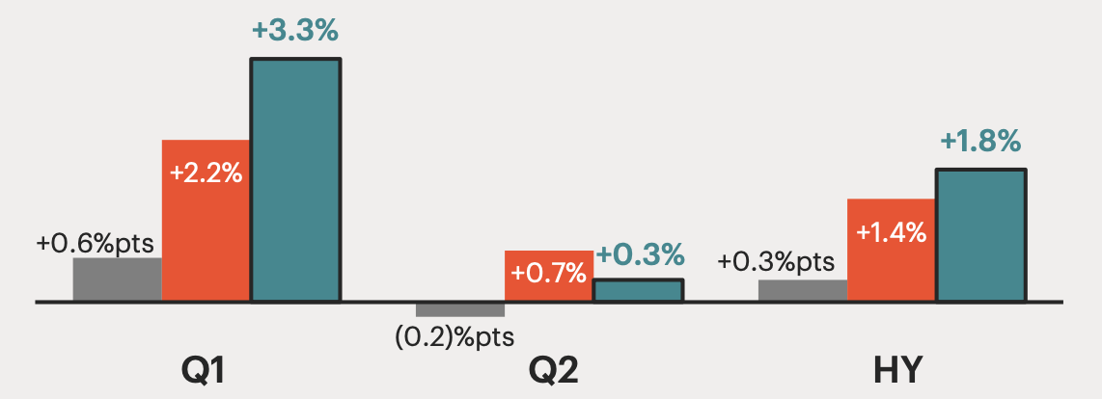
Figure 4: IHG Global RevPAR, Occupancy, and ADR
(Dockray, 2025)

5.9 Capital Rationing
The constraint of the amount of £100m allows any two of the two projects, which have expenditures of £50m, to be carried out. The following are the results of the pairwise analysis needed.
Combination | Investment (£m) | Combined PI | Combined NPV (£m) | Rank
A + B | 100 | 0.874 | −12.624 | 3
A + C | 100 | 0.943 | −5.686 | 2
B + C | 100 | 0.948 | −5.222 | 1
If management were required to spend exactly £100m on two projects, B+C would be the best combination, since its NPV of -5.222m would be less negative as compared to the alternatives. Nonetheless, it would ruin shareholder value. The choice of B+C due to its depleting the budget would thus create a mix-up of a spending constraint and an investment goal. It is this difference that is the focus of capital rationing. According to Jagannathan et al. (2016), the rationing of investment programmes may be done when such programmes are constrained in resources or even operation, but negative-NPV projects should not be accepted to simply put the available capital into use. The entire feasible-allocation analysis shows that Project C alone will give the highest achievable NPV of + £0.858m, with the addition of A, it will give a portfolio NPV of -£5.686m, and the addition of B will give a portfolio NPV of -£5.222m.
Based on this, the CFO must differentiate between the two answers. B+C would be the most preferable among the two required projects in comparison, but C alone would be the most cost-efficient utilisation of the maximum amount of the £100m. The remaining 50m ought to be held as liquidity, debt reduction or some other better prospect of positive NPV in the future instead of being tied up in a project that kills value. Such a conclusion is fitting especially for IHG since its 2025 risk framework expressly points out the turbulence in the market, uncertainty in the cost of capital and operations, which further reinforces the statement that it is better to maintain financial flexibility where there is no second value-creating project (IHG, 2025).

6. Critical Reflection on AI Usage

6.1 Tool Disclosure
Generative AI was applied in compliance with the allowed provisions of the research and data analysis in the assessment, which was primarily aimed at helping to find the sources, discover the relevant academic literature, find primary corporate data and help verify the financial data. The assessment specification clearly allows Generative AI to be used in research and data analysis and also allows the proofreading of the work created by students. The outputs of AI were not considered authoritative data; the primary data was obtained in IHG audited annual reports and in relevant academic or institutional sources.

6.2 Critical Evaluation of AI Output
The information that is produced by AI was considered a lead-in to research that needs to be verified and not a fact. The financial figures were compared with the annual reports audited by IHGA, the ratio formula was compared with module teaching materials, and independent testing of investment-appraisal calculations was done. The spreadsheet validation involved 204 arithmetic and reconciliation checks, formula-error scan, Excel NPV() validation and a manual IRR interpolation and Excel IRR. The process also revealed one previous anomaly of the convention of ROA; the module content was reviewed again, the equation was revised to net income/total assets, and the calculations that were impacted were re-calculated. This shows how seemingly small AI-assisted methodological mistakes can have the potential to further a false ratio into a false financial diagnosis. Eulerich et al. (2024) show that the effectiveness of generative AI in accounting also increases significantly in the presence of tools and external resources, but it is still not perfect and thus needs to be verified by humans.

6.3 Contribution Analysis
Making substantive financial judgement was my responsibility. This involved determining the evidence that was reliable enough, interpreting negative equity and ratio constraints, considering the importance of the liquidity and leverage position of IHGA, restructuring options and the ultimate investment decision. Project C was not picked due to the recommendation of an AI system; it was picked due to the independent checks indicating that the PBP and ARR are most robust, the only positive NPV, PI greater than one, and the IRR greater than the 8% hurdle rate.

6.4 Ethical and Professional Reflection
The exercise reaffirmed the need to be transparent, confidential, have financial data integrity, professional scepticism, and accountability in using AI in financial management. Dwivedi et al. (2023) name bias, obsolete information, and the lack of transparency and credibility as one of the biggest risks of generative AI; i.e., efficient research support can never replace source validation. Sugahara and Kano (2026) also demonstrate that generative-AI advice may affect accounting-related professional judgement, which is why the systems may require competence and critical evaluation to use them. These risks have a specific impact in a CFO environment, as inaccurate outputs may impact financing, restructuring and multimillion-pound investment decisions. AI has the potential to enhance the efficiency of research, but not the quality of evidence; ethical behaviour and the ultimate executive decision cannot be delegated to an algorithm.

7. Conclusion
IHG FY2021-FY2025 performance shows significant recovery in profitability, earnings and cash generation but has come with tightening liquidity, negative working capital and much greater leverage. The weakening of the cash operating cycle supports the necessity to have more discipline and maintenance of liquidity headroom in working capital. Restructuring the financial structure must thus focus more on responsible refinancing, resilience of debt and adherence to distributed shares as opposed to radical corporate reorganisation. Project C will be the best option investment as it offers the best overall appraisal result. Despite B+C being the optimal at the best of £100m pair, C maximises value where the ceiling of sustainable growth and shareholder wealth is given by £100m.

References
Baños-Caballero, S., García-Teruel, P.J. and Martínez-Solano, P. (2014). Working capital management, corporate performance, and financial constraints. Journal of Business Research, [online] 67(3), pp.332–338. doi:10.1016/j.jbusres.2013.01.016.
Cheng, B., Ioannou, I. and Serafeim, G. (2014). Corporate Social Responsibility and Access to Finance. Strategic Management Journal, 35(1), pp.1–23. doi:https://doi.org/10.1002/smj.2131.
Custódio, C., Ferreira, M.A. and Laureano, L. (2013). Why are US firms using more short-term debt? Journal of Financial Economics, [online] 108(1), pp.182–212. doi:10.1016/j.jfineco.2012.10.009.
Deloof, M. (2003). Does working capital management affect profitability of Belgian firms? Journal of Business Finance & Accounting, 30(3–4), pp.573–588. doi:https://doi.org/10.1111/1468-5957.00008.
Dockray, M. (2025). InterContinental hotels: U.S. demand concerns leave shares reasonably valued (rating upgrade). [online] Seeking Alpha. Available at: https://seekingalpha.com/article/4819305-intercontinental-hotels-us-demand-concerns-leave-shares-reasonably-valued [Accessed 11 Aug. 2026].
Dwivedi, Y.K. (2023). “So what if ChatGPT wrote it?” Multidisciplinary perspectives on opportunities, challenges and implications of Generative Conversational AI for Research, practice and policy. International Journal of Information Management, [online] 71(0268–4012), p.102642. doi:https://doi.org/10.1016/j.ijinfomgt.2023.102642.
Eulerich, M., Sanatizadeh, A., Hamid Vakilzadeh and Wood, D.A. (2024). Is it all hype? ChatGPT’s performance and disruptive potential in the accounting and auditing industries. Review of accounting studies. doi:10.1007/s11142-024-09833-9.
Fairfield, P.M. and Yohn, T.L. (2001). Using asset turnover and profit margin to forecast changes in profitability. Review of Accounting Studies, 6(4), pp.371–385. doi:10.1023/a:1012430513430.
GAMBA, A. and TRIANTIS, A. (2008). The value of financial flexibility. The Journal of Finance, 63(5), pp.2263–2296. doi:10.1111/j.1540-6261.2008.01397.x.
Graham, J.R. and Harvey, C.R. (2001). The theory and practice of corporate finance: Evidence from the field. Journal of Financial Economics, [online] 60(2–3), pp.187–243. doi:https://doi.org/10.1016/S0304-405X(01)00044-7.
Hilton Worldwide Holdings Inc. ( (2025). HLT-20251231. [online] Sec.gov. Available at: https://www.sec.gov/Archives/edgar/data/1585689/000158568926000007/hlt-20251231.htm [Accessed 11 Aug. 2026].
IHG (2021). True hospitality for good. In: Annual Report and Form 20-F 2021. [online] Available at: https://www.ihgplc.com/~/media/Files/I/Ihg-Plc/investors/annual-report-2021/ihg-2021-annual-report.pdf [Accessed 11 Aug. 2026].
IHG (2022). True hospitality for good. In: Annual Report and Form 20-F 2022. [online] Available at: https://www.ihgplc.com/~/media/Files/I/Ihg-Plc/investors/annual-report/annual-report-2022.pdf [Accessed 11 Aug. 2026].
IHG (2023). True hospitality for good. In: Annual Report and Form 20-F 2023. [online] Available at: https://www.ihgplc.com/~/media/Files/I/Ihg-Plc/investors/annual-report/2023/ihg-2023-annual-report-and-form-20-f.pdf [Accessed 11 Aug. 2026].
IHG (2024). Annual report and form 20-F 2024. In: Annual Report and Form 20-F 2024. [online] Available at: https://www.ihgplc.com/~/media/Files/I/Ihg-Plc/investors/annual-report/2024/ihg-ar-2024.pdf [Accessed 11 Aug. 2026].
IHG (2025). True hospitality for good. In: Annual Report and Form 20-F 2025. [online] Available at: https://www.ihgplc.com/~/media/Files/I/Ihg-Plc/investors/annual-report/2025/ihg-ar25-interactive.pdf [Accessed 11 Aug. 2026].
ihgplc.com (2025a). Full year results for the year to 31 december 2025. [online] InterContinental Hotels Group PLC. Available at: https://www.ihgplc.com/en/news-and-media/news-releases/2026/full-year-results-for-the-year-to-31-dec-2025 [Accessed 11 Aug. 2026].
ihgplc.com (2025b). Results, reports and presentations. [online] InterContinental Hotels Group PLC. Available at: https://www.ihgplc.com/investors/results-reports-and-presentations [Accessed 11 Aug. 2026].
IMF (2026). World economic outlook update, july 2026: Global economy in crosscurrents of war and technology. [online] IMF. Available at: https://www.imf.org/en/publications/weo/issues/2026/07/08/world-economic-outlook-update-july-2026 [Accessed 11 Aug. 2026].
InterContinental Hotels Group PLC (2023). Carbon and Energy. [online] InterContinental Hotels Group PLC. Available at: https://www.ihgplc.com/en/responsible-business/carbon-and-energy [Accessed 11 Aug. 2026].
Jagannathan, R., Matsa, D.A., Meier, I. and Tarhan, V. (2016). Why do firms use high discount rates? Journal of Financial Economics, 120(3), pp.445–463. doi:10.1016/j.jfineco.2016.01.012.
Marchica, M.-T. and Mura, R. (2010). Financial flexibility, investment ability, and firm value: Evidence from firms with spare debt capacity. Financial Management, 39(4), pp.1339–1365. doi:10.1111/j.1755-053x.2010.01115.x.
Marriott International, Inc. (2025). Mar-20251231. [online] Sec.gov. Available at: https://www.sec.gov/Archives/edgar/data/1048286/000104828626000007/mar-20251231.htm [Accessed 11 Aug. 2026].
Märklin, P. and Bianchi, G. (2021). A differentiated approach to the asset-light model in the hotel industry. Cornell Hospitality Quarterly, 63(3), p.193896552110060. doi:10.1177/19389655211006076.
Nissim, D. and Penman, S.H. (2018). Ratio analysis and equity valuation: From research to practice. Review of Accounting Studies, [online] 6(1), pp.109–154. doi:10.1023/a:1011338221623.
Sugahara, S. and Kano, K. (2026). The impact of ChatGPT’s advice on professional judgment related with accounting and the role of accounting education. Journal of Business Ethics. doi:10.1007/s10551-026-06365-x.

Appendices

Appendix A — Five-year income-statement data

2021
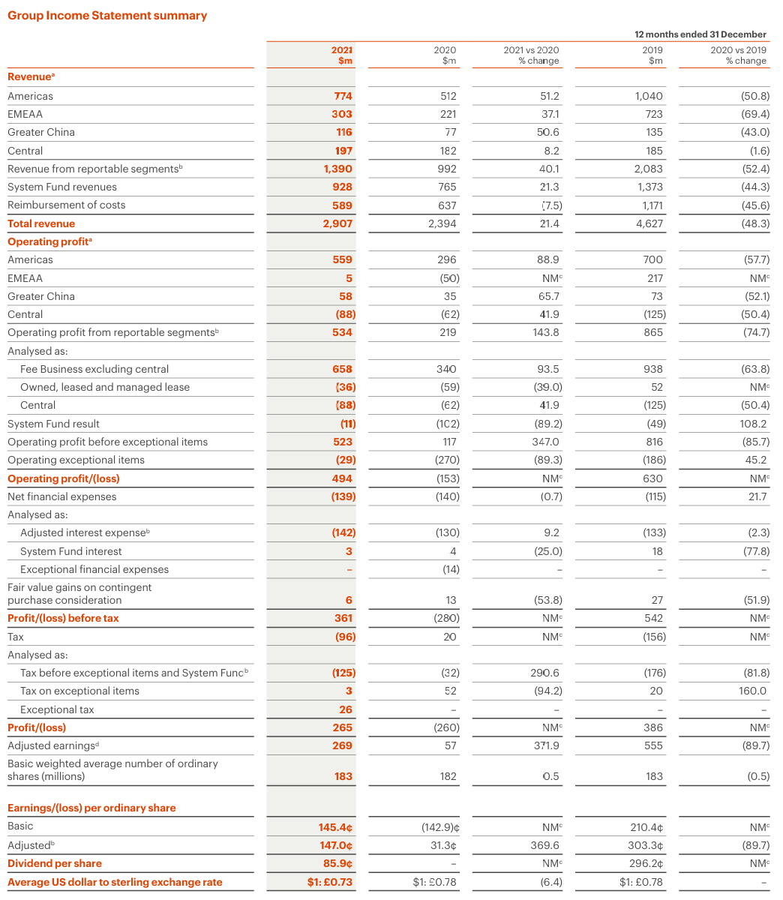

2022
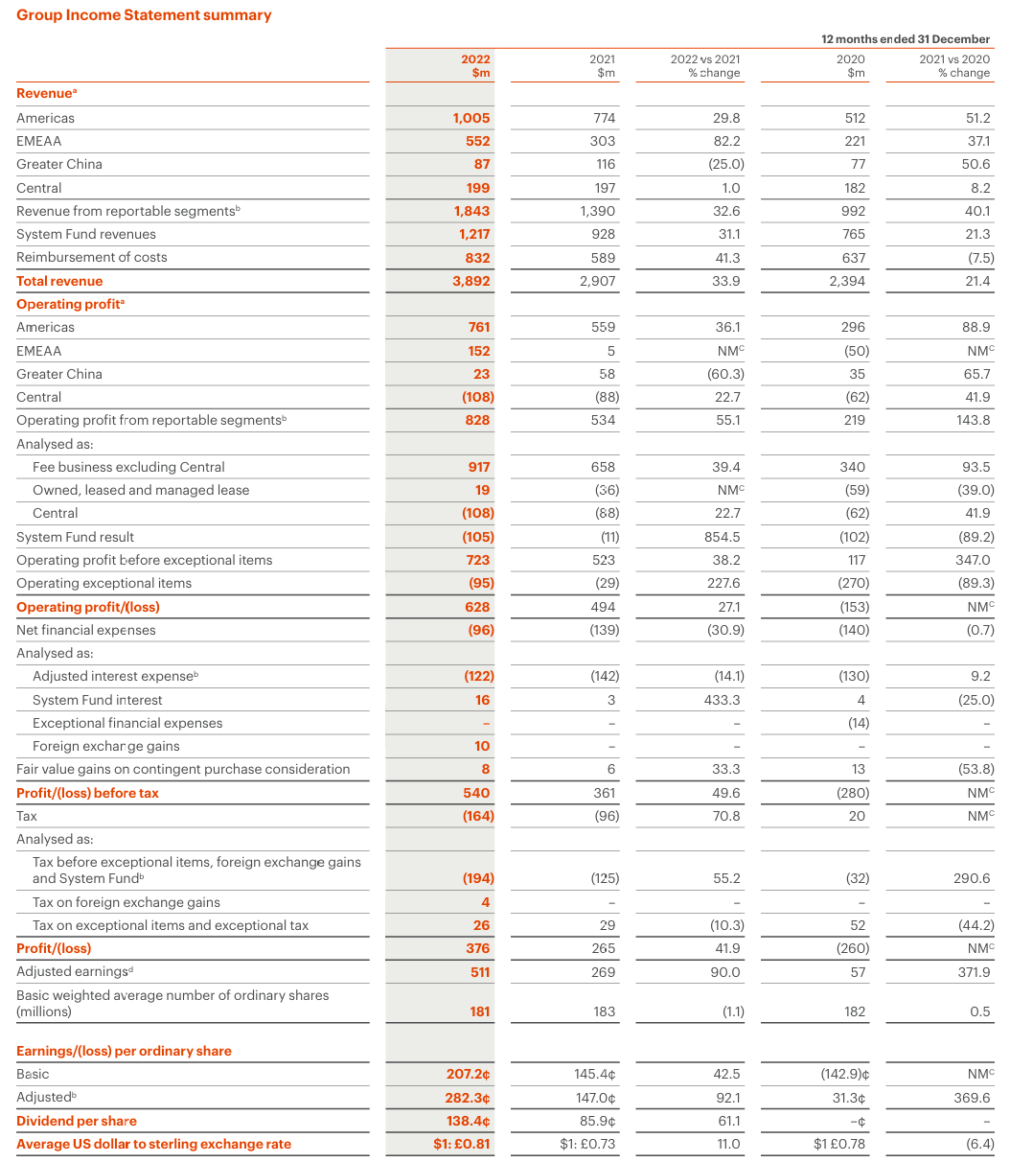

2023
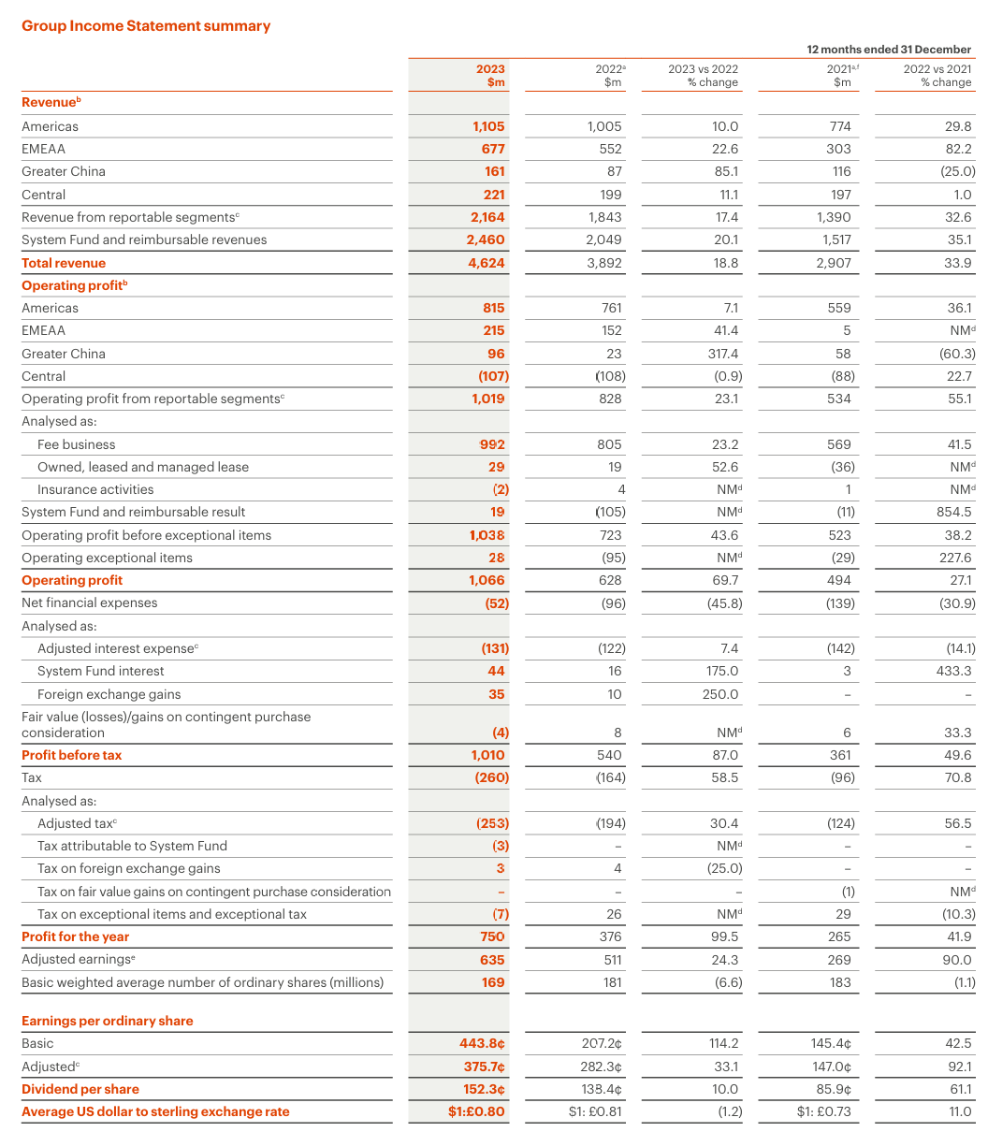

2024
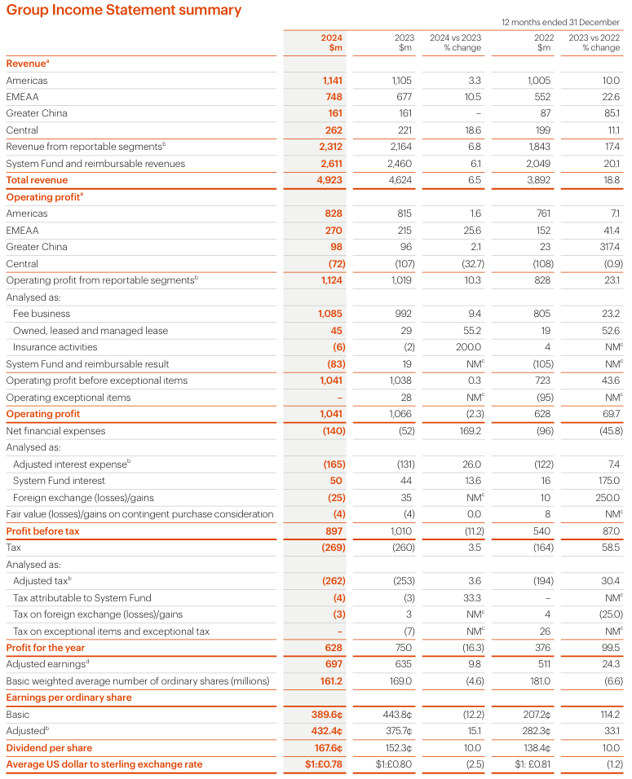

2025
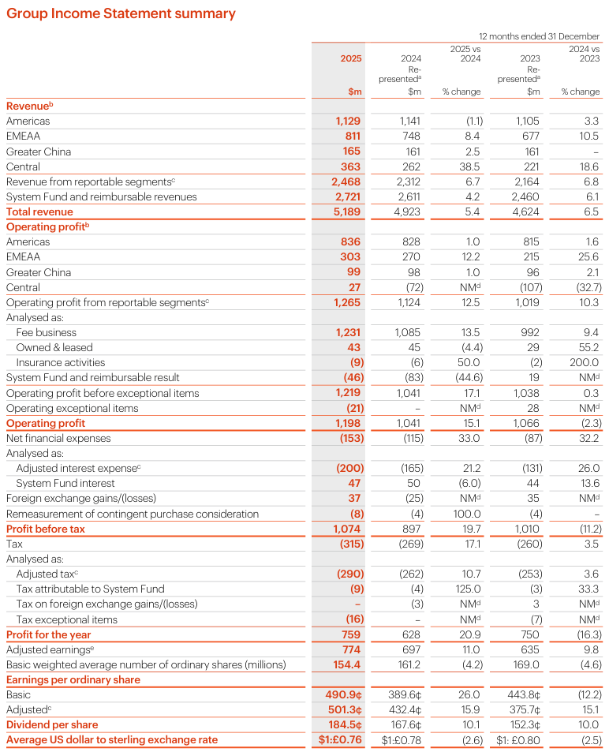

Appendix B — 5-year balance-sheet data

2021
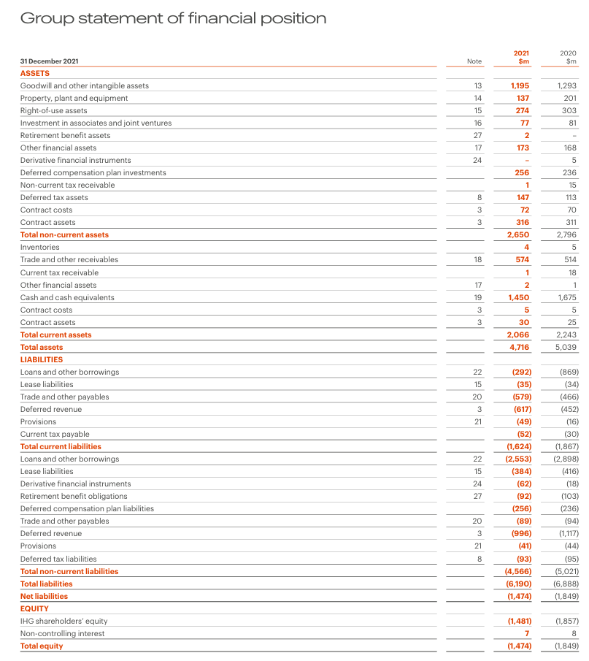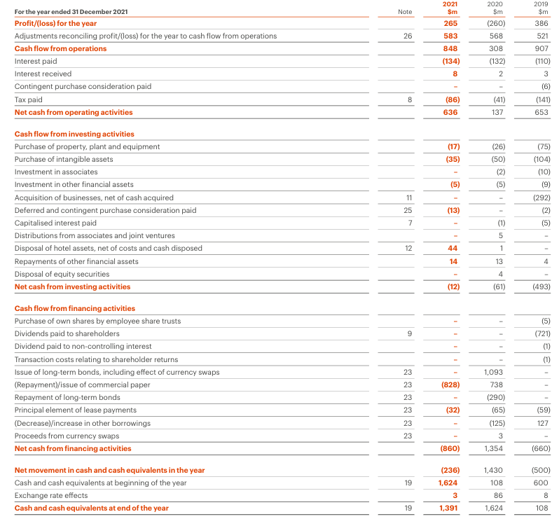

2022
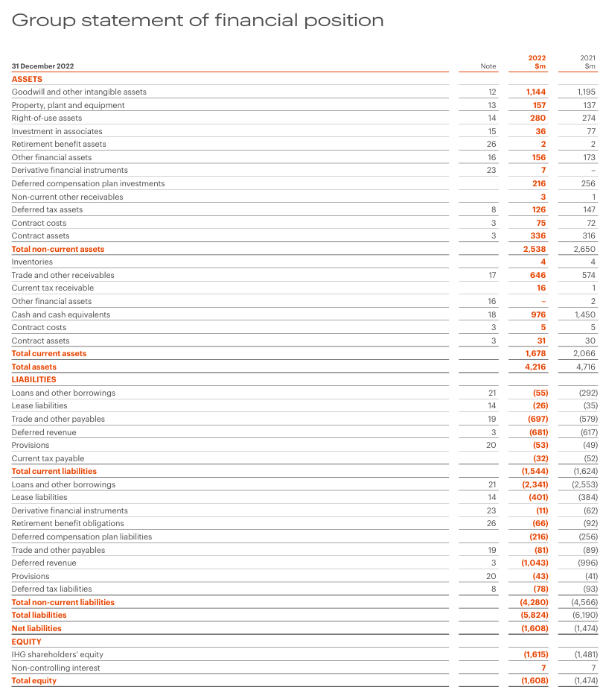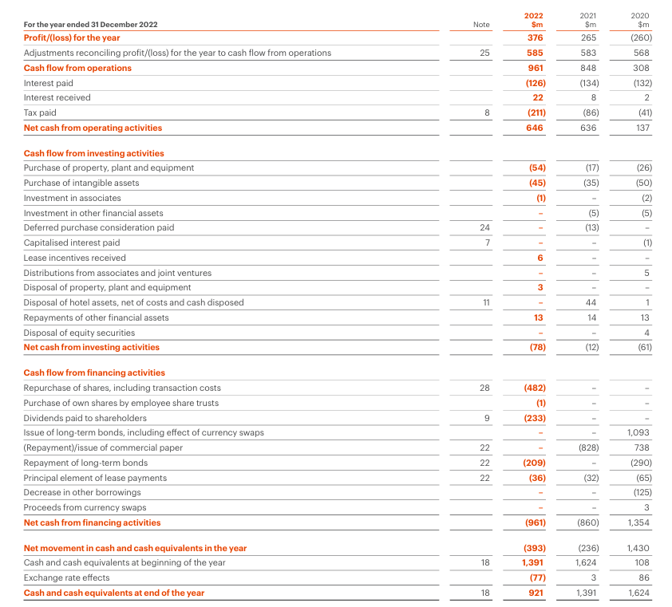

2023
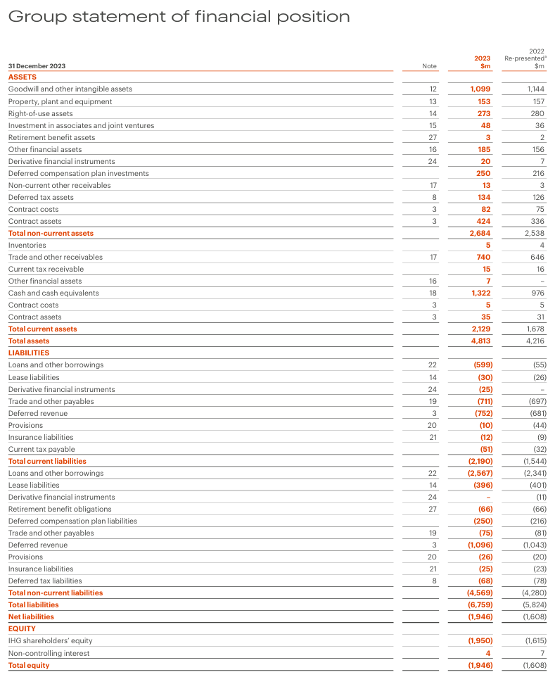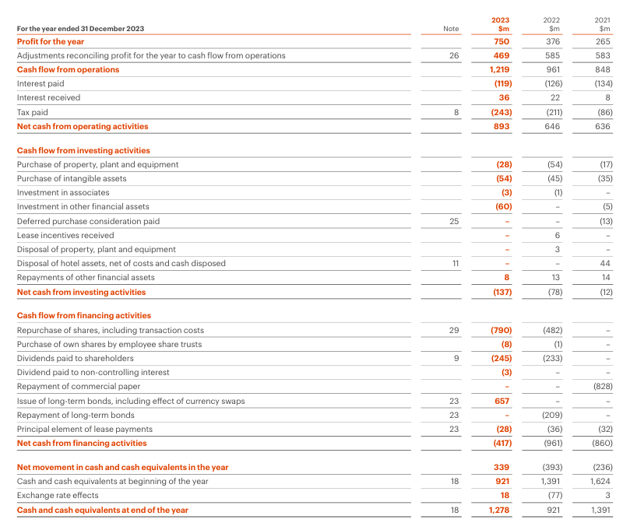

2024
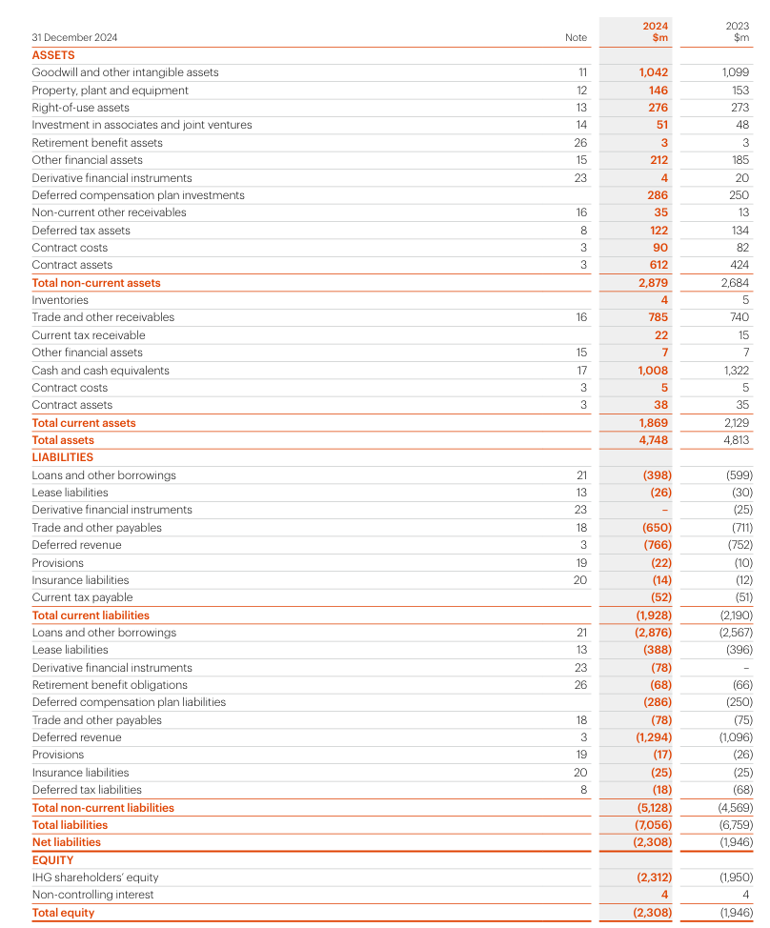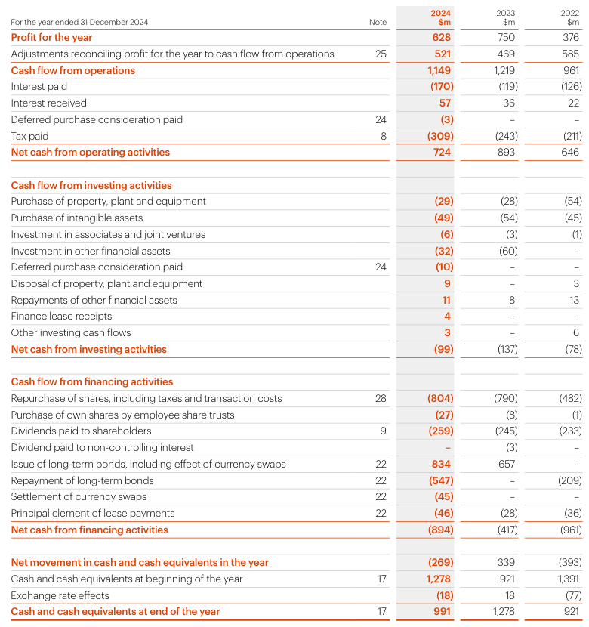

2025
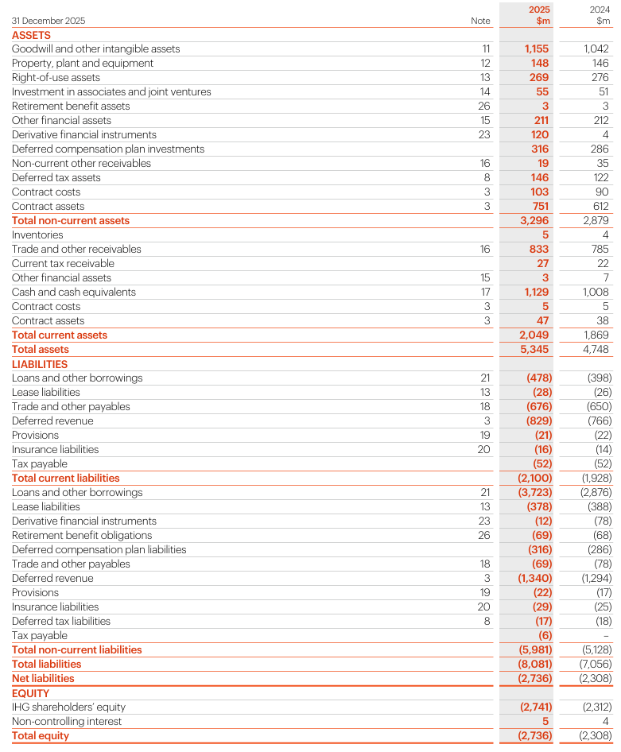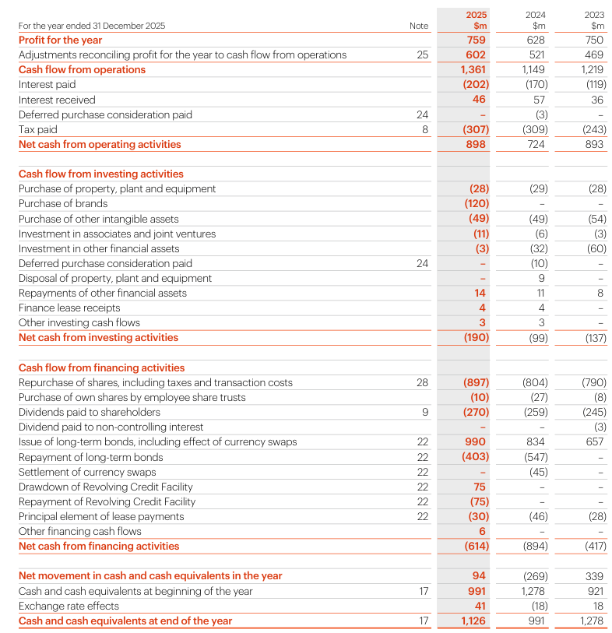

Appendix C — Five-year cash-flow data

2021
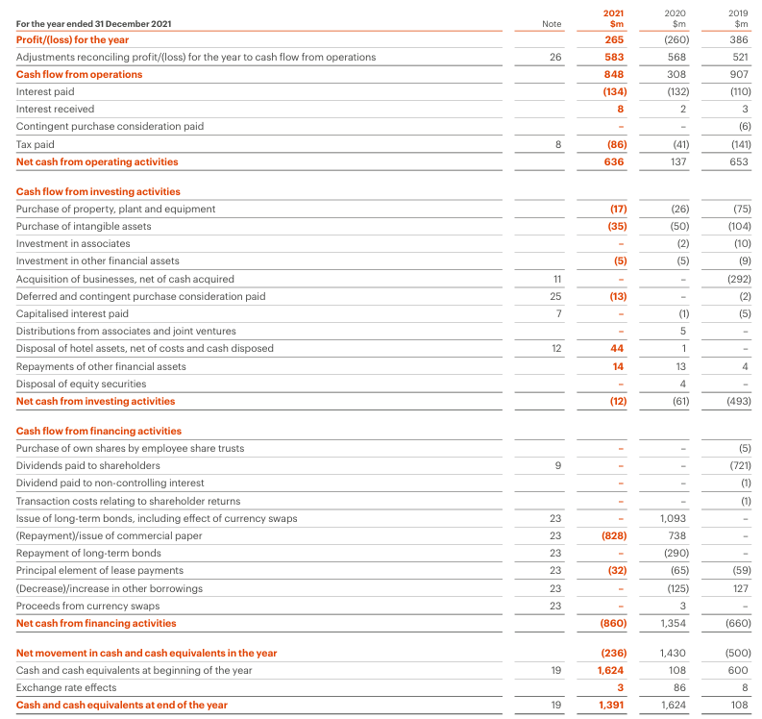

2022
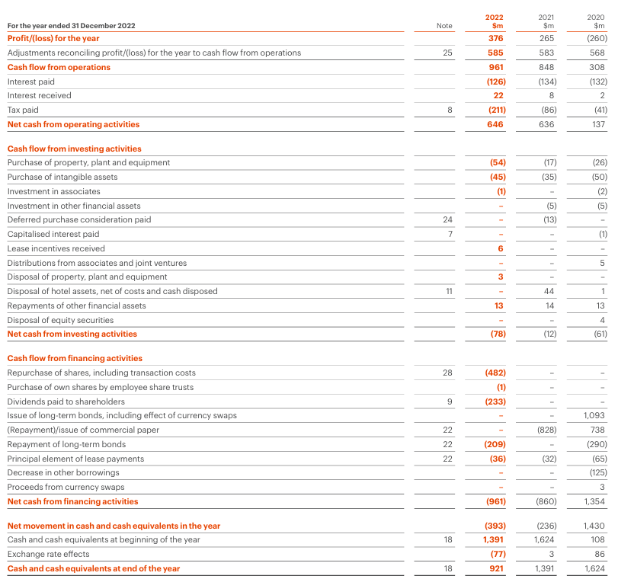

2023
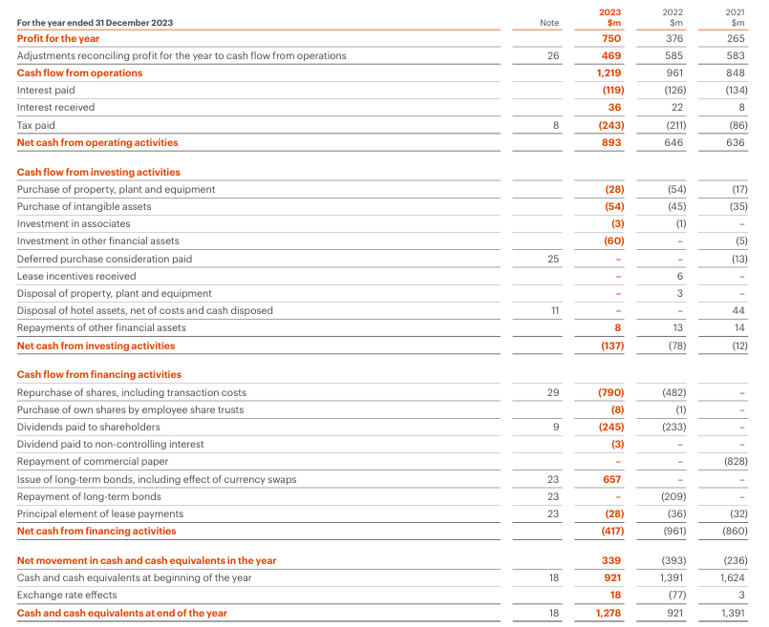

2024
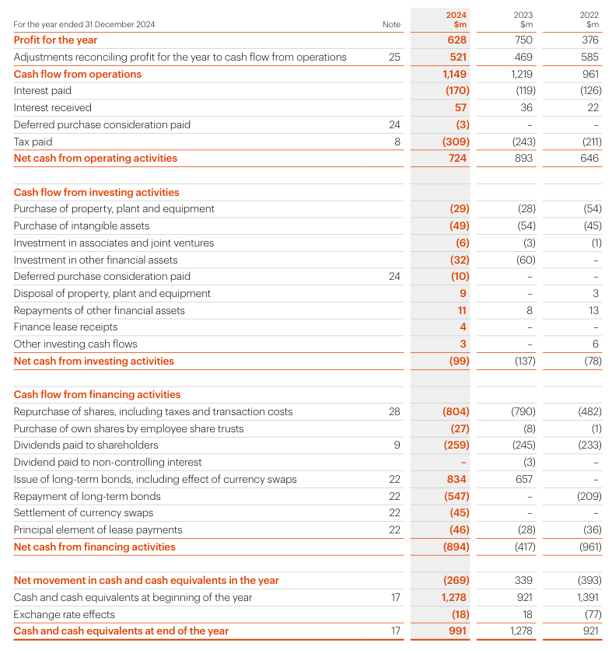

2025
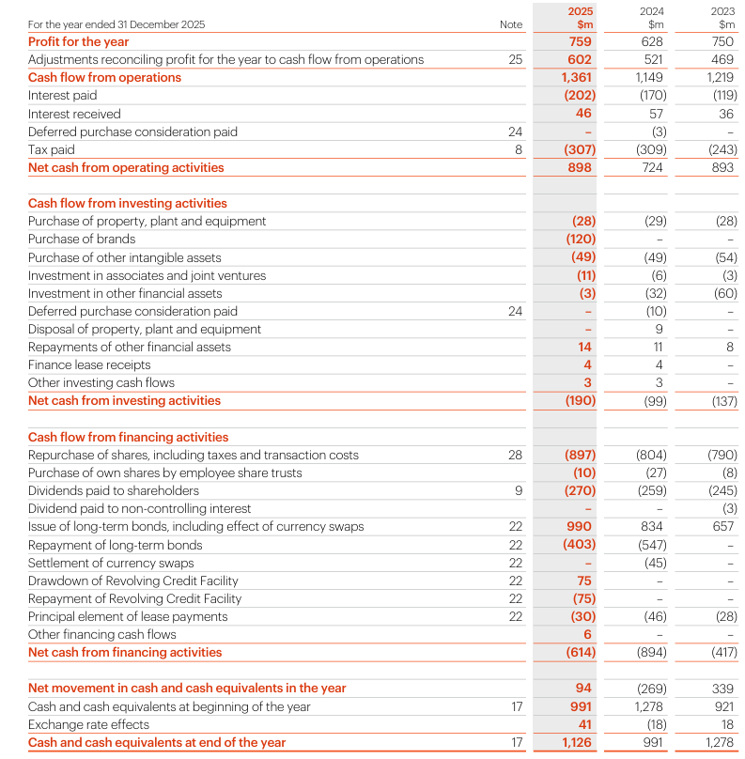

Appendix D — Ratios
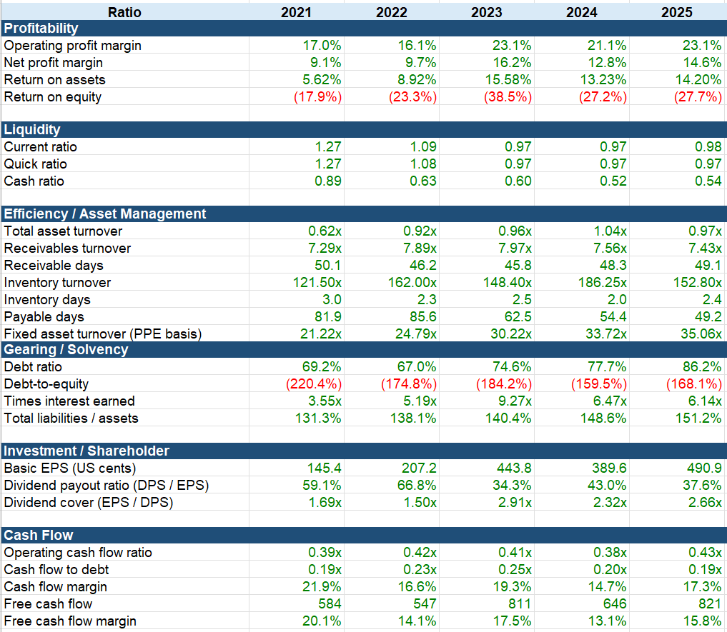

Appendix E — Graphs/Charts
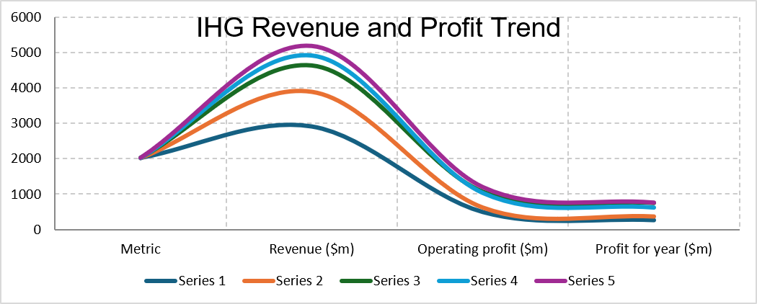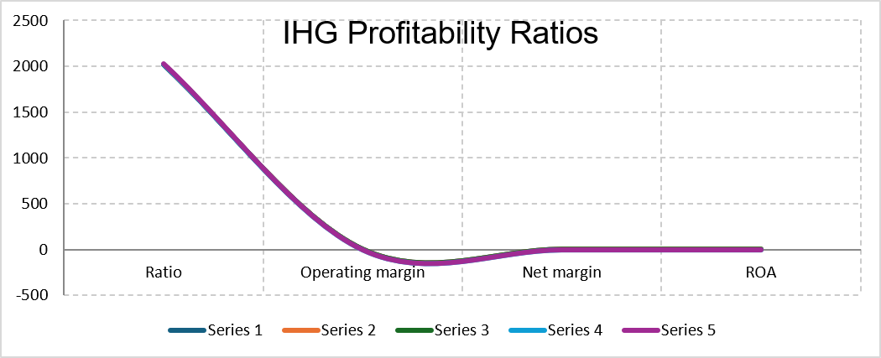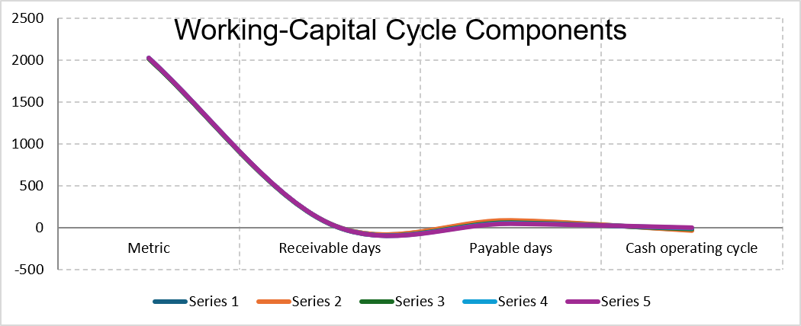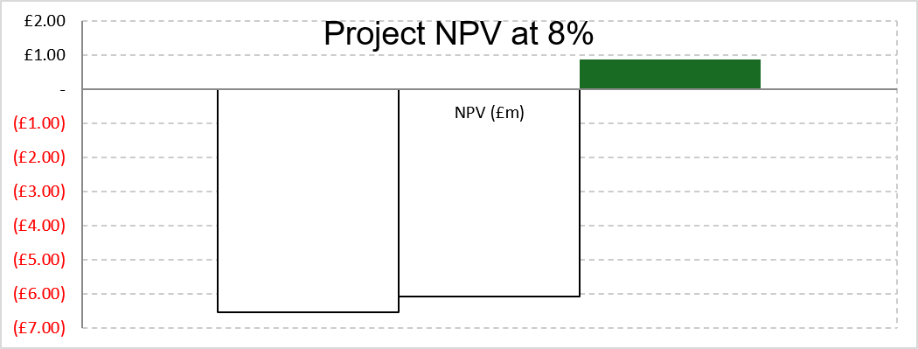

Appendix F — Working-capital
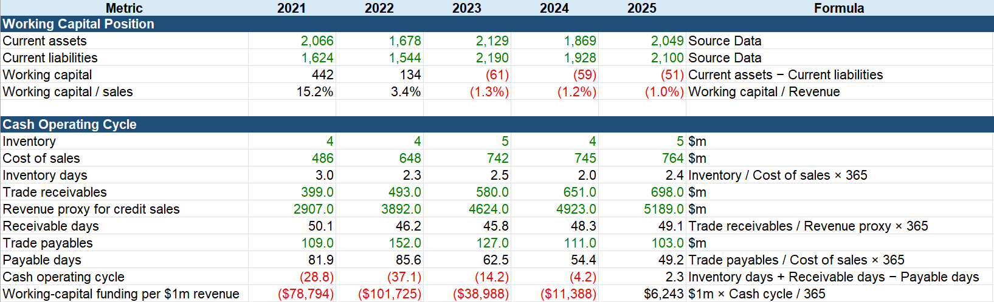

Appendix G — Project A appraisal
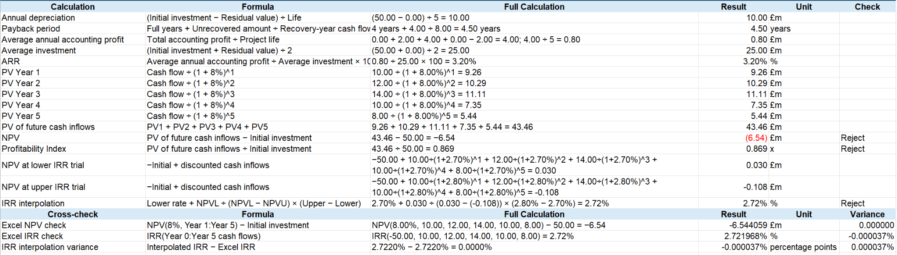

Appendix H — Project B appraisal
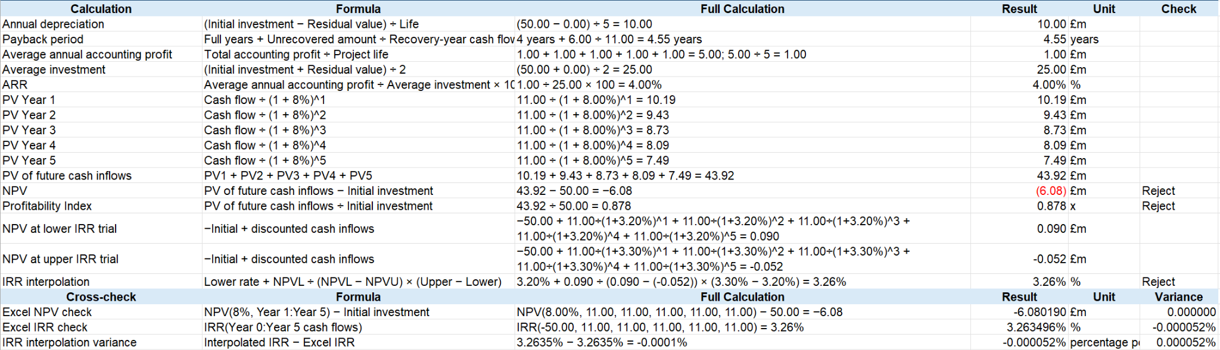

Appendix I — Project C appraisal
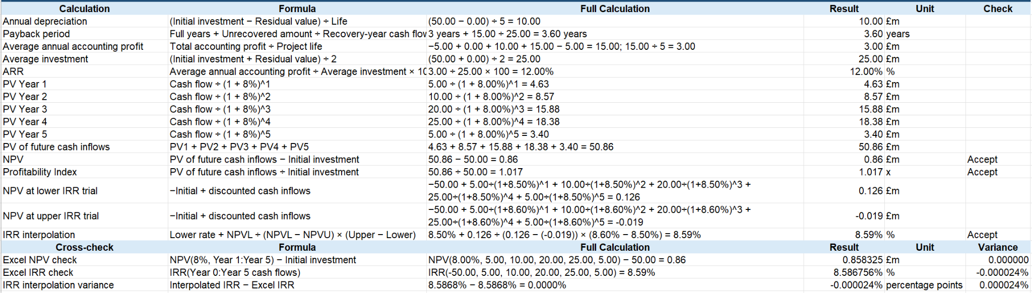

Appendix J — Capital-rationing calculations


