SPECIFIC ACTIVITY MANAGEMENT – Gorge Walking- Woodlands

Venue | Site Specific Issues | Arrangements
Blaen Y Glyn | Fallen trees in upper part of Gorge (Hidden Waterfall area)  Torpantau tunnel | This area has had significant felling and wind-throw therefore use upper part carefully on the newly established paths and away from trees overhanging the upper section of the gorge.  Wear helmets if going through in darkness. Access from North Eastern end only until further notice. Inspected with staff. Any changes monitored and shared with AHOEC and SWOAPG.  Boulders added to entrance from Northern End – these can be stepped around by groups to egress – confirmed with BBNPA, March 2021. Boulders were put in place to prevent access by motorbikes  Care on descent/ascent adjacent to stream back to lower car park from below tunnel entrance, caution and supervision when crossing the road.
Dinas Rock areas of gorge: Sychryd  Mellte | Access arrangements | Use in accordance with the SWOAPG Gorge code of conduct. No access to river left section of Sychryd. Do not park/get changed in residential street. Consider environmental impact.
Dinas Rock areas of gorge: Sychryd  Mellte | Jumping in at Mellte Gunpowder works (specifically Loonies Leap, river right) | Build up to the jump with the group. Position appropriately to ensure group members clear jump into the water and minimise risk to tutor. Ensure any participants not jumping are located safely.
Dinas Rock areas of gorge: Sychryd  Mellte | Water quality in Sychryd | There is no specific problem but avoid ingesting the water as it is below disused mines.

Blaen y Glyn Location:
Grid ref 064170, Park in lower car park at this location or upper car park or top of forest road if using Torpantau tunnel.

Dinas Rock Location:

Grif ref: 910079 (Car Park) lower Mellte used near car park (section from 100m above road bridge) and Sychryd up to wooden footbridge above the (horseshoe) waterfall.

Blaen Y Glyn and Torpantau tunnel

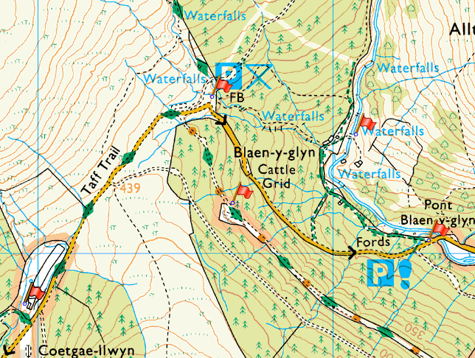

Sychryd, Dinas Rock and lower Mellte



