
Module: Project Management
Module code: LCBB5005
Assignment Title:
Coursework: Essay (Project Plan)

Student Name: Miroslava Velkova
Student Number: 2125655
Lecturer: Dr Anupam Mazumdar
Table of Contents
1. Introduction 3
2. Project Plan: The Hinkley Point C project 3
2.1 Overview 3
2.2 Timescale of Project 4
2.3 Budget of Project 5
2.4 Stakeholders of Project 6
2.5 Risk Factors of Project 7
2.6 Scope of Project 9
2.7 Human Resource Management 9
2.9 Procurement Management of Project 9
2.10 Reason behind the Delay 10
3. Conclusion 10
4. Recommendations 11
5. References 12

1. Introduction
Project management is a combination of different steps such as planning, decision-making, organising, controlling and leading (Gido and Clements, 2014). The aim of project management is to achieve the aim of the project and ensures success. This requires long-term monetarization through scheduling tasks and allocating resources. The case study is all about the project management plan of the Hinkley Point C Project. This project is about constructing the one and only nuclear power station in the UK. The project is currently under construction and expected to be completed by 2028. The project is situated in Somerset, UK. A subsidiary of the French company, EDF is the owner of the Hinkley Point C project with a share of around 66 percent (Daniel and Daniel, 2019). The rest of the share is of the China General Nuclear Station that is a major stakeholder of the project. The aim of the project is to fulfil the energy necessity of the UK by lowering carbon emissions. The project has currently created more than a thousand employee opportunities and it is claimed that it will create more job opportunities in future too. The critical evaluation of this case study will help to understand how the management process of the ongoing process is going. The budget and timescale of the project along with the risk associated with it will help to reach a proper conclusion. The critical evaluation will also help to give proper recommendations that can help the project overcome the delays occurring currently.

2. Project Plan: The Hinkley Point C project

2.1 Overview
Hinkley Point C is known as the most expensive nuclear power station in the world. The power station is currently under construction in Somerset of England. The HPC power station is in two units. The construction of the project began in the year 2017. The total cost allocation for the Hinkley Point C Project is 32.7 billion pounds (Smyth et al., 2018). However, the project is currently under construction because it was delayed due to some reasons including the Covid-19 pandemic. The decision of building the HPC project was announced by the UK government in the January of 2008 (Thomas, 2016). The current owner of the project is the EDF Energy and China General Nuclear Group. EDF Energy is mostly owned by the French government. The Hinkley Point C Project was started in 2016 and was expected to complete by 2025. However, the project was two years late because of the Covid pandemic that hit the UK economy massively. The budget of the project has risen to 26 billion dollars which are 50 percent of the previous budget (Baker, 2023). According to EDF, the budget can rise up to 32.7 billion pounds and the project will be delayed by 15 months from the expected completion date. The project is financed by EDF and China General Nuclear Group. Besides, the UK government is also supporting the project with a strike price of 92.50 Euros per MWh (Price et al., 2023).

2.2 Timescale of Project
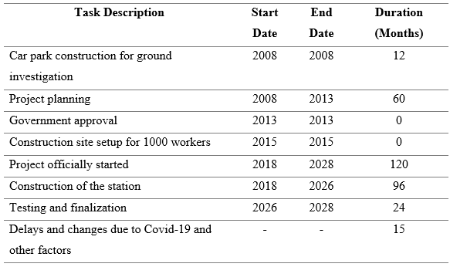
Figure 1: Summary of the Project Timescale/Source: (Author)
Before the start of the Hinkley Point C Project, a car park was constructed as a ground investigation in the year 2008 (Dyrda and Morrison, 2021). The planning of the project was also started in 2008. Later, the UK government approved the plan in 2013. In 2015, a construction site was made to give accommodation to 1000 workers on the project (Putti and Tóth, 2017). When China General Nuclear Power Station agreed to fund the project along with EDF, the actual work of the project started. The project was started officially in 2018. The estimated time for completing the project was 10 years. EDF announced that the first production of the station will be done by 2026. According to EDF, the construction of the station will be done in the first eight years and the rest two years will be spent in testing (Thomas, 2016). However, the project did not go according to the plan. From the beginning of its construction, it faced several delays and cost overruns. The cost per EDF Energy was increased to 18 billion pounds that was 16 billion previously (Chestney and Schomberg, 2016). Though the major reason behind the delay is the Covid-19 pandemic, there are some other reasons such as increased costs, changes in design and delays. Because of these reasons, the project is delayed for 15 months from the expected ending time. According to EDF, the project will be complete by the September of 2028.

2.3 Budget of Project
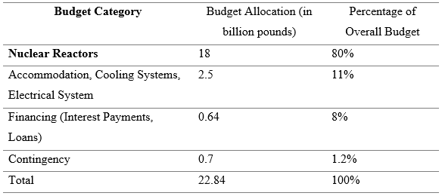
Figure 2: Summary of the Project Budget/Source: (Author)
The budget of the project has increased due to the inflation and Covid-19 pandemic. According to EDF, the cost of the project can rise up to 33 billion pounds. Based on the inflation of June 2022, EDF estimated that the budget can be 32.7 billion pounds (Price et al., 2023). Though this was 26-27 billion pounds in the May of 2022. This shows a massive increase in the budget in a month. The major portion of the budget is financed by EDF. China’s General Nuclear Power Group is holding 33 percent of the project. Though EDF can ask CGN for more capital for the increasing budget if CGN withdraws its funding due to inflation, the project will be hard to complete. The Hinkley Project C is the first nuclear project of Britain that will fulfil the emission target of the country by 2050 (Černoch and Zapletalová, 2015). That is why the majority of the budget is spent after the nuclear reactors which is 18 billion pounds. This holds 80 percent of the overall budget of the project. Other facilities such as accommodation for workers, cooling systems and the electrical system require 2.5 billion pounds that are 11 percent of the whole project. 8% of the budget is spent on financing such as interest payments and loans. The project also has a contingency plan to overcome any uncertain risks in future and this is around 700 million pounds approximately (Smyth et al., 2018).

2.4 Stakeholders of Project
A larger project like Hinkley Point C needs stakeholders to complete the work properly. Stakeholders can be internal or external that are interested in the project and have influence over it. As stakeholders play an important role in every project, it is necessary to understand the importance of stakeholders and their impact on the project (Bridgwater, 2011). There are several stakeholders of Hinkley Point C that help to make the project a success. The following are the major stakeholders of the project.
- A prime stakeholder of Hinkley Point C is the UK government. The UK Government has signed the contract for the project to help it with the necessary funding (Smyth et al., 2018). The aim of the UK government is to ensure that the nuclear station will fulfil the low carbon emission aim of the government by 2050. The aim is to use fewer fossils and create high electricity production.
- The major stakeholder of the Hinkley Point C Project is EDF. The organisation is the developer of the project. The major investments are financed by EDF. The organisation is responsible for maintenance, construction, operations, safety and security (Baker, 2023). The task of EDF is to fulfil the project in its estimated budget in time which will help to make it a success.
- China General Nuclear Power Station: This is another major owner of the Hinkley Point C project that holds around 33 percent of the total ownership. The company is responsible for funding in necessary sectors of the project as necessary (Daniel and Daniel, 2019).
- Besides the UK government, EDF and CGN, there are some other investors in the project too. These investors made investments in the project according to their needs. The financial condition of the project is monitored by the investors (Putti and Tóth, 2017).
- As Hinkley Point C is constructed with the aim of fulfilling the zero-emission goal by the UK government, the environmental groups are also acting as stakeholders of the project (Smyth et al., 2018). They are responsible to monitor the potential risks that the power station can cause to the environment.
- The general public is also a stakeholder in the project because the project is made to give them enough energy supply. As the UK people are concerned about safe and reliable energy sources, this project can help to fulfil their requirements along with leaving a positive impact on society by creating low-carbon emissions (Ansar and Flyvbjerg, 2016).

2.5 Risk Factors of Project
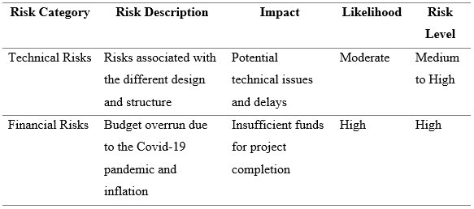
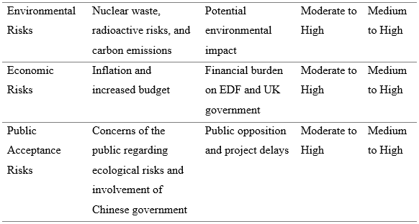
Figure 3: Summary of the Risk Assessment of the Project/Source: (Author)
The Hinkley Point C Project is a major nuclear power station development plan in the UK. As it is a long-term project and it is one of the big projects of Britain, there are several risks associated with the project. One major risk that can put the project in a complex situation is technical risks. The Hinkley Point C has two different water reactors that have a 1.6 GW capacity of each (Gandolfo, 2016). These reactors are different in design and structure that has a different type of technical risks. Another major risk for the project is financial risk. Due to the Covid-19 pandemic and inflation, the costs of the project have crossed the estimated budget. If CGN declines to invest the extra budget caused to the economic condition of the project, the budget will get short for the project (Newbery et al. 2019). This is a major risk that the project is currently facing that EDF cannot ask for more investment from CGN. The project is also associated with environmental risks such as nuclear waste, radioactive risks and carbon emissions. The project has to fulfil the goal of low emissions for the UK government. Economic risks such as inflation can increase the budget of the project. The extra budget will be hard to carry for both EDF and the UK government. However, the last and most probably major concern of the project is public acceptance. The project can cause the UK people concerned about the ecological risks associated with the project (Černoch and Zapletalová, 2015). As the Chinese government is involved with the project, this can be a major concern for the general people of the UK. The project can only be successful if the risks associated with it are managed properly and mitigated.

2.6 Scope of Project
- The Hinkley Point C Project will deliver the energy objectives set by the UK government. This will help to create an innovative economy, better jobs, better sources of earnings, huge scopes of business and lastly will lead to a modern infrastructure (Černoch and Zapletalová, 2015).
- One of the major challenges of the UK Government is clean growth. The project can fulfil these challenges through the transition to low carbon emissions (Glasson et al., 2021). It will also help to fulfil the zero-emission target of the government by 2050.
- The project is using low-carbon technologies that will help it to achieve Clean Growth Grand Challenge. The project will make sure that significant cost reduction is ensured in the nuclear sector (Daniel and Daniel, 2019).
- The project brings huge environmental benefits as its keys are sustainability and environmental protection. According to reports, the emission of carbon from this station will be lower than solar power and wind. To reduce carbon footprint and fulfil the zero carbon emission challenge of the UK government, more than 50 environmental engineers and ecologists are working continuously on the Hinkley Point C project (Glasson et al., 2021).

2.7 Human Resource Management
The human resource of the Hinkley Point C project has a vast workforce. The project has given around 25 thousand employment opportunities in different sectors (Dyrda and Morrison, 2021). During the Covid-19 pandemic, the number of people working for the team was limited. However, the project is now hiring engineers, ecologists and talented human forces for different sectors of the project. In order to gain the support of the local people, the project has given thousands of jobs in its local area that has cost around 3 billion pounds (Černoch and Zapletalová, 2015). The project also has a pipeline that is educating people to increase their skills that is ultimately leading them to work on the project. Employment opportunity is available for them throughout the power stations.

2.9 Procurement Management of Project
To ensure the successful construction of the only nuclear power station in Hinkley Point C, EDF needs suppliers and the support of local businesses. The organisation cannot successfully build the project. EDF is ensuring the success of the local manufacturers of the UK in order to gain support for the long term (Thomas, 2016). Currently, more than 4 thousand local businesses have invested in the project with a combined value of around 3.2 billion pounds (Dyrda and Morrison, 2021). This is why the project has a robust supply chain management that includes a wide range of local, national and international firms. However, due to some falsifying documents, the supply chain management of the project has been facing some criticism.

2.10 Reason behind the Delay
Hinkley Point C project is the new and only nuclear power station in the UK. This is why the project needs a long time to construct in comparison with other projects. The project has faced several difficulties from the beginning. These difficulties affect the project significantly. The design that was proposed in the beginning was changed many times due to the change in situations (Bridgwater, 2011). Later, the project added many safety requirements that were a local concern. The project also faced legal challenges from environmental groups. The joining of CGN was another controversy and this is why EDF faced hardship to gain support from the locality (Dyrda and Morrison, 2021). The supply chain management also faced some issues due to some false documents. One major issue behind the delay of the project was the Covid-19 pandemic. The project got two years late from its expected completion time. The project management also faced some difficulties that delayed the decision-making process (Ansar and Flyvbjerg, 2016). Any changes made during the construction of the project need approval which also delayed the construction of the Hinkley Point C Project.

3. Conclusion
In conclusion, it can be clearly understood that the Hinkley Point C project is an important part to reduce the negative effects of climate change. The project is not only significant in the UK but also across the world that will help to produce electricity with lower carbon emissions. The project has many benefits such as employment opportunities, environmental benefits, local developments, reliable energy sources and so on. However, there are some drawbacks and difficulties with the initiative. Because of this, the project needs a thorough plan to reduce risks. Project management should be able to handle unforeseeable risks like the COVID-19 pandemic.

4. Recommendations
The biggest project in the UK, Hinkley Point C, makes insufficient efforts to reduce risks. The following project guidance could make it easier for the project to foresee upcoming uncertainties.
- The project manager needs to undertake an environmental assessment with a view to understanding the impact of the project on the environment. Based on the assessment, the project management team of the project needs to take the initiative to minimise the impact of the project on the environment.
- Moreover, the project managers should also consider economic factors including inflation or any other changes to the economy which will enable the project managers to maintain the budget of the project effectively.
- The project management team can employ more workforce to meet the time gap caused by the covid 19 pandemic. This will fasten the advancement and completion of the project and hence make the project be completed on revised time. Also, the project management team should have a contingency plan in order to avoid any delays further.

5. References
Ansar, A. and Flyvbjerg, B. (2016). Big is fragile: Why the UK government should not approve the Hinkley Point C nuclear power station. Petroleum Review, 70(834), pp.37-40.
Baker, K. (2023). Nuclear Power in Britain: A Series of successful failures. International Review of Public Policy.
Bridgwater, C. (2011). Hinkley Point C.
Černoch, F. and Zapletalová, V. (2015). Hinkley point C: A new chance for nuclear power plant construction in central Europe?. Energy Policy, 83, pp.165-168.
Chestney, N. and Schomberg, W. (2016). Britain casts doubt on EDF’s $24 billion nuclear project. Reuters. [online] 29 Jul. Available at: https://www.reuters.com/article/uk-edf-britain-nuclear-idUKKCN1090EW [Accessed 8 Jul. 2023].
Daniel, E. and Daniel, P.A. (2019). Megaprojects as complex adaptive systems: The Hinkley point C case. International Journal of Project Management, 37(8), pp.1017-1033.
Dyrda, J. and Morrison, R. (2021). Overview of the Hinkley Point C EPR Project ‘J0’and Beyond. In EPJ Web of Conferences (Vol. 247, p. 20001). EDP Sciences.
Gandolfo, A. (2016). Hinkley Point C nuclear station: an expensive solution to a cheap problem. LSE Business Review.
Gido, J. and Clements, J. (2014). Successful project management. Cengage Learning.
Glasson, J., Durning, B., Broderick, M. and Welch, K. (2021). Monitoring and auditing the local socio-economic and environmental impacts of the early stage construction of Hinkley Point C Nuclear Power Station, UK. Impact Assessment and Project Appraisal, 39(2), pp.84-95.
Newbery, D., Pollitt, M., Reiner, D. and Taylor, S. (2019). Financing low-carbon generation in the UK: The hybrid RAB model.
Price, J., Keppo, I. and Dodds, P.E. (2023). The role of new nuclear power in the UK's net-zero emissions energy system. Energy, 262, p.125450.
Putti, K. and Tóth, Z. (2017). Economic analysis of the Hinkley Point C nuclear power plant based on the available data. In 2017 6th International Youth Conference on Energy (IYCE) (pp. 1-7). IEEE.
Smyth, H., Lecoeuvre, L. and Vaesken, P. (2018). Co-creation of value and the project context: Towards application on the case of Hinkley Point C Nuclear Power Station. International journal of project management, 36(1), pp.170-183.
Thomas, S. (2016). The Hinkley Point decision: An analysis of the policy process. Energy Policy, 96, pp.421-431.
‌

