7/28/2026
DESIGN AND IMPLEMENTATION OF A RELATIONAL DATABASE FOR THE AUTOPARK MANAGEMENT SYSTEM USING MICROSOFT ACCESS
(ACCA4023_LON)
Student Details:
Name: Munwar Hussain
Student ID: 2532062
Module: Introduction to Web and Database Concepts
Lecturer: Anum Paracha
Contents
I. INTRODUCTION 2
a. Background of Database Systems 2
b. Purpose of the Assignment 2
II. SCENARIO ANALYSIS 2
a. Overview of the AutoPark Management System 2
b. Functional Requirements 2
c. Identification of Entities 2
III. DATABASE DESIGN 3
a. Entity Description 3
b. Attributes of Each Entity 3
c. Entity Relationships 3
IV. NORMALISATION 3
a. First Normal Form (1NF) 3
b. Second Normal Form (2NF) 3
c. Third Normal Form (3NF) 4
d. Benefits of Normalisation 4
V. MICROSOFT ACCESS DATABASE IMPLEMENTATION 4
a. Table Creation 4
b. Relationship Creation 4
c. Sample Data Population 4
d. Database Forms 4
VI. QUERY DEVELOPMENT 4
a. Purpose of Queries 4
b. Query 1 – Available Parking Slots 5
c. Query 2 – Occupied Slots 5
d. Query 3 – Customer Booking History 5
e. Query 4 – Payment Report 5
f. Query 5 – Revenue by Parking Site 6
g. Summary of Query Results 6
VII. Validation and Testing 6
VIII. Conclusion 6
References 7
APPENDIX 7
Query 6: Reserved Parking Slots 7
Query 7: Customer Vehicle Details (JOIN) 7
Query 8: Pending Payments 7
Query 9: Parking Site Capacity 8
Query 10: Complete AutoPark Management Report 8

INTRODUCTION

a. Background of Database Systems
A database refers to an organized repository of related information that facilitates the storage, retrieval, and management of information easily. Relational databases store information in various interrelated tables through primary and foreign keys to ensure consistency and lessen duplication. Database Management System (DBMS) is applied in the organizations to ensure data accuracy, enhance security, facilitate quicker decision-making and automate the business processes with the help of the structured data management.

b. Purpose of the Assignment
This assignment is aimed at creating an Auto Park Management System in Microsoft Access to automate the parking management operations. The database has been developed to handle customer details, vehicle data, parking locations, parking places, reservations and payments in one unified database system. The adopted relational database system substitutes the manual record-keeping as it enhances better organization of the information, reduces the duplication of data and allows efficient retrieval of the information using SQL queries. The report describes the database design, entity relationships, implementation process and query execution that have been created to support an automated parking management solution.

II. SCENARIO ANALYSIS

a. Overview of the Auto Park Management System
Most parking lots are still using manual registers or spreadsheets to capture customer information, vehicle records, parking slot assignments, booking records and payment records. These manual tools can lead to the duplication of data, lost records, errors in calculations, and retrieving information slowly. The Auto Park Management System that has been developed manages these problems by storing all the information related to parking in a structured relational database using Microsoft Access [1]. The automated system enhances efficiency in operations and proper record management and quick accessibility to information.

b. Functional Requirements
The Auto Park Management System developed carries out several vital business functions. It maintains customer data along with the registered vehicles and operates various parking locations and parking spaces. The system tracks the vehicle booking by matching the customers, vehicles and the reserved parking slots. It also keeps the records of payments related to every booking [2]. These built-in capabilities facilitate proper parking control and minimize the number of manual operations and enhance performance.

c. Identification of Entities
This database has six major entities: Customer, Vehicle, Parking Site, Parking Slot, Booking, and Payment. Customer Entity stores personal data, whereas Vehicle stores registered vehicle data which is associated with the customers. Parking Site stores parking sites and Parking Slot stores a parking space in a parking site. Booking: A booking is used to match the customers, vehicles and the parking slots that have been assigned during parking transactions, and Payment: Payment is used to store the financial information that is related to each booking and finalizes the parking management process.

III. DATABASE DESIGN

a. Entity Description
Auto Park Management System database comprises six connected entities that are aimed at the management of parking operations. Customer table is the table that contains the details of the customers in terms of their name, phone number, email address, and residential address. Vehicle registration, vehicle type, colour and association of each vehicle with its owner is stored in the table called Vehicle. The table Parking Site contains data on the parking sites along with their capacity [3]. The table of Parking Slot contains the record of each parking space that exists in a particular parking location along with the types of slots and the availability field. The Booking table captures all reservations made by the customers in terms of connecting customers, vehicles and the designated parking slots and stores, the entry time, exit time and the booking date. Lastly, the Payment table registers the amount paid, method of payment, date of payment and payment status of every booking and the parking transaction is complete.

b. Attributes of Each Entity
Every table has a Primary Key which uniquely identifies all the records like: Customer ID, Vehicle ID, Site ID, Slot ID, Booking ID, and payment ID. Foreign Keys are keys that connect related tables such as CustomerID, Vehicle ID, Site ID, Slot ID and Booking ID. Data types that are appropriate like AutoNumber, Short Text, Number, Date/Time, Currency, and Long Text were chosen based on the information that is stored. Mandatory fields make sure that critical details are captured within a consistent manner [12].

c. Entity Relationships
The database consists of one-to-many relationships to ensure that there are integrity and reduced redundancy in the data present in the database. A customer is allowed to possess several vehicles, and a customer is allowed to make several bookings. There are several parking slots within one parking site and there is one parking slot within a parking site. Each booking is associated with one customer, one vehicle, and one parking lot. Each payment record is associated with booking by the Booking ID field [4]. These relationships were done in Microsoft Access with primary and foreign key and referential integrity on, to maintain the same and reliable data across the Auto Park Management System.3.4 Entity Relationship Diagram (ERD).
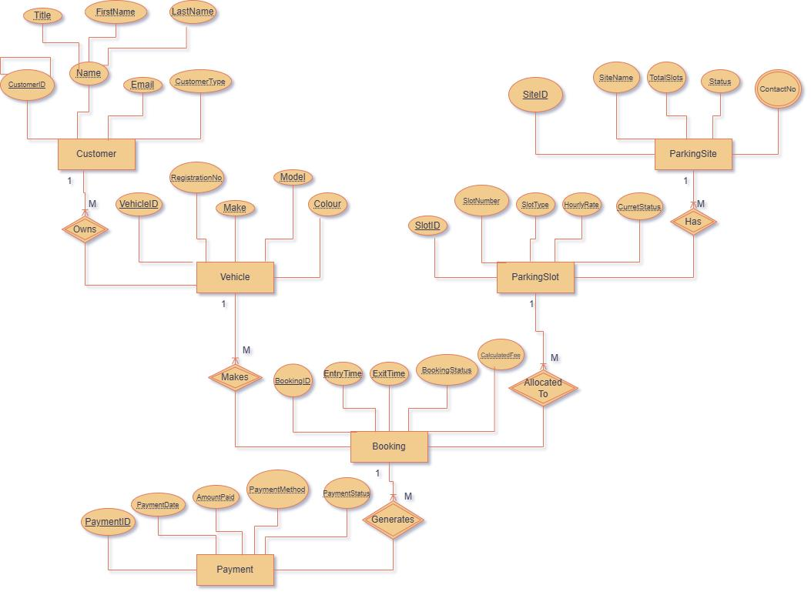
Fig 1: Entity Relationship Diagram (ER Diagram) of the Auto Park Management System
(Source: Draw.io)
This is an Entity Relationship Diagram (ERD) that was created to accompany the Auto Park Management System. This diagram indicates that there are six entities that are related by primary and foreign keys in a one-to-many relationship, and that booking is associated with a single payment. Cardinality determines the association of records in tables, which ensures referential integrity, minimizes redundancy of data, and facilitates effective retrieval of the customer, vehicle, booking, parking, and payment records.

IV. NORMALISATION

a. First Normal Form (1NF)
The Auto Park Management System meets the First Normal Form (1NF) in that each table has only atomic values, i.e. a single field of information. Duplications of groups and the presence of several values in the same column have been removed. The database is designed in a structured and organised manner by giving each record a unique identifier by a primary key [5].

b. Second Normal Form (2NF)
The database meets the Second Normal Form (2NF) by eliminating partial dependencies. All non-key attributes are fully dependent on corresponding primary key as opposed to being partially dependent on within a composite key. The data on Customer, Vehicle, Parking Site, Parking Slot, Booking, and Payment are stored in different tables and do not need to be duplicated unnecessarily and enhance the organisation of the data.

c. Third Normal Form (3NF)
The database meets the Third Normal Form (3NF) by eliminating transitive dependencies. Non-key attributes do not require other non-key attributes; they only require the primary key. As an illustration, payment data is hosted in the table of Payments whereas the data of customers, vehicles and parking are stored in corresponding tables and that guarantees the correct and independent data storage [11].

d. Benefits of Normalisation
Normalisation achieves a great deal in minimising redundancy of data as the information is stored in one place and the associated tables relate to the help of foreign keys. This enhances data consistency and reduces update anomaly. The structured database design also eases their maintenance, improves their data integrity, facilitates effective running of queries and it is easier to expand the Auto Park Management System in the future without disturbing the current records.

V. MICROSOFT ACCESS DATABASE IMPLEMENTATION

a. Table Creation
The database was developed using the Microsoft Access application and six relational tables are developed namely Customer, Vehicle, Parking Site, Parking Slot, Booking and Payment. The right type of data (AutoNumber, Short Text, Number, Date/Time, Currency and Long Text) was chosen based on the information kept in respective fields. Each table had a primary key that would be used to identify each record and ensure integrity of data.
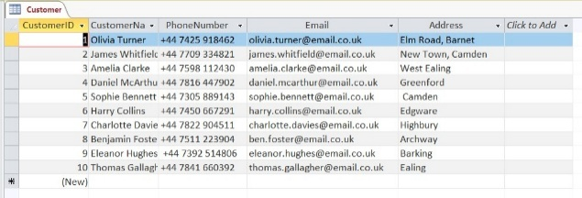
Fig 2: Table Design View (Customer Table)
(Source: Ms-Access)

b. Relationship Creation
The tables were related through primary and foreign keys to establishing a relational structure of the database. Referential integrity was applied to ensure that there were constant relationships among related records and avoidance of invalid data entry [6]. The Customer and Vehicle relationship, Customer and Booking, Vehicle and Booking, Parking Site and Parking Slot relationships, Parking Slot and Booking relationships, and Booking and Payment were established.
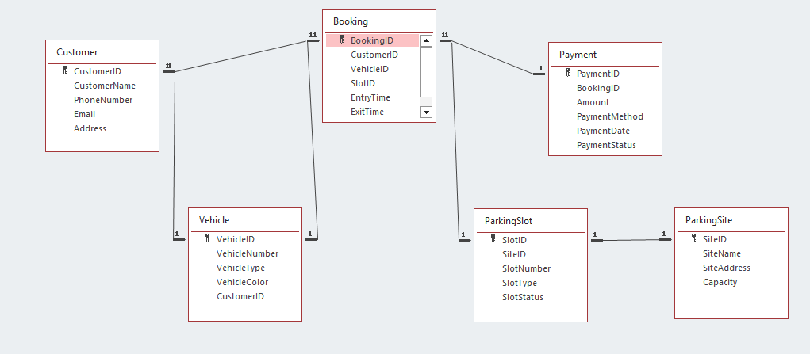
Fig 3: Relationship Diagram
(Source: Ms-Access)

c. Sample Data Population
Following the design of the database, sample records have been added to each table to show how the system works. Each table was filled with ten records and, therefore, made 60 records in the database. Customers were provided with realistic information, vehicle details, parking areas, booking and payment transactions that facilitated meaningful query execution and system testing [7].

d. Database Forms
The Microsoft Access forms offer a user-friendly way of entering or updating database entries. Customer registration can be made easier with a Customer Entry Form and vehicle parking reservations can be registered in an efficient manner with a Booking Form. Forms are optional in this implementation but enhance usability because they minimize the errors of manual data entry and enhance operational efficiency [8].
e. Database Structure Summary
The completed Auto Park Management System has six relational tables which are linked through six relationships. In each table, there are 10 sample records that make a total of 60 records in the database. The adopted structure helps in managing customers, registering vehicles, assigning parking slots, managing booking, processing payment, and accessing data efficiently using SQL queries established in Microsoft Access.

VI. QUERY DEVELOPMENT

a. Purpose of Queries
Queries are employed in retrieval, filtering, calculation and analysis of data contained in the database. They allow users to get records in a short period of time, create meaningful reports, facilitate operational decision-making, and enhance the overall performance of the Auto Park Management System by showing the relevant information depending on the needs of the users.

b. Query 1 – Available Parking Slots
This query shows all the parking slots that have the status Available and parking staff can see where they can park incoming vehicles.
Quarry 1: Available Parking Slots
SELECT *
FROM Parking Slot
WHERE Slot Status='Available';
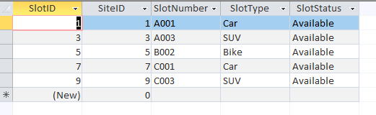

c. Query 2 – Occupied Slots
This query will bring all the occupied parking slots, and the management will be able to track the parking utilisation and identify the current occupancy of parking space.
Query 2: Occupied Parking Slots
SELECT *
FROM Parking Slot
WHERE Slot Status='Occupied';
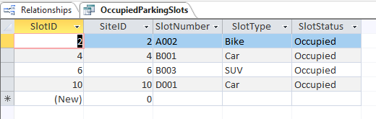

d. Query 3 – Customer Booking History
This query is composed of customer, vehicle and booking details to show the history of the parking history of each customer and the booking details.
Query 3: Booking Details
SELECT
Booking.BookingID,
Customer.CustomerName,
Vehicle.VehicleNumber,
ParkingSlot.SlotNumber,
Booking.EntryTime,
Booking.ExitTime
FROM
((Booking
INNER JOIN Customer
ON Booking.CustomerID = Customer.CustomerID)
INNER JOIN Vehicle
ON Booking.VehicleID = Vehicle.VehicleID)
INNER JOIN Parking Slot
ON Booking.SlotID = ParkingSlot.SlotID;
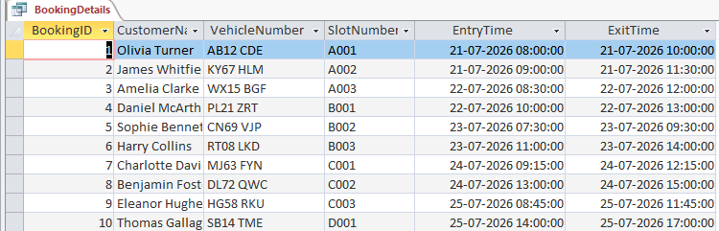

e. Query 4 – Payment Report

This query will retrieve payment information along with customer and vehicle information and enable the management to track the financial transactions completed and pending.
Query 4: Payment Details
SELECT
Payment.PaymentID,
Customer.CustomerName,
Vehicle.VehicleNumber,
Payment.Amount,
Payment.PaymentMethod,
Payment.PaymentDate,
Payment.PaymentStatus
FROM
((Payment
INNER JOIN Booking
ON Payment.BookingID = Booking.BookingID)
INNER JOIN Customer
ON Booking.CustomerID = Customer.CustomerID)
INNER JOIN Vehicle
ON Booking.VehicleID = Vehicle.VehicleID;
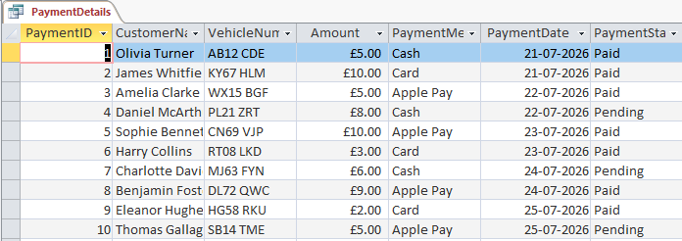

f. Query 5 – Revenue by Parking Site
This query summarises payment data to assess the revenue earned through parking operations, which can be used to support financial monitoring and analysis of business operations.
Query 5: Total Revenue
SELECT
SUM(Amount) AS Total Revenue
FROM Payment;
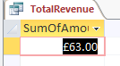

g. Summary of Query Results
The queries implemented are effective in retrieving operational and financial data in the database. They help the management to track the parking space, bookings, payment transactions and income generation. These queries aid in making informed decisions, enhance efficiency in operations and show the efficiency of the relational database created in Microsoft Access.

VII. Validation and Testing
The Auto Park Management System that had been completed was tested to ensure that the database functions were working properly. Relations among the six tables were verified to make sure that the primary and foreign keys were properly connected and that referential integrity was adhered to [9]. Each table was entered with sample data to ensure that there were no errors in storing and retrieving data. All the adopted SQL queries were run to ensure that they generated the right and desired outputs, such as the parking availability, booking, payment information, and revenue computation [10]. The fact that the test was successful and that the screenshots were provided is an indication that the database is reliable, its data is consistent and that the database meets the functional requirements of the system.

VIII. Conclusion
Auto Park Management System was designed and successfully implemented on Microsoft Access and it met its goals of controlling customers, vehicles, parking sites, parking slots, booking and payments in a relational database. The system implemented enhances accuracy of the data, minimizes redundancy and facilitates effective information retrieval using SQL queries. In the future, the system can be improved with user authentication, online booking system, automatic payment processing, dashboard reporting, and real-time availability of parking slots to enhance system functionality and user experience further.

References
- Trillo-Montero D, Cosano-Lucena S, Gonzalez-Redondo M, Luna-Rodriguez JJ, Santiago I. Design and Development of a Relational Database Management System (RDBMS) with Open Source Tools for the Processing of Data Monitored in a Set of Photovoltaic (PV) Plants. Applied Sciences. 2023 Jan 19;13(3):1357.
- Patel, S., Choudhary, J. and Patil, G., 2023. Revolution of database management system: a literature survey. International Journal of Engineering Trends and Technology, 71(7), pp.189-200.
- Lifschitz, S., Haeusler, E.H., Catanho, M., de Miranda, A.B., Molina de Armas, E., Heine, A., Moreira, S.G. and Tristão, C., 2022. Bio-strings: a relational database data-type for dealing with large biosequences. BioTech, 11(3), p.31.
- Zacharia, G., 2025. A Survey on Artificial Intelligence Techniques for Query Optimization in Relational Database Systems. International Journal of Computer Communication and Networking (IJCCN), 6(1), pp.95-101.
- Condon, F., Martínez, J.M., Eltamaly, A.M., Kim, Y.C. and Ahmed, M.A., 2022. Design and implementation of a cloud-IoT-based home energy management system. Sensors, 23(1), p.176.
- Omidi, S.A., Baig, M.J.A. and Iqbal, M.T., 2023. Design and implementation of node-red based open-source SCADA architecture for a hybrid power system. Energies, 16(5), p.2092.
- Shantal, M., Othman, Z. and Bakar, A.A., 2023. A novel approach for data feature weighting using correlation coefficients and min–max normalization. Symmetry, 15(12), p.2185.
- Felden, J., Möller, L., Schindler, U., Huber, R., Schumacher, S., Koppe, R., Diepenbroek, M. and Glöckner, F.O., 2023. PANGAEA-data publisher for earth & environmental science. Scientific Data, 10(1), p.347.
- Khaleel, M.A., Khan, A.H., Ghadzi, S.M.S., Adnan, A.S. and Abdallah, Q.M., 2022, February. A standardized dataset of a spontaneous adverse event reporting system. In Healthcare (Vol. 10, No. 3, p. 420). MDPI.
- Khan, S.M., Shafi, I., Butt, W.H., Diez, I.D.L.T., Flores, M.A.L., Galán, J.C. and Ashraf, I., 2023. A systematic review of disaster management systems: approaches, challenges, and future directions. Land, 12(8), p.1514.
- Junaid, S.B., Imam, A.A., Balogun, A.O., De Silva, L.C., Surakat, Y.A., Kumar, G., Abdulkarim, M., Shuaibu, A.N., Garba, A., Sahalu, Y. and Mohammed, A., 2022, October. Recent advancements in emerging technologies for healthcare management systems: a survey. In Healthcare (Vol. 10, No. 10, p. 1940). MDPI.
- Himeur, Y., Elnour, M., Fadli, F., Meskin, N., Petri, I., Rezgui, Y., Bensaali, F. and Amira, A., 2023. AI-big data analytics for building automation and management systems: a survey, actual challenges and future perspectives. Artificial intelligence review, 56(6), pp.4929-5021.

APPENDIX
Additional Querries:

Query 6: Reserved Parking Slots
SELECT *
FROM Parking Slot
WHERE Slot Status='Reserved';
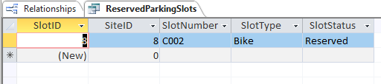

Query 7: Customer Vehicle Details (JOIN)
SELECT
Customer.CustomerName,
Customer.PhoneNumber,
Vehicle.VehicleNumber,
Vehicle.VehicleType,
Vehicle.VehicleColor
FROM Customer
INNER JOIN Vehicle
ON Customer.CustomerID = Vehicle.CustomerID;
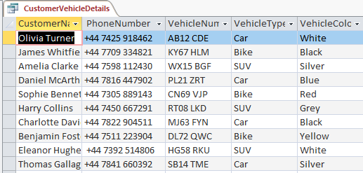

Query 8: Pending Payments
SELECT
Payment Payment ID
Customer Customer Name
Payment Amount
Payment Payment Method
Payment Payment Date
Payment Payment Status
FROM
Payment
INNER JOIN
(Booking
INNER JOIN Customer
ON Booking.CustomerID = Customer.CustomerID)
ON Payment.BookingID = Booking.BookingID
WHERE Payment.PaymentStatus='Pending';
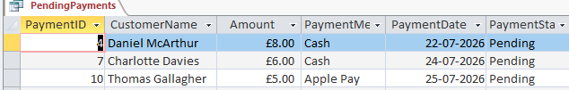

Query 9: Parking Site Capacity
SELECT
SiteName,
Capacity
FROM Parking Site;
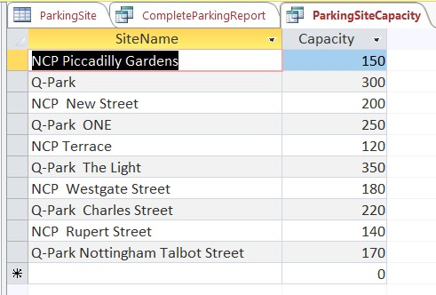

Query 10: Complete Auto Park Management Report
SELECT
Customer.CustomerName,
Vehicle.VehicleNumber,
ParkingSite.SiteName,
ParkingSlot.SlotNumber,
Booking.EntryTime,
Booking.ExitTime,
Payment.Amount,
Payment.PaymentStatus
FROM
((((Customer
INNER JOIN Vehicle
ON Customer.CustomerID = Vehicle.CustomerID)
INNER JOIN Booking
ON Vehicle.VehicleID = Booking.VehicleID)
INNER JOIN Parking Slot
ON Booking.SlotID = ParkingSlot.SlotID)
INNER JOIN Parking Site
ON ParkingSlot.SiteID = ParkingSite.SiteID)
INNER JOIN Payment
ON Booking.BookingID = Payment.BookingID;


