INDEPENDENT PROJECT, BSC H&SC
BMHP6020
CHLOE HARRIES
TINA CARPENTER
2309622

EXPLORING THE IMPACT OF ALCOHOL ABUSE BEYOND RETIREMENT AGE IN BIRMINGHAM IN THE LAST 10 YEARS.

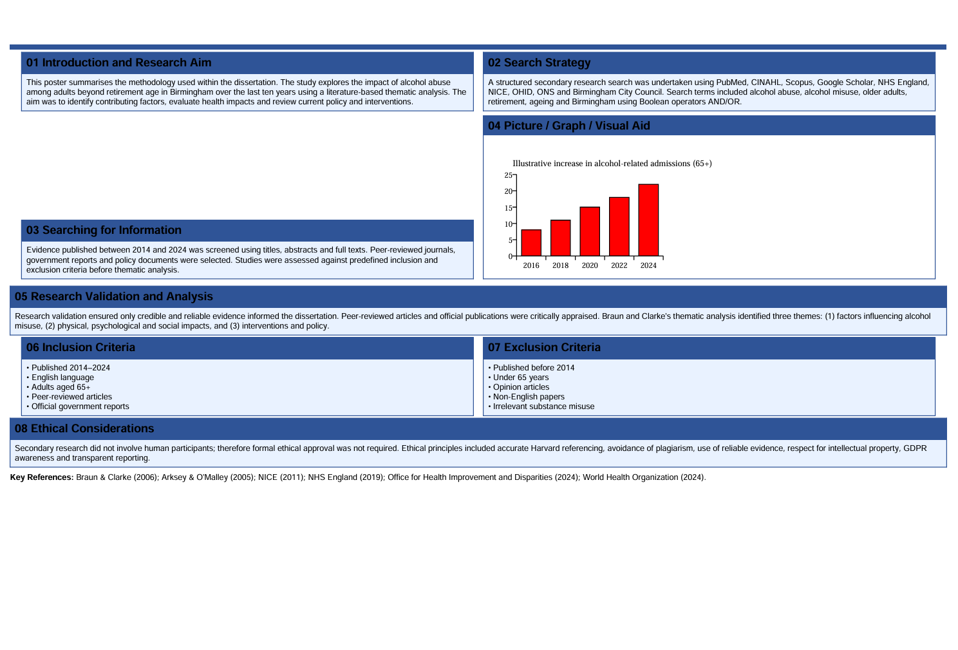

REFERNCES:

Bareham, B.K., Kaner, E., Spencer, L. and Hanratty, B. (2020) 'Drinking in later life: A systematic review and thematic synthesis of qualitative studies exploring older people's perceptions of alcohol use', BMJ Open, 10(12), e041357.
Braun, V. and Clarke, V. (2006) 'Using thematic analysis in psychology', Qualitative Research in Psychology, 3(2), pp. 77–101.
National Institute for Health and Care Excellence (2011) Alcohol-use disorders: Diagnosis, assessment and management of harmful drinking (high-risk drinking) and alcohol dependence (CG115). London: NICE.
Office for Health Improvement and Disparities (2024) Local Alcohol Profiles for England (LAPE). London: Department of Health and Social Care.
World Health Organization (2024) Global status report on alcohol and health 2024. Geneva: World Health Organization.

