Student : Liliana-Claudia Costache
Student ID : 2111821
Lecturer : Stephen Malone
Module : Leading and Implementing Change LCLM6003_BIRM

Strategic Change Management Report: Proper Snacks UK

Table of Contents
1. Introduction to the Organisation 3
2. Environmental and Organisational Analysis 4
2.1 External Environment Analysis (PESTLE and Porter’s Five Forces) 4
2.2 SWOT, McKinsey 7S, RBV 6
2.3 Triggers for Change 7
3. Review and Evaluation of Change Management Models 7
4. Leadership and Organisational Culture in Change 8
5. Proposed Strategic Change Management Plan 10
5.1 Change Vision and Objectives 10
5.2 Stakeholder Analysis 11
5.3 Implementation Framework 12
5.4 Communication Plan 13
5.5 Financial and Resource Plan 13
5.6 Risk Assessment and Mitigation 13
5.7 Evaluation and KPIs 14
6. Discussion and Critical Reflection 14
7. Conclusion 16
Reference List 18

1. Introduction to the Organisation
Proper Snacks UK is a United Kingdom–based fast-moving consumer goods organisation operating within the premium and health-oriented snack food sector. Founded in 2011, the organisation has become widely recognised for its flagship popcorn brand, Propercorn, which is positioned as a healthier alternative to conventional savoury snacks. The company operates within a highly competitive industry characterised by rapid product innovation, evolving consumer expectations, and increasing pressure for ethical and sustainable business practices (Mintel, 2023).
The UK snack food industry has experienced substantial growth and diversification over the past decade, driven by changing dietary preferences, rising health awareness, and demand for convenience products that align with lifestyle values (Euromonitor, 2022). Proper Snacks UK has capitalised on these trends by embedding ethical sourcing, natural ingredients, and transparent branding into its value proposition. The organisation’s mission is centred on making healthier snacking accessible without sacrificing taste, while its vision emphasises long-term growth achieved through responsible and sustainable business practices.
Despite its commercial success, Proper Snacks UK now faces a set of strategic challenges commonly associated with scale-up organisations. Rapid expansion across major UK retailers, international markets, and digital channels has placed increasing strain on internal systems, leadership capacity, and operational processes. What once functioned effectively within a small, entrepreneurial structure is now increasingly misaligned with the organisation’s scale and complexity (Burnes, 2017). As a result, the board of directors has expressed concern regarding the organisation’s long-term resilience and ability to adapt to a rapidly changing business environment.
The rationale for selecting Proper Snacks UK as the focus of this change management report lies in its exposure to multiple, overlapping change pressures. These include digital disruption within the FMCG sector, the growth of online shopping, the adoption of artificial intelligence across supply chains, and intensifying competition from both established brands and agile new entrants.
This report therefore aims to develop a comprehensive strategic change management plan for Proper Snacks UK. It critically analyses the organisation’s internal and external environment, evaluates relevant change management models, examines the role of leadership and organisational culture, and proposes a structured change programme designed to align operational capability with strategic intent.

2. Environmental and Organisational Analysis

2.1 External Environment Analysis (PESTLE and Porter’s Five Forces)
The external environment in which Proper Snacks UK operates has become increasingly complex and volatile. A PESTLE analysis highlights several macro-environmental forces that collectively act as drivers of organisational change. Politically, the post-Brexit regulatory landscape has introduced uncertainty into food supply chains, particularly with regard to import tariffs, customs procedures, and regulatory divergence. These changes have increased operational risk and placed additional compliance burdens on UK-based food manufacturers (ONS, 2023).
From an economic perspective, rising inflation and cost-of-living pressures have heightened consumer price sensitivity. Although health-oriented snack products often command premium pricing, consumers are increasingly value-conscious and willing to switch brands in response to price differentials, particularly in online environments where comparison is effortless (McKinsey, 2022). Social factors continue to shape demand patterns, with growing emphasis on health, wellness, and ethical consumption. While this trend supports Proper Snacks UK’s positioning, it also attracts new competitors seeking to exploit similar market niches (Euromonitor, 2022).
Technological forces represent one of the most significant external pressures. The adoption of artificial intelligence, automation, and advanced analytics across the FMCG sector has transformed expectations around supply chain efficiency, demand forecasting, and customer engagement (Davenport and Ronanki, 2018). Organisations that fail to integrate digital technologies risk falling behind more technologically sophisticated competitors. Legal factors, including food safety regulation and advertising standards, continue to evolve, requiring robust governance mechanisms. Environmental pressures, particularly around packaging waste and carbon reduction, further influence strategic priorities.
Applying Porter’s Five Forces highlights the structural pressures shaping competition in the snack food sector. The threat of new entrants is relatively low due to high capital investment, complex distribution systems, strict regulatory requirements, and the dominance of established brands. These barriers protect existing firms such as Proper Snacks, although they may also limit innovation and reduce market dynamism.
Buyer power is moderate to high. Consumers can switch easily between snack brands and substitute products, particularly within large retail environments where shelf space is highly competitive. In addition, major retailers exert considerable influence over pricing, promotions and distribution terms. Nevertheless, firms with strong brand identity and differentiated offerings can reduce price sensitivity and build customer loyalty.
Supplier power varies across the year. When raw materials are readily available, supplier influence remains moderate. However, during winter months, reliance on imported inputs increases costs and strengthens supplier bargaining power. Rising transportation and energy expenses further compress margins, especially for firms without exclusive supply arrangements.
The threat of substitutes remains high. Snacks compete directly with confectionery, soft drinks and healthier alternatives, as well as home-prepared options. Increased consumer awareness of nutrition, alongside pressure from schools and health professionals, intensifies this challenge.
Competitive rivalry is strong within this mature market, characterised by slow revenue growth, brand proliferation and low switching costs. Price competition and sustained advertising are common strategies. Overall, the combined impact of these forces reinforces the intensity of competition in the sector and underlines the need for operational efficiency, innovation and strategic adaptability (Porter, 2008).

2.2 SWOT, McKinsey 7S, RBV
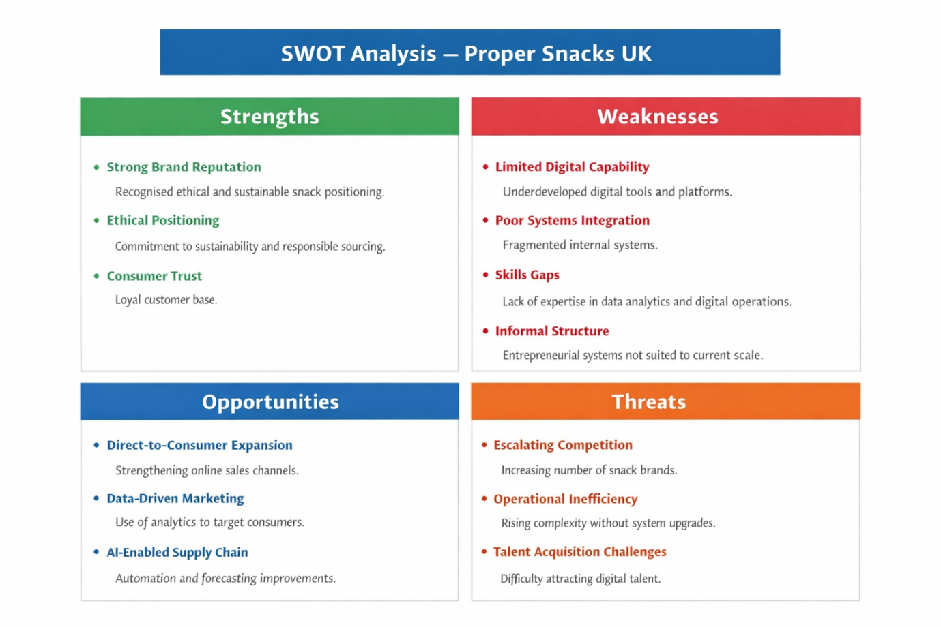
An internal analysis reveals that Proper Snacks UK possesses several distinctive strengths alongside notable constraints. Brand reputation, ethical positioning, and consumer trust represent valuable intangible assets that align with the Resource-Based View of the firm, which emphasises the role of rare and inimitable resources in sustaining competitive advantage (Barney, 1991). These strengths have enabled the organisation to differentiate itself within a crowded marketplace.
However, weaknesses are evident in areas such as digital capability, systems integration, and organisational structure. A SWOT analysis identifies opportunities in direct-to-consumer expansion, data-driven marketing, and AI-enabled supply chain optimisation. At the same time, threats include operational inefficiency, escalating competition, and difficulties in attracting and retaining digitally skilled talent.
The McKinsey 7S framework highlights misalignment between strategy, systems, and skills. While the organisation’s strategy emphasises innovation and sustainability, its internal systems remain relatively informal and fragmented, reflecting its entrepreneurial origins rather than its current scale (Johnson et al., 2020). Skills gaps are particularly evident in data analytics and digital operations, limiting the organisation’s ability to fully exploit technological opportunities.

Resource-Based View (RBV)
From a Resource-Based View (RBV) perspective, Proper Snacks UK’s competitive position is shaped by its unique internal resources and capabilities. The organisation’s strong brand equity, ethical reputation, and loyal consumer base represent valuable and difficult-to-imitate intangible assets that support differentiation within the premium snack segment. However, RBV analysis also highlights capability gaps, particularly in digital systems, analytics expertise, and integrated operational processes. These weaknesses reduce the firm’s ability to fully leverage its existing brand and market position. Consequently, the strategic change programme proposed in this report seeks to strengthen internal technological capabilities and organisational skills so that Proper Snacks UK can better exploit its distinctive resources and sustain competitive advantage in an increasingly digital FMCG environment.

2.3 Triggers for Change
The convergence of external disruption and internal capability constraints has created a clear imperative for change. Digital disruption within the FMCG sector has altered competitive norms, while the growth of online shopping has reshaped consumer purchasing behaviour and reduced reliance on traditional retail channels (ONS, 2023). Artificial intelligence has become increasingly embedded within supply chain management, enabling more accurate demand forecasting and inventory control (PwC, 2022).
Internally, leadership capacity has become stretched as founders transition from operational roles to strategic oversight. Decision-making processes have struggled to keep pace with organisational growth, creating inefficiencies and slowing responsiveness. These factors collectively represent structural and strategic triggers that necessitate a coordinated change management response.

3. Review and Evaluation of Change Management Models
In evaluating suitable change management frameworks, it is evident that no single model fully addresses the complexity of Proper Snacks UK’s transformation. The company faces both strategic realignment and behavioural change challenges, particularly in relation to digital capability, systems integration, and cultural adaptation.
Lewin’s three-step model (Lewin, 1951) offers a foundational understanding of change through unfreezing, moving, and refreezing behaviours. However, its assumption of a relatively stable end state makes it less suitable for a fast-moving FMCG environment characterised by continuous technological and competitive pressures (Burnes, 2017).
Kotter’s eight-step model provides a more dynamic leadership-driven framework. Its focus on creating urgency, building a guiding coalition, communicating a clear vision, and generating short-term wins is highly relevant for Proper Snacks’ digital transformation (Kotter, 1996). Establishing urgency around competitive intensity and capability gaps would help mobilise internal stakeholders. Short-term digital improvements, such as enhanced data analytics or supply chain efficiencies, could reinforce progress and sustain momentum. Nevertheless, critics argue that Kotter’s model follows a relatively linear process and may not fully capture organisational complexity (By, 2005).
The ADKAR model complements this by focusing on individual-level change through Awareness, Desire, Knowledge, Ability, and Reinforcement (Hiatt, 2006). This is particularly important for addressing employee resistance, skills gaps, and anxiety related to digital transformation. ADKAR ensures that employees not only understand the need for change but also develop the capability and motivation to implement it effectively.
However, leadership momentum and individual readiness alone are insufficient without organisational alignment. The McKinsey 7S framework addresses this gap by ensuring consistency between strategy, structure, systems, skills, staff, style, and shared values (Johnson et al., 2020). Given the identified misalignment between strategy and internal systems at Proper Snacks, this alignment perspective is critical.
Therefore, a hybrid approach combining Kotter’s leadership momentum, ADKAR’s behavioural focus, and McKinsey 7S alignment provides the most suitable framework for delivering sustainable change.

4. Leadership and Organisational Culture in Change
Leadership is widely recognised as a central determinant of successful organisational change, influencing both the direction and the pace of transformation. In the context of Proper Snacks UK, leadership assumes particular significance due to the organisation’s transition from an entrepreneurial growth phase towards a more structured and digitally enabled operating model.
Transformational leadership is especially relevant in this context, as it emphasises the articulation of a compelling vision, the alignment of individual and organisational goals, and the empowerment of employees to engage with change proactively (Bass and Riggio, 2006). For Proper Snacks UK, transformational leadership can help bridge the gap between the organisation’s ethical, values-driven identity and the need for increased formalisation and technological sophistication. By framing digital transformation as an enabler of sustainability, efficiency, and long-term resilience rather than as a purely cost-driven initiative, leaders can foster emotional commitment and reduce resistance.
However, transformational leadership alone is insufficient to address the varied responses to change that emerge within a diverse workforce. Situational leadership theory provides a complementary perspective by recognising that employees differ in terms of competence, confidence, and readiness for change (Hersey et al., 2013). Within Proper Snacks UK, levels of digital literacy and familiarity with data-driven decision-making are likely to vary significantly across functions. Leaders who adopt a situational approach can adjust their behaviours accordingly, providing directive support where capability is limited and delegative autonomy where employees demonstrate readiness. This flexibility is particularly important in avoiding the alienation of employees who may otherwise feel overwhelmed by technological change.
Organisational culture further shapes how leadership behaviours are interpreted and enacted. Culture influences what employees perceive as legitimate, acceptable, or risky during periods of change. Schein’s model of organisational culture emphasises the role of underlying assumptions, values, and artefacts in shaping behaviour (Schein, 2017). At Proper Snacks UK, deeply embedded assumptions around autonomy, creativity, and ethical purpose have contributed to strong employee identification with the brand. These cultural attributes represent a significant asset but can also become sources of resistance when change initiatives are perceived as threatening established norms.
For example, the introduction of more formalised systems and data-driven performance metrics may be interpreted as a loss of autonomy or a shift towards bureaucratic control. Without careful leadership framing, such changes risk being seen as inconsistent with the organisation’s founding values. Leaders therefore play a critical role in translating structural changes into culturally meaningful narratives, emphasising continuity of purpose alongside operational evolution. This aligns with the view that cultural change is most effective when it builds upon, rather than seeks to replace, existing values (Alvesson, 2013).
The need to balance cultural preservation with process discipline represents a central tension within Proper Snacks UK’s change journey. While increased standardisation is necessary to support scalability, excessive formalisation could erode the entrepreneurial spirit that differentiates the organisation. Leadership must therefore adopt a nuanced approach that reinforces shared values while selectively introducing new norms related to data use, accountability, and cross-functional collaboration.
In summary, leadership and organisational culture are deeply interdependent in shaping change outcomes at Proper Snacks UK. Transformational, situational, and transactional leadership styles each have a role to play at different stages of the change process. Their effectiveness, however, is contingent upon cultural alignment and ethical sensitivity. Leaders who are able to integrate strategic direction with cultural stewardship are more likely to achieve sustainable change that enhances, rather than diminishes, the organisation’s identity and long-term competitiveness.

5. Proposed Strategic Change Management Plan

5.1 Change Vision and Objectives
The proposed strategic change for Proper Snacks UK focuses on a clear transition towards a digitally integrated and data-driven operating model. The vision is to transform the organisation from an entrepreneurial snack producer with relatively informal systems into a digitally enabled, operationally efficient, and scalable FMCG organisation capable of sustaining growth in an increasingly competitive market. While Proper Snacks UK’s ethical and health-focused brand identity remains central to its differentiation, achieving long-term competitiveness requires stronger technological capability and more structured internal processes.
The change vision can therefore be articulated as follows: to implement AI-supported supply chain systems, strengthen direct-to-consumer digital channels, and embed data-driven decision-making across the organisation while preserving its ethical culture and innovative ethos. This direction aligns transformation initiatives with the organisation’s purpose and values, which is critical for maintaining legitimacy and employee commitment during change (Johnson et al., 2020).
From this vision, three key objectives emerge. First, Proper Snacks UK will introduce AI-enabled forecasting and inventory management to improve supply chain efficiency and reduce operational waste, which is essential in the cost-sensitive FMCG sector (Davenport and Ronanki, 2018). Second, the organisation will expand its direct-to-consumer and e-commerce capabilities in order to reduce reliance on large retailers and gain better consumer insights. Third, the change programme will develop digital capabilities among leaders and employees, ensuring the workforce can effectively operate within a data-driven environment.
Importantly, these objectives also support broader organisational goals related to sustainability, employee engagement, and ethical responsibility, reflecting the view that long-term strategic change must balance economic performance with social and environmental considerations (Burnes, 2017).

5.2 Stakeholder Analysis
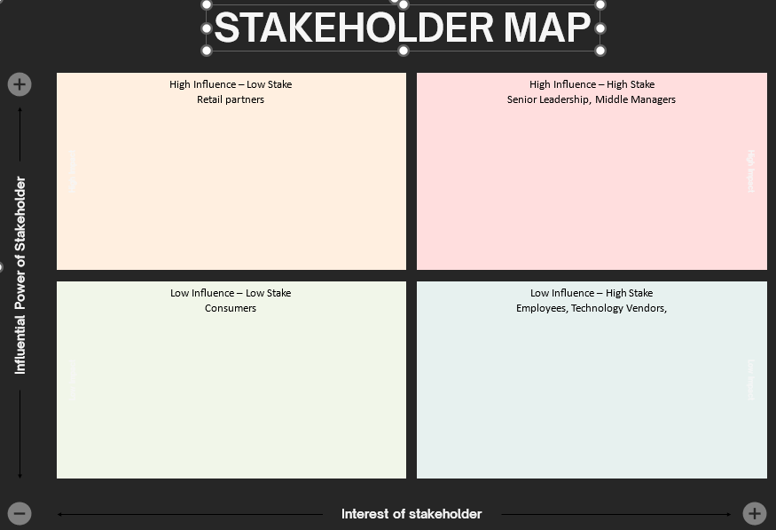
Effective change management at Proper Snacks UK depends on a nuanced understanding of stakeholder interests, power, and potential responses to change. Stakeholders can be broadly categorised into internal and external groups, each of which plays a critical role in the success or failure of the proposed transformation.
Internal stakeholders include senior leadership, middle managers, and employees across production, marketing, supply chain, and support functions. Senior leadership holds high power and high interest, as the success of the change programme directly affects organisational performance and board-level accountability. Middle managers occupy a particularly sensitive position, as they are responsible for translating strategic intent into operational action. Research suggests that middle managers often experience role ambiguity and stress during change initiatives, which can either enable or obstruct implementation depending on how effectively they are supported (Balogun and Johnson, 2004).
Employees represent a high-interest but variable-power stakeholder group. Digital transformation initiatives often provoke anxiety related to job security, skill obsolescence, and increased performance monitoring. At Proper Snacks UK, where organisational culture has traditionally emphasised trust and informality, poorly managed change communication could generate resistance or disengagement. Consequently, employee involvement and consultation are essential to building psychological ownership of the change process (Lewis, 2019).
External stakeholders include suppliers, retail partners, technology vendors, and consumers. Suppliers may be affected by changes to ordering systems and forecasting processes, while retail partners may experience shifts in distribution strategy as the organisation strengthens its direct-to-consumer channels. Consumers, although indirectly involved, are critical stakeholders whose perceptions of brand authenticity and ethical integrity must be carefully managed throughout the change process. Failure to consider these external perspectives could undermine brand equity, one of Proper Snacks UK’s most valuable strategic assets.

5.3 Implementation Framework
The implementation of strategic change at Proper Snacks UK will be guided by a hybrid framework combining Kotter’s eight-step change model with the McKinsey 7S framework. This integrated approach recognises that successful change requires both strong leadership-driven momentum and systemic alignment across organisational elements.
Kotter’s emphasis on establishing a sense of urgency is particularly relevant given the competitive pressures facing the organisation. Communicating the risks associated with digital stagnation, alongside the opportunities presented by transformation, will help legitimise the change programme and mobilise support (Kotter, 1996). The formation of a guiding coalition composed of senior leaders and influential middle managers will further reinforce commitment and provide visible sponsorship.
The McKinsey 7S framework complements this approach by ensuring alignment between strategy, structure, systems, skills, staff, style, and shared values. For example, the introduction of AI-enabled systems must be accompanied by appropriate training (skills), revised decision-making processes (systems), and leadership behaviours that encourage data-driven thinking (style). Without such alignment, change initiatives risk becoming fragmented and unsustainable (Waterman et al., 1980).
Implementation will be phased to reduce disruption and allow for learning and adjustment. Pilot projects within selected business units will enable the organisation to test new systems and processes before wider rollout. This incremental approach reflects best practice in managing complex change and reduces the risk of large-scale failure (Burnes, 2017).

5.4 Communication Plan
Communication is a critical determinant of change success, influencing employee perceptions, trust, and willingness to engage with new ways of working. At Proper Snacks UK, the communication plan must balance transparency with sensitivity, particularly given the organisation’s informal and people-centric culture.
Regular updates on progress, challenges, and early successes will help maintain momentum and credibility. Research suggests that uncertainty, rather than change itself, is often the primary source of employee resistance; therefore, timely and honest communication is essential even when outcomes are not yet fully defined (Lewis, 2019). Change champions drawn from across the organisation will play a key role in reinforcing messages and modelling desired behaviours at a local level.

5.5 Financial and Resource Plan
The proposed change programme requires a significant but strategically justified investment in financial and human resources. The estimated £2.5 million investment over three years will be allocated across several key areas, including digital infrastructure, AI-enabled systems, employee training, and external consultancy support where specialised expertise is required.
From a financial perspective, this investment should be viewed as a capability-building initiative rather than a discretionary cost. Improved forecasting accuracy, reduced waste, and enhanced operational efficiency are expected to generate long-term cost savings and margin improvement, offsetting initial expenditure (PwC, 2022). Additionally, strengthened direct-to-consumer capabilities offer potential revenue growth through higher margins and improved customer insight.
Human resources represent an equally critical component of the plan. Investment in training and development will focus on building digital literacy, analytical skills, and change leadership capability. This approach aligns with strategic human resource management theory, which emphasises the role of people as a source of sustainable competitive advantage (Barney, 1991).

5.6 Risk Assessment and Mitigation
Despite careful planning, the proposed change programme carries inherent risks that must be proactively managed. One of the most significant risks is employee resistance, particularly if digital transformation is perceived as threatening job security or organisational values. This risk will be mitigated through early engagement, transparent communication, and targeted training designed to build confidence and competence.
Finally, there is a reputational risk associated with data privacy and ethical use of AI. Proper Snacks UK’s ethical brand positioning makes it particularly vulnerable to stakeholder criticism if data governance is perceived as inadequate. Robust data protection policies and compliance with relevant regulations will therefore be essential components of the change programme.

5.7 Evaluation and KPIs
Evaluation of the change programme will be based on a combination of financial, operational, and behavioural indicators. Key performance indicators will include improvements in demand forecast accuracy, reductions in inventory waste, growth in online sales, and employee engagement scores. These measures reflect both short-term performance outcomes and longer-term capability development (Kaplan and Norton, 2004).
Regular review cycles will enable leadership to assess progress, identify emerging issues, and adjust strategy where necessary. This adaptive approach reflects contemporary views of change as an ongoing process rather than a finite event.

6. Discussion and Critical Reflection
The strategic change management plan proposed for Proper Snacks UK demonstrates a coherent response to the organisation’s current environmental and organisational challenges. One of its principal strengths lies in its explicit alignment between external disruption and internal capability development. Rather than framing digital transformation as a purely technological upgrade, the plan positions change as a multidimensional organisational process involving leadership behaviour, cultural adaptation, and structural realignment. This approach is consistent with contemporary change literature, which cautions against technology-led transformations that fail to account for human and cultural dynamics (Burnes, 2017).
A further strength of the proposed plan is its integration of multiple change management frameworks. The hybrid use of Kotter’s leadership-oriented model alongside the McKinsey 7S framework reflects an appreciation of the complexity of organisational change within a scale-up context. Proper Snacks UK does not operate in a stable or predictable environment; therefore, reliance on a single linear model would be insufficient. The proposed hybrid approach allows for both momentum creation and systemic alignment, increasing the likelihood that change will be embedded rather than superficially adopted.
However, several limitations warrant critical reflection. First, the success of the change programme is heavily contingent on leadership capability and consistency. While transformational leadership is advocated as the dominant style, not all leaders within Proper Snacks UK may possess the skills or inclination required to enact such leadership effectively. Leadership development initiatives can mitigate this risk, but they require time and sustained commitment. In periods of commercial pressure, there is a risk that leaders revert to short-term, transactional behaviours that undermine longer-term change objectives (Kotter, 1996).
Second, the proposed change plan assumes a level of organisational readiness that may not be uniformly present across all functions. Digital literacy and openness to data-driven decision-making are likely to vary significantly between departments. While phased implementation and training are designed to address this issue, there remains a risk that uneven capability development could create internal fragmentation or perceptions of inequality. Such outcomes could weaken trust and exacerbate resistance, particularly within an organisation whose culture has historically emphasised inclusivity and informality.
Sustainability considerations further complicate the change landscape. While digital optimisation and improved forecasting can reduce waste and enhance environmental performance, the implementation of new technologies also carries environmental costs associated with energy use and electronic waste. The proposed plan acknowledges sustainability benefits but could be strengthened by incorporating explicit environmental performance metrics linked to the change programme. This reflects a broader critique within the literature that sustainability is often rhetorically embraced but insufficiently operationalised within change initiatives (Alvesson, 2013).
Finally, it is important to recognise that strategic change is not a finite project with a definitive endpoint. The volatility of the FMCG sector suggests that Proper Snacks UK will continue to face emerging challenges beyond the scope of the current plan. As such, the most significant outcome of the proposed change programme may not be the successful implementation of specific systems or processes, but the development of organisational learning capability. Embedding reflective practice, feedback mechanisms, and adaptive leadership behaviours will be essential if the organisation is to respond effectively to future disruption.

7. Conclusion
This report has critically examined the strategic change challenges facing Proper Snacks UK within the context of an increasingly dynamic, digitally disrupted FMCG environment. Through a structured analysis of the organisation’s external and internal environment, it has been demonstrated that Proper Snacks UK is operating at a pivotal stage in its organisational development. External pressures arising from technological advancement, shifting consumer behaviour, and intensifying competition intersect with internal challenges related to scalability, capability alignment, and leadership transition.
The analysis has shown that while Proper Snacks UK possesses significant strengths, particularly in brand equity, ethical positioning, and entrepreneurial culture, these strengths alone are insufficient to guarantee long-term competitiveness. Without deliberate and structured strategic change, there is a risk that the very characteristics that enabled early success could become constraints on future growth. This insight reinforces the argument that strategic change is not merely a reactive response to external threats, but a proactive process of organisational renewal.
By evaluating multiple change management models, the report has highlighted the limitations of adopting singular or overly prescriptive frameworks. Instead, it has argued for a hybrid approach that combines leadership-driven momentum with systemic alignment across organisational elements. This approach recognises the complexity of change within a scale-up organisation and acknowledges the interdependence between strategy, culture, and operational capability.
Leadership and organisational culture have been identified as critical determinants of change success. The report concludes that transformational and situational leadership styles are particularly relevant to Proper Snacks UK’s context, enabling leaders to inspire commitment while adapting to varying levels of employee readiness. At the same time, the organisation’s values-driven culture must be carefully managed to ensure that formalisation and digitalisation do not erode the trust and creativity that underpin its identity.
The proposed strategic change management plan offers a structured yet flexible pathway for transformation. Its emphasis on digital capability, stakeholder engagement, ethical governance, and continuous evaluation reflects a holistic understanding of change as an ongoing organisational capability rather than a one-off initiative. While risks and limitations remain, particularly in relation to leadership capacity and implementation complexity, these challenges are not insurmountable if addressed through sustained commitment and reflective practice.
In conclusion, the key recommendation to the board of directors is that strategic change at Proper Snacks UK should be viewed as an investment in long-term organisational resilience rather than a short-term operational adjustment. By embedding adaptability, learning, and ethical consideration into its change processes, Proper Snacks UK can strengthen its competitive position and remain aligned with its mission and values in an uncertain future.

Reference List
Alvesson, M. (2013) Understanding Organisational Culture. 2nd edn. London: Sage.
Balogun, J. and Johnson, G. (2004) ‘Organizational restructuring and middle manager sensemaking’, Academy of Management Journal, 47(4), pp. 523–549.
Barney, J. (1991) ‘Firm resources and sustained competitive advantage’, Journal of Management, 17(1), pp. 99–120.
Bass, B.M. and Riggio, R.E. (2006) Transformational Leadership. 2nd edn. Mahwah, NJ: Lawrence Erlbaum Associates.
Burnes, B. (2017) Managing Change. 7th edn. Harlow: Pearson.
By, R.T. (2005) ‘Organisational change management: A critical review’, Journal of Change Management, 5(4), pp. 369–380.
Davenport, T.H. and Ronanki, R. (2018) ‘Artificial intelligence for the real world’, Harvard Business Review, 96(1), pp. 108–116.
Euromonitor (2022) Snack Foods in the United Kingdom. London: Euromonitor International.
Hersey, P., Blanchard, K.H. and Johnson, D.E. (2013) Management of Organizational Behavior: Leading Human Resources. 10th edn. Harlow: Pearson.
Hiatt, J. (2006) ADKAR: A Model for Change in Business, Government and Our Community. Loveland, CO: Prosci Research.
Johnson, G., Scholes, K. and Whittington, R. (2020) Exploring Strategy. 12th edn. Harlow: Pearson.
Kaplan, R.S. and Norton, D.P. (2004) Strategy-Focused Organization. Boston, MA: Harvard Business School Press.
Kotter, J.P. (1996) Leading Change. Boston, MA: Harvard Business School Press.
Lewis, L.K. (2019) Organizational Change: Creating Change Through Strategic Communication. 2nd edn. Hoboken, NJ: Wiley-Blackwell.
Lewin, K. (1951) Field Theory in Social Science. New York: Harper & Row.
McKinsey & Company (2022) The State of the Consumer 2022. London: McKinsey & Company.
Mintel (2023) UK Savoury Snacks Market Report. London: Mintel Group Ltd.
ONS (2023) UK Trade and Retail Statistics. London: Office for National Statistics.
Porter, M.E. (2008) ‘The five competitive forces that shape strategy’, Harvard Business Review, 86(1), pp. 78–93.
PwC (2022) AI in Operations: Supply Chain and Forecasting Trends. London: PricewaterhouseCoopers.
Waterman, R.H., Peters, T.J. and Phillips, J.R. (1980) ‘Structure is not organization’, Business Horizons, 23(3), pp. 14–26.

