
BA International Hotel Management

Management & Organizational Behaviour (BMIH5004)
Lecturer- Ernest Wavei
Written by; Mohammed Abdul Bathen
Student Number:2212002

Assignment 2- Written Report; Research on IHG as a case study

Execute Summary
This report has the goal of evaluating IHG through various factors, but not limited to the examination of the organisational culture, strategic directions, and business performance. To derive a comprehensive understanding of the strengthened business environment, applying a SWOT analysis is necessary. As a multinational business entity, IHG relies on structural and functional structures to enhance high coordination and good decision-making arrangements. According to Handy applying his organisation culture model of power, role, task, and person the above structure may be broken down to agree with strategic flexibility and enhance employees’ motivation. The long-term Organizational Goals and objectives of IHG include Focus on customer satisfaction, Growth of brand portfolio and adoption of innovation technologies to boost competitiveness. The analysis points to IHG’s key blessings as encompassing a notable and well-diversified brand portfolio and a vast geographical reach but also key curses in the form of an overreliance on the franchising business model and high absolute operational fixed costs. This article highlights the following strengths: growth opportunities in emerging markets, and a clear and distinct emphasis on sustainability-related issues, while threats refer to high fluctuations of revenue in line with the economic cycle and general market risks. A set of tactical suggestions based on the captivating theories of Mintzberg identified the very particular changes in IHG’s management, business procedures, and organisational infrastructures that can improve its effectiveness and adaptability to the general international hotel industry trends to persistently improve its performance in the global environment.
Table of Contents
Execute Summary 2
Introduction 4
Organisational Overview 5
Organisational Structure of InterContinental Hotels Group (IHG) 6
Application of Handy’s model to InterContinental Hotels Group (IHG) 8
The Hotel group's goals, visions or aims 10
Application of Mintzberg’s theory to evaluate changes in strategies 11
Application of SWOT analysis to evaluate business performance and strategic directions 13
Conclusion 15
Reference list 16

Introduction
InterContinental Hotels Group (IHG) is a global hotel chain which was founded in United Kingdom and has its operation in more than 100 countries across the world. Since the time it was established in the year 1946 IHG has witnessed the growth of its brands and today it is famous for InterContinental, Holiday Inn, Crowne Plaza, Kimpton Hotels & Restaurants (King, 2018). This broad brand portfolio is useful in that it allows IHG to target clients of various types and across multiple segments, thereby covering the market. Firstly, the report concentrates on identifying the structure that followed by the chosen organisation to ensure effective business operations. Besides, Handy’s model has been analysed to evaluate the cultural situation within the organisation. The author focuses on the company’s strategic direction that driving operational activities inside the workplace. Different aims and goals of the company have also been identified to assess the company’s progress towards the ultimate destination. Besides, SWOT analysis helped the author to evaluate current business performance along with growth potential in the long run.

Organisational Overview
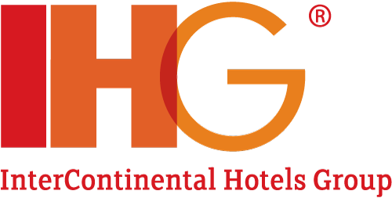
Source: (Vasić and Čerović, 2018).
InterContinental Hotels Group (IHG) is the world’s leading company in the hospitality industry based in Denham, United Kingdom. IHG was established in 1946 and has its operations in more than 100 countries, with a brand mix that targets different market segments, specifically the high-end segment, the near-luxury segment, and the economy segment, among others (Koushik, Higbie and Eister, 2012). The company operates several brands with first-class recognition, for instance, InterContinental Hotels & Resorts, Holiday Inn, Crowne Plaza, and Kimpton Hotels & Restaurants (Demsetz and Lehn, 2023). This information confirms the credibility of IHG with the London Stock Exchange and being part of the FTSE 100 Index, proving its stability in the global business market. They value the principle of outstanding customer satisfaction, leadership in hospitality and responsibility; Achievements of the company are reflected in the IHG Green Engagement system. IHG is a fast-growing hospitality chain that strengthens its position in a global market and develops new properties for guests.

Organisational Structure of InterContinental Hotels Group (IHG)
IHG is using the hierarchical structure of its organizational management that best suits the current global brand portfolios and geographical locations of its spread (Raynes, Pratt and Roses, 2019). This type of structure has despicable authority and communication lines, hence facilitating effective decision-making and management of operations throughout the organization.
Hierarchical Structure Overview
IHG organizational structure has a clear organizational structure with the Chief Executive Officer (CEO) as the head of the firm who is appointed with the overall responsibility of managing and directing the organization (Robbins and Al, 2008). The specific organisational structure of the Executive Committee and their reporting line are directly to the CEO of the company, though each of them heads a specific functional area of the company such as Operations, Finance, Marketing and Human Resources. This gives clear lines of reporting and makes the structure easily manageable from a central point and to cater for IHG’s overall aims and objectives.
Divisional Structure:
IHG also utilize a divisional organizational structure and it split its operations in accordance with brand and geographic location. This structure includes several key divisions:
Brand-Based Divisions: IHG has different brands based on tiers, among them are Luxury & Lifestyle, Premium, Essentials, and Suites each tier has its own management team. For example, the Luxury & Lifestyle subdivision is made up of InterContinental Hotels & Resorts, and Kimpton Hotels & Restaurants (Buchanan and Huczynski, 2013).
Geographical Divisions: It presents regions of operation such as the Americas, Europe, Middle East region, Asia region, and the African region. The company each geographical area has a person called the Regional President who is responsible for overseeing the growth and management of the different regions (Hashimoto and Wójcik, 2020).
Benefits of Hierarchical Structure:
Clear Authority and Responsibility: Deliveries and tasks are plainly stated and defined and this has enhanced the process of decision-making and management.
Centralized Control: First, centralized decision-making enables the creation of a standard for brand management and strategic planning across all the various brands and regions (Carmichael et al., 2011).
Efficient Communication: The organizational structure allows for proper communication from the top down; the trickle-down effect is vital in transmitting both strategies and executing plans across the organization (Williams, 2017).

Application of Handy’s model to InterContinental Hotels Group (IHG)
InterContinental Hotels Group (IHG) can be evaluated using Handy’s four types of organizational culture: The following are subcultures; Power culture: This is a type of organizational subculture that deals with distribution of power within the organization. These reflect the various ways of working and managing the IHG operation and business, where each cultural type, as found in the literature, is shown differently in practice.
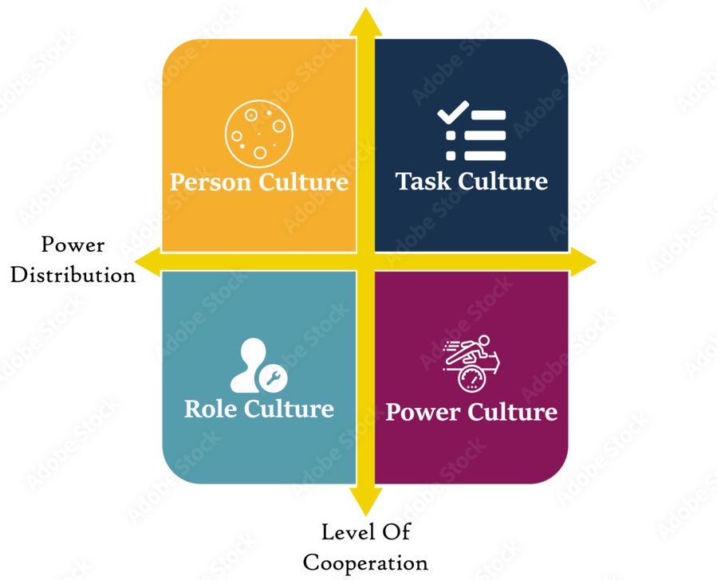
Source: (Scheiner and Rau, 2020).
Power Culture: The IHG has aspects of power culture, particularly in the executive branch of this organization (O’Sullivan, 2010). Decisions are made at the top that is the CEO and other managers at the top managerial level are more involved in the strategic decisions of the company. That’s how the main decision-making powers stay with IHG at the same time: the strategic vision is consistent worldwide.
Role Culture: IHG can be characterised as operating on role culture favourable due to the presence of both hierarchical and divisional structures. Every subordinate also occupies a certain rank in the company’s organizational chart and as such is endowed with certain tasks and duties. These roles are very clear hence they let specialism take root so that anyone handling any special division does it well.
Task Culture: The task culture is apparent at IHG from the practice followed in managing projects and undertaking operational activities (Boddy, 2014). For instance, aspects such as expansion of hotels or installation of improved technologies may involve combined efforts of cross-functional teams to achieve various objectives. This culture fosters cooperation and creativity in IHG, so the organisation can effectively respond to the changing environment and new possibilities.
Person Culture: While not as strongly manifested as a corporate culture within IHG’s commitment to people, it also positively affects employee development and satisfaction. Another factor is that IHG pays special attention to individual development, training and career advancement programs that mean a lot to the company (Hierling, Yeh and Chloe, 2018).

The Hotel group's goals, visions or aims.
Business Aims
InterContinental Hotels Group (IHG) has set vision that will make the organization the leading global hospitality company through the delivery of excellent customer service, through nurturing employees and sustainable development. Company’s goal, as stated by Hilton, is to become the kind of company Hilton already is, known as Great Hotels Guests Love with help of focusing on service and hospitality innovations.
Specific Goals:
Guest Satisfaction: IHG focuses on the effectiveness and efficiency of enhancing guest satisfaction to cover all the aspects that contribute to making their services more outstanding and unique. One strategic goal that has been developed and which the company is looking forward to achieving is a certain Net Promoter Score (NPS) target of 10% by the end of the third year (Mullins, 2016).
Brand Expansion: Indeed, IHG aims to continue strengthening its position on the international market and, over the course of the next five years, introduce not less than 300 new brands globally (Lockyer, 2017). This includes the expansion of services to new regions or emerging markets and the consolidation of markets in which the company already has a stake.
Digital Transformation: Building and strengthening information technology is significant for IHG. The company stated that it will make a large investment in technology in order to enhance the guests’ ability to book stays, to automate processes within the company, and to use analytic tools to better target its marketing campaigns (Baker, 2014).

Application of Mintzberg’s theory to evaluate changes in strategies.
The theory by Mintzberg on organizational configurations is useful in understanding the manner people structure organizations and set strategies into action. Thus, by analysing these changes in business strategies with the aid of Mintzberg’s theory, an understanding of various organizations’ abilities to respond to changes in environmental and internal conditions could be attained.
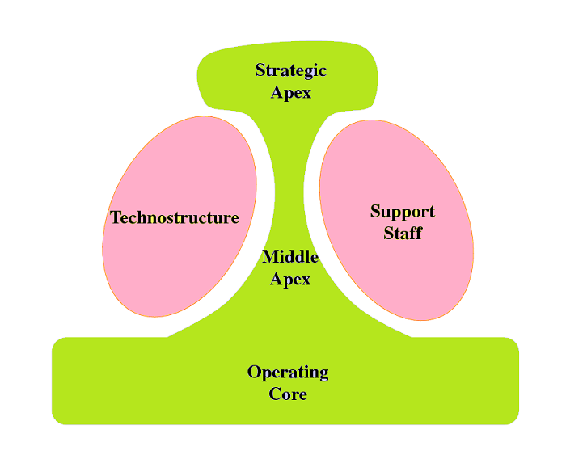
Source: (Simeone et al., 2023).
Strategic Apex: Strategic apex can be explained as the top managers who handle key decisions, and in this regard, businesses tend to simplify their leadership pyramid in a bid to increase effectiveness. It has for instance been noted that organizations such as InterContinental Hotels Group (IHG) have been perceived to have delegated some strategic decision-making areas to regional managers in a bid to make adaptations pertinent to certain regional markets.
Middle Line: Mintzberg’s middle line is a crucial sector that entails middle management whose responsibility is to implement the strategies set by the managers at the top. Organizations can redesign functions in middle management so as to enhance the link between the strategic model and the technical periphery (Mullins and Dossor, 2013). For instance, IHG might strengthen its middle management in a way that promotes picking up and decentralising key messages at different organisational levels, thus guaranteeing that their delivery is coherent with general corporate goals.
Operating Core: In the operating core, it is common for managers to initiate changes to optimise efficiency and productivity levels. For instance, under the current CEO, IHG has embarked on investment in digitalization to enhance guest booking and enhance operational workflows to improve on the operating core, which is a clear signal at focusing on how to offer quality guest services with efficient operating models (Mullins, 2019).
Support Staff: Mintzberg underscores the supportive specialization kind of work where support staff personnel provide the organizational support necessary for it to run efficiently. Steps made among support functions, which can be centralizing sometimes administrative tasks or outsourcing nonstrategic activities, can bring about major cost reductions and operational improvements (Withers, Williamson and Reddington, 2010).
Technostructure: Technostructure encompasses individuals in the organization who devise and implement formalized systems and processes (Michael Quinn Patton, Mckegg and Wehipeihana, 2016). In the context of IHG, it was found that the aim of integrating technostructural advancements is for pulling out critical decisions and marketing techniques, whereby engineering techniques are also in congruence with Mintzberg’s opinions regarding the effective application of technology.

Application of SWOT analysis to evaluate business performance and strategic directions.
The InterContinental Hotels Group (IHG) is one of the world’s largest and most well-established multinational companies in the lodging industry with various brands around the globe. Analysing business performance and strategy in terms of a SWOT analysis reveals the overall picture of assets, liabilities, opportunities, and threats.
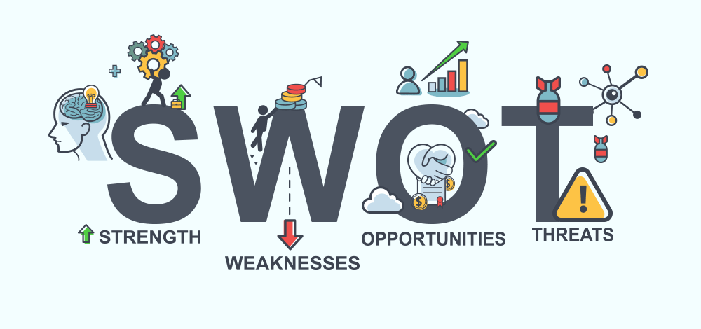
Source: (Vanek, 2022).
Strengths: Due to its diversified brand, IHG boasts some of the most famous hotel brands in the globe including InterContinental, Holiday Inn, Crown Plaza and Kimpton Hotel groups. This broad portfolio also helps IHG to cover all the levels of the travellers’ market, from business class and leisure to the economy. Also, IGH has a network across the world with over 5,000 hotels in more than 100 countries, which opens up more market and brand visibility.
Weaknesses: Nevertheless, some weaknesses can be attributed to IHG. They rely on franchised operations for a large percentage of their revenues which may restrict their entrance control in matters that relate to its services and adherence to their brand standards (P. Crick and Spencer, 2011). It also has high fixed costs related to operating, managing, and renovating its large portfolio of hotels, which can be a source of significant pressure.
Opportunities: The following are the possible strategies of growth for IHG; The firm’s expansion into the emergent markets, particularly in the Asian and Latin American regions has a high revenue associated with it. The company aim at sustainable and environmentally friendly travel – IHG’s opportunity to increase its focus in the field of sustainability and covering the needs of today’s environmentally-friendly guests (Eto, 2015).
Threats: A lot of importance and a great deal of vulnerability in the hospitality industry and particularly in IHG is given to the effects of economic fluctuations. In the likeable times, there are natural disasters, economic issues, and health crises that threaten, bestow, and challenge the general performance of the travel and ultimately of the Hotels (Akamavi, Ibrahim and Swaray, 2022). Challenges The major risk factor that is All competition from other hotel brands and other players such as Airbnb directly threatens IHG’s market share.

Conclusion
In conclusion, it could be seen that IHG has utilized a hierarchical and divisional structure to effectively operate across the global and manage its extensive brand. Handy’s model analysis proves that cultural characteristics act as complex systems that facilitate strategic management, organizational effectiveness, and human resources management. These objectives of IHG, which include increasing guest satisfaction, growing brand portfolio, and leveraging digital technologies, are critical to sustaining IHG’s competitiveness in the hospitality industry. The SWOT analysis reveals that IHG has many opportunities in the market and prospects for expansion, although it faces the threats of high operating costs and competition. By doing so, IHG can overcome these weaknesses and building on opportunities that are yet to be exploited, hence ensuring that it remains relevant and sustain its dominance in the global hospitality industry.

Reference list
Akamavi, R.K., Ibrahim, F. and Swaray, R. (2022). Tourism and troubles: Effects of security threats on the global travel and tourism industry performance. Journal of Travel Research, [online] 62(8), p.004728752211387. doi:https://doi.org/10.1177/00472875221138792.
Baker, M. (2014). Digital transformation. Charleston] [Createspace Independent Publishing Platform] Buckingham Monographs.
Boddy, D. (2014). Management.
Buchanan, D.A. and Huczynski, A.A. (2013). Organizational Behaviour. 8th ed. Harlow: Pearson Education Limited.
Carmichael, J., Collins, C., Emsell, P. and Haydon, J. (2011). Leadership and management development. Oxford; New York: Oxford University Press.
Demsetz, H. and Lehn, K. (2023). The Structure of Corporate Ownership: Causes and Consequences. Journal of Political Economy, 93(6), pp.1155–1177.
Eto, H. (2015). New Business Opportunities in the Growing E-Tourism Industry. IGI Global.
Hashimoto, T. and Wójcik, D. (2020). The geography of financial and business services in Poland: Stable concentration and a growing division of labour. European Urban and Regional Studies, p.096977642094366. doi:https://doi.org/10.1177/0969776420943664.
Hierling, M., Yeh, Y.-C. and Chloe (2018). Organizational Culture and the Case of Google. GRIN Verlag.
King, M.A. (2018). The Implementation of Dspace at the Intercontinental Hotels Group. IGI Global.
Koushik, D., Higbie, J.A. and Eister, C. (2012). Retail Price Optimization at InterContinental Hotels Group. Interfaces, 42(1), pp.45–57. doi:https://doi.org/10.1287/inte.1110.0620.
Lockyer, T.L.G. (2017). The international hotel industry: sustainable management. New York: Haworth Hospitality & Tourism Press.
Michael Quinn Patton, Mckegg, K. and Wehipeihana, N. (2016). Developmental evaluation exemplars: Principles in practice. New York: The Guilford Press.
Mullins, L.J. (2016). Management and Organisational Behaviour 11th edn. Harlow, United Kingdom: Pearson.
Mullins, L.J. (2019). Organisational Behaviour in the Workplace. 12th ed. Harlow, United Kingdom: Pearson Education Limited.
Mullins, L.J. and Dossor, P. (2013). Hospitality management and organisational behaviour. 5th ed. Harlow: Pearson.
O’Sullivan, J. (2010). Leadership Skills in the Early Years. Bloomsbury Publishing.
P. Crick, A. and Spencer, A. (2011). Hospitality quality: new directions and new challenges. International Journal of Contemporary Hospitality Management, 23(4), pp.463–478. doi:https://doi.org/10.1108/09596111111129986.
Raynes, N.V., Pratt, M.W. and Roses, S. (2019). Organisational structure and the care of the mentally retarded. New York: Praeger.
Robbins, S.P. and Al, E. (2008). Organisational behaviour. Frenchs Forest, N.S.W.: Pearson Education Australia.
Scheiner, J. and Rau, H. (2020). Mobility and travel behaviour across the life course: qualitative and quantitative approaches. Cheltenham, UK: Edward Elgar Publishing Limited.
Simeone, L., Drabble, D., Morelli, N. and Amalia de Götzen (2023). Strategic Thinking, Design and the Theory of Change. Edward Elgar Publishing.
Vanek, M. (2022). Evaluation methods of swot analysis. GeoScience Engineering, 58(2), pp.23–31.
Vasić, Ž. and Čerović, S. (2018). Financial function transformation in the information era case study Intercontinental Hotels Group. Turisticko poslovanje, (22), pp.51–59. doi:https://doi.org/10.5937/turpos1822051v.
Williams, D. (2017). Foundational Concepts of Effective Business Communication. GRIN Verlag.
Withers, M., Williamson, M. and Reddington, M. (2010). Transforming HR. Routledge.

