
How has Policing Domestic Abuse changed in the last 10 years?

Name of student: Sanchia Johnson
Student number: 2117988
Degree title: BSc (Hons) Professional Policing Practice

Acknowledgements
I would like to thank Depak PATEL who is my dissertation tutor for all the support, feedback and help throughout.
I would also like to thank all my colleagues who have been the most supportive and in addition I would like to thank the university and all the trainer staff members who have helped me throughout completing this process.
Finally, I would like to thank my family, specifically my mother and my sister who have encouraged me throughout and supported me endlessly.

Declaration
This work has not previously been accepted in substance for any degree and is not being concurrently submitted in candidature for any degree.
Signed: SJohnson
Date: 7th July 2024
STATEMENT 1
This dissertation is being submitted in partial fulfilment of the requirements for the degree of BA.
Signed: SJohnson
Date: 7th July 2024
STATEMENT 2
This dissertation is the result of my own independent work/investigation, except where otherwise stated.
Other sources are acknowledged by footnotes giving explicit references. A bibliography is appended.
Signed: SJohnson
Date: 7th July 2024
STATEMENT 3
I hereby give consent for my dissertation, if accepted, to be available for photocopying and for interlibrary loan, and for the title and summary to be made available to outside organisations.
Signed: SJohnson
Date: 7th July 2024

STATEMENT 4
I hereby give consent for my dissertation, if accepted, to be available on the university’s IT system to those who have consented to use the system
Signed: SJohnson
Date: 7TH July 2024

Abstract:
The aim of this dissertation is to discuss how Policing has changed in relation to Domestic Abuse incidents and investigations over the last 10 years.
This topic of discussion is an essential part of Policing, and it is important to understand the changes, including the positives and the negatives. This is worthy of a dissertation as it not just an essential part of policing but also it is part of people’s everyday lives.
Domestic Abuse is a main focus when it comes to Policing, it is one topic which can cover almost all criminal offences in one and is something Police officer’s come across in everyday Policing. It is also one particular subject that comes under scrutiny within Policing and one area within Policing that has changed drastically over the last 10 years.
This chapter of the dissertation provides the background and the context for this research and why this particular topic is important in relation to research.

Tablet of Contents:
Chapter 1: Introduction – P.8
1.1: Background into Domestic Abuse
1.2: Aims and Objectives
1.3: Structure
1.5: Conclusion
Chapter Two: Literature Review – P.11
2.1: Introduction
2.2: Coercive and Controlling Behaviour
2.3: Support Structures
2.4: Safeguarding Tools
2.5: Policing in previous years
2.6: Conclusion
Chapter Three: Methodology – P.20
3.1: Introduction
3.2: Research Design
3.3: Research Approach
3.4: Sampling Method
3.5: Conclusion
Chapter Four: Data Analysis and Findings – P.24
4.1: Introduction
4.2: Analysis of Results
4.3: Conclusion
Chapter Five: Findings and Recommendations – P.32
5.1: Introduction
5.2: Summary of Findings
5.3: Limitations
5.4 Recommendations
Chapter Six: Conclusion – P.34
Chapter Seven: Bibliography – P.35
Chapter Eight: Appendix – P.40

Chapter 1: Introduction
The purpose of this dissertation is to research How Policing Domestic Abuse has changed over the last 10 years. This chapter of the dissertation will provide some background information into Domestic Abuse and discuss why the topic of Domestic Abuse in Policing is important.
1.1: Background into Domestic Abuse
Women’s Aid, (2023) define Domestic Abuse as an incident or pattern of incidents which have numerous elements to it, some being controlling, coercive or violent behaviour. They continue to define Domestic Abuse as it usually being identified by partners or ex partners but can also include family members.
Centreforwomensjustice, (2021) completed a report which showed that over the last three years Police prosecutions in relation to Domestic Abuse have collapsed by 50%, this can be for many reason such as insufficient evidence or a victim retracting there statement and not willing to support a police prosecution.
On completing background research into this topic, Dowling and Morgan, (2018) discussed how different technologies over the last 10 years have been introduced into policing which have assisted with investigations one being Body Worn Video and another being work Mobile Phone’s for Police Officer’s. Body Worn Video will be further discussed in detail throughout the dissertation.
In 2018 a survey was completed in England and Wales which showed that 1.3 million women and 695,000 men experienced Domestic Abuse in just that year. Elkin, (2018). This research shows statistics of just how many people are suffering from Domestic Abuse and why it is so important that Police understand the changes that have come in and that more research is completed regarding Domestic Abuse.
1.2: Aims and Objectives
The aim of this research is to demonstrate the benefits and negatives in relation to Policing Domestic Abuse and also to express the changes that need to be continued in relation to Policing Domestic Abuse. This dissertation will focus on How Policing has changed over the last 10 years in relation to Domestic Abuse.
The key objectives of this research are:
1. Understand how Domestic Abuse investigations and incidents are currently undertaken by Response police Officer’s and staffs in order to demonstrate the benefits of Domestic Abuse investigation changes.
2. Discuss the positives and negatives changes contrary to Domestic Abuse investigation within the Police Force.
3. Discuss the changes in relation to Domestic Abuse over the last 10 years in terms of Policing.
These Objectives will be completed by specifically looking at how Domestic Abuse investigations and incidents are dealt with currently, researching particular problems surrounding Domestic Abuse investigations/incidents and analysing the positive outcomes since legislation changes have been introduced.
1.3: Structure
In this dissertation, chapters will be allocated to ensure that the aims and objectives are completed. Chapter two of the dissertation will cover the literature of the research. It will cover previous and current research on Domestic Abuse as well as discuss the changes that have come into policing.
Chapter three will discuss the research technique and methodology that will be used throughout the dissertation.
Chapter four will then discuss and analyse the data that is collected as a result of using the research technique which has been mentioned in chapter three. This data will then be analysed to compare and understand the research.
The next chapter will be chapter Five, this chapter will bring the dissertation to a close discussing the objectives that have been met, the limitations throughout the research and recommendations that will be made.
The final Chapter of the dissertation will be chapter six, Chapter six will just provide a conclusion to the dissertation.
1.5: Conclusion
This first chapter has discussed the background of Domestic Abuse which is the research topic as well as discussed how the dissertation will be laid out, it has also laid out the aims and objectives that the dissertation will aim to achieve. The next chapter will analyse current literature that currently exists within Domestic Abuse.

Chapter 2 – Literature Review
2.1: Introduction
This chapter of the dissertation seeks to provide an analysis of Domestic Abuse research which has been conducted over the last 10 years.
It will look at research that has already been completed on Domestic Abuse and focus on particular topics within Domestic Abuse like Coercive and Controlling Behaviour. It will look at the changes of Domestic Abuse when it comes to policing, the gaps within the research and how this will link into current research. It is important to conduct research into Domestic Abuse as it is one of all police forces biggest problems with the risk of police failing resulting in serious implications for victims. It is also important to see the positives changes within policing, completing research on this particular topic can provide victims with reassurance that more is being done to improve policing in regards to Domestic Abuse.
The purpose of this chapter is to achieve objective three of the dissertation which for reference, is: Discuss the changes in relation to Domestic Abuse over the last 10 years in terms of Policing
The objectives will be achieved by researching literature from other academics on this particular topic, using internet search engines and using general research surrounding Domestic Abuse and how Policing has changed regarding this topic in the last 10 years.

2.2: Coercive and Controlling Behaviour
Over the last 10 years policing has continued to change their approach to policing Domestic Abuse. One major change was the introduction to a new offence, the new offence being Coercive and Controlling Behaviour, which was introduced in 2015, specifically Section 76 of the Serious Crime Act 2015. Domestic Abuse, 10 years ago would be restricted to physical violence which occurred in a relationship only. Coercive and Controlling Behaviour extends Domestic Abuse and now covers emotional, financial, acts and patterns of acts in relationships where victims can now seek justice. Women’s Aid, (2018).
Section 76 Serious Crime Act 2015 also known as the offence of Coercive and Controlling Behaviour was introduced to cover more offences for Domestic Abuse. A person can now be arrested for their behaviour in the relationship such as if a person is monitoring another’s time, isolating a person and depriving a person of their basic needs they are now able to be arrested and put before the Crown Prosecution Service. Crown Prosecution Service, (2019).
Before this was introduced the offence was missed, it was not investigated or even assessed.
In current times, victims of Domestic Abuse are now able to report the offence of Domestic Abuse with different elements being investigated. Now, more elements of Domestic Abuse are able to be investigated such as emotional abuse, financial abuse and physical abuse. Stark and Hester, (2019). A person who commits the offence of Domestic Abuse can now be arrested and received a prison sentence based solely on one element of Domestic Abuse such as Emotional Abuse, whereas 10 years ago the main element looked at would by physical abuse. This provides victims with a chance to get justice for suffering Domestic Abuse whether it be one element of it or all elements. Staffordshire Police, (N.D).
The problem with this offence being brought in at the time was that Police officer’s
had no training on this legislation. Coercive and Controlling Behaviour can also be a difficult offence to prove with evidence not always being visible and there being different points to prove within the offence an example being, it can be difficult to provide evidence to the court that someone is being emotionally abused by being isolated from family and friends as this is not always recorded or visible evidence. Bishop and Bettinson, (2018).
Brennan et al, (2021) provides a report which focuses on Coercive and Controlling Behaviour within the policing context. This report solely focuses on Coercive and Controlling Behaviour within policing only. Coercive and Controlling Behaviour is just one of the many changes that has come into Police Forces within the last 10 years providing victims with an opportunity to receive justice for being emotionally abused. This report mainly focused on Coercive and Controlling Behaviour and how it was first introduced as an offence. It does not discuss the change that Police Forces have put into place since this legislation was introduced, it does not discuss the training that police officers have received since or discuss statistics, an example being of how Police arrest rates have improved in relation to Domestic Abuse since the introduction of Coercive and Controlling Behaviour legislation.

2.3 – Support Structures
Davies et al, 2021) completed a report whereby he discussed different interventions that have been put into place for domestic abuse such as engaging with the perpetrator, the report was completed with 4 different police forces using police staff and officer’s. The report discusses a lot of positives around policing Domestic Abuse however fails to discuss the failings of the police within Domestic Abuse. The report mentions about an Independent Domestic Abuse Advisor also known as IDVA.
IDVA’S have been introduced in the last 10 years, they are designed to engage with a victim of Domestic Abuse, support the victim and work with partner agencies in order to meet the victim’s need.
Despite IDVA’S being one of the great changes that has come into policing over the last 10 years, a major issue with this is funding. IDVA’S are majorly under funded which has a great effect on victims of Domestic Abuse, as IDVA’S are provided to the victim as a support structure. Forbes et al, (2023).
Gov, (2023) discusses how the Ministry of Justice are looking provide £34 million in funds to IDVA’S by 2024/2025. This will provide more victims of Domestic Abuse with more support, this report shows that Domestic Abuse changes are still needed despite the changes that are already in place.
Another change which has been introduced is the introduction of Body Worn Video Camera’s to police officer’s also known as BWV as briefly mentioned previously. BWV is a great evidential tool for investigations especially with Domestic Abuse victims. It can provide visible evidence especially with an offence such as Coercive and Controlling Behaviour, it can portray the victim as being withdrawn, frightened and nervous when speaking to officer’s about the offence which all provides good evidence within a case. Owens et al, (2014).
However BWV does also have its negatives, victim’s may be less willing to engage knowing they are being recorded and can pose a bigger risk to them. This is because some victim’s may feel it is difficult to open up and talk about their situation and when they are under the impression they are being recorded they may fear that what they have disclosed to Police Officer’s may get back to the offender. BWV can also feel like an invasion of privacy to some victims and even some police officer’s. Crow et al (2017).
BWV captures the surroundings of the victim which can also be proven negative for them if referrals go into to partner agencies such as social services whereby children are involved. Belknap and Grant, (2018).
Victims of Domestic Abuse can often have children involved in their relationship, a main concern for them when disclosing the abuse, they have suffered to police officer’s is the concern of social services getting involved. When surroundings are capture on Body Worn Video this can be provided to social services and victims may be less willing to allow Police Officers access to their home address because of this.
Body Worn Video were introduced over 10 years ago, however changes involving BWV with everyday policing continue. Lippert and Newell, (2016) completed a report on the negatives of Body Worn Video in relation to violating a person’s privacy which is a human right as previously mentioned above.
Despite this report there are many positives, it often protects a Police Officer from an allegation’s that can be made from members of the public or victims and also provides for good evidence for victims as mentioned in relation to the Crown Prosecution Service.
Another change which was introduced in 2003 was Multi Agency Risk Assessment Conference also known as MARAC. Robinson (2013). Any person in relation to Domestic Abuse can have a referral to MARAC, it tends to be for high-risk victims of Domestic Abuse. Police Officer’s will complete an assessment and if they deem suitable, they will put a referral into MARAC. MARAC will arrange a meeting and discuss the risks of the victim and the strategies they can put into place for safeguarding the victim the best they can.
Robbins et al, (2014) completed a report which showed that there were currently at the time of the report 260 MARAC meetings in England, Wales and Northern Ireland, the majority of the referrals coming from Police Forces. The report does not discuss how beneficial MARAC meetings are such as the communication between different organisations such as social services, police and GP’s, this is beneficial when it comes to a Domestic Abuse victim as all information can be shared in order to understand the full risks to the victim. MARAC is important in relation to Domestic Abuse as there are different partner agencies which will be involved in the meeting such as Police Officer’s, Social Services, GP’s, these partner agencies can share important information that they have on the victim which provides each partner agencies with the best strategy that can be put into place for safeguarding the victim. Mclaughlin et al, (2018).
2.4: Safeguarding tools
The most recent change which has come into policing which covers Domestic Abuse is Stalking Protection Orders, The Stalking Protection Act 2019 was introduced in 2019, it is an order which can prevent a person from being stalked. Legal Guidance, (2023).
Stalking does not always fall within the purview of Domestic Abuse however it often follows when a victim of Domestic Abuse leaves there abusive relationship. Perpetrators of Domestic Abuse find it difficult when the abuse cycle is broken and often commit further offences once the relationship is over such as Stalking. There are negatives to Stalking Protection Orders such as evidence is not always present and numerous unwanted contact needs to be recording in order to apply for one.
Taylor-DUNN and Erol, (2023) completed a report discussing improving a victim’s journey in relation to stalking, they discuss how police officers previously were not able to identify the difference between Stalking and Harassment, they discussed how lack of training for police officer’s failed the victims as victim’s often felt blamed by police officer’s and left feeling unsatisfied. This report is fairly recent which shows that more improvement needs to put in place in relation to Stalking so victims are not feeling blamed by Police Officers and are receiving full protection.
Another change which has come in before the last 10 years is the Domestic Abuse, Stalking and Harassment Risk Assessment Tool also known as DASH. DASH is a tool used by police officers to grade the risk of a relationship between an offender and victim by using their professional judgement. Thornton, (2017).
DASH is a standard practise tool used by all police officer’s when attending an Domestic Abuse whether there is offences or just an incident that has occurred, this report does not discuss the benefits of a DASH for police officer’s and the person’s involved. Almond et al, (2017).

Another benefit to DASH is that they are often completed before a victim provides a statement which allows the police officer to be more aware of particular offences that may have occurred in a Domestic Abuse relationship such as if a victim has been strangled the DASH covers this which can then be further explored if the victim provides a statement. The answers the victims provide to police officers will affect the action that the police force take. DASH, (2023).
Different Police forces have slowly introduced new programmes which are designed to work with the perpetrator in relation to Domestic Abuse, it gives them the opportunity to understand their behaviour and help them to change their ways, this is known as Domestic Abuse Perpetrator Programme also known as DAPP’S. The A Project, (N.D).
This is a fairly recent introduction into force therefore there is no research that has been completed on this.
A extremely important change that has been brought into UK Policing is Domestic Violence Protection Orders also known as DVPO’S and Domestic Violence Protection Notice’s, also known as DVPN’S. DVPN’S/DVPO’S are usually put in place if an offender has been arrested for a Domestic Abuse related offence but the decision has been made for No Further Action usually down to insufficient evidence. These orders are put in place in order to allow the victim time to plan long term safety away from the offender. BlackBurn and Graca, (2021).
This report fails to mention the negatives of a DVPN from a police officer’s perspective. One negative being they can be difficult to put into place due to needed authorisation from superior ranks in the police force such as a superintendent. It also fails to mention that a DVPN is a piece of paper instructing a person to not breach the conditions however a relentless offender can disregard this, a DVPN does not provide full safeguarding.
All police forces have their own policies in relation to Domestic Abuse and how they are expected to take action regarding it, Gwent Police have a Domestic Abuse policy whereby positive action must be taken. This positive action can be from separating parties, arresting the offender, and completing the correct referrals following an incident. College of policing, (2015). Rapport building is one of the most important tools when it comes to engaging with a Domestic Abuse victim, rapport building can be as easy as listening to a victim and appearing engaged. Roberts, (2010). It is important to build a rapport with a victim so they feel comfortable with opening up to police officers, this will then allow the victim to provide information to police officers so they are able to establish offences that have occurred in the relationship.
2.5: Policing in previous years
Police Officers have not always been as proactive as they are now when it comes to Policing Domestic Abuse. Police Officer’s previously would feel uncomfortable about arresting offenders in terms of Domestic Abuse, an example being if a person was assaulted but this has not been witnessed by a police officer they would feel uncomfortable arresting for it. There is most likely some stigma still around this however Police officers are not always present when offences occur which goes back to Gwent Police positive action, despite how they feel in relation to Domestic Abuse, positive action must be taken.
Sherman, (2018) researched Domestic Abuse but over the last 50 years. In this he discusses that there were certain impacts when it came to Police Officers arresting for Domestic Abuse, one being that arresting an offender would increase the risk to the victim and to the offender. This could be for many reasons, one being the offender could be released without bail conditions and return straight home to the victim. Another being a risk to the offender could be poor mental health following the arrest.
When it comes to Police Officer’s arresting a person for any offence there is always negatives and risks which may follow however this report does not discuss the detailed risk assessments that are now in place for offenders. These risk assessments are completed on an offender entering custody and completed one more when they are leaving Police Custody. Woof, (2020).
In terms of offenders returning straight to the victim, disregarding their bail conditions and returning to the victim there are offences in place such as Breach of Bail Conditions which can prevent an offender from Breaching their bail and protect the victim.
Victims are often withdrawn and reluctant to speak to police officers. Birdsall and Boulton, (2022) discus that changes need to be brought in to help the relationship between police officer’s and victims. However, this report fails to mention the tools already in place which can help police officer’s build and work on the relationship with victims to help them engage, despite these tools being in place, improvement can always be continued to be made in order for victims of Domestic Abuse to get the best service when reporting to Police. Victims of Domestic Abuse are often afraid to speak out due to the psychology abuse they have suffered from the perpetrator, when a police officer comes into the situation they are often seen as a stranger which can be difficult for the victim to speak out which is why rapport building is an essential for Police officers.
2.6: Conclusion
To conclude it is clear to see there have been many changes which have had a significant impact or members of the public and policing in relation to Domestic Abuse however Domestic Abuse research needs to continue, especially when it comes to policing changes towards Domestic Abuse to build public confidence in policing and to reduce Domestic Abuse offences. The next chapter will look at the method of research that will be used throughout the dissertation.

Chapter 3: Methodology
3.1 Introduction
The previous chapter of the dissertation achieved objective two of this study after analysing existing literature surrounding the topic of Policing Domestic Abuse over the last 10 years. This chapter of the dissertation provides the research methodology that will be employed in gathering data and analysis which is relevant to the research. The methodologies will include areas such as the location of the study, research designs, sampling and sample size, types of data and data collection method.
This research will cover Domestic Abuse overall and will not solely focus on one particular offence. This research will come from current serving police officers and staff who have seen the difference that has been made over the last 10 years. It will discuss the positives that have come, the negatives that have come and what changes will need to come.
Cambridge, (2019) define Research as “a detailed study of a subject, especially in order to discover (new) information or reach a (new) understanding. This research will be a detailed study on How Policing Domestic Abuse has changed over the last 10 years, furthermore, to discover more or new information and a better understanding on Policing Domestic Abuse.
The purpose of this study is to gain more insight into how policing Domestic Abuse has changed over the last 10 years. The objective of this research is to answer what major problems police officers have faced and the feedback that they have received regarding this from the public such as continuing to improve policing Domestic Abuse.
The topic of Domestic Abuse investigation has not been widely researched, smaller topics within Domestic Abuse have been researched but not overall, my research will look to cover Domestic Abuse overall.
3.2: Research design
There are numerous research designs but there are two particular research designs one being exploratory research and another being description research. Descriptive research focuses more on the “what” of the research subject than the “why” of the research subject. MCCOMBES, (2023). Descriptive research will be used in this particular research as not much is known on this research, questionnaires are often used to conduct it.
Exploratory research is used to understand, investigate and to have another perceptive on the research. HASSAN, (2022). Exploratory research will be used in this particular research as the researcher will look to investigate the researched question and get more knowledge of other persons perspective. This is important for the research in order to provide the best response.
In terms of collecting the data there are two research method designs to consider which are Primary and Secondary Data. Primary Data is when the data is collected directly from the source. Hassan, (2022). There are numerous methods used for this including Questionnaires which will be applied in this research. Secondary data is data that is already available to access making it pre-existing, this includes research which is already published such as journalism, books, ect. Hassan, (2022).
3.3: Research Approach
The respondents will be people who have worked within a Domestic Abuse teams or on police response having come across Domestic Abuse within their role whether that be Police officers or Police civilian staff. To collect this data the respondents will be asked to complete a specific questionnaire in relation to the subject matter Domestic Abuse. In relation to research approach there are two types of research approach, one being qualitative approach and the other being quantitative approach.
Qualitative Data is when the data cannot be numerical and the data can only be approached as description or words. MCLEOD, (2023).
Quantitative data is numerical data, this data is often used in relation to statistics as it can provide data that is only numerical such as percentages and sizing. Bhandari, (2023). This will be achieved in via the questionnaire as the respondents will provide statics in relation to the questions asked. Both research approaches will be used in this research
3.4: Sampling Method
The survey for this study will be limited to Police officers who currently work for Gwent Police but there are some limitations. It has already been mentioned that this research will solely focus on Policing Domestic Abuse over the last 10 years however the researcher will have to figure out the target audience and who will fall under it or not. If they fall under the category being focused on, then they will take part in an online questionnaire which will take no longer than 15 minutes to complete. The sample size will be for 50 people as this is also achievable, taking into consideration that 50 people may not also take part in questionnaire which could affect the results and the research overall.
The study will be carried out within Gwent Police Force, the reason for this is because it can be narrowed down into one particular police force. It is also more achievable to solely focus on one police force and be able to reach respondents therefore being able to obtain the necessary and relevant data from these police officers. Solely focusing on Gwent Police will also show independently how they feel policing has changed when it comes to domestic abuse.
It will also only be carried out on current serving Police officer’s and staff who have been in Gwent Police Force for over 10 years in order to get a more accurate response. The primary data will be collected from police officers or police staff currently working for Gwent police and this data will be gathered directly from the respondents through a questionnaire. The questionnaire will be online which means it is easily accessible for respondents resulting in a quicker response.
The data analysis of this research will be mostly approached on qualitative manner. It has been mentioned earlier that, the data will be gathered by a questionnaire. As a result, the analysis will be qualitative, however there will also be a quantitative approach with some of the questions in the questionnaire being numerical related. Qualitative data is typically gathered by opinions and perspectives gathered by free text or open-ended questions which will be applied throughout the questionnaire allowing respondents to give their opinion. This data will be analysed using statistics to get a theme on the perspectives and opinions providing answers to the research.
3.5: Conclusion
To summarise this research will be conducted on how policing Domestic Abuse over the last 10 years has changed, the benefits of this and the negatives. The research used will be a combination of Quantitative and Qualitative data but mainly use Quantitative.
Primary and Secondary data will both be used in the research however Primary data will be the focus as the data will be conducted via a survey where the data will come directly from the source.

Chapter 4 – Data Analysis and Findings
4.1 Introduction
The previous chapter outlined the research methodology employed for the research project. This chapter will attempt to provide the findings of the primary research conducted and analysis of this data to achieve the objective of How Policing Domestic Abuse over the last 10 years has changed.
4.2: Analysis of Results
The questionnaire which was sent out via a link to participants contained 13 questions relating to How Policing Domestic Abuse has changed over the last 10 years. This questionnaire was sent out to 50 participants in a range of departments in order to get more of an accurate understanding of how Policing has changed in regards to Domestic Abuse.
The questionnaire was sent to Police Officers who have served 10+ years, Student Police officer’s, Policing Staff and Police Officers who are of Rank such as Sergeant and Inspectors who would have come across Policing Domestic Abuse in their Career.
Out of 50 Participants only 33 responded, this made for good results as over half of the participants responded.
The purpose of this questionnaire was to get an accurate response in relation to How Policing Domestic Abuse has changed over the last 10 years, the 13 questions asked in the questionnaire related to this, they consisted of a multiple-choice answer. Looking at the response of the questionnaire now the results are in, it would have been more effective to have more open-ended questions instead of closed ended questions whereby the participants could respond to the questions how they wished.
The questionnaire choice was chosen due to it being an easily accessible way for participants to take part.
Question one. Are you a current serving Police officer?
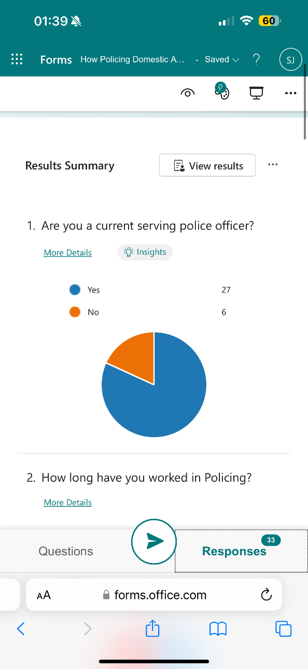
Question one has provided the participants with two choices to answer the question, Yes or No. 27 of the participants have stated Yes they are a serving Police officer with the other 6 participants responding No. This made for good results as the majority of the participants are Police Officer where they will be dealing with Domestic Abuse often.
Question Two. How long have you worked in Policing?
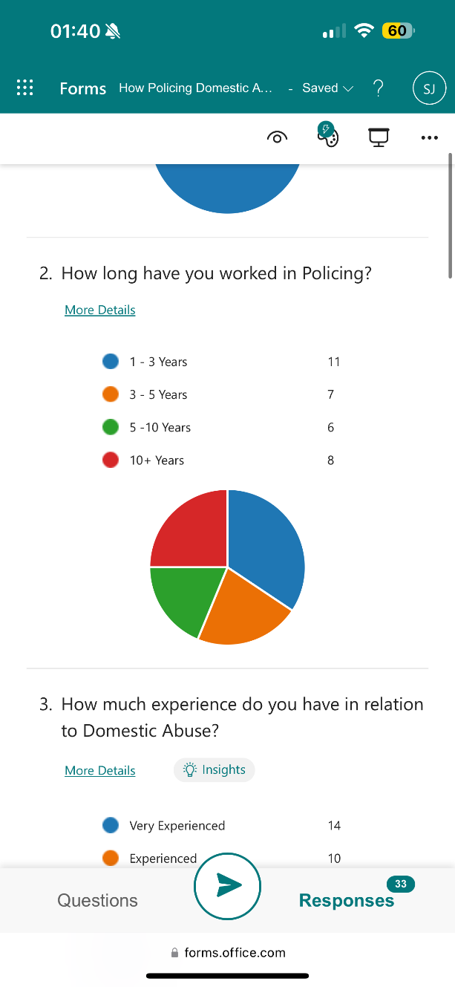
This questionnaire did not specially target Police Officer’s however the majority of the participants were Police Officers from Gwent Police. Question Two showed that these participants had a range of length of service with 8 of them being in the Police Force for 10+ years. It was important for questionnaire to target Police Officer’s or Police Staff who had been in service for the last 10 years as the research is about Policing Domestic Abuse over the last 10 years. Seven of the participants answered that their length of services was 3 to 5 years, 6 of the participants responded that they had 5 to 10 years’ service and the rest of the responded only had 1 to 3 years’ service.
Question Three. How much experience do you have in relation to Domestic Abuse?
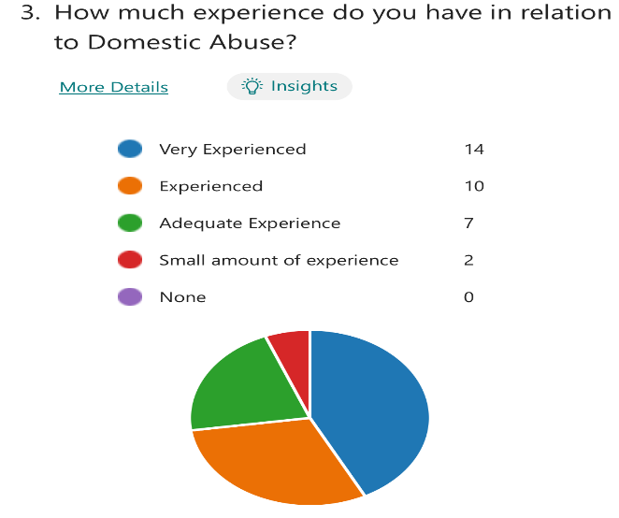
The results following Question three is that majority of participants responded that they are very experienced within Domestic Abuse with 14 participants responding very experienced. However only 8 of the participants had 10 + years in in response to question two. This means that respondents have responded that they feel they are very experienced within dealing with Domestic Abuse incidents however they have less than 10 years services which leads onto question five.
Question Four. How confident are you dealing with Domestic Abuse?
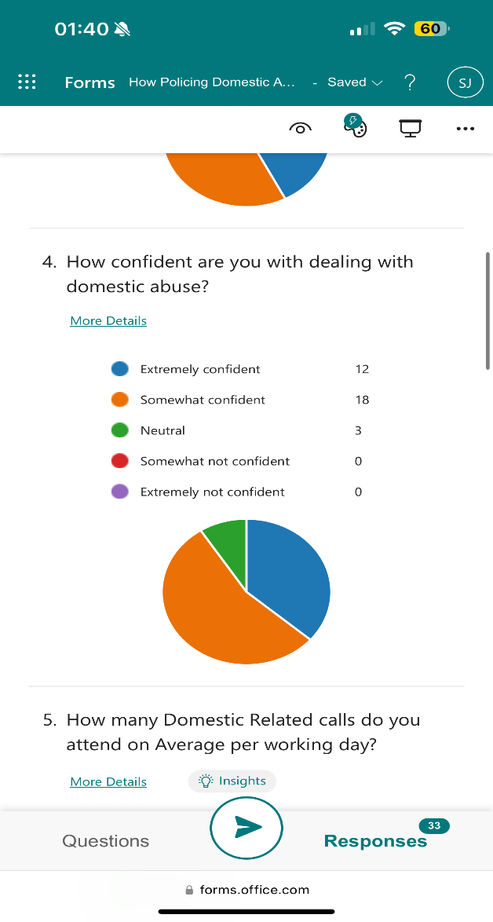
The majority of the respondents have responded Somewhat confident, another 12 of the participants stated they are extremely confident and 3 felt neutral about dealing with Domestic Abuse. However, comparing this response to question two less people have responded with extremely confident than they did for feeling very experienced dealing with Domestic Abuse. The understanding would be the most experience a person has with dealing with Domestic Abuse that they would be more confident in dealing with Domestic Abuse however these results do not portray that.
Question Five. How many Domestic related call do you attend on average per working day?
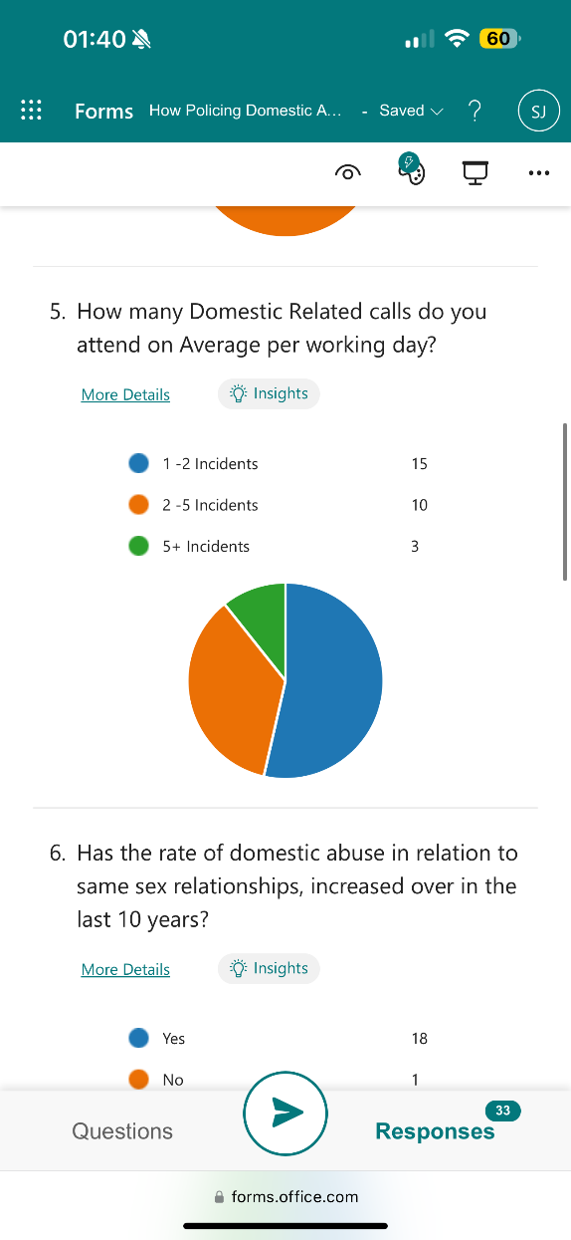
In relation to question five majority of participants responded that they attended 1 to 2 incidents per working day that relate to Domestic Abuse, showing that it is a demand on the police force however another category should have been added whereby participants could have answered “None” for attending incidents to give a more accurate results. This would have helped when analysing the data as it would have provided a more accurate result. However, 15 participants responded that they attend 1-2 incidents per working day which leads back to Question three. A respondent may feel they are very experienced within Domestic Abuse due to the area they work in; they may work in an area which the majority of the incidents they attend are Domestic Abuse proving that it is not about length of service but the area where the demand for Domestic Abuse is highest.
Question Six. Has the rate of Domestic Abuse in relation to same sex relationships, increased over the last 10 years?
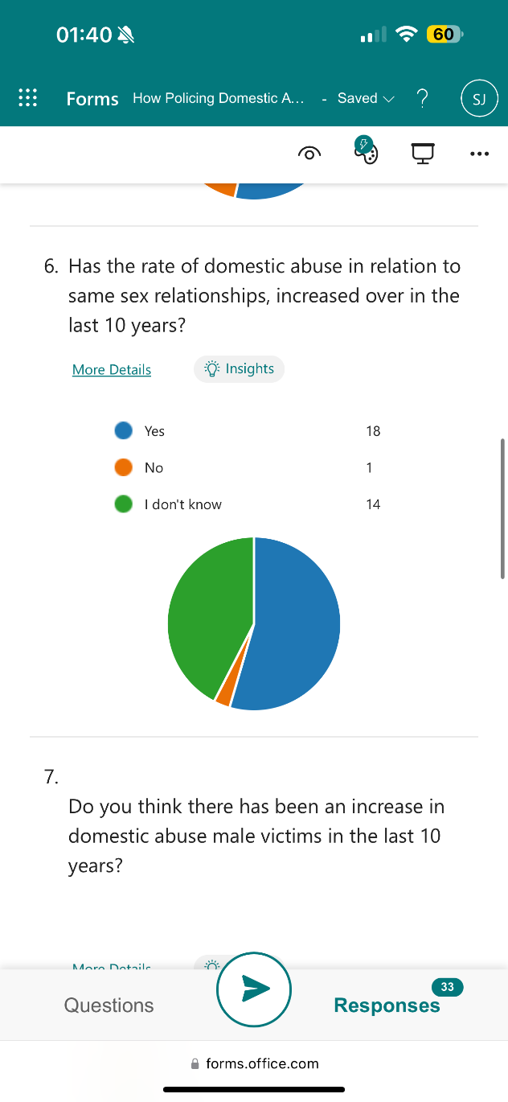
Samons, (2012) discusses how there are very few domestic violence shelters that cater to male victims, the results from his research also show it is difficult for members of the LGBT community to seek shelter to whereby they return to their abuser. In relation to question six,
18 of the participants responded yes to they think the rate of domestic abuse in same sex relationships has increased over the last 10 years, whereas 14 participants responded Not they do not believe the rate has increased.
The participants that responded No, may have not dealt with same sex domestic abuse which influences their response and again relates back to question five in relation to demand and the area the participant works.

Question Seven. Do you think there has been an increase in Domestic Abuse male victims in the last 10 years?
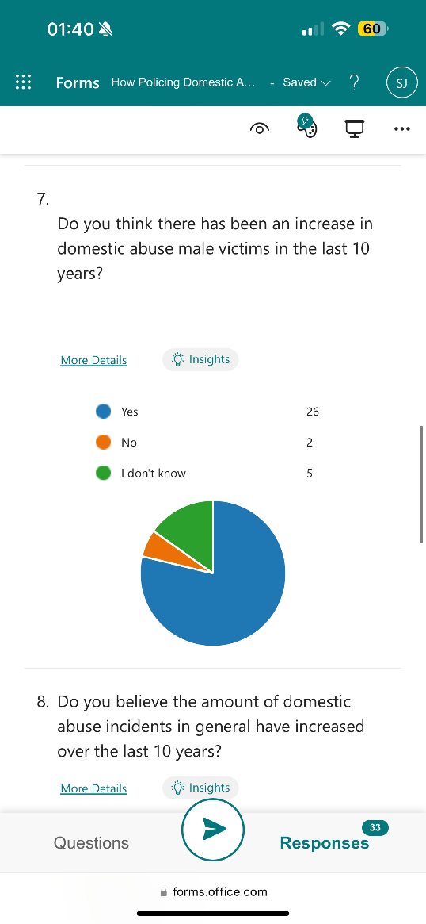
In relation to question seven, the majority of participants responded yes, they believe there has been an increase in Domestic Abuse Male Victims in the last 10 years. Dutton and White, (2013) completed a study on male victims of Domestic Abuse whereby the results of their findings suggested that males were previously disregarded if they reported Domestic Abuse to the police and were not taken as seriously in court, whereas due to policing training, male victims are now being taken seriously. The majority of the participants responded yes to this which indicates there is a clear increase of male victims.
Question Nine. Are you aware of any changes to Domestic Abuse legislation in the last 10 years?
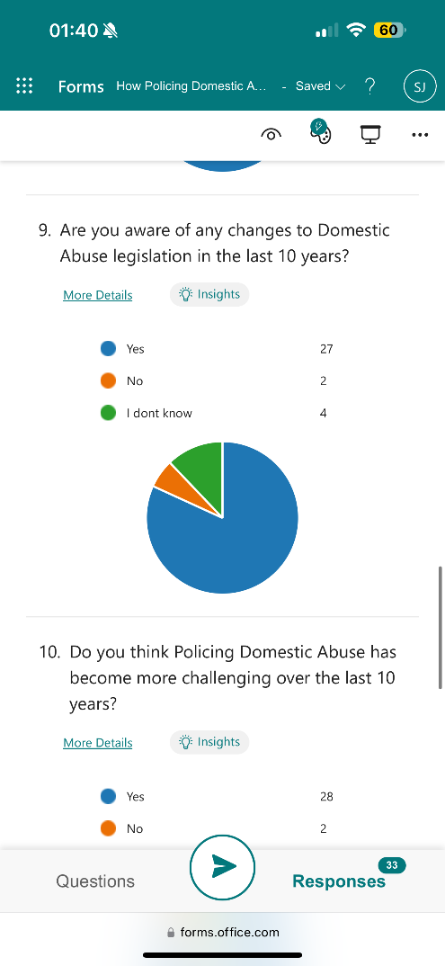
27 of the participants have answered Yes they are aware however 2 participants have answered No to being aware of changes to Domestic Abuse legislation and 4 participants answered “I don’t know”. This response shows that Police Officer’s and Police Staff are not always updated on new legislation that may come into the Police Force. If Police officer’s and Police staff were offered more training and support in knowing these changes it could provide a better service with victims as more offences could be identified.
Question Ten. Do you think Policing Domestic Abuse has become more challenging over the last 10 years?
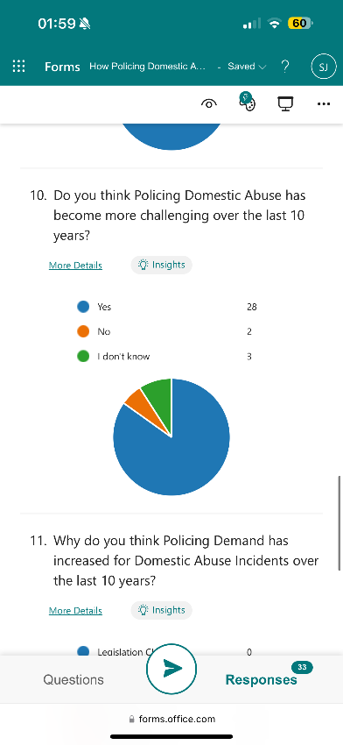
Walklate et al, (2022) completed a study on policing demand during Covid- 19 Lockdown and the results for this showed that Covid-19 had increased the demand for Domestic Abuse in relation to Policing.
This research relates to Question ten of the questionnaire as Covid-19 is something that has happened over the last 10 years which increased the demand for Domestic Abuse. Covid 19 was only within the last 4 years, this relates back to question two of how long the participants have worked within Policing, 11 participants answered they 1 to 3 years, 7 of the participants answered 3 to 5 years, 6 participants answered 5 to 10 years and 8 participants responded they have 10 years or more in Policing. This means the majority of the participants would have experienced Policing withing Covid-19 and experienced the demand it had on Policing in relation to Domestic Abuse.
Question Eleven. Why do you think Policing demand has increased for Domestic Abuse incidents over the last 10 years?
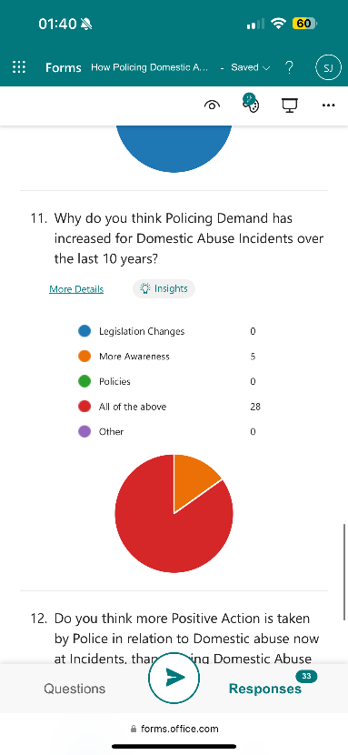
Robinson et al, (2016) completed a study whereby UK and US Police officers participated and the results from this show that the UK Police Officers had more training on Domestic Abuse and there are more roles for Police Officer’s within Domestic Abuse in the UK, this related to the research findings within Question 11. Most participants responded with all the above which indicates that the UK in relation to Policing has more awareness, more legislation and more Policies which increases the demand for Policing Domestic Abuse.
Question Twelve. Do you think more Positive Action is taken by police in relation to Domestic Abuse now at incidents, than Policing domestic Abuse 10 years ago?
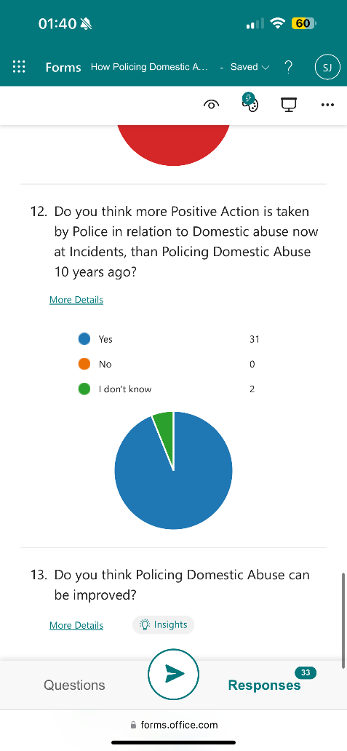
In relation to question 12, 31 participants have responded “yes” they think more Positive action is taking now at Domestic Abuse incidents that it was 10 years ago. Only 2 participants responded, “I don’t know”. Looking at the respondents answers it would appear that the two that have responded “I don’t know” could be down to the fact they were not in the police force 10 years ago and are not able to compare their current policing to policing 10 years ago. The participants who have answered “yes” could be down to their own personal experience or knowledge of policing before they joined the job as according to question two only 8 of the participants have over 10 years’ experience.
Question Thirteen. Do you think Policing Domestic Abuse can be improved?
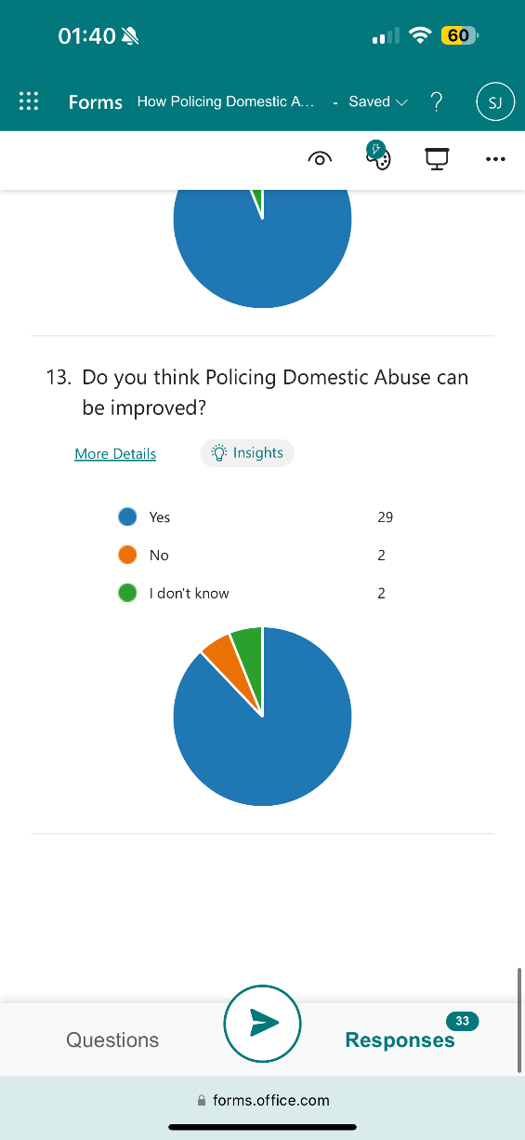
In relation to Question 13, majority of the participants responded Yes to Policing Domestic Abuse can be improved. Davies and Barlow, (2024) completed a study about Coercive Control in relation to Domestic Abuse and the analysis of their results suggest that despite there being more awareness, legislation and policies in place than previously, Policing still needs to improve in relation to how they respond to Domestic Abuse more specifically Coercive Control, the participant’s in this research have also agreed with this with 29 of the participants responding yes.
4.3: Conclusion
To summarise, this chapter has analysed the results of the questionnaire. It is clear to see that Policing Domestic abuse has changed, this is clear from the results based on particular answers such as 31 of the participants answering yes to the increase of Domestic abuse incidents in relation to question 8 which for reference is, “Do you believe the amount of Domestic Abuse incidents in general have increased over the last 10 years”, majority of people answering yes to all of the above in relation to question eleven and majority of people answering yes to more positive action being taken now than 10 years ago which for reference is “Do you think more Positive Action is taken by Police in relation to Domestic Abuse now at incidents, than Policing Domestic Abuse 10 years ago?”. Despite the majority of these answers indicating that Policing Domestic Abuse has changed over the last 10 years, the results are also slightly inaccurate due to only a small percentage of participants having 10+ years’ experience within the Police Force which means they participants who have less than 10+ years’ experience would not know the difference.

Chapter Five: Findings
5.1: Introduction
The previous chapter outlined the findings of the primary research conducted and analysed the data received from participants.
The final chapter will seek to provide recommendations based on the research conducted and findings and the potential limitations of the research. It will look at whether the objectives of the research were met throughout.
5.2: Summary of findings
The Research has solely focused on the last 10 years and how Policing Domestic Abuse has changed. Throughout this research numerous areas have been explored, such as research from other academics about Domestic Abuse, research questionnaires requesting the information directly from serving Policing Officer’s/ Police staff and research found on Policing in relation to Domestic Abuse. Throughout this research, positive changes in relation to Policing Domestic Abuse have been discussed such as new Legislation that have come into Policing and the negatives have been discussed such as the demand Domestic Abuse has on Police forces. The main objective of the research was to understand and reflect on Domestic Abuse and realise that whilst over the last 10 years Policing Domestic Abuse has changed drastically, it was also important to recognise that Police Forces need to continue to make improvements regarding Domestic Abuse as throughout the research it has showed that the demand for Domestic Abuse incidents has increased over the last 10 years.
The research shows that the majority of participants agreed that Policing Domestic Abuse has improved whether that be new Policies, new legislation or more safeguarding that has been put in place and the majority of participants also agreed that the demand for Policing Domestic Abuse is greater now than it was 10 years ago, whether that is because there is more awareness surrounding Domestic Abuse or more relationships are experiencing Domestic Abuse.
The research was conducted with Gwent Police officer’s and staff which shows how important Domestic Abuse is within the force. It is one of the most important investigations Police can deal with and it is essential that the Police get it right, it is also important as it is in people’s everyday lives and more awareness needs to be carried out.
5.3: Limitations
Despite the main objective of the research being met, there were weaknesses and limitations throughout the research. One being the Questions on the Questionnaires which were sent to Gwent Police officer’s and staff.
Some of the Questions were quite Vague and participants may have not been able to answer them accurately, an example being Question two asked, “How long have you been a serving Police Officer?” with the only options to answer being from a minimum of 1 years to 10 years. This is not an accurate question to ask participants considering Question one was, “Are you a current serving Police Officer?”, to which some participants have answered, “No”. By giving more answers on the multiple choice such as one of the answer being, “I’m not a serving Police Officer”, a more accurate result would have been conducted.
Another limitation throughout this research was discovering research that is already out there in order to compare to this research. There is a small amount of research which is specifically on How Policing Domestic Abuse has changed, even smaller amount on specifically the last 10 years. There seemed to be numerous research throughout the last 30- 50 years however this would not be relevant to this research being conducted. Not being able to compare research proved difficult to fully research the main objective of Has Policing Domestic Abuse changed over the last 10 years.
5.4: Recommendations
1. There have been numerous beneficial changes brought into Domestic Abuse such as the introduction of Coercive and Controlling Behaviour however it is also clear that the demand for Domestic Abuse is higher than it has ever been. More positive action needs to be done in order to lower the demand for Domestic Abuse.
2. More funding needs to go into Domestic Abuse and Policing. As mentioned in Chapter two IDVA’S are underfunded therefore Domestic Abuse victims are not getting the support they should be. If more funding was providing to IDVA’S it could reduce the risk of a victim returning to the offender which then reduces the demand on Policing.

Chapter six: Conclusion
The previous chapter discussed the summary of the findings from the research, discussed the limitations throughout the research and provided recommendations based on the research conducted.
To conclude, the study provided answers for the main aims and objectives of the research. It has been discussed about the limitations and weaknesses of the study. It has also been discussed the importance of the research and why this topic was chosen specifically.
It has also been discussed that the research could be improved and the recommendations which have been made going forward.

Chapter Seven: Bibliography
Almond, L., McManus, M., Brian, D. and Merrington, D.P., (2017). Exploration of the risk factors contained within the UK’s existing domestic abuse risk assessment tool (DASH): do these risk factors have individual predictive validity regarding recidivism? Journal of aggression, conflict and peace research, 9(1), pp.58-68.
Available at: Revision 2-Validating DASH risk factors.pdf (ljmu.ac.uk)
Accessed on: 30/01/2024
Belknap.J. and Grant D. (2018). Fifty Years After the 1967 Crime Commission Report, How Non policing Domestic Violence Research and Policies have changed and expanded
Available at: Fifty Years After the 1967 Crime Commission Report - Belknap - 2018 - Criminology & Public Policy - Wiley Online Library (uwtsd.ac.uk)
Accessed on: 01/02/2024
Bhandari, P. (2023). What Is Quantitative research? | definition, Uses and Methods.
Available at: What Is Quantitative Research? | Definition, Uses & Methods (scribbr.com)
Accessed on: 10/03/2024
Birdsall, N. and Boulton, L. (2022) “Theorising victim decision making in the police response to domestic abuse,” International review of victimology, 28(3), pp. 330–344
Available at: Theorising victim decision making in the police response to domestic abuse (sagepub.com)
Accessed on: 01/02/2024
Bishop, C. and Bettinson, V. (2018). Evidencing domestic violence*, including behaviour that falls under the new offence of ‘controlling or coercive behaviour’. The International Journal of Evidence & Proof, 22(1), pp.3-29.
Available at: EPJ725535 1..27 (dmu.ac.uk)
Accessed on: 30/01/2024
Blackburn, K. and Graca, S. (2021). A critical reflection on the use and effectiveness of DVPNs and DVPOs. Police Practice and Research, 22(1), pp.23-39.
Available at: UseDVPOs_MainDoc_Consolidated_Reviewed_Upload.pdf (canterbury.ac.uk)
Accessed on: 01/02/20024
Brennan, I., Myhill, A., Tagliaferri, G. and Tapley, J. (2021). Policing a new domestic abuse crime: Effects of force-wide training on arrests for coercive control. Policing and society, 31(10), pp.1153-1167.
Available at: Preprint_Policing a new domestic abuse crime.pdf
Accessed on: 02/02/2024
Cambridge Dictionary. (2019). RESEARCH | meaning in the Cambridge English Dictionary.
Available at: RESEARCH | English meaning - Cambridge Dictionary
Accessed on: 12/03/2024
Centre for Women's Justice. (2021). Police super-complaint Report Shines a Light on Police Failure to Protect Domestic Abuse Victims as Prosecutions Collapse by 50% in Just Three Years.
Available at: Police super-complaint report shines a light on police failure to protect domestic abuse victims as prosecutions collapse by 50% in just three years — Centre for Women's Justice (centreforwomensjustice.org.uk)
Accessed on: 05/01/2024
College of Police. (2015). Arrest and Other Positive Approaches, Positive Action
Available at: Arrest and other positive approaches | College of Policing
Accessed on: 04/02/2024
Crow, M.S., Snyder, J.A., Crichlow, V.J. and Smykla, J.O. (2017). Community perceptions of police body-worn cameras: The impact of views on fairness, fear, performance, and privacy. Criminal justice and behavior, 44(4), pp.589-610.
Available at: CJB.pdf (pbcgov.org)
Accessed on: 03/02/2024
Crown Prosecution Service. (2019). Controlling or coercive behaviour in an intimate or family relationship.
Available at: Controlling or Coercive Behaviour in an Intimate or Family Relationship | The Crown Prosecution Service (cps.gov.uk)
Accessed on: 27/11/2023
DASH Risk Checklist. (2023). The Domestic Abuse, Stalking and Honour Based Violence Risk Identification.
Available at: DASH Risk Checklist
Accessed on: 06/01/2024
Davies, P. and Barlow, C.F. (2024). Policing domestic abuse: the onus on first responders. Policing and Society, pp.1-14.
Available at: Policing domestic abuse: the onus on first responders (tandfonline.com)
Accessed on: 05/02/2024
Davies, P., Rowe, M., Brown, D.M. and Biddle, P. (2021). Understanding the status of evidence in policing research: reflections from a study of policing domestic abuse. Policing and society, 31(6), pp.687-701.
Available at: Policing_Society_Article_Final.pdf (northumbria.ac.uk)
Accessed on: 05/02/2024
Dowling, C. and Morgan, A. (2018). Police investigations of domestic violence: What does the evidence say. Police Science: Australia and New Zealand Journal of Evidence Based Policing, 3(2), pp.6-11.
Dutton, D.G. and White, K.R. (2013). Male victims of domestic violence. New male studies: An international journal, 2(1), pp.5-17.
Available at: Layout 1 (lakilakibaru.or.id)
Accessed on: 30/04/2024
Elkin, M. (2018). Domestic abuse: findings from the Crime Survey for England and Wales: year ending March 2018. Office for National Statistics.
Forbes, C., Alderson, H., Domoney, J., Papamichail, A., Berry, V., McGovern, R., Sevdalis, N., Rankin, J., Newburn, M., Healey, A. and Easter, A. (2023). A survey and stakeholder consultation of Independent Domestic Violence Advisor (IDVA) programmes in English maternity services. BMC pregnancy and childbirth, 23(1), p.404.
Available at: A survey and stakeholder consultation of Independent Domestic Violence Advisor (IDVA) programmes in English maternity services (springer.com)
Accessed on: 04/02/2024
GOV. (2023). Clause 15: Guidance about Independent Advisors (ISVA’S and IDVA’S)
Available at: Guidance about independent advisors (ISVAs and IDVAs) fact sheet (publishing.service.gov.uk)
Accessed on: 05/02/204
Hassan, M. (2022). Exploratory Research - Types and Methods.
Available at: Exploratory Research - Types, Methods and Examples (researchmethod.net)
Accessed on: 16/03/2024
Hassan, M. (2022). Primary Data - Types and Methods.
Available at: Primary Data - Types, Methods and Examples - Research Method
Accessed on: 16/03/2024
Hassan, M. (2022). Secondary Data - Methods and Types.
Available at: Secondary Data - Types, Methods and Examples (researchmethod.net)
Accessed on: 16/03/2024
Legal Guidance. (2023). Domestic Abuse, Controlling or Coercive Behaviour in an intimate Relationship.
Available at: Controlling or Coercive Behaviour in an Intimate or Family Relationship | The Crown Prosecution Service (cps.gov.uk)
Accessed on: 02/02/2024
Legal Guidance. (2023) Stalking Protection Order. The Crown Prosecution Service
Available at: Stalking Protection Orders | The Crown Prosecution Service (cps.gov.uk)
Accessed on: 05/02/2024
Lippert, R.K. and Newell, B.C. (2016). Debate introduction: the privacy and surveillance implications of police body cameras. Surveillance & society, 14(1), pp.113-116.
Available at: body-cams-debate-full.pdf
Accessed on: 02/02/2024
McCombes, S. (2023). Descriptive research design | definition, methods and examples.
Available at: Descriptive Research | Definition, Types, Methods & Examples (scribbr.com)
Accessed on: 16/03/2024
McLaughlin, H., Robbins, R., Bellamy, C., Banks, C. and Thackray, D. (2018). Adult social work and high-risk domestic violence cases. Journal of social work, 18(3), pp.288-306.
Available at: JSW Ad SW Maracs Dv Final April2016.pdf (uclan.ac.uk)
Accessed on: 03/02/2024
McLeod, S. (2023). Qualitative Vs Quantitative Research Methods & Data Analysis.
Available at: Qualitative vs Quantitative Research: What's the Difference? (simplypsychology.org)
Accessed on: 14/03/2024
Owens, C., Mann, D. and Mckenna, R. (2014). The Essex body worn video trial. The impact of body worn video on criminal justice outcomes of domestic abuse incidents. College of Policing, Essex, United Kingdom.
Available at: Main heading goes here (bapcojournal.com)
Accessed on: 03/02/2024
Robbins, R., McLaughlin, H., Banks, C., Bellamy, C. and Thackray, D. (2014). Domestic violence and multi-agency risk assessment conferences (MARACs): a scoping review. The Journal of Adult Protection, 16(6), pp.389-398.
Available at: Domestic violence and multi-agency risk assessment conferences (MARACs): a scoping review (researchgate.net)
Accessed on: 05/02/2024
Roberts, K. (2010). Great expectations: Relations of trust and confidence in police interviews with witnesses of crime. Policing: A Journal of Policy and Practice, 4(3), pp.265-272.
Available at: plc10032_prn 197..198 (researchgate.net)
Accessed on: 01/02/2024
Robinson, A.L., Pinchevsky, G.M. and Guthrie, J.A. (2016). Under the radar: Policing non-violent domestic abuse in the US and UK. International journal of comparative and applied criminal justice, 40(3), pp.195-208.
Available at: Under the radar: policing non-violent domestic abuse in the US and UK (tandfonline.com)
Accessed on: 03/05/2023
Robinson, A. (2013). November. A risk-led approach to domestic violence: the MARAC model in the UK. In International Conference on “Violence in Close Social Relationships and Stalking–Police Officers Dealing with High Risk Cases.” Rhineland-Palatinate Police Academy, Germany.
Available at: National Delivery Plan for Domestic Violence (researchgate.net)
Accessed on: 03/02/2024
Samons, C. (2012). Same-sex domestic violence: The need for affirmative legal protections at all levels of government. S. Cal. Rev. L. & Soc. Just., 22, p.417.
Available at: 5.Samons.pdf (usc.edu)
Accessed on: 03/05/2024
Sherman, L.W. (2018). Policing domestic violence 1967–2017. Criminology & public policy, 17(2), pp.453-465.
Available at: Policing Domestic Violence 1967–2017 (squarespace.com)
Accessed on: 01/02/2024
Staffordshire Police. (N.D). Controlling or coercive behaviour help guide. We’re on your side.
Available at: coercive-behaviour-brochure.pdf (staffordshire.police.uk)
Accessed on: 30/01/2024
Stark, E. and Hester, M. (2019). Coercive control: Update and review. Violence against women, 25(1), pp.81-104.
Available at: Coercive Control: Update and Review (sagepub.com)u
Accessed on: 01/02/2024
Taylor-Dunn, H. and Erol, R. (2023). “Improving the ‘victim journey’ when reporting domestic abuse cyberstalking to the police – A pilot project evaluation,” Criminology & criminal justice, 23(5), pp. 694–715.
Available at: Improving the ‘victim journey’ when reporting domestic abuse cyberstalking to the police – A pilot project evaluation (sagepub.com)
Accessed on: 05/02/2024
The A Project. (N.D). Domestic Abuse Perpetrator Programme (DAPP).
Available at: DAPP (theaproject.co.uk)
Accessed on: 05/02/2024
Thornton, S. (2017). Police Attempts to Predict Domestic Murder and Serious Assaults: Is Early Warning Possible Yet?. Camb J Evid Based Polic 1, 64–80.
Available at: s41887-017-0011-1.pdf
Accessed on: 01/02/2024
Walklate, S., Godfrey, B. and Richardson, J. (2022). Changes and continuities in police responses to domestic abuse in England and Wales during the Covid-19 ‘lockdown’. Policing and Society, 32(2), pp.221-233.
Available at: Changes and continuities in police responses to domestic abuse in England and Wales during the Covid (tandfonline.com)
Accessed on: 03/05/2024
Women's Aid. (2018). Coercive control - Womens Aid.
Available at: Coercive control - Women’s Aid (womensaid.org.uk)
Accessed on: 04/02/2024
Women's Aid. (2023). What Is Domestic abuse?
Available at: What is domestic abuse? - Women’s Aid (womensaid.org.uk)
Accessed on: 04/02/2024
Wooff, A. (2020). ‘I feel trapped’: The role of the cell in the embodied and everyday practices of police custody. The Prison Cell: Embodied and Everyday Spaces of Incarceration, pp.95-118.
Available at: I feel trapped The role of the cell in the embodied and everyday practices of police custody.pdf (worktribe.com)
Accessed on: 04/02/2024

Chapter eight: Appendix
Appendix 1: Questionnaire on How Policing Domestic Abuse has changed over the last 10 years.
Thank you for your interest in taking this survey. This survey is being conducted by GWP 2421 Police Constable Sanchia JOHNSON to collect data on the subject of Policing Domestic Abuse and how it has changed over the last 10 years.
The survey is anonymous, and your participation is voluntary. This survey uses assumed consent, therefore if you participate in the survey, it is assumed that you consent for your answers to be used in the research.
Please ensure that no personal details of yourself or others are included in the responses. The data collected will be kept securely and will be deleted at the end of the research.
If you have any questions about the survey or about the research, please contact Sanchia Johnson at,
Sanchia.johnson@gwent.police.uk
Please submit your response by 29th APRIL 2024.
Question 1:
Are you a current serving Police Officer? Single Choice.
Yes
No
Question 2:
How long have you working in Policing? Single Choice
1-3 years
3-5 years
5-10 Years
10+ Years
Question 3:
How much experience do you have in relation to Domestic Abuse? Single Choice
Very experienced
Experienced
Adequate experience
Small amount of experience
None
Question 4:
How confident are you dealing with Domestic Abuse? Single Choice.
Extremely confident
Somewhat confident
Neutral
Somewhat not confident
Extremely not confident

Question 5:
How may Domestic Related calls do you attend on Average per working day?
1-2 incidents
2-5 incidents
5+ incidents
Question 6:
Has the rate of domestic abuse in relation to same sex relationships. Increased over in the last 10 years? Single Choice
Yes
No
I don’t know
Question 7:
Do you think there has been an increase in domestic abuse male victims in the last 10 years? Single Choice
Yes
No
I don’t know.

Question 8:
Do you believe the amount of domestic abuse incidents in general have increased over the last 10 years? Single Choice
Yes
No
I don’t know

Question 9:
Are you aware of any changes to Domestic Abuse legislation in the last 10 years? Single Choice
Yes
No
I don’t know
Question 10:
Do you think Policing domestic Abuse has become more challenging over the last 10 years?
Yes
No
I don’t know
Question 11:
Why do you think Policing Demand has increased for Domestic Abuse incidents over the last 10 years?
Legislation changes
More awareness
Policies
All of the above
Other
Question 12:
Do you think more Positive Action is taken by Police in relation to Domestic abuse now at incidents, than Policing Domestic Abuse 10 years ago?
Yes
No
I don’t know
Question 13:
Do you think Policing Domestic Abuse can be improved?
Yes
No
I don’t know

Appendix 2: Questionnaire Responses
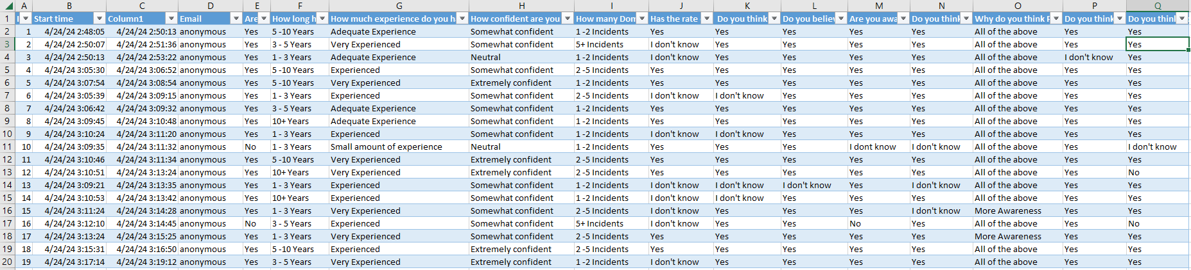

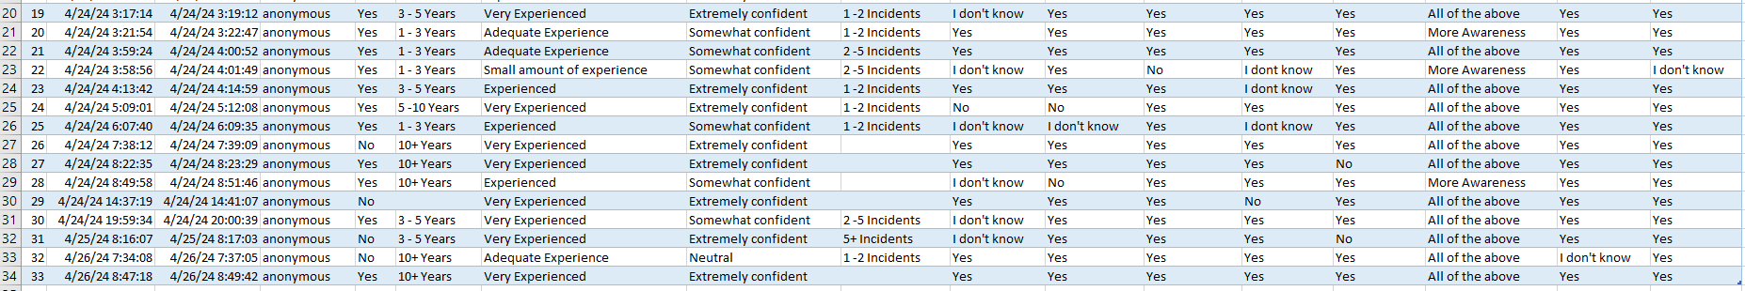

Appendix 3: Proposal
Domestic Abuse: How has Policing Domestic Abuse changed within the last 10 years.

The aim of the research is to see the changes that have come into Policing regarding Domestic abuse over the last 10 years.

Objectives of Research:
- Demonstrate benefits of Domestic Abuse investigation changes.
-It will also discuss the negative for Domestic Abuse investigation changes in relation to policing.
- It will express the changes that need to be conducted in relation to Domestic Abuse Policing.
Introduction
This dissertation will be 8,000 words discussing how Policing has changed in relation to Domestic Abuse incidents and investigations. This particular topic is a main focus in policing and is something officer’s come across in everyday policing. It is also one particular subject that comes under scrutiny and one area in policing that has changed drastically over the last 10 years. This topic of discussion is an essential part of policing and it is important to understand the changes, including positives changes and negative changes. This is worthy of a dissertation as it is not just an essential part of policing, it Is part of people’s everyday lives, On completing background research into this topic. Morgan (2018) discuss how different technologies over the last 10 years which have been introduced into policing have assisted with investigations some being Body Worn Video and mobile phones. In 2018 a survey was completed in England and Wales which showed 1.3 million women and 695,000 men experienced Domestic Abuse in just that year, Elkin (2018). This particular research shows statistics of just how many people are suffering from Domestic Abuse and why it is so important that police understand the changes that have come in.
The target audience will be Police officer’s and Police staff who work within Gwent Police and have done for the last 10 years.
There will be no ethical issues due to the participants consenting to take part in the survey and no personal information will be requested from the participants.
Appendix 4: Ethics Form Application


