Introduction:

Data analysis is a process involving statistical or logical techniques to illustrate and evaluate a data set. Shampoo and Resnick(2003) state that several analytic procedures “provide a way of drawing inductive inferences from data and distinguishing the signal from the noise present in data”. Qualitative research involves statistical procedures, several times analysis develop a continuous iterative process where data is ongoing and collected, analysed simultaneously. It is important to note that Researchers analysed for patterns in observation where the entire data collection phase. “An essential component of ensuring data integrity is the accurate and appropriate analysis of research findings. Improper statistical analyses distort scientific findings, mislead casual readers (Shepard, 2002), and may negatively influence the public perception of research. Integrity issues are just as relevant to analysis of non-statistical data as well” (hhs.gov,2005). It is important to note that the census data is collected to be used by the government to initiate future plants for maternity care, education, pensions, employment, housing and transport. The data also used for resource management for the public(BBC,2018).The Townsend index was initially founded by Peter Townsend in 1988 which measures four variables(Unemployment, on car Ownership, non-home ownership, household overcrowding) which are included in the nongovernmental data set This Report will investigate two data sets based in the Swansea Wales area and process the results and discuss any correlation between the government and non-government data.

Methodology:

The Data sets were extracted via the UK census data website through selecting aggregate data and accessing the infuse census data with the latest version of the geography route. This assignment is based on Swansea Wales (Lower super output areas, Output areas, work place zones) and then added and processed, the Government data was under the Deprivation, classification of household 1-4 dimensions and data was then downloaded in excel form. Similar procedure was done for non-government data. However, required different categories within economic activity, bedroom rating, Tenure, no cars or vans. The non-governmental data went through a calculation process to gain Townsend index. The Boundary data map was provided via the UK census data and was inserted first into MapInfo. The Non-governmental and Governmental data was then inserted in the MapInfo GIS for visual interpretation and some data charts were done via excel to more visual interpretation.

Results:

In the results section it will present some visual aid to show the data collected and if there is any correlation between the government and non-government data

Figure 1
The graph above demonstrates the Townsend index for the output area and it shows that the low geo codes contain the highest Townsend index score which translate to the most deprived areas are with lowest geo codes.

Figure 2

The graph above demonstrates the unemployment by geo code and there is a direct link between this and the Townsend index and the graph flow is very similar. This graph is considered to be one of the most important index in the Townsend data as unemployment is the biggest factor to deprivation. The

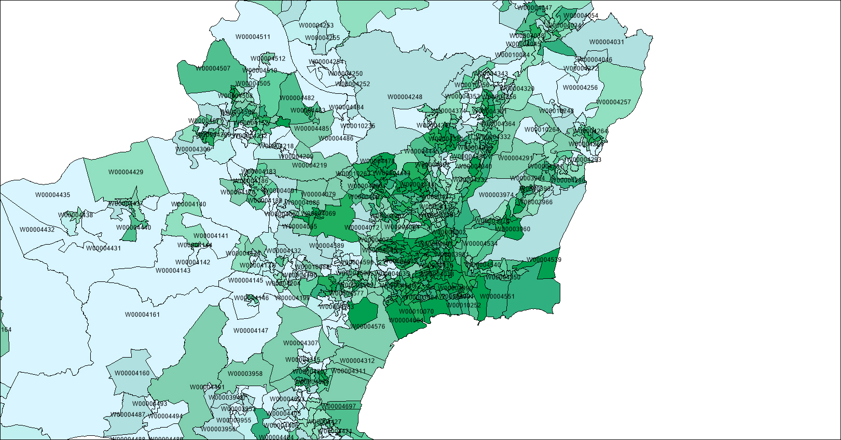

Figure 3

The map above demonstrates the Townsend index of Output areas deprivation with its geo code. The Darker the colour the more deprived the area is and the most of the deprived areas are near Swansea centre.

Figure 4

The scatter plot above shows the dimensions 1 to 4 and the highest score is the dimension 1 as most people Identify with the one type of deprivation in the governmental data. It is important to note that the dimension zero is not included due to the fact dimension zero was unable to include in the scatter chart. Although, containing the highest percentages.

Figure 5
The above pie chart illustrates an example of the typical layout in the governmental output data set. 1 is dimension zero, 2 is dimension one and 3 is dimension 2. Which shows most of the governmental data stats the deprivation is low. Although, there are other figures showing there is a mix of data stating there is certain deprivation in other dimensions.

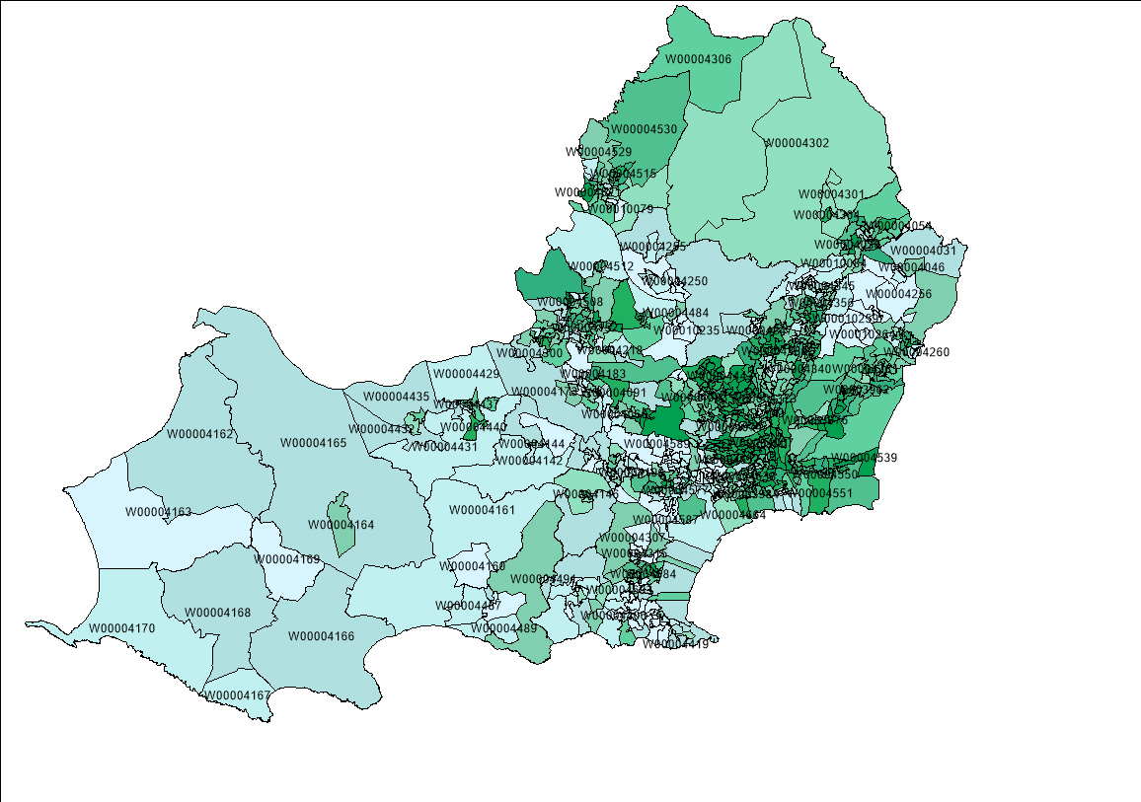
Figure 6
The map above is a done via GIS map info and it is a snap shot of the governmental map score which is very similar to the Townsend index earlier as the darker the green the more deprived the area is.

Figure 7

The graph above shows the total score of the dimensions for the government data and the highest score is around 300. This shows that it is higher than the Townsend index count.

Figure 8

The government and non-government graph demonstrates the correlation of the two data as the general flow of data is very similar.

SUMMARY OUTPUT
Regression Statistics
Multiple R | 1.00
R Square | 1.00
Adjusted R Square | 1.00
Standard Error | 2.72
Observations | 792.00

ANOVA
 | df | SS | MS | F | Significance F
Regression | 1.0 | 1223322.3 | 1223322.3 | 165755.3 | 0.0
Residual | 790.0 | 5830.4 | 7.4
Total | 791.0 | 1229152.7

 | Coefficients | Standard Error | t Stat | P-value | Lower 95% | Upper 95% | Lower 95.0% | Upper 95.0%
Intercept | 74.1 | 0.6 | 129.1 | 0.0 | 73.0 | 75.2 | 73.0 | 75.2
Score | 1.2 | 0.0 | 407.1 | 0.0 | 1.2 | 1.2 | 1.2 | 1.2

The highlighted Data above are of most importance as they show the significant positive relationship between the Government and Non-Government data as if the significant f is less than 0.05 it means the correlation is statically significant. In accordance to parsons method in which if the correlation number is 1 or near which translate in a strong correlation between the two variables.

Figure 9

The graph above illustrates the Townsend index also known as the deprivation index each geo code in Swansea’s lower super output areas and it shows that the highest index is within the highest geocodes and is considerably similar to the output area index in sense of numbers as the out put area is slightly higher .

Figure 10

The above graph shows one of the important components to deprivation data which is unemployment rate as employability is the key source of earnings which influence the deprivation rate and the economy in the area.
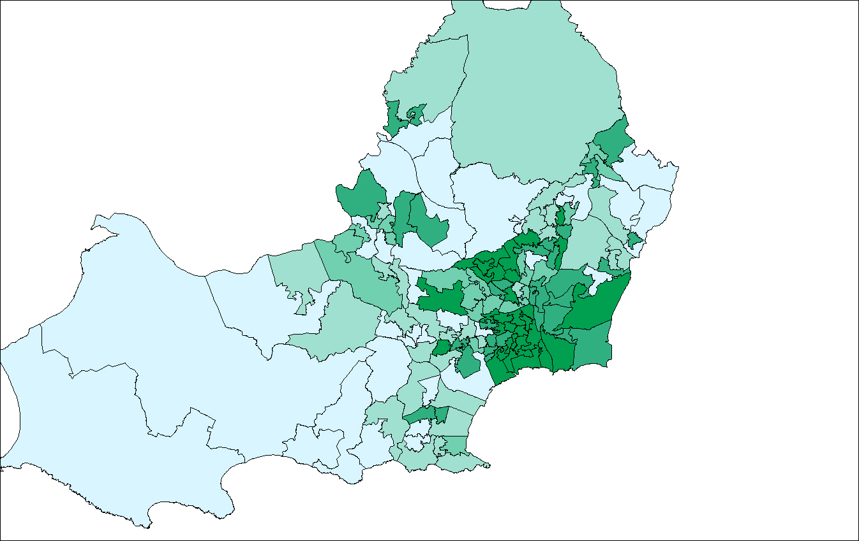
Figure 11
The map above demonstrates a snap shot from MapInfo of the Townsend index for Lower super output areas where the darker green shades represent areas of high deprivation and lower green shades are of lower or no deprivation.

Figure 12
The figure above illustrates the significant of each dimension as the dimension one has the highest percentage compared to dimension 2,3,4. Dimension zero is the dimension with highest percentage. That shows that many household are not affected by each category in the governmental data (health and disability,……………..

Figure 13

The pie chart demonstrates an example of the 1-5 dimensions from the government data in lower super area. 1 dimensions and 2 dimensions are observed to be the highest.

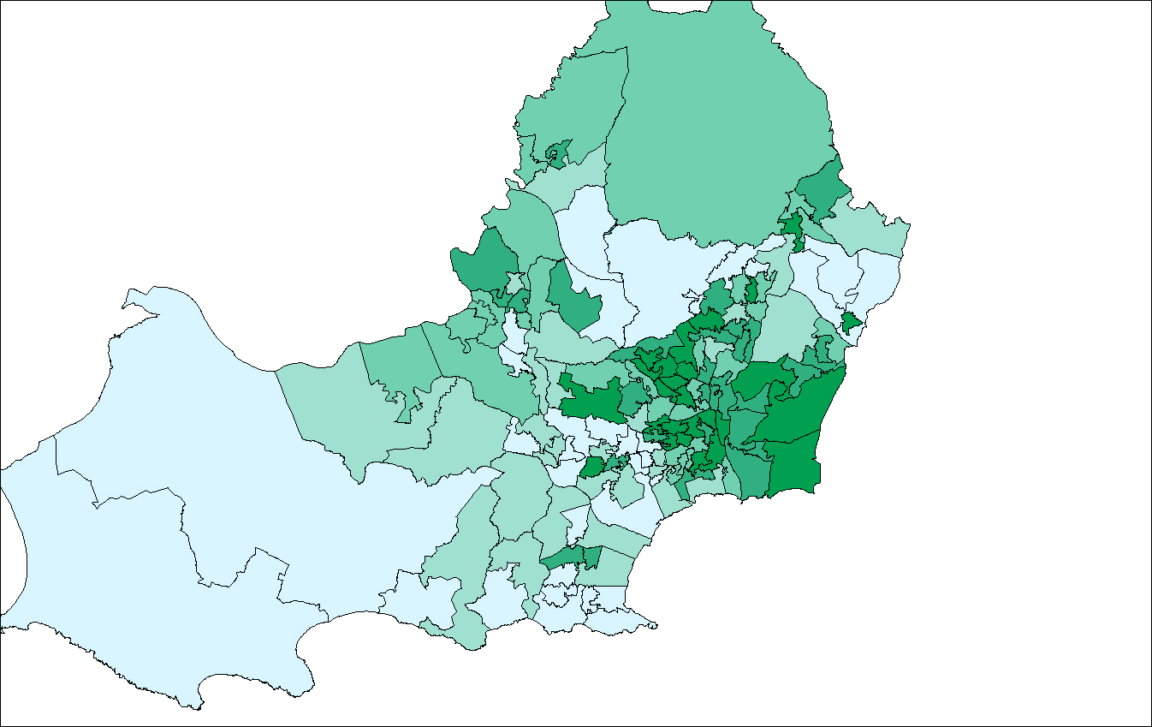

Figure 14

The map represents the total score of the government deprivation data where the dark green shade shows the higher deprivation areas. However, it is important to note the similarity of the Townsend index map (nongovernment data) and the total score on the map earlier for lower super output.

The government and non-government graph demonstrates the correlation of the two data as the general flow of data is very similar.

SUMMARY OUTPUT
Regression Statistics
Multiple R | 0.99948953
R Square | 0.99897932
Adjusted R Square | 0.99897233
Standard Error | 0.88976759
Observations | 148

ANOVA
 | df | SS | MS | F | Significance F
Regression | 1.00 | 113129.03 | 113129.03 | 142896.28 | 0.00
Residual | 146.00 | 115.59 | 0.79
Total | 147.00 | 113244.62

 | Coefficients | Standard Error | t Stat | P-value | Lower 95% | Upper 95% | Lower 95.0% | Upper 95.0%
Intercept | 37.8463 | 0.4260 | 88.8456 | 0.0000 | 37.0044 | 38.6882 | 37.0044 | 38.6882
Townsend | 0.7050 | 0.0019 | 378.0162 | 0.0000 | 0.7013 | 0.7087 | 0.7013 | 0.7087

The highlighted Data above are of most importance as they show the significant positive relationship between the Government and Non-Government data as if the significant f is less than 0.05 it means the correlation is statically significant. In accordance to parson’s method in which if the correlation number is 1 or near which translate in a strong correlation between the two variables.

Discussion:

The government data which was labelled as Deprivation index on the UK census website and contains 0-4 dimensions with each used as indicators to classify households based on four selected characteristics weather each dimension applies to each household conditions are as following. 1- Employment: conditions apply if the members of the house are not fulltime students and is either unemployed or long-term sick, 2- Education: apply if the household is at least level 2 educated and no students aged 16 to 18 full time students.3- Health and disability: any person In the household is in bad or long term health issues an finally 4- “The household s accommodation is overcrowded with an occupancy rating -1 or less or is in a shared dwelling or has no central heating”(UK data service. 2018). Compared to the Townsend index which is based on several topics such as economic activity, Tenure, Bedroom occupancy rating, car or van availability with each having several layers.

The Townsend index is census-based on material of deprivation calculated by the mixture of four census data and have been used widespread use in different field to measure socioeconomics and further. The Townsend index is an area-based where geo codes stand for in the given excel sheets and it measure can be created for all geographical regions for which census data are accessible, especially with the widespread use of 1981, 1991 and 2001 censuses throughout the UK, most usually calculated for wards, enumeration districts (EDs) and output areas (OAs). A comparable measure can be constructed in other countries where the same census variables are available. The simple nature of the score and its use of readily-available data mean that it can be calculated directly for any geographical areas based on census geography. Geographical linkage may then be required in order to allocate deprivation scores to records referenced to incompatible geographies such as postcodes. Geographical information systems have been used in this case to provide visual aid of the exact areas of deprivation in Swansea.The Townsend index is made from the following four census variables, each of which must be divided by the appropriate count of households or persons to obtain a percentage score. The exact census counts to be used will vary slightly for different censuses.(Restore.2016)

-Households without a car
-Overcrowded households
-Households not owner-occupied
-Persons unemployed

The overcrowding and unemployment percentages (+1) which are subjected to a log alteration in order to normalise the raw values, which could be highly skewed. In the excel sheet where the calculations were done have all four variables are then standardized using a Z-score (subtract the mean value and divide by the standard deviation) . the 4 standardized scores are then summed to obtain a single value which is the Townsend deprivation index. Positive values of the index will indicate areas with high material deprivation, whereas those with negative values will indicate relative affluence. A score of 0 represents an area with overall mean values. The calculating of the Townsend scores, it is essential to distinguish the mean and standard deviation for each variable for the appropriate geographical units across a large reference area - typically the whole country. The score can be standardized over smaller areas, such as a region, but this will not produce nationally comparable values. (Townsend,1988)

There are many issues associated with the census data such as reliability as some areas within the UK change quite often as he questionnaire is done every decade which causes some information gap to recent updates for example in 2011 Swansea population was 239,023 and in 2016 is approximately 244,500 (Swansea.Gov,2016) and increasing as it is one of the highest population in Wales. It would be a good suggestion to conduct the census on a five-year basis to increase data efficiency. The method used to collect data and its accuracy which is also considered as one of its limitations for this Townsend index and government data for example most of the deprived areas as it showed on the GIS map in the results section is within the centre of Swansea which where most students live, and students make up a percentage of the Swansea population and economy and depending on the units (persons, Household) used to measure the two different data set which make up the significant difference. There are some issues faced with the accessibility of the UK census website as many of the data could not be downloaded which could translate into that the website may only be able to assist a certain number of users.

MapInfo Geographical information systems was used to demonstrate the deprivation index the map for the Swansea area was downloaded via the UK census data via boundary data. The software is deemed to be great for visual aid to demonstrate areas with high pollution rate as well as deprivation. However, it is deemed to be not as user friendly as other GIS as it has a special requirement of entry data for it to produce a map. Compared to ArcGIS or Qgis which are considered to be more user friendly as it is easier to use due to the atomisation and coding of the software for it to be able to create the required map. The environmental management community have been using geographical information system to organize existing data and communicate that information throughout their organizations. GIS can be used as a strategic tool to automate processes, transform environmental management operations by garnering new knowledge, and support decisions that make a profound difference on our environment. GIS is considered enterprise if, by design, it is part of the overall information technology architecture of the organization. ArcGIS can be integrated with most standard corporate systems such as work management, customer service, and reporting systems. Both GIS functionality and data accessing ability can be embedded directly into other agency applications. GIS workflow applications simplify and automate procedures within environmental management operations, resulting in improved efficiency and significant time savings. ESRI software developers and business partners work together to bring the environmental management community benefit and value from GIS(esri,2005).

Conclusion:

The Townsend index and the governmental data are both useful tools extracted from the UK census data to show deprivation areas within a certain location which are considerably similar as they show a direct correlation. Either method of data collection for Townsend or Governmental data can be useful to estimate the deprivation as well as other means which were not included in this assignment. MapInfo GIS has been a visual aid assistant as well as the Microsoft excel to show areas of deprivation via geo code and via map. Although the were some issues with UK census outdated and the UK census website delays, it is still a good way in collecting data.

