Salt Mummification Experiment
Abstract
This experiment investigated how salt preserves organic material replicating the mummification process. Half an orange and frankfurter were placed in salt mixture, while the other half was left untreated. Over three weeks, the salted samples became drier and more preserved whereas the untreated samples were showing signs of decay. The results support the hypothesis that salt removes moisture through osmosis, slowing decomposition.
Key words: Mummification, dehydration, decomposition, preservation, salt mixture.
Introduction
Mummification is the process of preserving the body after death by deliberately drying or embalming flesh. This typically involved removing moisture from a deceased body and using chemicals or natural preservatives, such as resin, to desiccate the flesh and organs.
The key part of this process was the removal of moisture using a natural salt called natron, preventing decomposition. This experiment aimed to investigate how effective salt is at preserving organic material like fruit, by replicating this process on a smaller scale. An orange and a frankfurter hot dog sausage were used as substitutes for body tissue, and natron salt was replaced with a mixture of sodium bicarbonate, table salt and epsom salt.
Aims and Hypothesis
The aim of this experiment was to investigate how salt affects the preservation of materials by simulating the process of mummification. It also aimed to compare the changes that happened to the orange and frankfurter when half of each sample was covered in salt and the other half left untreated over three weeks.
It is predicted that the halves of the orange and frankfurter that are covered in the salt mix would become dehydrated and perhaps smaller than the untreated halves.
Method
For this experiment four bags in total were used, two were for the controlled item and the other two for the experiment. Firstly items were chosen, this being a frankfurter hotdog and an orange. These products were then cut in half and measurements were taken for example, weight, height,width and length,which were recorded each week of the experiment. These measurements were taken using a calliper. Before these items were placed into the bags, they were colour matched using the Pantone colour chart website to get an accurate description of colour which would later be compared at the end of the experiment. The salt to go into the experiment bags was then measured out, containing 20% sodium bicarbonate, 70% table salt and 10% epsom salt. The same measurement was used for both experiment bags. The frankfurter and orange were then placed into the bags, half was covered in this salt and the other half was left empty. Bags were sealed and taped closed.

Results
Week 1
week One Measurements | Frankefurter A (control) | Orange A (control) | Frankefurter B (experiment) | Orange B (experiment)
Weight | 19.3g | 40.7g | 18.2g | 46.1g
Height | 16.64mm | 42.81mm | 16.74mm | 43.22mm
Width | 17.35mm | 29.16mm | 17.47mm | 29.74mm
Length | 76.12mm | 59.49mm | 73.65mm | 59.45mm

This table illustrates the measurements that were taken after the foods were cut and before the salt was added. Each week they will be measured and compared to the original measurements to see any changes. Along with the measurements, the foods were colour matched as accurately as possible against the Pantone colour chart. The results of this shown below:



Orange: Peel (1575c) Flesh (2013c) Pith (4201tcx)


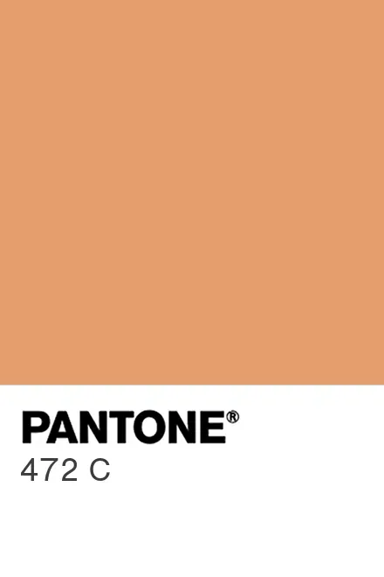
Frankefurter: Outside (472c) inside (698c)

Week 2
Week Two Measurements | Frankefurter A (control) | Orange A (control) | Frankefurter B (experiment) | Orange B (experiment)
Weight | 18.8g | 40g | 10.6g | 38g
Height | 16.54mm | 40.1mm | 13.71mm | 40.1mm
Width | 17.2mm | 28.5mm | 14.14mm | 27.03mm
Length | 75.6mm | 60mm | 66.9mm | 56.2mm

The measurements of week 2 compared to week 1 show that the controlled items without any salt have roughly stayed the same in every category, however the experimental foods have shrunk. The frankfurter shrinks a lot more compared to the orange. The texture is also quite different on each half compared to week one. Orange A, the control, has soggy edges and is beginning to rot around the flesh where it was cut in half. The flesh inside is slightly sticky to touch while the pith seems to be shrinking and pulling away from the flesh. The frankefurter A, the control, has produced a thick white liquid, presumably a fat substance, however the texture itself has not really changed from the original. Orange B, the experiment, is softer than the control however the flesh is in better condition and doesn't seem to be rotting as much. The salt is full of moisture and has hardened. Orange B also smells a lot less than orange A. Frankfurter B, the experiment, has noticeably shrunk and hardened while also feeling quite dry. The colour of B has also darkened compared to A.
Below are the colours that were recorded using the same method as week one, with each half now being recorded separately.
Orange A Control: Peel (1575c) Flesh (2013c) Pith (4201tcx)

Orange B Experiment: Peel (6018c) Flesh(1485c) Pith (134c) Moisture (6014)



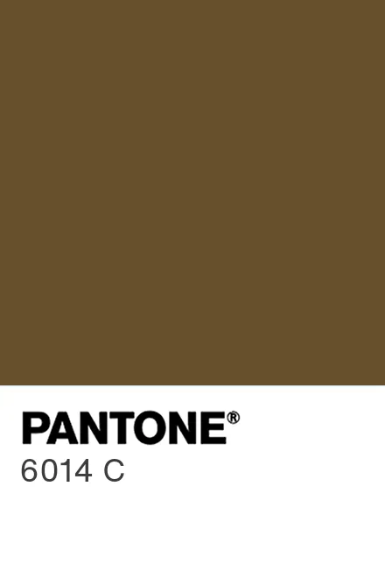

Frankefurter A Control: Outside (472) Inside (698c) Fat (4201tcx)

Frankefurter B Experiment: Outside (4271c) Inside (435c)

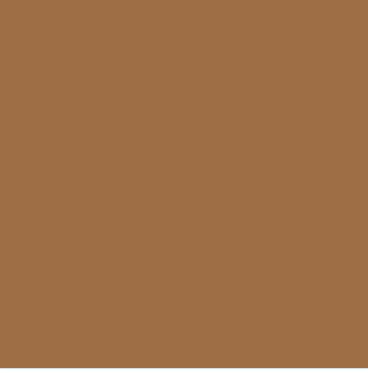

Week 3
Week Three Measurements | Frankefurter A (control) | Orange A (control) | Frankefurter B (experiment) | Orange B (experiment)
Weight | 18.0g | 39.4g | 10.8g | 32.1g
Height | 15.68mm | 37.7mm | 13.78mm | 37.37mm
Width | 17.02mm | 27.13mm | 14.44mm | 25.6mm
Length | 74.73mm | 58.46mm | 67.16mm | 57.08mm

The results of week three show little differences to the previous week. Most of the measurements have stayed the same. However the texture and colours of the materials compared to week two have changed quite a bit. The moisture around orange A (control) has grown, leaving the peel looking a lot darker than it was before, it was also still quite sticky to touch, with the bottom part continuing to harden. The pith has split from the fresh even more. Frankefurter A (Control) began to mold with black spots forming on the inside, the slimy residue is still present in the bag however seemed to be less than last week. The texture has changed and the frankefurter was very slimy and sticky, sticking to the bag quite a lot. Where the frankefurter had been cut, the skin seemed to be folding around the inside. Orange B (experiment) was nearly fully covered in moisture, with the bottom part remaining the original orange colour. The salt was full of liquid and had an orange tint to it, there were also some dark spots in the middle of the orange with the flesh shrinking even further away from the pith. Frankfurter B (experiment) skin hardened and became leathery in texture, the salt had also hardened around the frankfurter. The colours remained the same. (See appendix for colours of week 3.)

Discussion of results
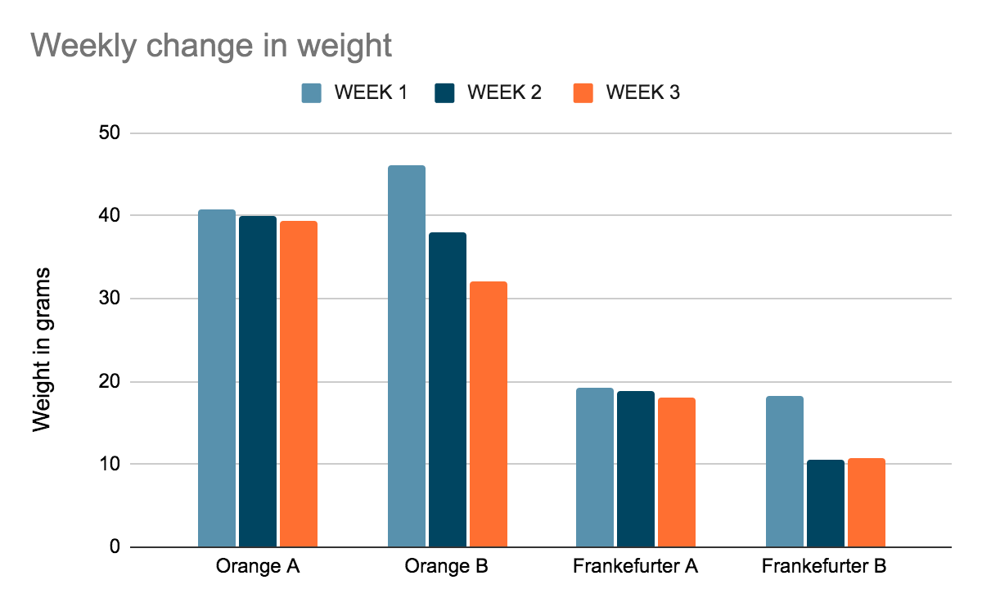
The graphs below display the changes made each week separated by weight, height, length and width. The graphs show that throughout the experiment the controlled materials that were not covered in salt stayed mostly the same in terms of these measurements. The experimental materials however changed slightly more, with the biggest jump in weight. A similar experiment that had taken place for the Clinical Anatomy book also observed the same changes. This experiment used organs and artificial natron to dehydrate them, during this process the scientists also ‘observed a considerable loss of weight and volume’. Just by observing frankfurter B we could see how much it had shrunk by week two, meaning the salt mixture was having an impact on the way the frankfurter was rotting. Shown further by the fact frankfurter A was beginning to grow mold by week 3 and producing a fat substance whereas frankfurter B continued to harden with no mold growing. The salt was removing the liquid and moisture from the frankfurter which slowed down the rotting process. This was also shown by the fact the salt had hardened into clumps, suggesting it had soaked up a lot of liquid. The salt mixture likely worked through osmosis, drawing the water out of the frankfurter, same with the orange, which slowed down the growth of bacteria and prevented decomposition. This process is similar to ancient Egyptian mummification, where a salt called natron was used to dehydrate the body. By removing moisture, the Egyptians prevented decay, similar to the way this experiment worked.
There were some limitations in the experiment, such as it taking place only over a short period of time, if it went on for longer more changes would have been visible. Furthermore environmental factors such as temperature and airflow could not be fully controlled, which could have influenced the rate of decay. The sample size was also small, and the structure of the orange and frankfurter is very different to human tissue, meaning these results are a very simple model of mummification. Unlike real mummification, internal parts were not removed so the salt may not have fully been able to reach all parts of the samples. To improve the experiment, a different variety of samples could have been used and more weeks could have been recorded. Overall, the experiment suggests that salt is an effective method of preservation, replicating ancient mummification techniques.
(For other graphs refer to the appendix.)

Conclusion
After three weeks in the salt mixture, both the orange and frankfurter showed signs of dehydration supporting the hypothesis. The salt drew out moisture from the materials which slowed down decomposition and caused them to shrink, more so the frankfurter than the orange which became dry and leathery, while the orange was still a little soft. This mirrors what happened in Egyptian mummification in a simpler form. The salt helped create an environment that was too dry for bacteria to grow therefore preventing decomposition and preserving the material for longer, shown by the fact the controlled items were beginning to mold whereas the ones with salt were not.

Reference list:
Egypt Museum. (N/A). The Mummification Process. [Online]. Egypt Museum. Available at: https://egypt-museum.com/the-mummification-process/ [Accessed 5 April 2026].

Pantone Colour Chart Online Available at:https://www.pantone.com/uk/en/color-finder

Öhrström L, Tekin A, Biedermann P, et al. Experimental mummification—In the tracks of the ancient Egyptians. Clin Anat. 2020;33:860–871. https://doi.org/10.1002/ca.23568

Appendix.
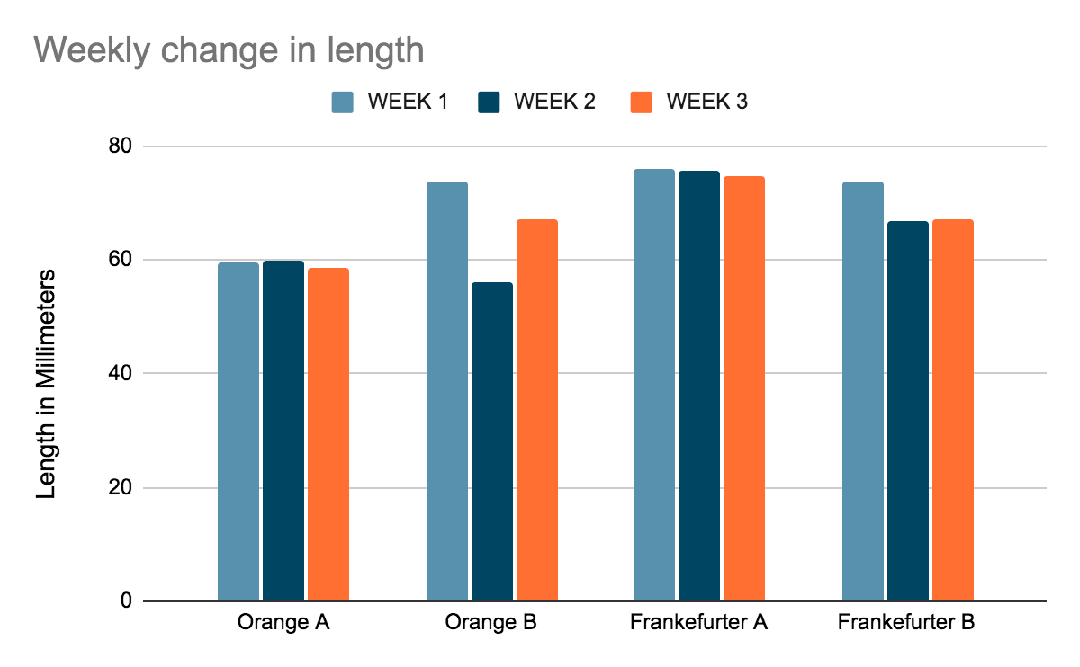
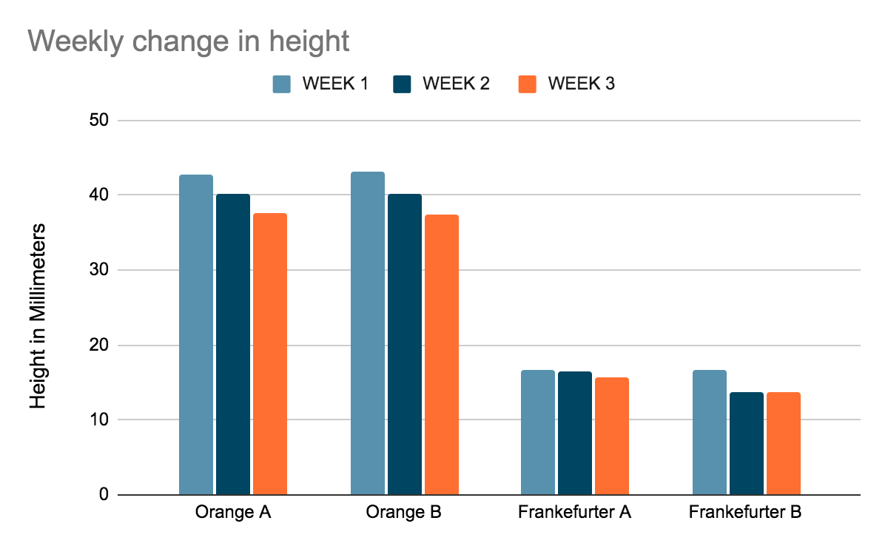

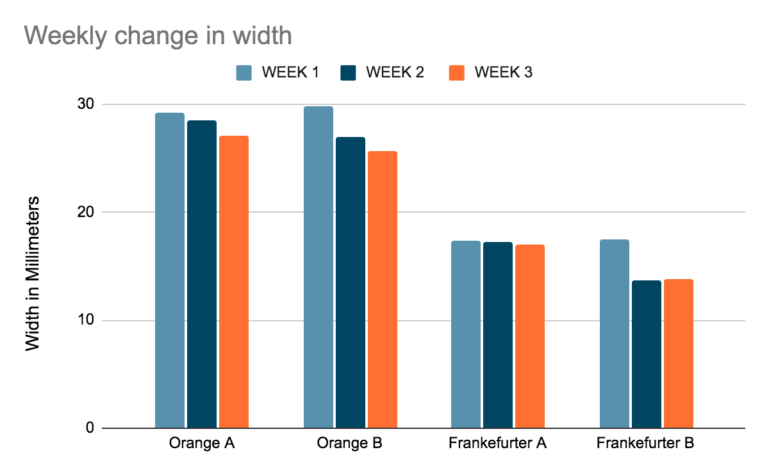

Week 3 colours:


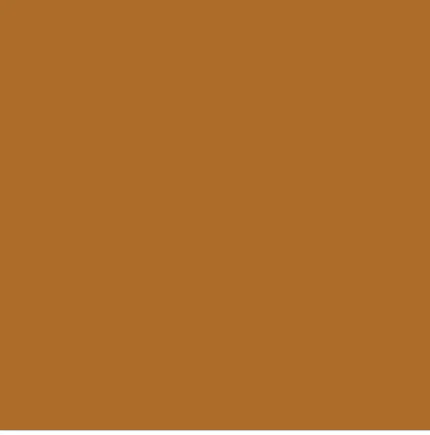
Orange A Control: Peel 18-1160tcx Flesh 2013c Pith 4201

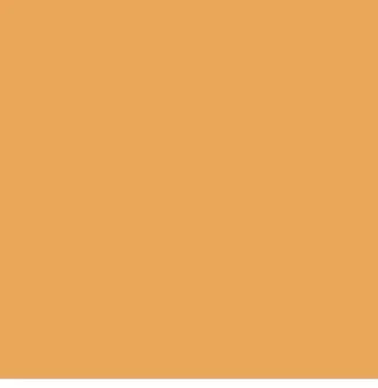

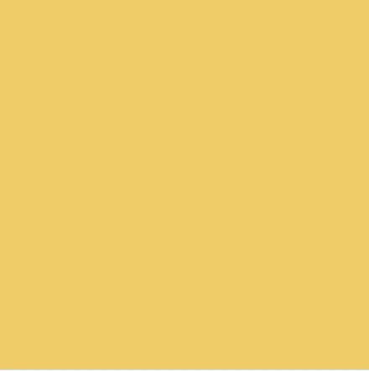
Orange B experiment: Peel 6018c Flesh 1485c pith 143c


Frankfurter A control: Inside 698c outside 472c mold spot 18-5913tcx

Frankfurter B Experiment: Inside 435c outside 4261c

https://www.pantone-colours.com/
Öhrström L, Tekin A, Biedermann P, et al. Experimental mummification—In the tracks of the ancient Egyptians. Clin Anat. 2020;33:860–871. https://doi.org/10.1002/ca.23568
Egypt Museum. (N/A). The Mummification Process. [Online]. Egypt Museum. Available at: https://egypt-museum.com/the-mummification-process/ [Accessed 5 April 2026].

