
Programme: Master of Business Administration
Module: Marketing management
Module Code: LCMB7024

Assignment Title: Portfolio: Brand development
Student Name: Jainil Kanubhai Patel
Student ID: 2519957
Group: 3

Lecturer: Dr Tola Odugbsesan

Poster
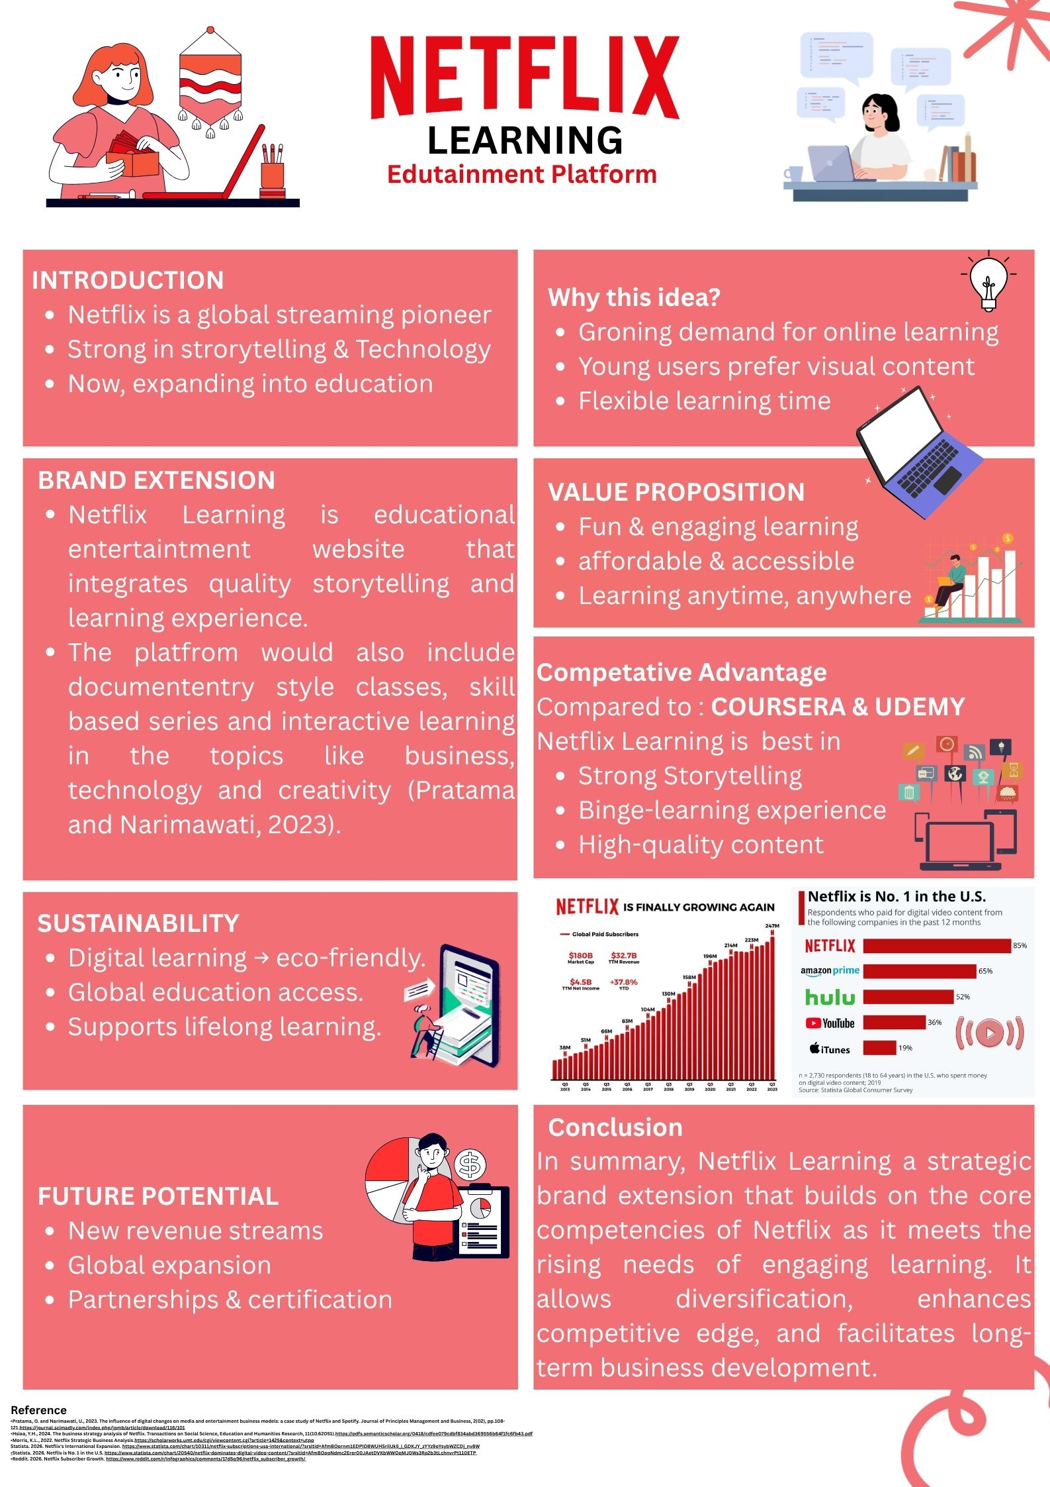

Reference
  - Pratama, O. and Narimawati, U., 2023. The influence of digital changes on media and entertainment business models: a case study of Netflix and Spotify. Journal of Principles Management and Business, 2(02), pp.108-121.https://journal.scimadly.com/index.php/jpmb/article/download/116/101
  - Hsiao, Y.H., 2024. The business strategy analysis of Netflix. Transactions on Social Science, Education and Humanities Research, 11(10.62051).https://pdfs.semanticscholar.org/0418/cdfee079cdbf834abd369556b64f1fc6fb43.pdf
  - Morris, K.L., 2022. Netflix Strategic Business Analysis.https://scholarworks.umt.edu/cgi/viewcontent.cgi?article=1425&context=utpp
  - Statista. 2026. Netflix is No. 1 in the U.S. https://www.statista.com/chart/20540/netflix-dominates-digital-video-content/?srsltid=AfmBOopNdmc2Erer00JAetDVKbWWOqMJ0Ws3Rp2b3tLchnvrPt110ETP
  - Reddit. 2026. Netflix Subscriber Growth. https://www.reddit.com/r/Infographics/comments/17d5q96/netflix_subscriber_growth/

