
This Photo by Unknown Author is licensed under CC BY-SA

MODULE CODE: BMSW4004
Title: Problem Solving and Decision Making
Student Name: Titilola Fadina
Student Number: 1913881
Lecturer Name: Hossein Shokri
Task 2 - Individual Report on Role Play

Table of Contents

Section 1: Introduction. 3
Section 2: Problem Definition 3
Section 3: Problem Analysis 3
Section 4: Alternative Solutions 4
Section 5 Evaluation of solutions Proferred 8
Section 6: Develop Implementation Plan 10
Section 7: Communicate the Plan to Stakeholders 11
Section 8: Assess Appropriate Monitoring and Review Techniques 12
Section 9: Conclusion ……………………………….. …………………………………………………………………………..13
Bibliography………………………………………………………………………………………………………………………...… 14

Section 1: Introduction. This report applies recognised problem-solving tools and techniques to an identified problem in the workplace including an evaluation of possible solutions. The identified work-place problem that was explored in the role play class exercise is bullying and harassment.
Section 2: Define a complex problem in the workplace including its scope and impact
Bullying and harassment is behaviour that makes someone feel intimidated or offended. Harassment is unlawful under the Equality Act 2010 whilst there is no legislation against bullying. Examples of bullying and harassing behaviour include spreading malicious rumours,
unfair treatment, picking on or regularly undermining someone, denying someone’s training or promotion opportunities. Bullying and harassment can happen face-to-face, by letter, email, or telephone. Using the fishbone diagram, the root cause of bullying and harassment in the workplace has been found to be poor work culture, lack of training and the effect has been low job satisfaction, demotivated staff and low productivity for the individual and the team. This in turn affects the productivity of the organisation. A high staff absenteeism and turnover is also an indication that there is low job satisfaction in the workplace, and this has cost implications around training and recruitment.
Cotton and Hart (2011) points out Organizational health research has shown that both positive emotional states (morale) and negative emotional states (distress) make independent contributions to overall levels of employee wellbeing and subsequently their productivity.
Levels of employee morale directly contribute to a range of people and performance-related outcomes including discretionary performance, aspects of task performance and a range of withdrawal and counterproductive behaviors. (Cotton and Hart, 2011)
Cotton and Hart (2011), suggests Positive psychology certainly have a significant impact in the corporate world. Across all industry sectors, leadership and organizational development programs have incorporated positive psychology concepts; ‘psychological wellness' is being increasingly accentuated in workplace wellbeing programs; and ‘stress management' training has long been overtaken by ‘resilience building' workshops.

Section 3: Analyse information on the identified problem, to help inform the decision-making process
Using the SWOT analysis tool:
- Strength is the ability of the organisation to recruit a consultant that can help to build a better workplace culture.
- Weakness is the lack of effective policies to address bullying and harassment in the workplace.
- Opportunity is for the organisation to put policies in place that address bullying and harassment in the workplace effectively.
- Threat is low job satisfaction, a high rate of staff absenteeism and turnover which in turn leads to the competition employing the dissatisfied staff. Also, there is a risk of increasing unemployment and mental health crisis.
Using the Isikawa Fishbone Analysis (adapted):

Using the PESTLE analysis tool:
- Political factors are the unemployment figures that could be generated because of high staff turnover and the consequent training costs.
- Economic factors are the reduction in revenue generated from PAYE in the economy due to increased unemployment and payment of statutory sick pay.
- Social factors are the social footprint; stress and consequent mental health deterioration that victims of bullying and harassment suffer which then impacts negatively on the community via breakdown of family relationships, pressure on the NHS mental health services which requires more funding. Cultural change that enforces the mental wellbeing of people should be put in place.
- Technology: Social media platforms should be monitored by menta health professionals and used to promote mental wellbeing in the society at large.
- Legal factor: Employment legislation protects rights of workers by setting up anti-discrimination and anti-harassment legislation.
- Environmental: There are no physical environmental factors to apply to this situation.
- Adapted Fishbone Diagram below:

Section 4: Propose a range of alternative solutions to the problem
According to ACAS, bullying and harassment in the workplace can be resolved in the following ways:
- Early conciliation: Employees have an informal chat with their employer first. An informal chat with their employer can range from a quiet word to a more structured meeting.
The employee should check their workplace grievance policy to find out the full grievance procedure. If there is no workplace grievance procedure, the employee should approach their line manager first. If they do not feel comfortable doing that, they should approach someone else they feel comfortable talking to e.g. another manager or someone in HR. Employees can also talk to their trade union, if they have one, for advice and support.

- Mediation at work: When there is a disagreement or dispute between two or more people or groups, an external organisation like ACAS can try to help both sides come to an agreement. Mediation cannot be used if a claim has been made, or could be made, to an employment tribunal about a dispute. Mediation is held by a neutral person. They are there to help both parties find a solution that all the parties agree to. Mediation is not judging who was right or wrong in the past but looks at how to agree on working together in the future. Mediation is quick, less formal, flexible, voluntary, confidential, and not legally binding.

- Collective conciliation: When there is a disagreement or dispute between an employer and a group of employees, an external body like ACAS can help both sides to try to come to an agreement and settle the dispute. Collective conciliation is held by a neutral person known as a conciliator. The conciliator will try to find common ground to help both sides find a way forward. Collective conciliation is free, voluntary, confidential and both sides can agree outcomes.

- Arbitration: When there is a disagreement or dispute between an employer and an employee or a group of employees, a third party can decide on the dispute to settle it. Both sides should try and work something out together or get help from an external body like ACAS. If this does not work, arbitration can help resolve the dispute.

Collective arbitration can be used for disputes between an employer and a group of employees. The arbitrator, (a neutral person), considers the arguments from both sides of the dispute and decides based on the evidence presented.
Before arbitration starts, both sides must agree to accept the arbitrator’s decision. They do this by setting out the issues in the dispute, called 'terms of reference', which both sides agree to and sign on an ACAS form. Collective arbitration is free, voluntary, confidential, and it brings the dispute to an end.

In addition to the resolution options above, there is the option of the organisation developing a positive work culture and training all line managers in positive psychology. As Cotton, (2012) points out, research suggests that leadership behavior and work-team climate impact greatly on workplace wellbeing and organizational performance.
According to Cotton and Hart (2011), increases in positive emotions have a more significant impact on employee wellbeing and a range of other people and performance-related outcomes than a comparable reduction in levels of employee negative emotions.
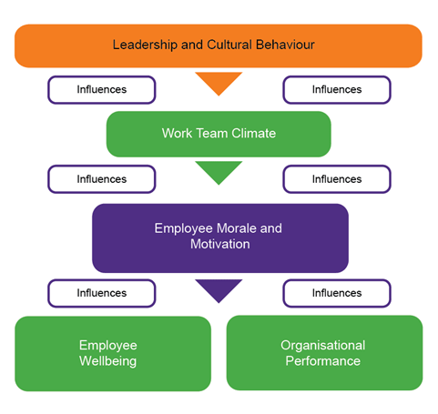
Cotton (2012) http://pimg.mhcc.org.au/images/c2.21a.gif

As Cotton (2012) points out, "empathy, clarity, engagement and learning" have been found to explain:
- 80% of employee motivation & wellbeing
- 25% of employee retention
- 15% of absence cost
- and organisational indicators (below)

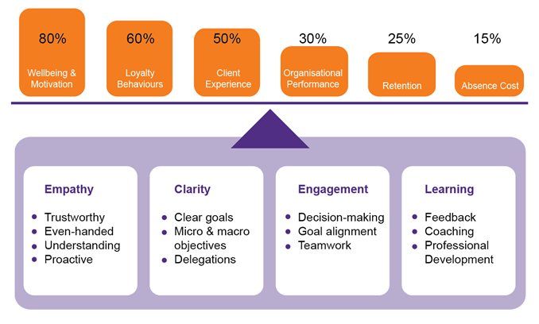
Cotton (2012) http://pimg.mhcc.org.au/images/c2.21b.gif
According to Cotton (2012), the type of leadership that produces high morale amongst their workforce is the supportive leadership. Supportive leadership is associated with:
- higher employee morale
- higher job satisfaction
- less employee suffering
- higher discretionary performance over the long term
- higher quality of work
- less employee withdrawal behaviours
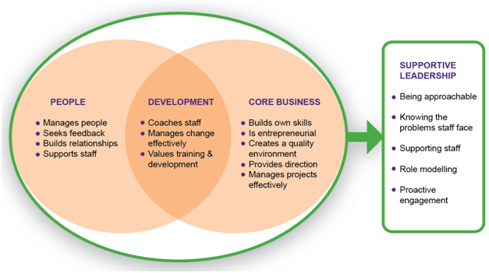
http://pimg.mhcc.org.au/images/c2.2.3a.gif

Section 5
4: Use a decision-making technique to evaluate a range of solutions to identify the most appropriate option
- PMI decision making tool
In “Tactics: The Art and Science of Success”, Edward de Bono (n.d) writes about using the PMI technique to improve your thinking. PMI (plus, minus, interesting) is a brainstorming, decision-making and critical thinking tool used to encourage the examination of ideas, concepts, and experiences from more than one perspective.
Simply put, the PMI tool weighs the pros and cons of a decision. The points in the plus column are simply the positive (pros), the points in the minus column are the negative (cons) and the points in the interesting column are neither negative nor positive but just interesting.
The decision that is being considered in the table below is the creation of anti-bullying and harassment policies and the creation of a workplace culture that discourages such behaviour. In addition to this decision is the enforcement of the policies by making managers responsible for the creation of a sustainable positive workplace culture by including accountability into the reporting of compliance by the line managers and senior managers.

Idea  - Create policies that address bullying and harassment clearly  - Consider the cause and effect of bullying on the individual and on the organisation  - Develop the process of training and accountability for managers  - Develop success criteria  - Monitor and control the culture creation process | Plus  Creates awareness of offensive behaviour  Addresses the issue of bullying directly  Makes the leadership responsible for the creation of culture  Accountability  Makes the people factor important | Minus  Sincerity of purpose is required  Will expose narcissist managers  Can be costly and time consuming  Useless without objectivity  Will succeed only if all are on board | Interesting  Call out attitudes and behaviours that are deemed to be offensive  There might be an attempt to cover up for bad managers  If not monitored will be of no use  Integrity is required  Sincerity required

Section 6: Develop a plan for implementing the solution
The ADKAR model of Change.
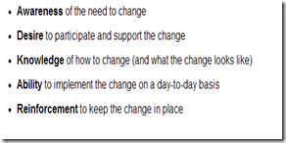
This Photo by Unknown Author is licensed under CC BY

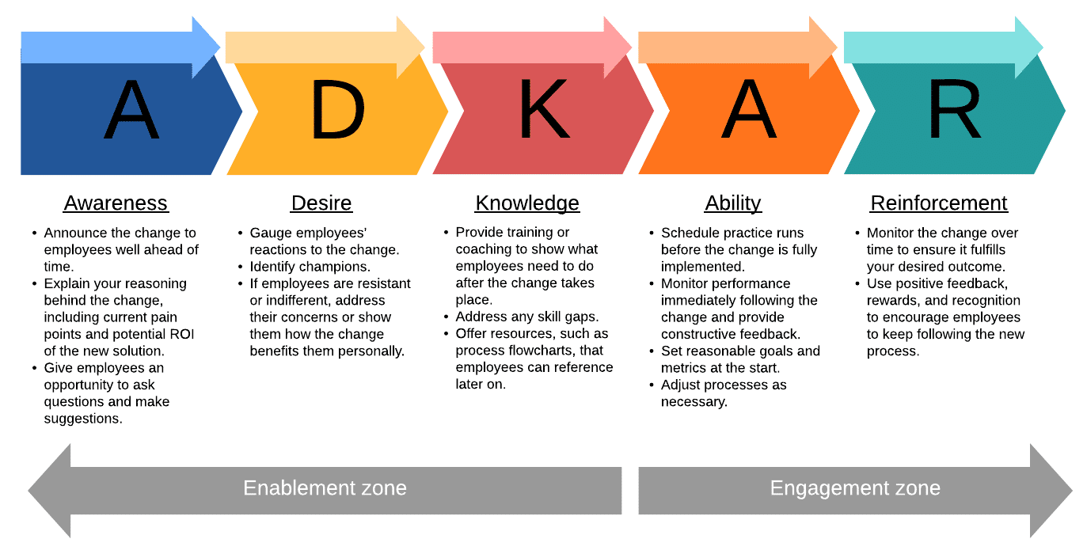
- Source: https://sergiocaredda.eu/wp-content/uploads/2020/03/adkar-change-model-overview.png

Section 7: Communicate the Plan to Stakeholders
Organisational Stakeholders:
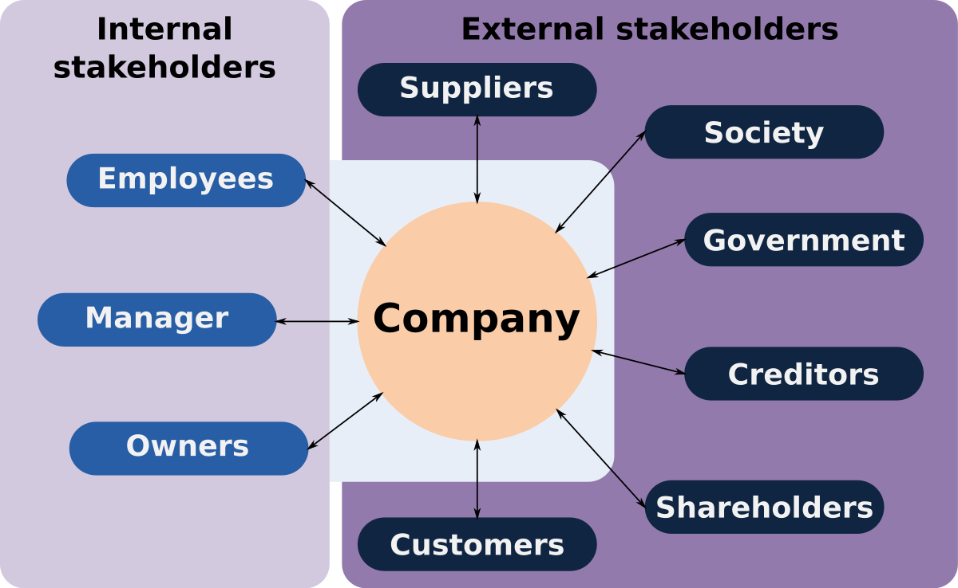
This Photo by Unknown Author is licensed under CC BY-SA
Stakeholder analysis map:
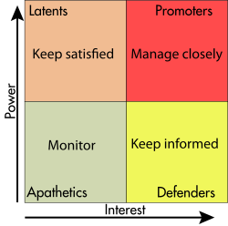
This Photo by Unknown Author is licensed under CC BY-SA

Internal Stakeholder Communication plan
Stakeholder | Power/Interest | Key Interest/ Issues | Communication medium |  | Frequency |  | comments
Owners | Keep satisfied | Reduce employee turnover | Email |  | Major Milestones only |  | Prefers to see final approved files only.
Senior Managers | promoters | Leadership training for all managers | Conference call and email | Weekly |  | Final approval on milestones, strategic direction if needed
Line Managers | monitor | Promote positive work culture | Conference call and email | Weekly |  | Ensure actionable items are monitored
Non- Managerial Staff | Keep informed | improvements in workplace culture | Face to face and email | Weekly |  | 360 degree feedback process in place

Section 8: Assess appropriate monitoring and review techniques to ensure successful implementation of the solution
Steps in the Organisational Change Process
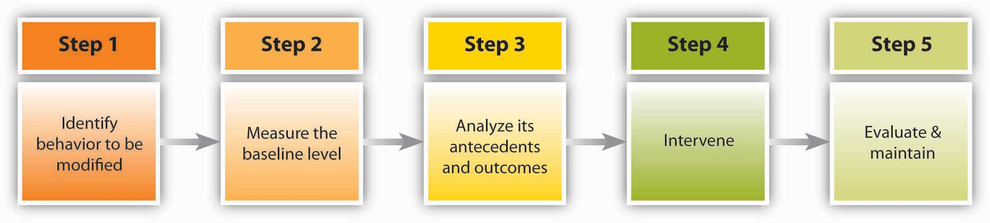
This Photo by Unknown Author is licensed under CC BY-SA-NC

Decision Implementation Plan
Action | Responsible | Priority | Status | Start Date | End Date | Notes
Design online anonymous survey covering the existing culture in the workplace | External Consultant | High | green | 04/01/21 | 31/01/21 | Deadline can be extended if response is not high enough
Leadership training for all managers as a continuous process | External Consultant | High | In pipeline | 01/02/2021 | 20/02/2021 | Appoint consultant to handle this. Cost must be within budget for approval.
Design new policies to change workplace culture and entrench in appraisal process for accountability and responsibility monitoring | External Consultant | High | In pipeline | 01/03/2021 | 30/03/2021 | Monitor appraisals and integration effort by the organisation using the 360 degree feedback system and total quality management concepts.

Section 9: Conclusion
After identifying bullying and harassment in the workplace as a problem, the fishbone diagram, SWOT and PESTLE analysis was applied, the PMI decision making technique was used to weigh and evaluate a range of solutions in order to identify the most appropriate option. The ADKAR model was used to develop an implementation plan with the control process steps in change management directing the flow. The outcome of the decision implementation plan is that an external consultant was hired to handle the change project for objectivity and monitoring.

Bibliography:
- ACAS https://www.acas.org.uk
- Carroll, A. and Buchholtz, A. (2015). Business & society. 9th ed. Stamford: Cengage Learning.
- Cotton, P. (2012). What is Good Work? http:// www.thinkers.sa.gov.au/lib/pdf/MartinSeligman/sowppts/BallC_1210_Cotton.pdf
- Cotton, P (2009). Current Issues in the Return to Work Management of Psychological Injury. www.workcover.com/documents.ashx?Id=1614&type=ppt
- Cotton, P. and Hart, P. (2011). Positive psychology in the workplace | APS. [online] Psychology.org.au. Available at: https://www.psychology.org.au/publications/inpsych/2011/april/cotton [Accessed 27 Jul. 2018].
- Jones, G. and George, J. (2007). Contemporary management. 5th ed. Boston: McGraw-Hill/Irwin.
- Maund, A., Schreik, M. and Tinkler, P. (2017). Certificate in higher education: Skills for the workplace student yearbook. london: london, pp.181-201.
- Prosci (2008) ADKAR: Introduction to Change Management
- Robbins, S. and Coulter, M. (2016). Management. 13th ed. Boston [etc.]: Pearson.
- Stevenson, W. (2009). Operations management. 9th ed. Boston: McGraw-Hill/Irwin.
- https://www.virtuallibrary.info/pmi-plus-minus-interesting-strategy
- https://sergiocaredda.eu/wp-content/uploads/2020/03/adkar-change-model-overview.png

