1. Viruses and Ransomware

1.1 What are they?
“Malware (a portmanteau for malicious software) is any software intentionally designed to cause damage to a computer, server, client, or computer network.[1] Malware does the damage after it is implanted or introduced in some way into a target's computer and can take the form of executable code, scripts, active content, and other software.^{[2] The code is described as} computer viruses, worms, Trojan horses, ransomware, spyware, adware, and scareware, among other terms. Malware has a malicious intent…” [1]
The general term covers viruses, spyware, trojans, worms etc.

1.2 Why does ransomware differ to a virus?
A virus:
“...a contagious piece of code that infects the other software on the host system and spreads itself once it is run. It is mostly known to spread when software is shared between computers. This acts more like a parasite.” [2]
Ransomware:
“...an advanced type of malware that restricts access to the computer system until the user pays a fee...The cybercriminal demands a ransom to be paid in order for the restriction to be removed. The infamous Cryptolocker is one type of ransomware.” [2]
Ransomware encrypts your files rather than damage the systems, and it does it quickly. Data from a test in 2016:

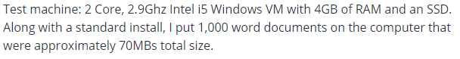
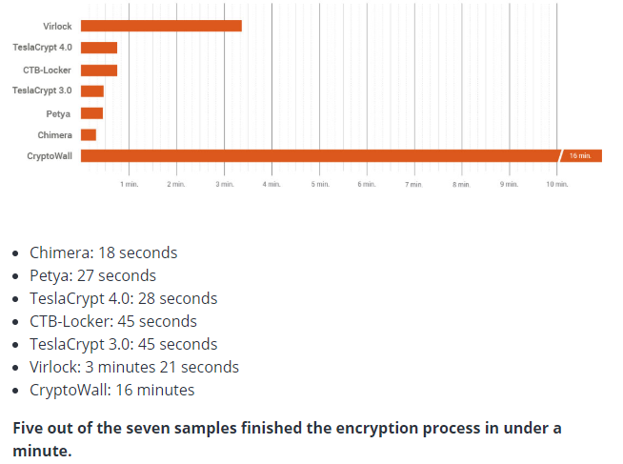 [3]
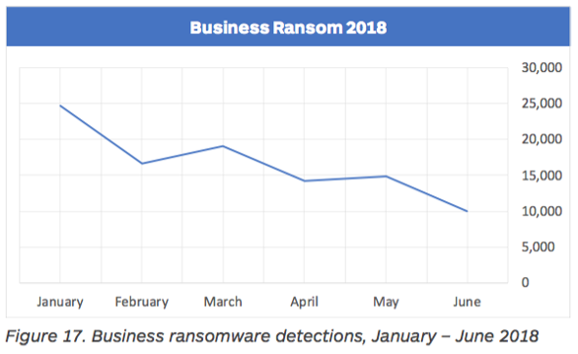 [4]

2. Cryptowall

2.1 What Cryptowall does to your data
There are several versions circulating, but all do the same thing – encrypt your data to such a high level that decryption is not possible unless you get the decryption key.
You will be offered the chance to get the key. A pop up or notepad appears on screen giving you information about what has happened and how to pay for the decryption key. Less than 20% of those that pay will receive the key.

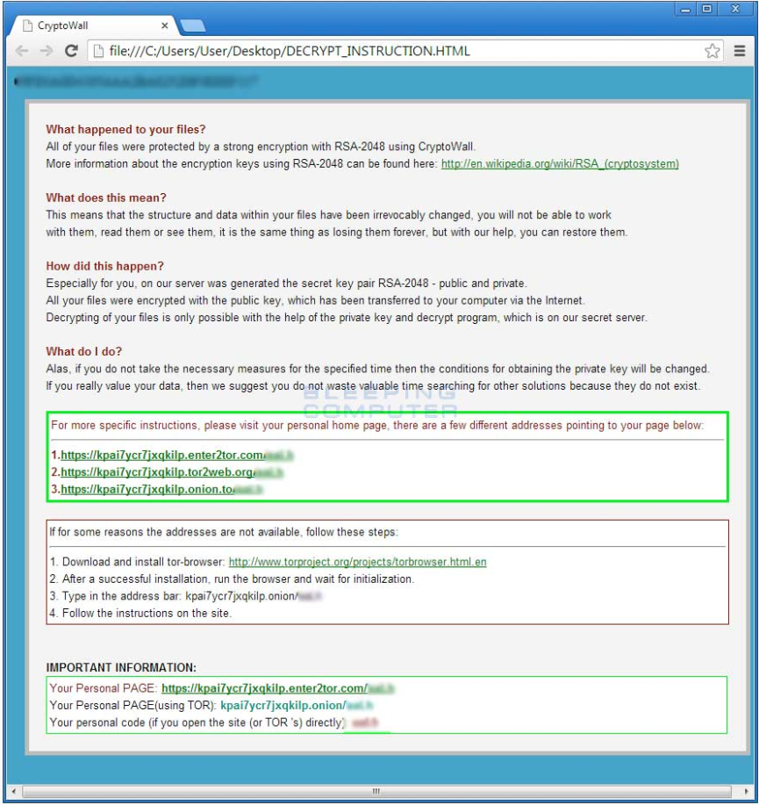 [5]

2.2 Why it’s so dangerous

“...according to the 2018 Verizon Data Breach Investigation Report, ransomware incidents now make up about 40% of all reported malware incidents! Some reports say CryptoWall 3.0 has caused over 325 million dollars in damages since it first came on the scene.” [6]
“CryptoWall is a particularly nasty form of ransomware. It does much more than just encrypt your files and prompt you to pay for the key: it tries to hide inside the OS and adds itself to the Startup folder. Worse still, CryptoWall deletes volume shadow copies of your files – making it difficult (or in some cases impossible) to restore your data. And while it’s there, it’ll try to get your passwords and Bitcoin wallets for good measure.” [6]
It can move quickly inside a network once it’s inside. Most business will have data on servers and NAS (network attached storage) boxes rather than PCs, and once it gets to a server it can move through ALL the data, and as tests have shown it does it fast.

3. Business Impact
Assuming all data is kept backed up the data loss is likely moderately small – the work done since last backup. If you have a solid back up strategy, such as ongoing incremental backups, the impact will be reduced. The downtime will be significant though. With servers and NAS offline in order to clear the malware and restore data, no one can work.
“...whether your business will be able to recover from the damage caused by the infection. Losing access to critical files and applications for any length of time is problematic, to say the least, and it’s estimated that less than half of all ransomware victims are able to fully recover after an attack.” [7]
Also consider your reputation as a business should you need to be offline.
You may even infect others. If a client’s network allows infection from your network, you will be remembered as the source.

4. How to prevent infection
As a business you already have a firewall and antivirus software. Ensure that the antivirus software also covers ransomware protection.
Keep all OS, firewalls and firmware up to date
Restrict user access to the minimum they need to do their job. Restrict web access, fileshare site access, USB drive use etc.
Many infections come from a link in an email. Educate employees – if they don’t know the sender or recognise the subject, treat the email as suspicious. If they don’t know the website, don’t visit it.
Restrict .exe use. Executables can install malware

Summary
It is easy to remain safe if you take appropriate steps as detailed above. Some steps may seem minor or inconvenient, but it’s when they are missed that the problems start.
Educate staff constantly – publish statistics and reports to them.
“As the old adage goes, "An ounce of prevention is worth a pound of cure" - Ben Franklin” [8]

References

[1] | “Wikipedia,” 20 12 2018. [Online]. Available: https://en.wikipedia.org/wiki/Malware. [Accessed 24 12 2018].
[2] | “Comodo Security Solutions,” 27 7 2018. [Online]. Available: https://antivirus.comodo.com/blog/computer-safety/malware-vs-viruses-whats-difference/. [Accessed 24 12 2018].
[3] | R. Correa, “Barkly,” April 2016. [Online]. Available: https://blog.barkly.com/how-fast-does-ransomware-encrypt-files. [Accessed 24 12 2018].
[4] | T. B. Team, “Barkly,” August 2018. [Online]. Available: https://blog.barkly.com/ransomware-statistics-2018. [Accessed 24 12 2018].
[5] | “Bleeping Computer,” 10 7 2014. [Online]. Available: https://www.bleepingcomputer.com/virus-removal/cryptowall-ransomware-information. [Accessed 24 12 2018].
[6] | “Varonis,” 1 6 2018. [Online]. Available: https://www.varonis.com/blog/cryptowall/. [Accessed 24 12 2018].
[7] | “Puryear IT,” [Online]. Available: https://www.puryear-it.com/what-is-the-financial-impact-of-a-ransomware-attack. [Accessed 24 12 2018].
[8] | “TechRepublic,” 21 10 2014. [Online]. Available: https://www.techrepublic.com/article/cryptowall-what-it-is-and-how-to-protect-your-systems/. [Accessed 24 12 2018].

