

From augmented reality for construction based on multiple sensory modalities to artificial intelligence within the design process. How does AI technology change the way we approach design?

School of Architecture, Built and Natural Environment
Course: BSc Architecture

Name: Clare Joe Padilla
Student Number: 1901439
Module code: M6X01986
Word count: 10,110
Date:



Author’s Declaration
I declare that the work in this dissertation was carried out in accordance with the regulations of the University of Wales, Trinity Saint David. The work is original except where indicated by special references in the text and no part of the dissertation has been submitted for any other degree.
Any views expressed in the dissertation are those of the author and in no way represent those of the University of Wales, Trinity Saint David.
The dissertation has not been presented to any other University for examination either in the United Kingdom or overseas.
I hereby give permission for my work, if accepted, to be available for photocopying and inter-library loan, and for the title and summary to be made available to outside organisations.

Signed: | Clare Joe Padilla
Date:

Copyright statement

The copyright of this dissertation rests with the University of Wales, Trinity Saint David. No information derived from this dissertation shall be published without the prior written consent of the University.

Signed: | Clare Joe Padilla
Date:

Abstract

Architects today should be knowledgeable about current legislation, ergonomics, and technology. Designing a space requires a keen appreciation of its quality and a high degree of creativity. As a result of the development of information technology, it is a profession that has seen major changes in recent years. Computer algorithms are generating such complex designs that some designers are starting to wonder if they are more the work of computers than of humans. Furthermore, there is increasing speculation about the possibility of humans becoming redundant as a result of software development.

A wide range of experts provide their opinions on the possibility that computer algorithms may replace architects. We ask: will computers eliminate the human factor in design? This study also considers the artificial intelligence or communication skills needed to achieve this goal. In addition to determining the future of architecture, these questions will provide insight into the profession’s current state. By examining the technologies that are enabling computers to replace many aspects of the human workforce, we will also gain a better understanding of how they work.

Acknowledgements

I would like to acknowledge and give my warmest thanks to my supervisor, Gavin Traylor who made this work possible. His guidance and advice carried me through most stages of writing my project. His dynamism, vision, sincerity, and motivation have deeply inspired me.
I am extremely grateful to my parents for their love, prayers, caring and sacrifices for educating and preparing me for my future. I also express my thanks to my sisters, brother and friends for their support and valuable prayers
Finally, I would like to thank God, for letting me through all the difficulties. I have experienced your guidance day by day. You are the one who let me finish my degree. I will keep on trusting you for my future.

Table of Contents
PAGE TITLE | PAGE NO
Author’s Declaration | 2
Copyright statement | 3
Abstract | 4
Acknowledgments | 5
List of Illustrations | 7
Introduction | 9
Aims and objectives | 10
Methodology | 11
Chapter 1: History and background of artificial intelligence | 13
Early adoption of technology | 14
Modularity | 16
Computational design | 18
Parametricism | 21
Artificial Intelligence | 24
Chapter 2: Artificial intelligence in architecture | 29
Alan Turing | 32
Artificial intelligence used in architecture practice | 34
Case studies | 41
Chapter 3: Analysis and comparison of case studies | 45
Conclusion | 54
Bibliography | 55
Appendix A: Questionnaire | 61

List of Illustrations
PAGE TITLE | PAGE NO
Figure 1: The Guggenheim Museum Bilbao, Frank Gehry. | 13
Figure 2: The Heydar Aliyev Centre, Zaha Hadid. | 13
Figure 3: Inventions & Innovations. | 15
Figure 4: The prototype of the Dymaxion House by Buckminster Fuller. | 17
Figure 5: Design concept drawing of the Dymaxion House. | 17
Figure 6: Design Thinking ideology. | 19
Figure 7: Kartal Masterplan, Zaha Hadid Architects. The Kartal masterplan is a 2006 winning competition proposal for a new civic, residential , commercial and transport hub approximately 25 km to the southeast of the city. | 22
Figure 8: Artificial Intelligence, which involves having a computer do something we assume only entities with human-like intelligence could do. Machine learning, which involves AI in which the computer learns how to perform a particular task. Deep learning in machine learning “technique or algorithm for learning a pattern”. | 25
Figure 9: ‘FREDDY’ The original Freddy was created in the early 1970s by researchers at the University of Edinburgh’s Department of Artificial Intelligence. Freddy the robot was the first robot to combine vision and touch through AI. | 27
Figure 10: The Turing test in 1950. | 33
Figure 11: The Foster + Partners archive holds all the studio’s many thousands of previous drawings, models, slides and photographs, publications, awards, and other practice-related ephemera. Their digitalised image server contains over 600,000 files. | 35
Figure 12: The left side shows a laminate in its initial state (above) that is then encoded into grey-scale image (below). The right shows the same laminate in the deformed state (after running a non-linear structural analysis) and its encoding to a depth map. The different colours illustrate how much each part of the laminate was deformed. | 37
Figure 13: The images show how the system has learnt to predict the correct material layering pattern that would produce each desired depth map (or material in its deformed state). The left column shows the required depth maps that were presented to the system. The right column is the target layering required. In-between we see the system progressing towards the target. | 37
Figure 14: It demonstrates a comparison between an arbitrary designed laminate in a set deformed state, and the result of an original non-linear analysis run on the laminate’s initial state, as predicted from the set deformation. Those two deformations are not identical but close enough to prove the effectiveness of this approach and system’s ability to generalise. | 37
Figure 15: A still taken from a custom, interactive design assistant application, into which the trained neural network is embedded. | 37
Figure 16: A material with the desired deformed states on the left, is inputted into the trained neural network (centre) and the required material cut-out pattern is provided by the system on the right. This is the reverse of how the problem was initially conceived, where the diagram shows how an inverse problem is solved after the training has finished. | 37
Figure 17: The top row of images shows a sample of the floor plan outputs from the parametric model, showing three compartmentalised (left) and three open plan workspaces (right) The middle row visualises the output of the spatial connectivity analysis on these floor plans, and the bottom row shoes the visual connectivity analysis. | 39
Figure 18: A series of stills showing the model’s floorplan analysis. In In each frame, the left-hand floor plan shows correct (and pre-known) output of connectivity analysis on the plan. While the central animation (showing the same floor plan) is the model’s steadily improving predictions of this analysis as it trains. By the end of the animation (bottom right), it matches the correct analysis shown in the left-hand plan. The right-hand plan illustrates the difference between the two, darkening as the model’s prediction gets closer to reality. | 40
Figure 19: Yokohama International Port terminal. | 41
Figure 20: Guggenheim Museum. | 42
Figure 21: Physical models for the Embryological House. | 42
Figure 22: What do you understand by the term ‘artificial intelligence’ in architecture? | 46
Figure 23: What is your experience with artificial intelligence? | 46
Figure 24: What is your opinion on using artificial intelligence in architecture? | 46
Figure 25: How would you define ‘Architecture’? | 47
Figure 26: Do you think the social value in architecture is important? If so, why? | 48
Figure 27: What do you understand by the role of architecture in today’s society? | 49
Figure 28: Is AI just a tool that can technical problems or a potential to change the way we design architecture in the near future? | 50
Figure 29: Do you think AI can replace in the near future? | 51
Figure 30: In terms of creative thinking, will AI enhance or limit the design process in architecture? | 51

Introduction

The technology advancement in our generation is everywhere, from the infrastructure we use to investigate the workers to the objects we use to communicate. Digital tools have given architects and designers great opportunities to communicate their work to a larger audience internationally, especially during COVID 19; sharing new techniques utilising them has enabled the possibilities of design techniques and processes to a much wider group.

This research aims to describe how the innovations in digital technology for design and fabrication have contributed to our daily lives as architects. It is essential to note the history of architecture and design, including architects and thinkers as references who are continually working within digital design and fabrication in architectural research, therefore understanding the state of digital design today and future trends.

Aims and objectives
Aim 1 – Investigate the history and background of Artificial Intelligence

Objective 1.1 – What was architecture before AI?
Objective 1.2 – What type of AI is used in architecture?
Objective 1.3 – Explore the progressive adaptation of technological solutions.

Aim 2 – Does Artificial Intelligence enhance or limit the design process in Architecture?

Objective 2.1 – Investigate the relationship between AI and architects?
Objective 2.2 – Can AI replace the creative factor in architecture?
Objective 2.3 – Explore case studies that use AI technology in their architectural firm, big and small practices such as Foster & Partner and Frank Gehry.

Aim 3 – Is AI just a method that can solve technical problems, or can we foresee their potential to change the way we design architecture in the future?

Objective 3.1 – How will AI develop in the future, in terms of the systems gaining technical and ethnical knowledge and experiences of an architect?
Objective 3.2 – is AI seen as a threat, or an opportunity to explore new ideas, enhance creativity, and constantly optimising and pushing boundaries of our designs.
Objective 3.3 – Will it change the definition architecture?

Methodology
Literature review – using literature to find out the history of AI technology and how it has evolved since technology has been introduced in the industry, using a mixture of primary and secondary research to support facts, as well as online research. In other words, how technology is revolutionising architectural design.

Case study – a primary research method to research of Foster + Partners and Frank Gehry work, which supports how AI technology define the terminology of architecture.

Questionnaire – A secondary research method includes a short questionnaire distributed to the industry about how they feel digital tools have changed the way we design and build as architects.

Chapter 1: History and background of artificial intelligence

Architecture can be described as the built realisation of a particular concept. This can be seen in “construction, or the way people will use a building, or how the building fits into a physical, or social environment.” The balanced integration of artistic sensibility and scientific methodology applied to designing buildings and their environment is essential to creating great architecture. We are affected on both a practical and emotional level by how a building appears in its context and interior environment.

“But what is ‘Architecture’?”
Undoubtedly, this has become an increasingly important question for students searching for different perspectives on architecture as they develop their definitions and career paths. Architecture exists everywhere and at its roots to create the physical environment; it is also a part of our culture, representing how we see ourselves and how we see the world.

Before defining ‘architecture’, the term has a two-part definition of ‘designing’ (art) and ‘engineering’ (science), which must be made clear. ‘Designing’ allows us to provide an outlet for creative expression and society to uniquely view, create, and shape their environment and living space. We value this as architects because it becomes a permanent expression of social values, desires, ways of thinking and ideology and many other things at a fixed point in time. Architecture takes imagination and empathy, the ability to order ideas and communicate them clearly and creatively, with a keen interest in human behaviour, our habitat and the natural environment and problem-solving skills.

Concerning the terms science and engineering, it covers our functional needs, which provides us with a living space and environment that is both practical and comfortable. Architects use scientific methods to research and develop concepts on numerous levels to create buildings. These levels include understanding the surrounding context from environmental, historical, stylistic and infrastructure perspectives and determining program areas required for users such as interior products, structure, mechanical, electrical, plumbing, fire protection, technological and security systems.

Architecture can also create tiny time capsule of human history, revealing human thoughts, and ideas. It reflects our culture, who we are and where we belong within the society.
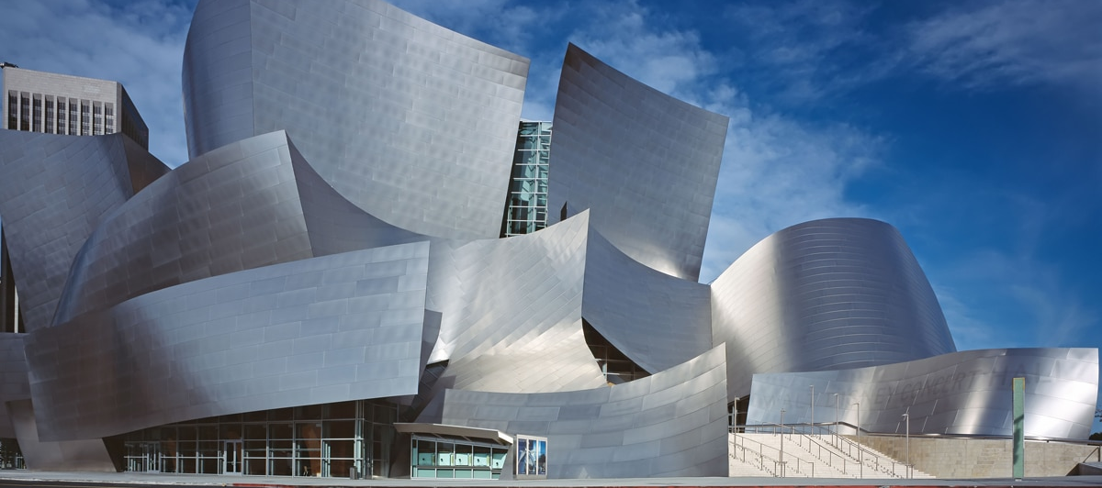
Figure 1: The Guggenheim Museum Bilbao, Frank Gehry.
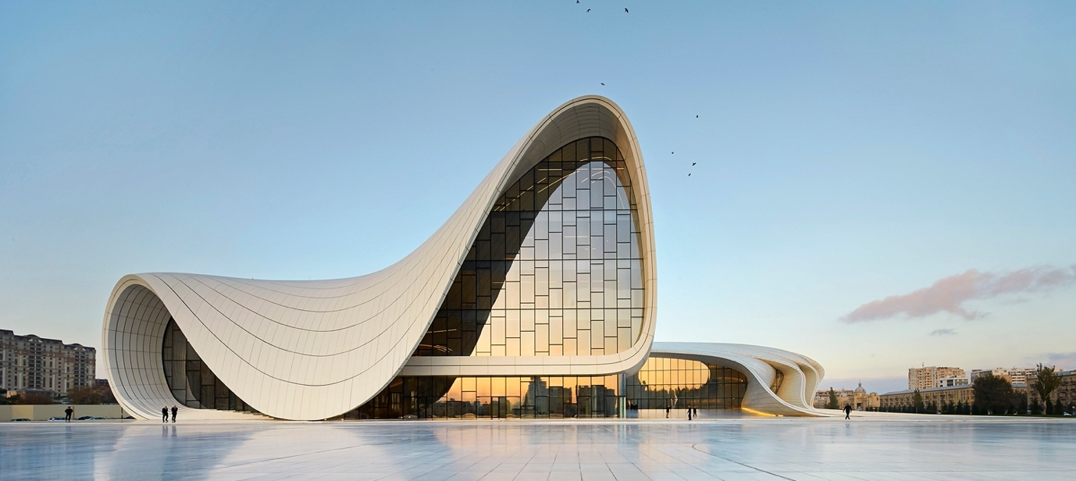
Figure 2: The Heydar Aliyev Centre, Zaha Hadid.

Early adoption of technology

The use of technology in architecture is highly utilised to automate repetitive tasks and increase efficiency. For instance, using blueprints to produce copies of hand drawings was one of the first methods of communicating design between disciplines (e.g., from architects to builders working on the construction site). Furthermore, advancements in desktop computing have led to computer-aided software such as AutoCAD and Revit to become a viable production method in architecture offices, eventually replacing the process of physical hand drafting.

Chaillou (2020) suggests that the advent of technology in Architecture can be defined in four periods: modularity, computational design, parametricism, and artificial intelligence, as shown in figure 3. These reflect the chronology of the progress which has been shaping and refining architectural means and methods. Each period aims to show the deeply interwoven evolutions of the computational and the architectural fields before introducing the age of Architecture and Artificial intelligence.

Figure 3: Inventions & Innovations.

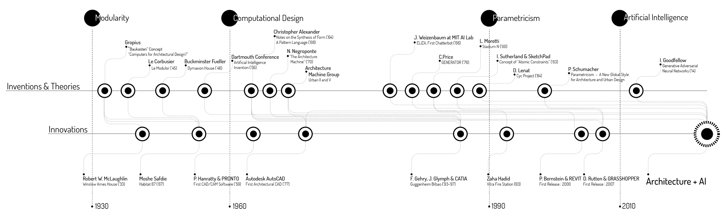

Modularity (1930s)

“Modularity in design’ can be set as a starting point of a systematic architectural design initiated in the early 1930s. The modular construction brought both a language and an architectural grammar to the conception phase, simplifying and rationalising building design. Since its initiation, modularity in construction has proven to be a highly constraining system with limited options for potential designs. Nevertheless, such options quickly met construction feasibility criteria, and their architectural quality was questioned early on. With this design approach, a system is divided into smaller parts called modules or skids that can be independently created and used in different systems. A modular system is characterised by functional partitioning into discrete scalable and reusable modules rigorous use of well-defined modular interfaces.

An example of this approach was shown in the 1920s and 1930s, during the Great Depression and the Inter-war period through the work of Buckminster Fuller. Many lacked the money to invest in new homes. Fortunately, Fuller knew the war would create demand for his design to become more simplifies, cheap, and temporary. Fuller was determined to design a sustainable and inexpensive concept. He incorporates many inventive features into his pods, including a compost-based methane heating system, a wind power generator, and a recirculating greywater plumbing system. By applying a modular design approach, Fuller was able to keep costs down by creating an assembly line home. The triangular panels were used to construct the roof, floor, and walls. Aside from the central mast, every single piece of the kit was light enough to carry, which would be easily transported onto the site. (As shown in in figure 4 and 5)

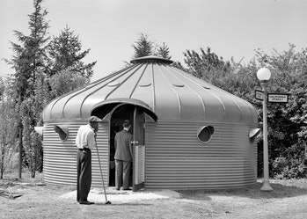

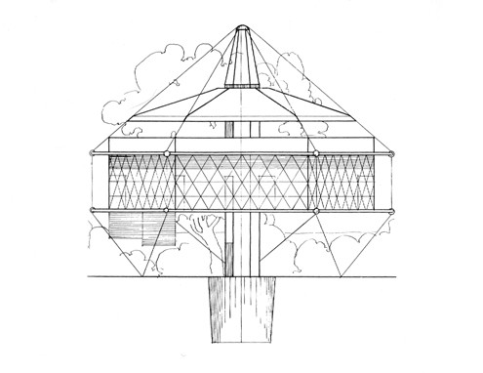

Figure 4: The prototype of the Dymaxion House by Buckminster Fuller.
Figure 5: Design concept drawing of the Dymaxion House.

With modularity, you can achieve a variety of designs while achieving low development costs and cost-saving in the design and construction process. As a result, you find that modularity is “pushing out the productivity frontier in design creation” (McCluskey, 2000). On the contrary, modularity may lead to excess cost due to over-design, inefficient performance, and too many standard modules to lose design identity.

Computational design (1960s)

As the complexity of modular systems soared, the dawn of computation brought back feasibility and scalability to the modular. “Beyond the resurrection of the module, the systematicity of rule-based design was somehow rehabilitated.” The designer can finally escape the grid’s rigidity to design feasible buildings with actual singularity with computational design. Moreover, it allows the software to solve such complex shapes, which would help drive down conception costs and generate more design iterations.

Computational design is a way of solving design problems by applying computational strategies. While designers typically use intuition and experience to make decisions, the computational design enhances the process by encoding the decisions in a computer language. A designer’s approach to solving problems is called design thinking, which is a human-centred, prototyping-driven, iterative problem-solving method. In order for computational tools to help enhance design thinking, it would need to go through the following modes: empathise, define, ideate, prototype and test. For example, an architect would gain empathy for the client they are designing for to identify their latent needs, and then redefines and scopes the problem, generating multiple design ideas and then creates experiential prototypes to test with the client. As a result, providing new avenues to iterate upon the solutions or on the problem itself.

“Notes on the Synthesis of Form”
Christopher Alexander

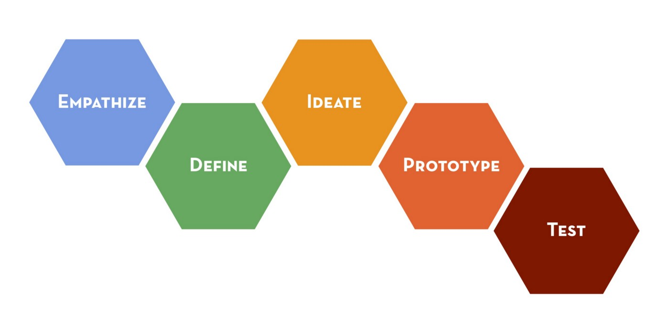
This is a study based on how designs are formed and how those forms are adapted to real-world problems. Design borrows elements from both art and science, but in reality, it is unique and distinct from both. The design output is neither a statement of truth nor a philosophical exercise in communication through aesthetics. Instead, design is a pursuit of what it could be. The common themes in design thinking are shown in figure 6.
Figure 6: Design Thinking ideology.
Alexander (1964) states that “every design begins with an effort to achieve fitness between two entities: the form and its context. The form is the solution to the problem; the context defines the problem.”

Architects are tasked designing buildings, and in doing so, they must consider the building as the ‘form’ and the environment where it will be used as the ‘context’. As Alexander describe how forms are shaped by forces in the context, he uses the analogy of iron filings in a magnetic field. Depending on the direction of the field; the context, the filings arrange themselves in a certain way, which results in the form. However, he notes that it is not always straightforward because we do not know the direction of the field. In other words, a successful design depends on how well a form fits the context, not just the form itself. And when Alexander describes an ensemble as having a ‘good fit’ when it is working well.

“Good fit is a desired property of the ensemble which relates to some particular division of the ensemble into form and context.” (Alexander, 1964) Studying the context results to finding misfits in the system. For example, a designer could decide that a kettle is the wrong way to heat water, then starts to work on a different part of the ensemble. This happens when a designer is sensitive to fit in several boundaries within the ensemble at once.

Alexander illustrated the failure of contemporary methods to consider the requirements and conditions that surround their development. He further argues that contemporary methods fail to produce products the meet the precise requirements placed upon them by individuals and society, meet user’s needs, and respond to the basic requirement that design and engineering need to improve the human condition. Although architectural artefacts exemplify Alexander’s arguments and methods, his concerns and methods apply just as well to software systems, subsystems, objects, etc. At this level of discussion, there are obvious differences between houses and software. For example: software entities engage in greater dynamic interaction (e.g., sending messages to each other). In some cases, describing software is the same as creating it (as with programming). Also, users are unaware of how a software is designed, this is because software is usually less physically constrained. Software requirements are allegedly more precise and explicit than building a house.

Computational design tools enable designers to utilise the power of computation without having to learn complicated algorithms. In addition, these tools allow architects and designers to create their tools. For example, computational design allows a rigours control of geometry, which boosts the design’s reliability, feasibility, and costs. It also facilitates and eases collaboration between designers. And lastly it enables more design iterations than traditional hand-sketching could afford. As a result, more tests are done for better designs.

Parametricism (1990s)

What’s old is new again.” This phrase has its place in ‘Architecture’. Parametric tools use algorithms that make it easier to produce intricate designs. Design teams can devise sets of parameters before experimentation. Both repetitive tasks and complex shapes could be tackled in parameters when rationing to simple sets of rules. By encoding the rules on the program, it would eliminate the time-consuming manual process.

“Parametricism: A new Global Style for Architecture and Urban Design”
Patrik Schumacher

Samuel Geisberg described the parametric ideal as “the goal is to create a system that would be flexible enough to encourage the engineer to easily consider a variety of designs. And the cost of making designs. And the cost of making design changes to be as close to zero as possible.”

Architects were becoming more and more able to manipulate their design by utilising parameters, and the discipline “slowly converged” to parametricism, according to P. Schumacher. In his article in 2009, Schumacher highlights how Parametricism was inspired by a growing understanding of parameters within architecture. There are a few key individuals who have shaped the arrival of parametricism, from their invention to their translation into innovations throughout the industry. Zaha Hadid Architect’s work is the best example to start in terms of parametrisation. As an Iraqi architect with a background in mathematics, Hadid began her practice with the intention of using maths in architecture through parametric design. Using rules encoded in the program, Hadid was able to take control of the geometry of her buildings to an unprecedented degree. As a result, each architectural move corresponds to a particular tuning of the parameters, resulting in a certain building shape.

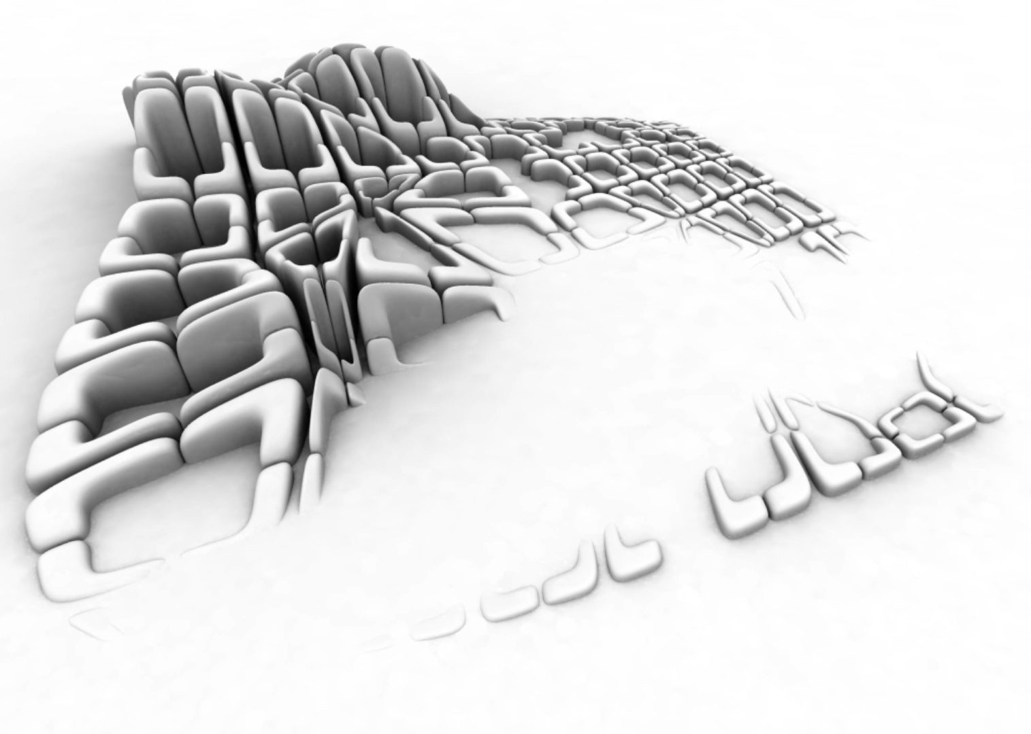
Figure 7: Kartal Masterplan, Zaha Hadid Architects. The Kartal masterplan is a 2006 winning competition proposal for a new civic, residential , commercial and transport hub approximately 25 km to the southeast of the city.

One of the examples that Schumacher uses to explain how Hadid used Parametricism in her designs is the Kartal Masterplan. A fabric study where both perimeter and cross towers make up the urban fabric. Figure 7 illustrates how the parameter blocks vary in morphology. And secondary pedestrian paths are created by dividing blocks into four quadrants. In addition, there are specific network crossing points where the block system becomes assimilated to the tower system: each block sponsors one quadrant around a crossing point to form a pseudo-tower.

Parametricism brought even more control over organic shapes through testing. Moreover, by standardising their geometry, entire buildings could be discretised into buildable elements and resolved assembly systems. However, the parametric style got rapidly trivialised, generating generic and repetitive patterns of spaces leading to poor architectural quality. This is because parametric has failed to consider the compound effect of multiple variables, the importance of spatial organisation and style over strict efficiency, the viability of scenarios, and the computational costs of simulation.

Artificial Intelligence (2010s)

In its simplest form, artificial intelligence is a statistical approach to Architecture. By combining statistical principles with computations, artificial intelligence provides a new approach that overcomes the shortcomings of parametric architecture. In the end, artificial intelligence has become a viable alternative to parametricism legibility and generic style, while obtaining all of the benefits of previous generations. Introducing it, marks the arrival of a new era in Architecture and, to architects, a step towards a better quality in design.

“What is Artificial Intelligence”
A major technological breakthrough of the digital age is artificial intelligence, which aims to mimic human intelligence on machines to behave and think like humans. It refers to the ability of a computer or computer-controlled robot to perform tasks commonly associated with intelligent beings. For example, artificial intelligence could emulate human cognitive processes, such as reasoning, discovering meaning, generalising, or learning from experience.

As a result of the advent of modern technology in the 1940s, computers have demonstrated their ability to perform many complex tasks, such as discovering proofs or playing chess. Additionally, some software programs have attained the level of performance of human professionals or experts in performing a specific task. Therefore, artificial intelligence in this limited sense can be found in medical diagnosis, computer search engines, and voice recognition.

The common themes in artificial intelligence
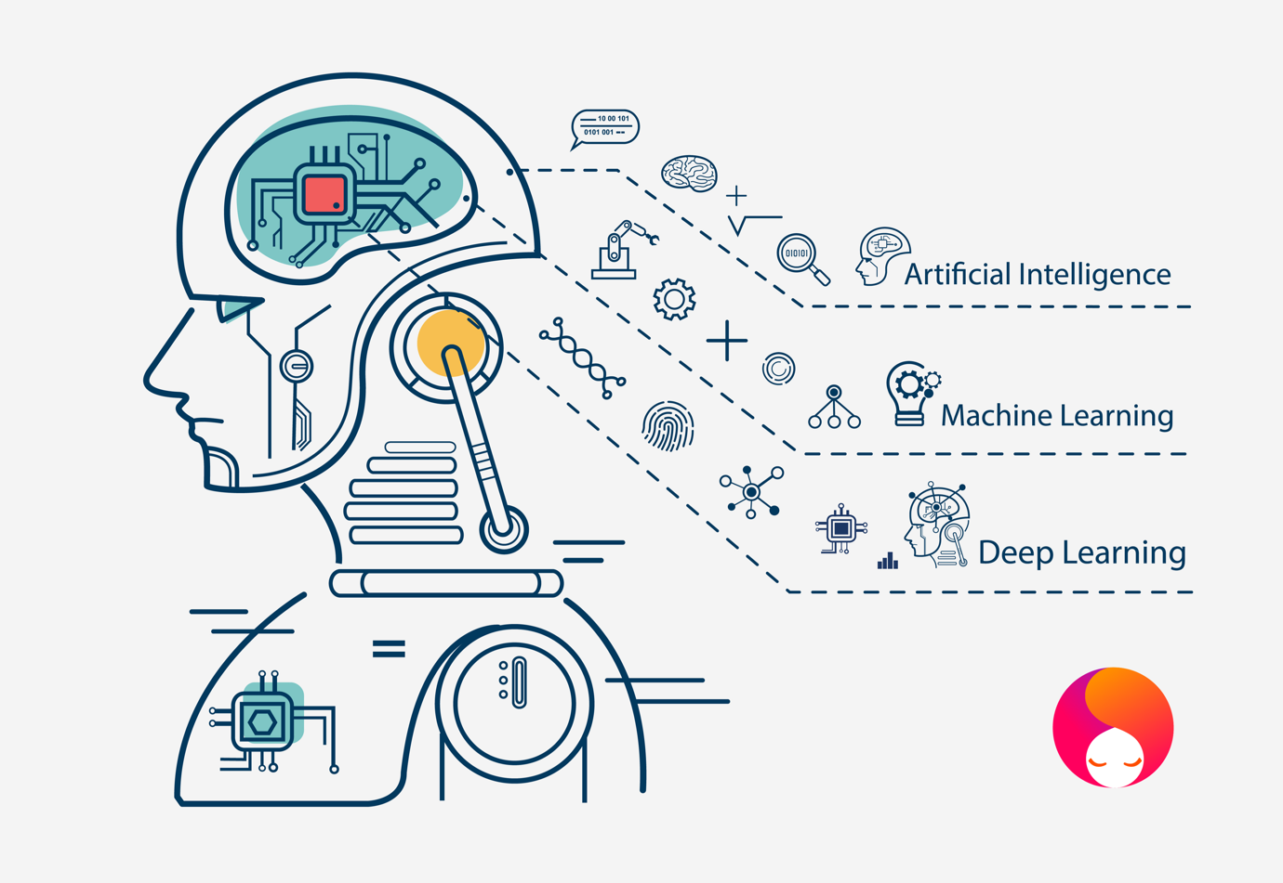
Research in artificial intelligence has focused on the following components of intelligence: learning, reasoning, problem solving, perception, and using language.

Figure 8: Artificial Intelligence, which involves having a computer do something we assume only entities with human-like intelligence could do. Machine learning, which involves AI in which the computer learns how to perform a particular task. Deep learning in machine learning “technique or algorithm for learning a pattern”.

Learning
There are a few different forms of learning as applied to artificial intelligence, learning through trial and error. For instance, a single computer program might look for a solution to a mate-in-one chess problem by playing moves at random. The program might then store a solution with the position. The next time the computer encountered the same position, it would recall the solution by memorising individual items and procedures known as rote learning, which relatively easy to implement on a computer. In other words, artificial intelligence requires a learning process of trial and error. Furthermore, once trained, the machine should be able to perform tasks independently, without the need for instructions, by using a memorisation technique based on repetition.

The problem with implementing is that it involves generalisation when applying experience to analogous new situations. For example, a program that learns the past tense of a regular verb through rote learning, will not produce the past tense of a word such as jump unless it is previously presented with jumping. In contrast, a program that can be generalised can be generalised can result in learning to “add ed” rule, and so it forms the past tense of jump based on experience with similar verbs.

Reasoning
In order to reason, it is draw inferenced appropriate to the situation. The inferences are classified as either deductive or inductive. The conclusions are guaranteed to be accurate using deductive reasoning if the premises are true. In contrast, inductive reasoning means that the truth of the premise supports the conclusion but does not provide a guarantee. A standard method of reasoning in science is inductive reasoning, which involves collecting data and developing models that describe and predict future behaviour until anomalous data force the model to be revised. Mathematics and logic provide elaborate structure for deductive reasoning, where elaborate structures of irrefutable theorems are built up from a small set of basic axioms and rules.

Problem solving
It is characterised as a systematic search through a range of possible actions to reach some predefined goal or solution. This method can be divided into specific purposes and general purposes. The special-purpose method exploits feature of the specific situation in which the problem occurs and is explicitly designer to solve it. One general-purpose technique used in artificial intelligence is a means-end analysis, in other words, a step-by-step or a reduction of the difference between the current state and the final goal. The program selects actions from a list of means: pick up, put down, move forward, move back, move left, and move right.

Perception
The environment is scanned by various sensory organs, natural or artificial, and the scene is decomposed into a separate object in various spatial relationships. In this case, the analysis is complicated since an object may appear differently depending on the angle from which it is viewed, the direction and intensity of illumination in the scene, and how much the object contrast with the surrounding area.

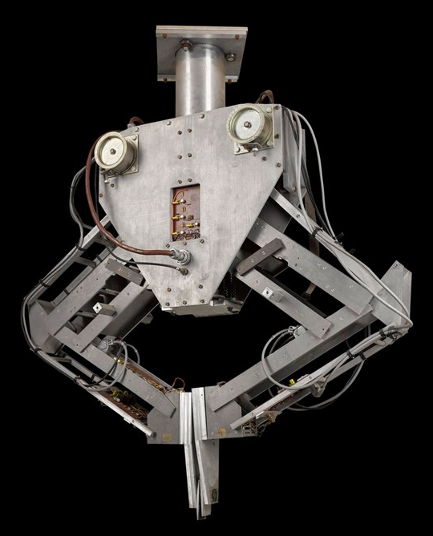
Artificial perception is sufficiently well advanced to enable optical sensors to recognise an individual, autonomous vehicles to drive at moderate speeds on an open road, and robots to roam through buildings collecting empty soda cans. For example, in 1966-73, Donal Michie developed FREDDY, a stationary robot with a moveable television eye and a pincher hand, constructed at the University of Edinburgh, Scotland. This robot could recognise various objects and be instructed to assemble products from a random heap of components, such as a toy car (shown in figure 9).

Figure 9: ‘FREDDY’ The original Freddy was created in the early 1970s by researchers at the University of Edinburgh’s Department of Artificial Intelligence. Freddy the robot was the first robot to combine vision and touch through AI.
Language
There is no limit to the concept of language as it is a system of signs that have meaning by convention, which means that it is not restricted to the spoken word. Languages are characterised by meaning-by-convention linguistic units. “Linguistic meaning is very different from natural meaning, exemplified in statements such as “those clouds mean rain” and “the fall in pressure means the valve is malfunctioning.”

In contrast to birdcalls and traffic signs, an essential characteristic of human languages is their productivity, which means that a productive language can formulate an unlimited variety of sentences. And programmable computers can respond fluently to questions and statements in human languages in severely limited contexts. Even though, none of these programs understands language, the principle reaches the point where their command of a language, the principle reaches the point where their command of a language is indistinguishable from that of an average human. What is involved in genuine understanding, if even a computer that uses language like a native human speaker is not acknowledged to understand?

Chapter 2: Artificial intelligence in architecture

Artificial intelligence has managed to impact most of the fields, but what about Architecture. Artificial intelligence has the potential to make the design process of the architects significantly easier, giving them access to countless amounts of data, creating models, interpreting the building environment, and creating cost estimates. These days, every architect uses a computer, whether it’s for 3D modelling or documentation. As a result, architects now need to know almost as much about the software as they do about structure, building regulations, and designs. That being said, not everyone has the time or the desire to learn how to use the software, as it is already time-consuming with projects to run, drawings to review, and buildings to design. Fortunately, there are tools available to enable programming to be executed with ease.

In a field that sways between art and engineering aspects, can AI replace the creative process in design?

Research
Artificial intelligence in the design process, acts as the foundation. And when researching, it tends to take as much time as 75% of the entire design process. As AI software already knows everything about us, our interests, habits, likes, and dislikes, activities, friends, etc. AI is able to predict the growth of the population, prioritise projects, categorised streets according to their usage and so on, and then create plans that will satisfy everyone. In other words, AI supplements the architect’s research by showing simplified and specific results. Architects can evaluate site conditions with minute precision using existing BIM tools, which tap into these data constellations. In addition, architects can conduct building and environmental analyses without ever leaving the office through software such as Ecodesigner Star and open-source plugins for Google Sketchup.

Experimentation
Artificial intelligence as the final juror means that the design’s stability, strength, and performance could not assessed earlier. And with the help of AI, we can test the design close enough to the site conditions and other parameters. And as a result, it enables the architect to experiment without affecting anybody.

Also, artificial intelligence gives us the opportunity to help bring your vision to life through ‘Augmented Reality’ and ‘Virtual Reality’. A technology evolved to the point where you can walk through a design. In augmented reality, it allows the architects to interact with their projects by combining a digital model with the physical space, creating a 3D version of the proposed model, and placing it over the actual environment of the project. On the other hand, with virtual reality becoming more accessible to consumers and firms alike, the architecture industry has noticed. Virtual reality is typically experienced by wearing by wearing a headset that completely covers the user’s eyes and fully immerses them in the virtual environment.

Empathy
However, artificial intelligence cannot currently deal with everything. Although AI can give us outputs from an asset of data and information stored previously it cannot curate one on its own. Although artificial intelligence has no knowledge of emotional aspect and decision making, AI can offer a set of viable options for an architect, which was mentioned on the ‘Synthesis of Form’ on design thinking. For example, an architect puts themselves into their client’s shoes and tries to figure out solutions that suit best for each scenario, giving an empathetic and emotive response, a human characteristic. Studies show that “most of the professions that were on the least likely side had human interaction as one of their cornerstones along with empathy and emotions.”

Creativity
Artificial intelligence can take over repetitive tasks. ”Software tools and programs can now make building calculations and environmental analysis a simple task.” Redrafting and revising drawings will be taken over by AI, which would help render precise and accurate drawings, meaning that the architect would be left with time in hand to focus more on the project.
“But can AI learn to be creative?”
With the advancements in artificial intelligence today, there is a possibility that computers can be taught on some parameters of creativity. However, studies point out that teaching computers to be creative, is inherently different from how humans learn to create. Therefore, many questions how AI can develop its sense of creativity.

University of Sussex cognitive scientist, Margaret Boden, who also serves as an advisor at Stephen Hawking’s Leverhulme Centre for the Future of Intelligence, explains that “many examples of creativity involve learning and exploring in a hierarchy style. For example, if you have a computer that comes up with random combinations of musical notes, a human being who has sufficient insight and time could well pick up an idea or two. Whereas a gifted artist might hear the same random compilation and come away with a completely novel idea, one that sparks a totally new form of composition.”

Boden estimates that 95% of what professional artists and scientists do is exploratory and perhaps the other 5% is truly transformational creativity. There is a lot of processes behind creative thinking, and she believes that artificial intelligence has a big role to play.

Alan Turning

In 1935, Alan Turing described the computing machine “as a limitless memory and a scanner that moves back and forth through the memory, symbol by symbol, reading what it finds and writing further symbols.” The scanner operates on, modifies, or improves its program through a program of instructions. Later in 1947, Turing mentioned that the computer intelligence, saying “what we want is a machine that can learn from experience, and that the possibility of letting the machine alter its own instructions provides the mechanism for this.”

“Can machines think?” Turning (1950) states that a computer deserves to be called intelligent if it could deceive a human into believing that it was human. In 1950, Turing proposed that a computer can possess artificial intelligence if it could mimic human responses under specific conditions. As a result, he introduced a practical test for computer intelligence known as the Turing test, which involves three participants: a computer, a human interrogator, and a human foil. The interrogator attempts to determine by asking questions of the other two participants, which is the computer.

The test is administered in a room under the supervision of a judge. A person and a computer program are hidden during the test. During the conversation, the judge attempts to tell which party is the human and which is the computer. If he or she cannot identify the party from its differences, as a result the computer has demonstrated human intelligence, proving that it can think. Using this simple method, it can be determined whether or not a machine can demonstrate human intelligence; if a machine engages in a conversation with a human, it has demonstrated human intelligence (as shown in figure 10)

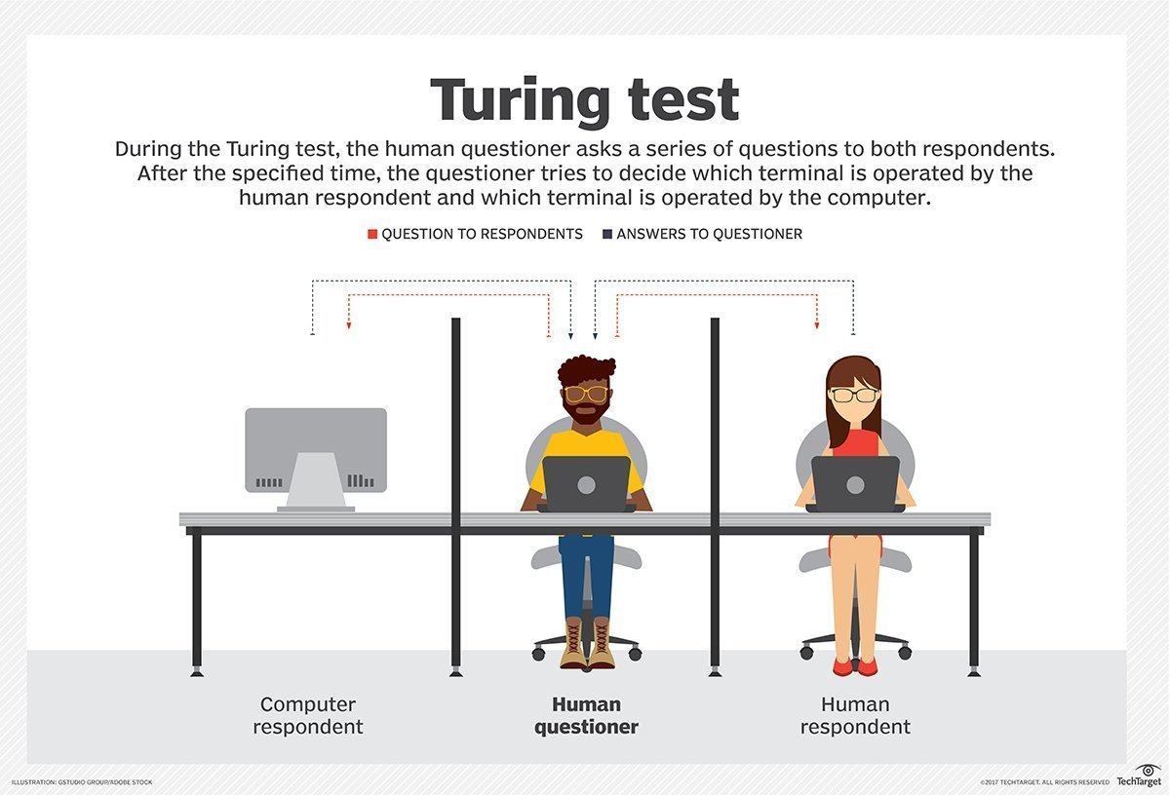
Figure 10: The Turing test in 1950.

As a result of this test, the Turing test judges the conversational skills of the machine. According to the test, a computer program can think if its responses can fool a human into believing it is human. Many questions the validity of the test, but padding it remains a significant challenge for artificial intelligence developers. Will artificial intelligence gain empathy and creativity through the improvements of AI thinking?

Artificial intelligence used in architecture practice

Rethinking the mindset of embracing machine learning, not replicating, or replacing architects, rather than embracing our knowledge, instincts, and sensitivities with them. With AI established in the 1950s through modularity, computational design and parametricism, many systems and processes must be perfected to mimic human intelligence accurately. An example would be the subset of AI known as machine leaning, summarised by a computer scientist from Tom Mitchell (1951) as ‘the study of computer algorithms that allow computer programs to automatically improve through experience.’

Machine learning has great potential to analyse our designs quickly and at a less cost. The ARD (Applied research and Development) team in Foster + Partners, have been exploring two ways in which it can be incorporated into the design process, as well as some potentially more revolutionary applications.

Surrogate modelling
Surrogate modelling is a direct replacement for analytical engineering simulations (such as structural deformation, solar radiation, pedestrian movement), which takes valuable hours or days to complete. In other words, the surrogate method interpolates a mathematical model based on the relationships between design parameters and performance criteria, therefore using this model, architects can explore the approximate impact of the changing design variables. Due to the time and work involved, it is nearly impossible to optimise designs based on their findings, therefore undermining these tools’ benefits by helping through the research stage. Machine learning might enable architects to solve problems and detect patterns historically dependent on complex analytical simulations and programmes.

To solve this problem, ARD team investigated surrogate models where a computationally ‘cheaper’ predictive model is constructed based on a number of intelligently chosen simulation results. The designer can then use the results from the surrogate model’s approximation of a simulation in real-time, which benefits in them making a quick decision.
Data: Original versus synthesised
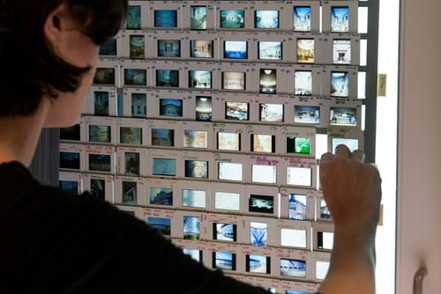
“With machine learning, the input data is the key.” However, with the success of the system’s output, it is only good as the volume of quality of data they provide. Fortunately, architectural datasets are rich, complex, and often produced in significant numbers; they can provide vast amounts of invaluable information and ideally suited to train AI systems.
Figure 11: The Foster + Partners archive holds all the studio’s many thousands of previous drawings, models, slides and photographs, publications, awards, and other practice-related ephemera. Their digitalised image server contains over 600,000 files.

It has become a necessity in both surrogate and design assistance models when it comes to data. There are two types of data; original or synthesized. At Foster + Partners, the practice has compiled an archive of drawings, models sketches, details, covering more than five decades of activity. In contrast, the synthesized data is automatically generated with the help of a generative design system.
Currently, each of the data presents its own challenges. For example, in terms of original data, it takes time to sort through decades of digitally archived work in different file formats produced by many employee’s projects to fin the data relevant to their work. In addition, while synthesized data may not always be an option, developing generative models with the type of richness of data necessary may prove to be an impossible task.

Simulation of thermo-active laminates
It is the ability of materials to change their shape without the assistance of an external mechanical force. In other words, how smart, passively actuated materials react like living organisms, adapting to changes in their physical environment such as temperature, light and humidity, which could result in great architectural potential. For example, a passively actuated façade might not have any mechanical shading devices like motor-controlled louvres. Instead, they would prefer to dilate under external light conditions, like an eye’s iris, to provide shading, prevent overheating, or increase privacy.

This is achieved by mixing patterns of thermo-active materials around passive laminates (multi-layered materials). And as a result, contraction rates occurs where there is a difference in expansion. Therefore, if curated it can lead to specific deformations, which could help architects control and exploit designs.

The ARD team was interested in the material’s morphological deformation, a controlled transition from an initial state to the end and back. There is a non-linear relationship between the laminate’s internal forces and their displacements, which is opposed to a more linear analysis. The effect of tweaking input parameters on the output is predictable. For example, a cantilevered beam with its known dimensions paired with a material that will permanently deform in the same way under a constant force will deform a non-linear way during an earthquake. Therefore, a non-linear analysis requires a sophisticated and time-consuming simulation strategy. (Shown in figures 12 and 13)

It might be possible to repeatedly change the laminate’s layering and analyse the results, adjusting at a steady yield to come closer to the target deformation. However, due to the complexity of the non-linear simulation, it goes through the process of trial and error to achieve the expected results.
Figure 12: The left side shows a laminate in its initial state (above) that is then encoded into grey-scale image (below). The right shows the same laminate in the deformed state (after running a non-linear structural analysis) and its encoding to a depth map. The different colours illustrate how much each part of the laminate was deformed.

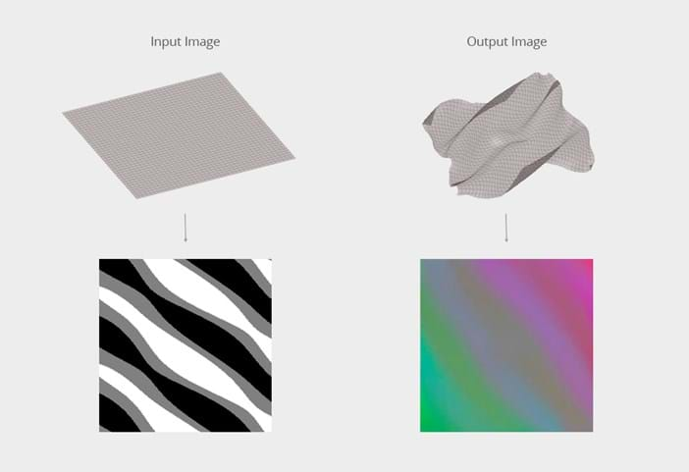
Figure 13: The images show how the system has learnt to predict the correct material layering pattern that would produce each desired depth map (or material in its deformed state). The left column shows the required depth maps that were presented to the system. The right column is the target layering required. In-between we see the system progressing towards the target.

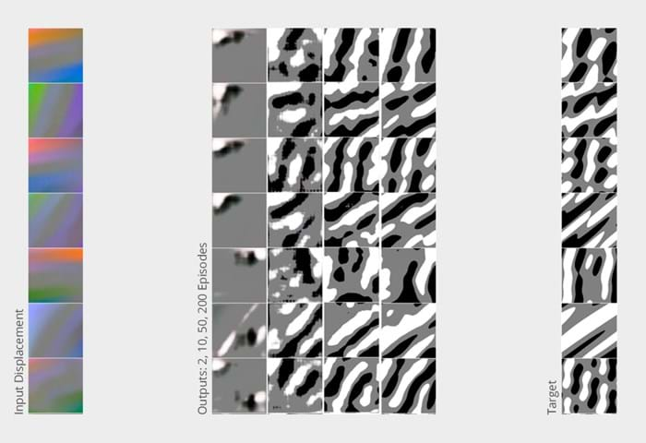

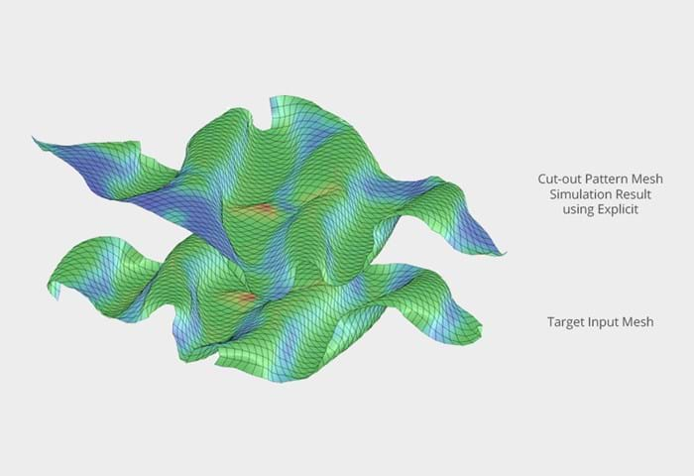
Figure 14: It demonstrates a comparison between an arbitrary designed laminate in a set deformed state, and the result of an original non-linear analysis run on the laminate’s initial state, as predicted from the set deformation. Those two deformations are not identical but close enough to prove the effectiveness of this approach and system’s ability to generalise.

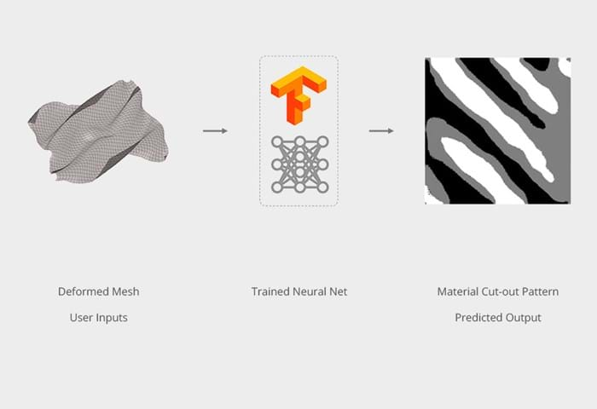

Figure 15: A still taken from a custom, interactive design assistant application, into which the trained neural network is embedded.
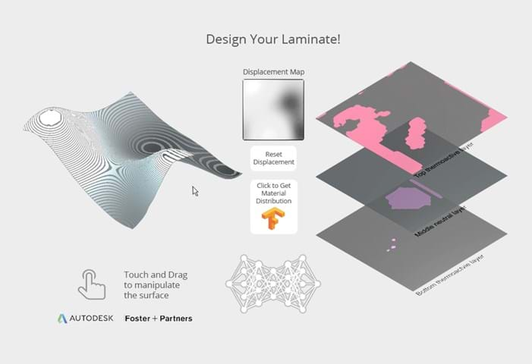

Figure 16: A material with the desired deformed states on the left, is inputted into the trained neural network (centre) and the required material cut-out pattern is provided by the system on the right. This is the reverse of how the problem was initially conceived, where the diagram shows how an inverse problem is solved after the training has finished.

Spatial and visual connectivity
When evaluating and experimenting with the function of a floorplan, for example, in an office, they consider issues such as visual navigation, walkability, the balance of private offices and shared spaces, and facilitating serendipitous collaboration. However, to achieve spatial and visual connectivity analysis, sometimes it can take a long time to compute for large-scale floor plans. Space and visual connectivity can provide valuable insights into the effectiveness of a floor plan early in the design process (shown in figure 17 and 18).On a grid, spatial connectivity measures the distance between two points. It facilitates the analysis of walking distances between points of interest, and applications include analysis of escape routes, connectivity can be used for analysing visual distances rather than physical distances. The space configuration must be provided as an input for preforming spatial analysis and visual analysis, which includes the interior elements of an organisation such as walls, partitions, and furniture. In particular, for visual connectivity, the analysis can be conducted at knee level, where walls and furniture are included, or at eye level, where only walls are included as obstacles.

Following from the laminate research, the ARD team investigated the use of machine learning and training a surrogate model to mimic the analysis output. The team developed a parametric model capable of generating basic office floor plans that incorporate an open-plan and compartmentalised workspace, finished with walls, doors, and furniture. As a result, the generative parametric model has created a synthetic dataset of thousands of floor plans, each with a corresponding set of visual and spatial analysis results, meaning that the outputs from the ARD inputs. This data can be used to train the machine learning system to provide spatial and visual connectivity analysis.

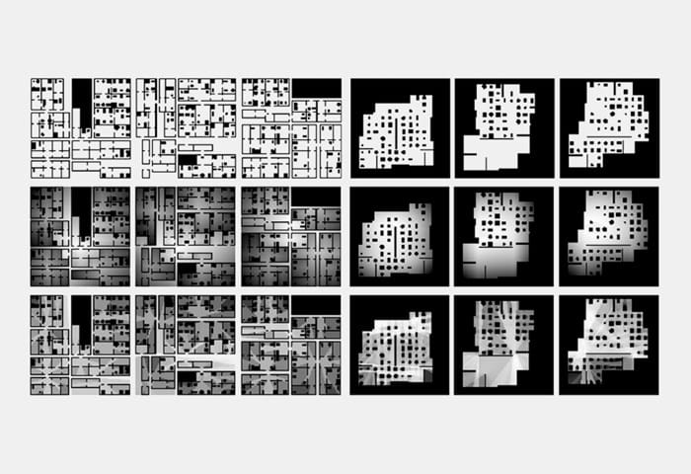

Figure 17: The top row of images shows a sample of the floor plan outputs from the parametric model, showing three compartmentalised (left) and three open plan workspaces (right) The middle row visualises the output of the spatial connectivity analysis on these floor plans, and the bottom row shoes the visual connectivity analysis.

And as part of the machine ‘training’, it goes through trial and error, where it continues trying to improve itself by comparing the results. It goes through a phase where it starts inaccurate, and as time goes by, the artificial neural network receive feedback and starts to correct its mistakes and answers to get the correct results. By the end, the models find their own ‘recipe’ to map from the input of a floor plan to output a floorplan with the correct spatial and visual connectivity analysis, which was not the case at the start.

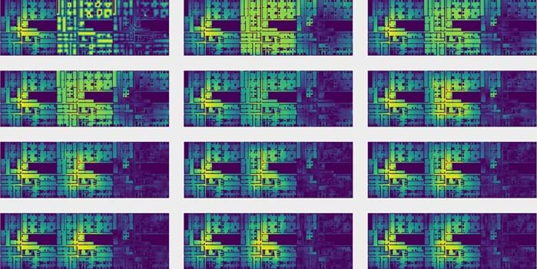

Figure 18: A series of stills showing the model’s floorplan analysis. In In each frame, the left-hand floor plan shows correct (and pre-known) output of connectivity analysis on the plan. While the central animation (showing the same floor plan) is the model’s steadily improving predictions of this analysis as it trains. By the end of the animation (bottom right), it matches the correct analysis shown in the left-hand plan. The right-hand plan illustrates the difference between the two, darkening as the model’s prediction gets closer to reality.

As soon as the model is trained, it can be put to work, which would start to run both the spatial and visual analysis on any architect’s floor plans, producing results in less than 0.03 seconds. Equipped with such a powerful tool, the ARD team begins to see the effectiveness of a change in office arrangement on screen as they adjust.

Case studies
The use of artificial intelligence in the industry represents a significant shift from using the technology for purely automating processes to utilising it for guiding progressive design and constructability. There are other projects that define this transformation seen in projects through the technical solution to using artificial intelligence such as:

Yokohama Terminal, Foreign office architects (1995 – 2002)
Designed in 1995, it exemplifies a building design made possible by significant technological advancements in architecture modelling during the decades prior; personal computing, MicroStation, AutoCAD and Computer Numerical Control Milling. Through its hyper-technological design, the project pushed the boundaries of architectural form and simultaneously provoked dialogue regarding the social responsibility of large-scale projects to enrich urban spaces. However, to achieve this striking appearance, a computer-aided design had to be used.
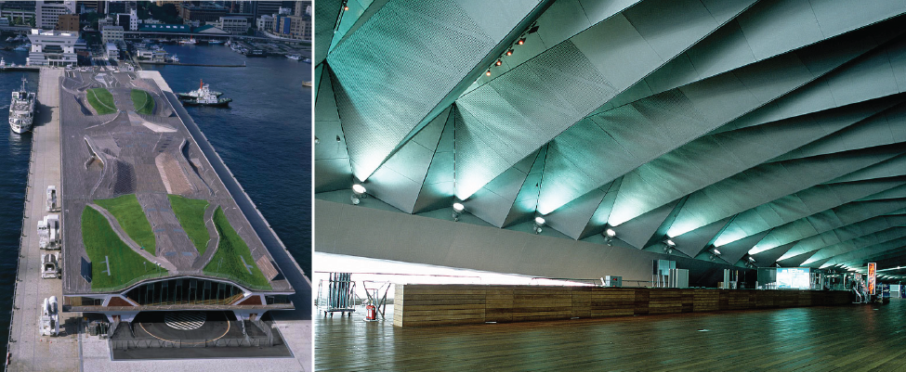
Figure 19: Yokohama International Port terminal.
The book “Drawing Architecture” (2018) by Helen Thomas describes FOA’s design process for the Yokohama port terminal as one that constantly mutated and proliferated computer programs. These programs resulted in undulating planes or new landscapes rather than discrete, volumetric structures. By the early 1990s, personal computing advancements had enabled widespread adoption of MicroStation and AutoCAD. Then, after decades of refinement, CNC Milling became more widely used.

Guggenheim Museum, Frank Gehry (1991 – 1997)
Foreign office architects utilise the same technology used when creating the Guggenheim Museum in Bilbao, Spain. In the book “Frank O. Gehry: The Complete Works,” (1998), he recalls that the software programs initially developed for designing airplane fuselages (CATIA), provided the matrix for shaping and refining every part and element in the Guggenheim’s design and construction. Due to their mathematical complexity, these curves were designed using 3D design program called CATIA, which enables complex designs and calculations that were impossible years ago. Gehry’s hand-built models are digitalised by the software so that it can create on-screen animations based on edges, surfaces, and intersections of his models. For example, CATIA calculated the number of bars required in each location and the bars’ “positioning and orientation”.
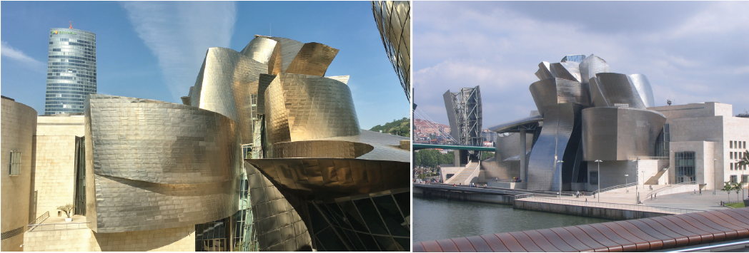
Figure 20: Guggenheim Museum.
This software development boasted by human ingenuity opened the seemingly singular-in-use technological advancements to more creative purposes. The book also notes that the Guggenheim at Bilbao set the trajectory for a productive capacity whereby a building could be conceived and executed into an uninterrupted loop rather than in separate and distinct phases.

Embryological House, Greg Lynn (1997 – 2001)
This case study in the preservation of digital architecture shows the dynamic forms of the house comprise flowing, and vector-based surfaces sometimes referred to as “blob” architecture, made possible through animation software. Lynn expects the new computer-aided design capabilities and computer numerically controlled manufacturing to support this design process. In architectural construction, the early adoption of software in creating and fabricating without following a prototypical journey demonstrates the early adoption of software.

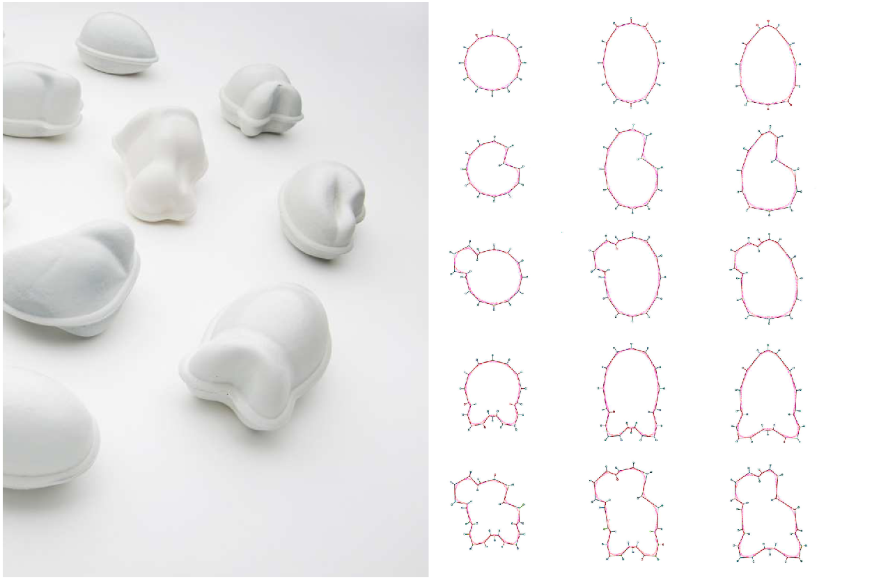
Physical models for the Embryological House were produced using prototyping technology to test the design’s compatibility with the available manufacturing technology. The materiality of his models formed an essential part of the creative process. For example, Lynn deliberately exposed the means of manufacture by allowing the computer-controlled tools to leave their marks on the model’s surfaces.
Figure 21: Physical models for the Embryological House.
The concept was to create a family of architectural forms built from unrestricted iterations if a basic primitive, ultimately resulting in a similar yet unique construction. In addition, forms and houses would have “shared regulating principles” that would allow customisation and mass production of each component. In conjunction with CNC manufacturing, computers can use computer-controlled design tools to communicate directly with robotically controlled devices in the production process. From example, the 2D/3D drafting program MicroStation was transformed into an animation and visualisation program called MAYA by combining computer drafting and animation software.

Chapter 3: Analysis and comparison of case studies

What will the future hold for architects, and what role will artificial intelligence play in shaping the future and the built environment? A global pandemic has dramatically accelerated the emergence and use of new design techniques as well as creative possibilities as a result of this questionnaire. After the results were sent on Friday 11th of February, the data was collected and analysed on Monday, 21st of February. We had 22 respondents from within the architecture industry. Despite some limitations when analysing the data, it still provides an interesting insight into how the technologies and software have affected architects in the industry.

Nowadays, 50% of those working in practice describe artificial intelligence as a machine used to analyse and solve problems with minimal human input. Many say artificial intelligence introduces a new design method by applying the software that mimics human-driven processes traditionally. However, it is also a method for eliminating human input from the design process. (Shown in figure 22) When using artificial intelligence in architecture, 45% believe that AI is another tool used to optimise resources, producing efficient and sustainable designs. However, according to 13% of architects, AI offers solutions in terms of space and practical considerations. In terms of aesthetics and sensitivity, it is less useful in the architectural field. (Shown in figure 24) With artificial intelligence in the design process, it should be able to utilise two systems, called “Expert Systems” and “Rule Based Systems”, that simplify and clarify all constraints, from client briefs to building regulations to planning and legal constraints. A designer or design team can easily explore multiple design options using neural networks and algorithmic exploration and select from a palette of available options. Neural networks should also be able to monitor construction in real-time to ensure it conforms to the design intent and adapt to the building’s usage in real-time, thus serving as a real-time monitor system. These systems are similarly done through Fosters + Partners, where they are able to explore the multiple design options using AI, through the common themes of learning, reasoning and problem solving during their research/ experimentation process.

Figure 22: What do you understand by the term ‘artificial intelligence’ in architecture?

Figure 23: What is your experience with artificial intelligence?

Figure 24: What is your opinion on using artificial intelligence in architecture?

Architecture and social values

During the 1950s and 1960s, through modularity and computational design, artificial intelligence was envisioned as a computer learning to perform cognitive tasks and operations like a human brain, until it was tested by Turing if machines can think. Today, artificial intelligence is shaping our aesthetics choices with algorithms that suggest what we should see, read, and listen to. We use it when making movies, music albums, product, and website designs, and to evaluate aesthetic choices.

Figure 25: How would you define ‘Architecture’?

59% of architects define ‘architecture’ as art and science, whereas 45% defined it as a built environment and space. (Shown in figure 25) The respondents believe that the built environment defines places and society numerous ways, reflecting the conditions and aspirations of the inhabitants of a specific location with its particularities. It influences how people live, meet, and congregate in the modern world. In other words, we are shaped and effected by the built environment. Architecture provides safe environments to provide comfort, security, warmth, and shelter for the people who live and work in them. As a result, they are a direct influence on our culture and society, and influence on our culture and society, and influences how we behave.

Architecture is also defined as social art. However, these days in ‘Grand Designs’, where the focus is mainly on enlisted projects. Creates the feeling that architecture is something reserved for the affluent, and everyone else should accept what they are given. On the contrary, architecture’s role is to be more inclusive and should be seen to focus on the wants and needs of the vast majority rather than the elite few. (Shown in figure 26)

Figure 26: Do you think the social value in architecture is important? If so, why?

Figure 27: What do you understand by the role of architecture in today’s society?

68% of those working in the architecture industry believe that the social value in architecture is important and should be shown while using artificial intelligence as a tool. There are many aspects of our existence that the world and contemporary society permit, including environmental responsibility, social responsibility; mental health and physical well-being; beauty and creativity as a positive stimulus to the society as a whole. (Shown in figure 27)

Future of artificial intelligence and architecture

Artificial Intelligence uses algorithms to create better buildings as it can help to refine, inform, and generate designs. In other words, artificial intelligence provides architects with a new tool to help them obtain their goals and enhance their ideas. It is a tool that can also reveal hidden patterns while proposing new and existing constructions. But what does this mean for the future of architects?

Figure 28: Is AI just a tool that can technical problems or a potential to change the way we design architecture in the near future?

18% of respondents believed that artificial intelligence could solve technical problems in architecture. This is because it acts as a tool that enhances the design and minimises the danger of a bad design, through the components of trial and error and minimum human input. For example, artificial intelligence acts as a tool that allows architects to explore design spaces in virtual reality. A third of respondents saw artificial intelligence as an opportunity to change how we design or improve our designs. As AI and it uses, grows in complexity, they are likely to play a more significant role in the duties of the future architects in the ‘Metaverse,’ which is seeing vast investment, as one respondent stated. In the near future, 45% see it as a tool for solving technical problems as well as a tool for changing the way we design architecture. (Shown in figure 28)

Figure 29: Do you think AI can replace in the near future?

Figure 30: In terms of creative thinking, will AI enhance or limit the design process in architecture?

In the near future, technological advances may eliminate the need for architects. However, majority of architects perceive artificial intelligence as a tool and will have to adopt and use it to benefit society as a whole. 29% says it’s highly unlikely and have not been proven that AI can replace humans, especially designers. For example, uber driverless cars has shown that Artificial intelligence is getting better at handling complex tasks, proving the unlikely possibility of AI replacing designers based on AI’s limitations in cognitive capabilities such as such as judgement and emotions. This refers back to the fact that AI has no knowledge of emotional aspect and decision making when it comes to the design process. It will need the human input to be able to have the empathetic and emotive response after a client meeting to best suit a design for each scenario. Artificial intelligence can solve commodity and firmness; however, architects should limit their involvement to only the technical side of things and consider depending on AI with all its data, which means it may replace technicians. (Shown in figure 29)

68% say there is a possibility that artificial intelligence could enhance the architectural process as a tool, but potentially as a solution to improve the process if it is sufficiently advanced. (Shown in figure 30) Despite the fact that AI can think, the result will be a simple box solution, with more than four walls, a roof, and a floor. The process would enhance if the AI was utilised correctly. However, if AI is used incorrectly or overused, the result will be extremely repetitive. The ability of artificial intelligence to think creatively about space in relation to the human experience is questionable, for example would AI ever have the emotional response that humans have? Architects would also have an easier time demonstrating their proposals through AI. However, those new to using software designs may say otherwise, “My experience over the last 30 years has been that the digital age has increasingly removed control, reduced leisure time and increased stress throughout society – the opposite of all the things we were promised it would deliver.”

Many did not have enough experience with artificial intelligence to answer this question in figure 30. Nevertheless, AI can play a role in the development of a design and the function of a space, depending on what the input parameters are supposed to achieve. Assessing priority whether its cost, environmental control, material selection, sustainability, and adapting the outcome if those parameters change could increase the future potential. The idea of having design meetings with all key design and consulting parties present, using VR headsets in the space being designed, would make the design process more engaging and, therefore more informed. The ability to share things quickly and remotely, and send designs into VR headsets easily, would be helpful for multiple users at once.

Conclusion
Artificial intelligence has been developing and growing since the 1930s to become a tool that would potentially aid in the complexity of designs. These complex algorithms are generating such complex designs that some designers are beginning to wonder if they are more the work of computers than humans. Designing a space requires a keen appreciation of its quality and a high degree of creativity. By encoding the decisions in a computer language, artificial intelligence can simply enhance the designer’s intuition and experience, acting as a tool in this industry.
Even if we don’t believe artificial intelligence will replace us, it has already changed the way architecture is practiced. The future of architecture involves exploring how AI will enhance aesthetics and how we can improve the design process. Artificial intelligence and machine learning will continue to play a significant role in shaping our future. When machines are capable of understanding and influencing our perception of beauty, then we must seek better ways to use these tools and processes in design. Even though most of an architect’s role may be replaced by AI, it would never be able to completely replace an architect. For example, decision making, emotions, and conscience are a few of the parameters that AI is yet to explore and master.
Architecture provides safe environments to offer social values such as comfort, security, warmth, and shelter for the people who live and work in them. But if artificial intelligence improves in terms of gaining the knowledge necessary to meet these needs, will it keep these values or change them, as architecture still today has a direct influence on our culture and society. Some may say that the use of artificial intelligence can yield opportunities for future developments in architecture and the world, allowing for a better outcome, a faster design process, and appropriate solutions. But what does it mean when artificial intelligence gains the knowledge of human characteristics such as having the creativity and empathetic response to architectural design? Will it change the definition of architecture, or will AI simply form its way into a new form of architecture?
In conclusion, the findings remain uncertain since their effects have not yet been fully understood. Artificial intelligence will be less likely to replace architects in the long run , and in the context of architecture practice, it will allow new methods to adapt to future demands

Bibliography: Published Works
** Use the Harvard referencing convention for ALL your sources **

A
Alexander, C., 1964. Notes on the synthesis of form.
Available at: https://monoskop.org/images/f/ff/Alexander_Christopher_Notes_on_the_Synthesis_of_Form.pdf
(Accessed: 18 March 2022)

Appen., 2022. AI vs. Deep Learning vs. Machine Learning: Everything You’ve Ever Wanted to Know.
Available at: https://appen.com/blog/ai-vs-deep-learning-vs-machine-learning-everything-youve-ever-wanted-to-know/
(Accessed: 18 March 2022)

B
Boden, M., 2017. What’s next for AI.
Available at: https://www.ibm.com/watson/advantage-reports/future-of-artificial-intelligence/margaret-boden.html
(Accessed: 09 March 2022)
C
Copeland, B.J., 2021. Artificial Intelligence. Encylopedia Britannica.
Available at: https://www.britannica.com/technology/artificial-intelligence#ref219078
(Accessed: 05 March 2022)

D
Davis, D., 2013. Chapter 2 – The Challenges of Parametric Modelling.
Available at: https://www.danieldavis.com/thesis-ch2/
(Accessed: 20 March 2020)

E
F
G
Goel, A., 2014, Notes on Christopher Alexander’s Notes on the Synthesis of Form and Design Thinking.
Available at: https://medium.com/@ashpodel/good-design-is-making-a-misfit-free-ensemble-2ce5fe25bdb0
(Accessed: 18 March 2022)

George, B and Gillis, A., 2021. Turing Test.
Available at: https://www.techtarget.com/searchenterpriseai/definition/Turing-test
(Accessed: 09 March 2022)

Goldsberry, M. and Thomas, I.C., 2020. Navigating the Growing Influence of Artificial Intelligence in Building Design.
Available at: https://www.hdrinc.com/insights/navigating-growing-influence-artificial-intelligence-building-design
(Accessed: 18 December 2021)

H
Howard, S. 2019. Embryological House.
Available at: https://www.cca.qc.ca/en/articles/issues/4/origins-of-the-digital/5/embryological-house
(Accessed: 18 December 2021)
I
J
Jones, R., 2013. AD Classics: Walt Disney Concert Hall / Gehry Partners.
Available at: https://www.archdaily.com/441358/ad-classics-walt-disney-concert-hall-frank-gehry
(Accessed: 20 March 2022)

K
Kilkelly, M., 2016. 5 ways computational design will change the way we work.
Available at: https://www.archdaily.com/785602/5-ways-computational-design-will-change-the-way-you-work
(Accessed: 08 March 2022)

L
Langdon, D., 2014. AD Classics: Yokohama International Passenger terminal / Foreign Office Architects.
Available at: https://www.archdaily.com/554132/ad-classics-yokohama-international-passenger-terminal-foreign-office-architects-foa
(Accessed: 20 December 2021)

M
McCluskey, A., 2020. Modularity: upgrading to the next generation design architecture.
Available at: https://connected-archive.secret-paths.com/media/modular.html
(Accessed: 08 March 2022).

Merin, G., 2019. AD Classics: The Dymaxion House / Buckminster Fuller.
Available at: https://www.archdaily.com/401528/ad-classics-the-dymaxion-house-buckminster-fuller
(Accessed: 08 March 2022)

N
National Museums Scotland., 2019. Freddy the Robot.
Available at: https://www.nms.ac.uk/explore-our-collections/stories/science-and-technology/freddy-the-robot/
(Accessed: 18 December 2021)

O
Oberste-Ufer, K., 2019. 7 ways Artificial Intelligence is revolutionising architecture.
Available at: https://blog.dormakaba.com/7-ways-artificial-intelligence-is-revolutionizing-architecture/
(Accessed: 09 March 2022)

P
Pagnotta, B., 2013. AD Classics: The Guggenheim Museum Bilbao / Gehry partners.
Available at: https://www.archdaily.com/422470/ad-classics-the-guggenheim-museum-bilbao-frank-gehry
(Accessed: 20 December 2021)

Q
R
Raphy, R., 2020. Can artificial intelligence replace architects, a realist’s perspective.
Available at: https://www.re-thinkingthefuture.com/rtf-fresh-perspectives/a579-can-artificial-intelligence-replace-architects-a-realists-perspective/
(Accessed: 26 October 2021)

Rhodes, M., 2016. Tracing the Legacy of Zaha Hadid, Architecture’s Esteemed Anomaly.
Available at: https://www.wired.com/2016/03/tracing-legacy-zaha-hadid-architectures-esteemed-anomaly/
(Accessed: 20 March 2022)

S
Suzuki, E., 2020. What is Parametric design in Architecture, and how is it shaping the industry?
Available at: https://www.autodesk.com/products/fusion-360/blog/parametric-design-architecture-shaping-industry/
(Accessed: 08 March 2022)

Schumacher, P., 2009. Parametricism: A new Global Style for Architecture and Urban Design. Architectural Design, Vol 79(4), pp.14-23.
Available at: https://onlinelibrary.wiley.com/doi/10.1002/ad.912
(Accessed: 03 December 2021)

Signorelli, P., 2018. Artificial Intelligence: Transforming the Nature of Work, Learning, and Learning to Work.
Available at: https://www.thetambellinigroup.com/artificial-intelligence-transforming-the-nature-of-work-learning-and-learning-to-work/
(Accessed: 20 March 2022)

T
Tsigkari, M. and Tarabishy, S. and Kosicki, M., 2021. Towards Artificial Intelligence in Architecture: How machine learning can change the way we approach design? [blog]
Available at: https://www.fosterandpartners.com/plus/towards-artificial-intelligence-in-architecture/
(Accessed: 27 October 2021)

U
V
W
Wood, H., 2017. The Architecture of Artificial Intelligence.
Available at: https://archinect.com/features/article/149995618/the-architecture-of-artificial-intelligence
(Accessed: 20 March 2022)

X
Y
Z
Zaha Hadid Architects., 2006. Kartal Masterplan.
Available at: https://www.zaha-hadid.com/masterplans/kartal-pendik-masterplan/
(Accessed: 20 March 2022)

Appendix A: Questionnaire

Friday 11th February – Monday 21st February 2022
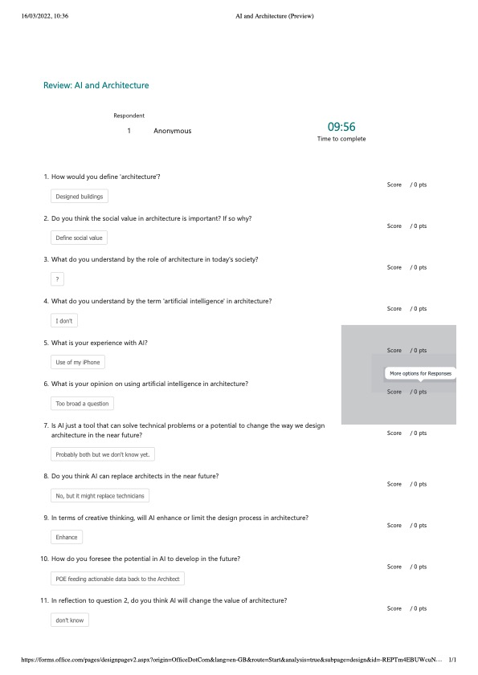

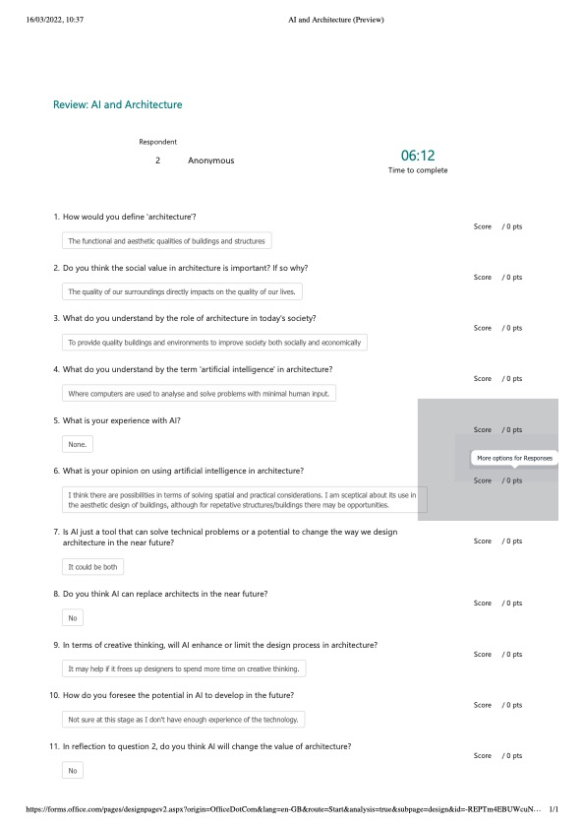

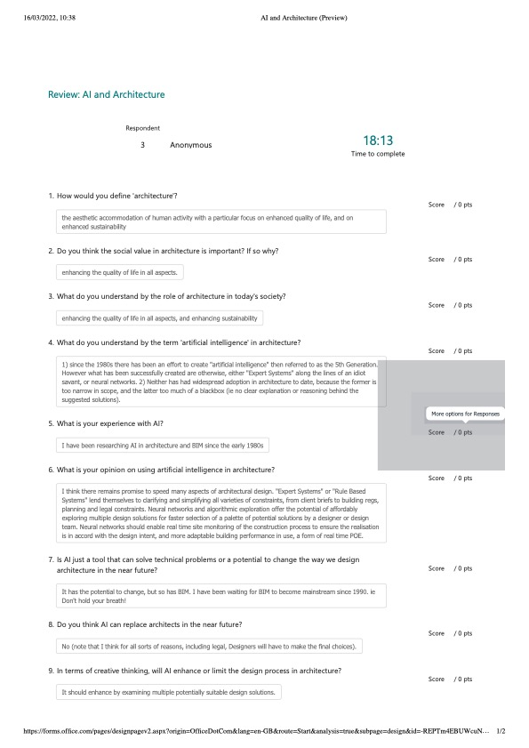

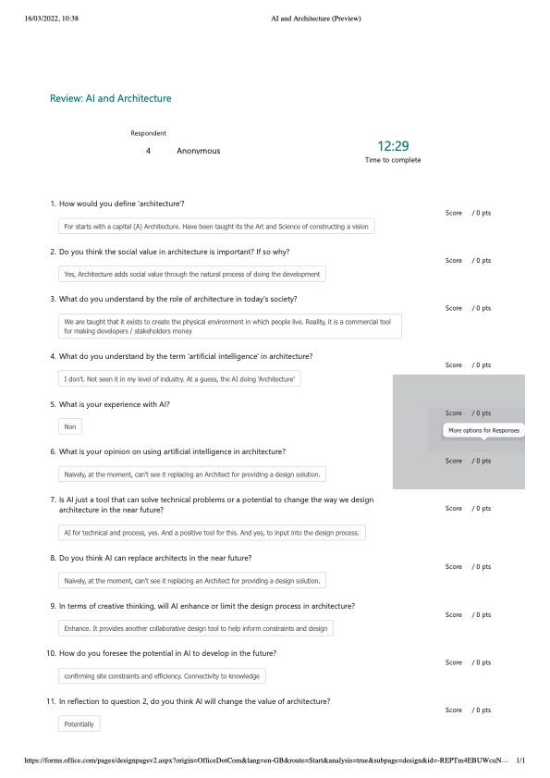

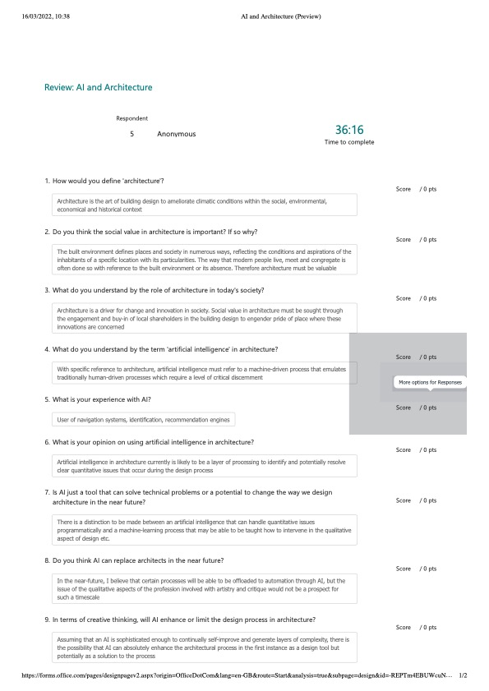

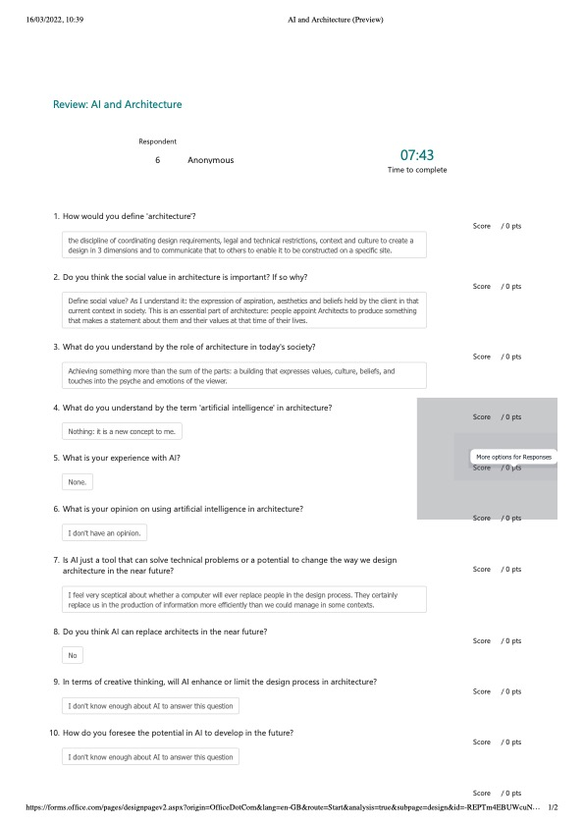

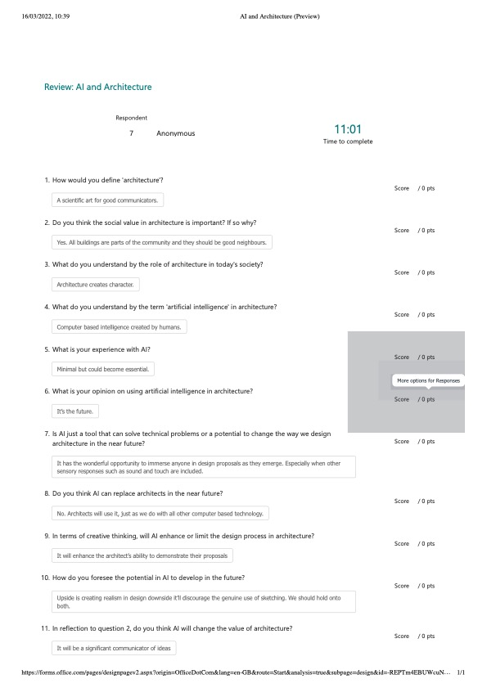

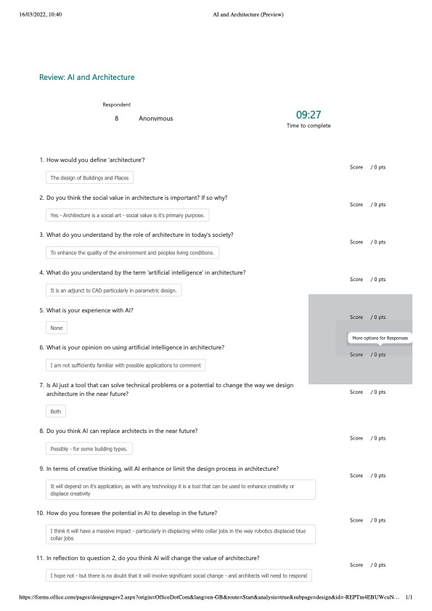

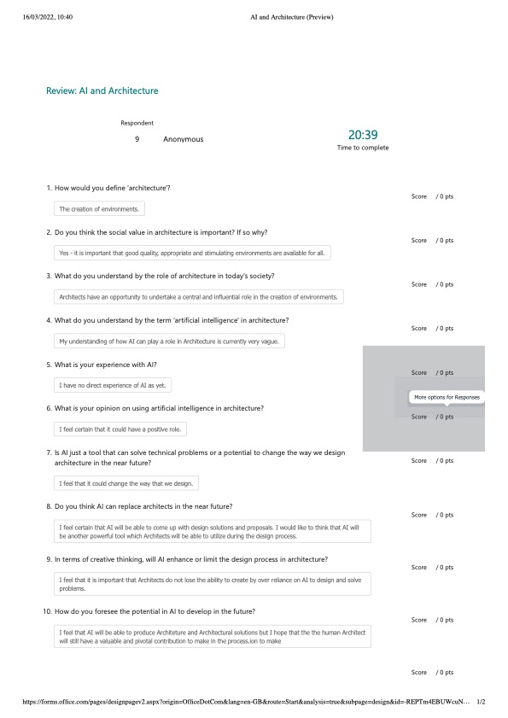

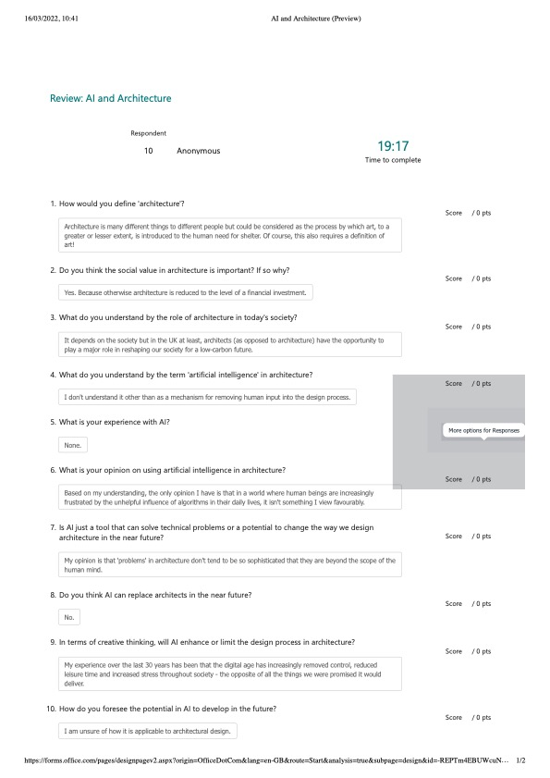

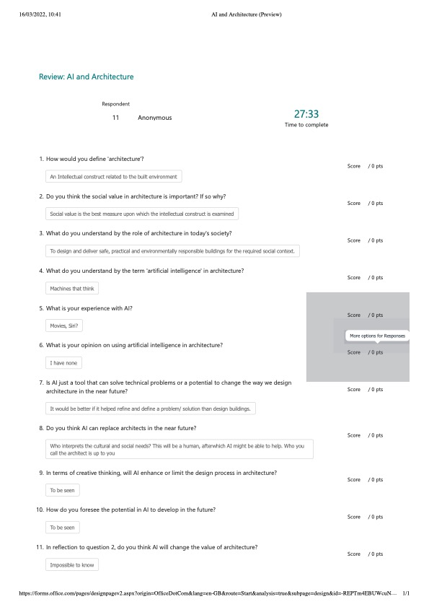

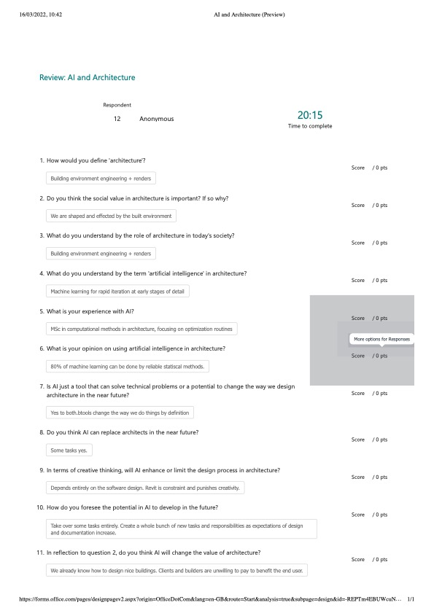

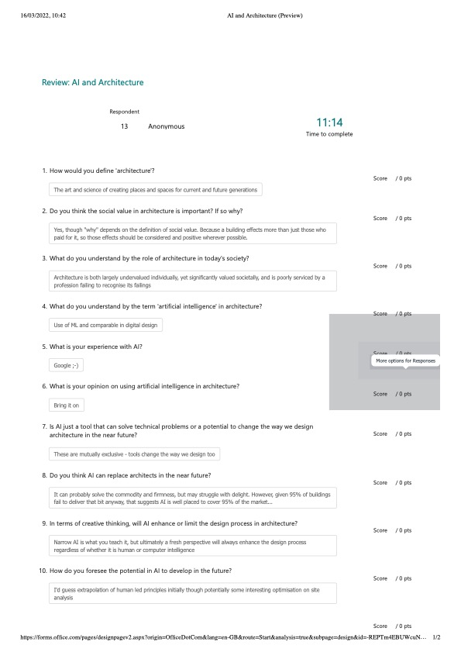

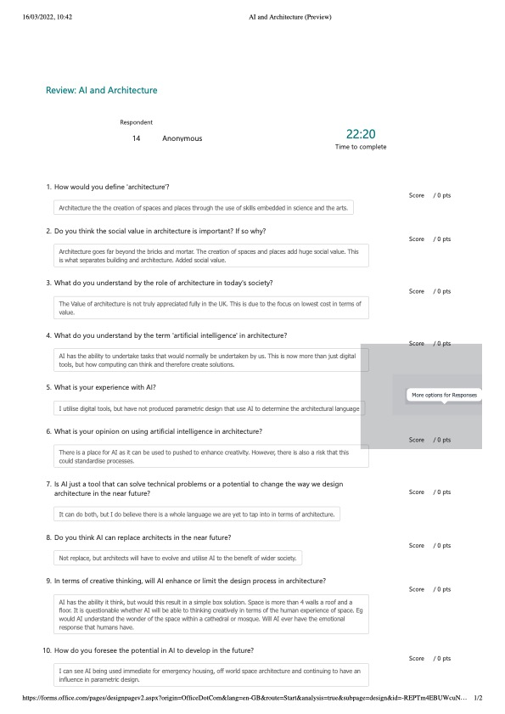

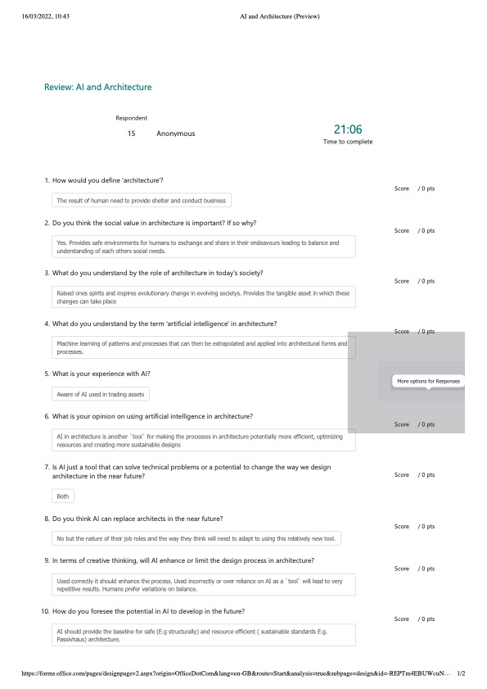

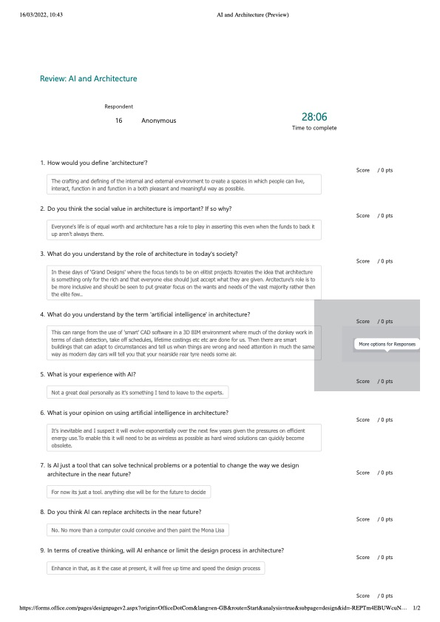

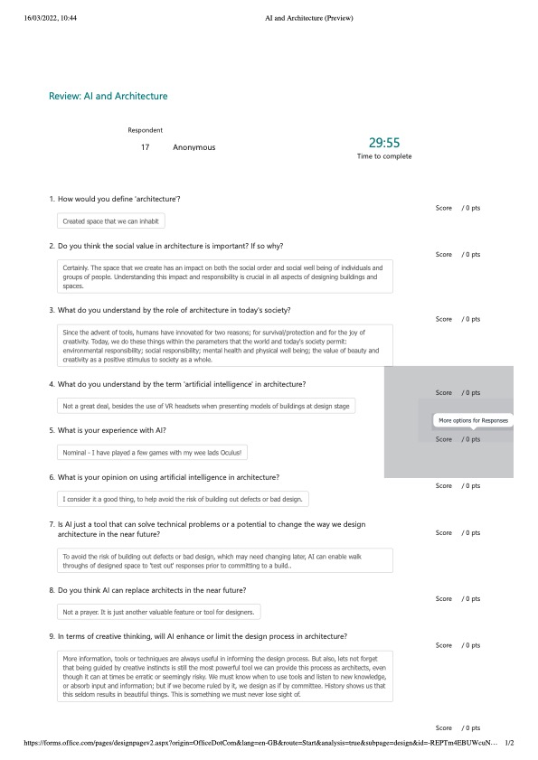

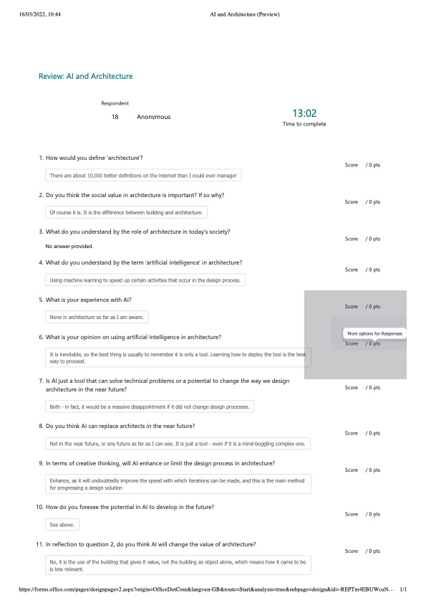

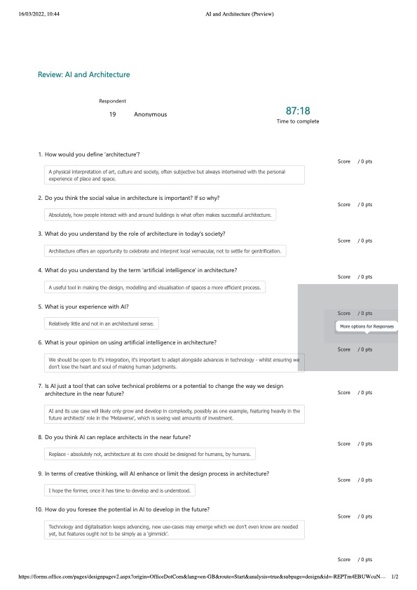

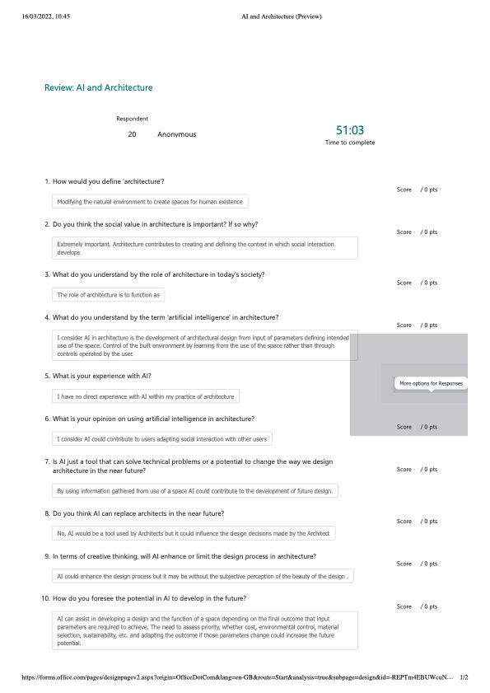

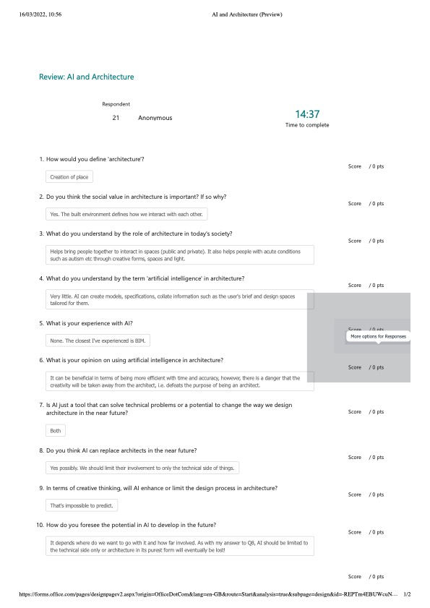

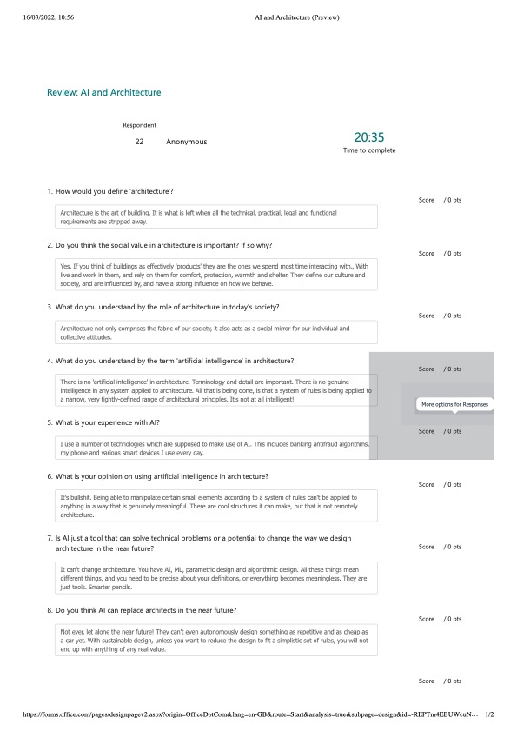

Jones, R., AD Classics: Walt Disney Concert Hall / Gehry Partner. 2013
Rhodes, M., Tracing the legacy of Zaha Hadid, Architecture’s Esteemed Anomaly. 2016
Chillou, S., A tour of AI in Architecture. 2020
McCluskey, A., Modularity: upgrading to the next generation design architecture. 2016
Merin, G., AD Classics: The Dymaxion House / Buckminster Fuller. 2019
Chillou, S., A tour of AI in Architecture. 2020
Kilkelly, M., 5 ways Computational design will change the way you work. 2016
Geol, A., Notes on Christopher Alexander’s Notes on the Synthesis of Form and Design Thinking. 2014
Suzuki, E., What is Parametric design in Architecture, and how is it shaping the industry? 2020
Davis, D., Chapter 2 – The Challenges of Parametric Modelling. 2013
Zaha Hadid Architects. “Kartal Masterplan”. 2006
Chillou, S., A tour of AI in Architecture. 2020
Appen., AI vs. Deep Learning vs. Machine Learning: Everything You’ve Ever Wanted to Know. 2022
Copeland, B.J., “artificial intelligence”. 2021
Copeland, B.J., “artificial intelligence”. 2021
National Museums Scotland., Freddy the Robot. 2022
Copeland, B.J., “artificial intelligence”. 2021
Wood, H., The Architecture of Artificial Intelligence. 2017
Alexander, C., Notes on the synthesis of form. 1964
Raphy, R., Can artificial intelligence replace Architects – A realist’s perspective. 2020
Oberste-Ufer, K., 7 ways artificial intelligence is revolutionising Architecture. 2019
Boden, M., “The quest for AI creativity”. 1973
Copeland, B.J., “artificial intelligence”. 2021
George, B. and Gillis, A.S., Turing test. 2021
George, B. and Gillis, A.S., Turing Test. 2021
Tsigkari, M. and Tarabishy, S. and Kosicki, M., Towards Artificial Intelligence in Architecture: How machine learning can change the way we approach design. 2021
Tsigkari, M. and Tarabishy. and S. Kosicki, M., Towards Artificial Intelligence in Architecture: How machine learning can change the way we approach design. 2021
Tsigkari, M. and Tarabishy, S. and Kosicki, M., Towards Artificial Intelligence in Architecture: How machine learning can change the way we approach design. 2021
Tsigkari, M. Tarabishy, S. Kosicki, M., Towards Artificial Intelligence in Architecture: How machine learning can change the way we approach design. 2021
Langdon, D., AD Classics: Yokohama International Passenger terminal / Foreign Office Architects. 2014
Godsberry, M. and Thomas, I.C., Navigating the Growing Influence of Artificial Intelligence in Building Design. 2020
Godsberry, M. and Thomas, I.C., Navigating the Growing Influence of Artificial Intelligence in Building Design. 2020
Pagnotta, B., AD Classic: The Guggenheim Museum Bilbao / Gehry partners. 2013
Goldsberry, M. and Thomas, I.C., Navigating the Growing Influence of Artificial Intelligence in Building Design. 2020
Lynn, G., “Greg Lynn’s Embryological House, “AD” Contemporary Processes in Architecture”. 2007

