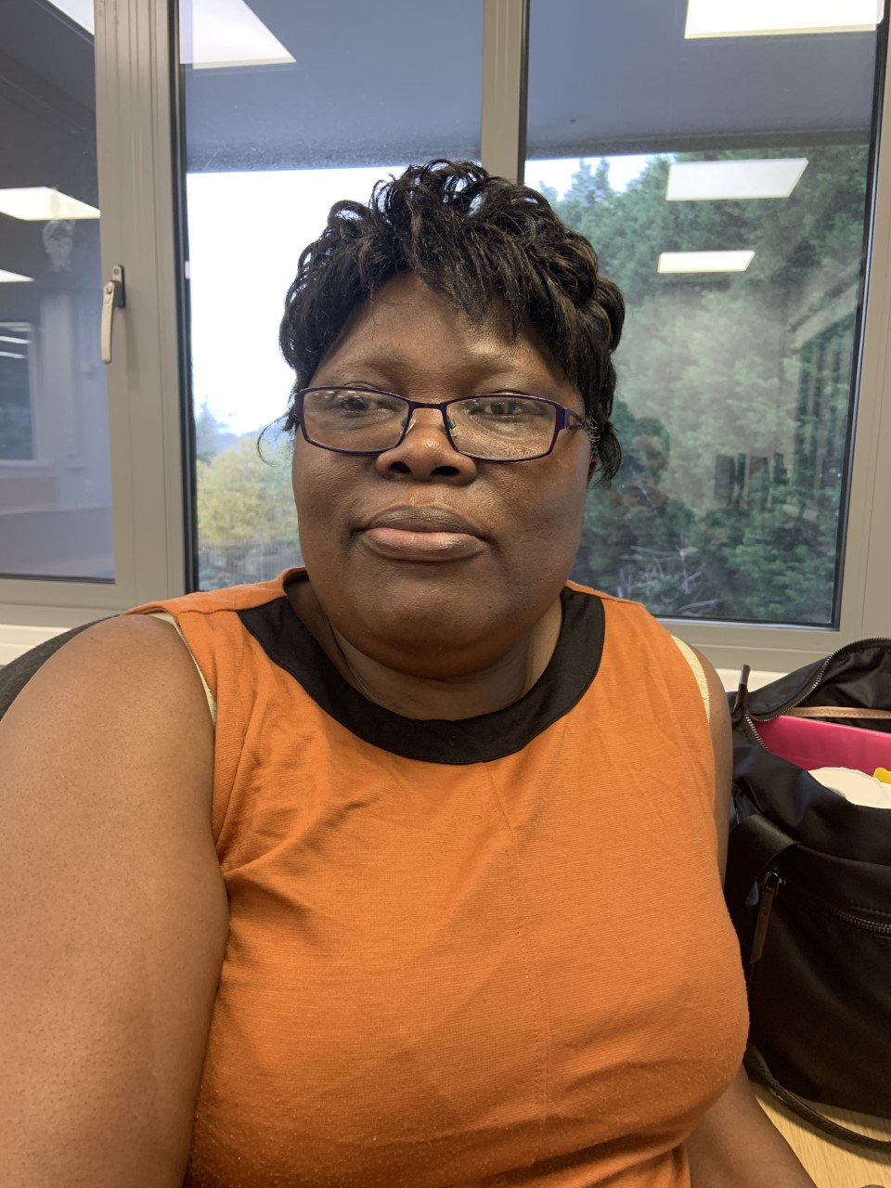

Name Dora Balogun

Student number 1902347

Student e-mail address 1902347@student.uwtsd.ac.uk

Contact number 07383544635

I have chosen the course of study because l like to care for the vulnerable, have work in care sector for the past 15 years, working with different client group in different home – Nursing, Residential home and the hospital.
l have decided to study Adult Nursing to acquire more knowledge to attain a Degree Level and do my job in a professional manner thereby elevate suffering and pain to the best of my ability, knowledge and experience.
My special interest is to promote the gospel, to locate prospective members to turn from their bad ways and try to follow the example of our lord

