Task-1 Poster.
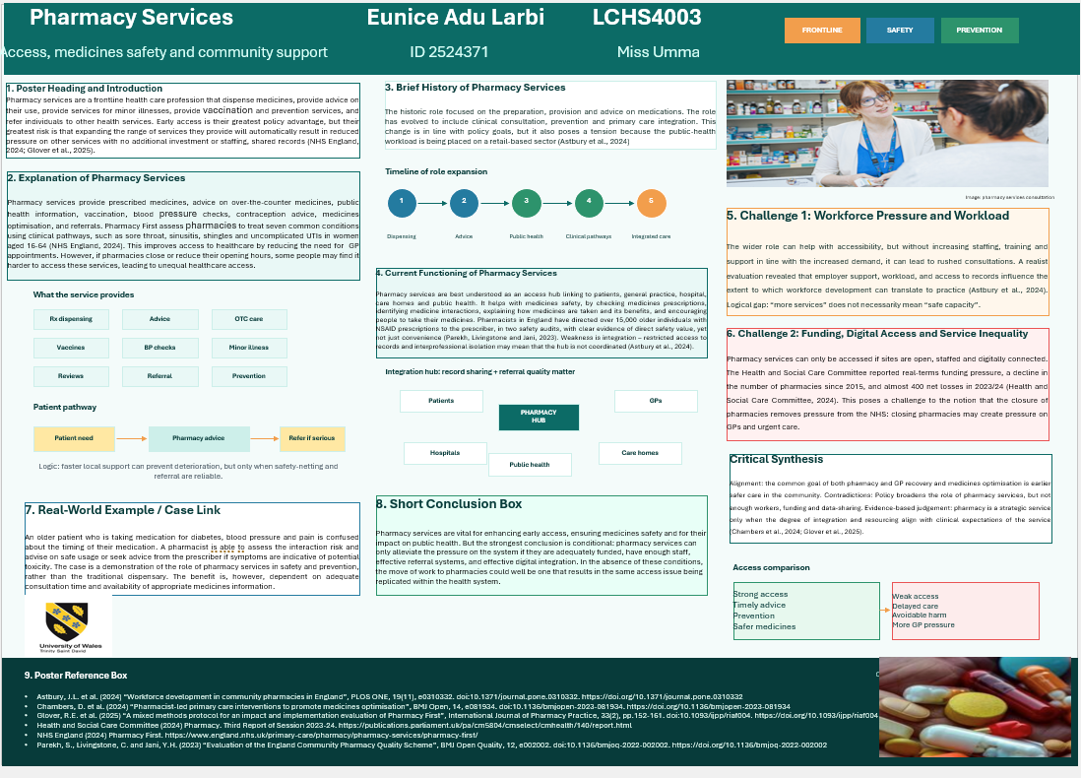

Eunice Adu Larbi
ID 2524371
LCHS4003
Miss Umma

Activity2 Essay
Exploring History, Current Practices, and the Impact of Residential Care Homes on Enhancing the Quality of Life
Introduction
Residential care homes provide housing, assistance with daily needs, and supervision for individuals who need ongoing support and cannot live safely on their own. This essay examines their historical development, current functions, and contributions to quality of life, while evaluating risks to independence, privacy, and choice.

Origins and Historical Context

Historical development
Residential care in England developed from charitable, religious and workhouse provision for older, poor and disabled people. Although the welfare state increased public responsibility for care, adult social care remains means-tested rather than free at the point of use (The King’s Fund, 2023). Therefore, access is shaped by need and financial circumstances.

Changing purpose of residential care
Residential care has shifted from basic shelter to regulated, person-centred support. Modern provision should promote dignity, safeguarding, choice and individualised care planning. However, Damant et al. (2025) show that person-centred care depends on staffing, leadership and everyday practice, not care plans alone.

How Residential Care Homes Function Today

Core functions
Care homes support people with washing, dressing, eating, mobility, medicines, activities and safeguarding. They are valuable when living alone creates risks such as falls, neglect, malnutrition or isolation. However, rigid routines may reduce privacy, identity and family contact.

Regulation and care quality
Care homes are regulated for safety, effectiveness, caring practice, responsiveness and leadership (Care Quality Commission, 2025a). Regulation supports accountability, although ratings cannot fully show residents' lived experience. CQC ratings also combine older and newer frameworks, limiting direct comparison (Care Quality Commission, 2025b).

Critical evaluation
Care homes can offer security, routine and social contact, but quality depends heavily on workforce stability. Skills for Care (2025) identifies continuing recruitment, retention and pay pressures. The StaRQ study also found variation in the quality of care, with staffing as a key factor (Gordon et al., 2024).

Significance of Quality of Life

Positive contribution
Residential care can improve quality of life through safety, nutrition, companionship and emergency support. For example, a person with dementia who forgets meals or medicines may be safer in a well-run home. Towers et al. (2021) link better quality-of-life outcomes with stronger CQC ratings and working conditions.

Critical balance
Nevertheless, protection can become restrictive. Residents may gain physical safety but lose independence, privacy and meaningful choice. The King’s Fund (2026) reports that 37% of care home residents in England in 2023 were self-funders, showing choice is linked to personal resources.

2.5 Conclusion
Residential care homes have developed from institutional origins into regulated social care services. They remain vital for people with complex needs, but effectiveness depends on staffing, safeguarding and person-centred practice. High-quality homes improve quality of life by protecting residents from harm while supporting dignity, independence and social connection.

References
Care Quality Commission (2025a) Assessment framework. Available at: https://www.cqc.org.uk/guidance-regulation/providers/assessment/assessment-framework (Accessed: 13 July 2026).
Care Quality Commission (2025b) Appendix: ratings charts: State of Care 2024/25. Available at: https://www.cqc.org.uk/publications/major-report/state-care/2024-2025/charts (Accessed: 13 July 2026).
Damant, J., Hamashima, Y., Toma, M., Smith, N., Taylor, J., Caprioli, T., Jasim, S., Prato, L., Mcleod, H., Giebel, C., Peters, M., Ferguson Montague, A., Wright, L., Knapp, M. and Towers, A. (2025) ‘Investigating person-centred care planning in care homes across England: an exploratory study of practices and contextual factors’, Journal of Advanced Nursing. Available at: https://doi.org/10.1111/jan.16965.
Gordon, A.L. et al. (2024) ‘Relationship between staff and quality of care in care homes: StaRQ mixed methods study’, Health and Social Care Delivery Research, 12(8). Available at: https://doi.org/10.3310/GWTT8143.
Skills for Care (2025). The state of the adult social care sector and workforce in England. Available at: https://www.skillsforcare.org.uk/Adult-Social-Care-Workforce-Data/workforceintelligence/Reports-and-visualisations/National-information/The-State-of-report.aspx (Accessed: 13 July 2026).
The King’s Fund (2023) A history of social care funding reform in England: 1948 to 2023. Available at: https://www.kingsfund.org.uk/insight-and-analysis/data-and-charts/short-history-social-care-funding (Accessed: 13 July 2026).
The King’s Fund (2026) Social Care 360. Available at: https://www.kingsfund.org.uk/insight-and-analysis/long-reads/social-care-360 (Accessed: 13 July 2026).
Towers, A.M., Smith, N., Allan, S., Vadean, F., Collins, G., Rand, S., Bostock, J., Ramsbottom, H., Forder, J., Lanza, S. and Cassell, J. (2021) ‘Care home residents’ quality of life and its association with CQC ratings and workforce issues: the MiCareHQ mixed-methods study’, Health and Social Care Delivery Research, 9(19). Available at: https://doi.org/10.3310/hsdr09190.

