THE GLOBAL BUSINESS ENVIRONMENT
MODULE CODE: LCBB4005

STUDENT NAME: ELENA ALINA GRIGORAS
STUDENT ID: 2112864

LECTURER NAME: MR. NADEEM MIRZA

UNIVERSITY OF WALES TRINITY SAINT DAVID
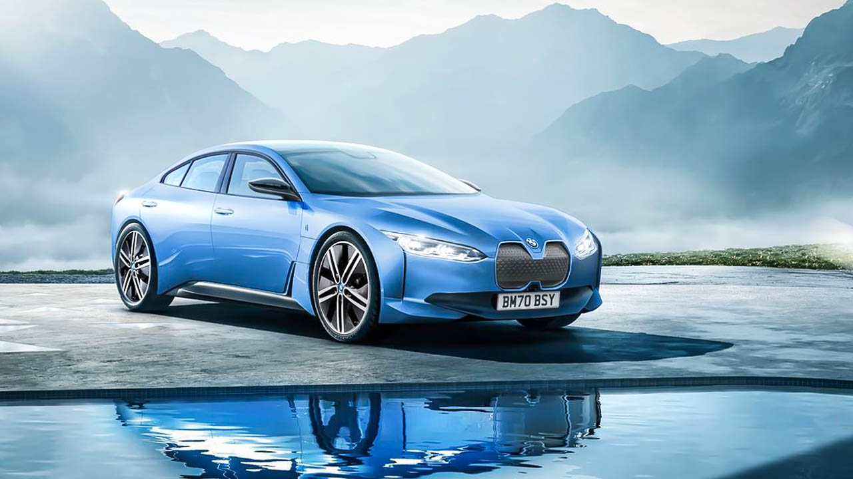Assessement 2

TABLE OF CONTENTS

Introduction 3
1. “Analyzing the impact of the pandemic upon the automobile industry” 4
2. “Developing survival and success factors for the industry with consideration to megatrends” 7
Conclusion 10
References 11

INTRODUCTION
BMW is one of the automotive car manufacturing companies that deal up in selling of premium cars. They are profound of luxury vehicles and high branding motorcycle in the industry. They are referring to be the world’s fourteenth largest manufacturer and producer of high expensive motor vehicles. They subjected to produce about 3,50,475 vehicles in the industry and are established in china, Mexico, UK, US etc. The automotive industry is reflected concisely with a wide range of organisations and companies that are involved within the design, manufacturing, development and subjectively selling up of motor vehicles. It is subjected to be one of the world's largest industries by revenue. The report will refer to assessment 1 and will put light upon the impact of pandemic over the automobile industry. The report will also develop success factors in reflection to megatrends.

1. “Analysing the impact of the pandemic upon the automobile industry”

The automotive industry has been completely devastated by the negative impact of covid-19 pandemic. Majority of the countries across the globe had been seen limiting up transportation due to the outbreak of covid-19. This involves a prolonged truncation of need and requirement because of national lockdowns and a slowdown of their respective supplies as each and every manufacturing plant has seen to be closed (Ojha, Mathew and Venkatesh, 2021). Countries like Europe and US have seen they’re less going down and ratio of production and selling of cars has committed to drop up by 70% during the period of March and April. When the demand started to hit up within the period of 2021. The semiconductors sector has reflected back its manufacturing of its microchip because of lack of demand within the period of 2020. As these semiconductors play a high role in controlling the air conditioning systems, then it is subject to monitor the pressure of the tire or to assure that the airbag of the cars be safe so that customers can manage it safely while facing accidents (Arribas-Ibar, Nylund and Brem, 2021). The shortage of chips globally has wisely impacted the automotive supplies and left them to initiate harder for their particular manufacturers to meet the emerging demand of the cars. One of the known cars has seen a high drop within its inventory and has not been able to retain its position.
The worldwide sales of automotive vehicles have seen dropping to 65 million within the period of 2020. Major production of motor vehicles has seen going down and also refer to the European markets within the month of October 2020. The UK has seen dropping up their inventory to sales ratio vastly within the period of 2020. The interest loans upon the new cars also saw enabling low within the period of 2014 (Wang and Wells, 2020).
The impact of covid-19 has also been reflected within the automobile manufacturers worldwide sales. For example, companies like the Volkswagen team has seen an immense drop of over a million units within their specific deliveries. They have reported to close its manufacturing within European countries within the period of March 2020. They also faced production cuts within the period of August because of a global shortage of chips. Even they have been reflected to seek drops in revenues of about 35 billion Euros.
The impact of covid-19 pandemic has pushed the economy to seek a disaster. The extended truncation of client’s demands because of the lockdowns is seen to be drastically impacting upon the auto manufactures of the automobile industry. The auto dealers are reflected in major issues and problems. They have not been able to transport vehicles for the lockdown period. They have been committing to a low price for the commencement of the post lockdown. They have been predicted that an amount of 7-9% of the dealership will be performing inappropriately. The auto suppliers are reflected to have sophisticated reliance upon the immigrant labour, whose absence is anticipated to more delay “restoration” post lockdown, ensuing within a high consequence upon the total assessment chain. The automotive suppliers have stood to face high challenges of liquidity that may commit to fade up in the market situation or circumstances, causing more effective troubles around the complete manufacturing network.
The automotive sector is on the major line because of the high predictive cause though the epidemic to trade and have reflected negative within the financial position into an unwanted situation. The sales of automobile vehicles have seen dropping by 18% globally and have blocked the complete production of these cars. About a rate of 80milion automobile vehicles have been produced and out of that 17% went down. As per 2021, global sales of the vehicles have been committed to drop to an amount of 75 million units. Within the terms of sales, about a reduction of 14% is forecast for the period of 2020 (Purwanto et al., 2020).
As per to the society of automobile force, the sector had been registered a high negative growth within sales of each and every vehicles has sacred and decline of about 3% within the sales of the passengers vehicles, and an amount of 14% fall within the sales of two-wheelers, an about of 21% of fall within the sales of the commercial vehicles and an account of 68% fall within sales of three wheelers. The production cuts fell upon negatively and had impacted the employment growth. Majority of the well-known cars brands had derived about a cut of within temporary workforce by 7% which functioned to drop within the car sales. The automobile sectors are one of the fast growing and demandable and are one who contributes the highest to the country’s GDP, but the automakers are seen facing up the decline over the years because of the pandemic within a rate of about 35% within the recent months. As within the pandemic, when the following dealership across the world scrambled to meet evolution within individual restrictions, the dealers and to connect with the customers through calls and video conferencing it through by specific appointment, the pandemic related restrictions has subject to process inappropriate flow of purchasing cars through visiting showrooms, as they can book a car through online but can’t reflect to get the car online (SUBATHRA et al., 2021). Individual’s still, reflected to function to connect automobile dealers and want to sit in and take real test drives through visiting their respective showrooms. These have been a challenging aspect for them to reconnect within these tough times. Supply chain has been a key concern to the automotive manufacturers as they all negatively had to face geopolitical tensions, then the extensive shortages of chip has made them stressed and have seen committing pressures within them. They have seen it lose the main motivations as the new entrants have been stood within a difficult position, as this pandemic will not subject them to sustain in these competitive industries. The big giants have already processed strategy to reflect back upon such situations like pandemic. Due to poor and low trading connections could have loosened up its market strength and opportunities.
Impact of covid-19 has been high and precise upon the giant automobile company BMW which reflects to surface up expensive models to the world. Therefore, the CEO of BMW felt to seek misbalance within its production of cars. They further committed that their first priority is to protect up its employees and to intermittently adapt to function up responsibilities for the society. They have committed to from out a corona competence team within the period of January and they even commenced that it needs to function further in the future. They have been actively moving on within the pandemic. They have been flexibly trying up to adjust to meet up demands. But their operations in South Africa and Europe have seen to determinate within to commencing up their car dealerships (Dehal, Vaidya and Kumar, 2021). Their demands drowned and have seen to be got weakened. They supply and drive out premium cars that only be brought up by the customers with high profits and to book up their cars seen a devastating side within a lower margin line of about 70% down. But on the other the productive strategies compiled to get a stand out signs be drive within the right path by acquiring about 96% of dealers to get reconnected within China’s production house and this arrival of orders started to acquire position within the pandemic (Bentvelsen et al., 2022).
The CEO of BMW, a popular international car manufacturing company, reflected to state that impact of covid worldwide has created a chance of low earnings before the tax to get decrease significantly. BMW had commenced that they will on the track and will lead to more innovations that can eliminate covid to not harm up their productions. They are initialising investment on high up fronts and developing e-mobility, then autonomous vehicles and to surface through vehicle connectivity. They conserve profound abilities that has left them lower level of impact of covid upon them (Figure 1). BMW has drawn to loss about 670 million euros that is before the interest and taxes within the month of April. They have seen to make more late deliveries and are surfaced to hit up pandemic by shutting up their factories and dealerships which was stated up by the CEO. BMW was seemed to whop for trading that lost up about 5% in the Frankfurt trading and they have committed to loss up more than a fifth of this year. They have been finding to recover within from the April (Szkudlarek, 2022). Within such ineffectiveness they have been stated to drive out IX3 in the market of china to start a flow of rapid production.

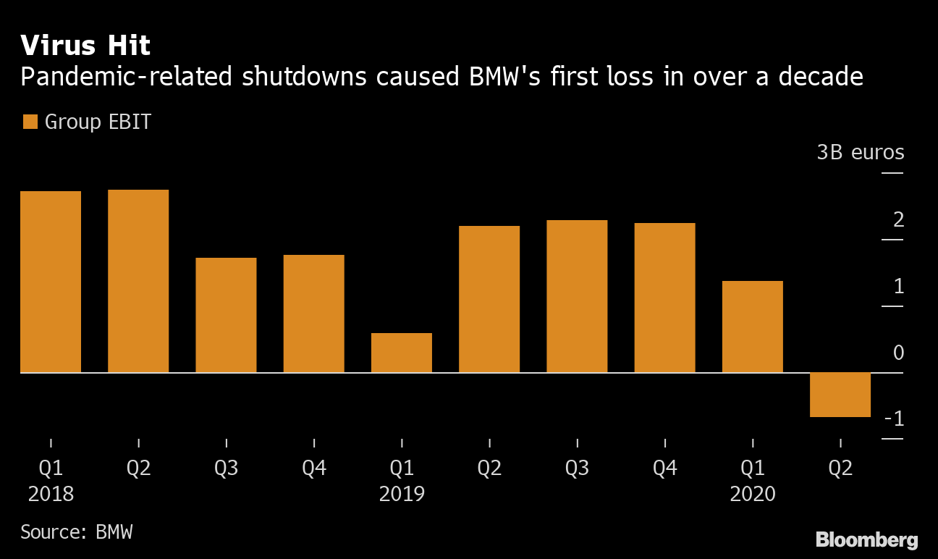

Figure 1. Pandemic BMW shutdowns

2. “Developing survival and success factors for the industry with consideration to megatrends”
The success factor for automobiles is to sustain through the mega trends which will reflect upon to be an effective factor to drive enormous strength to contribute positively and advancement to its customer and the economy. The automotive future will be electrified, will be shared, autonomous and will be connected and also will be updated from time to time (Verma and Venkatesan, 2021). It will emit low exhaust fumes and noise within its environment due to its eclectic nature. These will be reflected to take and initiate less personal time and specific space due to its autonomy. These will create more accessibility due to the user and clients will not specifically require any driving license to utilize it. About a rate of 45% of the mileage driven in Europe will be reflected to get covered through autonomous vehicles within the next 10years. From the perspective of customers these choices will serve more benefits and will be easier, cheaper, and safer and will reflect to be highly comfortable (Van Veldhoven and Vanthienen, 2021). These will be changing paths, as this individual mobility will force the automobile industry to reinvent to a wider extent. As they have figured to increase focus upon the inventory of the existing cars and within the sales of the new cars. It has been depicted that about 26% of personal mileage will rise in the UK by the next 9 years. The change in mobility behaviour will rise widely when the legal question will be clarified and hurdles that are engaging through technologies will commence to be stopped, therefore the share in autonomous mobility will increase in terms of road traffic. Because of the rise in population figures and demands of higher mobility has seen rising and the referred mileage will increase, these will be committed to be safer, reliable and comfortable will strongly move towards individual’s mobility. Individual transport could be an emerging option which can be preferable for the group of people who have not accessed transport at all in the past. These can be for physically disability people. As per report about 290 to 150 million vehicles inventory will be decreased within the next 10 years.
More than about 60% of each and every new car will be completely electrified by next 7 years. Within the phase of the next 3years that the subjective suppliers and manufacturers are committed to strengthening margins and will definitely be spending upon the customer oriented innovations. Increase in sales volumes of the new vehicles that are subject to investment upon the mobility services to leave out initial declines upon the core areas of businesses (Androsch and Redl, 2019). These will be demanding more investment in the production ability for the essential hardware and the companies that implement more flexible and scalable derivations will reflect to play an effective role within shaping future from next 6 years. About a rate of 27% of companies that are subject to invest upon software applications through the R&D department will see immense growth and development and strong strength to sustain within the market for a longer period of time. The automobile industry had to make high concerns about the priority of its needs and the comfort of their respective users.
Lightweight materials within the automotive design could have decrease up the strong weight of the chassis at a rate of 55% and each of its 15% deduction within the weight can rise up more fuel efficiency through up to 9% (Krause, 2020). They became more essential to the automotive sector shifts towards rising of the electrification as subjectively allows the cars to carry much precise safety, emissions and electronics without respectively rising up the mass of the vehicles. As per the report of consumers will be commit to save more than 6 billion gallons of fuel or by a single year within the next 10 years. As even carbon fibre is one of the subjective materials that functions to attract automobile manufacturers because these process engineers to generate parts with significantly lower mass but are similar within functioning up any performance that are basically similar to lightweight metals. The other successive paths that can lead to the automobile industry can seek through the mega trends such as automation and self-driving cars, the IoT technologies are committing to transform the whole automobile industry. Through progressing with artificial intelligence, they are reflected to enhance both the safety and efficiency of their respective vehicles (Kreuzer and Tomaschitz, 2020). The commitment of electric vehicles is shaping up the whole automotive industry. These are even less expensive to respective manufacturers. These will drive success to the companies about what to initiate and how they will be taking up a move towards shaping up their organisation. The success factor for BMW is to look out the most fascinating and extensive megatrend that are to introduce more electric cars in the industry (Lewin, 2019). BMW has been suspected to drive and planned out more electric vehicles in the market such as big IX SUV that are consuming to do well and are reflected to commit more progression in situating competitive factor in the market. BMW has signified to commit less production in pandemic, therefore they have been initialising to stay up in frontline so that they can regain pace in its competitive edge (Ratnaparkhi et al., 2019). These are a successive move for them that they had been implied to dual development of electric vehicles. These will make a high competition to Tesla in the future.

CONCLUSION
This report has discussed the impact of the pandemic over the automobile industry. The impact of covid-19 has also been reflected within the automobile manufacturers worldwide sales. For example, companies like the BMW teams have seen an immense drop of over a million units within their specific deliveries. They have reported to close its manufacturing within European countries within the period of March 2020. This report also derived success factors within reflection to megatrends. Through progressing with artificial intelligence they are reflected to enhance both the safety and efficiency of their respective vehicles. The commitment of electric vehicles is shaping up the whole automotive industry.

REFERENCES
1. Androsch, F.M. and Redl, U. (2019). How Megatrends Drive Innovation. BHM Berg- und Hüttenmännische Monatshefte, 164(11), pp.479–483.
2. Arribas-Ibar, M., Nylund, P. and Brem, A. (2021). The Risk of Dissolution of Sustainable Innovation Ecosystems in Times of Crisis: The Electric Vehicle during the COVID-19 Pandemic. Sustainability, 13(3), p.1319.
3. Bentvelsen, R.G., Arkel, A.L.E.V., Rijpstra, T.A., Kant, M.K.M., Brugge, S.V.D.S.-V.D., Loth, D.W., Van Wijngaarden, P., Mée, A.W.F.D., Yick, D.C.Y., Diederen, B.M.W., Wever, P.C., Leenders, A.C.A.P., Van Dommelen, L., Groot, K.H.D., Van den Bijllaardt, W. and Verweij, P.E. (2022). Regional Impact of COVID-19-Associated Pulmonary Aspergillosis (CAPA) during the First Wave. Journal of Fungi, 8(2), p.96.
4. Dehal, A., Vaidya, A.N. and Kumar, A.R. (2021). Biomedical waste generation and management during COVID-19 pandemic in India: challenges and possible management strategies. Environmental Science and Pollution Research, pp.1-16.
5. Krause, M., (2020). Technologies and Innovations for the Plastics Industry: Polymer 2030. In Innovative Technologies for Market Leadership (pp. 233-243). Springer, Cham.
6. Kreuzer, V.I. and Tomaschitz, M., 2020. Organizational challenges in automotive development. Systems Engineering for Automotive Powertrain Development, pp.1-24.
7. Lewin, T., 2019. The BMW century (No. 1, pp. 1-240). Motorbooks.
8. Ojha, R., Mathew, J. and Venkatesh, U. (2021). Excellence Through Downstream Innovation in Times of Pandemic: Insights from the Auto Sector. International Journal of Global Business and Competitiveness, 16(1), pp.16-28.
9. Purwanto, A., Fahlevi, M., Zuniawan, A., Kusuma, R.P., Supriatna, H. and Maryani, E., 2020. The Covid-19 pandemic impact on industries performance: an explorative study of Indonesian companies. Journal of Critical Review, 7, pp.1965-1972.
10. Ratnaparkhi, S., Gandhi, S.J. and Hecht, D., (2019). LIFE CYCLE ANALYSIS OF ELECTRIC AND GASOLINE CARS. In Proceedings of the International Annual Conference of the American Society for Engineering Management. (pp. 1-9). American Society for Engineering Management (ASEM).
11. SUBATHRA, C., KRISHNAKUMARI, S. and YUVARAJ, D., 2021. COVID-19 PANDEMICS EEFECT ON INDUSTRY--A STUDY. Ilkogretim Online, 20(4).
12. Szkudlarek, B., (2022). An Interview with Milena Pighi, Head of Corporate Social Responsibility at the BMW Group. In Advances in Global Leadership. Emerald Publishing Limited.
13. Van Veldhoven, Z. and Vanthienen, J. (2021). Digital transformation as an interaction-driven perspective between business, society, and technology. Electronic Markets. (pp. 1-9).
14. Verma, A. and Venkatesan, M. (2021). Industry 4.0 workforce implications and strategies for organisational effectiveness in Indian automotive industry: a review. Technology Analysis & Strategic Management, pp.1–9.
15. Wang, L. and Wells, P. (2020). Automobilities after SARS-CoV-2: A Socio-Technical Perspective. Sustainability, 12(15), p.5978.

