

Report:
Analysing the flexible working procedure within South Wales Police and the perceived impact on the workforces’ wellbeing
Submitted by: Daniel Taylor
Student ID: 2311575
Word count: Research paper – 2938
Poster – 870
Total: 3810

Contents
Introduction 2
Literature review 2
Flexible working – growth of hybrid/ home working 2
Work life balance and impact on wellbeing 3
Flexible working perceptions and gender disparity 4
Methodology 4
Aim and objectives 4
Research Philosophy 4
Research Methodology 5
Research participants 5
Reliability, validity and research limitations 6
Analysing the data 6
Research findings 6
Demographic 6
Employee type and length of service 7
Rank and Grade 8
Flexible working process and information available 8
Application process and impact on wellbeing 9
Support during the process 10
Further improvements to the process 11
Perception of flexible working 11
Conclusion 12
Reference List 13
Appendices 15
Email sent to sample identified 15
Poster – word submission 16

Introduction

The demand for organisations to offer flexible working has increased, providing flexible working arrangements to individuals can provide benefits to the individual and the organisation (McCartney 2024) & (Brower 2022). From the 6th April 2024, the Flexible Working (Amendment) Regulations 2023 were published. Key changes included consultation with individuals when they make a request and the right to request flexible working arrangements from day one (Legislation.go.uk 2023). Research conducted by CIPD (2023a) highlighted that there has been a 40% increase in flexible working requests, with 6% of individuals leaving their jobs due to lack of flexible working, but highlighted improvements to employee wellbeing.
South Wales Police (SWP) is a public sector organisation, it is the largest police force in Wales. The force has roughly 6,500 employees consisting of police officers and police staff (SWP 2024a). SWP aim is to keep South Wales safe, by providing an effective service to the communities it serves (SWP no date).

As part of the forces vision and values it has committed to promoting and supporting a family friendly working environment, recognising the value of flexible working practices to enable employees to balance their professional and personal lives (SWP 2021).

The aim of this report is to analyse the flexible working procedure within SWP and the perceived impact on the workforces’ wellbeing.
The report will consist of primary and secondary research. It will also explore the current practices in place at SWP and how this is impacting on the workforce’s wellbeing. If employee wellbeing is low, this could impact the force aim of providing an effective service to the communities it serves by individuals poor performance or attendance in the workplace. If employee wellbeing is high this could impact SWP by improving employee engagement and productivity.

Literature review

Flexible working – growth of hybrid/ home working

CIPD (2022) data between April 2010 - December 2021 indicated minimal changes in uptake of many flexible working arrangements. However, one flexible working approach which has seen a significant increase is hybrid/ home working. This has been largely driven by the Covid-19 pandemic and workforces’ responses to this.
ONS (2020) data highlighted in April 2020, 46.6% of people in employment did some work at home. Following this ONS (2023) reported that roughly 28% of workers used hybrid working. Showing this approach was still utilised. CIPD (2024a) highlights several benefits to this approach such as reduced absence at work and increased wellbeing. However, Cholteeva (2023) did indicate that engagement and wellbeing among younger workers was worse working within a hybrid approach.
SWP chief constable delivery plan 2021-2025 highlights equipping staff with the right resources to deliver an effective service (SWP 2021a). This is reinforced within the people strategy outlining the requirements for a flexible workforce that can provide agile and collaborative solutions (SWP 2021b).
SWP has a ‘Smart working’ policy, this describes how staff can work agilely, the aim is to assist staff balancing their personal and professional lives (SWP 2022). All staff and officers are categorised under three work styles.
Fixed | Work is transactional, in a team within a fixed location.
Field | Undertake work activity from any place provided individuals have the right technology.
Flexible | Undertake work in a variety of locations and this can be achieved in a shared space.

Table 1: Smart working categorisation of roles (SWP 2022).
SWP data indicates that from May 2022 to present, there has been a 7.5% increase in posts which are deemed flexible and 10.09% decrease in fixed posts (SWP 2024b). This data signals the force recognising the benefit of hybrid working.

Work life balance and impact on wellbeing

Suff (2024) highlights the importance of managing and supporting workforces’ wellbeing through various initiatives. Including having a healthy work life balance. CIPD (2023b) Health and Wellbeing report 2023, highlighted the promotion of flexible working and work life balance as key indicator for supporting wellbeing in work. Shifrin and Michel (2022) supported this view discussing the positive impact of flexible working processes on workforces. In a policing context, Rohwer, E. et al. (2022) highlighted changing working patterns had a benefit on the wellbeing for those officers affected improving their work life balance. In contrast a poor work life balance can have a negative impact on organisations through individuals leaving their jobs because of the impact on their wellbeing.
CIPD (2024b) good work index indicated a poor work life balance was one of the top three reasons that individuals left their job. Duxbury, Bardoel and Halinski (2021) review re-iterated that a work life balance is a challenge for police officers which can impact on work and personal life negatively. Demou, Hale, and Hunt (2020) study highlighted the main work-related stressors in the Scottish police were working hours/ workload and work life balance. Platts, Breckon and Marshall (2022) highlighted the need for organisations to rethink their working practises, ensuring the mental health of the workforce is considered and further flexible working practices would help build workforce resilience.
In contrast, Bryson, Fort and Stokes (2015) established a positive relationship between job satisfaction in the workplace and performance. Showing the positive impact an individual’s workplace arrangements can have on their performance and their organisation.
The literature identifies that organisations have a duty of care for their workforce to support their work life balance and wellbeing.

Flexible working perceptions and gender disparity

SHRM (2021) and Brecheisen (2023) research highlighted negative perceptions from management and workforces regarding those who can work from home versus those who could not. Walker et al (2023) conducted research with individuals working from home highlighting the unrealistic demands from line managers and the requirement to always be showing as available for meetings/ contact from others.
Sailer, Thomas and Pachilova (2023) emphasized challenges organisations now face for those working a hybrid approach such as cost of technology. Highlighting HR, line management and the culture of the organisations as key drivers for change.
Mayne (2024) survey showed that flexible working options were more of a benefit to workers rather than a pay rise when considering a new role.
Further to this Chung (2020) highlighted that there was a stigma associated with flexible working and the negative connotations associated with this approach. The study also indicated there is a disparity between male versus female take up and that positive reinforcement of flexible working can help improve productivity and remove the stigma. However, Howlett (2020) indicated that following the covid-19 pandemic more males had shown an interest in flexible working. Deloitte (2023) detailed that flexibility offered to women meant that they were more inclined to remain with their employer.
All the above show how important it is for SWP to ensure flexible working within the force is embraced and seen as a supportive process and not negatively stigmatised.

Methodology

Aim and objectives

The main aim of this report was to analyse the flexible working procedure within SWP and the perceived impact on the workforces’ wellbeing. To achieve this the following objectives were applied:
- Research and analyse literature regarding flexible working practices.
- Review existing secondary data from within SWP.
- Conduct quantitative and qualitive research through a questionnaire, to establish the impact of the flexible working procedure on wellbeing and critically analyse research findings.
- Make recommendations for improvement to the current flexible working procedure.

Research Philosophy

Young (2024) set out that evidence-based practice allows individuals to make better decisions by utilising reliable data from a range of sources, ensuring they are trustworthy. To help avoid inconsistencies.
There are many models which can be implemented when carrying out a research project. One model which can assist with selecting a research approach and decision-making is Saunder’s research onion. Saunders, Lewis and Thornhill (2019) developed this model which consists of six layers, the outer layer discusses the philosophy.
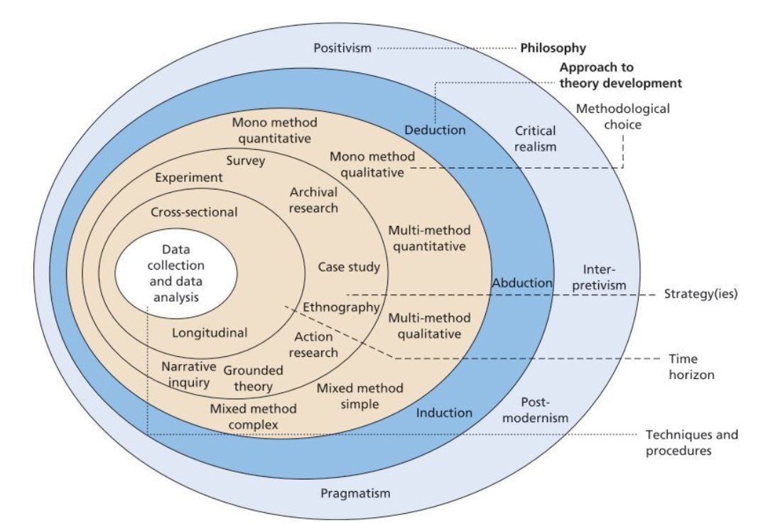
Figure 1: The research onion (Saunders, Lewis and Thornhill 2019).
Within the onion there are five philosophies highlighted which depend on an individuals’ views and type of the research which is to be carried out.
Pragmatism was the philosophical approach applied during this research project. This project focused on highlighting the flexible working practice in place, exploring individuals’ thoughts and feelings regarding this, with a view to make recommendations to improve this. The research was conducted via a mixed methods approach. Pragmatism focuses on a mixed method approach which was applied during the research (Hammond & Wellington, 2021). In comparison positivism focuses on factual knowledge which is obtained via observation. This would not be an effective philosophy given this approach is reliant on factual knowledge whereas pragmatism focuses on thoughts and views.

Research Methodology

Obtaining data has been utilised via a questionnaire which included both open and closed questions, by utilising quantitative data in relation to the number of responses received and demographic of those who responded. Qualitative data has been obtained through the questions asked which relate to the individuals’ feelings on the flexible working practise currently in place within SWP. Which will inform research findings and conclusion.

Research participants

The total sample size was 358 individuals which consisted of both police officers and police staff at various ranks and grades. These individuals were identified as submitting a flexible working request or had their current arrangement reviewed over a 12-month period (July 2023 – July 2024). These individuals were selected due to recently taking part in the process.

Reliability, validity and research limitations

As the questionnaire is specifically asking for feedback on the flexible working process there may be possible bias, based on previous experience of the process. Further to this, it captured the individual’s thoughts and feelings at that set time which could fluctuate depending on their circumstances and outcome of their application.
If there is insufficient engagement this could be because of nonresponse bias as individuals may not be willing to share their responses, this could result in sufficient data to make informed decisions. Scheaf, et al (2023) highlighted that nonresponse bias could result in a low response rate which can impact the validity of the research. One possible limitation could be that those highlighted submitted the application, the sample did not incorporate line management or other individuals who could have a vested interest in the process.

Analysing the data

The data was captured within Microsoft forms and analysed utilising Microsoft excel to pivot. Whilst utilising thematic analysis to identify trends within the qualitative data.

Research findings

The sample size was 358 individuals of which there were 148 responses, which is just over 41% return rate. Individuals were contacted via email, over the summer period with no follow up, the response rate indicates that the flexible working process is an emotive process in which the workforce want to provide feedback on.

Demographic

Over 77% of submissions were from female members of staff. Age was more equally split between the range of 30 to 59.
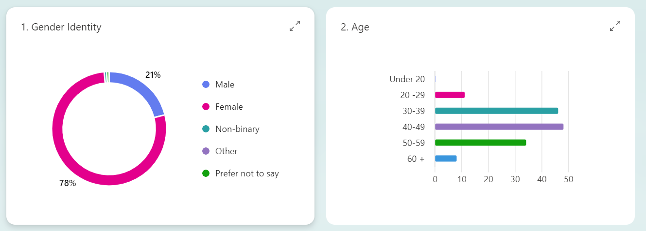
This data supports that highlighted by Chun (2020) in relation to the gender make up of those who apply for flexible working. Positive aspect of this for SWP is that literature studied discussed the benefit of having a flexible working options available for female staff which could lead to longer service and engagement with their employer (Deliotte 2023). Whilst the questionnaire highlights a disparity in gender, there was 31 responses from male members of the workforces showing there is an engagement with the process.

Employee type and length of service

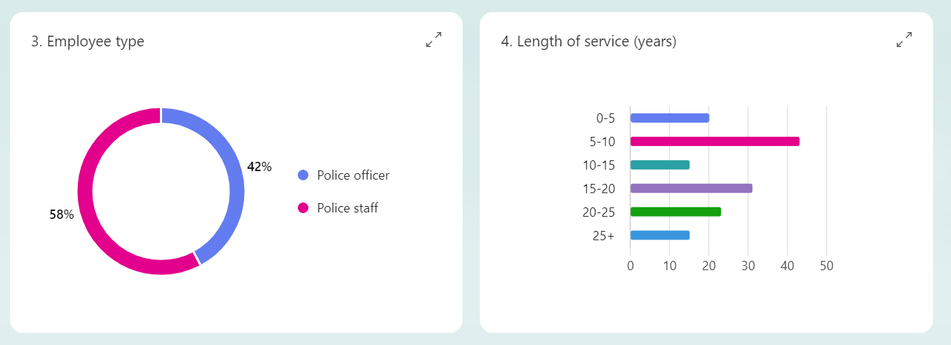
There were slightly more police staff responses. The lower response rate from officers could be linked to the nature of the roles and difficulties officers face in finding arrangements that would be suitable for them and the organisation. This was highlighted by Duxbury, Bardoel and Halinski (2021).
Length of service, 0 to 15 years there were 78 responses and 15 to 30 + years there were 70 responses. This indicates that of the sample size, flexible working options are being utilised throughout an individual’s service. When matching this with the age demographic this displays both younger and older members of the workforce are utilising flexible working.

Rank and Grade

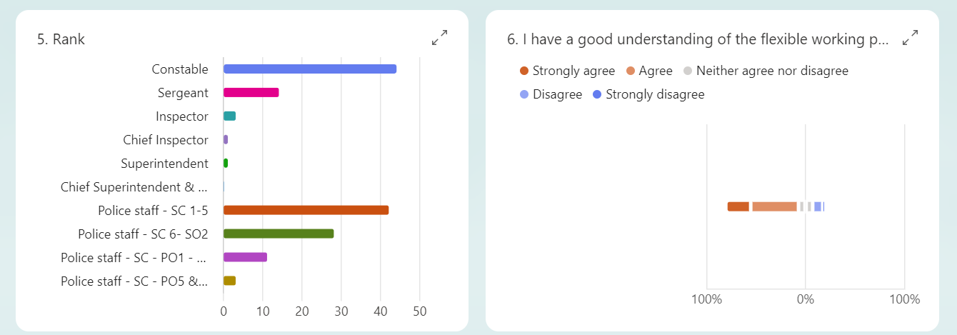
Police officers’ highest response rate came from constable and sergeant positions. Of the 64 police officer responses only 5 responses came from those of inspector rank and above. This could indicate that senior officers are reluctant to submit flexible working requests due to pressures or it could be the number of inspectors and above equate for a much smaller sample of police officers. The police staff response rate mirrors this, 70 responses were for police staff roles up to SO2 grade. Then senior principal roles accounted for 14 responses. Further research could review this narrative to see if the stigma highlighted earlier applied to those in senior positions.

Flexible working process and information available

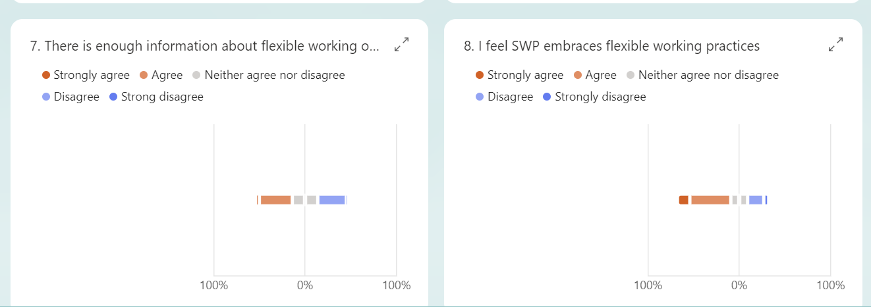
Recipients highlighted they had a good understanding of the flexible working processes available to them with only 12% disagreeing with this statement. However, 32.5% highlighted there was not enough information about flexible working on the force intranet and HR page. 58.1% of responses highlighted they feel SWP embraces flexible working practices and 23.6% of responses highlighted that they feel SWP doesn’t embrace flexible working practices. This indicates there is a requirement for SMT and HR to improve the information which is available to the workforce and how the organisation supports flexible working requests.

Application process and impact on wellbeing

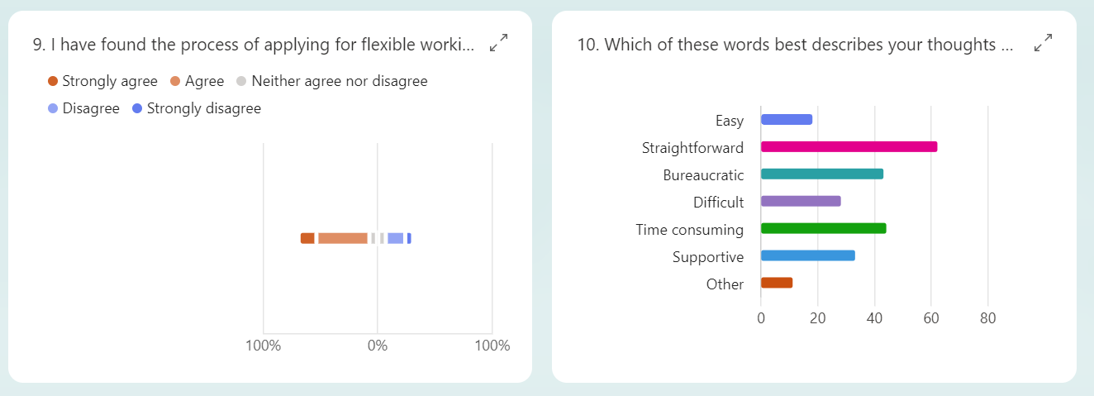
62.1% felt the process for applying was easy, with 23.7% disagreeing with this statement. When asking recipients to highlight which words applied most to them regarding the process. Highest response was straightforward with 62, however this was closely followed by time consuming with 45 and then bureaucratic with 44. The data highlighted that whilst individuals feel it’s an easy process, they also indicated it is a process which takes time and rigid. This is something SWP could explore to support the workforce.
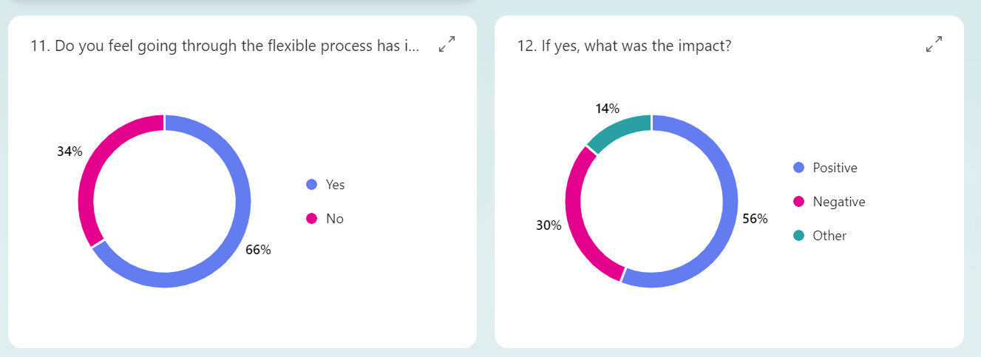
Of 148 responses, 98 felt that their wellbeing had been impacted by the process. The impact was more evenly split 56% felt it was positive. 30% felt it was negative and 14% marked other effects. One respondent detailed “Whilst the FL1 request was relatively easy to complete, it felt that it took several months to finally be approved which at time caused some anxiety” another mentioned “it can be quite a long process which is hard when you're waiting on answers. Maybe updates throughout each stage”. The data displayed that whilst there is a fairly even split on wellbeing, those impacted negatively indicate its due to the process and time taken to be approved. One response said, “depending on what supervisor can be a positive or negative experience” This could be something SWP can look to refine and utilise. To ensure all line managers buy into the process.

Support during the process

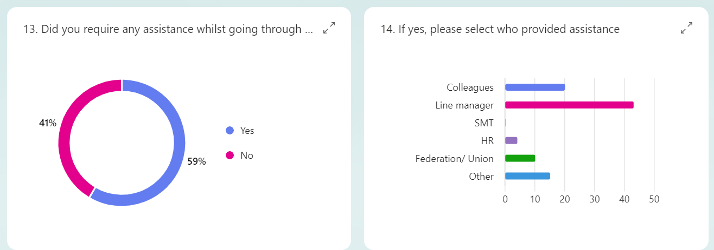
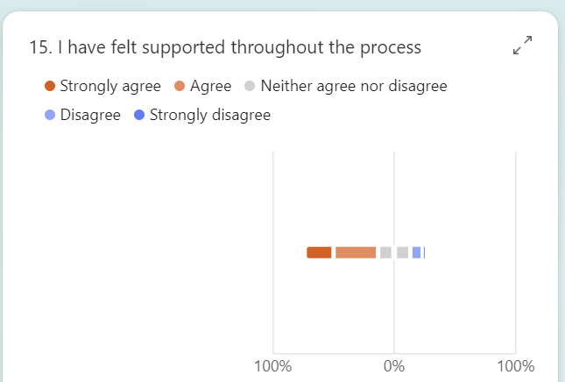
59% of respondents highlighted they needed support during the flexible working process. Highest response for support received was from line managers, followed by colleagues. This indicates line managers and colleagues are supporting one an another whilst going through this process. HR, were only required to support on 4 responses, highlighting there could be further work to ensure the workforce are aware of the support HR can provide. Over 60% of individuals felt they were supported during the process. With just 12.8% feeling they did not receive any support.

Further improvements to the process

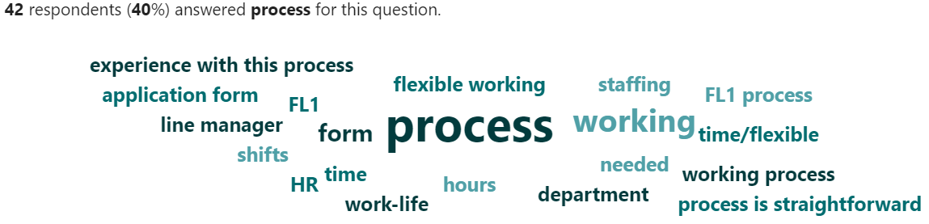
There were 107 responses to this question, with 40% highlighted the process of flexible working could be reviewed to improve the process. The responses centred around the form, process, and time to complete. One respondent detailed ‘The form is chaotic, and the time scale is ridiculous’ another stated, ‘The bottom part of the form was time consuming adding all the shift details in’, further noted ‘Regular updates as to the progress of applications with applicants throughout the process’ the feedback has highlighted the form, process and updates are crucial when going through the flexible working process.

Perception of flexible working

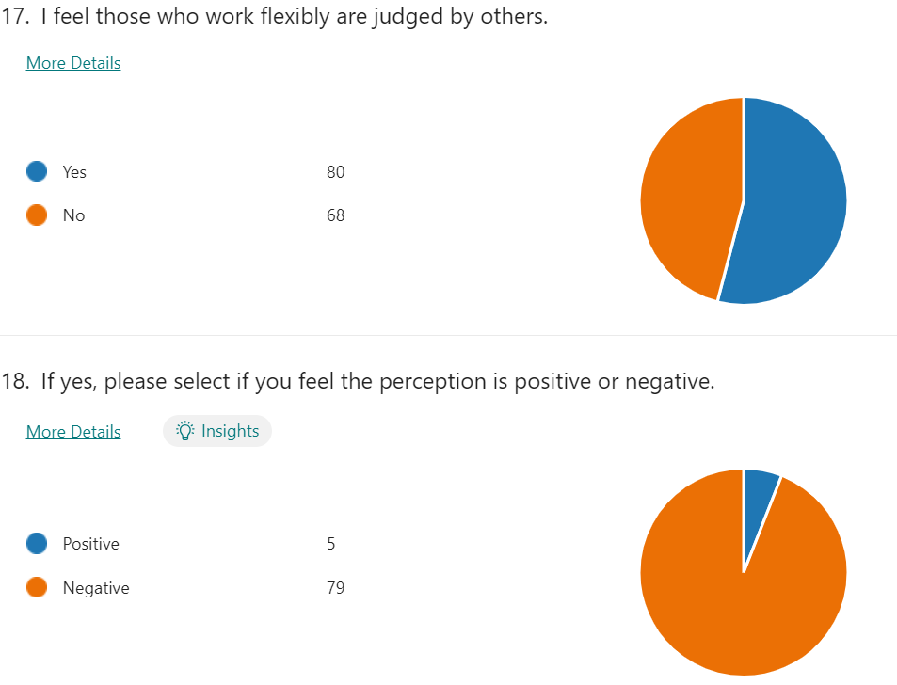
54% of respondents felt that those who work flexibly are judged by others, 94% indicated this was in a negative way. This percentage highlights the perception and negative connotations attached to flexible working are still in place within SWP. This narrative is supported by the work of SHRM (2021) and Brecheisen (2023).

Conclusion

During this research paper the aim was to focus on the flexible working procedure within SWP and the perceived impact on the workforces’ wellbeing. It’s clear from the primary and secondary research that flexible working is a sensitive process which organisations need to address in the right way.
The Covid-19 pandemic has shown organisations that flexible working practices can improve employee wellbeing and service delivery.
Wellbeing and work life balance are key indicators which need to be considered when individuals are considering or applying for flexible working. Within SWP there needs to be a wider consideration of how this can affect both officers and staff, the chief constable and SMT have committed to improving this but from the questionnaire its clear further communication is required to reinforce this message and show staff the organisation is supportive. Literature has shown, flexible working is often looked at negatively from those who have those who don’t have arrangements in place, this is highlighted within the questionnaire also with individuals feeling they are perceived negatively.
Following the research, SWP internal flexible working process will need to be reviewed with a view to identify ways to refine the process, simply the forms and ensure there is communication throughout each stage of the process. Further qualitative data could support by reviewing the process individuals are following when applying for flexible working. Currently there are a few options which are being utilised. Supportive guidance and its accessibility will need to be evaluated as individuals felt this wasn’t available on the force intranet.

Reference List

Brecheisen, J. (2023) Research: Flexible Work Is Having a Mixed Impact on Employee Well-Being and Productivity. Available at: (https://hbr.org/2023/10/research-flexible-work-is-having-a-mixed-impact-on-employee-well-being-and-productivity) (Accessed: 28 August 2024).
Brower, T. (2022) New Data Proves Flexible Work Really Works: 7 Factors For Success. Available at: (https://www.forbes.com/sites/tracybrower/2022/11/06/new-data-proves-flexible-work-really-works-7-factors-for-success/) (Accessed: 17 August 2024).
Bryson, A., Forth, J. and Stokes, L. (2015) Does worker wellbeing affect workplace performance? London School of Economics and Political Science. Centre for Economic Performance.
Cholteeva, Y. (2023) Is hybrid work good for everyone’s wellbeing? Available at: (https://www.peoplemanagement.co.uk/article/1826471/hybrid-work-good-everyones-wellbeing) (Accessed: 13 September 2024).
Chung, H. (2020) ‘Gender, Flexibility Stigma and the Perceived Negative Consequences of Flexible Working in the UK’, Social indicators research, 151(2), pp. 521–545. Available at: https://doi.org/10.1007/s11205-018-2036-7.
CIPD. (2022) Trends in flexible working arrangements. Available at: (https://www.cipd.org/uk/knowledge/reports/flexible-working-trends/) (Accessed: 17 August 2024).
CIPD. (2023a) Flexible and hybrid working practices in 2023. Available at: (https://www.cipd.org/globalassets/media/knowledge/knowledge-hub/reports/2023-pdfs/2023-flexible-hybrid-working-practices-report-8392.pdf) (Accessed: 17 August 2024).
CIPD. (2023b) Health and wellbeing at work. Available at: (https://www.cipd.org/globalassets/media/knowledge/knowledge-hub/reports/2023-pdfs/8436-health-and-wellbeing-report-2023.pdf) (Accessed: 28 August 2024).
CIPD. (2024a) Hybrid working: Guidance for people professionals. Available at: (https://www.cipd.org/uk/knowledge/guides/planning-hybrid-working/) (Accessed: 13 September 2024).
CIPD. (2024b) CIPD Good Work Index 2024. Available at: (https://www.cipd.org/globalassets/media/knowledge/knowledge-hub/reports/2024-pdfs/8625-good-work-index-2024-survey-report-web.pdf) (Accessed: 28 August 2024).
Deloitte. (2023) For women, flexibility is a matter of time (not place). Available at: (https://action.deloitte.com/insight/3324/for-women-flexibility-is-a-matter-of-time-not-place) (Accessed: 05 September 2024).
Demou, E., Hale, H. and Hunt, K. (2020) ‘Understanding the mental health and wellbeing needs of police officers and staff in Scotland’, Police practice & research, 21(6), pp. 702–716. Available at: https://doi.org/10.1080/15614263.2020.1772782.
Duxbury, L., Bardoel, A. and Halinski, M. (2021) ‘“Bringing the Badge home”: exploring the relationship between role overload, work-family conflict, and stress in police officers’, Policing & society, 31(8), pp. 997–1016. Available at: https://doi.org/10.1080/10439463.2020.1822837.
Hammond, M. and Wellington, J.J. (Jerry J.) (2021) Research methods: the key concepts. Second edition. London; Routledge.
Howlett, E. (2020) Flexible working more popular with male employees since lockdown, survey finds. Available at: (https://www.peoplemanagement.co.uk/article/1747130/flexible-working-more-popular-with-male-employees-since-lockdown0 (Accessed: 05 September 2024).
Legislation.gov.uk. (2023) The Flexible Working (Amendment) Regulations 2023. Available at: (https://www.legislation.gov.uk/uksi/2023/1328/pdfs/uksi_20231328_en.pdf?mc_cid=8ad68b89c0&mc_eid=c8247d5eac) (Accessed: 17 August 2024).
Mayne, M. (2024) Flexible working more important to most employees than a pay rise – People Management poll. Available at: (https://www.peoplemanagement.co.uk/article/1861233/flexible-working-important-employees-pay-rise-%E2%80%93-people-management-poll) (Accessed: 01 September 2024).
McCartney, C. (2024) Flexible working practices. Available at: (https://www.cipd.org/uk/knowledge/factsheets/flexible-working-factsheet/#title3) (Accessed: 17 August 2024).
Office for National Statistics. (2020) Coronavirus and homeworking in the UK: April 2020. Available at: (https://www.ons.gov.uk/employmentandlabourmarket/peopleinwork/employmentandemployeetypes/bulletins/coronavirusandhomeworkingintheuk/april2020) (Accessed: 25 August 2024).
Office for National Statistics. (2023) Characteristics of homeworkers, Great Britain: September 2022 to January 2023. Available at: (https://www.ons.gov.uk/employmentandlabourmarket/peopleinwork/employmentandemployeetypes/articles/characteristicsofhomeworkersgreatbritain/september2022tojanuary2023) (Accessed: 25 August 2024).
Platts, K., Breckon, J. and Marshall, E. (2022) ‘Enforced home-working under lockdown and its impact on employee wellbeing: a cross-sectional study’, BMC public health, 22(1), pp. 199–199. Available at: https://doi.org/10.1186/s12889-022-12630-1.
Rohwer, E. et al. (2022) “Police officers’ work–life balance, job satisfaction and quality of life: longitudinal effects after changing the shift schedule,” BMJ open, 12(9), pp. e063302–e063302. Available at: https://doi.org/10.1136/bmjopen-2022-063302.
Sailer, K., Thomas, M. and Pachilova, R. (2023) ‘The challenges of hybrid work: an architectural sociology perspective’, Buildings & cities, 4(1), pp. 650–668. Available at: https://doi.org/10.5334/bc.350.
Saunders, M.N.K., Lewis, P. and Thornhill, A. (2019) Research methods for business students. Eighth edition. Harlow, England: Pearson.
Scheaf, D.J. et al. (2023) ‘Nonresponse bias in survey‐based entrepreneurship research: A review, investigation, and recommendations’, Strategic entrepreneurship journal, 17(2), pp. 291–321. Available at: https://doi.org/10.1002/sej.1453.
Shifrin, N.V. and Michel, J.S. (2022) ‘Flexible work arrangements and employee health: A meta-analytic review’, Work and stress, 36(1), pp. 60–85. Available at: https://doi.org/10.1080/02678373.2021.1936287.
SHRM. (2021) SHRM Research Reveals Negative Perceptions of Remote Work. Available at: (https://www.shrm.org/in/about/press-room/shrm-research-reveals-negative-perceptions-remote-work) (Accessed: 28 August 2024).
South Wales Police. (no date) Overview. Available at: (https://www.south-wales.police.uk/police-forces/south-wales-police/areas/about-us/about-us/overview/) (Accessed: 17 August 2024).
South Wales Police. (2021a) Chief constable delivery plan 2021-2025. Internal Report. Unpublished.
South Wales Police. (2021b) People strategy. Internal Report. Unpublished.
South Wales Police. (2022) Smart Working procedure. Internal report. Unpublished.
South Wales Police. (2024b) Post categorisation. Internal report. Unpublished.
South Wales Police. (2024a) Employee headcount. Internal report. Unpublished.
Suff, R. (2024) Mental health in the workplace. Available at: (https://www.cipd.org/uk/knowledge/factsheets/mental-health-factsheet/) (Accessed: 28 August 2024).
Walker, L. et al. (2023) ‘“Make it the done thing”: an exploration of attitudes towards rest breaks, productivity and wellbeing while working from home’, International archives of occupational and environmental health, 96(7), pp. 1015–1027. Available at: https://doi.org/10.1007/s00420-023-01985-6.
Young, J. (2024) Evidence-based practice for effective decision-making. Available at: (https://www.cipd.org/uk/knowledge/factsheets/evidence-based-practice-factsheet/) (Accessed: 02 September 2024).

Appendices

Email sent to sample identified

Good afternoon all,

Hope you’re well. My name is Daniel Taylor. I am a HR Advisor for South Wales Police.

Currently I am studying CIPD Level 7 Strategic People Management at University of Wales Trinity Saint David.
My aim is to enhance my knowledge and skills at a strategic level within the organisation.

I am completing a piece of research into Flexible working within SWP to ensure the process is fit for purpose.

I understand that during the last 12 you have gone through the flexible working application process.

I would really appreciate your support with this project by completing the questionnaire on MS forms which is detailed in the link below.

The data you provide will be confidential and anonymised.

If you have any concerns or questions in relation to the data or information requested, please let me know, I will be happy to discuss this further.

Thank you in advance for your support.

Poster – word submission

Introduction
Flexible working is a practice in which organisations have seen an increased pressure to ensure they offer their workforce. Flexible working regulations have changed from the 6th April 2024, changes include allowing workers to make flexible working requests as a day one right. These changes are set out in the Flexible Working (Amendment) Regulations 2023 (Legislation.gov.uk 2023).
Since the Covid-19 pandemic organisations have seen a 40% increase in flexible working requests (CIPD 2023a).
South Wales Police (SWP) is a public sector organisation, it has roughly 6,500 employees consisting of police officers and police staff (SWP 2024a).

The aim of the research paper was to analyse the flexible working procedure within SWP and the perceived impact on the workforces’ wellbeing, consisting of primary and secondary research. Objectives included analysing literature regarding flexible working practices, reviewing secondary data within SWP, research via a questionnaire and recommendations for improvement to the flexible working process.

Literature review
Flexible working – growth of hybrid/ home working
CIPD (2022) data showed minimal changes in uptake of flexible working arrangements, apart from hybrid/ homeworking this has seen a substantial increase linked to the covid-19 pandemic and organisations responses to this.
The SWP delivery plan 2021-2025 highlights supplying staff with the right resources to deliver an effective service (SWP 2021). A ‘Smart Working’ policy has been implemented to support staff by identifying suitable working arrangements. Since May 2022 there has been an increase in flexible posts and decrease in fixed posts (fixed work location). This data shows the shift to a more agile workforce (SWP 2024b).

Work life balance and impact on wellbeing
Suff (2024) highlighted the benefits of supporting workforce wellbeing and link to flexible working. Further work by Rohwer, E. et al. (2022) highlighted this within a policing context. However, Duxbury, Bardoel and Halinski (2021) and Demou, Hale, and Hunt (2020) indicated the barriers that police officers face trying to establish a work life balance.

Flexible working perceptions and gender disparity
There appears to be a negative perception applied to those individuals who work from home (SHRM 2021 & Brecheisen). The literature highlights how important it is for SWP to ensure flexible working is a process which is embraced.
Chung (2020) outlined male versus female uptake of flexible working and how organisations can utilise flexible working to improve performance.

Methodology
Research Philosophy
Pragmatism was the philosophical approach applied during this research project. Pragmatism focuses on a mixed method approach to research (Hammond & Wellington, 2021).

Research Methodology
Mixed method approach was applied for research, both qualitative and quantitative data was obtained. Within the questionnaire both open and closed questions were used to identify the demographic and views on the flexible working practice within SWP.

Research participants
358 individuals were identified which consisted of both police officers and police staff. These individuals submitted a flexible working request or had their current flexible working arrangement reviewed over a 12-month period (July 2023 – July 2024).

Reliability, validity and research limitations
Possible biases were highlighted due individuals previous experience having a possible impact on individuals. Non-response bias and the impact on the response rate was highlighted (Scheaf, et al 2023).

Research findings
41% response rate for questionnaire.

Demographic & employee type
77% of responses were from female members of staff, supporting the work of Chun (2020). Slightly higher return rate from police staff versus officers, this could be linked to the difficulties officers face in finding suitable arrangements. Length of service varied, showing engagement at all points of individuals’ service.

Rank and grade
Highest response rate for officers and staff came from lower ranks and grades. Minimal response from senior level positions. This could be linked to the stigma attached to working flexibly Brecheisen (2023). Further research could explore if this also applies when in a senior position.

Flexible working process and information available
32.5% of individuals highlighted concerns around the information on the force intranet. SWP need to consider the support online and further enhance this. CIPD (2023b) highlighted promotion of flexible working as a key driver for supporting wellbeing.

Further improvements to the process
Key findings highlight the need for a review of the form, process and updates to individuals who are going through the flexible working process, 45 individuals responded confirming the form was time consuming and 44 found it bureaucratic.

Perception of flexible working
Findings highlighted negative perceptions. Indicating SWP workforce feel there is a negative stigma attached to flexible working. Of 148 responses, 98 felt that their wellbeing had been impacted by the process, 56% felt it was positive. 30% felt it was negative and 14% marked other effects.

Conclusion
Both primary and secondary research indicate that flexible working is an emotive subject which organisations need to address properly.
Wellbeing and work life balance are key areas and considerations for individuals when they apply for flexible working. SWP has committed to supporting flexible working, but further consideration needs to be given to a possible relaunch in communication to re-in force this support.
Questionnaire data shows the process, forms and literature on the force intranet need to be refined. Further qualitative data could support by reviewing the process individuals are following when applying for flexible working. Currently there are a few options which are being utilised.

References
Brecheisen, J. (2023) Research: Flexible Work Is Having a Mixed Impact on Employee Well-Being and Productivity. Available at: (https://hbr.org/2023/10/research-flexible-work-is-having-a-mixed-impact-on-employee-well-being-and-productivity) (Accessed: 28 August 2024).
Chung, H. (2020) ‘Gender, Flexibility Stigma and the Perceived Negative Consequences of Flexible Working in the UK’, Social indicators research, 151(2), pp. 521–545. Available at: https://doi.org/10.1007/s11205-018-2036-7.
CIPD. (2022) Trends in flexible working arrangements. Available at: (https://www.cipd.org/uk/knowledge/reports/flexible-working-trends/) (Accessed: 17 August 2024).
CIPD. (2023a) Flexible and hybrid working practices in 2023. Available at: (https://www.cipd.org/globalassets/media/knowledge/knowledge-hub/reports/2023-pdfs/2023-flexible-hybrid-working-practices-report-8392.pdf) (Accessed: 17 August 2024).
CIPD. (2023b) Health and wellbeing at work. Available at: (https://www.cipd.org/globalassets/media/knowledge/knowledge-hub/reports/2023-pdfs/8436-health-and-wellbeing-report-2023.pdf) (Accessed: 28 August 2024).
Demou, E., Hale, H. and Hunt, K. (2020) ‘Understanding the mental health and wellbeing needs of police officers and staff in Scotland’, Police practice & research, 21(6), pp. 702–716. Available at: https://doi.org/10.1080/15614263.2020.1772782.
Duxbury, L., Bardoel, A. and Halinski, M. (2021) ‘“Bringing the Badge home”: exploring the relationship between role overload, work-family conflict, and stress in police officers’, Policing & society, 31(8), pp. 997–1016. Available at: https://doi.org/10.1080/10439463.2020.1822837.
Hammond, M. and Wellington, J.J. (Jerry J.) (2021) Research methods: the key concepts. Second edition. London; Routledge.
Legislation.gov.uk. (2023) The Flexible Working (Amendment) Regulations 2023. Available at: (https://www.legislation.gov.uk/uksi/2023/1328/pdfs/uksi_20231328_en.pdf?mc_cid=8ad68b89c0&mc_eid=c8247d5eac) (Accessed: 17 August 2024).
Rohwer, E. et al. (2022) “Police officers’ work–life balance, job satisfaction and quality of life: longitudinal effects after changing the shift schedule,” BMJ open, 12(9), pp. e063302–e063302. Available at: https://doi.org/10.1136/bmjopen-2022-063302.
Scheaf, D.J. et al. (2023) ‘Nonresponse bias in survey‐based entrepreneurship research: A review, investigation, and recommendations’, Strategic entrepreneurship journal, 17(2), pp. 291–321. Available at: https://doi.org/10.1002/sej.1453.
SHRM. (2021) SHRM Research Reveals Negative Perceptions of Remote Work. Available at: (https://www.shrm.org/in/about/press-room/shrm-research-reveals-negative-perceptions-remote-work) (Accessed: 28 August 2024).
South Wales Police. (2021) Chief constables’ delivery plan 2021-2025. Internal Report. Unpublished.
South Wales Police. (2024a) Employee headcount. Internal report. Unpublished.
South Wales Police. (2024b) Post categorisation. Internal report. Unpublished.
Suff, R. (2024) Mental health in the workplace. Available at: (https://www.cipd.org/uk/knowledge/factsheets/mental-health-factsheet/) (Accessed: 28 August 2024).

