MARKETING FUNDAMENTALS
( LCCB4004 )

Assessment 1: Blogging To Communicate

Presented by Ana Maria Dragoi ( 2027456 )

Table of Contents

Introduction 3
Blog 1: 3 reasons to celebrate Christmas with KFC 4
1. The best ever signature taste. 4
2. NEW CHRISTMAS SPECIAL Popcorn Chicken! 4
3. Hygienic and healthy. 5
Blog 2: Why is Chicken Popcorn the best snack you can ever have? 6
A pack of protein: 6
The perfect balance of healthy nutrients: 6
A blast of deliciousness: 6
Blog 3: 3 best destinations to have Chicken popcorn in the United Kingdom 7
Number One: None other than our all-time favourite KFC! 7
Number Two: The cutest and heartiest CHIK’N 8
Number Three: All-time classy The Fat Walrus 8
Blog 4: KFC- The most affordable place to start your party 9
A highly affordable place for everyone. 9
An exciting range of delicacies to start at. 9
Blog 5: The secret of customer satisfaction at KFC 10
The idea of segmentation: 10
7Ps of Marketing Mix: 10
The approach of Promotional Mix: 11
Blog 6: Best KFC Meals to pick for a f 12
un food venture 12
Zinger Chicken Popcorn 12
Chicken Salad 12
Wing Meal 12
Conclusion 13
Bibliography: 14

Introduction

KFC is one of the most famous fast-food restaurant chains in the USA. KFC is the second-largest restaurant chain on the globe. KFC has its branches in approximately 150 countries and moreover, it has its mark over 22, 621 locations. After Mc Donald's KFC is considered the most popular restaurant. The company was founded by Colonel Harland Sanders. The main food served in KFC is fried chicken.
This assignment discusses how KFC uses six blogs to enhance its marketing strategies. The blogs are used to improve customer engagement and sales. The company wants to attract more customers with these blogs.

Blog 1: 3 reasons to celebrate Christmas with KFC

Are you done with your Christmas planning this year? Maybe yes or maybe not. But we think we have something to make your Christmas absolutely brilliant! Would you like to know what it is? Christmas feels better when you are served with a bunch of delicacies in front of you. The brand Kentucky Fried Chicken is made to deliver you a brilliant range of foods that are just amazing and highly delicious. Whether you are planning a lovely on-the-go snack delight for the evening or you are looking for some tasty option for your hunger, KFC has always something amazing to deliver to you. Here are 3 reasons why KFC can be the best option for your Christmas fun:

The best ever signature taste.

Since the beginning, one thing which is constant about our service is, we never compromise with the deliciousness and quality of our food. Even though we have changed a lot over the 91 years, our legacy over taste is unchanged and unmatched which can accompany you for a brilliant Christmas treat.

NEW CHRISTMAS SPECIAL Popcorn Chicken!

This year KFC has something new for you to show you our warmest Christmas greeting. Let this chilling Christmas become more enjoyable with hot and smokey chicken popcorns rolling over your tongue with a new twist in taste. This time your favourite chicken popcorn has just gone through a new makeover with more intense spices and fresh chicken. Hence, Christmas night is worth trying out this new delicacy from us.
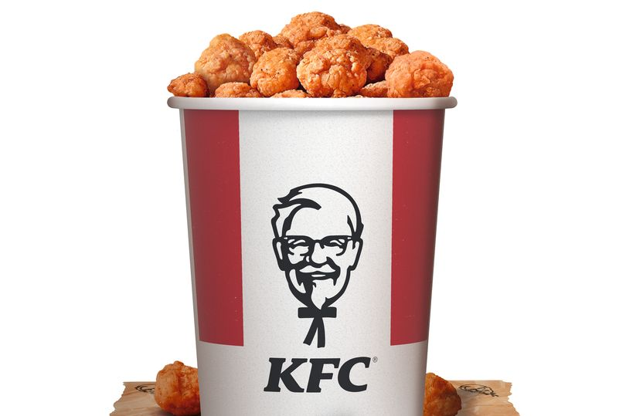
Figure 1: KFC Zinger Chicken Popcorn

Hygienic and healthy.

Even though the restrictions are quite casual, we are still not out of the radar of the pandemic. However, whenever you visit our shop to buy your meal or you order online from us, you can always stay worry-free about hygiene and safety. We use the best means of sanitation and cleanliness to make sure there is no unnecessary virus transmission.

Wrap up: Are you thinking of making your Christmas treats more enjoyable for you and your family? Then all you can do is, reach out to us and grab your bowl of chicken popcorn and let yourself delve into the best tantalizing taste ever!

Blog 2: Why is Chicken Popcorn the best snack you can ever have?

What can be the best hunger blaster option for you? Let us guess… Something soft yet crunchy; or something spicy yet comfy to have any time; also something satisfies your hunger and at the same time leaves you craving for some more. Well, my friend, let us inform you, Chicken popcorn is the exact delicacy that can match all these criteria which makes it the greatest of all snacks. Here are some more reasons behind this claim:

A pack of protein:

When you are hungry and at the same time conscious about your health, you must have a kind of food which includes healthy elements such as protein. Chicken popcorn is made out of solid and fresh chicken which usually constitutes 8 gms of protein in each piece. Would you miss the chance to feed some healthy protein to your stomach?

The perfect balance of healthy nutrients:

A bowl of chicken popcorn is not just filled with protein, rather there is a perfect combination of taste and health nutrients combined. Chicken popcorns are a great source of calories, carbohydrates, sodium, potassium, fibre and iron which have impeccable benefits in your body to keep you healthy and energetic.

A blast of deliciousness:

You can stay assured with one fact that a bowl of chicken popcorn will never disappoint you in matters of taste. This crunchy fast food is an amalgamation of authentic spices such as onion and garlic powder, paprika powder, dried oregano, sugar and salt which sum up into a brilliant flavour and fragrance which is quite tough to ignore.

Wrap up: One of the best things about chicken popcorn is, it is a lighter food yet makes you full, which helps you to say adieu to your hunger for a long time. Are you thinking of having some crispy tasty Chicken Popcorn right in front of your eyes? Reach out to KFC, the ultimate destination for fresh snacks and treat your tummy with the best taste ever with their all-new Zinger Popcorn Chicken with a spicy makeover!

Blog 3: 3 best destinations to have Chicken popcorn in the United Kingdom

Are you currently in the UK and running too and fro to find out the best places that serve the most brilliant Chicken Popcorn delicacy at a great price? Then you have tapped into the right place. Here we will be discussing the 3 best-fried chicken hotspots in the UK that can be your next hang out spot to grab some chicken popcorn. Read on…

Number One: None other than our all-time favourite KFC!

KFC is currently the leading fried chicken and snacks outlet all over the world. No wonder, their magical tastes are enough to make anyone happy. KFC has recently launched its new Zinger Popcorn Chicken which is winning over the mind of the foodies due to all the right reasons. The store serves fresh healthy chickens seasoned with the best-quality spices and fried with a low level of oiliness and takes care of the best customer satisfaction (Al Hamdhan, 2021). Apart from that, the store facilitates a highly hygienic process to combat the COVID-related risks which makes KFC a great spot to check out right now. The company is also taking its green initiative to create a great environmental-friendly impact (Ali, Bangsawan, and Rouly, 2020).
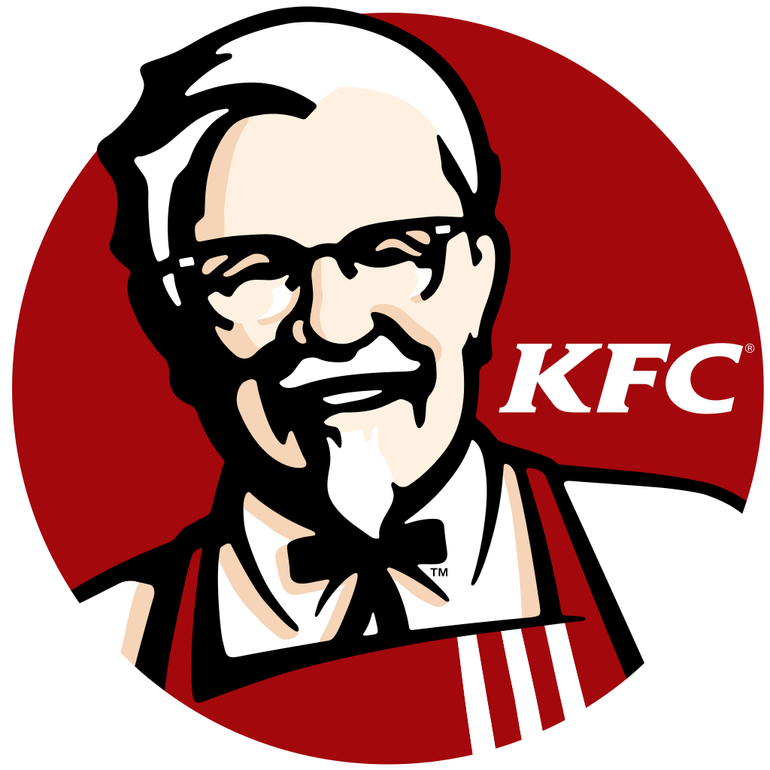
Figure 2: KFC

Number Two: The cutest and heartiest CHIK’N

CHIK’N is quite a friendly fried chicken store in London where you can find some brilliant delicacies along with your all-time favourite Chicken popcorn. Their succulent fried chicken prepared with the best-flavoured spices and a tasty coating is simply great to make anyone’s day great and fun-filled. Hence, whenever you are in the town, check out this place.

Number Three: All-time classy The Fat Walrus

The Fat Walrus is all-time great for its lip-smacking delicacy options which makes it a heartiest place for any of the diehard chicken lovers. Even though this place has some great options such as BBQ Cheesy Beany Fries, Buttermilk Fried Chicken etc, the Popcorn Chicken is a game-changer in terms of taste and crunchiness that you must try out.

Conclusion: The country UK is filled with destinations that can be overwhelming zones for all the chicken lovers. Especially if you are a chicken popcorn lover, then you can enjoy your fullest while visiting the above-mentioned ones.

Blog 4: KFC- The most affordable place to start your party

Is it the new Holiday party that is giving you concerns; or is it your birthday around, that deserves a fun-filled birthday bash? Anything can be your concern, ranging from what should be there on the menu, how to select the best restaurant in the town, or how to arrange an affordable party. All answers to your concerns are KFC. Here’s why:

A highly affordable place for everyone.
KFC offers its customers the best range of meals at a brilliant range of pricing. Apart from that, there are plenty of combo offers and bucket meals available which are great for a family or a group of friends. The company believes in offering ultimate customer satisfaction with a brilliant pricing strategy (Sheth, 2021).

An exciting range of delicacies to start at.

The company takes pride in delivering the best quality fried chicken delicacies which are lip-smacking and healthier. Delivering a myriad of options is a brilliant branding strategy of KFC (Long, et al. 2019). Whether it is their Fillet meal box, Boneless Banquet, or the newly launched Zinger Popcorn Chicken, anything can be the best starting point for your party.

Wrap up: When the holiday is around budget is everyone’s concern apart from the fun-filled parties. However, when you are planning your treats with KFC, nothing will go out of your budget. Apart from that, it is really a pleasure for all to have meals that are highly hygienic and served at a well-sanitized place.

Blog 5: The secret of customer satisfaction at KFC

Being one of the best food outlets all over the world, KFC has gradually overcome plenty of challenges swiftly. What is the secret behind their success and what makes their customer the happiest? The company’s marketing authority is great at managing a highly effective team who are brilliant at creating great brand awareness. Here are the principles the company follows:

The idea of segmentation:

One of the most impressive approaches of KFC is the principle of Segmentation. According to Kotler and Armstrong, segmentation refers to the acknowledgement of the fact that you cannot serve all the clients with a similar level of satisfaction. Rather it is better to offer the best form of pleasure to the target market (Syafril, and Hadziq, 2021). No wonder, the company follows it at its best. It uses the best means of digital marketing tactics to catch the attention of its customers (Shah, 2018). The Chicken lover community will agree for sure!

7Ps of Marketing Mix:

In order to evaluate its marketing tactics the company highly relies upon the idea of the 7Ps of the marketing mix- Product, Price, Promotion, Place, People, Physical Evidence, Process (Jamshid O'g'li, RakhmonjonZokirjono'g'li and Kholdorovna, 2020). The company is simply great at making its Products high quality, both in terms of taste and hygiene. Apart from that, the Price is another key factor that makes people keep visiting the store repeatedly. Promotion is the area where the company excels every time. At least all of us once day comes across one KFC commercial which has made this brand become omnipresent (Mallik, and Farhan, 2018). Moreover, the company uses an emotion-based marketing design to connect with consumers. (Jiang, and Zhang, 2021). KFC is highly strategic at choosing its location, hence the Place where it starts easily becomes convenient for everyone (Sheraj, 2017).

Figure 3: 7Ps of Marketing Mix
(Source: Sheraj, 2017)

The approach of Promotional Mix:

In order to stay relevant to the field of marketing and to give tough competition to Burger King, McDonald’s, Starbucks etc, KFC uses its highly effective Promotional Mix strategy (Al Hamdhan, 2021). It refers to a blend of promotional variants that helps in chasing the goal. KFC spends a good amount of resources in advertising, promotional selling, sales promotion, publicity stunts (PRs, anniversary events), direct marketing, corporate image building, sponsorship, digital marketing and Guerrilla marketing.

Wrap up:KFC is one of the food shops which are highly preferred by people of all ages. Not just the way it deals with its customers, but also the company focuses on giving its best to apply the relevant marketing models which are effective. Are you looking for the best food with great customer service in the United Kingdom? Then reach out to the official website of KFC UK to find out the outlets near you.

Blog 6: Best KFC Meals to pick for a f

un food venture

Are you wondering about visiting KFC for a fun food experience? The fried chicken store serves a myriad of preparations that are not only great in taste but also facilitate a brilliant quality. At the same time, it is not unnatural to feel confused about what to choose when you are at the store. Here are some great points to start with:

Zinger Chicken Popcorn
The company has recently launched one of its great delicacies, i.e the Zinger Chicken Popcorn. This item is slightly different from the basic KFC Chicken popcorn as it comes with a new spicy makeover that tastes better and heavenly. Hence, it’s a must-try!

Chicken Salad
If you are a great fan of something healthy and light in your meal that is enriched with great taste, then the Chicken Salad by KFC can be the best choice for you. This dish is filled with brilliant flavours which is a great combination of healthy veggies and protein-packed succulent chickens which is a great delight to have.

Wing Meal
The wing meal is a great treat for chicken wing lovers. The spice coated fresh chicken wings are coated with tasty batter and fried to become crispy and tasty which is served with delicious mayonnaise and mustard dip, simply making a great snack option to start your evenings.

Wrap up: KFC is the ultimate destination for those who have a big corner in their heart for the fried chicken dishes. Not only is the place great at serving you the best quality meals by it also follow all the COVID-19 protocols and proper hygienic practices while satisfying their guests. Do you want to know more about KFC? Take a fun tour at your nearby outlet in the UK.

Conclusion

KFC has included blogs in its marketing strategy to attract more customers and improve its sales. However, the blog is the part of content marketing that plays a vital part in attracting more customers to the brand.
The blog used for marketing purposes will definitely make a place for the restaurant to welcome more customers to it. The restaurant will make more profit by greeting more customers.

Bibliography:

- Al Hamdhan, R., 2021. Application of Emphatic Marketing Strategy at Burger King Company on Social Media Against Customer Engagement During the Covid-19 Pandemic. Jurnal REKOMEN (Riset Ekonomi Manajemen), 5(1), pp.73-80.
- Ali, M., Bangsawan, S. and Rouly, D., 2020. Consumer characteristics and the effects of social factors on purchasing decisions of Kentucky Fried Chicken (KFC) eco-friendly products. In The Future Opportunities and Challenges of Business in Digital Era 4.0 (pp. 86-89). Routledge.
- Jamshid O'g'li, R.D., RakhmonjonZokirjono'g'li, O. and Kholdorovna, R.F., 2020. Changes in market relations in the period of market economy and their classification. South Asian Journal of Marketing & Management Research, 10(4), pp.120-129.
- Jiang, X. and Zhang, F., 2021, July. Application of Emotion-Based Design in Brand Communication—Taking KFC as an example. In the International Conference on Applied Human Factors and Ergonomics (pp. 490-497). Springer, Cham.
- Long, N.H., Van Oanh, D., Hoa, P.H., Dung, V.T., Thanh, P.T.K. and Quang, N.N., 2019. THE EFFECTS OF CUSTOMER EQUITY ON CUSTOMER LOYALTY FOR CHAIN RESTAURANTS: CASE STUDY OF KFC VIETNAM. SOCIO-ECONOMIC AND ENVIRONMENTAL ISSUES IN DEVELOPMENT, p.229.
- Mallik, A. and Farhan, S.N., 2018. Customer Centric Approach Using 7ps of Marketing Mix. International Journal of Innovative Knowledge Concepts, 6(11), pp.136-149.
- Shah, J., 2018. Impact of digital marketing in business and politics. Int J Sci Eng Res, 9(2), pp.10-14299.
- Sheraj, S., 2017. A comparative analysis of the marketing mix of KFC in China and Bangladesh. International Journal of Science and Business, 1(2), pp.78-87.
- Sheth, J., 2021. New areas of research in marketing strategy, consumer behavior, and marketing analytics: the future is bright. Journal of Marketing Theory and Practice, 29(1), pp.3-12.
- Syafril, S. and Hadziq, M.F., 2021. Islamic Principles in Marketing: An Overview of Islamic Marketing mix in Social-Media Campaign. El-Qish: Journal of Islamic Economics, 1(1), pp.69-82.

