

Management and Quality Management in Construction
ACBA5001
Kamran Davies
2014508@student.uwtsd.ac.uk

Table of Contents
1. Introduction 1
2. Method of Findings 1
3. The Meaning of Quality 1
4. Results 2
4.1. Quality Assurance 2
4.2. Quality Control 3
4.3. What Is The Difference Between QA And QC? 4
4.4. Total Quality Management 5
5. Management Theories – X and Y (Douglas McGregor) 5
6. Conclusion 6
References 6
Appendices 7
Appendix (A.1), First Page – My Employer’s Certification 7
Appendix (A.2), Second Page – My Employer’s Certification 8
Appendix (B) - Quality Control vs Quality Assurance 9
Appendix (C) – X and Y Theory 10

Introduction

Throughout this assignment I will be focusing on identifying quality assurance and quality control and their values for project effectiveness in construction and management.
Another option to consider is how total quality management would strengthen or weaken the project effectiveness.

Method of Findings

The subject matter from this report will be sourced from booked, online resources and lecture presentations uploaded through Microsoft teams.

The Meaning of Quality

The majority of quality seek to identify and assess how closely a given good or service resembles this overall composite. Other words like dependability, serviceability, and maintainability have also been used to define product quality on occasion. It is crucial to

acknowledge this fact because it is a prerequisite for determining service quality. (Feigenbaum, 1991)
Within the industry, companies will have their own quality management systems in place, however the company will have to have these systems by the British standards to deem that they comply with BSI EN ISO 9001:2015. Please see in appendix (A) Dyer and Butler certification as an example of the 9001:2015 certification documentation.

Results

4.1. Quality Assurance

Quality assurance is a means of minimising probable mistakes in a building project by establishing "procedures" for minimum quality and ensuring that all decisions adhere to these standards. (Harenberg, 2022)
ISO 9000 identifies as part of the quality management which aims on providing that the quality and belief can be met. The quality assurance approach involves administrative and routine actions so that the required goals for a construction project and services can be accomplished. Quality assurance implies the main two principles:
- Fit for purpose – Ensuring that it is appropriate for it’s planned objective
- Right first time – All possible errors are removed
There are many factors which are associated to quality assurance. The management of quality of raw materials, products and parts, services related to construction and management and inspection procedures. The quality is determined by both the product users and clients. However, has no implications with price. (CIOB, The Construction Wiki, 22)
It is possible to get rid of a problem's fundamental cause by identifying and fixing it after a non-conformance has been produced. Only by focusing organisational efforts on planning and stopping issues in their tracks can quality be improved permanently and continuously. The evolution of quality management is facilitated by this idea. Providing assurance that quality criteria will be met was one of the goals of the quality management process. (BS EN ISO 9000 (20002)). (Barrie G. Dale, 2007)
One of the most important issues on a construction site is quality assurance. Even though over 90% of clients claim to be pleased with the quality of their new project, poor construction quality can drastically harm a client's reputation and have a huge financial impact for the worse. The industry has created demanding quality assurance requirements in part because of this. Because of these self-imposed standards and guidelines, building companies may measure quality consistently and impartially. (Harenburg, 2022)

Following the five golden rules for quality assurance in construction and checking that the decisions meet the specifications, and the standards are set.
- Clear definitions of quality – Meaning that everyone working on the project will need to know the expectations are for that given task.
- Planning, design, and development – Assessments are to be carried out safeguarding that there are no clashes and mistakes early on.
- Material purchasing – Confirming that all plant, material and equipment purchased meet the standards. Usually, buying “lower quality” material may save money in the short term, however, could result in further issues in the future.

- Continuous interaction during the build – Making sure that communication is to a full at all times and verifying progression and consider any concerns.

- Handover and snagging – Once the structure is complete, it is to check and ensure the structure meets your projected quality standards.

(Harenberg, 2022)

4.2. Quality Control
As part of quality management, quality control makes certifying that goods and services meet standards. It is a work process that makes it easier to measure a unit's quality attributes, compare them to defined criteria, and analyse discrepancies concerning actual and expected outcomes in order to make correction decisions. To safeguard the construction project are conducted out properly, it will include the performance and close of the works, not just the product and material. Controlling the quality will be implemented on inspection or confirmation of the finished result. (CIOB, The Construction Wiki, 2022)
Three aspects are highlighted by this strategy. They are as follows:
- Controls, task management, well identified and managed procedures. Along with operation and integrity standards, and recorded documentation.
- Knowledge, experience and competencies.
- Motivation, quality relationships and organisation.
(Demski, Quick Base, 2022)
A management system known as "construction quality control" makes sure that deliverables adhere to the criteria and regulations established by the client at the start of the construction development. This can contain a variety of standards, such finishing the project within the constraints of the job. Plans and practises that provide high-quality results are

referred to as quality control. In construction quality control, it's important to recognise and address the factors that affect the quality of the project. This helps to ensure that the results are high quality, and that problems don't arise again in the future. There are different ways to manage quality control in construction, and one of these is by following ISO 9001 standards. This standard sets out specific requirements for how a company must do things to ensure that their products are of the best possible quality. (Demski, Quickbase, 2022)
The basic principle of the total quality perspective and its fundamental difference from all other ideas is that to be truly effective, control must begin with the identification of requirements for quality. Effective control is now a central requirement for successful management. This control case fails, it is the main cause of increasing business costs and reducing business revenue. With the rapid rise of technology for many products and services, this now creates a growing need for economic and practical integration into corporate practices. (Feigenbaum, 1991)

What Is The Difference Between QA And QC?

Fundamentally, quality assurance (QA) is focused on preventing defects, and quality control (QC) is focused on identifying the faults.
Quality assurance is a process of monitoring the quality of a product or service before it is released to the public or sent to a customer such as a construction project awaiting to start. Quality assurance records the methods, principles, standards, and strategies that should be followed in order to ensure the quality of a product or service. This ensures that everyone involved in the production or delivery of the product or service is aware of the necessary steps in order to produce a quality product or service.
Quality control is the process of verifying the quality of a product or service. It is essential to the success of a project, as it ensures that the finished product meets customer expectations. Quality control involves observing the work being done on a construction site and checking to make sure that it meets the required standards.
(DigiQC, DigiQC, 2022)
Please see appendix (B) for quality control vs quality assurance.

Total Quality Management

The idea behind Total Quality Management is to help an organisation improve its overall ability to produce quality products and services, and to do so on a continual basis. (DigiQC, DigiQC, 2022)
There are several key differences between TQM and traditional management approaches. For example, total quality management is focused on process over results, promotes quality over cost, and is based on a more horizontal, rather than vertical, organisational structure. Total quality management believes that profits will follow quality, rather than the other way around. Although delays and faults are inherent in construction, far more so than in a more regulated industrial setting, the adoption of total quality management necessitates that the employee's mindset transition from one of simply monitoring to one of always searching for possibilities to improve. Total quality management can be used in construction to approach goal formulation, conception, and achievement to ensure excellence and production, with an emphasis on improvement and new technology. (Buildings, 2022)
TQM implementation is more difficult in the construction sector due the workmanship flaws, time and cost overruns are all problems in the building sector. Inadequate or non-existent quality control and quality-assurance systems may allow costly errors in design and contract documents to go undetected. Total quality management is a management strategy for a client focused business in which all staff members participate in ongoing development. Through policy, data, effective communication, and involvement of all levels of employees, it infuses quality discipline into the organisation's culture and actions. (Placements, 2022)

Management Theories – X and Y (Douglas McGregor)

In 1960, Douglas McGregor offered two hypotheses and how managers should view and deal with employee motivation. These contrasting motivational strategies were referred to by him as “Theory X” and “Theory Y” management. Each presupposes that the manager's job is to allocate resources, including people, in a way that is most advantageous to the business. (Lumen, 2022)
The idea of Theory X is that an employee has a fond dislike to their job and will do anything in their power to avoid it. The employee has very little ambition, prefers to be guided, and wants to avoid responsibilities. Therefore, a Theory X management style necessitates strict, close supervision and tasks that are well defined. McGregor admits that the persuasion strategy can be effective, but it fails when people's needs are primarily selfish. (Balls, 2022)

McGregor urged businesses to use more Theory Y leadership techniques. Although it is significantly and calls for greater manager involvement, it also believes that employees will be dedicated to the company's long-term objectives. He thought that managers may inspire their staff to reach their full potential by applying Theory Y. Workers will be able to accept all challenges and be proud of their work if they hold to this philosophy. Recognising their want to engage in decision-making and to contribute to their work and acknowledging that they do not require micromanagement. (Library, 2022). See Appendix (C) for X and Y Theory.

Conclusion

Total quality management is a practice that aims to achieve the highest possible level of quality in products and services. There are several stages that must be successfully implemented to achieve this, and each has its own benefits. A small organisation might not implement a full quality control management system, while a large one might have a different process for different stages of the procurement process.

The emphasis on incorporating processes and inspections gets more obvious as the Quality Management System develops. The report's findings suggest that overall quality management is the best strategy for ensuring quality, while each stage may have drawbacks. Simply implementing quality management and executing processes within an organisation does not guarantee quality. The standard of quality, in my opinion, results from a group's determination to work together and continuously develop, which is based on pride, self-respect, and commitment to their roles in whatever that may be in. As a result, the organisation would develop a quality mindset and culture.

References
Bach, J. S. (2022, 11 29). DTU. Retrieved from Quality assurance methods in project management: http://apppm.man.dtu.dk/index.php/Quality_assurance_methods_in_project_management
Balls, B. (2022, 12 10). Business Balls. Retrieved from What is X-Y Theory of Management?: https://www.businessballs.com/improving-workplace-performance/mcgregors-xy-theory-of-management/
Barrie G. Dale, T. v. (2007). Managing Quality . Oxford: Blackwell Publishing .
Buildings, D. (2022, 12 08). Designing Buildings - The Construction Wiki. Retrieved from Total Quality Management In Construction: https://www.designingbuildings.co.uk/wiki/Total_quality_management_in_construction
CIOB. (2022, 11 29). The Construction Wiki. Retrieved from Quality Control For Construction Works: https://www.designingbuildings.co.uk/wiki/Quality_control_for_construction_works
CIOB. (22, 11 22). The Construction Wiki. Retrieved from The Construction Wiki: https://www.designingbuildings.co.uk/wiki/Quality_assurance#Construction_Quality_Assurance_.28CQA.29
Demski, J. (2022, 11 29). Quick Base. Retrieved from Understanding Quality Control In Construction: https://www.quickbase.com/blog/quality-control-in-construction
Demski, J. (2022, 12 06). Quickbase. Retrieved from Understanding Quality Control In Construction: https://www.quickbase.com/blog/quality-control-in-construction
DigiQC. (2022, 12 07). DigiQC. Retrieved from What Is Quality Management In Construction: https://www.digiqc.com/blog/what-is-quality-management-in-construction#:~:text=Total%20Quality%20Management%20in%20Construction&text=TQM%20prioritizes%20quality%2C%20flexibility%2C%20and,quality%20and%20not%20vice%2Dversa.
DigiQC. (2022, 12 07). DigiQC. Retrieved from What is the difference between QA and QC: https://www.digiqc.com/blog/what-is-the-difference-between-qa-and-qc-in-construction
Feigenbaum, A. V. (1991). Total Quality Control. McGraw-Hill.
Harenberg, M. (2022, 11 19). Quality assurance in construction. Retrieved from PlanRadar: https://www.planradar.com/gb/quality-assurance-in-construction-5-golden-rules-saving-money/#:~:text=Quality%20assurance%20is%20a%20method,all%20decisions%20meet%20these%20standards.
Harenburg, M. (2022, 11 22). Plan Radar. Retrieved from Quality assuarnce in construction: https://www.planradar.com/gb/quality-assurance-in-construction-5-golden-rules-saving-money/#:~:text=Quality%20assurance%20is%20a%20method,%2C%20size%2C%20shape%20and%20material%3F
Jelvix. (2022, 12 07). Jelvix. Retrieved from Quality Assuarnce v Quality Control: https://jelvix.com/blog/quality-assurance-vs-quality-control
Library, E. (2022, 12 12). Education Library. Retrieved from Theory X And Theory Y, Douglas McGregor: https://educationlibrary.org/theory-x-and-theory-y-douglas-mcgregor/
Lumen. (2022, 12 10). Introduction To Business. Retrieved from McGregor’s Theory X and Theory Y: https://courses.lumenlearning.com/wmintrobusiness/chapter/reading-douglas-mcgregors-theory-x-and-theory-y-2/
McCownGordon. (2022, 12 06). McCownGordon. Retrieved from Quality Assurance & Qulaity Control: https://mccowngordon.com/the-importance-of-quality-control-in-construction-midwest-construction-experts/
Placements, C. (2022, 12 08). Construction Placements . Retrieved from Total Quality Management - TQM In Construction Industry: https://www.constructionplacements.com/tqm-in-construction/#gsc.tab=0

Appendices

Appendix (A.1), First Page – My Employer’s Certification

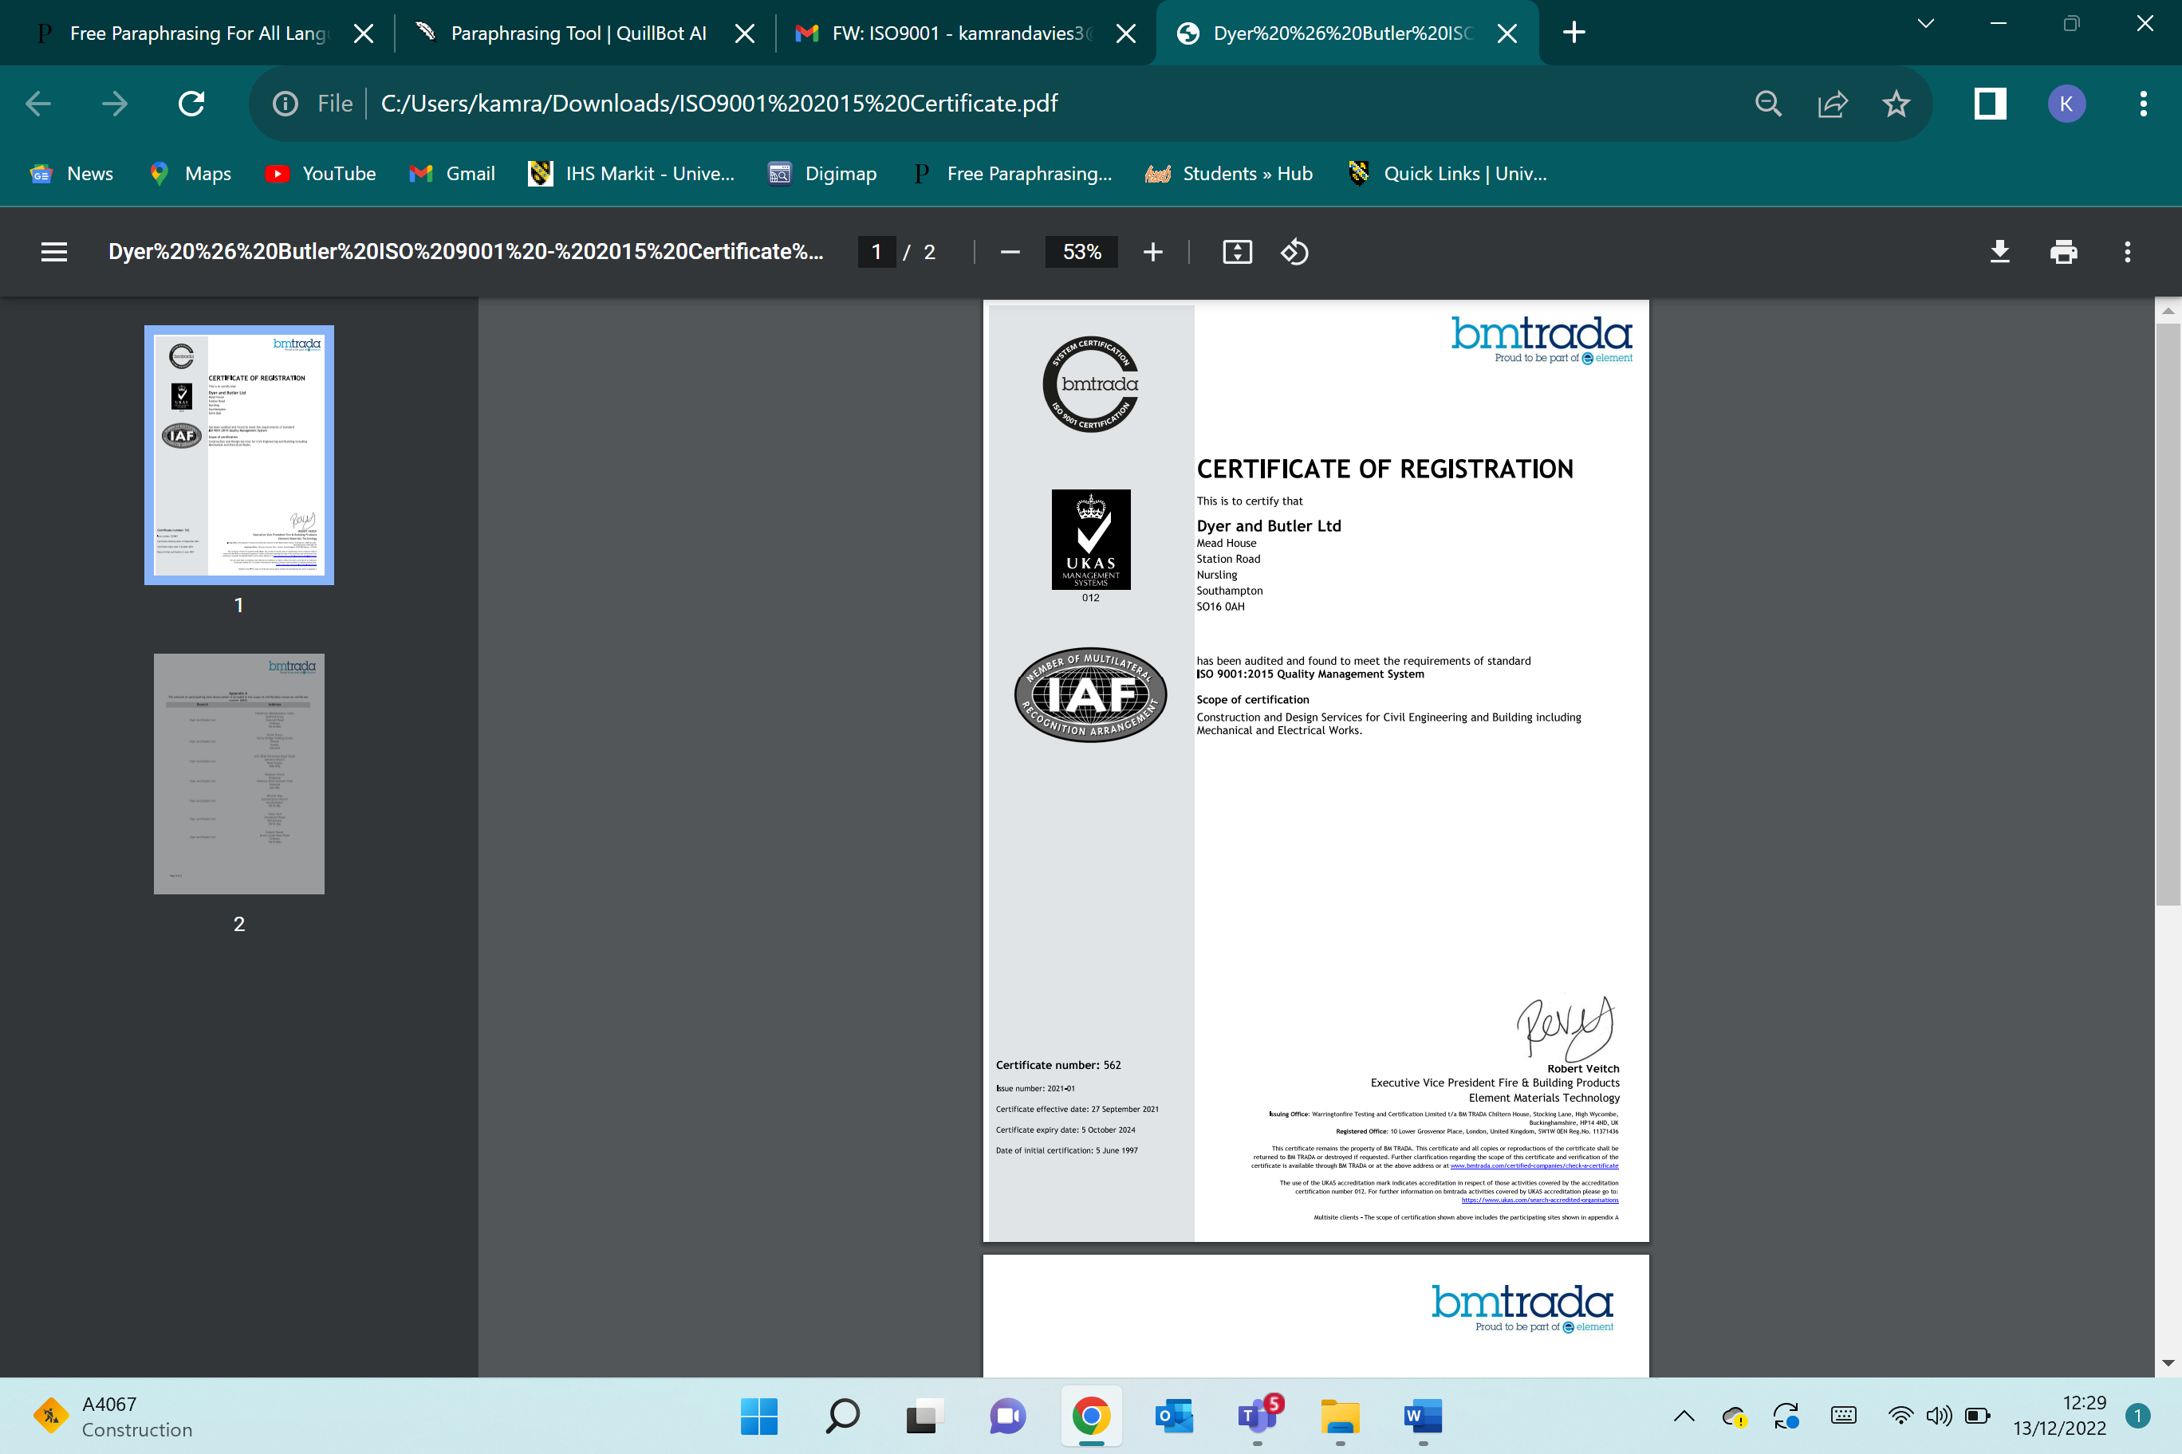

Appendix (A.2), Second Page – My Employer’s Certification



Appendix (B) - Quality Control vs Quality Assurance

(Jelvix, 2022)
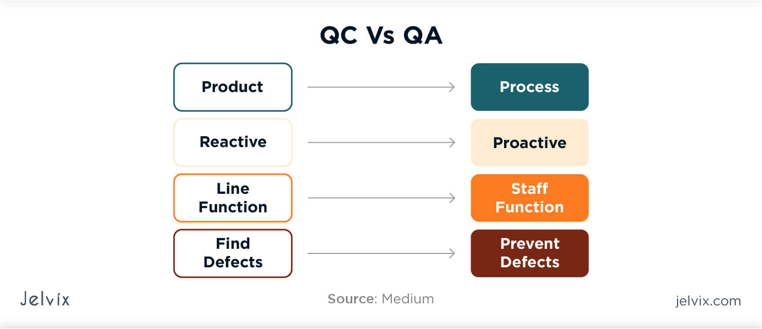

Appendix (C) – X and Y Theory

(Library, 2022)



